Supporting Information

Distinguishing High-Metastasis-Potential Circulating Tumor Cells through Fluidic Shear Stress in a Bloodstream-Like Microfluidic Circulatory System

Wenxiu Li 1,2,5, Zhengjun Guo1,3,5, Zhihang Zhou4,5, Zhengdong Zhou1,2, Huimin He1,2, Jiayu Sun1,2, Xiaoyu Zhou1,2, Y. Rebecca Chin1,2, Liang Zhang1,2, Mengsu Yang1,2,*

1. Department of Precision Diagnostic and Therapeutic Technology, City University of Hong Kong Shenzhen Futian Research Institute, Shenzhen, 518057, China
2. Department of Biomedical Sciences, and Tung Biomedical Sciences Centre, City University of Hong Kong, 83 Tat Chee Avenue, Kowloon, Hong Kong SAR, China
3. Cancer Center, the Second Affiliated Hospital of Chongqing Medical University, Chongqing, China
4. Department of Gastroenterology, the Second Affiliated Hospital of Chongqing Medical University, Chongqing, China
5.These authors contributed to this work equally
*Corresponding author: bhmyang@cityu.edu.hk

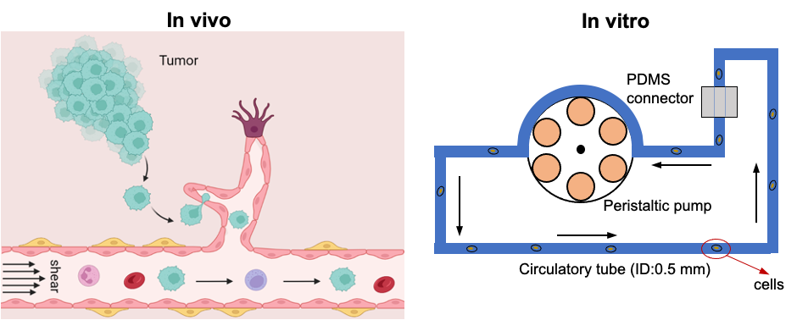
Figure S1. Schematic illustration of the in vivo circulatory system and the established in vitro microfluidic circulatory system.

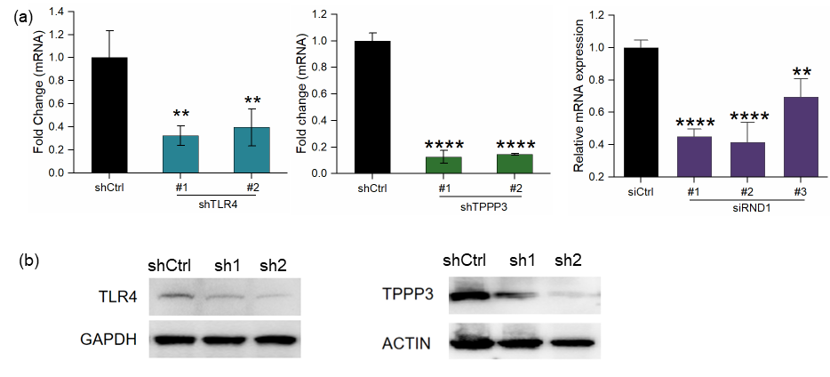
Figure S2. The efficiencies of knocking down candidate genes in HepG2 cells were determined by qRT-PCR (a) and Western blotting (b).

Figure S3. Quantification of the survival under high fluid shear stress after candidate genes were silenced with shRNAs in HepG2 cells, respectively.

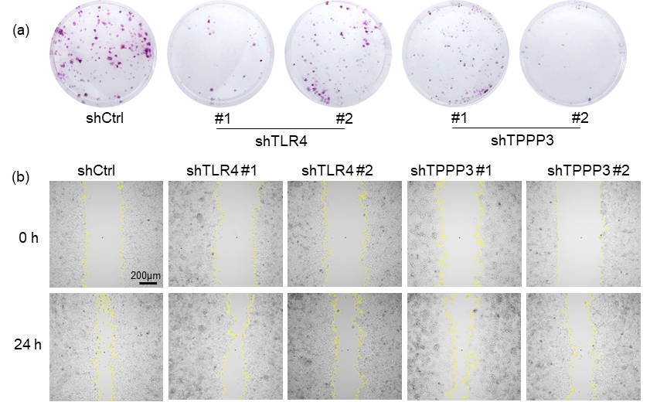
Figure S4. Representative images of colony formation (a) and wound healing assay (b) after candidate genes were silenced with shRNAs in HepG2.

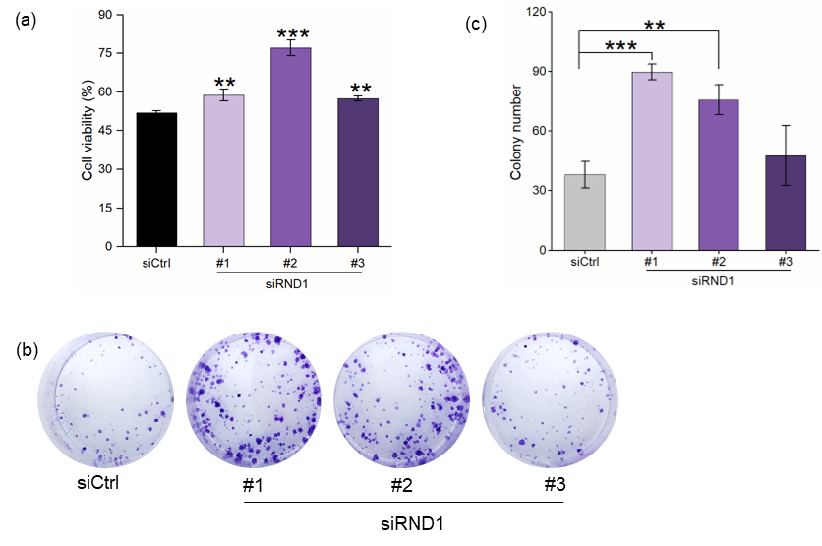
Figure S5. The effect of knockdown of candidate genes on the survival in circulation, colony formation, and migratory ability of HepG2 cells. Quantification of the survival under high (a) and low (b) fluid shear stress after candidate genes were silenced with shRNAs or siRNAs in HepG2 cells, respectively. (c) Representative images and quantified results of the colony formation assay after silencing RND1 in HepG2 cells.

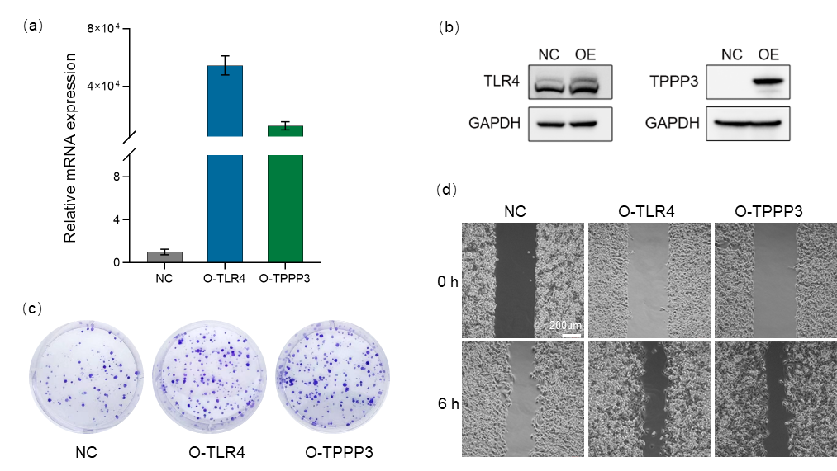
Figure S6. RT-qPCR (a) and Western blot (b) results showing mRNA and protein levels after overexpression of TLR4 (O-TLR4) and TPPP3 (O-TPPP3) in SK-Hep-1 cells. GAPDH is a housekeeping gene. The mRNA level in the negative control group (NC) of in SK-Hep-1 cells was normalized to 1 and used as an internal reference for calculating the mRNA levels of the three overexpressed groups. The results represent the mean± SD from three independent experiments. The western blot experiments were performed 3 times, and representative blot images are presented in panels b. Representative images of colony formation (a) and wound healing assay (d) after candidate genes were overexpressed in SK-Hep-1 cells.

Table S1. shRNA and siRNA list.
shRNA name | Target sequence (5’-3’)
shTLR4#1 | 5’-AGGAAUGAGCUAGUAAAGAAUUUAG-3’
shTLR4#2 | 5’-GGAUGGUAAAUCAUGGAAUCCAGAA-3’
shTPPP3#1 | 5’-CCAAUGUGGGCGUCACUAAAGCAAA-3’
shTPPP3#2 | 5’-GGCAAGAGAUGAAUGGCAAGAACTG-3’
shCtrl | 5’-AAACGTGACACGTTCGGAGAA-3’
siRND1#1 | 5’-AGGAUCUCCCUACUACGAUAAUGTC -3’
siRND1#2 | 5’-GGAGUGUUUCAAUCUGUUAUAUGTT-3’
siRND1#3 | 5’-CGAACAGACCUGAGUACUCUGAUGG-3’

Table S2. Primer list for RT-qPCR.
Gene symbol | Forward primer (5’-3’) | Reverse primer (5’-3’)
GAPDH | GACAGTCAGCCGCATCTTCT | GCGCCCAATACGACCAAATC
RND1 | TTAGCGAAGGATTGCTATCCAGA | GTATCCCAGAGACTAAGCTCCA
TLR4 | GAGCCGCTGGTGTATCTTTGA | CTCCCACTCCAGGTAAGTGTT
TPPP3 | TGACGGAAAGTCCGTGACAG | CCTCCTTGCTCTTCCCCTTG

