Subsurface mixing and ventilation of oxygen minimum zone waters in southern Bay of Bengal during summer monsoon

^{1*}Rajdeep Roy; ²P. N. Vinayachandran, ³Jenson George; ⁴Amit Sarkar, ²Chandanlal Parida

¹Indian Space Research Organization, National Remote Sensing Centre, Hyderabad-503007, India
²Centre for Atmospheric and Oceanic Sciences, Indian Institute of Science, Bangalore-560 012, India.
³National Centre for Antarctic and Polar Research, Ministry of Earth Sciences, Govt. of India, Goa-403804, India
⁴Kuwait Institute of Scientific Research, Safat-13109, Kuwait
⁵Indian National Centre for Ocean Information Services, Ministry of Earth Sciences, Govt. of India, Hyderabad-500090, India
*Corresponding author Email: rajdeeproy2003@yahoo.com; rajdeep_roy@nrsc@gov.in

Supplementary Fig. 1

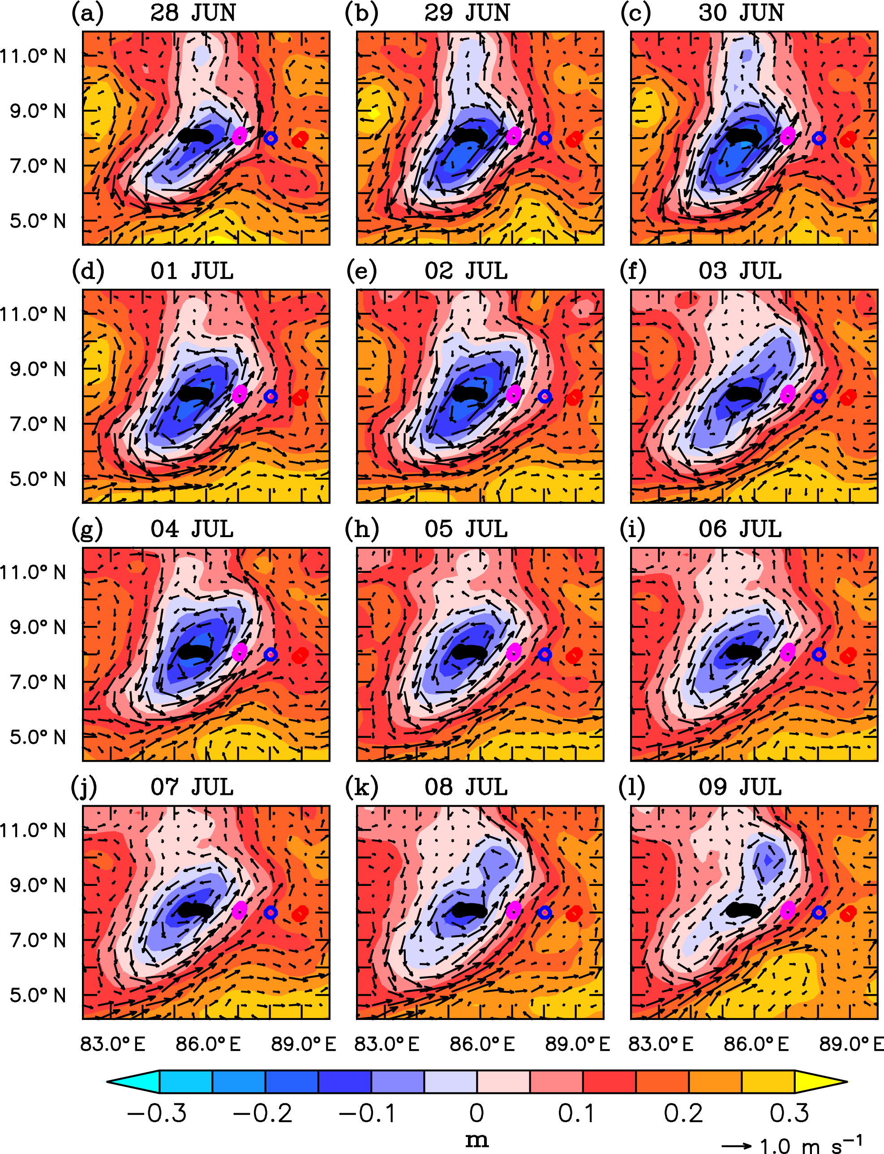

Supplementary Fig. 1 : Sea level anomalies (SLAs; m) and surface currents (m s⁻¹) from AVISO for the period 28 June to 9 July 2016. Evolution of Sri Lanka Dome (SLD) is represented by the negative SLAs embedded within the cyclonic circulation. Adapted from (Tushara et al., 2019)
Supplementary Fig. 2

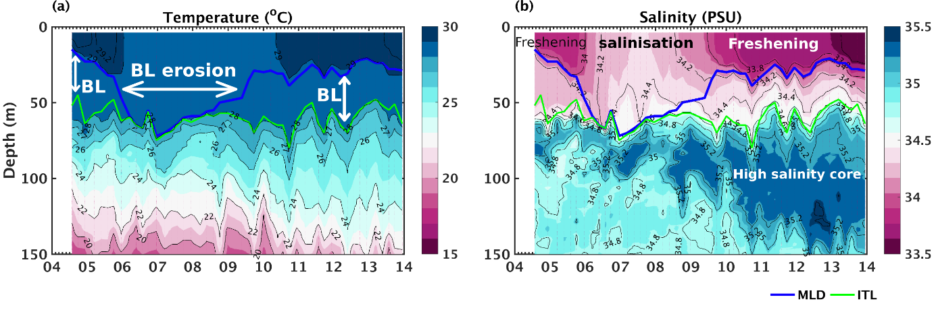

Supplementary Fig. 2 : Temporal variability of hydrographic properties during the time series (4–14 Jul 2016) at 8°N, 89°E: (a) temperature , (b) salinity showing the formation and erosion of the barrier layer. ). The blue and green lines represent the MLD and isothermal layer depth, respectively (George et al., 2019).

Supplementary Fig. 3

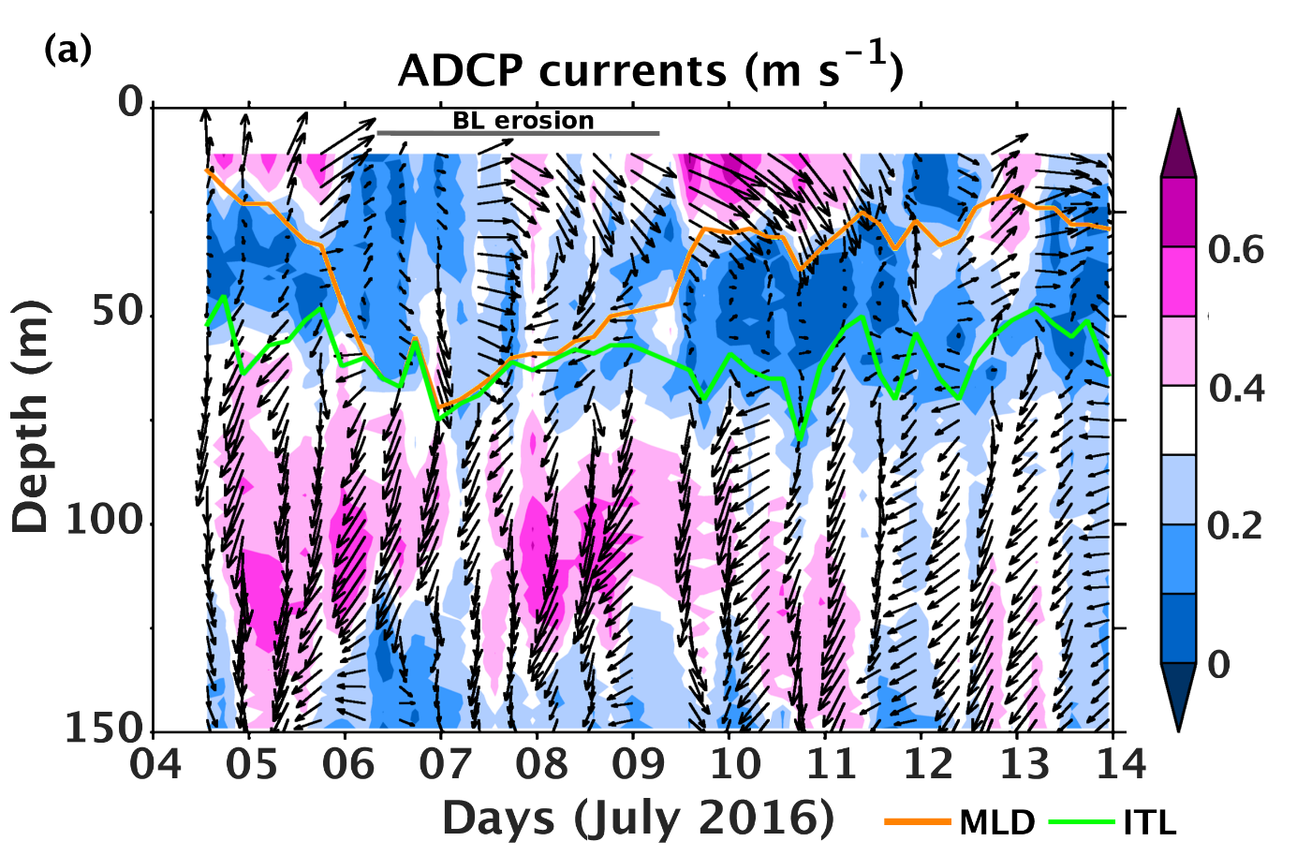

Supplementary Fig. 3 : Time–depth sections of (a) ADCP current speed (m s ⁻¹) overlaid by the horizontal current vectors during 4–14 Jul 2016 at the time series location. The organge and green lines represent the MLD and isothermal layer depth, respectively (George et al., 2019).

