Table S1. The detailed information of removed SNPs.
 | Exposure | Outcome | SNP | EA | OA | Reasons for exclusion
1 | Endometrial cancer | Breast cancer | rs9668337 | A | G | the SNP not found in breast cancer GWAS
2 | Endometrial cancer | Breast cancer | rs3184504 | C | T | the SNP not found in breast cancer GWAS
3 | Endometrial cancer | Breast cancer | rs4767257 | T | C | the SNP not found in breast cancer GWAS
4 | Endometrial cancer | Breast cancer | rs10089519 | G | A | the SNP is an outlier by MR-PRESSO analysis
5 | Endometrial cancer | ER+ breast cancer | rs9668337 | A | G | the SNP not found in breast cancer GWAS
6 | Endometrial cancer | ER+ breast cancer | rs3184504 | C | T | the SNP not found in breast cancer GWAS
7 | Endometrial cancer | ER+ breast cancer | rs4767257 | T | C | the SNP not found in breast cancer GWAS
8 | Endometrial cancer | ER- breast cancer | rs9668337 | A | G | the SNP not found in breast cancer GWAS
9 | Endometrial cancer | ER- breast cancer | rs3184504 | C | T | the SNP not found in breast cancer GWAS
10 | Endometrial cancer | ER- breast cancer | rs4767257 | T | C | the SNP not found in breast cancer GWAS
11 | Endometrial cancer | ER- breast cancer | rs10089519 | G | A | the SNP is an outlier by MR-PRESSO analysis
12 | Endometrial cancer | ER- breast cancer | rs7981863 | T | C | the SNP is an outlier by MR-PRESSO analysis
13 | Breast cancer | Endometrial cancer | rs56891541 | TCC | T | the SNP not found in endometrial cancer GWAS
14 | Breast cancer | Endometrial cancer | rs11571833 | T | A | the SNP not found in endometrial cancer GWAS
15 | Breast cancer | Endometrial cancer | rs62237573 | T | C | the SNP not found in endometrial cancer GWAS
16 | Breast cancer | Endometrial cancer | rs418053 | C | G | palindromic SNP
17 | Breast cancer | Endometrial cancer | rs9284657 | G | C | palindromic SNP
18 | Breast cancer | Endometrial cancer | rs10054203 | C | G | the SNP is an outlier by MR-PRESSO analysis
19 | Breast cancer | Endometrial cancer | rs10623258 | CTT | C | the SNP is an outlier by MR-PRESSO analysis
20 | Breast cancer | Endometrial cancer | rs2853669 | G | A | the SNP is an outlier by MR-PRESSO analysis
21 | Breast cancer | Endometrial cancer | rs67087079 | A | G | the SNP is an outlier by MR-PRESSO analysis
22 | Breast cancer | Endometrial cancer | rs71557345 | A | G | the SNP is an outlier by MR-PRESSO analysis
23 | ER+ breast cancer | Endometrial cancer | rs35353761 | G | A | the SNP not found in endometrial cancer GWAS
24 | ER+ breast cancer | Endometrial cancer | rs56891541 | TCC | T | the SNP not found in endometrial cancer GWAS
25 | ER+ breast cancer | Endometrial cancer | rs11571818 | C | T | the SNP not found in endometrial cancer GWAS
26 | ER+ breast cancer | Endometrial cancer | rs62237573 | T | C | the SNP not found in endometrial cancer GWAS
27 | ER+ breast cancer | Endometrial cancer | rs2735846 | G | C | palindromic SNP
28 | ER+ breast cancer | Endometrial cancer | rs418053 | C | G | palindromic SNP
29 | ER+ breast cancer | Endometrial cancer | rs4752569 | T | A | palindromic SNP
30 | ER+ breast cancer | Endometrial cancer | rs688601 | A | T | palindromic SNP
31 | ER+ breast cancer | Endometrial cancer | rs2403907 | A | C | the SNP is an outlier by MR-PRESSO analysis
32 | ER+ breast cancer | Endometrial cancer | rs3217992 | T | C | the SNP is an outlier by MR-PRESSO analysis
33 | ER+ breast cancer | Endometrial cancer | rs34196306 | C | G | the SNP is an outlier by MR-PRESSO analysis
34 | ER+ breast cancer | Endometrial cancer | rs4076654 | T | A | the SNP is an outlier by MR-PRESSO analysis
35 | ER- breast cancer | Endometrial cancer | rs11571833 | T | A | the SNP not found in endometrial cancer GWAS
36 | ER- breast cancer | Endometrial cancer | rs191981806 | C | T | the SNP not found in endometrial cancer GWAS
37 | ER- breast cancer | Endometrial cancer | rs62116991 | C | G | palindromic SNP
38 | ER- breast cancer | Endometrial cancer | rs2735846 | G | C | palindromic SNP
39 | ER- breast cancer | Endometrial cancer | rs4143044 | G | T | the SNP is an outlier by MR-PRESSO analysis
40 | ER- breast cancer | Endometrial cancer | rs55872725 | T | C | the SNP is an outlier by MR-PRESSO analysis
SNP: single nucleotide polymorphism; EA: effect allele; OA: other allele; GWAS: Genome-Wide Association Studies.

Figure S1 Scatter plot: SNP-outcome associations are plotted against the SNP-exposure associations to provide the effect estimate for each individual variant. The lines with different colors represent the regression slope fitted by different MR methods. (A) The causality of endometrial cancer on breast cancer. (B) The causality of endometrial cancer on ER+ breast cancer. (C) The causality of endometrial cancer on ER- breast cancer.
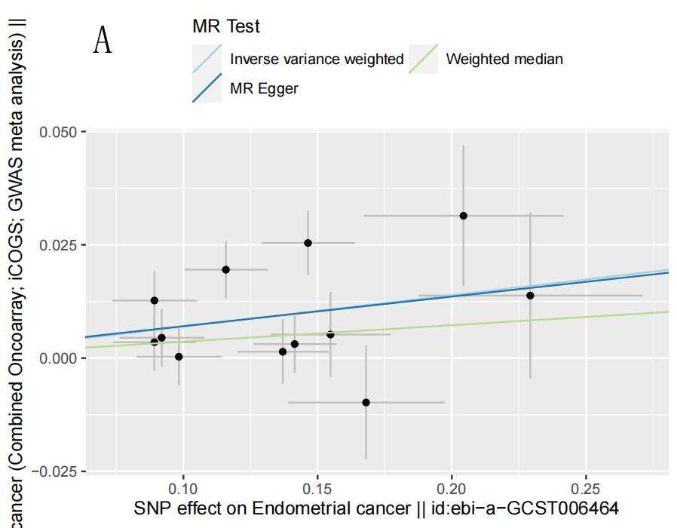
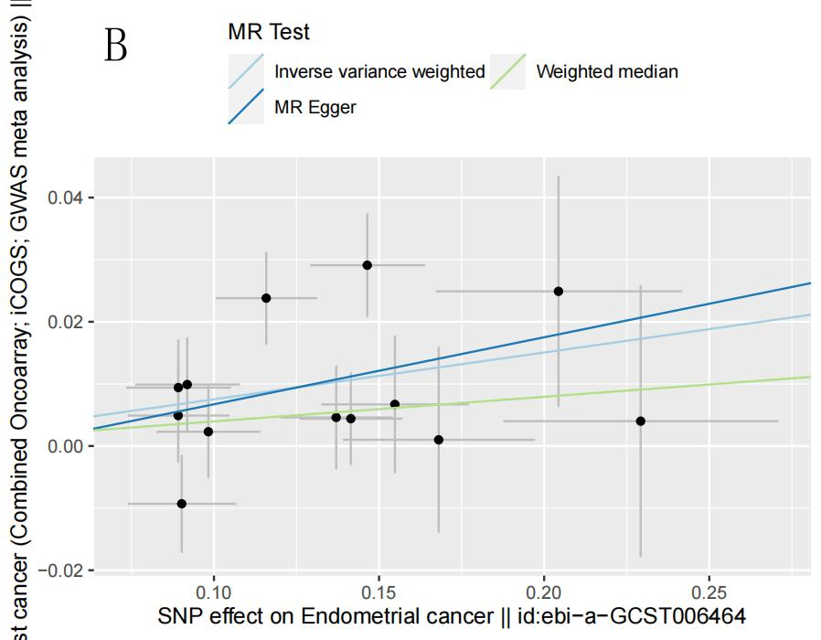
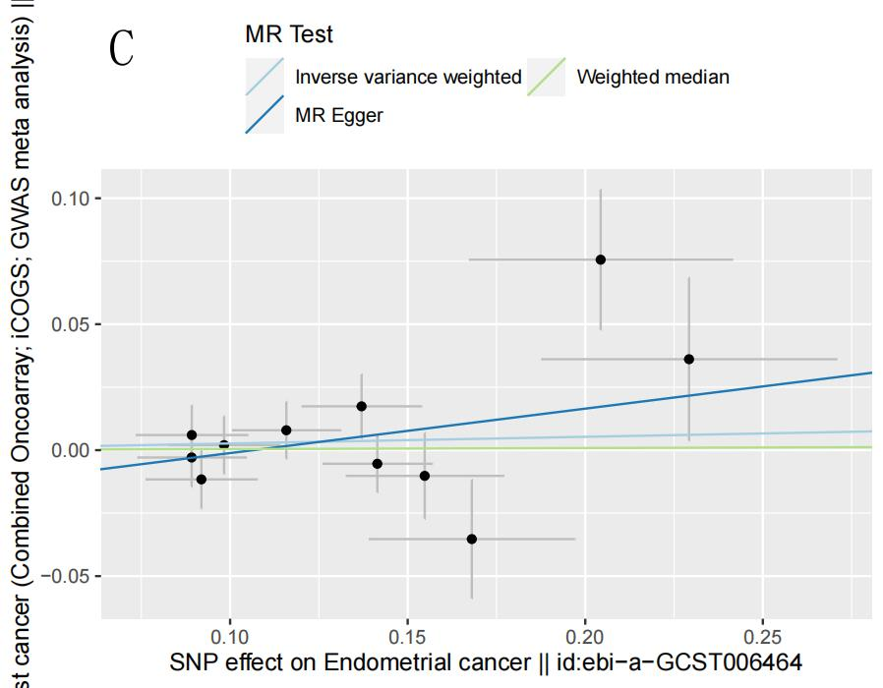

Figure S2 The leave-one-out analysis; The effect estimates is re-calculated after removal of each SNP to identify if a single SNP is driving the association. (A) Leave-one-out of the effect of endometrial cancer on breast cancer. (B) Leave-one-out of the effect of endometrial cancer on ER+ breast cancer. (C) Leave-one-out of the effect of endometrial cancer on ER- breast cancer.
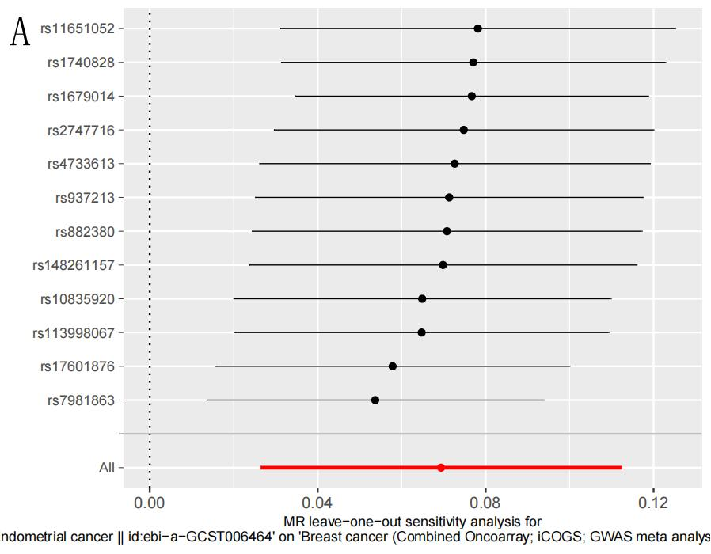
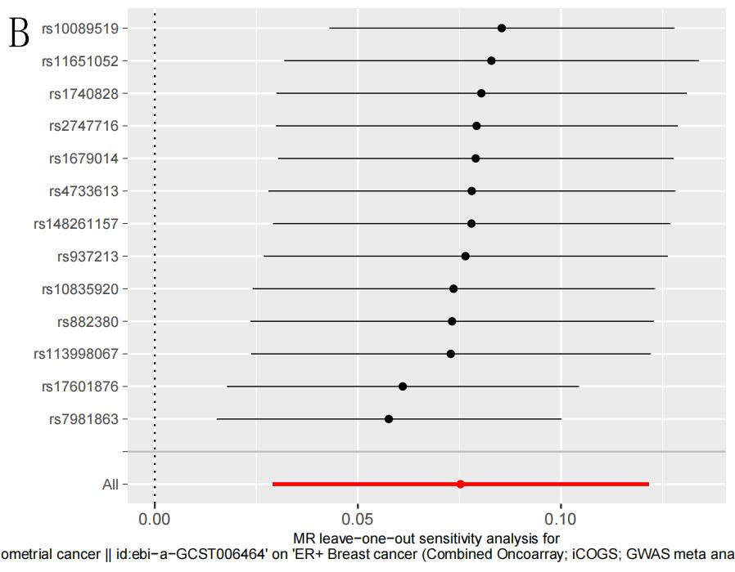
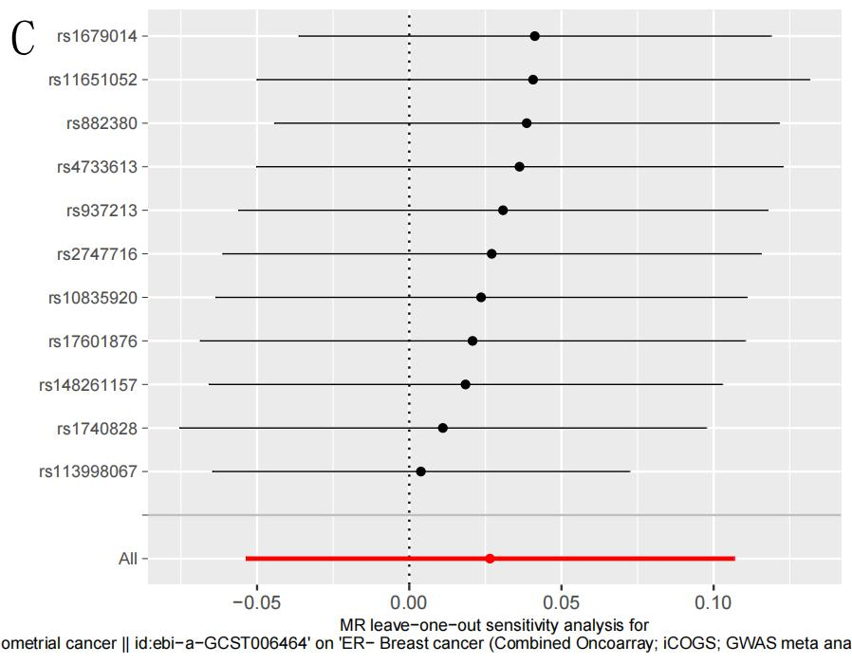

Figure S3 Funnel plot: the estimates are plotted against the precision of the estimates to test for potential asymmetry. (A) Endometrial cancer and Breast cancer; (B) Endometrial cancer and ER+ breast cancer; (C) Endometrial cancer and ER- breast cancer.
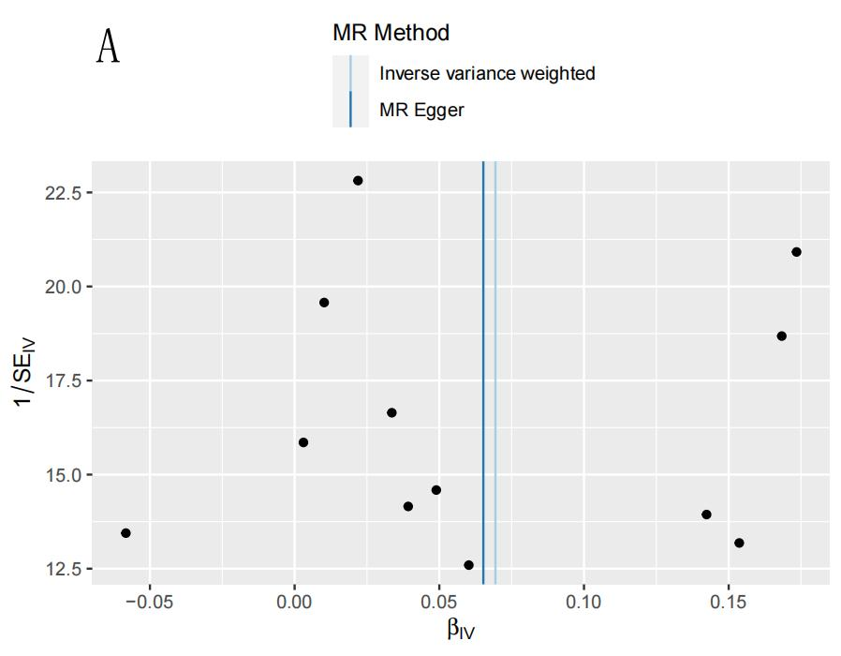
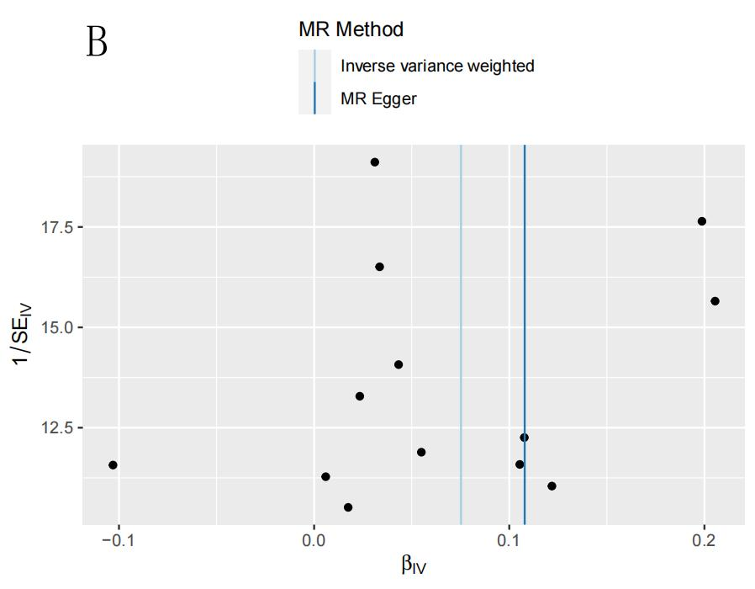
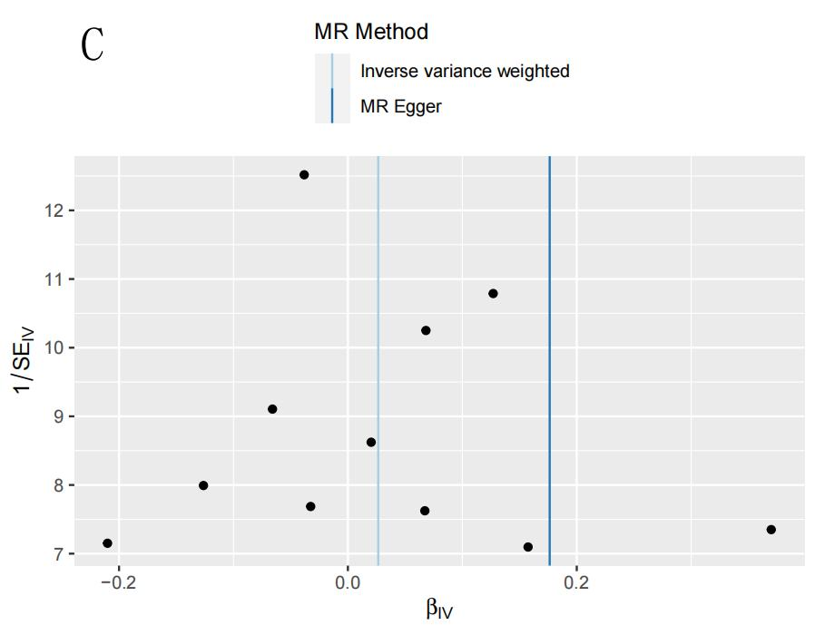

Figure S4 Scatter plot of the causality of breast cancer on endometrial cancer. (A) Scatter plot of the causality of breast cancer on endometrial cancer. (B) Scatter plot of the causality of ER+ breast cancer on endometrial cancer. (C) Scatter plot of the causality of ER- breast cancer on endometrial cancer.
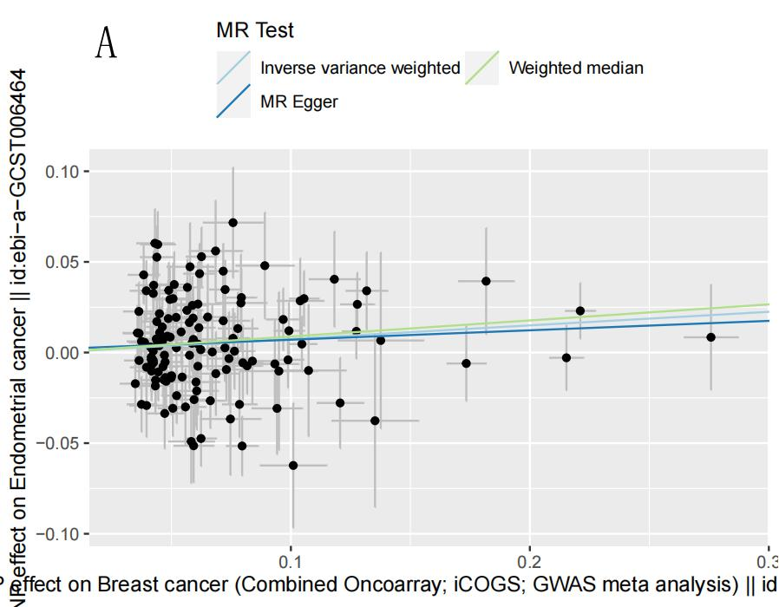
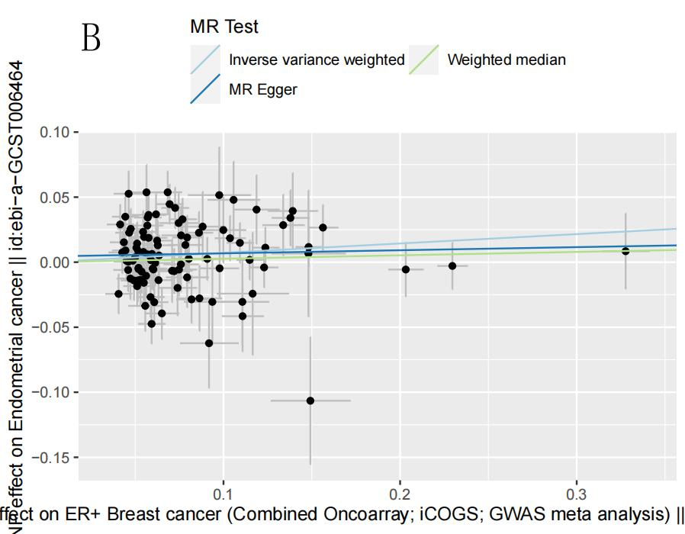
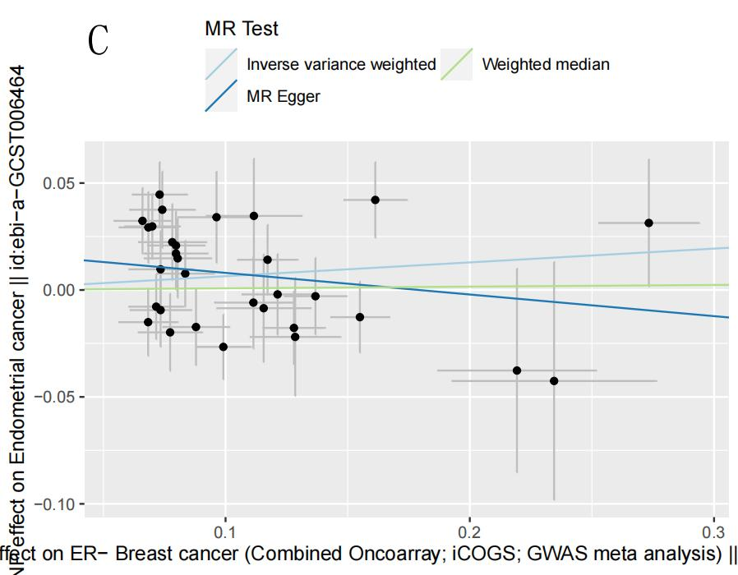

Figure S5 Leave-one-out of the effect of breast cancer on endometrial cancer. (A) Leave-one-out of the effect of breast cancer on endometrial cancer. (B) Leave-one-out of the effect of ER+ breast cancer on endometrial cancer. (C) Leave-one-out of the effect of ER- breast cancer on endometrial cancer.
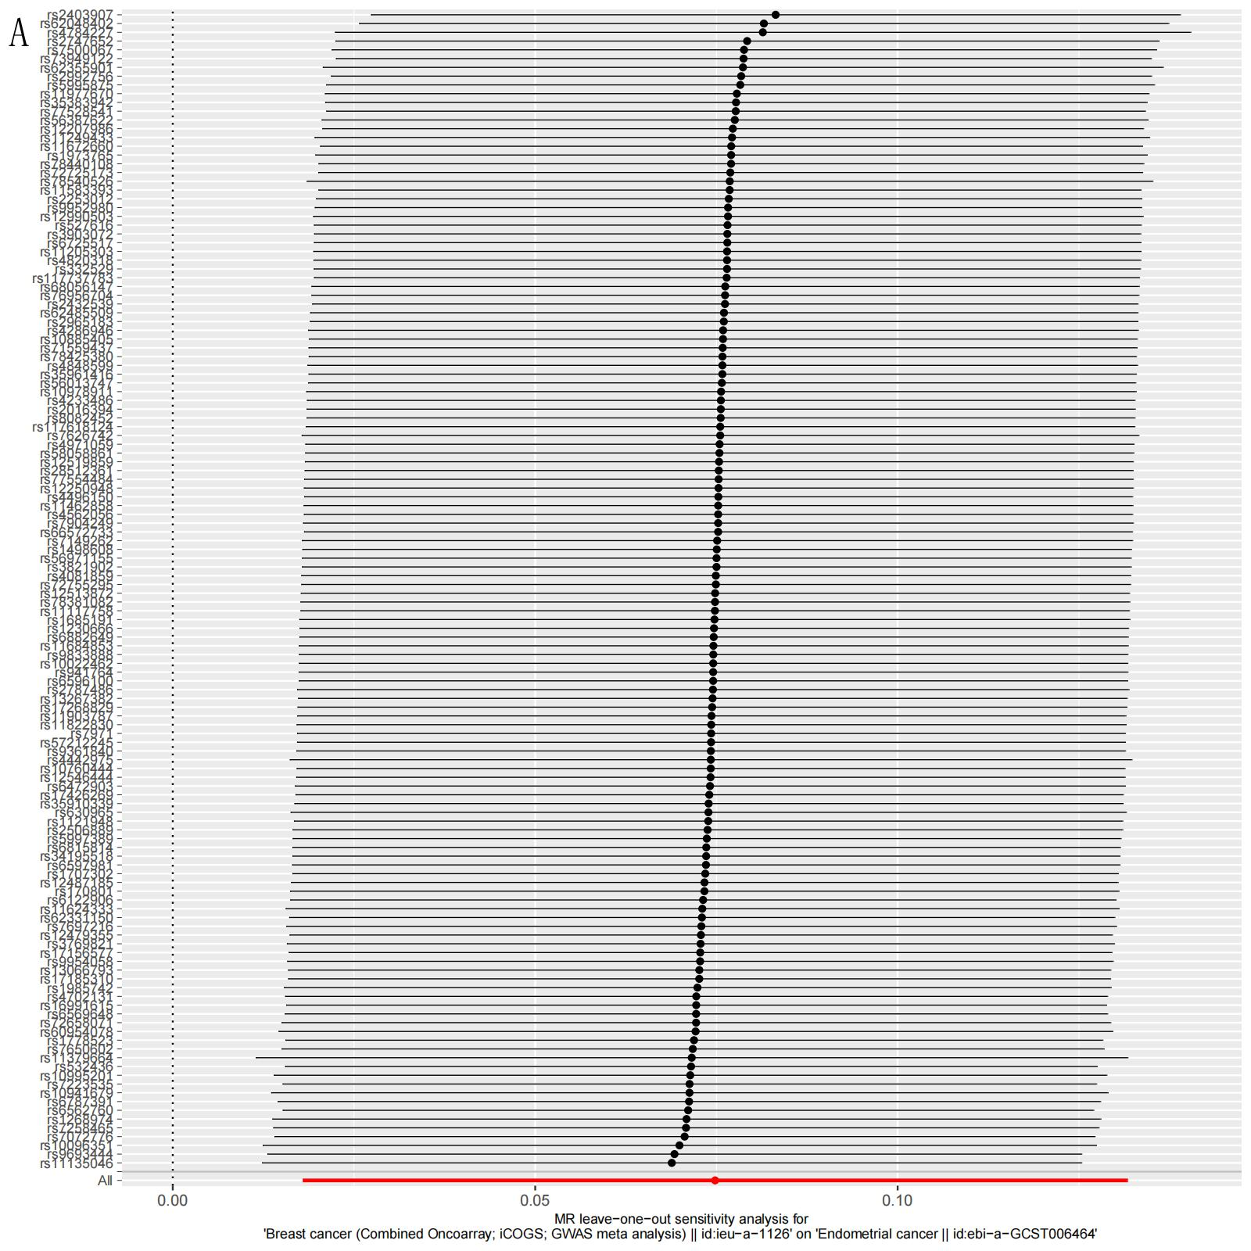
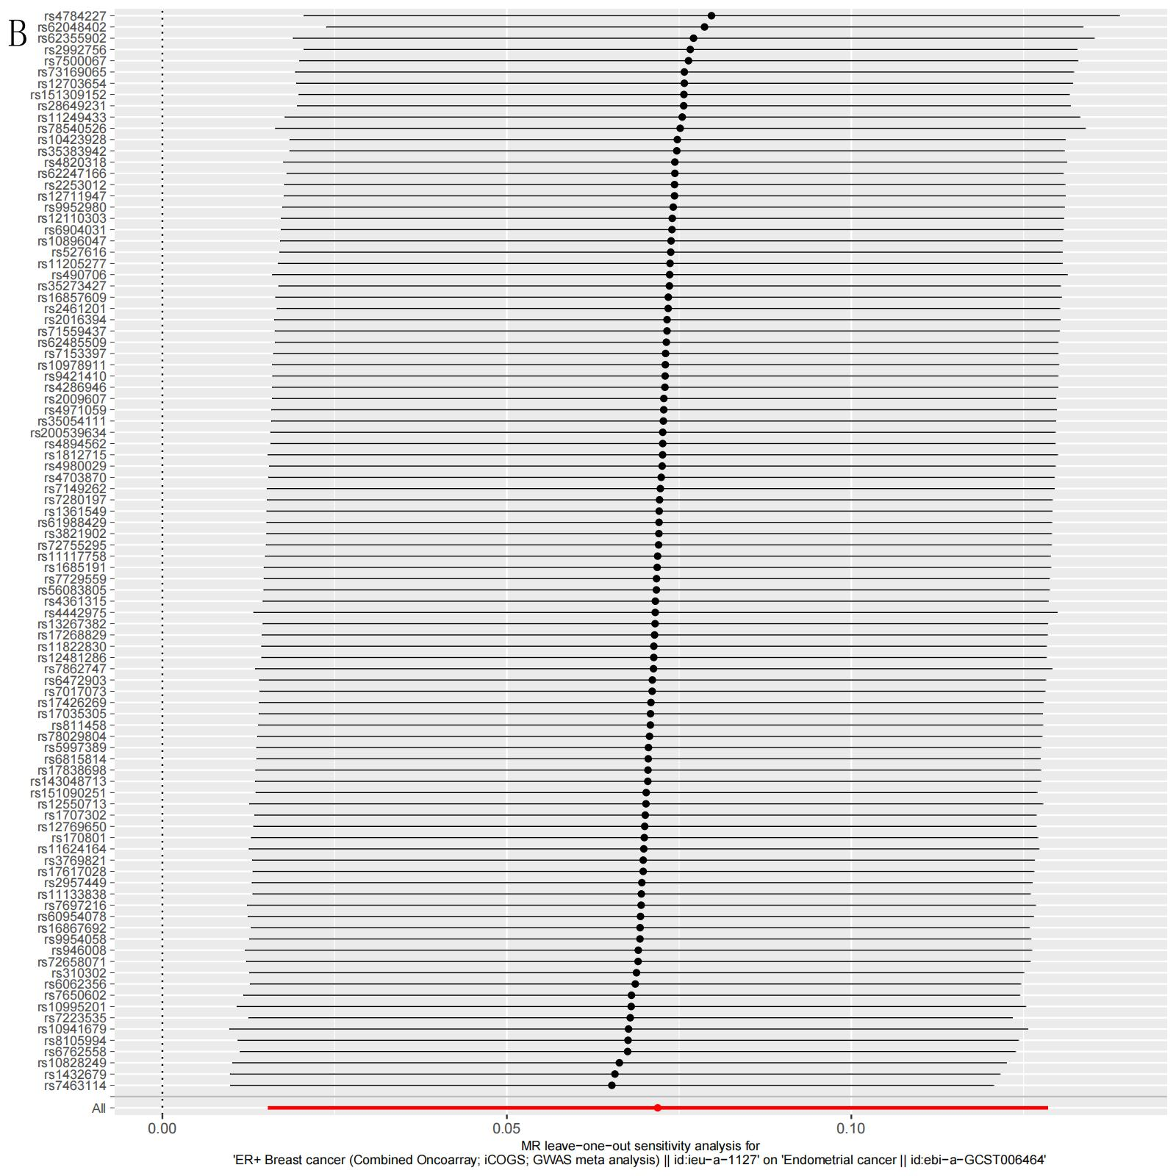
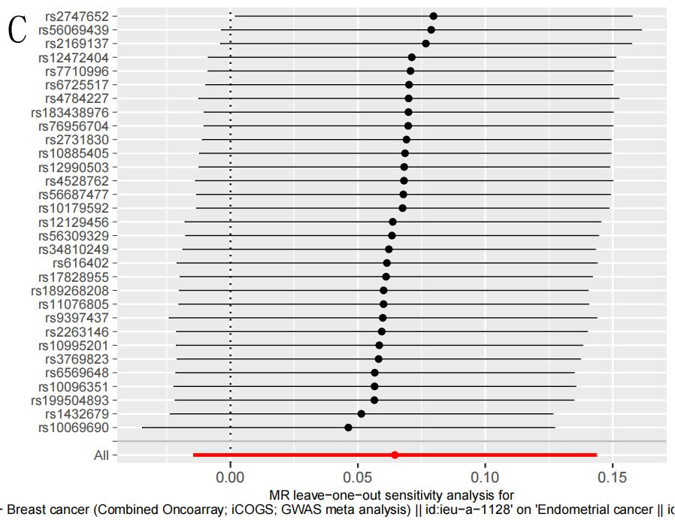

Figure S6 Funnel plot in the Mendelian randomization analysis of breast cancer and endometrial cancer. (A) Breast cancer and Endometrial cancer; (B) ER+ breast cancer and Endometrial cancer; (C) ER- breast cancer and Endometrial cancer.
