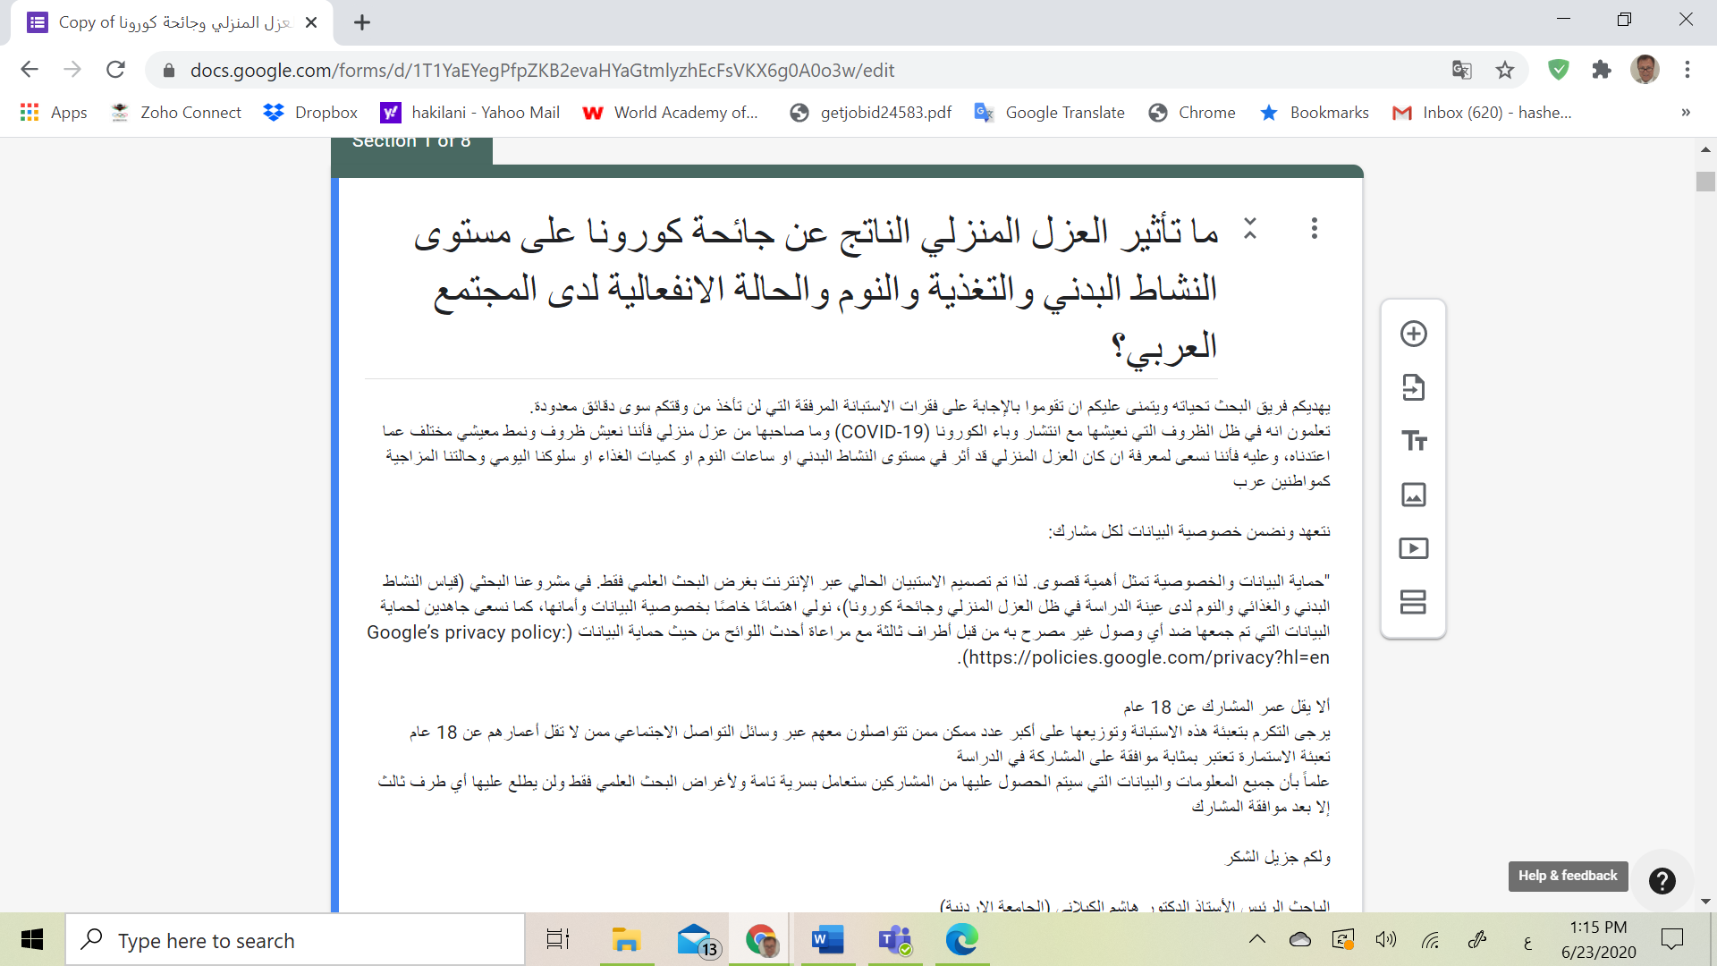
https://docs.google.com/forms/d/1T1YaEYegPfpZKB2evaHYaGtmlyzhEcFsVKX6g0A0o3w/edit
This below is a translation to the above consent form:
The research team gives you greetings and wishes you to answer the accompanying questionnaires that will only take a few minutes from your time.
You know that in light of the conditions we live in with the spread of the Corona epidemic (COVID-19) and the accompanying of house isolation, we live in conditions and a different way of life than what we are used to, and therefore we seek to know if the house isolation affected the level of physical activity, hours of sleep, or food quantities Or our daily behaviour and mood as Arab citizens

We undertake and guarantee data privacy for each participant:

"Protection of data and privacy is of the utmost importance. Therefore, the current questionnaire is designed online for scientific research only. In our research project (measuring physical and nutritional activity and sleep for the study sample in light of domestic isolation and Corona pandemic), we pay special attention to data privacy and security, and we strive hard To protect the data collected against any unauthorized access by third parties taking into account the most recent data protection regulations (Google's privacy policy: https://policies.google.com/privacy?hl=en).

The participant must not be less than 18 years old
Please kindly fill out this questionnaire and distribute it to the largest possible number of people you communicate with on social media who are at least 18 years old.
Filling in the form is considered as approval to participate in the study
Note that all information and data that will be obtained from the participants will be treated strictly confidential and for the purposes of scientific research only, and no third party will see it except after the participant’s approval.

Thank you very much

Principal Investigator Professor Dr. Hashem Al-Kilani (University of Jordan)
Participating researchers: Dr. Moaz Bataineh, prof. Khaled Al-Atiyat, d. Ali Al-Nawaiseh, Dr. Maher AlKilani, Prof. Taiysir Al-Mansi (University of Jordan) and d. Ahmed Suwaidan, and Mawaheb Homsi, in addition to a distinguished group of researchers from Arab and foreign countries

