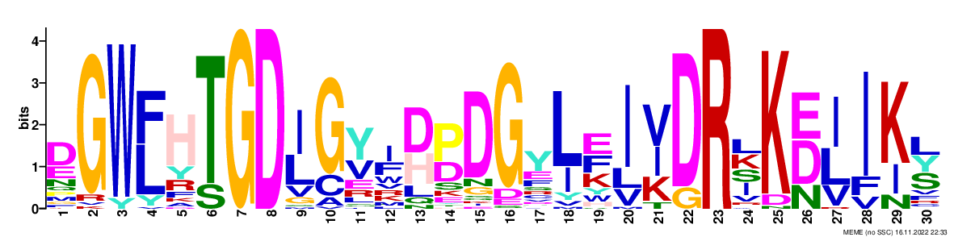 Motif 1
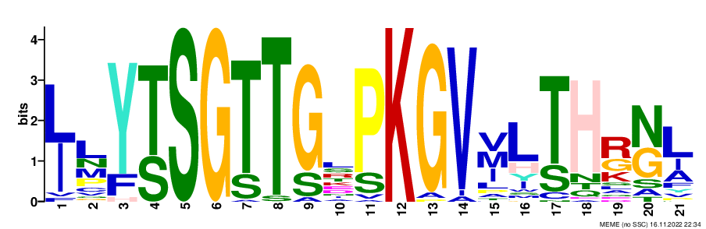 Motif 2
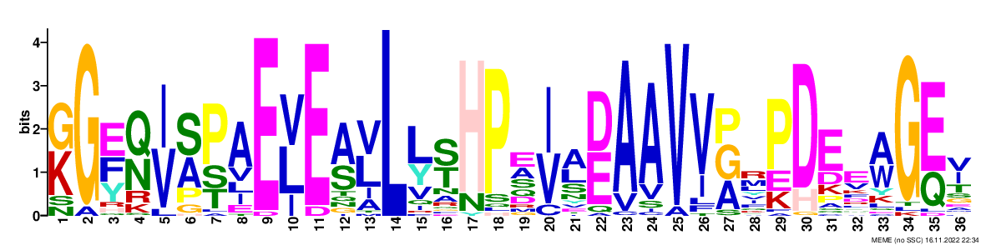 Motif 3
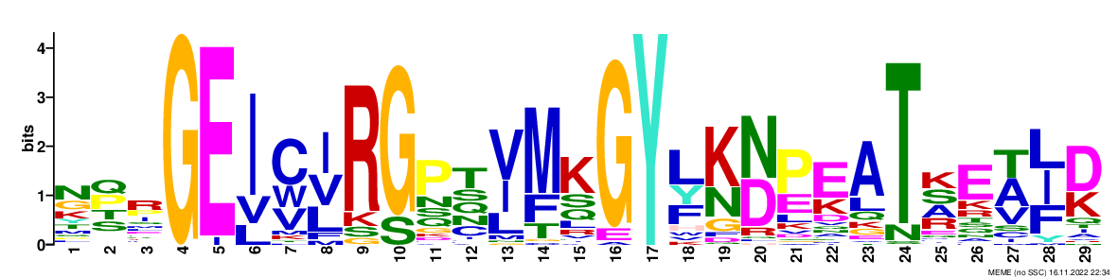 Motif 4
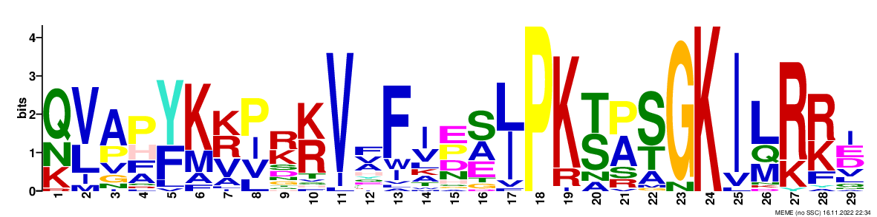 Motif 5
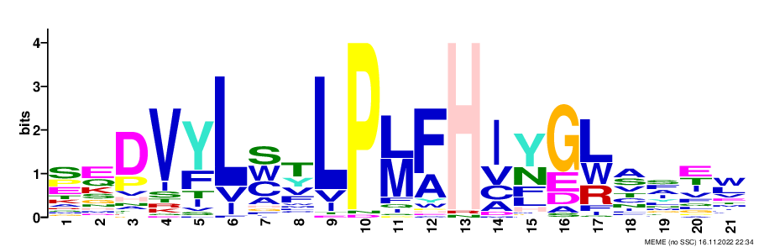 Motif 6
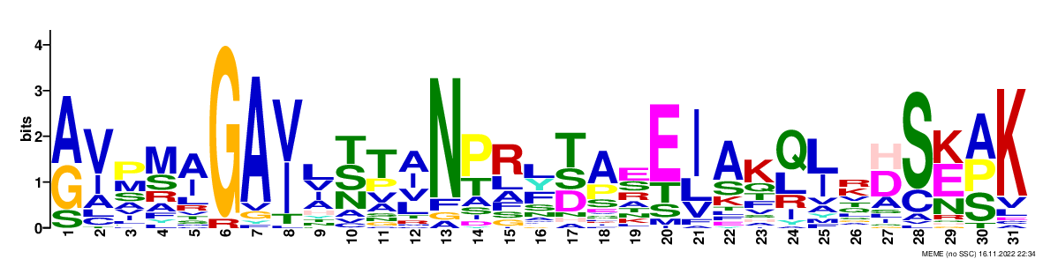 Motif 7
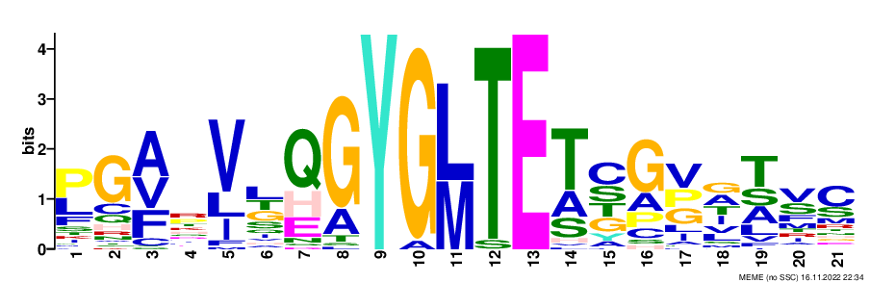 Motif 8
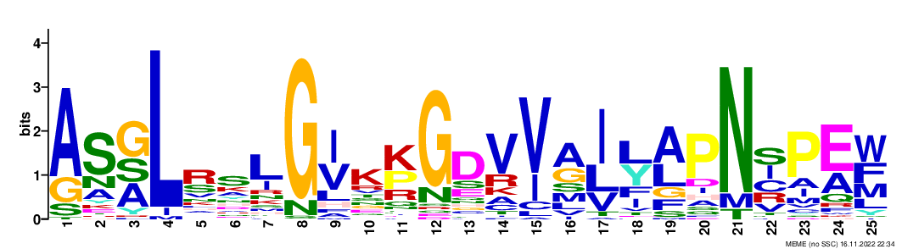 Motif 9
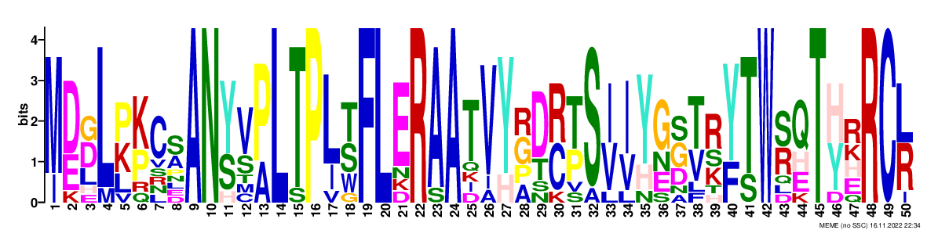 Motif 10
Supplementary Figure S1: Predicted Conserved Motifs of Cassava 4CL Proteins. A higher numerical value indicates more significant amino acid conservation at this site, indicating a higher degree of homology with other species.
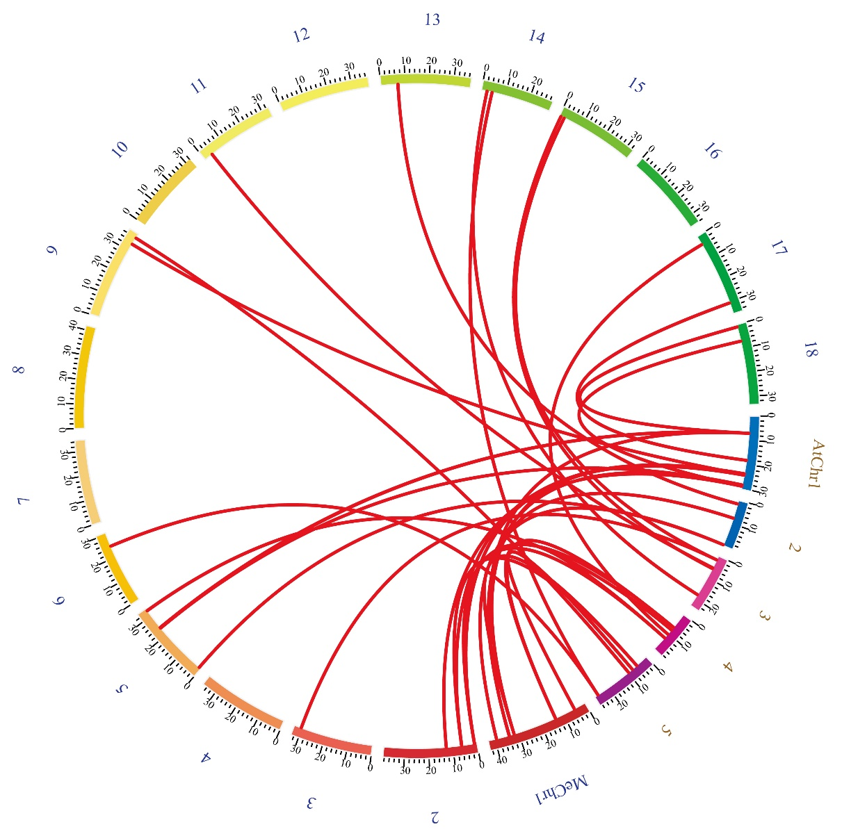Supplementary Fig.S2: Homology analysis of the Me4CL Genes with Arabidopsis thaliana. The segmentally duplicated gene pairs are connected by lines. The vertical lines on a single chromosome indicate tandem replication events. The numbers in blue font are chromosomal numbers of cassava, and the numbers in orange font are chromosomal numbers of the Arabidopsis thaliana.

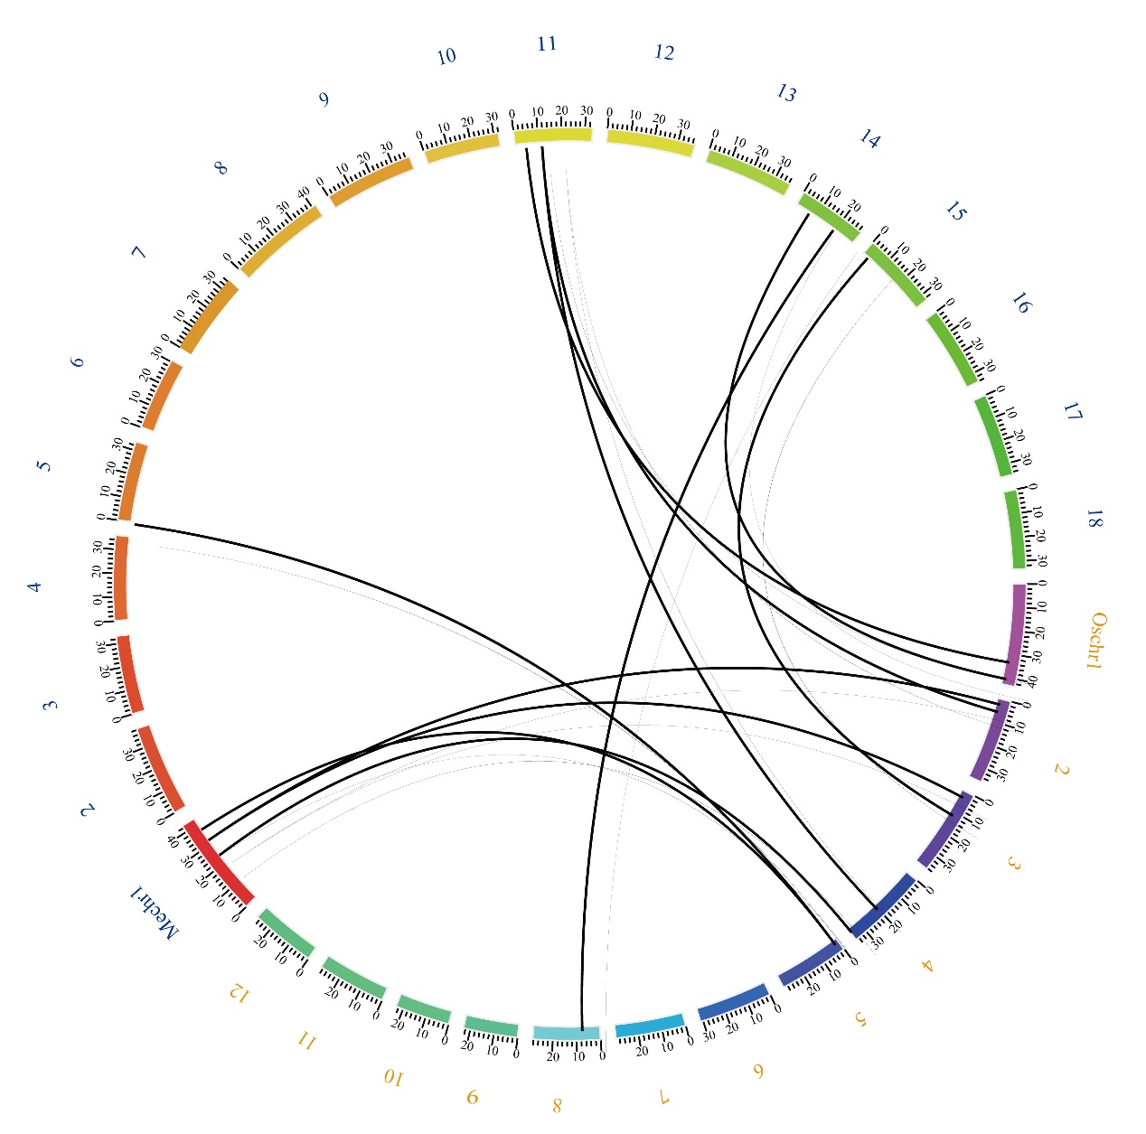
Supplementary Fig.S3: Homology analysis of the Me4CL Genes with Oryza sativa Japonica group. The segmentally duplicated gene pairs are connected by lines. The vertical lines on a single chromosome indicate tandem replication events. The numbers in blue font are chromosomal numbers of cassava, and the numbers in orange font are chromosomal numbers of the Oryza sativa Japonica.

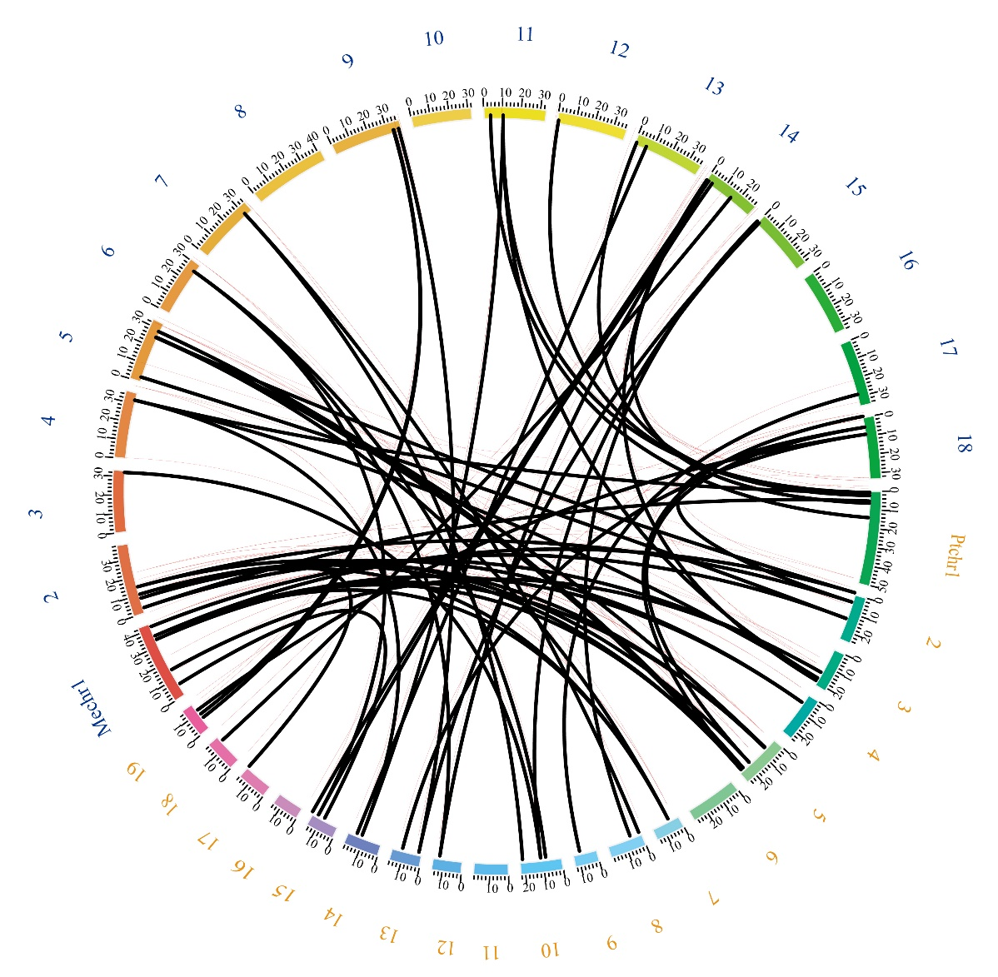
Supplementary Fig.S4: Homology analysis of the Me4CL Genes with Populus trichocarpa. The segmentally duplicated gene pairs are connected by lines. The vertical lines on a single chromosome indicate tandem replication events. The numbers in blue font are chromosomal numbers of cassava, and the numbers in orange font are chromosomal numbers of the Populus trichocarpa.

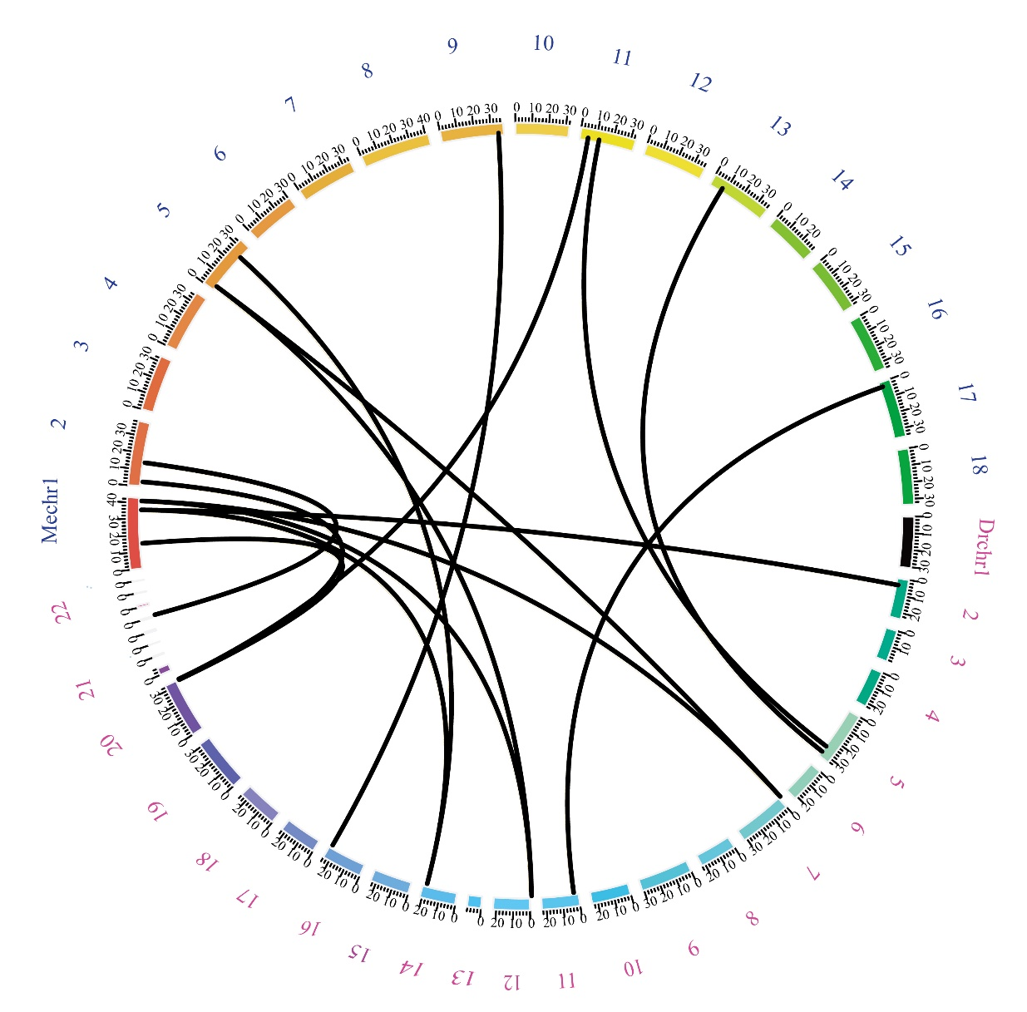
Supplementary Fig.S5: Homology analysis of the Me4CL Genes with Dioscorea rotundata. The segmentally duplicated gene pairs are connected by lines. The vertical lines on a single chromosome indicate tandem replication events. The numbers in blue font are chromosomal numbers of cassava, and the numbers in rose red font are chromosomal numbers of the Dioscorea rotundata.

