The exploration of a new technology: preservation of immovable silicate cultural relics against salt efflorescence by directional induction of water and salt migration

SI Appendix

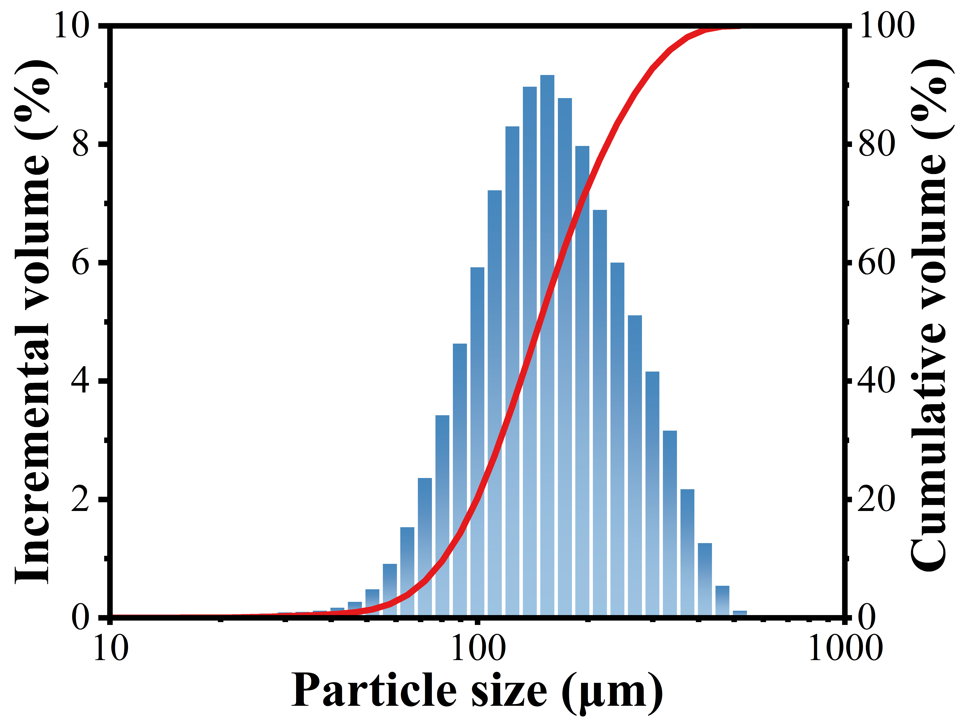
Figure. S1. Particle size distribution curve of sand.

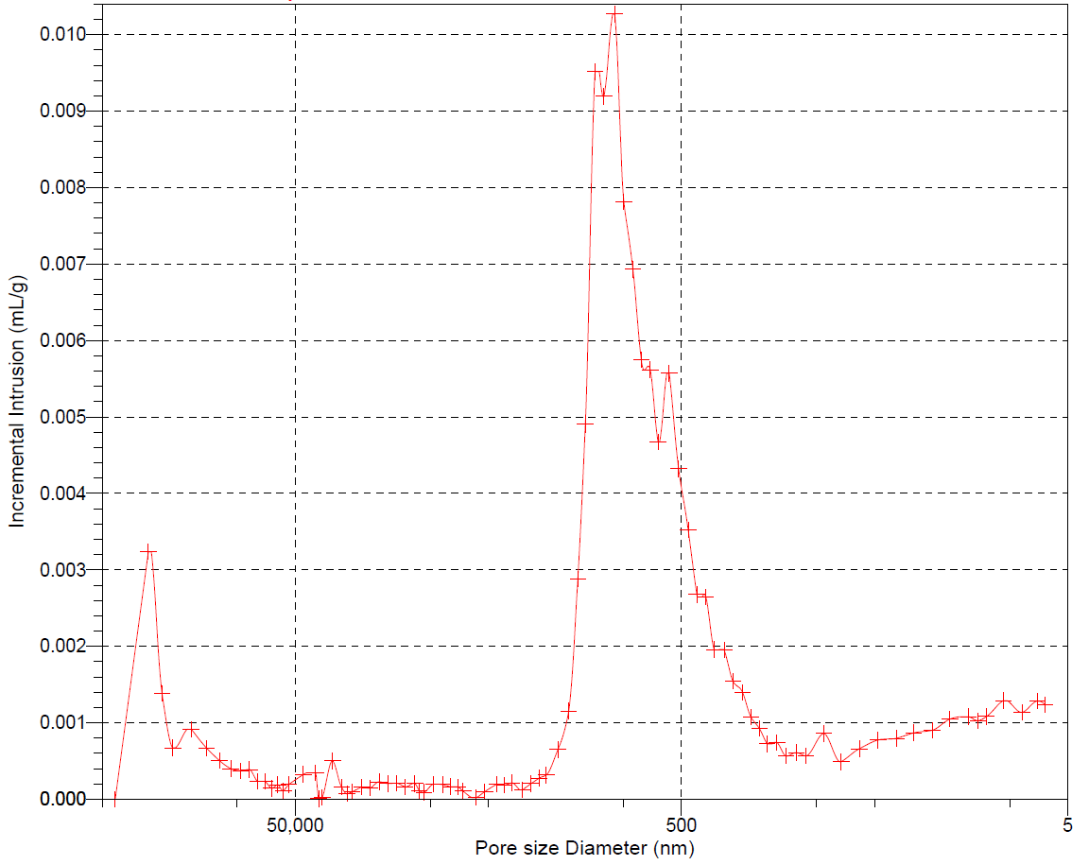
Figure S2. The pore size distribution of pottery.
Total Intrusion Volume = 0.1299 mL/g, Total Pore Area = 4.335 m²/g, Median Pore Diameter (Volume) = 944.1 nm, Median Pore Diameter (Area) = 12.6 nm, Average Pore Diameter (4V/A) = 119.8 nm, Bulk Density at 0.50 psia = 2.0306 g/mL, Apparent (skeletal) Density = 2.7580 g/mL, Porosity = 26.3744 %, Stem Volume Used = 25 %.

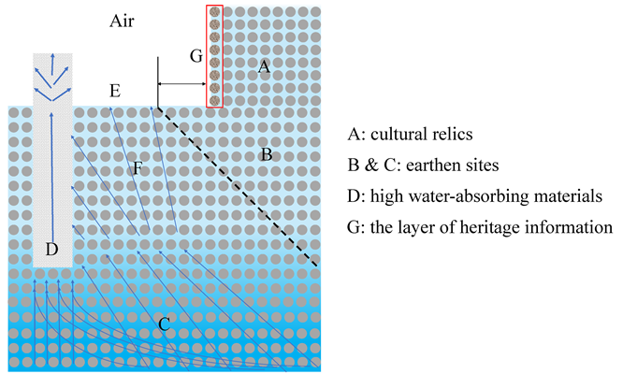
Figure. S3. Schematic diagram of simplified laboratory experiment.
The experimental schematic is shown in Figure S3, where the salt solution in the C and F regions is directed to the D and its surrounding regions by the moisture concentration gradient induced by the D. And it causes evaporation and crystallization at the atmosphere exposed side of D, or at the E area away from the cultural relics. Meanwhile, this makes the concentration of the salt solution in the B region decrease, avoiding the increase of the salt solution in the A region linked to the B region and its evaporation and crystallization in the G layer.

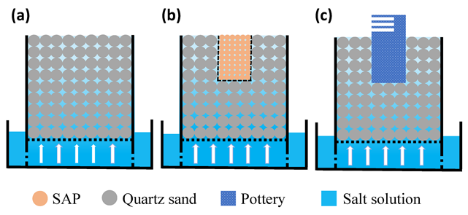
Figure. S4. The schematic diagram of simplified laboratory experiment. (a) reference sample, (b) SAPs, (c) pottery.
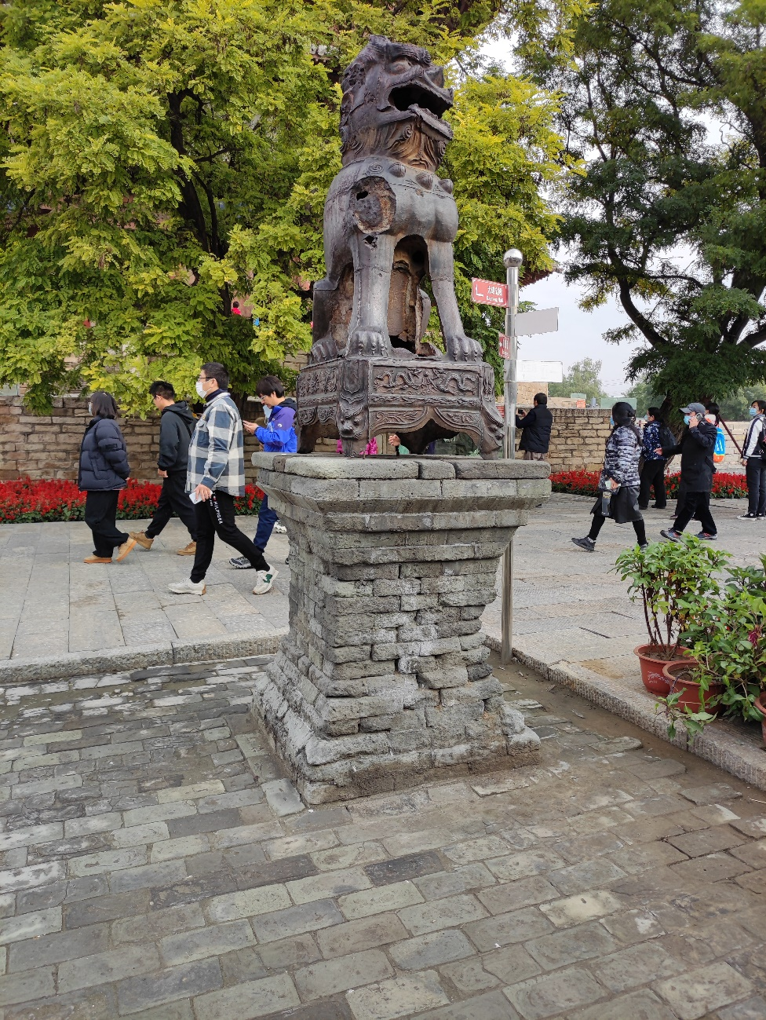
Figure S5. The salt damage of Iron lion pedestal brick. (Taken in Shanxi Province, Shanxi Fogong Temple in 2021), Ancient city walls in many parts of China have similar diseases. [1]

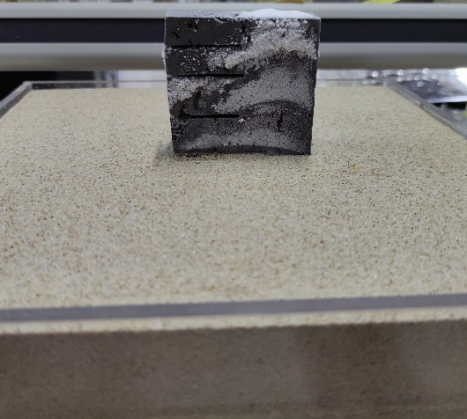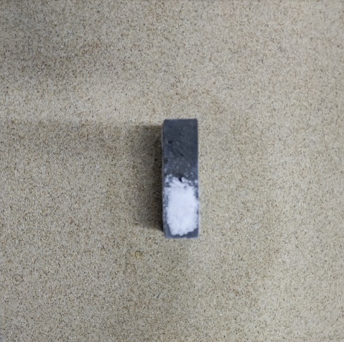
Figure S6. Photographs of the pottery after directional induction of water and salt migration: (a) side view; (b) overhead view.

Reference

1. Xie Qihua. Study on the risk assessment and prediction of deterioration of the bottom wall of Xi’an Dayan pagoda, Changsha: Southeast University Press, 2021, 18-20

