Supplementary Information

Discovery of antimicrobial peptides targeting Acinetobacter baumannii via a pre-trained and fine-tuned few-shot learning-based pipeline
Junjie Huang^{1,3&}, Wentao Zhang^{2&}, Aowen Wang², Yuxian Lai^{1,3}, Yanchao Xu², Cong Wang¹, Junbo Zhao²*, Peng Zhang^{1,3,4}*, Jian Ji^{1,3,4}*

¹MOE Key Laboratory of Macromolecule Synthesis and Functionalization of Ministry of Education, Department of Polymer Science and Engineering, Zhejiang University, 866 Yuhangtang Road, Hangzhou, Zhejiang, 310027, P. R. China;
²College of Computer Science and Technology, Zhejiang University, 38 Zheda Road, Hangzhou, Zhejiang, 310027, P.R. China;
³International Research Center for X Polymers, International Campus, Zhejiang University, Haining, Zhejiang, 314400, P. R. China;
⁴State Key Laboratory of Transvascular Implantation Devices, Qidi Road 456, Hangzhou, Zhejiang, P. R. China.

& Junjie Huang and Wentao Zhang contributed equally
*Corresponding authors, j.zhao@zju.edu.cn; zhangp7@zju.edu.cn; jijian@zju.edu.cn.

Contents
Dataset preparation 3
Peptide encoding 3
Model Evaluation Proxy 4
Pre-screening based on the empirical selection 6
Model Development 6
Supplementary Fig. 1 10
Supplementary Fig. 2………………………………………………………………………..……....11
Supplementary Fig. 3 12
Supplementary Fig. 4 13
Supplementary Table 1 14
Supplementary Table 2 15
Supplementary Table 3 19
Supplementary Table 4 20
Supplementary Table 5 21
Supplementary Table 6 22
Supplementary Table 7 23
Supplementary Table 8 24
Supplementary Table 9 25
Supplementary Table 10 26
Supplementary Table 11 27
Supplementary Table 12 28
Supplementary Table 13 29
Supplementary Table 14 30
Reference 31
Dataset preparation. In this manuscript, the dataset for Antimicrobial Peptides (AMPs) was obtained from two sources: (i) the open-source Grampa¹ dataset, which contains MIC (Minimum Inhibitory Concentration) values annotated for positive AMP sequences, and (ii) negative samples (Non-AMPs) retrieved from the UniProt database. We commence our exposition with an introduction to the Grampa dataset. In general, this dataset comprises 51,345 peptide sequences with experimental results indicating their antimicrobial activity, sourced from various open datasets such as APD², DADP³, DBAASP⁴, DRAMP⁵, and YADAMP⁶. During the dataset preprocessing phase, we selectively retained amino acid sequences that featured standardized C-terminal amidation. Additionally, outliers, specifically peptides with lengths exceeding 80 or falling below 5, were eliminated to simplify the training process. Furthermore, in consideration of the target bacterial strains required for fine-tuning our model and those employed in our laboratory experiments, we retained data that specifically indicated activity against Acinetobacter baumannii (A. baumannii) and Pseudomonas aeruginosa (P. aeruginosa).For instances where the same AMP possessed MIC values with conflicting annotations from two or more sources, we applied a straightforward geometric mean approach to derive the final bacterial-AMP measurement. Following the aforementioned preprocessing rules applied to the Grampa dataset, we ultimately obtained 1186 positive samples exhibiting specific activity against P. aeruginosa and 148 positive samples displaying specific activity against A. baumannii. Moreover, we gathered 5,898 negative samples (devoid of "antimicrobial" related field annotations) from the UniProt database (http://www.uniprot.org/). These negative samples exhibited sequence lengths ranging from 0 to 40. To facilitate the training of ranking and regression models, we assigned a simulated MIC value of 8192μg/mL to all negative samples. Furthermore, to smoothen the label data, we followed the settings from SMEP⁷ and employed the log10 operator to transform the output target space.

The dataset was partitioned differently based on the tasks to be executed within the pipeline, as outlined in Supplementary Table 1.

Peptide encoding. To harness the power of deep learning techniques for Antimicrobial Peptide (AMP) identification, it is imperative to effectively represent peptide sequences in a format that is readily comprehensible by machine learning models. In our research, we employ two distinct peptide encoding methodologies to efficiently input peptide sequences into our model. The first approach involves transforming peptide sequences into physicochemical feature descriptors, yielding structured tabular data. We referred the readers to related works^{8,9} for further details on these protein feature descriptors. These descriptors encompass fundamental attributes such as amino acid composition, autocorrelation, physicochemical composition, pseudo-sequence order, and pseudo-amino acid composition. More comprehensive information on these descriptors is available in Supplementary Table 2. The encoding of this segment leverages Python computation packages provided in prior research⁹, with corresponding code accessibility detailed in the Code Availability section.

While physicochemical feature descriptors prove to be highly effective, structured data also possesses inherent limitations. With the recent emergence of large-scale language models, the application of embedding vectors has garnered increasing attention. Embedding vectors represent entities in a high-dimensional space, where each entity is mapped to a vector. In natural language processing, this technique is employed to embed vocabulary into a continuous vector space, facilitating the proximity of semantically related words in the vector space and thereby capturing semantic relationships between words. This representation of entities in a high-dimensional space naturally aligns with sequence tasks, as sequence data is fundamentally composed of entities (e.g., amino acids). In the realm of proteins and peptides, similar embedding vector concepts are applied to map amino acid sequences to continuous vectors, thus encapsulating interactions and features among amino acids within vector representations.

In recent years, pre-trained large language models have become transformative tools in various domains of bioinformatics. Models such as AlphaFold¹⁰, ESM-1b¹¹, and DNABert¹² have achieved remarkable success in tasks ranging from protein structure prediction to amino acid sequence analysis and genome data processing. These models, trained on extensive biological data, have acquired rich amino acid representations and patterns. Inspired by these cutting-edge models, our research adopts a similar strategy for the task of antimicrobial peptide recognition, despite having limited training data. We specifically select the ESM-1b pre-trained model and transfer it to downstream antimicrobial peptide recognition tasks through multi-step fine-tuning. More precisely, we fine-tune the parameters of the last BERT layer of the ESM-1b¹¹ model to adapt it to the antimicrobial peptide recognition task. The resulting encoded embedding vectors contain semantic and structural information about peptide sequences, thus providing robust feature representations for subsequent antimicrobial peptide recognition.

Model Evaluation Proxy. Certainly, evaluating a trained model ideally involves wet-lab experiments and additional laboratory validations of its predicted samples. However, relying solely on these processes would incur significant costs and time constraints. In order to quickly gather feedback for improving and refining our trained models, including the selection of hyperparameters for each stage of our pipeline, we introduce a computational proxy for evaluation.

To be more specific, in order to obtain a computational score for a trained model, we typically perform an inference pass with the model on a validation dataset to derive a proximal score. Subsequently, we select the model with the highest proximal score for the final evaluation on the test dataset. It's important to note that all evaluation results presented in our paper are based on the test dataset.

In the context of our machine learning funnel, consisting of three distinct stages, we employ the following proximal evaluation metric for each stage.

- - Accuracy, recall, precision, and F1 for the classification stage. In particular, we use TP, TN, FP, FN to represent true positive, true negative, false positive, and false negative, respectively.
$Accuracy=\frac{TP+TN}{TP+FP+FN+TN}$ (2)
$Recall=\frac{TP}{TP+FN}$ (3)
$Precision=\frac{TP}{TP+FP}$ (4)
$F1=\frac{2×Precision×Recall}{Precision×Recall}$ (5)

- - Topk-MSE for regression stage. The mean-squared-error (MSE) function was an popular metric for evaluating the regression models. we selected multiple scales of mean squared error(MSE) to comprehensively evaluate the performance of models. Top-k MSE evaluates the error of the model’s MIC prediction for the top K sequences with the best antibacterial performance:
Topk-MSE= $\frac{1}{K}\sum_{i=1}^{K}{{\left(y_{i}^{'}-y_{i}\right)}^{2}}$ (6)
where K is the number of sequences with the best antibacterial performance we choose to evaluate performance, $i$ is an index. $y^{'}$ and $y$ represent the predicted and the ground-truth label values
.
- - Topk-Prec for ranking stage. Similar to the TopK-MSE approach commonly employed in regression tasks, we have adopted a method of precision assessment at varying scales to evaluate the performance of our ranking model. In this context, TopK-Prec is utilized to gauge the predictive precision of the model concerning peptides with the most optimal antimicrobial properties.

Pre-screening based on the empirical selection. As an initial step, we employed an empirical selection process based on established criteria from the existing literature to preclude sequences that were unlikely to be Antimicrobial Peptides (AMPs) before implementing the FSLSMEP. Utilizing a recursive algorithm, we systematically curated a candidate peptide library, ultimately comprising approximately 3,930,000 peptides.

(i) The peptides in our library exhibit a net positive charge. To meet this criterion, the count of positively charged amino acid residues (AAR) exceeds that of negatively charged AAR.
$n_{positiveAAR}-n_{negativeAAR}>0$ (7)

(ii) Furthermore, the peptides possess a distinctive amphipathic structure as described in the literature. Broadly, two models were considered for constructing this amphipathic structure. In the first model, hydrophilic AARs and hydrophobic AARs are segregated onto distinct sides of the peptide sequence. Conversely, in the second model, hydrophobic AARs are interspersed with hydrophilic AARs at intervals of 2-3 residues. The generation of all eligible peptides was automated using a Python script, and the relevant source code can be located in the code availability section.

Model Development. In order to screen out a few most promising AMP candidates from massive candidate peptides, we adopt the strategy of coarse-to-fine screening, and design a pipeline consisting of classification, ranking, and regression. In previous researches, traditional machine learning solutions as well as deep learning methods based on convolutional neural networks (CNNs) or RNN (such as BiLSTM) have been attempted for AMP identification-related tasks⁷.

However, it is too difficult to start training models from scratch for recognizing anti-A.baumannii peptides when only a small amount of annotated data related to A. baumannii is available.
To achieve this goal, we try a new model framework: multi-step fine-tuning framework based on large-scale protein pre-training models. Considering that protein pre-training models have shown excellent performance in various downstream tasks, we believe that the hidden information learned by pre-training models about spatial structure in vast sequences can be very effective in guiding the model to recognize effective antibiotic peptide sequences. This information can also be transferred to the antimicrobial peptide recognition task through fine-tuning. In our pipeline, we choose one of the best-performing pre-training models in this field, ESM-1b¹¹, a protein pre-training model that uses the Roberta architecture and is pre-trained on Uniref50¹³ database, to perform fine-tuning for downstream tasks. Furthermore, considering that there is only a tiny amount of labeled data for anti-A.baumannii peptide, every module (classification, ranking, and regression) in our pipeline adopts a two-step fine-tuning strategy. The first step uses representative Gram-negative bacteria P. aeruginosa as the training data for fine-tuning. We hope that this step can learn domain knowledge relevant to Gram-negative bacteria. In the second step of fine-tuning, we use sequences related to A. baumannii, transferring the model's domain knowledge to the target domain.

Our pipeline is illustrated in Figure 1b, providing an overview of its components. The following sections provide detailed descriptions of each module in the pip-eline.

- Classification Model
As the first step of our pipeline for identifying antimicrobial peptides, the classification task aims to perform coarse-grained filtering, significantly reducing the number of sequences in our vast candidate library to manageable levels. For the classification model, we fine-tune the protein pre-training model ESM-1b¹¹ with a frozen bottom layer up to layer 32, while only adjusting the parameters of the last Bert layer (layer 33). Specifically, the final representation of a sequence is obtained from the [CLS] token of ESM-1b's last layer, which is then fed into a classification head composed of multiple MLP layers. Adam optimizer is chosen with a learning rate of 1e-4, more details can be found in our code. For this binary classification task, we employ binary-cross-entropy loss function${ L}_{CE}$:
$L_{CE}=\sum_{i=1}^{N}{-}y_{i}log(p_{i})-(1-y_{i})\log{(1-p_{i})}$ (8)
where $p_{i}$ represents the categorical probability output of the classification model with the input $x_{i}$, and $y_{i}$ is the corresponding ground truth class label.

- The Ranking Model
The ranking task plays a crucial role in the entire process; it constitutes the core of the entire pipeline, handling the most critical tasks. While the classification model aids in the initial screening phase by filtering out approximately 80% of candidate sequences that lack antimicrobial potential, the subsequent ranking model takes it a step further. Its purpose is to precisely select a few hundred peptides with the highest antimicrobial performance, discarding nearly 99.99% of the data, thus alleviating the predictive burden of the final regression task.

In terms of technical details, our ranking model is an improvement on LambdaRank. We employ an incremental ranking strategy, where in each iteration, we randomly select a batch of samples from the dataset and optimize the model parameters by maximizing their $NDCG@k$
(Normalized Discounted Cumulative Gain).
$NDCG@k= \frac{DCG@k}{IDCG@k}$ (9)

$DCG@k=\sum_{i=1}^{k}{\frac{2^{{rel}_{i}}-1}{\log_{2}{(i+1)}}}$ (10)

$IDCG@k=\sum_{i=1}^{k}{\frac{2^{\max\left({rel}_{i},0\right)-1}}{\log_{2}{(i+1)}}}$ (11)

Here, ${rel}_{i}$ represents the relevance score of the item at rank $i$. $DCG@k$ is the Discounted Cumulative Gain at position $k$, and $IDCG@k$ is the Ideal Discounted Cumulative Gain at position $k$.

For example, during a specific iteration, K sequences were randomly sampled from the dataset. Subsequently, these sequences were ranked based on their Minimum Inhibitory Concentration (MIC) values, with lower MIC values corresponding to higher rankings. In cases where negative samples shared identical MIC values, they were assigned the same rank. This procedure allowed the derivation of relative scores ${rel}_{i}$ for each sequence.

In the context of model selection for the ranking task, we leverage protein feature descriptors embodying the physicochemical attributes of peptides as the model input. The structural framework of the ranking model is established through the adoption of a multi-layer perceptron (MLP). This strategic decision is substantiated by two primary considerations: firstly, antecedent investigations underscore the utility of traditional structured data modeling in facilitating the discernment of the structural nuances inherent in peptides. Secondly, given the computational intricacies associated with ranking models, the employment of a comparatively parsimonious model structure is conducive to heightened inference speed, thereby facilitating the handling of voluminous datasets.

Given the presence of a limited sample size in our overall task, employing traditional machine learning models is not conducive to multi-step fine-tuning. Therefore, we opted for a straightforward yet efficient neural network model as the foundational structure for the ranking model. The ultimate results from our wet lab experiments also indicate that employing such a trained ranking model in the pipeline leads to antimicrobial peptides with overall superior antibacterial performance against Acinetobacter baumannii.

- The Regression Model
After the ranking phase, several hundred candidate peptides remain. To refine our selection and identify the top ten peptides with the most potent antibacterial properties, we train a regression model that can predict minimum inhibitory concentration (MIC) values accurately. As the final stage in our pipeline, the model must minimize prediction bias in MIC. Through experimental comparison, we opt for the same fine-tuning strategy applied in the classification stage, using ESM-1b pre-trained model, freezing the parameters in the first 32 layers, and adjusting only the last layer. The final representation of a sequence is obtained from the [CLS] token of ESM-1b's last layer, which is then input into a regression head composed of multiple MLP layers. Our rationale behind choosing this model architecture is that it achieves the lowest K-MSE score and delivers the best wet-lab results among all options explored. Details regarding hyperparameters can be found in our code. The employed loss function is defined as:
$f_{regression}^{*}= \underset{f_{regression}}{argmin}{L_{L2}(f_{regression}\left(x\right),y)}$ (12)

where $y$ denotes the label corresponding to input $x$ and $w$ is the intermediate parameters of the regressing model $f_{regression}$.

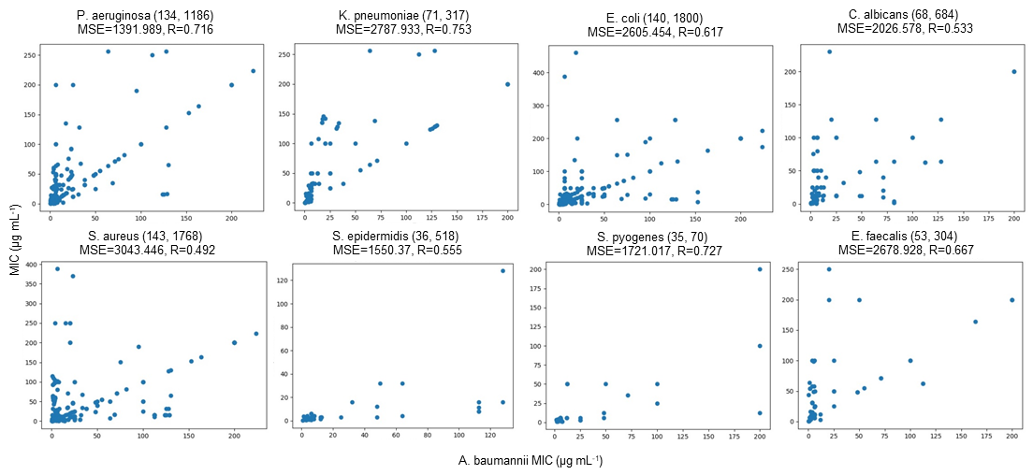
Supplementary Fig. 1. MIC comparation of the same AMPs against A. baumannii and other strains.

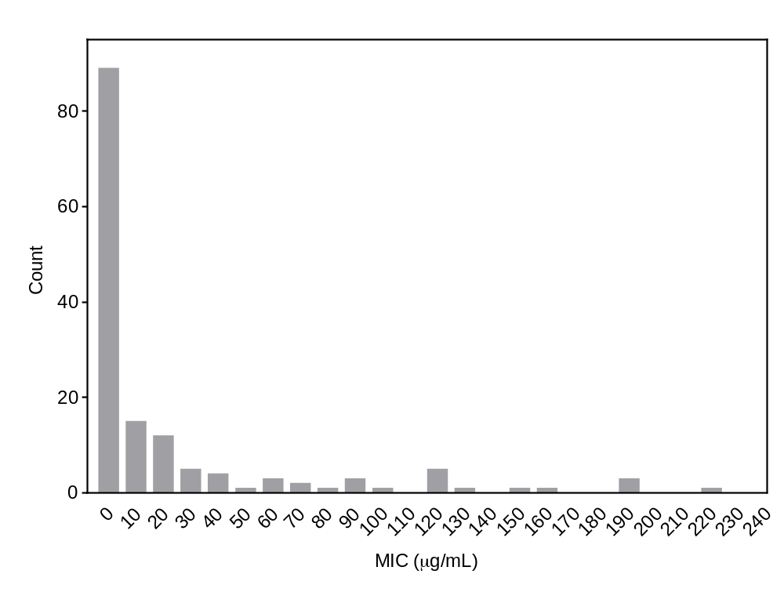Supplementary Fig. 2. MIC distribution of the positive samples in the dataset used for model training.

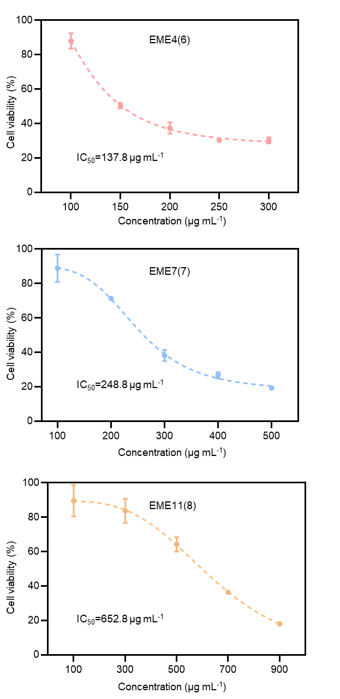
Supplementary Fig. 3. Cytotoxicity data used to calculate the IC₅₀ of the leading AMPs (n=3 biologically independent, mean±s.d.).

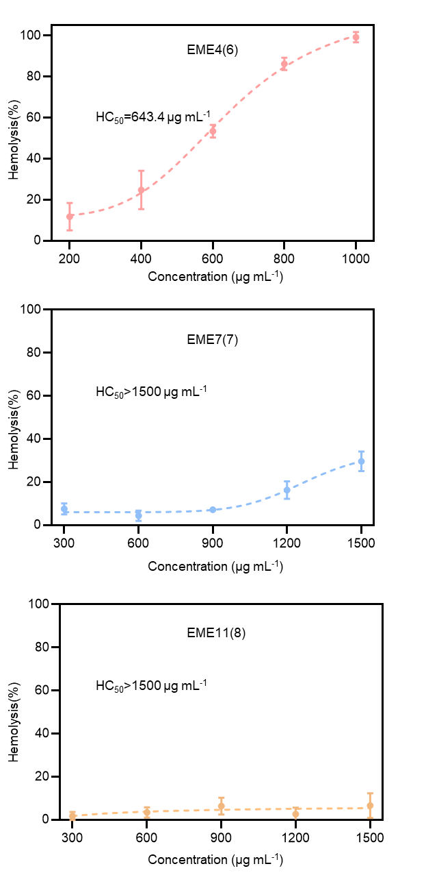
Supplementary Fig. 4. Hemolysis data used to calculate the HC₅₀ of the leading hexa-AMPs (n=3 biologically independent, mean±s.d.).

Supplementary Table 1. Dataset partition based on pipeline tasks.
Task | Datasets | Positive:Negative | Training Set: Test Set
Classification | P. aeruginosa | 1186:5898 | 9:1
Classification | A. baumannii | 148:5898 | 8:2
Ranking | P. aeruginosa | 1186:5898 | 8:2
Ranking | A. baumannii | 148:5898 | 7:3
Regression | P. aeruginosa | 1186:5898 | 9:1
Regression | A. baumannii | 148:5898 | 8:2

Supplementary Table 2. Physicochemical descriptors.
Feature Groups | Features | No. of descriptors
Basic character | Molecule weight | 1
Basic character | Charge | 3
Basic character | Polarity | 2
Basic character | No. of benzene ring | 1
Basic character | Mean hydrophobicity | 1
Basic character | Mean vdW volume | 1
Amino acid composition | Amino acid composition | 20
Amino acid composition | Dipeptide composition | 400
Autocorrelation | Normalized Moreau-Broto  autocorrelation | 8×δmax
Composition, transition, and distribution | Composition | 21
Composition, transition, and distribution | Transition | 21
Composition, transition, and distribution | Distribution | 105
Sequence order  features | Sequence order coupling number | 2×δmax
Sequence order  features | Type I pseudo-amino acid composition | 20+δmax
Sequence order  features | Type II pseudo-amino acid composition | 20+δmax

Explanatory note: The charge contains three descriptors including the net charge, the number of groups carrying positive charges, and the number of groups carrying negative charges. The net charge is defined as the sum of charges of each residual. H, K, and R are defined to carry +1 charge, D and E are defined to carry -1 charge, and the remaining 15 are defined to be uncharged. The polarity contains two descriptors, including the number of polar groups and nonpolar groups on one peptide. The mean hydrophobicity is defined as the per residue Eisenberg consensus hydrophobicity averaged over all residues in the peptide²⁰. The mean vdW volume is defined as the average per residue normalized van der Waals volume. The definitions of other features can be referred to the works of Lee et al., Cao et al., and Chou et al. The separation between any pair of amino acid positions, δ, is required to calculate the autocorrelation and sequence order features. δ exceeds the length of the peptide is not meaningful, so we set δmax as 5 considering that our study focused on hexapeptides.

Detailed descriptors
A R N D C E Q G H I L K M F P S T W Y V AA AR AN AD AC AE AQ AG AH AI AL AK AM AF AP AS AT AW AY AV RA RR RN RD RC RE RQ RG RH RI RL RK RM RF RP RS RT RW RY RV NA NR NN ND NC NE NQ NG NH NI NL NK NM NF NP NS NT NW NY NV DA DR DN DD DC DE DQ DG DH DI DL DK DM DF DP DS DT DW DY DV CA CR CN CD CC CE CQ CG CH CI CL CK CM CF CP CS CT CW CY CV EA ER EN ED EC EE EQ EG EH EI EL EK EM EF EP ES ET EW EY EV QA QR QN QD QC QE QQ QG QH QI QL QK QM QF QP QS QT QW QY QV GA GR GN GD GC GE GQ GG GH GI GL GK GM GF GP GS GT GW GY GV HA HR HN HD HC HE HQ HG HH HI HL HK HM HF HP HS HT HW HY HV IA IR IN ID IC IE IQ IG IH II IL IK IM IF IP IS IT IW IY IV LA LR LN LD LC LE LQ LG LH LI LL LK LM LF LP LS LT LW LY LV KA KR KN KD KC KE KQ KG KH KI KL KK KM KF KP KS KT KW KY KV MA MR MN MD MC ME MQ MG MH MI ML MK MM MF MP MS MT MW MY MV FA FR FN FD FC FE FQ FG FH FI FL FK FM FF FP FS FT FW FY FV PA PR PN PD PC PE PQ PG PH PI PL PK PM PF PP PS PT PW PY PV SA SR SN SD SC SE SQ SG SH SI SL SK SM SF SP SS ST SW SY SV TA TR TN TD TC TE TQ TG TH TI TL TK TM TF TP TS TT TW TY TV WA WR WN WD WC WE WQ WG WH WI WL WK WM WF WP WS WT WW WY WV YA YR YN YD YC YE YQ YG YH YI YL YK YM YF YP YS YT YW YY YV VA VR VN VD VC VE VQ VG VH VI VL VK VM VF VP VS VT VW VY VV MoreauBrotoAuto_Hydrophobicity1 MoreauBrotoAuto_Hydrophobicity2 MoreauBrotoAuto_Hydrophobicity3 MoreauBrotoAuto_Hydrophobicity4 MoreauBrotoAuto_Hydrophobicity5 MoreauBrotoAuto_AvFlexibility1 MoreauBrotoAuto_AvFlexibility2 MoreauBrotoAuto_AvFlexibility3 MoreauBrotoAuto_AvFlexibility4 MoreauBrotoAuto_AvFlexibility5
MoreauBrotoAuto_Polarizability1 MoreauBrotoAuto_Polarizability2 MoreauBrotoAuto_Polarizability3 MoreauBrotoAuto_Polarizability4 MoreauBrotoAuto_Polarizability5 MoreauBrotoAuto_FreeEnergy1 MoreauBrotoAuto_FreeEnergy2 MoreauBrotoAuto_FreeEnergy3 MoreauBrotoAuto_FreeEnergy4 MoreauBrotoAuto_FreeEnergy5 MoreauBrotoAuto_ResidueASA1 MoreauBrotoAuto_ResidueASA2 MoreauBrotoAuto_ResidueASA3 MoreauBrotoAuto_ResidueASA4 MoreauBrotoAuto_ResidueASA5 MoreauBrotoAuto_ResidueVol1 MoreauBrotoAuto_ResidueVol2 MoreauBrotoAuto_ResidueVol3 MoreauBrotoAuto_ResidueVol4 MoreauBrotoAuto_ResidueVol5 MoreauBrotoAuto_Steric1 MoreauBrotoAuto_Steric2 MoreauBrotoAuto_Steric3 MoreauBrotoAuto_Steric4 MoreauBrotoAuto_Steric5 MoreauBrotoAuto_Mutability1 MoreauBrotoAuto_Mutability2 MoreauBrotoAuto_Mutability3 MoreauBrotoAuto_Mutability4 MoreauBrotoAuto_Mutability5 _PolarizabilityC1 _PolarizabilityC2 _PolarizabilityC3 _SolventAccessibilityC1 _SolventAccessibilityC2 _SolventAccessibilityC3 _SecondaryStrC1 _SecondaryStrC2 _SecondaryStrC3 _ChargeC1 _ChargeC2 _ChargeC3 _PolarityC1 _PolarityC2 _PolarityC3 _NormalizedVDWVC1 _NormalizedVDWVC2 _NormalizedVDWVC3 _HydrophobicityC1 _HydrophobicityC2 _HydrophobicityC3 _PolarizabilityT12 _PolarizabilityT13 _PolarizabilityT23 _SolventAccessibilityT12 _SolventAccessibilityT13 _SolventAccessibilityT23 _SecondaryStrT12 _SecondaryStrT13 _SecondaryStrT23 _ChargeT12 _ChargeT13 _ChargeT23 _PolarityT12 _PolarityT13 _PolarityT23 _NormalizedVDWVT12 _NormalizedVDWVT13 _NormalizedVDWVT23 _HydrophobicityT12 _HydrophobicityT13 _HydrophobicityT23 _PolarizabilityD1001 _PolarizabilityD1025 _PolarizabilityD1050 _PolarizabilityD1075 _PolarizabilityD1100 _PolarizabilityD2001
_PolarizabilityD2025 _PolarizabilityD2050 _PolarizabilityD2075 _PolarizabilityD2100 _PolarizabilityD3001 _PolarizabilityD3025 _PolarizabilityD3050 _PolarizabilityD3075 _PolarizabilityD3100 _SolventAccessibilityD1001 _SolventAccessibilityD1025 _SolventAccessibilityD1050 _SolventAccessibilityD1075 _SolventAccessibilityD1100 _SolventAccessibilityD2001 _SolventAccessibilityD2025 _SolventAccessibilityD2050 _SolventAccessibilityD2075 _SolventAccessibilityD2100 _SolventAccessibilityD3001 _SolventAccessibilityD3025 _SolventAccessibilityD3050 _SolventAccessibilityD3075 _SolventAccessibilityD3100 _SecondaryStrD1001 _SecondaryStrD1025 _SecondaryStrD1050 _SecondaryStrD1075 _SecondaryStrD1100 _SecondaryStrD2001 _SecondaryStrD2025 _SecondaryStrD2050 _SecondaryStrD2075 _SecondaryStrD2100 _SecondaryStrD3001 _SecondaryStrD3025 _SecondaryStrD3050 _SecondaryStrD3075 _SecondaryStrD3100 _ChargeD1001 _ChargeD1025 _ChargeD1050 _ChargeD1075 _ChargeD1100 _ChargeD2001 _ChargeD2025 _ChargeD2050 _ChargeD2075 _ChargeD2100 _ChargeD3001 _ChargeD3025 _ChargeD3050 _ChargeD3075 _ChargeD3100 _PolarityD1001 _PolarityD1025 _PolarityD1050 _PolarityD1075 _PolarityD1100 _PolarityD2001 _PolarityD2025 _PolarityD2050 _PolarityD2075 _PolarityD2100 _PolarityD3001 _PolarityD3025 _PolarityD3050 _PolarityD3075 _PolarityD3100 _NormalizedVDWVD1001 _NormalizedVDWVD1025 _NormalizedVDWVD1050 _NormalizedVDWVD1075 _NormalizedVDWVD1100 _NormalizedVDWVD2001 _NormalizedVDWVD2025 _NormalizedVDWVD2050 _NormalizedVDWVD2075 _NormalizedVDWVD2100 _NormalizedVDWVD3001 _NormalizedVDWVD3025 _NormalizedVDWVD3050
_NormalizedVDWVD3075 _NormalizedVDWVD3100 _HydrophobicityD1001 _HydrophobicityD1025 _HydrophobicityD1050 _HydrophobicityD1075 _HydrophobicityD1100 _HydrophobicityD2001 _HydrophobicityD2025 _HydrophobicityD2050 _HydrophobicityD2075 _HydrophobicityD2100 _HydrophobicityD3001 _HydrophobicityD3025 _HydrophobicityD3050 _HydrophobicityD3075 _HydrophobicityD3100 tausw1 tausw2 tausw3 tausw4 tausw5 taugrant1 taugrant2 taugrant3 taugrant4 taugrant5 PAAC1 PAAC2 PAAC3 PAAC4 PAAC5 PAAC6 PAAC7 PAAC8 PAAC9 PAAC10 PAAC11 PAAC12 PAAC13 PAAC14 PAAC15 PAAC16 PAAC17 PAAC18 PAAC19 PAAC20 PAAC21 PAAC22 PAAC23 PAAC24 PAAC25 APAAC1 APAAC2 APAAC3 APAAC4 APAAC5 APAAC6 APAAC7 APAAC8 APAAC9 APAAC10 APAAC11 APAAC12 APAAC13 APAAC14 APAAC15 APAAC16 APAAC17 APAAC18 APAAC19 APAAC20 APAAC21 APAAC22 APAAC23 APAAC24 APAAC25 Mw charge of all positive_charge negative_charge polar_number unpolar_number ph_number hydrophobicity vdW_volume

Supplementary Table 3. Performance of various models in classification task.
Methods | Precision | Accuracy | Recall | F1 Score | Sample (+:-)
ESM(All) | 0.905 | 0.968 | 0.882 | 0.893 | 11321: 59728
ESM(All+P.a.) | 0.943 | 0.978 | 0.959 | 0.951 | 1186: 5898
ESM(A.b.) | 0.933 | 0.995 | 0.875 | 0.903 | 148:5898
ESM(All+A.b.) | 0.861 | 0.995 | 0.969 | 0.912 | 148:5898
ESM(All+P.a.+A.b.) | 0.886 | 0.996 | 0.969 | 0.925 | 148:5898
ESM(P.a.+A.b.) | 0.968 | 0.998 | 0.938 | 0.952 | 148:5898

Supplementary Table 4. Performance of various models in ranking task.
Methods | Top10-Prec | Top20-Prec | Top40-Prec | Samples (+:-)
ESM(A.b.) | 0.4 | 0.5 | 0.8 | 148:5898
ESM(P.a.+A.b.) | 0.3 | 0.6 | 0.8 | 148:5898
MLP(A.b.) | 0.4 | 0.6 | 0.775 | 148:5898
ESM(A.b.)* | 0.5 | 0.65 | 0.875 | 148:5898
MLP(P.a.+A.b.) | 0.4 | 0.65 | 0.825 | 148:5898
ESM(P.a.+A.b.)* | 0.4 | 0.65 | 0.925 | 148:5898

Methods | Top10-Prec | Top50-Prec | Top100-Prec | Top200-Prec | Samples (+:-)
ESM(P.a.) | 0.1 | 0.42 | 0.65 | 0.870 | 1186:5898
ESM(P.a.) * | 0.1 | 0.26 | 0.54 | 0.910 | 1186:5898
MLP(P.a.) | 0.4 | 0.5 | 0.71 | 0.885 | 1186:5898
*Using the parameters from the classification model fine-tuned by anti-P. aeruginosa AMPs to initialize parameters for the pre-training model.

Supplementary Table 5. Performance of various models in regression task.
Methods | MSE | Top-10 MSE | Top-20 MSE | Top-40 MSE | Pos MSE | Samples (+:-)
ESM(A.b.) | 0.031 | 1.032 | 0.920 | 0.461 | 1.202 | 148:5898
ESM(P.a.+A.b.) | 0.015 | 0.215 | 0.373 | 0.187 | 0.394 | 148:5898
MLP(A.b.) | 0.255 | 1.848 | 2.183 | 1.763 | 1.952 | 148:5898
ESM(A.b.)* | 0.034 | 1.044 | 0.994 | 0.497 | 1.137 | 148:5898
MLP(P.a.+A.b.) | 0.027 | 0.273 | 0.452 | 0.285 | 0.362 | 148:5898
ESM(P.a.+A.b.) * | 0.012 | 0.119 | 0.352 | 0.176 | 0.359 | 148:5898

Methods | MSE | Top-10 MSE | Top-20 MSE | Top-40 MSE | Pos MSE | Samples (+:-)
ESM(P.a.) | 0.126 | 0.714 | 0.517 | 0.525 | 0.551 | 1186:5898
MLP(P.a.) | 0.217 | 2.863 | 1.87 | 1.12 | 0.759 | 1186:5898
ESM(P.a.)* | 0.09 | 0.693 | 0.414 | 0.445 | 0.459 | 1186:5898
*Using the parameters from the classification model fine-tuned by anti-P. aeruginosa AMPs to initialize parameters for the pre-training model.

Supplementary Table 6. Experimental MICs (EMICs) of the top-10 peptides from the EEE pipeline (n=3).
ID | Sequence | EMIC (μg/mL)
EEE1(6) | KRRRWI-NH₂ | >512
EEE2(6) | AIRWKK-NH₂ | >512
EEE3(6) | IIWRRR-NH₂ | >512
EEE4(6) | LWWWRR-NH₂ | 128
EEE5(6) | IVWRRR-NH₂ | >512
EEE6(6) | IWRWWR-NH₂ | 64
EEE7(6) | KRKRIW-NH₂ | >512
EEE8(6) | IWWWRR-NH₂ | 128
EEE9(6) | WLWWRR-NH₂ | 128
EEE10(6) | IIWWRR-NH₂ | >512

Supplementary Table 7. Experimental MICs (EMICs) of the top-10 peptides from the EMM pipeline (n=3).
ID | Sequence | EMIC (μg/mL)
EMM1(6) | KWAKLW-NH₂ | 512
EMM2(6) | KLWRWF-NH₂ | >512
EMM3(6) | KLWRWW-NH₂ | 256
EMM4(6) | KLWRIW-NH₂ | >512
EMM5(6) | KLWRAL-NH₂ | >512
EMM6(6) | KLWKWF-NH₂ | 512
EMM7(6) | KWFKLW-NH₂ | 512
EMM8(6) | KWFRIW-NH₂ | 512
EMM9(6) | KWIKLW-NH₂ | 32
EMM10(6) | KWFRLW-NH₂ | 512

Supplementary Table 8. Experimental MICs (EMICs) of the top-10 peptides from the EFE pipeline (n=3).
ID | Sequence | EMIC (μg/mL)
EFE1(6) | KWIKWI-NH₂ | >512
EFE2(6) | RWIKWI-NH₂ | >512
EFE3(6) | WIRWAK-NH₂ | >512
EFE4(6) | KWFKWI-NH₂ | >512
EFE5(6) | WFRWIK-NH₂ | >512
EFE6(6) | KWIKIW-NH₂ | >512
EFE7(6) | RWIKWL-NH₂ | >512
EFE8(6) | KWFKIW-NH₂ | >512
EFE9(6) | KWWKWI-NH₂ | 128
EFE10(6) | RWFRLA-NH₂ | >512

Supplementary Table 9. Experimental MICs (EMICs) of the top-10 peptides from the EME pipeline (n=3).
ID | Sequence | EMIC (μg/mL)
EME1(6) | RWIRWI-NH₂ | 256
EME2(6) | RWIRWW-NH₂ | 64
EME3(6) | RWIRWF-NH₂ | 128
EME4(6) | RWWRWI-NH₂ | 16
EME5(6) | KWIRIW-NH₂ | 256
EME6(6) | RWFRWI-NH₂ | 256
EME7(6) | RWIRWV-NH₂ | 512
EME8(6) | RIWRWW-NH₂ | 64
EME9(6) | RWIRVW-NH₂ | 128
EME10(6) | KWIRWW-NH₂ | 64

Supplementary Table 10. Experimental MICs (EMICs) of the top-10 peptides from the EME* pipeline (n=3).
ID | Sequence | EMIC (μg/mL)
EME1(6)* | RWFRIW-NH₂ | 128
EME2(6)* | FFRIWY-NH₂ | >512
EME3(6)* | RGIRWW-NH₂ | >512
EME4(6)* | WAKWIH-NH₂ | >512
EME5(6)* | RWIHFF-NH₂ | 256
EME6(6)* | RIGRWW-NH₂ | >512
EME7(6)* | WIRIWH-NH₂ | 256
EME8(6)* | RWFRIF-NH₂ | 256
EME9(6)* | FFRLIH-NH₂ | >512
EME10(6)* | RWIHFW-NH₂ | 256
EME* pipeline trained without the inclusion of anti-A. baumannii peptides during fine-tuning.

Supplementary Table 11. Experimental MICs (EMICs) of the top-10 peptides from the EME pipeline (n=3).
ID | Sequence | EMIC (μg/mL)
EME1(7) | KRWIRIW-NH₂ | 128
EME2(7) | RRWFRWI-NH₂ | 64
EME3(7) | RRWIRIW-NH₂ | 64
EME4(7) | KRWFRIW-NH₂ | 64
EME5(7) | RRWFRIW-NH₂ | 256
EME6(7) | RWIRWIH-NH₂ | 64
EME7(7) | RRWWRIW-NH₂ | 8
EME8(7) | RWFRWIM-NH₂ | 32
EME9(7) | KRWAKWI-NH₂ | >512
EME10(7) | RWIRWWT-NH₂ | 64
EME11(7) | RWFRWIT-NH₂ | 64
EME12(7) | RWFRWIH-NH₂ | 256
EME13(7) | RRWIKLW-NH₂ | 128
EME14(7) | RWIRWVT-NH₂ | 256
EME15(7) | RWWKAIM-NH₂ | 64

Supplementary Table 12. Experimental MICs (EMICs) of the top-10 peptides from the EME pipeline (n=3).
ID | Sequence | EMIC (μg/mL)
EME1(8) | RRWIRIWK-NH₂ | 256
EME2(8) | RRWIRWFR-NH₂ | 32
EME3(8) | RRWIRWWK-NH₂ | 32
EME4(8) | RRWFRWIR-NH₂ | 32
EME5(8) | RRWWKLIR-NH₂ | 32
EME6(8) | KRWIRWLT-NH₂ | 32
EME7(8) | RRWWRILK-NH₂ | 32
EME8(8) | RRWIRLLK-NH₂ | 512
EME9(8) | RRWIRILK-NH₂ | >512
EME10(8) | RRWFRWIT-NH₂ | 32
EME11(8) | RRWIRWIT-NH₂ | 16
EME12(8) | RRWFRWIK-NH₂ | 256
EME13(8) | RRWIRWIH-NH₂ | 128
EME14(8) | RRWIKLIK-NH₂ | 128
EME15(8) | KRWIKWLT-NH₂ | 128

Supplementary Table 13. Bacterial strains.
Bacterial strains | Source | Features
A. baumannii 19606 | Guangdong culture  collection center | /
A. baumannii 17978 | Guangdong culture  collection center | /
A. baumannii XH197 | laboratory-evolved mutant of 17978 | loss of lipopolysaccharide

Supplementary Table 14. The initial MICs (MIC₀) of the drugs against A. baumannii 17978 used in the drug resistance test (n=3).
Sample | MIC₀ (μg/mL)
EME4(6) | 16
EME7(7) | 8
EME11(8) | 16
Polymyxin B | 4

Reference

1. Witten, J. & Witten, Z., Deep Learning Regression Model for Antimicrobial Peptide Design. Preprint at bioRxiv http://dx.doi.org/10.1101/692681 (2019).
2. Wang, G. S., Li, X. & Wang, Z., APD3: the antimicrobial peptide database as a tool for research and education. Nucleic Acids Res. 44, D1087-D1093 (2016).
3. Novkovic, M., Simunic, J., Bojovic, V., Tossi, A. & Juretic, D., DADP: the database of anuran defense peptides. Bioinformatics 28, 1406-1407 (2012).
4. Pirtskhalava, M., et al., DBAASP v.2: an enhanced database of structure and antimicrobial/cytotoxic activity of natural and synthetic peptides. Nucleic Acids Res. 44, D1104-D1112 (2016).
5. Fan, L. L., et al., DRAMP: a comprehensive data repository of antimicrobial peptides. Sci. Rep. 6, 24482 (2016).
6. Piotto, S. P., Sessa, L., Concilio, S. & Iannelli, P., YADAMP: yet another database of antimicrobial peptides. Int. J. Antimicrob. Agents 39, 346-351 (2012).
7. Huang, Junjie et al. Identification of potent antimicrobial peptides via a machine-learning pipeline that mines the entire space of peptide sequences. Nat. Biomed. Eng. 7, 797-810 (2023)
8. Lee, E. Y., Fulan, B. M., Wong, G. C. L. & Ferguson, A. L., Mapping membrane activity in undiscovered peptide sequence space using machine learning. Proc. Natl. Acad. Sci. USA 113, 13588-13593 (2016).
9. Cao, D. S., Xu, Q. S. & Liang, Y. Z., propy: a tool to generate various modes of Chou's PseAAC. Bioinformatics 29, 960-962 (2013).
10. Jumper, John, et al. Highly accurate protein structure prediction with AlphaFold. Nature 596, 583-589 (2021).
11. Rives, Alexander, et al. Biological structure and function emerge from scaling unsupervised learning to 250 million protein sequences. Proc. Natl. Acad. Sci. USA 118, e2016239118 (2021).
12. Ji, Yanrong, et al. DNABERT: pre-trained Bidirectional Encoder Representations from Transformers model for DNA-language in genome. Bioinformatics 37, 2112-2120 (2021).
13. Liu, Yinhan, et al. Roberta: A robustly optimized bert pretraining approach. Preprint at arXiv https://doi.org/10.48550/arXiv.1907.11692 (2019).

