Octopus body language: body patterns of Abdopus capricornicus during social interactions. Supplementary material.
Gabriella Scata*¹ ² (0000-0002-4078-7325), N Justin Marshall¹ (0000-0001-9006-6713), Wen-Sung Chung¹ (0000-0003-0943-8933)
*corresponding author: gabry.scata@gmail.com
1. Queensland Brain Institute, The University of Queensland, St Lucia, QLD, 4072, Australia
2. Department of Agriculture and Fisheries, Ecosciences Precinct, Dutton Park, QLD, 4102, Australia

Table S1 Abdopus capricornicus collected between 2019 and 2020. Maturity stages were defined as following : stage 3 – juvenile which the sex is not distinguished with the naked eye; stage 4 - sub-adult with developing gonad/testis, stage 5 - mature adult ready for reproduction (Jereb et al. 2014, Mangold 1987).

Date collected | Animal ID | Sex | Maturity stage | Mantle length (mm) | Number of arms
2019
27/08/2019 | Abdopus 1 | F | 4 | 50 | 8
28/08/2019 | Abdopus 2 | M | 5 | 41 | 8
28/08/2019 | Abdopus 3 | M | 5 | 39 | 7
29/08/2019 | Abdopus 4 | F | 5 | 64 | 6
29/08/2019 | Abdopus 5 | F | 4 | 55 | 7
31/08/2019 | Abdopus 6 | M | 4 | 37 | 5
01/09/2019 | Abdopus 7 | F | 5 | 62 | 8 (7)*
2020
17/08/2020 | Abdopus 1 | F | 3-4 | 48 | 8
17/08/2020 | Abdopus 2 | F | 5 | 60 | 8
18/08/2020 | Abdopus 3 | M | 5 | 50 | 4
20/08/2020 | Abdopus 4 | F | 3 | 38 | 7
18/08/2020 | Abdopus 5 | M | 3 | 36 | 6
19/08/2020 | Abdopus 6 | M | 4 | 44 | 7
20/08/2020 | Abdopus 7 | M | 4 | 46 | 8
20/08/2020 | Abdopus 8 | F | 4-5 | 58 | 8
20/08/2020 | Abdopus 9 | F | 5 | 44 | 7
18/08/2020 | Abdopus 10 | M | 3 | 35 | 8

*Abdopus 7 (2019) lost an arm during handling on 12/09/19 after the first trial.

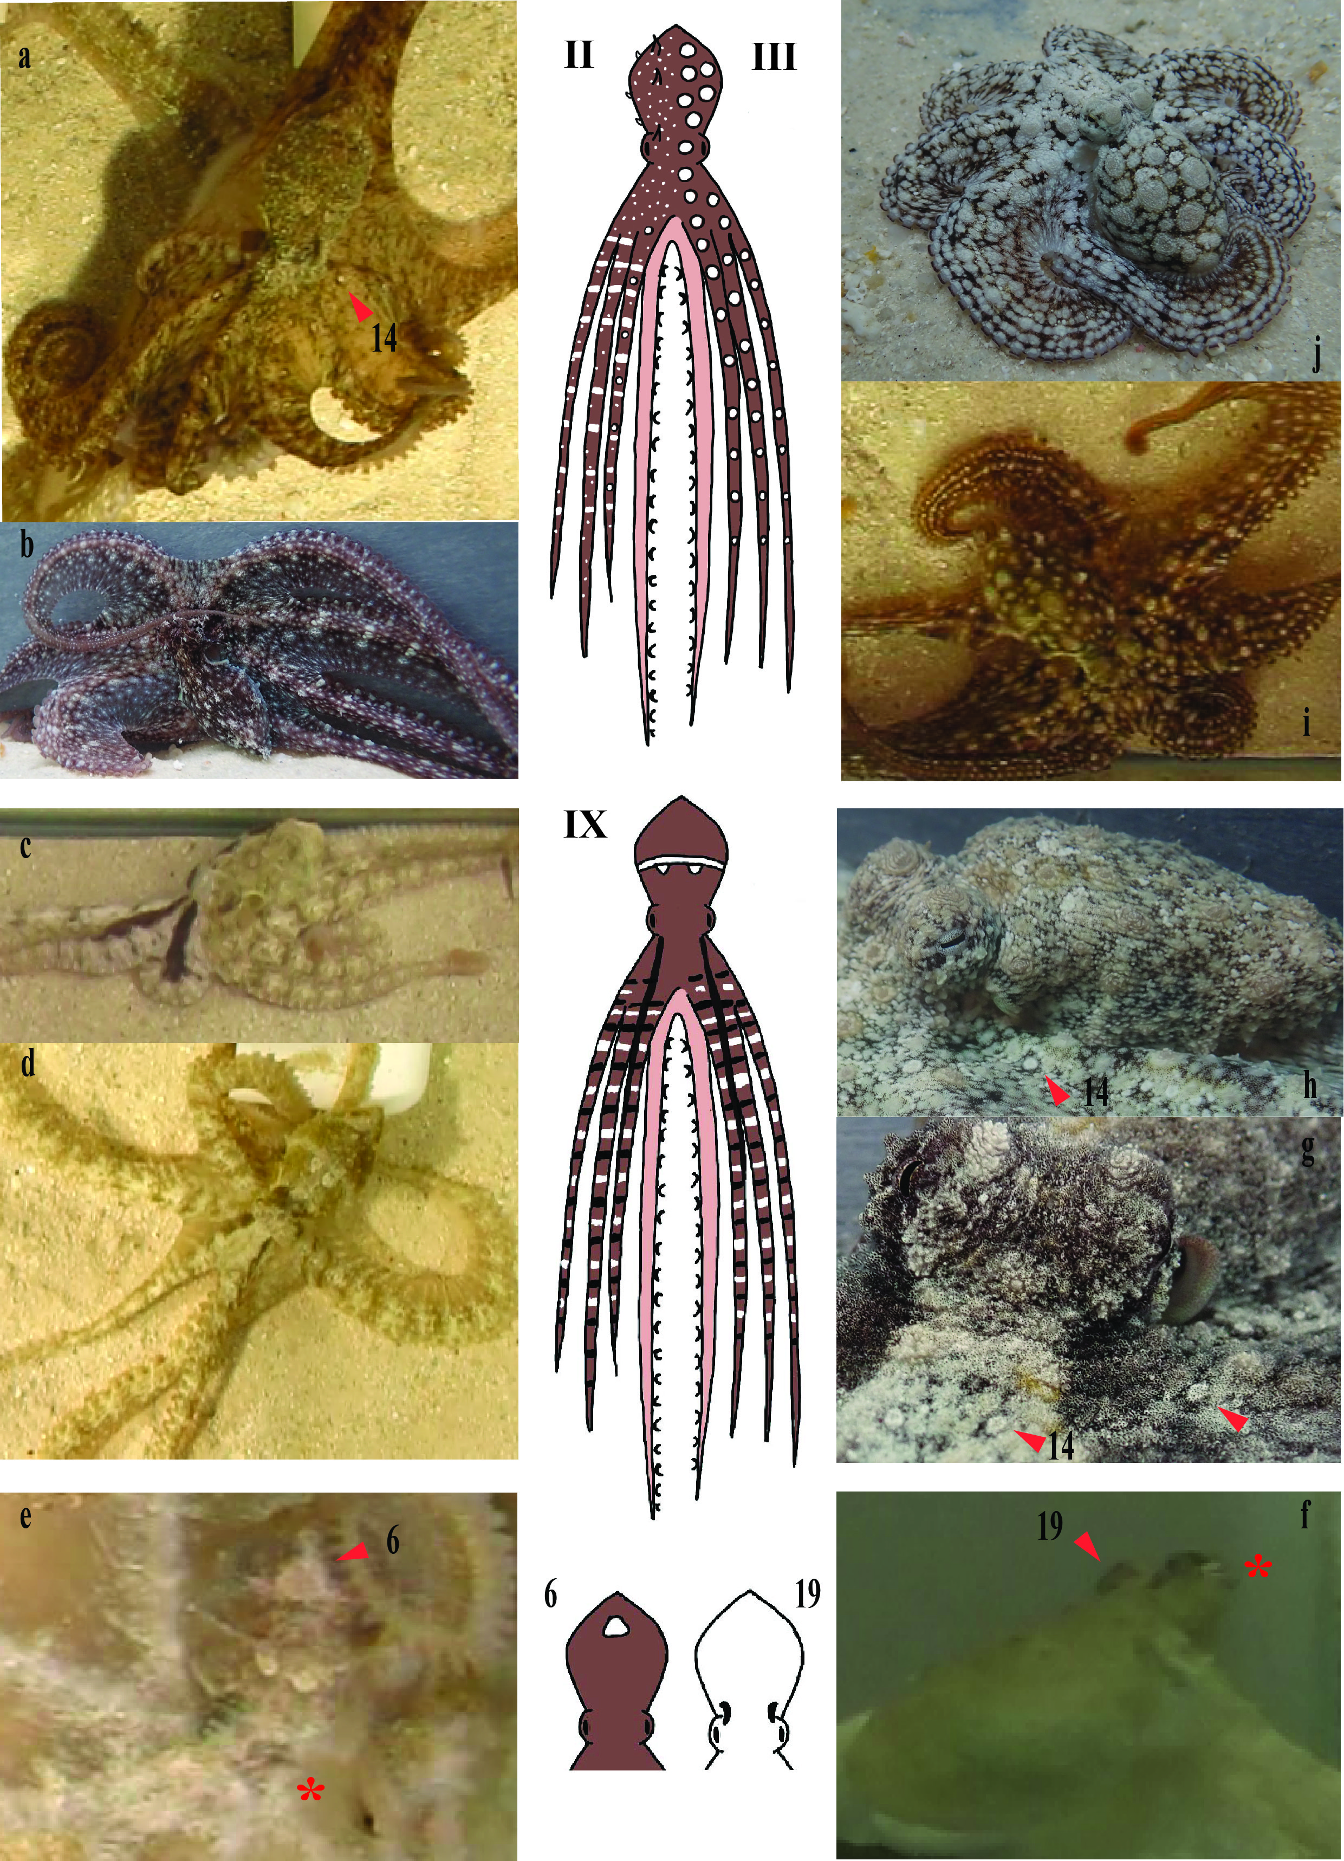
Fig. S1 Additional photos representing key body patterns and some of the new components identified in A. capricornicus. a) Mottle general pattern (II) with Ringed-White Spots (RWS) (14) on arms indicated by the red arrowhead (see also Fig 1 a-b); b) Mottle general pattern (II) with White Arm Bars (WAB); c-d) Aggressive Banding pattern (IX). In c) this pattern is shown only on the left side of the animal, while on the right side the “Pale background with dark longitudinal stripes” (BWS) pattern is shown towards the conspecific being approached; e) the new component Posterior White Triangle (PWT) (6) (indicated by the red arrowhead) expressed along with dorsal Mantle White Spots (MWS); f) the new component Dark Eyebrows (19) (indicated by the red arrowhead); g-h) close-up of the new component Ringed-White Spots (RWS) (14) (indicated by the red arrowhead); i-j) Mottle conflict pattern (III) in its dark and light variations, respectively. Refer to Table 3 and Fig. 1-3 as well

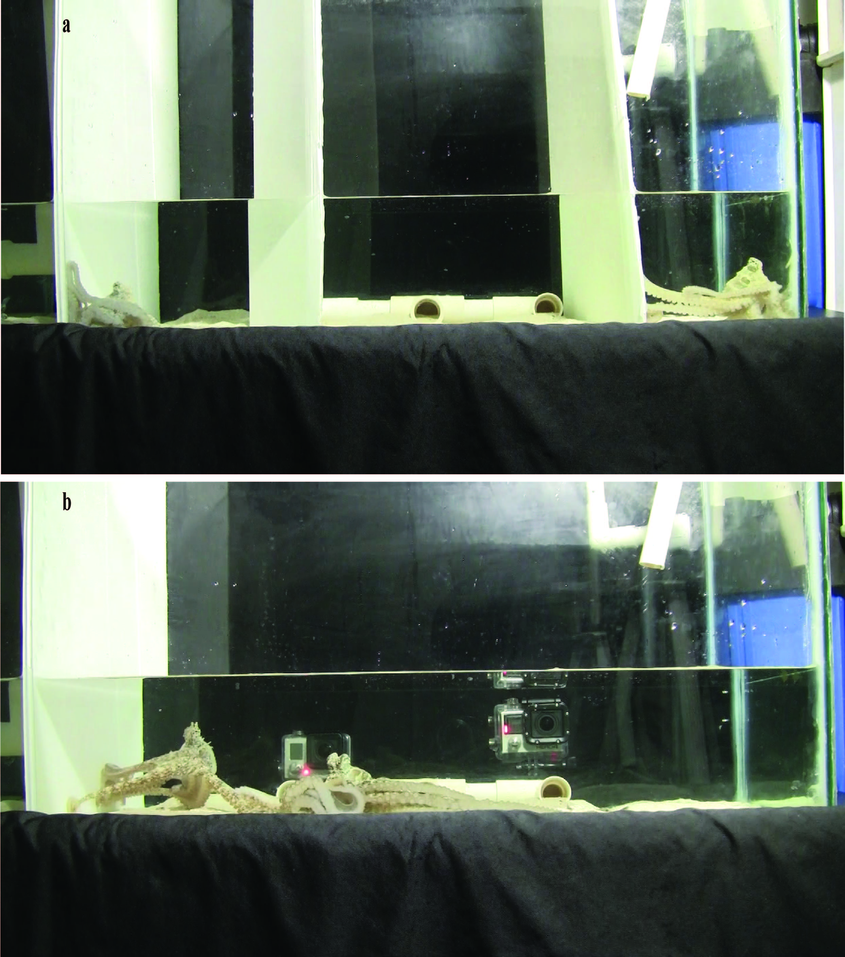

Fig. S2 Experimental tank setup. a) opaque separators in place during acclimation phase; b) separators removed during the interaction trial

Notes to Table 2
a. In O. cyanea Roper and Hochberg (1988) reported the presence of an “Eye Stripe” without a detailed description, but stating that “Typical cryptic colouration is a light mottle of red/brown on a cream/beige background. A dark black band extends along the head and through the eye effectively masking it.” According to Borrelli and colleagues (2006) this “dark Eye Stripe” corresponds to the “Extended Eye Bar” (EEB) of O. vulgaris; however, it is surprising that O. cyanea expresses the EEB but not the EB.
Van Heukelem (1966) also reports that “Dark grey lines frequently appeared around the eyes, one of these ran horizontally from both sides of the eye through the pupil, reminiscent of the black bar running through and disguising the pupil of many fish in the family Chaetodontidae.” Therefore, here O. cyanea is considered as expressing the EB as well.
b. In O. cyanea Van Heukelem (1966) described the male courtship display (equivalent to Abdopus spp BWS) as “dark vertical stripes from the head down the arms”, hence the stripes do not appear to continue longitudinally over the mantle as in A. aculeatus and A. capricornicus, or as the “dark longitudinal stripes” described for O. vulgaris by Cowdry (1911) and Packard and Sanders (1971).
c. In O. cyanea, Roper and Hochberg (1988) reported a “Dark Conflict Mottle”, but did not describe it. Hanlon and colleagues (1999) also mention “chronic mottle patterns” given by diverse spots and blotches throughout the skin”, but their specific characteristics (i.e. large or small spots and their specific location) are not provided and the images referred to (Fig 1J, M) are of poor quality thus the patterns are not clear. Hanlon and colleagues (1999) also describe a Deimatic display characterised by “bold, high-contrast mottling combined with expression of the ocelli and spreading of the arms and web” (Fig. 4E). This Deimatic pattern appears similar to O. vulgaris Broad Conflict Mottle (Packard and Sanders 1969, 1971), and potentially to A. aculeatus Deimatic (with large pale spots on a dark background”) and A. capricornicus Mottle conflict. However, once again the description is not detailed and the image is unclear. This Deimatic of O. cyanea may correspond to the “Acute Mottle” of O. bimaculoides, which has also been suggested to be equivalent to O. vulgaris Broad Conflict Mottle (Packard and Hochberg 1977). Therefore, here O. cyanea is considered has possibly “S” showing a form of Conflict Mottle but not equivalent to that of Abdopus spp and O. vulgaris, but as possibly expressing “✓” a Chronic General Mottle similar to that described for O. vulgaris.
d. Dark longitudinal stripes were not reported in O. bimaculoides but the Extended Eye Bar shown in the strong Disruptive pattern appears just a shorter and thinner version of the Dark longitudinal stripes described by Packard and Sanders (1971) in O. vulgaris, and corresponding to the dark stripes of the BWS pattern in O. cyanea and Abdopus species. Therefore, here O. bimaculoides is considered as expressing a component not equivalent but similar “S”
e. The BrDots of A. capricornicus could correspond to the Yellow-orange spots of O. bimaculoides, which are found on the dorsal mantle and arms and mark the location of major body papillae (Forsythe and Hanlon 1988).
f. The Acute Mottle of O. bimaculoides has been suggested to be comparable to the Broad Conflict Mottle of O. vulgaris (Packard and Sanders 1971) (and hence would be equivalent to A. capricornicus Mottle Conflict). However, from Fig. 11 of Forsythe and Hanlon (1988) the resemblance is not so evident.
g. A Weak Disruptive pattern with the “White Longitudinal Center Stripe bordered by a uniform darkening on either side” in O. bimaculoides (Forsythe and Hanlon 1988), seems to correspond to the Bold Pied Stripes of O. cyanea (Hanlon et al. 1999) and to the Dark brown with Pale medial stripe of Abdopus species.
h. The Strong Disruptive pattern described in O. bimaculoides (Forsythe and Hanlon 1988), resembles the Aggressive Banding pattern of A. capricornicus.
i. O. burryi bears Dark longitudinal arm stripes, but these are thin stripes on the rim of the arms, very different from the Dark longitudinal stripes of O. vulgaris (Packard and Sanders 1971).
j. The Acute Mottle of O. burryi was reported as similar to the Broad Conflict Mottle of O. vulgaris (Packard and Sanders 1971); but it does not appear as similar from Figure C in Hanlon and Hixon (1980)
k. Acute Resemblance of O. burryi (Hanlon and Hixon 1980) is equivalent to the General Resemblance of O. vulgaris and O. cyanea, but as for those species not described in detail (G)
l. O. briareus expresses an Acute Mottle with White Patches on the mantle, papillate skin and web spread possibly similar to the Broad Conflict Mottle of O. vulgaris (Packard and Sanders 1969, 1971), but from Fig. 22 of Hanlon and Wolterding (1989) it does not appear to be as similar to the Broad Conflict Mottle of O. vulgaris or the Mottle conflict of A. capricornicus.
m. Dark Eyebrows of A. capricornicus could be equivalent to the “dark extensions down from the eyes” shown by a male adult O. vulgaris in Bermuda (Fig. 1F in Mather and Mather 1994). The authors state that these octopuses showed “no Hood” as the one described for O. vulgaris by Packard and Sanders (1971) and that these “dark extensions down the eyes” were the nearest to the dark Hood.
n. O. vulgaris expresses “white longitudinal stripes over a dark reddish brown body colouration”. These striped pattern is also expressed in social interactions, as well as in other contexts, hence it may be similar to the BWS pattern. See “BWS pattern section” in Discussion for further details.
In addition, the White Medial Stripe on the mantle can be expressed independently of the lateral longitudinal white stripes along the arms, and its expression on a dark reddish brown body colour would represent a pattern equivalent to the Bold Pied Striped of O. cyanea (Hanlon et al. 1999) and the “Dark brown with Pale medial stripe” of Abdopus spp (Huffard 2007, this study). Hence, here this pattern is considered as potentially expressed in O. vulgaris.
o. Strong Disruptive pattern described in detail in O. bimaculoides by Forsythe and Hanlon (1988).
p. Dymantic patterns have been described in detail in most of the species listed, but they are quite different across species: in A. aculeatus, a pattern similar to that defined here as Dymantic for A. capricornicus was described by Norman and Finn (2001) as “alarm display” (“pale/green base colour with regular narrow transverse black bars along the arms); however, Huffard termed “dymantic” a pattern similar to what we named here “Mottle conflict”. In O. cyanea, the dymantic has been described as a “high contrast mottled pattern with ocelli”, while in O. briareus and O. vulgaris, the classical description of “dymantic” holds with “pale body, dilated pupil, dark eye ring and dark edge suckers”.
q. Cowdry (1911) also described one of the Striped Phases of O. vulgaris from Bermuda (now recognized as O. americanus, Avendaño et al. 2020) as composed by “dark brown stripe extending from the distal end of the second arm over the optic prominence to the posterior end of the mantle”; thus this stripe would include the DLS defined here and correspond to the "dark longitudinal stripes” described by Huffard (2007) for A. aculeatus.

Note that General Resemblance & Disruptive patterns are mentioned in some of the octopus species listed above but not described in detail (G); only in A. aculeatus a General Resemblance pattern is described in detail and matches the one observed in A. capricornicus.
Video S1 Mating behaviour with the male displaying the Pale background with dark longitudinal stripes (BWS) pattern (see Fig. 3e) with Chevron Stripes (CS) (see Fig. 2k) unilaterally towards the female, with in addition the Dark Arm Bars (DAB) which are expressed on and off.

Video S2 Aggressive Banding pattern (see Fig. 3c, S1 c-d) expressed by one of the males which was enveloped by another male; Mantle White Spots (MWS) and White Mantle Bar (WMB) expressed as well.

Video S3 Bold Pied Stripes pattern (see Fig. 3d) expressed by one male attacking another male.

Video S4 Passing Cloud pattern expressed by a female during mating, while the male expresses a weak Pale background with dark longitudinal stripes (BWS) pattern with Eye Stripes (ES).

Video S5 Mottle conflict Brown pattern (see Fig. 3f) expressed by one male attacking another male; some long Mantle papillae (Mpap) are expressed as well. The male receiving the attack is expressing a Mottle general Dark pattern (see Fig. 3a) and then it transitions to a Uniform Dark pattern.

Video S6 Mottle conflict Light pattern (see Fig. S1j) expressed by one male receiving an attack from another male which is expressing a Mottle general Brown pattern (see Fig. 3a).

Video S7 Both octopuses are expressing a Mottle general pattern (Dark or Brown) (see Fig. 3a) during an aggressive interaction.

Video S8 Male approaching a female while expressing the Pale background with dark longitudinal stripes (BWS) pattern with Chevron Stripes (CS) unilaterally towards the female; the female expresses a Mottle conflict Light at first and then Dark.

