Table.3. Decomposition stages of the buried pig carcasses at depths of 100 cm
Days | Pig | Picture
0 | Fresh stage | 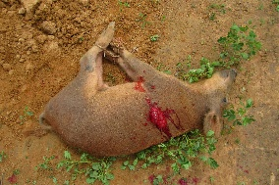
14 | -Beginning of the active decomposition stage  -Strong corpse-like smell  -Partial detachment of the skin and fur  -Deflating of the body  -Decomposition of the body reaching the extremities of the limbs  -Collapse of the eyes  -Paste-like flesh on extremities.  -Dorsal part with intact flesh  - Leakage of body fluid appearing as dark discolorations in certain areas of the ground surrounding the carcasses | 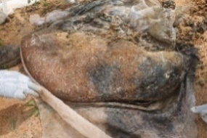
28 | -Active stage of decomposition  -Strong corpse-like odor  -Total deflation of the carcass  -Soft flesh  -Blackish discoloration of the ground surrounding the carcass  -Total detachment of epidermis and fur | 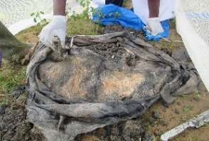
42 | Late decay stage  -Stage of active decomposition  -Release of cadaveric odor  -Total deflation of the carcass  -Paste-like flesh under pressure  -Abdomen still intact | 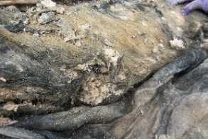
56 | Late decay stage,  -Cadaveric odor release  -Soft flesh under pressure,  -Partial decomposition with stomach intact.  -Partial decomposition of the intestinal tract | 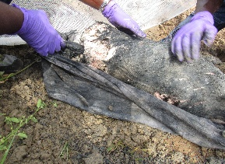

Table 3: (Continued)
70 | -Late decay stage  Release of cadaveric odor  Visible bones coming loose  Paste-like flesh under pressure  Advanced degradation process (granular flesh) | 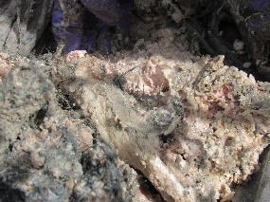
84 | Beginning of skeletonization  Decrease in the smell of the carcass  Hair falls out  Bones appear  The body has a whitish appearance | 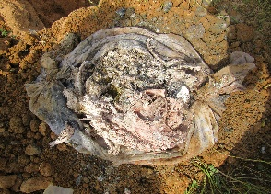
98 | Skeletonization of the carcass  Decrease in corpse odor  Loss of hair  Appearance of bones | 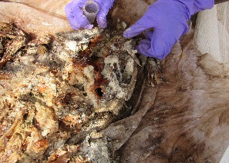
112 | Skeletonization of the carcass  Progressive reduction of odors  Appearance of bones | 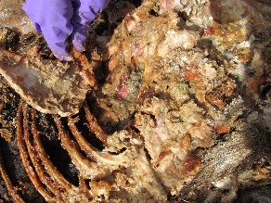
126 | Skeletonization of the carcass  Blackening of the skin with drying  Appearance of bones | 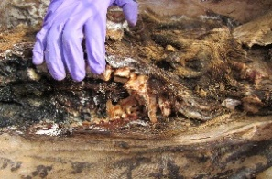

Table 4. Decomposition stages of the buried rabbit carcasses at depths of 50 cm
Days | Rabbit | Picture
0 | Fresh stage | 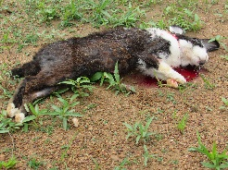
14 | Start of active decomposition  Release of cadaveric odor  Total deflation of the carcass. | 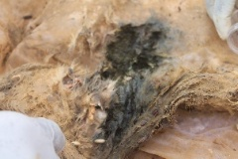
28 | Active decomposition  Total deflation of the carcass  Soil surrounding the carcass becomes blackish in color.  Beginning of bone growth | 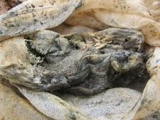
42 | Beginning of skeletonization  No smell of decay  Appearance of bones | 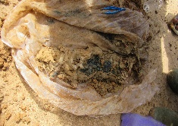
56 | skeletonization | 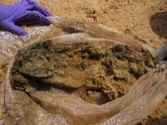
70 | Skeletonization  Absence of carcass smell  loose hair  Visible bones | 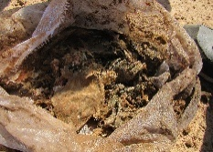

Table 4. (Continued)
84 | Skeletonization  No smell of death  wet back  dry head of the carcass | 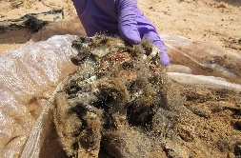
98 | Skeletonization  Absence of carcass smell  Body dried out | 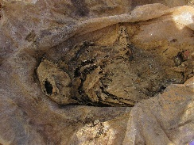
112 | Skeletonization  Absence of cadaveric odor  Partially dry carcass with presence of hair | 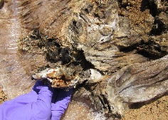
126 | Skeletonization  fully dried carcass | 