Supporting Information

Low-Cost Laser for Fabrication of Affordable Graphene-Induced Microband Sensors

Leonardo M. A. Ribeiro¹ (ORCID: 0000-0003-2508-5007)
Deissy. J. Feria² (ORCID: 0009-0003-8206-5077)
Paula C. Falcoswki¹ (ORCID: 0000-0003-4136-5471)
Marcelo. N. P. Carreño² (ORCID: 0000 0003 2124 1623)
Ines Pereyra² (ORCID: 0000 0002 3353 0644)
Mauro Bertotti¹* (ORCID: 0000-0001-9566-7577)
¹ Department of Fundamental Chemistry, Institute of Chemistry, University of São Paulo, Av. Prof. Lineu Prestes 748, 05508-000, São Paulo, SP, Brazil.
² Department of Electronic Systems Engineering, Polytechnic School, University of São Paulo, 05508-010, São Paulo, SP, Brazil.
*Corresponding Author E-mail Address [mbertott@iq.usp.br]

Fig. S1 Approach curve recorded above an insulating substrate (Kapton tape) with a Pt microelectrode (E = 0.1 V) in a 5 mM ferricyanide + 1.0 M KCl solution.

Fig. S2 CVs recorded in 5 mM ferricyanide + 1.0 M KCl solution using one individual microband at different scan rates (10 (red curve) to 200 mV/s).

Fig. S3 CVs recorded in 5 mM ferricyanide + 1.0 M KCl solution with WE1 and WE2 (blue and green curves) and both electrodes interconnected (red curve). The black curve corresponds to the CV recorded in supporting electrolyte with the interconnected electrodes.

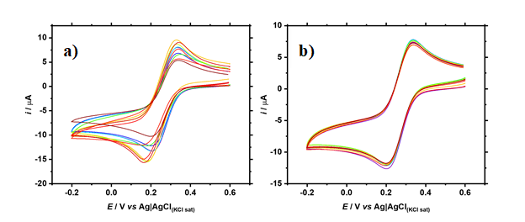

Fig. S4 Reproducibility (A) (n =10) and repeatability (B) (n = 10) experiments performed in a 5 mM ferricyanide + 1.0 M KCl solution. Scan rate: 50 mV/s
Fig. S5 – Chronoamperograms recorded using four different microbands in 5 mM ferricyanide + 1.0 M KCl solution. E = 0.1 V.

