Supplemental Figures

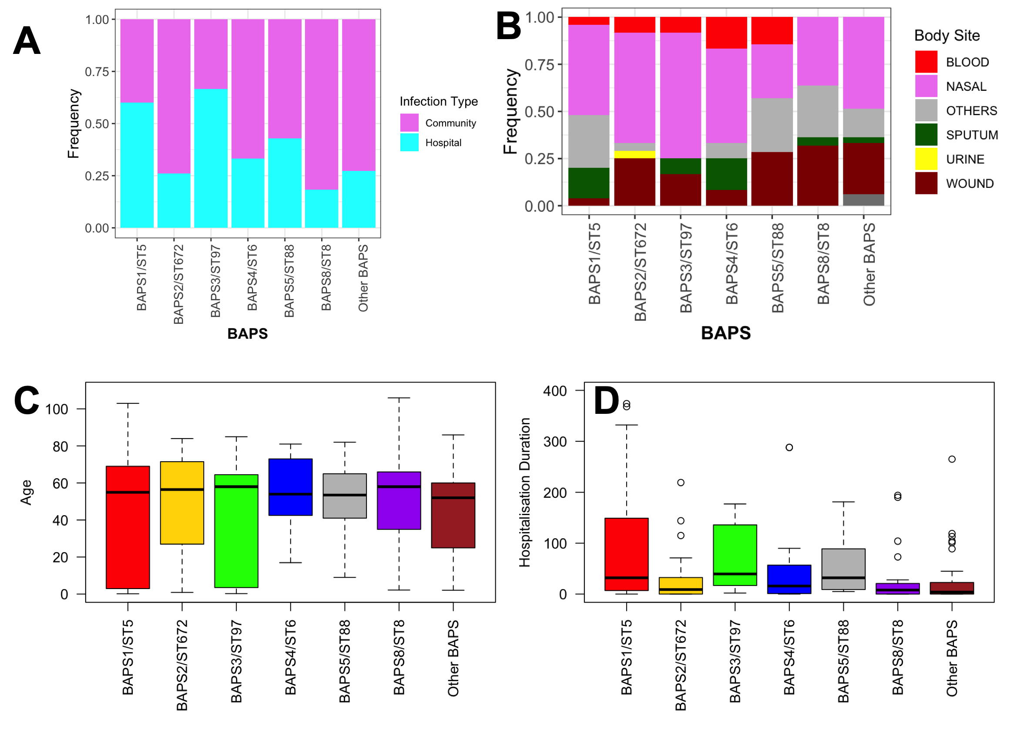
Figure S1 Clinical features of identified clones for community mode of acquisition A), site of infection B) and age of the patients C) hospitalization period D).
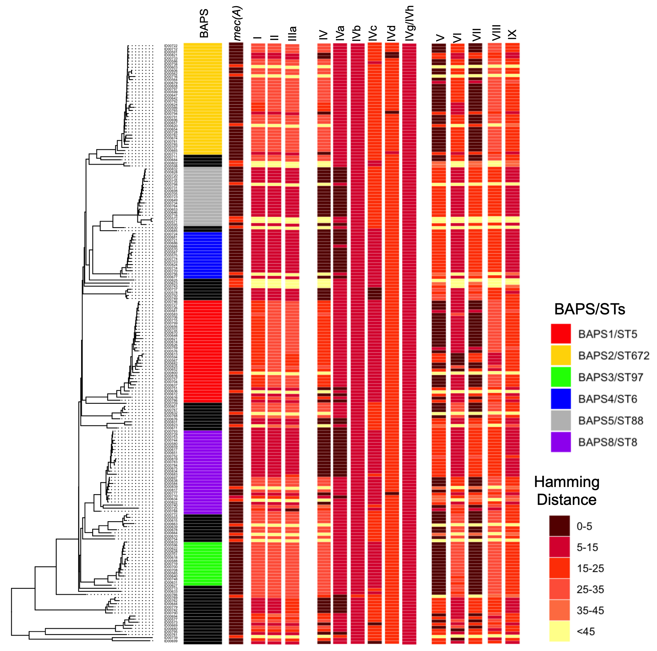
Figure S2: The phylogenetic distribution of SCCmec elements. Color intensity corresponds to the similarity level as measured by the Hamming distance between the identified SCCmec element and the known elements in the Staphoria database. The first column shows the distance between the mecA element and the mec(A) gene in the database of known SCCmec elements.

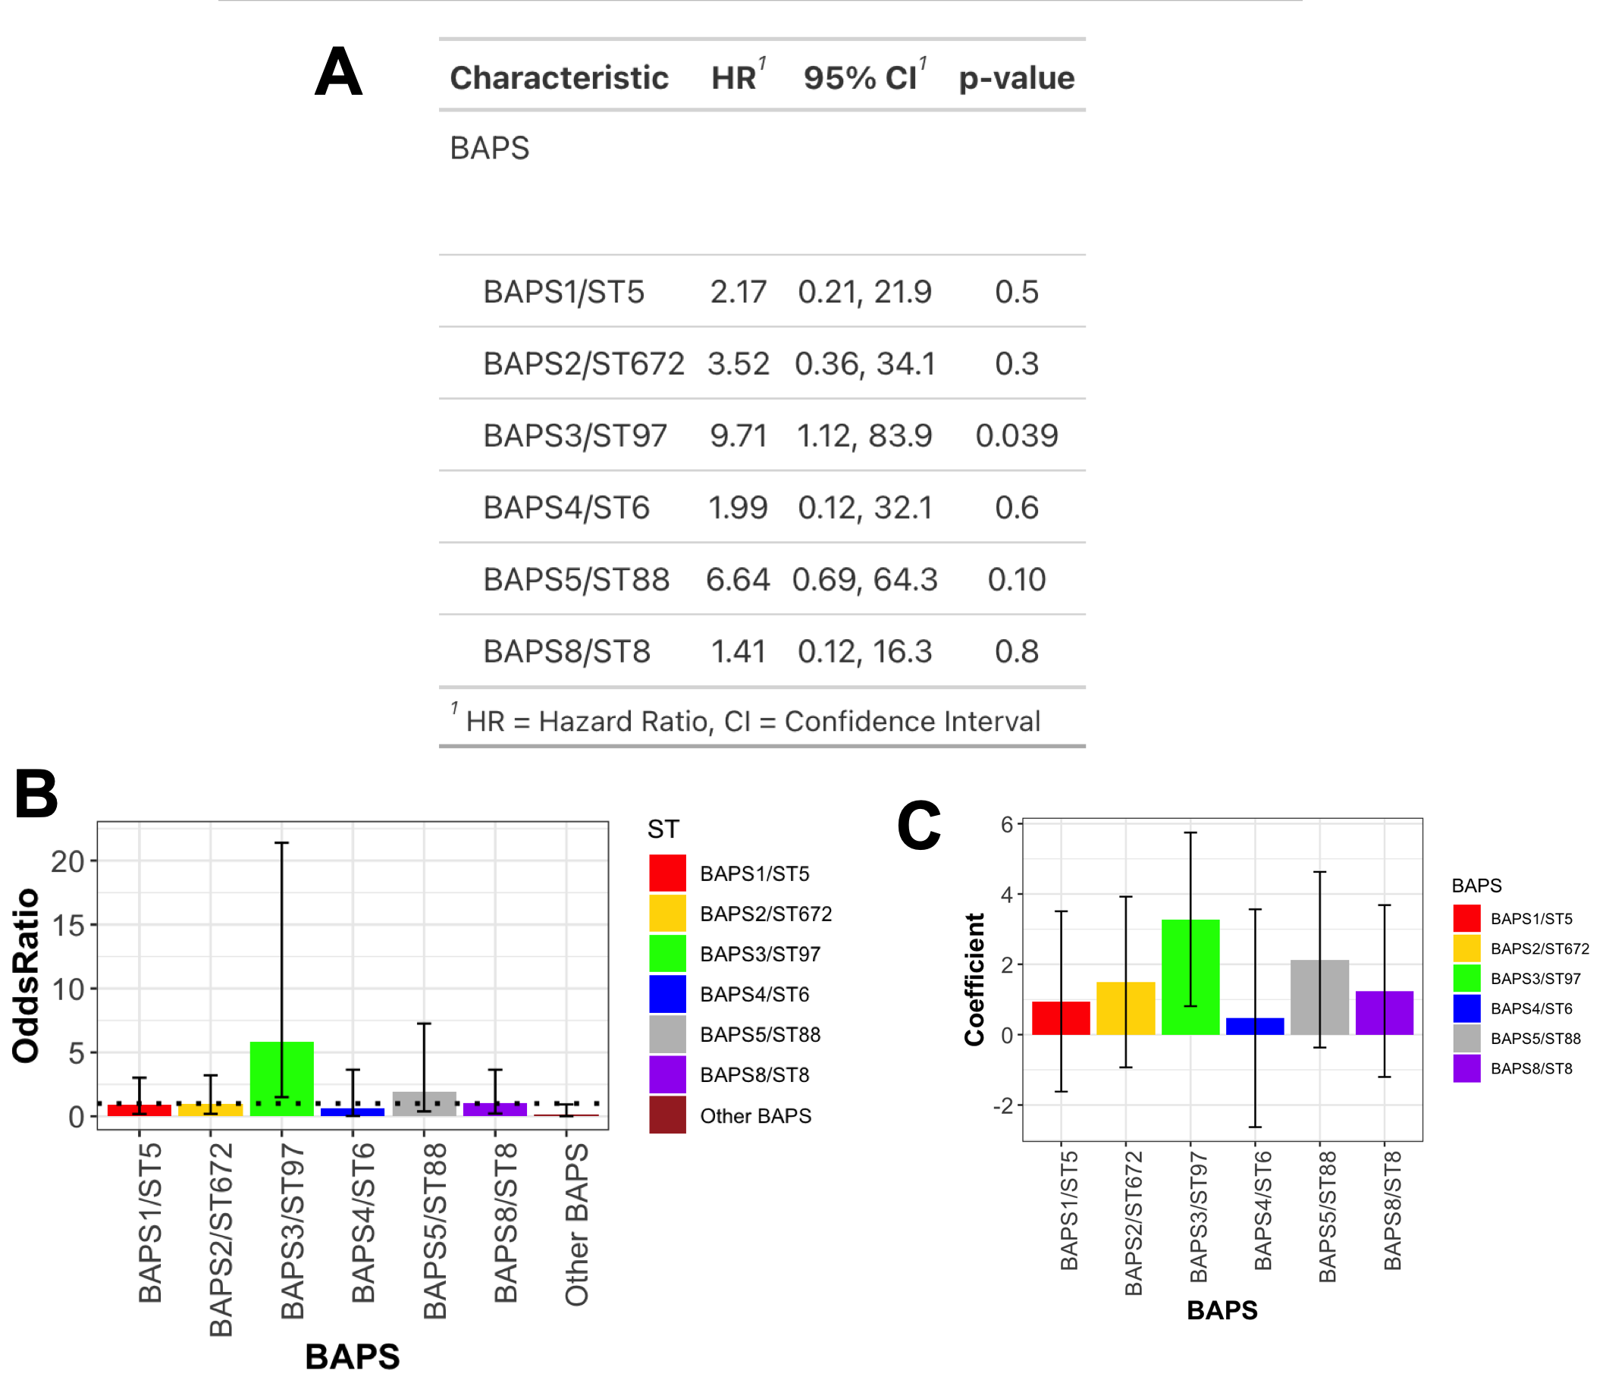
Figure S3 The association of the colonization by the clones and their links with in-hospital mortality. A) Cox regression model. The HR values greater and smaller than one correspond to the increased and decreased hazard of death. B) Odd-ratio values computed for major clones and other clones collectively. The dotted line show odds-ratio of one indicating no effect. C) Coefficients from logistic regression after accounting for the impact of age and infection source. The bars in B) and C) represent 95% confidence interval.

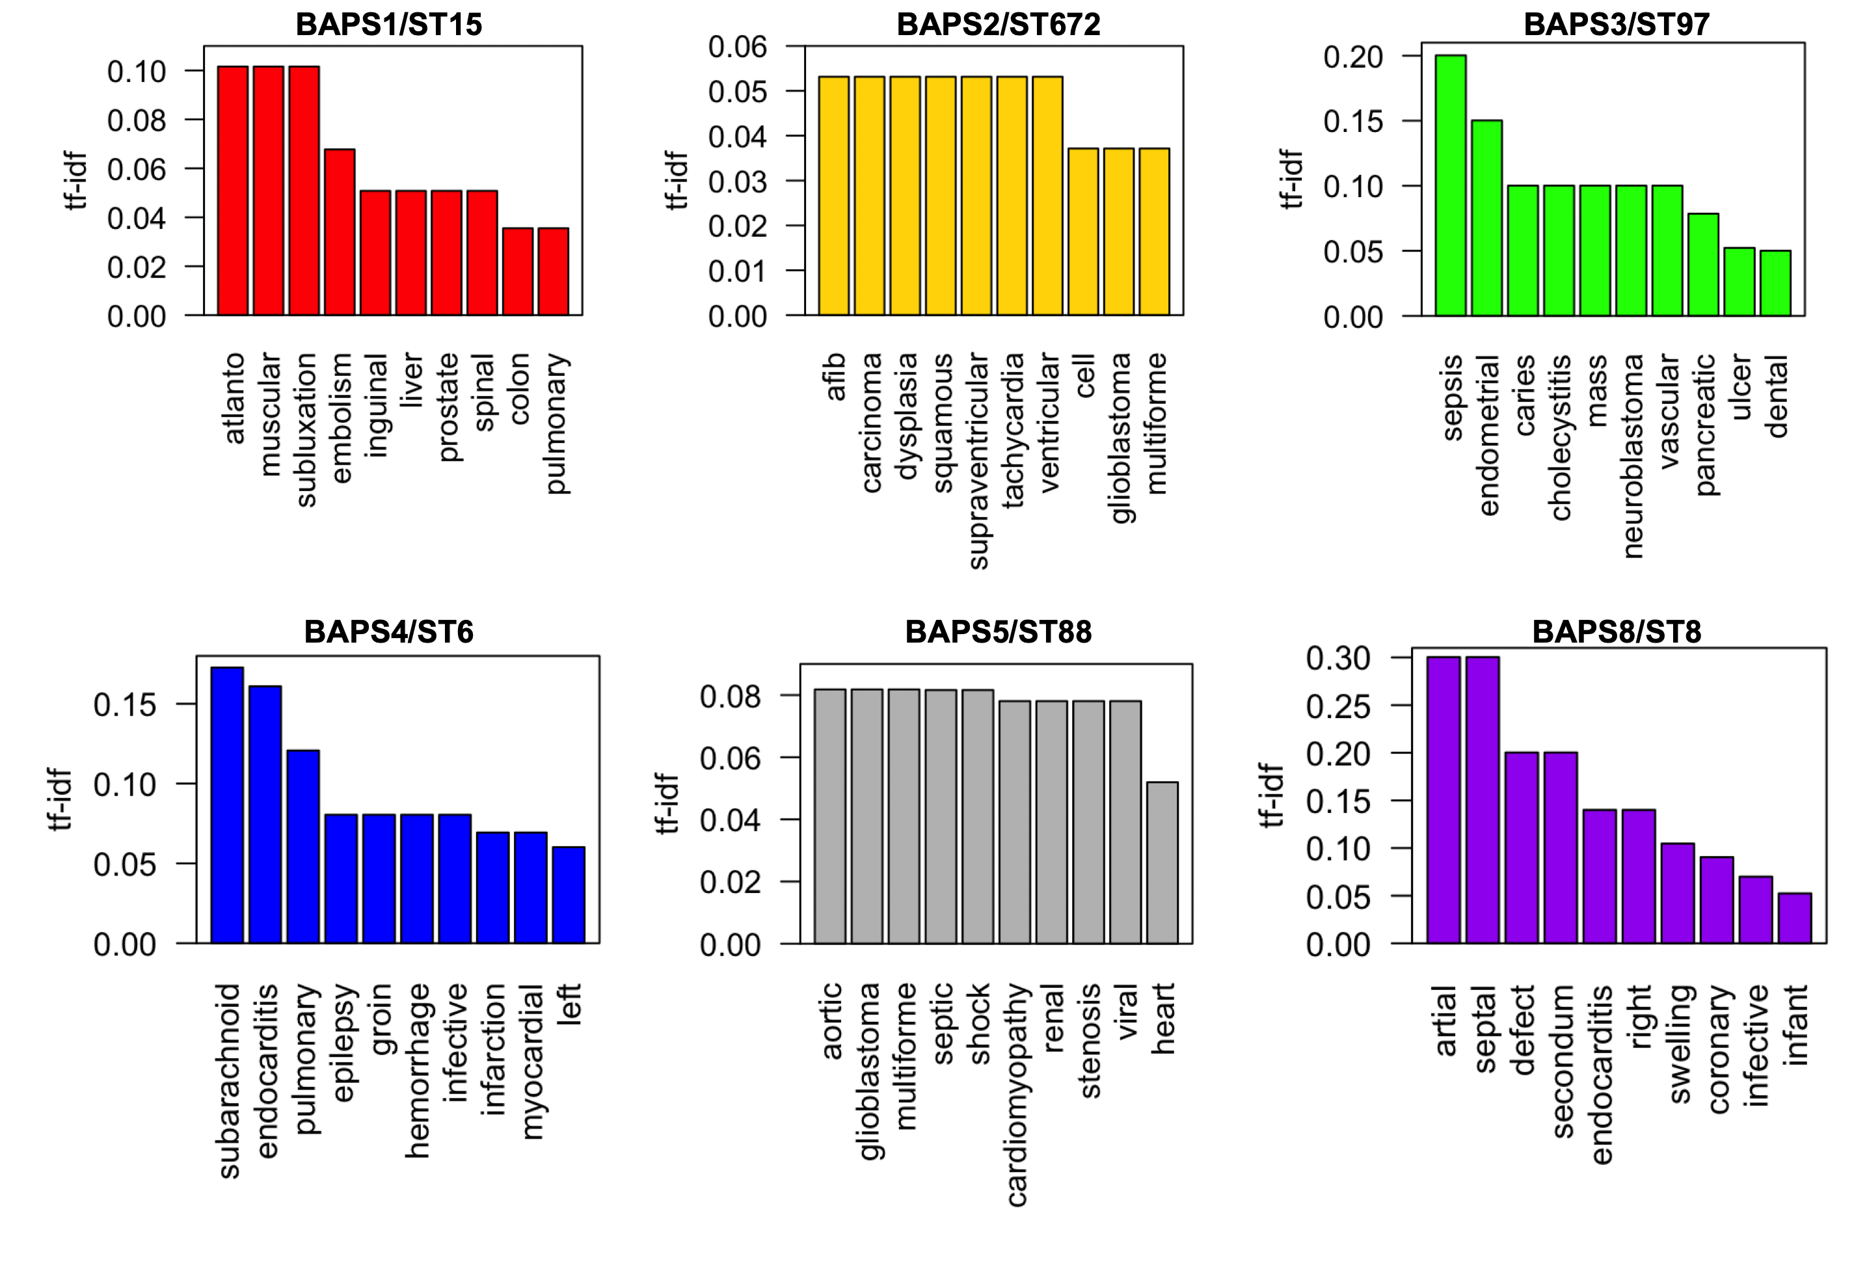
Figure S5 Importance of diagnostic terms in the corpus of patients’ diagnosed with the strains from different BAPS groups. Tf-IDF (Term Frequency - Inverse Document Frequency) values stands corresponds to how relevant the word is to a given corpus of the patients colonized by each BAPS strain.

