Graphical Abstract

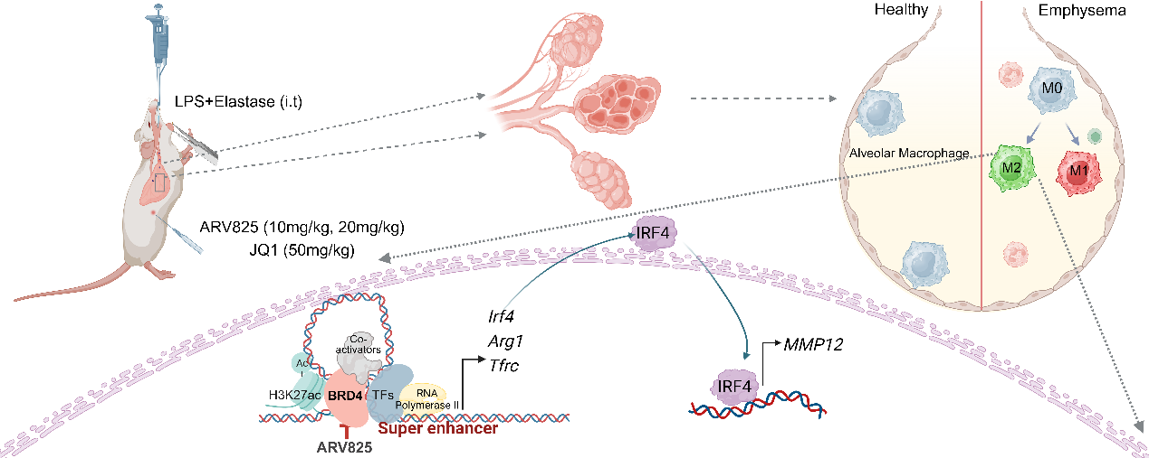
A diagram of the mechanism by which BRD4 mediated super-enhancer of IRF4 in M2 AMs
Graphic illustration showed targeting BRD4 in M2 polarized alveolar macrophages leads to the downregulation of MMP12 expression, resulting in the amelioration of experimental emphysema by disrupting the super-enhancer of IRF4.

