Supplementary Information

Production of NiMn₂O₄ Hollow Spheres and CoFe₂O₄ Bowl-like Structures by Using Block Copolymer Stabilized Polystyrene Spheres as a Hard Template

Gökhan KOCAK, Vural BÜTÜN*

Synthesis of PDPA-b-PDMA Diblock Copolymer with GTP
The synthesis of PDPA-b-PDMA diblock copolymer has been performed as follows using group transfer polymerization [1]: First, a 250 mL three-necked flask taken from the oven at 130 °C was placed on the vacuum line and heated with a heat gun and vacuumed in high vacuum. Solid tetra-n-butyl ammonium bibenzoate (TBABB) catalyst (approximately 100 mg) was added into the three-necked flask in the presence of dry nitrogen and vacuumed again. 160 mL of tetrahydrofuran (THF) as solvent and 0.55 mL of 1-methoxy-1-trimethylsiloxy-2-methyl-1-propene (MTS) as initiator, respectively, were transferred into the three-necked flask via cannula. After the initiator was activated by stirring the solution for 15 minutes, DPA monomer (10 mL), as first monomer, was added to the reaction medium to obtain the first block. In the meantime, the temperature change of the reaction medium was observed with a contact thermocouple attached to the surface of the balloon, and it was determined that the temperature increased by 4 °C with the exothermic polymerization. The polymer solution was stirred for 40 minutes at room temperature. At the end of 40 minutes, 1 mL of sample was taken from the medium for GPC and proton NMR analysis and was terminated with 0.1 mL of methanol. The second monomer, DMA (23 mL), was added to the reaction medium under nitrogen atmosphere via a cannula, just as in the first monomer addition. A second exotherm was observed (10 °C). The reaction was stirred at room temperature for about 1 hour and at the end of this period, polymerization was terminated by adding 1 mL of methanol to the reaction medium. GPC and proton NMR analyzes were performed by taking 1 mL sample. The solid polymer obtained by evaporating the polymer solution in a rotary evaporator was dried in the freeze dryer. Homopolymer residues were observed as a result of GPC. The polymer was dissolved in THF and precipitated in n-pentane to get rid of these residues. As can be seen from the GPC chromatograms of the homopolymer and diblock copolymer, polymers with very narrow molecular weight distribution (M_{w}/M_{n}) have been obtained and there is no homopolymer residue in the diblock copolymer (Figure S1). GPC result indicated the number average molecular weight (M_{n}) and molecular weight distribution value of the diblock copolymer to be 25500 g mol⁻¹ and 1.08, respectively.

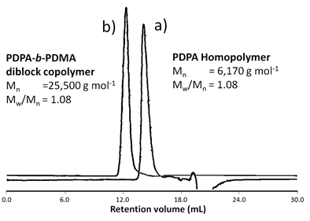
Figure S1. GPC chromatograms of PDPA homopolymer (a) and PDPA-b-PDMA diblock copolymer (b).

End group analysis was performed to determine the composition (in mol%) and polymerization degree (DP) of the PDPA-b-PDMA diblock copolymer. In the synthesis, first the PDPA block was produced, then the second monomer, DMA, was added and the ¹H NMR spectrum of the PDPA homopolymer was also taken just before addition of DMA monomer as given in Figure S2.

In order to determine comonomer ratios or mol percentages, the integral area of the isopropyl group C-H protons (c signal) of the PDPA at 2.94 ppm (see Figure S3) was compared with the integral area of the a+g signals of –C(=O)OCH₂- protons belonging to both PDPA and PDMA blocks in the range of 3.64-4.21 ppm (see Figure S3). The DPA and DMA contents of diblock copolymer were determined to be 16.7 mol% and 83.3 mol%, respectively. Thus the block copolymer was expressed as PDPA_{0.17}-b-PDMA_{0.83}. This polymer was soluble in water at room temperature. It is soluble molecularly in acidic solution but it forms micelles in neutral water or in basic conditions by PDPA block forming the micellar core.¹

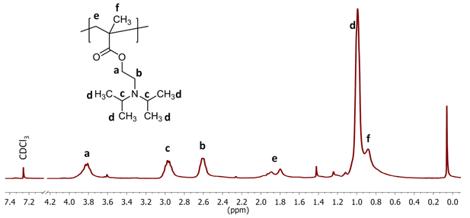
Figure S2. ¹H NMR spectrum of PDPA homopolymer in CDCl₃.

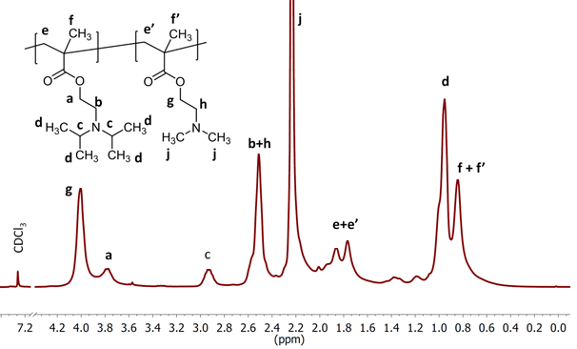
Figrue S3. ¹H NMR spectrum of PDPA-b-PDMA diblock copolymer in CDCl₃.

References
[1] V. Butun, S.P. Armes, N.C. Billingham, Synthesis and aqueous solution properties of near-monodisperse tertiary amine methacrylate homopolymers and diblock copolymers, Polymer 42(14) (2001) 5993-6008. https://doi.org/10.1016/s0032-3861(01)00066-0.

