Nutraceuticals and phytoceuticals in the treatment of schizophrenia: a systematic review and network meta-analysis
“Nutra NMA SCZ”

Michele FORNARO^{1#*}, Claudio CAIAZZA^{1#}, Martina BILLECI¹, Michael BERK², Wolfgang MARX³, Vicent BALANZá-MARTINEZ⁴, Michele De PRISCO⁵, Rosanna PEZONE¹, Giuseppe DE SIMONE^{1,6}, Niccolò SOLINI¹, Felice IASEVOLI^{1,6}, Fabrice BERNA⁷, Guillaume FOND⁸, Laurent BOYER⁸, Andre FèRRER CARVALHO⁹, Elena DRAGIOTI¹⁰; Jess G. FIERDOROWICZ^{11,12,13}, Andrea de BARTOLOMEIS^{1,6}, Christoph U. CORRELL^{14,15,16,17&}, Marco SOLMI^{11,12,13,17&}

1 Department of Neuroscience, Reproductive Sciences, and Dentistry, Section of Psychiatry. University School of Medicine Federico II, Naples, Italy.
2 Deakin University, IMPACT, the Institute for Mental and Physical Health and Clinical Translation Strategic Research Centre, School of Medicine, Geelong, VIC, Australia; Mental Health Drug and Alcohol Services, Barwon Health, Geelong, VIC, Australia; Orygen, The National Centre of Excellence in Youth Mental Health, Melbourne, VIC, Australia; Centre for Youth Mental Health, Florey Institute for Neuroscience and Mental Health, Melbourne, VIC, Australia; Department of Psychiatry, The University of Melbourne, Melbourne, VIC, Australia.
3 Deakin University, IMPACT (the Institute for Mental and Physical Health and Clinical Translation), Food & Mood Centre, Geelong, VIC, Australia.
4 Teaching Unit of Psychiatry and Psychological Medicine, La Fe University and Polytechnic Hospital, University of Valencia Medical School, Centro de Investigación Biomédica En Red de Salud Mental (CIBERSAM), Valencia, Spain.
5 Bipolar and Depressive Disorders Unit, Institute of Neuroscience, Hospital Clinic, University of Barcelona, IDIBAPS, CIBERSAM, 170 Villarroel st, 12-0, 08036, Barcelona, Catalonia, Spain.
6 Section of Psychiatry, Laboratory of Translational and Molecular Psychiatry and Unit of Treatment-Resistant Psychosis, Department of Neuroscience, Reproductive Sciences and Odontostomatology, University Medical School of Naples “Federico II,” Via Pansini 5, 80131 Naples, Italy.
7 Psychiatry, Strasbourg University Hospital, University of Strasbourg, Strasbourg, France.
8 Assistance Publique des Hôpitaux de Marseille, Aix-Marseille University, CEReSS-Health Service Research and Quality of Life Center, UR3279, 27 boulevard Jean -Moulin, 13005 Marseille, France; Fondation FondaMental, Créteil, France. Fondation FondaMental Fondation de coopération scientifique en santé mentale, Université Paris Est, Créteil, France.
9 Innovation in Mental and Physical Health and Clinical Treatment (IMPACT) Strategic Research Centre, School of Medicine, Barwon Health, Deakin University, Geelong, Victoria, Australia.
10 Pain and Rehabilitation Center, Department of Medicine and Health Sciences, Linköping University, Linköping, Sweden.
11 Department of Psychiatry, University of Ottawa, Ontario, Canada; Department of Mental Health, The Ottawa Hospital, Ontario, Canada.
12 Department of Mental Health, The Ottawa Hospital, Ottawa, Ontario, Canada.
13 Ottawa Hospital Research Institute, University of Ottawa, Ottawa, Ontario, Canada
14 Department of Psychiatry, Zucker Hillside Hospital, Northwell Health, Glen Oaks, NY, USA.
15 Department of Psychiatry and Molecular Medicine, Zucker School of Medicine at Hofstra/Northwell, Hempstead, NY, USA.
16 Center for Psychiatric Neuroscience, Feinstein Institute for Medical Research, Manhasset, NY, USA.
17 Department of Child and Adolescent Psychiatry, Charité Universitätsmedizin, Berlin, Germany.

#Joint co-first.

*Corresponding author: Michele Fornaro, MD, Ph.D. Address: via Pansini n.5, Ospedale Policlinico, Edificio 18, Psichiatria,

Appendix
Contents
Section 1 (S1) - Description of the search strategy 4
e-box 1. Hits fetched by different databases/registers. 12
Section 2 (S2) - Risk of Bias 13
Section 3 (S3) - Network plots, forest plots and cumulative rankings 17
Section 4 (S4) - League tables 52
Section 5 (S5) - Evaluation of heterogeneity and inconsistency 84
Section 6 (S6) - Evaluating confidence in NMA 86
6.1 CINeMA methods and reasoning 86
Section 7 (S7) - Amendments to the protocol 189
Section 8 (S8) - List of excluded studies after full-text assessment, with reason(s) 190
Section 9 (S9) - References 193
Section 10 (S10) - PRISMA NMA Checklist of Items to Include When Reporting A Systematic Review Involving a Network Meta-analysis 201

Section 1 (S1) - Description of the search strategy

PubMed (up until October 17th, 2023)
(((("psychosis"[Title/Abstract]) OR ("psychotic"[Title/Abstract])) OR (schizo*[Title/Abstract]))) AND ((((((((((((((((((((((((((((((((((((((((((((((((((((((((((((((((((((((((((((((((((((((((((((((((((((((((((((((((vitamin*[Title/Abstract]) OR (mineral*[Title/Abstract])) OR (nutrient*[Title/Abstract])) OR (food supplement*[Title/Abstract])) OR (meal replacement*[Title/Abstract])) OR (nutritional supplement*[Title/Abstract])) OR (health supplement*[Title/Abstract])) OR (multivitamin*[Title/Abstract])) OR ("omega 3"[Title/Abstract])) OR (fish oil*[Title/Abstract])) OR ("alpha lipoic acid"[Title/Abstract])) OR ("alpha linolenic acid"[Title/Abstract])) OR ("alpha linoleic acid"[Title/Abstract])) OR ("eicosapentaenoic"[Title/Abstract])) OR ("docosahexaenoic"[Title/Abstract])) OR (fatty acid*[Title/Abstract])) OR (amino acid*[Title/Abstract])) OR ("taurine"[Title/Abstract])) OR ("sadenosylmethionine"[Title/Abstract])) OR ("creatine"[Title/Abstract])) OR ("acetylcysteine"[Title/Abstract])) OR ("cysteine"[Title/Abstract])) OR (probiotic*[Title/Abstract])) OR (prebiotic*[Title/abstract])) OR (psychobiotic*[Title/Abstract])) OR (postbiotic*[Title/Abstract])) OR (synbiotic*[Title/abstract])) OR ("tryptophan"[Title/Abstract])) OR ("tocopherol"[Title/Abstract])) OR ("alphatocopherol"[Title/Abstract])) OR ("carotene"[Title/Abstract])) OR ("retinol"[Title/Abstract])) OR ("thiamine"[Title/Abstract])) OR ("riboflavin"[Title/Abstract])) OR ("niacin"[Title/Abstract])) OR ("niacinamide"[Title/Abstract])) OR ("nicotinic acid"[Title/Abstract])) OR ("pantothenic"[Title/Abstract])) OR (pyridox*[Title/Abstract])) OR ("biotin"[Title/Abstract])) OR ("methylfolate"[Title/Abstract])) OR (5-MTH*[Title/Abstract])) OR ("levomefolic acid"[Title/Abstract])) OR ("folate"[Title/Abstract])) OR ("folinic acid"[Title/Abstract])) OR ("folic acid"[Title/Abstract])) OR ("inositol"[Title/Abstract])) OR ("cyanocobalamin"[Title/Abstract])) OR ("methylcobalamin"[Title/Abstract])) OR ("cobalamin"[Title/Abstract])) OR ("ascorbic acid"[Title/Abstract])) OR ("cholecalciferol"[Title/Abstract])) OR ("iron"[Title/Abstract])) OR ("ferrous"[Title/Abstract])) OR ("tocopherols"[Title/Abstract])) OR ("trace element"[Title/Abstract])) OR ("calcium"[Title/Abstract])) OR ("phosphorus"[Title/Abstract])) OR ("magnesium"[Title/Abstract])) OR ("potassium"[Title/Abstract])) OR ("manganese"[Title/Abstract])) OR ("zinc"[Title/Abstract])) OR ("selenium"[Title/Abstract])) OR ("boron"[Title/Abstract])) OR ("chromium"[Title/Abstract])) OR ("lycopene"[Title/Abstract])) OR (isoflav*[Title/Abstract])) OR (flavonoid*[Title/Abstract])) OR (bioflavonoid*[Title/Abstract])) OR ("micronutrient"[Title/Abstract])) OR ("carnitine"[Title/Abstract])) OR ("herbal"[Title/Abstract])) OR ("herbal medicine"[Title/Abstract])) OR ("plant medicine"[Title/Abstract])) OR ("phytomedicine"[Title/Abstract])) OR ("supplement"[Title/Abstract])) OR ("st john s worth"[Title/Abstract])) OR ("kava"[Title/Abstract])) OR ("ginseng"[Title/Abstract])) OR ("saffron"[Title/Abstract])) OR ("curcumin"[Title/Abstract])) OR ("valerian"[Title/Abstract])) OR ("ginkgo"[Title/Abstract])) OR ("rhodiola"[Title/Abstract])) OR ("bacopa monniera"[Title/Abstract])) OR ("centella asiatica"[Title/Abstract])) OR ("crocus sativus"[Title/Abstract])) OR ("curcuma longa"[Title/Abstract])) OR ("hypericum perforatum"[Title/Abstract])) OR ("galphimia"[Title/Abstract])) OR ("ginkgo biloba"[Title/Abstract])) OR ("lavandula"[Title/Abstract])) OR ("matricaria"[Title/Abstract])) OR ("panax ginseng"[Title/Abstract])) OR ("passiflora incarnata"[Title/Abstract])) OR ("piper methysticum"[Title/Abstract])) OR ("rhodiola rosea"[Title/Abstract])) OR ("valeriana"[Title/Abstract])) OR ("withania somnifera"[Title/Abstract])) OR ("melissa officinalis"[Title/Abstract])) OR ("sarsasapogenin"[Title/Abstract])) OR ("mangosteen"[Title/Abstract])) OR ("scutellaria"[Title/Abstract])) OR ("silexan"[Title/Abstract])) OR ("citicoline"[Title/Abstract])) OR ("coenzyme q10"[Title/Abstract])) OR ("theanine"[Title/Abstract])) OR ("sarcosine"[Title/Abstract])) OR ("d serine"[Title/Abstract])) OR ("glycine"[Title/Abstract])) OR ("d alanine"[Title/Abstract])) OR ("lysine"[Title/Abstract])) Filters: Clinical Trial, Randomized Controlled Trial
Number of retrieved references: 518

Cochrane Central (Trials) (up until October 17th, 2023)
#1 (schizo* OR psycho*):ti,ab,kw 186,195
#2 vitamin OR mineral OR nutrient OR supplement OR "omega 3" OR oil OR "alpha lipoic" OR linolenic OR eicosapentaenoic OR docosahexaenoic OR "fatty acid" OR aminoacid OR taurine OR sadenosylmethionine OR creatine OR acetylcysteine OR cysteine OR probiotic OR prebiotic OR psychobiotic OR postbiotic OR synbiotic OR tryptophan OR tocopherol OR alphatocopherol OR carotene OR retinol OR thiamine OR riboflavin OR niacin OR niacinamide OR nicotinic acid OR pantothenic OR pyridoxine OR biotin OR methylfolate OR folate OR folinic OR folic OR inositol OR cyanocobalamin OR methylcobalamin OR cobalamin OR ascorbic OR cholecalciferol OR iron OR ferrous OR tocopherol OR "trace elements" OR calcium OR phosphorus OR magnesium OR potassium OR manganese OR zinc OR selenium OR boron OR chromium OR lycopene OR isoflavonoid OR flavonoid OR bioflavonoid OR micronutrient OR carnitine OR herbal OR phytomedicine OR supplement OR "st john worth" OR kava OR ginseng OR saffron OR curcumin OR valerian OR ginkgo OR rhodiola OR "bacopa monnieri" OR centella OR "crocus sativus" OR curcuma OR "hypericum perforatum" OR galphimia OR "ginkgo biloba" OR lavandula OR matricaria OR ginseng OR passiflora OR "piper methysticum" OR rhodiola OR valeriana OR withania OR melissa OR sarsasapogenin OR mangosteen OR scutellaria OR silexan OR citicoline OR "coenzyme q10" OR theanine OR sarcosine OR "d serine" OR glycine OR "d alanine" OR lysine 231,187
#3 random OR randomized OR controlled OR placebo 2,056,708
#4 #1 AND #2 AND #3
Number of retrieved references: 10,563

ClinicalTrial.gov (up until October 17th, 2023)
Studies With Results | Interventional Studies | schizophrenia OR psychosis | dietary supplement OR herbal OR phytoceutical OR nutraceutical OR fatty acid OR vitamin OR trace element OR amino acid OR probiotic OR prebiotic
Number of retrieved references: 27

EMBASE (up until October 17th, 2023)
(schizophrenia:ti,ab,kw OR psychosis:ti,ab,kw) AND (vitamin:ti,ab,kw OR mineral:ti,ab,kw OR nutrient:ti,ab,kw OR 'omega 3':ti,ab,kw OR oil:ti,ab,kw OR 'alpha lipoic':ti,ab,kw OR linolenic:ti,ab,kw OR eicosapentaenoic:ti,ab,kw OR docosahexaenoic:ti,ab,kw OR 'fatty acid':ti,ab,kw OR aminoacid:ti,ab,kw OR taurine:ti,ab,kw OR sadenosylmethionine:ti,ab,kw OR creatine:ti,ab,kw OR acetylcysteine:ti,ab,kw OR cysteine:ti,ab,kw OR probiotic:ti,ab,kw OR prebiotic:ti,ab,kw OR psychobiotic:ti,ab,kw OR postbiotic:ti,ab,kw OR synbiotic:ti,ab,kw OR tryptophan:ti,ab,kw OR alphatocopherol:ti,ab,kw OR carotene:ti,ab,kw OR retinol:ti,ab,kw OR thiamine:ti,ab,kw OR riboflavin:ti,ab,kw OR niacin:ti,ab,kw OR niacinamide:ti,ab,kw OR 'nicotinic acid':ti,ab,kw OR pantothenic:ti,ab,kw OR pyridoxine:ti,ab,kw OR biotin:ti,ab,kw OR methylfolate:ti,ab,kw OR folate:ti,ab,kw OR folinic:ti,ab,kw OR folic:ti,ab,kw OR inositol:ti,ab,kw OR cyanocobalamin:ti,ab,kw OR methylcobalamin:ti,ab,kw OR cobalamin:ti,ab,kw OR ascorbic:ti,ab,kw OR cholecalciferol:ti,ab,kw OR iron:ti,ab,kw OR ferrous:ti,ab,kw OR tocopherol:ti,ab,kw OR 'trace elements':ti,ab,kw OR calcium:ti,ab,kw OR phosphorus:ti,ab,kw OR magnesium:ti,ab,kw OR potassium:ti,ab,kw OR manganese:ti,ab,kw OR zinc:ti,ab,kw OR selenium:ti,ab,kw OR boron:ti,ab,kw OR chromium:ti,ab,kw OR lycopene:ti,ab,kw OR isoflavonoid:ti,ab,kw OR flavonoid:ti,ab,kw OR bioflavonoid:ti,ab,kw OR micronutrient:ti,ab,kw OR carnitine:ti,ab,kw OR herbal:ti,ab,kw OR phytomedicine:ti,ab,kw OR supplement:ti,ab,kw OR 'st john worth':ti,ab,kw OR kava:ti,ab,kw OR saffron:ti,ab,kw OR curcumin:ti,ab,kw OR valerian:ti,ab,kw OR ginkgo:ti,ab,kw OR 'bacopa monnieri':ti,ab,kw OR centella:ti,ab,kw OR 'crocus sativus':ti,ab,kw OR curcuma:ti,ab,kw OR 'hypericum perforatum':ti,ab,kw OR galphimia:ti,ab,kw OR 'ginkgo biloba':ti,ab,kw OR lavandula:ti,ab,kw OR matricaria:ti,ab,kw OR ginseng:ti,ab,kw OR passiflora:ti,ab,kw OR 'piper methysticum':ti,ab,kw OR rhodiola:ti,ab,kw OR valeriana:ti,ab,kw OR withania:ti,ab,kw OR melissa:ti,ab,kw OR sarsasapogenin:ti,ab,kw OR mangosteen:ti,ab,kw OR scutellaria:ti,ab,kw OR silexan:ti,ab,kw OR citicoline:ti,ab,kw OR 'coenzyme q10':ti,ab,kw OR theanine:ti,ab,kw OR sarcosine:ti,ab,kw OR 'd serine':ti,ab,kw OR glycine:ti,ab,kw OR 'd alanine':ti,ab,kw OR lysine:ti,ab,kw) AND (random:ti,ab,kw OR randomized:ti,ab,kw OR controlled:ti,ab,kw OR placebo:ti,ab,kw) Number of retrieved references: 1,139

Scopus (up until October 17th, 2023)
#1: ( TITLE-ABS-KEY ( schizophrenia OR psychosis OR psychotic )
319,747 results
#2: TITLE-ABS-KEY ( nutraceutical OR phytoceutical OR nutrient OR vitamin OR mineral OR nutritional OR dietary OR omega 3 fatty OR omega 6 fatty OR eicosapentaenoic OR docosahexaenoic OR fatty AND acid OR thioctic OR linolenic OR linoleic OR aminoacid OR taurine OR ademetionine OR creatine OR acetylcysteine OR cysteine OR probiotic OR probiotic OR psychobiotic OR synbiotic OR tryptophan OR tocopherol OR retinol OR thiamine OR carotene OR riboflavin OR nicotinic OR biotin OR methylfolate OR folic OR folate OR pantothenic OR pyridoxine OR inositol OR cyanocobalamin OR mecobalamin OR cobalamin OR ascorbic OR cholecalciferol OR iron OR ferrous OR phosphorus OR magnesium OR calcium OR zinc OR chromium OR potassium OR boron OR lycopene OR selenium OR flavonoid OR bioflavonoid OR carnitine OR herbal OR plant OR saffron OR crocus OR ginseng OR curcumin OR ginkgo OR rhodiola OR bacopa OR centella OR curcuma OR hypericum OR passiflora OR matricaria OR lavender OR valeriana OR withania OR scutellaria OR melissa OR citicoline OR theanine OR ubiquinone OR kava OR mangosteen OR silexan OR sarcosine OR glycine OR D-serine OR D-alanine OR lysine )
29,852 results
#3: TITLE-ABS-KEY ( randomized OR randomised OR controlled AND trial )
1,517,574 results
#4: #1 AND #2 AND #3
( TITLE-ABS-KEY ( schizophrenia OR psychosis OR psychotic ) AND TITLE-ABS-KEY ( nutraceutical OR phytoceutical OR nutrient OR vitamin OR mineral OR nutritional OR dietary OR omega 3 fatty OR omega 6 fatty OR icosapentaenoic OR docosahexaenoic OR fatty AND acid OR thioctic OR linolenic OR linoleic OR aminoacid OR taurine OR ademetionine OR creatine OR acetylcysteine OR cysteine OR probiotic OR probiotic OR psychobiotic OR synbiotic OR tryptophan OR tocopherol OR retinol OR thiamine OR carotene OR riboflavin OR nicotinic OR biotin OR methylfolate OR folic OR folate OR pantothenic OR pyridoxine OR inositol OR cyanocobalamin OR mecobalamin OR cobalamin OR ascorbic OR cholecalciferol OR iron OR ferrous OR phosphorus OR magnesium OR calcium OR zinc OR chromium OR potassium OR boron OR lycopene OR selenium OR flavonoid OR bioflavonoid OR carnitine OR herbal OR plant OR saffron OR crocus OR ginseng OR curcumin OR ginkgo OR rhodiola OR bacopa OR centella OR curcuma OR hypericum OR passiflora OR matricaria OR lavender OR valeriana OR withania OR scutellaria OR melissa OR citicoline OR theanine OR ubiquinol OR kava OR mangosteen OR silexan OR sarcosine OR glycine OR d-serine OR d-alanine OR lysine ) AND TITLE-ABS-KEY ( randomized OR randomised OR controlled AND trial ) )
Number of retrieved references: 73.
PsycInfo (up until October 17th, 2023)
#1: AB (schizophrenia OR psychosis OR psychotic)
154,366 results
#2: AB (nutraceuticals OR phytoceuticals OR nutrients OR polyunsaturated fatty acids OR vitamins OR amino acids OR minerals OR trace element OR probiotics OR prebiotics OR herbal OR curcumin OR curcuma OR mangosteen OR food supplement OR nutritional supplement OR multivitamin OR omega 3 OR alpha lipoic acid OR alpha linolenic acid OR alpha linoleic acid OR eicosapentaenoic OR docosahexaenoic OR taurine OR sadenosylmethionine OR creatine OR acetylcysteine OR cysteine OR psychobiotics OR postbiotics OR synbiotic OR tryptophan OR tocopherol OR retinol OR thiamine OR riboflavin OR niacin OR niacinamide OR nicotinic acid OR pantothenic OR pyridoxine OR biotin OR methylfolate OR 5-MTH OR levomefolic acid OR folate OR folic acid OR inositol OR cyanocobalamin OR methylcobalamin OR cobalamin OR ascorbic acid OR vitamin D OR iron OR tocopherols OR calcium OR phosphorus OR amagnesium OR potassium OR manganese OR zinc OR selenium OR boron OR chromium OR lycopene OR flavonoids OR micronutrient OR carnitine OR st john s worth OR kava OR ginseng OR saffron OR ginkgo OR rhodiola OR bacopa monniera OR centella asiatica OR crocus sativus OR curcuma longa OR hypericum perforatum OR galphimia OR ginkgo biloba OR lavandula OR matricaria OR panax ginseng OR passiflora incarnata OR piper methysticum OR rhodiola rosea OR valeriana OR withania somnifera OR melissa officinalis OR sarsasapogenin OR scutellaria OR silexan OR citicoline OR sarcosine OR glycine OR D-serine OR D-alanine OR lysine OR coenzyme q10 OR theanine OR yokukansan)
63,110 results
#3: AB (randomized OR randomised OR controlled)
170,196 results
#4: #1 AND #2 AND #3
AB (schizophrenia OR psychosis OR psychotic) AND AB (nutraceuticals OR phytoceuticals OR nutrients OR polyunsaturated fatty acids OR vitamins OR amino acids OR minerals OR trace element OR probiotics OR prebiotics OR herbal OR curcumin OR curcuma OR mangosteen OR food supplement OR nutritional supplement OR multivitamin OR omega 3 OR alpha lipoic acid OR alpha linolenic acid OR alpha linoleic acid OR eicosapentaenoic OR docosahexaenoic OR taurine OR sadenosylmethionine OR creatine OR acetylcysteine OR cysteine OR psychobiotics OR postbiotics OR synbiotic OR tryptophan OR tocopherol OR retinol OR thiamine OR riboflavin OR niacin OR niacinamide OR nicotinic acid OR pantothenic OR pyridoxine OR biotin OR methylfolate OR 5-MTH OR levomefolic acid OR folate OR folic acid OR inositol OR cyanocobalamin OR methylcobalamin OR cobalamin OR ascorbic acid OR vitamin D OR iron OR tocopherols OR calcium OR phosphorus OR amagnesium OR potassium OR manganese OR zinc OR selenium OR boron OR chromium OR lycopene OR flavonoids OR micronutrient OR carnitine OR st john s worth OR kava OR ginseng OR saffron OR ginkgo OR rhodiola OR bacopa monniera OR centella asiatica OR crocus sativus OR curcuma longa OR hypericum perforatum OR galphimia OR ginkgo biloba OR lavandula OR matricaria OR panax ginseng OR passiflora incarnata OR piper methysticum OR rhodiola rosea OR valeriana OR withania somnifera OR melissa officinalis OR sarsasapogenin OR scutellaria OR silexan OR citicoline OR sarcosine OR glycine OR D-serine OR D-alanine OR lysine OR coenzyme q10 OR theanine OR yokukansan) AND AB (randomized OR randomised OR controlled)
Number of retrieved references: 357.

e-box 1. Hits fetched by different databases/registers.
Databases, trial registers, and other sources |  | Citations
Databases:
PubMed |  | 527
Cochrane CENTRAL |  | 10,563
EMBASE |  | 1,139
PsycINFO | 357
Scopus | 73
Total (databases) |  | 12,659
Trial registers:
ClinicalTrials.gov |  | 27
Total (trial registers) | 27
Other sources (citation searching): | 67
Total hits: |  | 12,753

Section 2 (S2) - Risk of Bias
e-table 1: Risk of Bias (RoB2) of the included studies.

Study | Intervention1 | Intervention2 | D1 | D2 | D3 | D4 | D5 | Overall
Atmaca M et al., 2005 | GINKGO+TAU | PBO+TAU | + | + | + | ? | + | !
Berk M et al., 2008 | NAC+TAU | PBO+TAU | + | + | + | + | + | +
Breier A et al., 2018 | NAC+TAU | PBO+TAU | + | + | + | + | + | +
Chen EYH et al., 2011 | GINS+TAU | PBO+TAU | + | + | + | + | + | +
Chengappa KNR et al., 2018 | WSE+TAU | PBO+TAU | + | + | + | + | + | +
D'Souza DC et al., 2013 | D-SER+TAU | PBO+TAU | — | + | + | + | + | —
Dakhale GN et al., 2005 | vitC+TAU | PBO+TAU | + | + | + | — | + | —
Dickerson F et al., 2021 | SULFO+TAU | PBO+TAU | + | — | — | + | + | —
Doruk A et al., 2008 | GINK+TAU | PBO+TAU | — | — | + | + | + | —
Emsley R et al., 2014 | OMEGA3-alphaLA | PBO | + | + | + | + | + | +
Emsley R et al., 2002 | EPA+TAU | PBO+TAU | + | + | + | + | + | +
Evins AE et al., 2000 | GLY+TAU | PBO+TAU | + | + | + | + | + | +
Farokhnia M et al., 2013 | NAC+TAU | PBO+TAU | + | + | + | + | + | +
Fenton W et al., 2001 | EPA+TAU | PBO+TAU | + | + | + | + | + | +
Ghaderi A et al., 2019 | vitD3PROB+TAU | PBO+TAU | ? | + | + | + | + | !
Heresco-Levy U et al., 2004 | D-SER+TAU | PBO+TAU | + | + | + | + | + | +
Hill M et al., 2011 | FOL+TAU | PBO+TAU | + | ? | + | + | + | !
Hosseininasab M et al., 2021 | nCURC+TAU | PBO+TAU | + | — | + | + | + | —
Jamilian H et al., 2014 | OMEGA3+TAU | PBO+TAU | + | ? | ? | + | + | !
Jamilian H et al., 2021 | SELPROB+TAU | PBO+TAU | + | — | ? | + | + | —
Krivoy A et al., 2017 | vitD+TAU | PBO+TAU | + | + | + | + | + | +
Lane H-Y et al., 2005 | SARCO+TAU, D-SER+TAU | PBO+TAU | + | ? | + | + | + | !
Lane H-Y et al., 2006 | SARCO+TAU | PBO+TAU | + | + | + | + | + | +
Lane H-Y et al., 2010 | SARCO+TAU, D-SER+TAU | PBO+TAU | + | + | + | + | + | +
Lin C-Y et al., 2015 | SARCO+TAU, SARCO+BEN+TAU | PBO+TAU | + | — | + | + | + | +
Miodownik C et al., 2019 | CURC+TAU | PBO+TAU | + | + | + | + | + | +
Miyaoka T et al., 2014 | YOKU+TAU | PBO+TAU | + | + | + | + | + | +
Ghajar A et al., 2017 | CITI+TAU | PBO+TAU | + | + | + | + | + | +
Pawelczyk T et al., 2016 | OMEGA3+TAU | PBO+TAU | + | + | + | + | + | +
Peet M et al., 2001a | EPA+TAU, DHA+TAU | PBO+TAU | + | — | + | + | + | —
Peet M et al., 2002 | EPA+TAU | PBO+TAU | + | + | + | + | + | +
Ritsner MS et al., 2010 | L-THEA+TAU | PBO+TAU | + | + | + | + | + | +
Roffman JL et al., 2013 | FOLB12+TAU | PBO+TAU | + | + | + | + | + | +
Roffman JL et al., 2017 | L-METFOL+TAU | PBO+TAU | + | + | + | + | + | +
Sephermanesh Z et al., 2016 | NAC+TAU | PBO+TAU | ? | — | + | + | + | —
Serrita J et al., 2018 | GLY+TAU | PBO+TAU | + | + | + | ? | + | !
Strzelecki D et al., 2018 | SARCO+TAU | PBO+TAU | + | + | + | ? | + | +
Tang W et al., 2020 | OMEGA3+TAU | PBO+TAU | + | — | + | — | + | —
Tsai GE et al., 2004 | SARCO+TAU | PBO+TAU | + | + | + | + | + | +
Tsai GE et al., 2005 | D-ALA+TAU | PBO+TAU | + | ? | + | + | + | !
Tsai GE et al., 1999 | D-SER+TAU | PBO+TAU | ? | + | + | ? | + | !
Xiao S-H et al., 2012 | CERLYS+TAU | PBO+TAU | + | — | + | + | + | —
Xiao S-F et al., 2011 | SARSA+TAU | PBO+TAU | ? | — | + | — | + | —
Zeinoddini A et al., 2014 | L-LYS+TAU | PBO+TAU | + | + | + | + | + | +
Zhang X-Y et al., 2000 | GINKGO+TAU | PBO+TAU | + | + | + | + | ? | !
Buchanan RW et al., 2007 | GLY+TAU, D-CYCL+TAU | PBO+TAU | + | + | + | + | + | +
Qiao X et al., 2020 | OMEGA3+TAU | PBO+TAU | + | — | ? | + | + | —
Sheikmoonesi F et al.,2016 | vitD3+TAU | PBO+TAU | — | — | ? | + | + | —
Turner A et al., 2020 | MANG+TAU | PBO+TAU | + | + | + | + | + | +
Levine et al., 2006 | FOL+PYR+B12+TAU | PBO+TAU | + | + | + | + | ? | !

e-box 2. RoB 2 Legend

D1 | Randomization process
D2 | Deviations from the intended interventions
D3 | Missing outcome data
D4 | Measurement of the outcome
D5 | Selection of the reported result

+ | Low risk
! | Some concerns
- | High risk

Section 3 (S3) - Network plots, forest plots and cumulative rankings

Legend. CERLYS=Cerebrolysin; CITI=Citicoline; CURC=Curcumin; D-ALA=D-Alanine; DHA=Docosahexaenoic acid; D-SER=D-Serine; EPA=Eicosapentaenoic acid; FOL=Folate; FOLB12=Folates+Vitamin B12; GINKGO=Ginkgo Biloba; GINS=Ginseng extract; GLY=Glycine; L-LYS=L-Lysine; L-THEA=L-Theanine; MANG=Mangosteen; NAC=N-Acetylcysteine; O3MIX=Omega 3 admixture; PBO=Placebo; WSE=Whitania Somnifera Extract; SARCO=Sarcosine; SARCO+BEN=Sarcosine+Sodium Benzoate; SARSA=Sarsasapogenin; SULFO=Sulforaphane; VitD=Vitamin D; vitdPROB=Vitamin D+Probiotics; YOKU=Yokukansan.
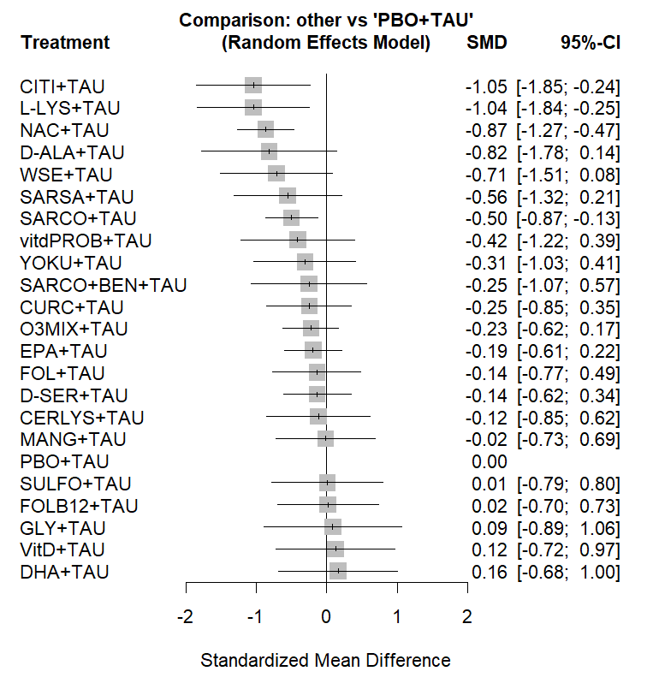
e-figure 1. Network plot and cumulative ranking of nutraceuticals and phytoceuticals for change in PANSS total symptomatology, all studies. SUCRA is intended to present the molecules ranked from the most effective to the least effective agent for schizophrenia-specific total symptomatology reduction.
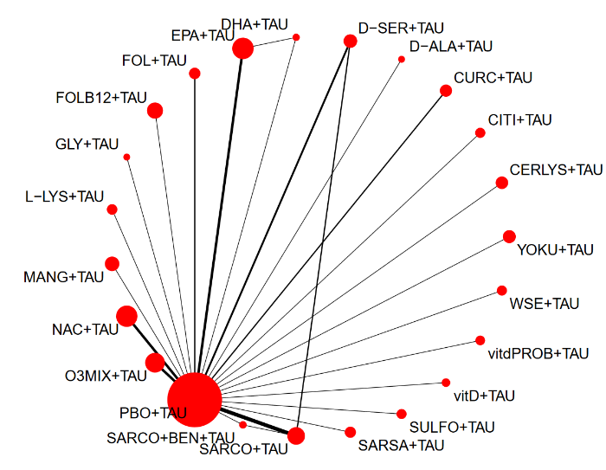
SUCRA
CITI+TAU | 0.8861
L-LYS+TAU | 0.886
NAC+TAU | 0.8616
D-ALA+TAU | 0.7846
WSE+TAU | 0.7491
SARCO+TAU | 0.6795
SARSA+TAU | 0.6632
vitdPROB+TAU | 0.5705
YOKU+TAU | 0.5073
CURC+TAU | 0.4675
O3MIX+TAU | 0.4585
SARCO+BEN+TAU | 0.4555
EPA+TAU | 0.433
CERLYS+TAU | 0.3947
FOL+TAU | 0.3946
D-SER+TAU | 0.3931
MANG+TAU | 0.3253
SULFO+TAU | 0.3074
FOLB12+TAU | 0.2908
GLY+TAU | 0.272
PBO+TAU | 0.258
VitD+TAU | 0.2436
DHA+TAU | 0.2181

e-figure 2. Funnel plot for change in schizophrenia PANSS total symptomatology, all studies.
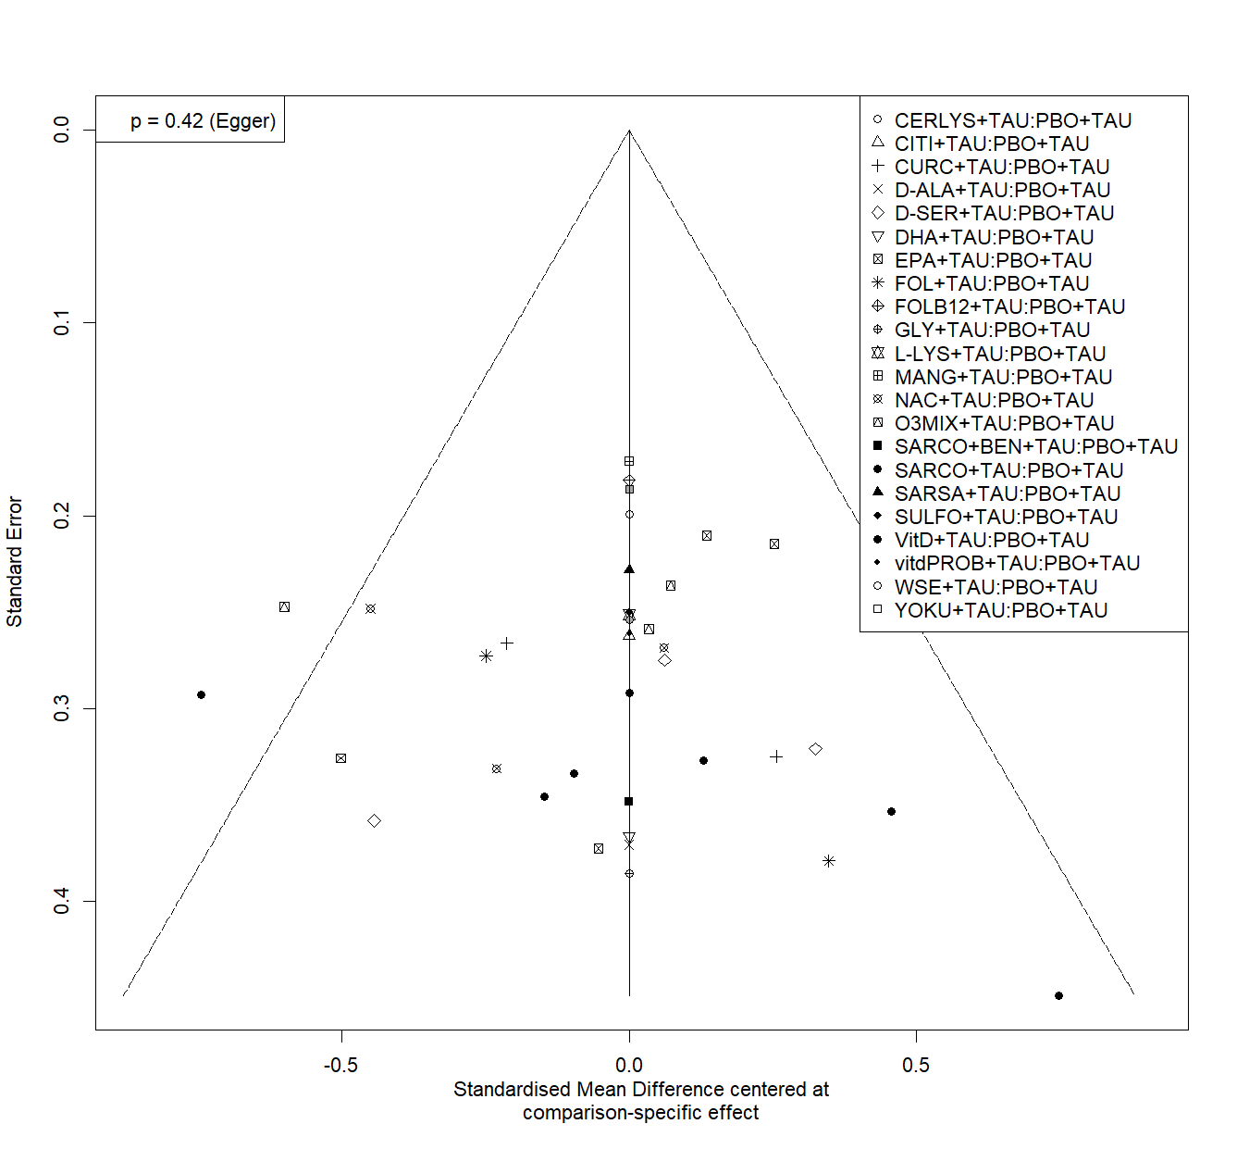
e-figure 3. Network plot and cumulative ranking of nutraceuticals and phytoceuticals for change in PANSS total symptomatology, acute phase studies. SUCRA is intended to present the molecules ranked from the most effective to the least effective agent for schizophrenia-specific total symptomatology reduction.
SUCRA
L-LYS+TAU | 0.7604
NAC+TAU | 0.7561
WSE+TAU | 0.6243
SARCO+TAU | 0.5081
O3MIX+TAU | 0.4644
vitD+TAU | 0.3203
PBO+TAU | 0.3096
D-SER+TAU | 0.2567
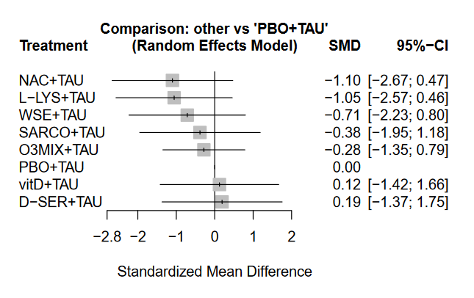
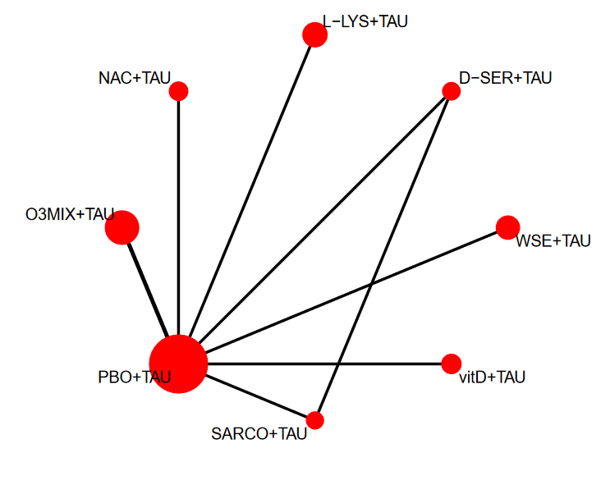
e-figure 4. Network plot and cumulative ranking of nutraceuticals and phytoceuticals for change in PANSS total symptomatology, studies considering clinically stable patients. SUCRA is intended to present the molecules ranked from the most effective to the least effective agent for schizophrenia-specific total symptomatology reduction.
SUCRA
SARCO+TAU | 0.9586
CITI+TAU | 0.9148
NAC+TAU | 0.732
YOKU+TAU | 0.561
CURC+TAU | 0.5263
O3MIX+TAU | 0.4249
D-SER+TAU | 0.3639
GLY+TAU | 0.2821
FOLB12+TAU | 0.2808
PBO+TAU | 0.272
FOL+TAU | 0.1836
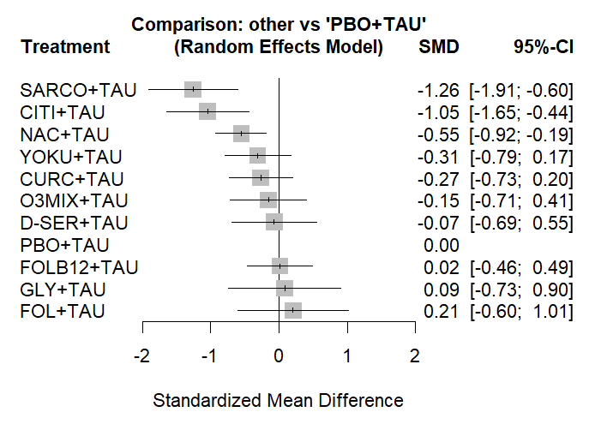
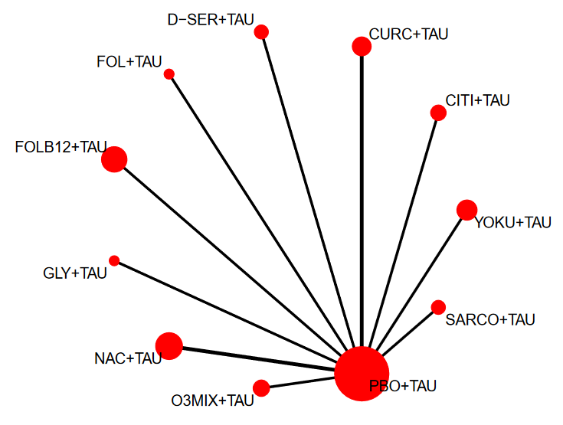
e-figure 5. Funnel plot for change in schizophrenia PANSS total symptomatology, studies with clinically stable patients.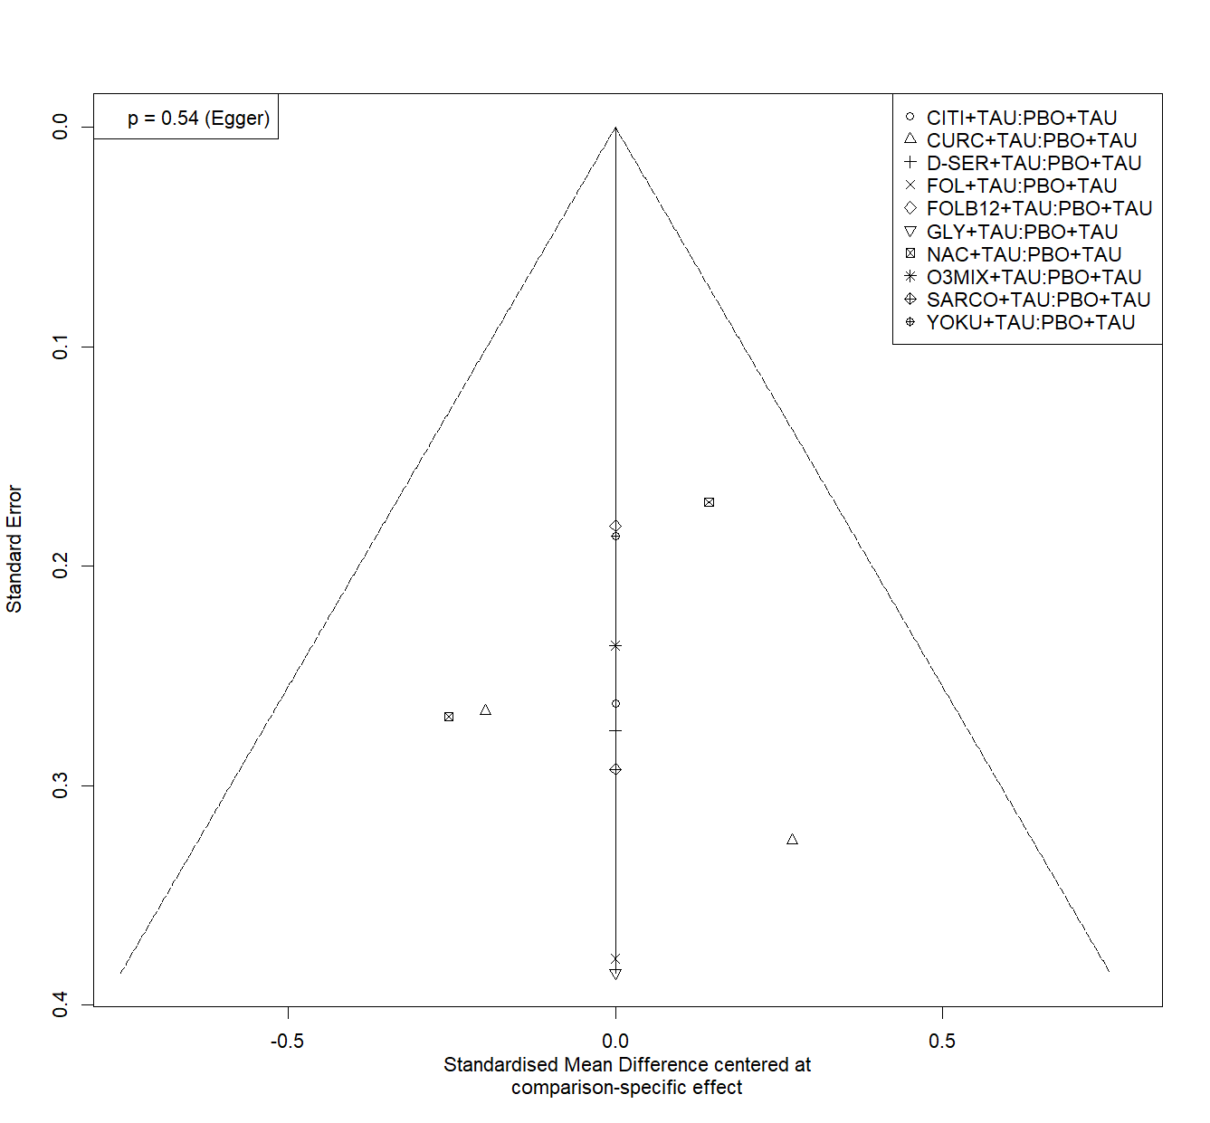
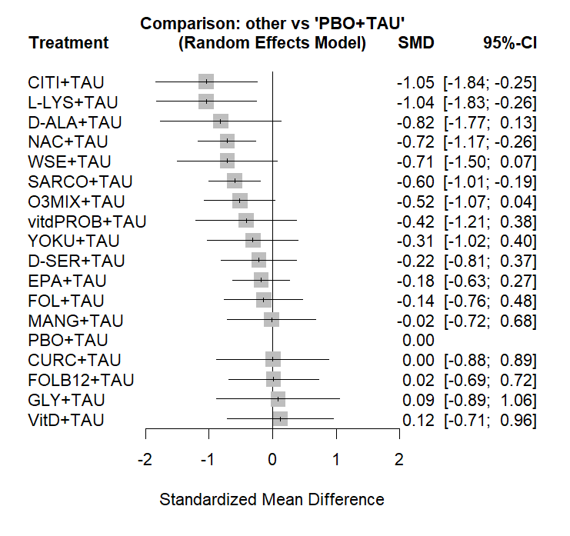
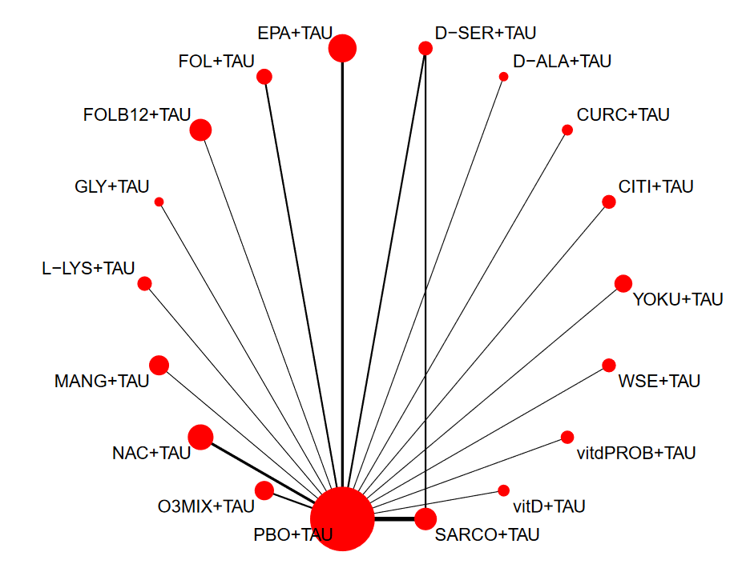
e-figure 6. Network plot and cumulative ranking of nutraceuticals and phytoceuticals for change in PANSS total symptomatology, all phases, sensitivity analysis without high RoB studies. SUCRA is intended to present the molecules ranked from the most effective to the least effective agent for schizophrenia-specific total symptomatology reduction.

SUCRA
CITI+TAU | 0.8712
L-LYS+TAU | 0.8611
D-ALA+TAU | 0.7586
NAC+TAU | 0.7402
WSE+TAU | 0.7261
SARCO+TAU | 0.6865
O3MIX+TAU | 0.6295
vitdPROB+TAU | 0.5478
YOKU+TAU | 0.4702
D-SER+TAU | 0.4082
EPA+TAU | 0.39
FOL+TAU | 0.3609
CURC+TAU | 0.2967
MANG+TAU | 0.2884
FOLB12+TAU | 0.263
GLY+TAU | 0.2522
PBO+TAU | 0.2302
VitD+TAU | 0.219

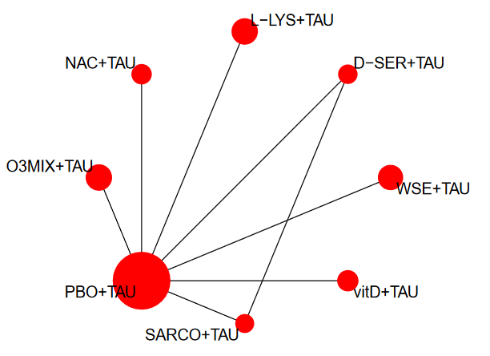
e-figure 7. Network plot and cumulative ranking of nutraceuticals and phytoceuticals for change in PANSS total symptomatology, acute phase studies, sensitivity analysis without high RoB studies. SUCRA is intended to present the molecules ranked from the most effective to the least effective agent for schizophrenia-specific total symptomatology reduction.
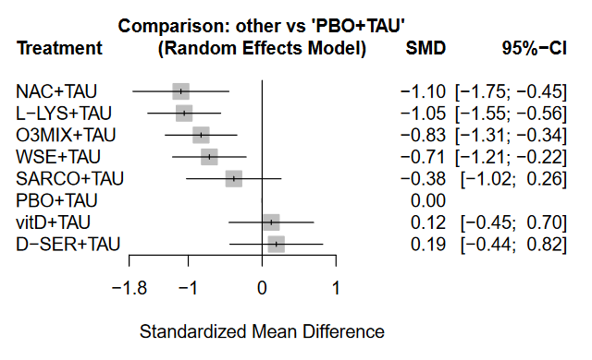
SUCRA
NAC+TAU | 0.8679
L-LYS+TAU | 0.8491
O3MIX+TAU | 0.7181
WSE+TAU | 0.6311
SARCO+TAU | 0.4546
PBO+TAU | 0.2153
vitD+TAU | 0.1483
D-SER+TAU | 0.1156

e-figure 8. Network plot and cumulative ranking of nutraceuticals and phytoceuticals for change in PANSS total symptomatology, studies with clinically stable patients, sensitivity analysis without high RoB studies. SUCRA is intended to present the molecules ranked from the most effective to the least effective agent for schizophrenia-specific total symptomatology reduction.
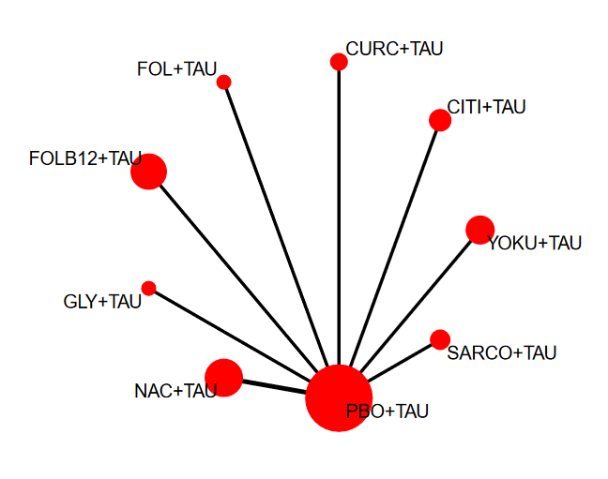
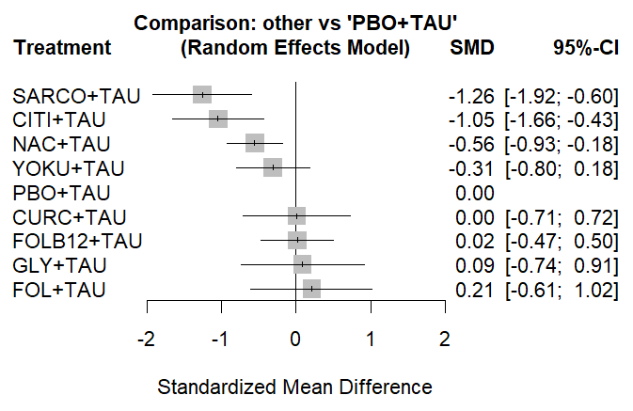

SUCRA
SARCO+TAU | 0.9516
CITI+TAU | 0.8965
NAC+TAU | 0.7058
YOKU+TAU | 0.5596
CURC+TAU | 0.3239
FOLB12+TAU | 0.3025
PBO+TAU | 0.2986
GLY+TAU | 0.2616
FOL+TAU | 0.1999

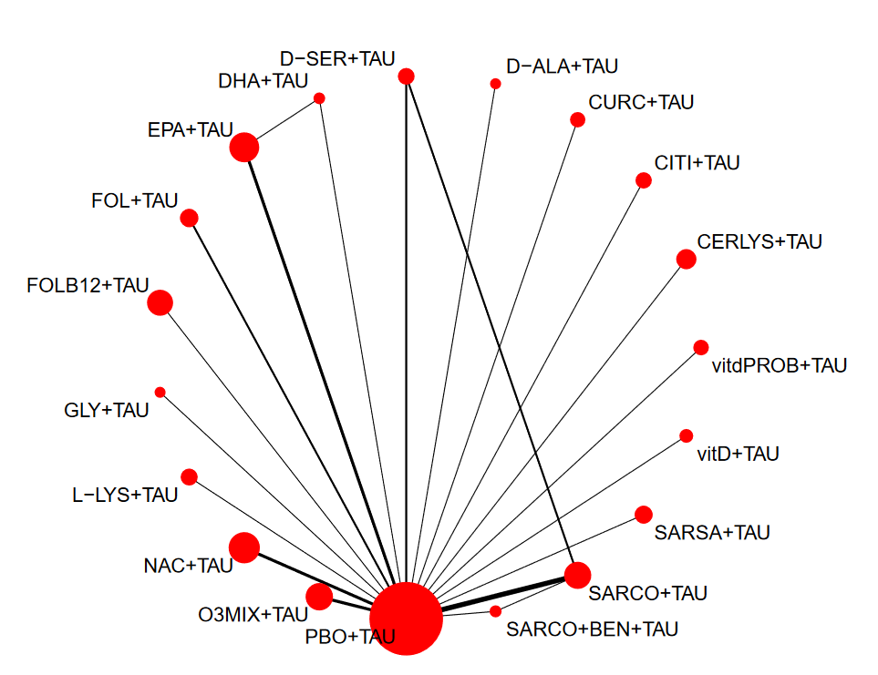
e-figure 9. Network plot and cumulative ranking of nutraceuticals and phytoceuticals for change in PANSS total symptomatology, all phases, sensitivity analysis with SCZ patients only. SUCRA is intended to present the molecules ranked from the most effective to the least effective agent for schizophrenia-specific total symptomatology reduction.
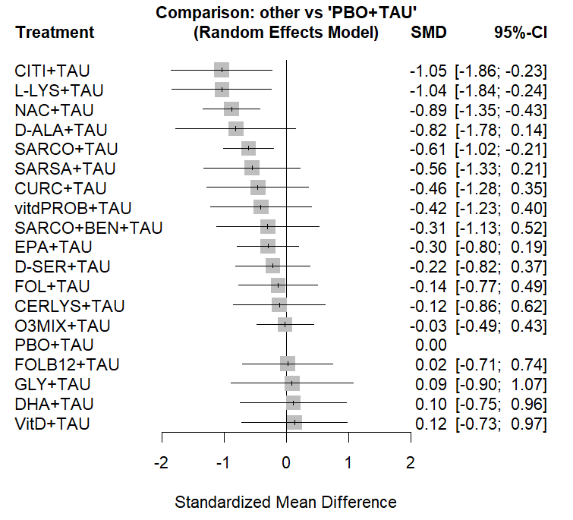
SUCRA
CITI+TAU | 0.8756
L-LYS+TAU | 0.8685
NAC+TAU | 0.8407
D-ALA+TAU | 0.7581
SARCO+TAU | 0.6999
SARSA+TAU | 0.6358
CURC+TAU | 0.5712
vitdPROB+TAU | 0.5579
EPA+TAU | 0.4889
SARCO+BEN+TAU | 0.4887
D-SER+TAU | 0.4304
FOL+TAU | 0.3791
CERLYS+TAU | 0.3696
O3MIX+TAU | 0.2841
FOLB12+TAU | 0.2756
PBO+TAU | 0.2489
GLY+TAU | 0.2489
DHA+TAU | 0.2427
VitD+TAU | 0.2354

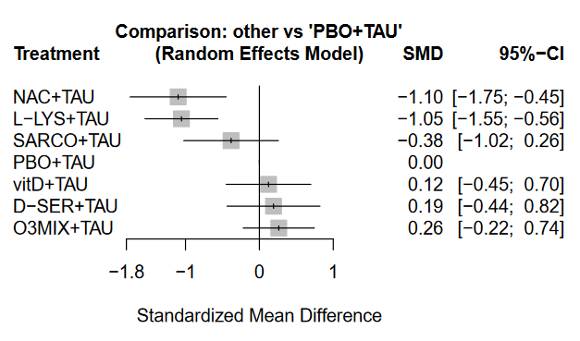
e-figure 10. Network plot and cumulative ranking of nutraceuticals and phytoceuticals for change in PANSS total symptomatology, acute phase studies, sensitivity analysis with SCZ patients only. SUCRA is intended to present the molecules ranked from the most effective to the least effective agent for schizophrenia-specific total symptomatology reduction.
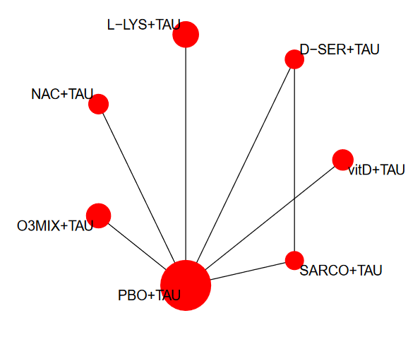
SUCRA
NAC+TAU | 0.9135
L-LYS+TAU | 0.9008
SARCO+TAU | 0.6265
PBO+TAU | 0.3925
vitD+TAU | 0.2715
D-SER+TAU | 0.2248
O3MIX+TAU | 0.1703

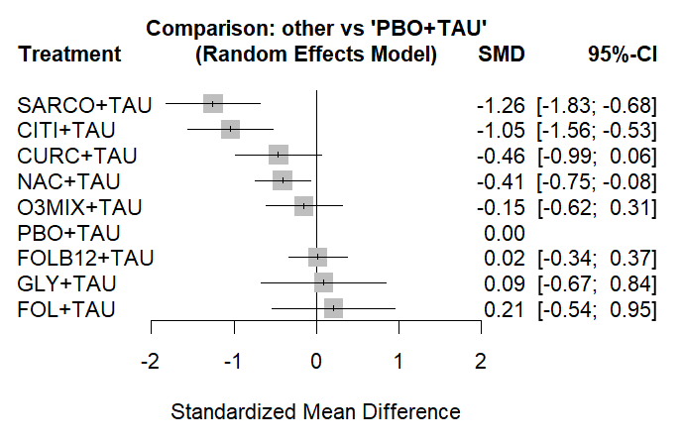
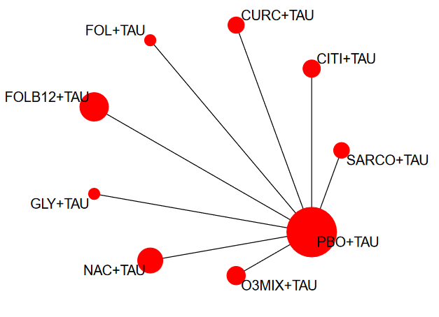
e-figure 11. Network plot and cumulative ranking of nutraceuticals and phytoceuticals for change in PANSS total symptomatology, studies with clinically stable patients, sensitivity analysis with SCZ patients only. SUCRA is intended to present the molecules ranked from the most effective to the least effective agent for schizophrenia-specific total symptomatology reduction.

SUCRA
SARCO+TAU | 0.9589
CITI+TAU | 0.9021
CURC+TAU | 0.6411
NAC+TAU | 0.6294
O3MIX+TAU | 0.409
PBO+TAU | 0.2706
FOLB12+TAU | 0.2658
GLY+TAU | 0.2527
FOL+TAU | 0.1704

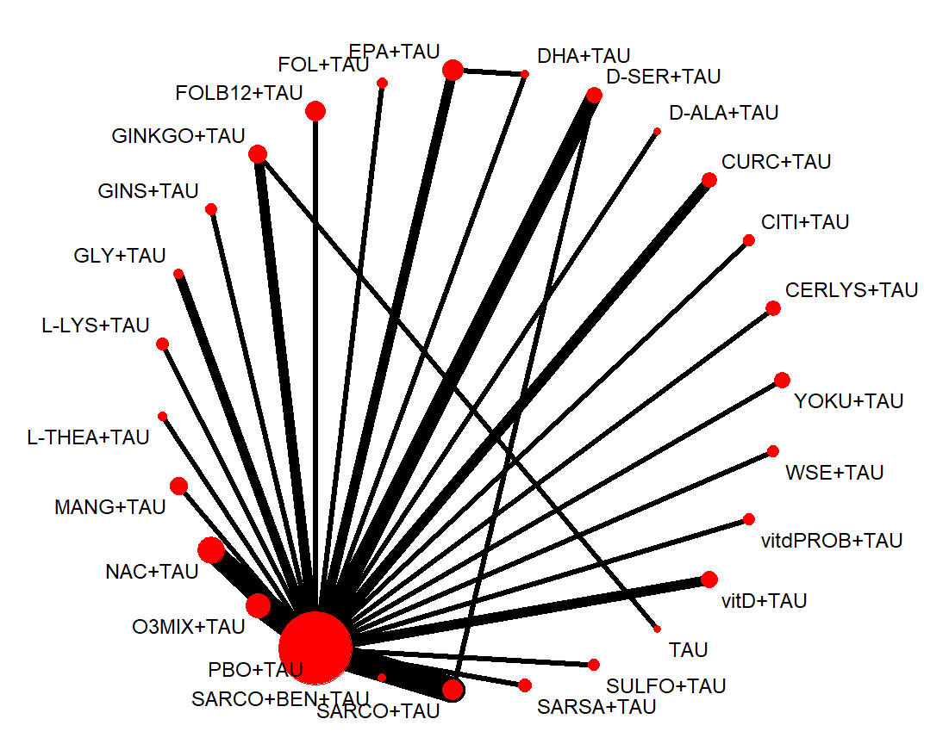
e-figure 12. Network plot, forest plot and cumulative ranking of nutraceuticals and phytoceuticals for change in positive symptoms, all phases of disease. SUCRA is intended to present the molecules ranked from the most effective to the least effective agent for positive symptoms reduction.
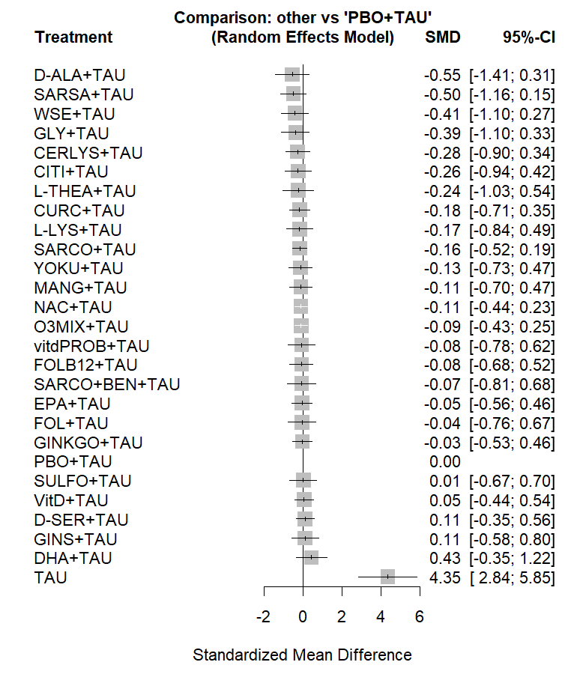

SUCRA
D-ALA+TAU | 0.8078
SARSA+TAU | 0.7959
WSE+TAU | 0.7402
GLY+TAU | 0.7216
CITI+TAU | 0.6415
CERLYS+TAU | 0.6371
L-THEA+TAU | 0.608
CURC+TAU | 0.5718
L-LYS+TAU | 0.5703
SARCO+TAU | 0.5679
YOKU+TAU | 0.5288
NAC+TAU | 0.5138
MANG+TAU | 0.5092
vitdPROB+TAU | 0.5021
O3MIX+TAU | 0.4943
SARCO+BEN+TAU | 0.4912
FOLB12+TAU | 0.4877
EPA+TAU | 0.4435
GINKGO+TAU | 0.4415
FOL+TAU | 0.4357
SULFO+TAU | 0.4316
PBO+TAU | 0.3832
VitD+TAU | 0.3649
GINS+TAU | 0.3257
D-SER+TAU | 0.3121
DHA+TAU | 0.1724
TAU | 0

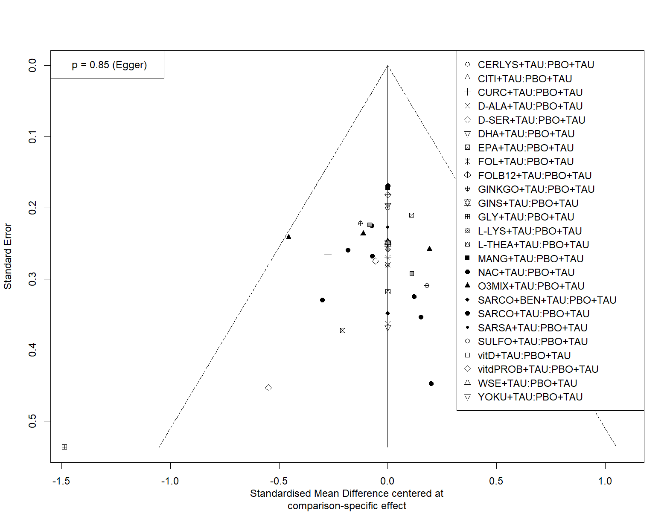
e-figure 13. Funnel plot for change in positive symptoms, all phases of disease.

e-figure 14. Network plot, forest plot and cumulative ranking of nutraceuticals and phytoceuticals for change in positive symptoms, acute phase studies. SUCRA is intended to present the molecules ranked from the most effective to the least effective agent for positive symptoms reduction.
SUCRA
WSE+TAU | 0.7236
O3MIX+TAU | 0.6063
L-LYS+TAU | 0.601
SARCO+TAU | 0.5181
PBO+TAU | 0.5061
VitD+TAU | 0.419
NAC+TAU | 0.3774
D-SER+TAU | 0.2484
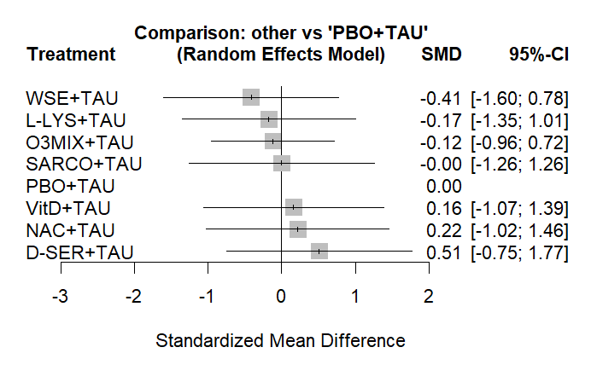
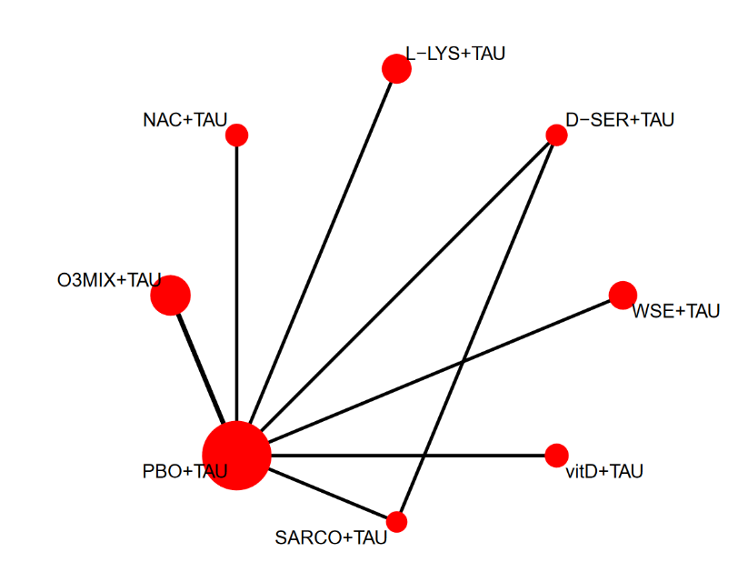
e-figure 15. Network plot, forest plot and cumulative ranking of nutraceuticals and phytoceuticals for change in positive symptoms, studies considering clinically stable patients. SUCRA is intended to present the molecules ranked from the most effective to the least effective agent for positive symptoms reduction.
SUCRA
GLY+TAU | 0.7009
CITI+TAU | 0.5662
L-THEA+TAU | 0.5552
O3MIX+TAU | 0.5321
SARCO+TAU | 0.5241
NAC+TAU | 0.5176
D-SER+TAU | 0.5045
CURC+TAU | 0.4976
YOKU+TAU | 0.4722
FOLB12+TAU | 0.4316
PBO+TAU | 0.365
GINS+TAU | 0.3329
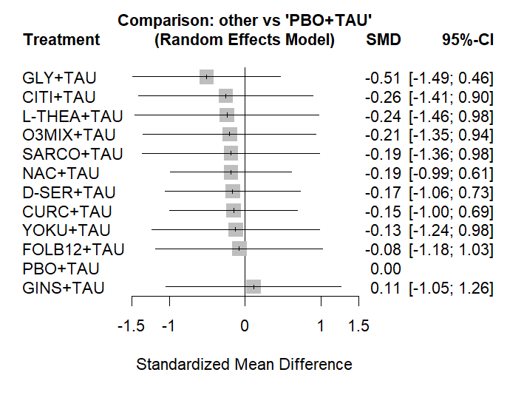
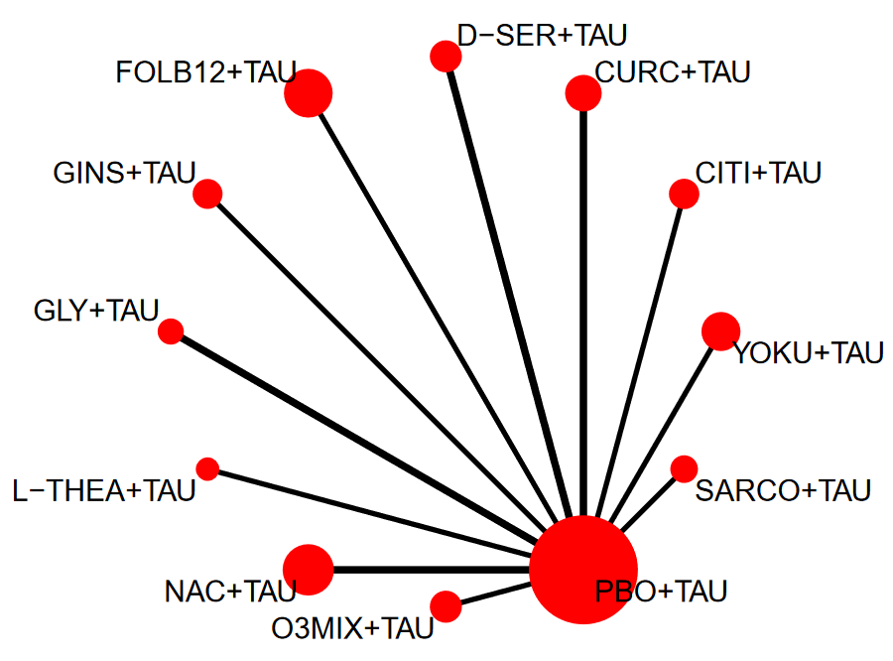
e-figure 16. Network plot, forest plot and cumulative ranking of nutraceuticals and phytoceuticals for change in negative symptoms, all studies. SUCRA is intended to present the molecules ranked from the most effective to the least effective agent for negative symptoms reduction.
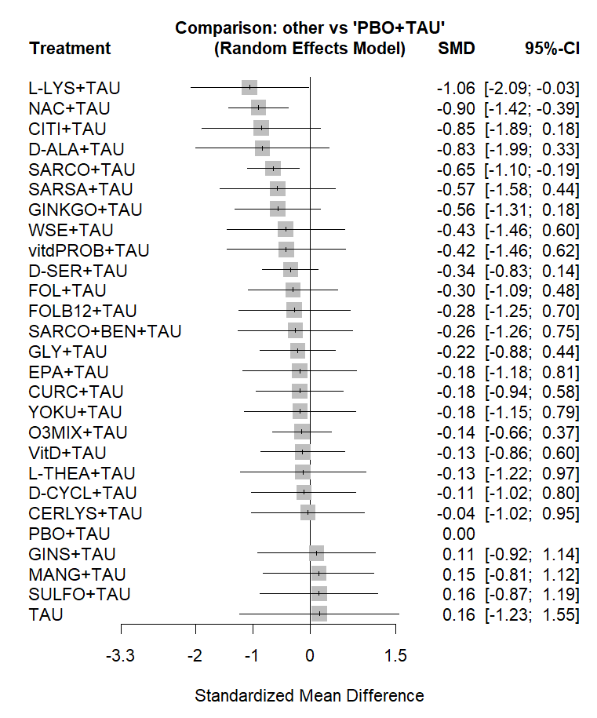
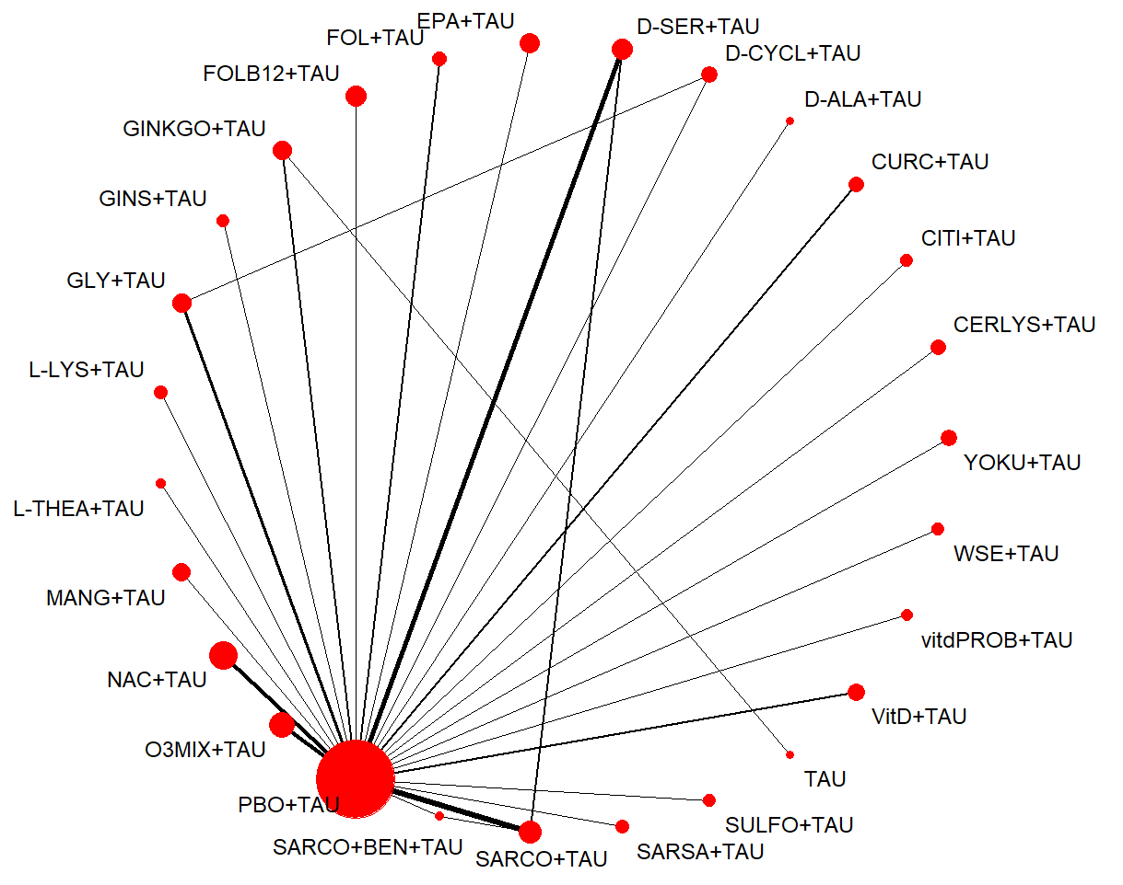
SUCRA
L-LYS+TAU | 0.8503
NAC+TAU | 0.8478
CITI+TAU | 0.7699
D-ALA+TAU | 0.762
SARCO+TAU | 0.7395
GINKGO+TAU | 0.6778
SARSA+TAU | 0.6534
vitdPROB+TAU | 0.5686
WSE+TAU | 0.5673
D-SER+TAU | 0.524
FOL+TAU | 0.505
SARCO+BEN+TAU | 0.4834
FOLB12+TAU | 0.4699
EPA+TAU | 0.4453
GLY+TAU | 0.4415
YOKU+TAU | 0.4364
CURC+TAU | 0.4255
O3MIX+TAU | 0.4043
L-THEA+TAU | 0.4015
VitD+TAU | 0.3973
D-CYCL+TAU | 0.3863
CERLYS+TAU | 0.3608
GINS+TAU | 0.2943
TAU | 0.2915
PBO+TAU | 0.2805
MANG+TAU | 0.2653
SULFO+TAU | 0.2503

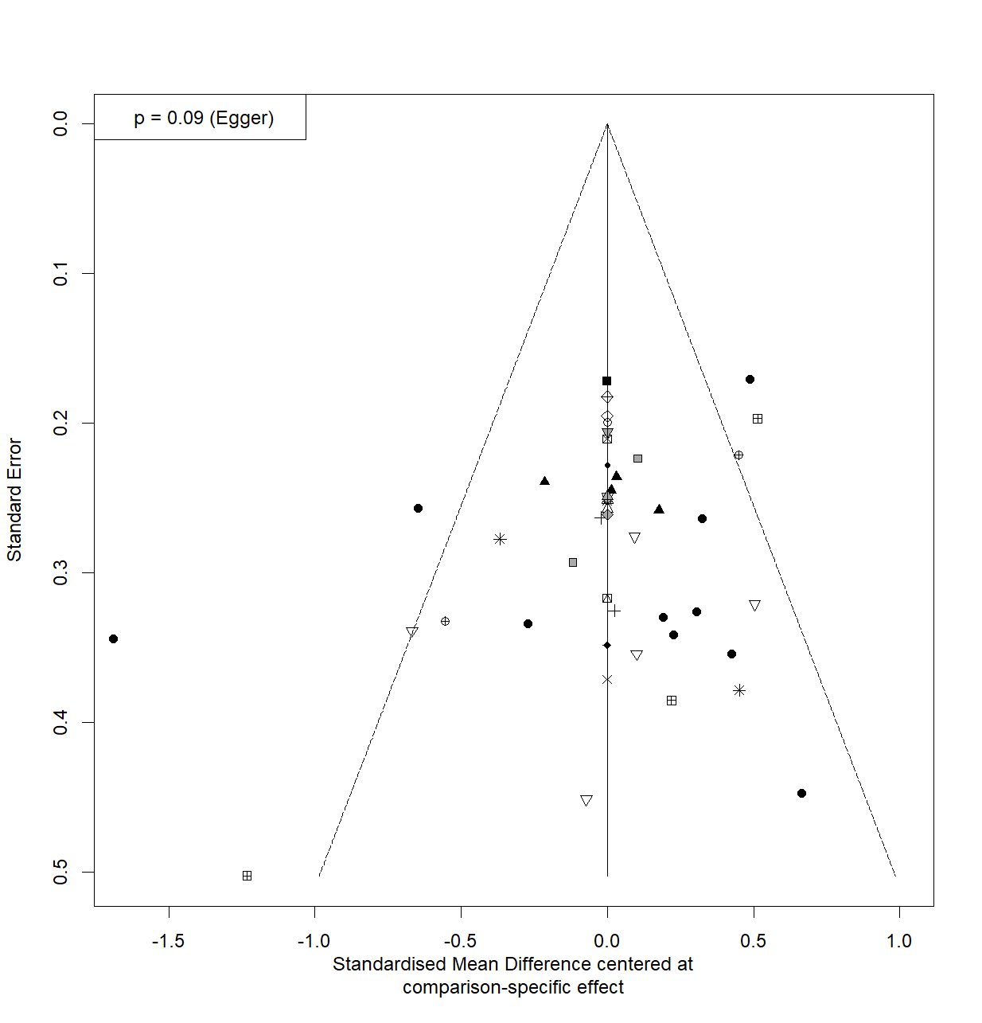
e-figure 17. Funnel plot for change in negative symptoms, all studies.

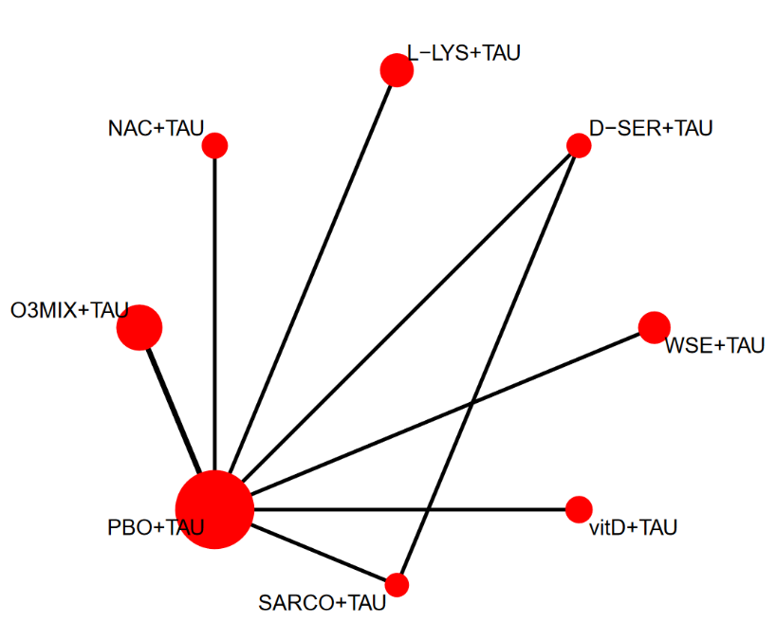
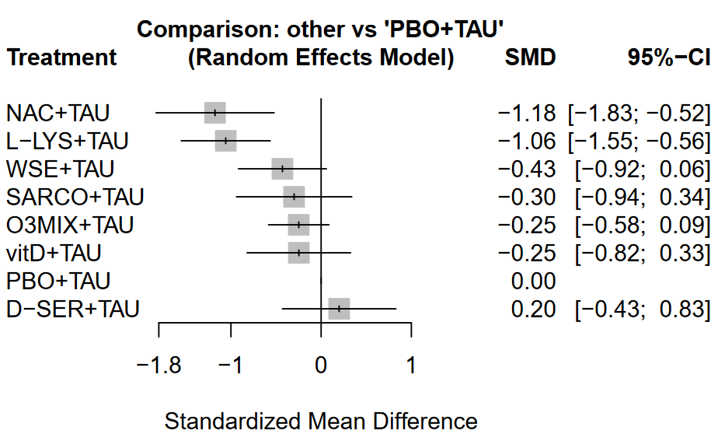
e-figure 18. Network plot, forest plot and cumulative ranking of nutraceuticals and phytoceuticals for change in negative symptoms, acute phase of disease. SUCRA is intended to present the molecules ranked from the most effective to the least effective agent for negative symptoms reduction.
SUCRA
NAC+TAU | 0.9357
L-LYS+TAU | 0.9011
WSE+TAU | 0.5586
SARCO+TAU | 0.481
O3MIX+TAU | 0.4336
vitD+TAU | 0.4047
PBO+TAU | 0.179
D-SER+TAU | 0.1063

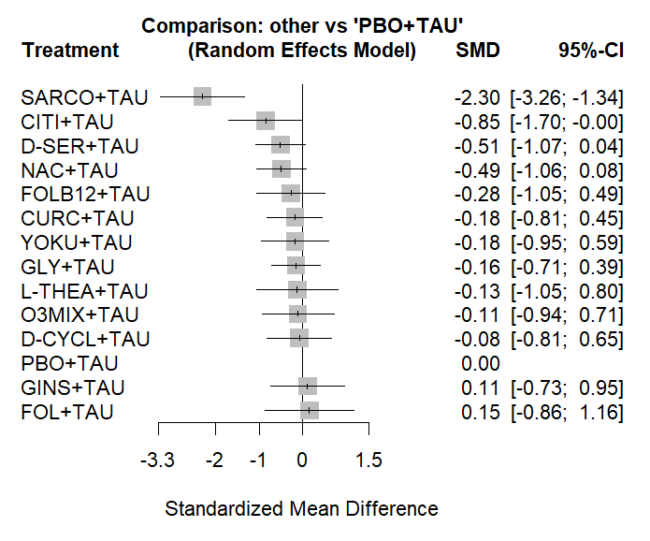
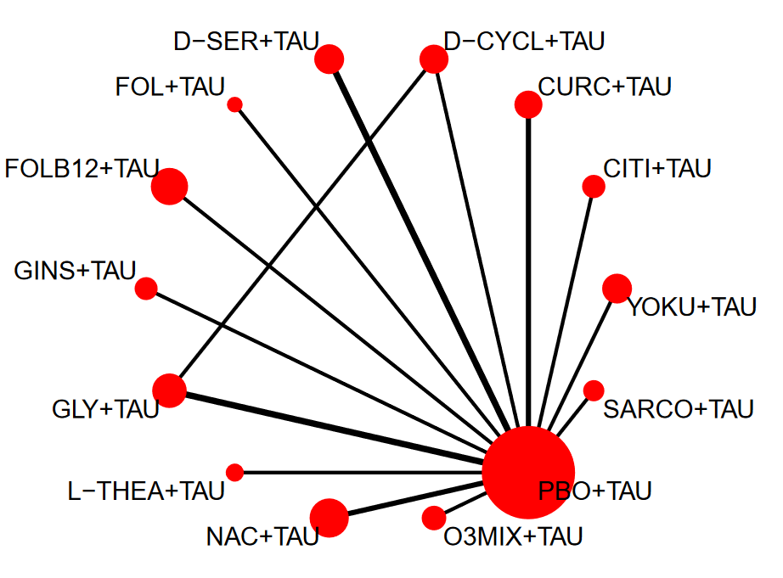
e-figure 19. Network plot, forest plot and cumulative ranking of nutraceuticals and phytoceuticals for change in negative symptoms, studies with clinically stable patients. SUCRA is intended to present the molecules ranked from the most effective to the least effective agent for negative symptoms reduction.

SUCRA
SARCO+TAU | 0.9988
CITI+TAU | 0.8103
D-SER+TAU | 0.69
NAC+TAU | 0.6682
FOLB12+TAU | 0.5125
CURC+TAU | 0.446
GLY+TAU | 0.4407
YOKU+TAU | 0.4355
L-THEA+TAU | 0.408
O3MIX+TAU | 0.405
D-CYCL+TAU | 0.3692
PBO+TAU | 0.2813
GINS+TAU | 0.278
FOL+TAU | 0.2564
e-figure 20. Funnel plot for change in negative symptoms, studies with clinically stable patients.
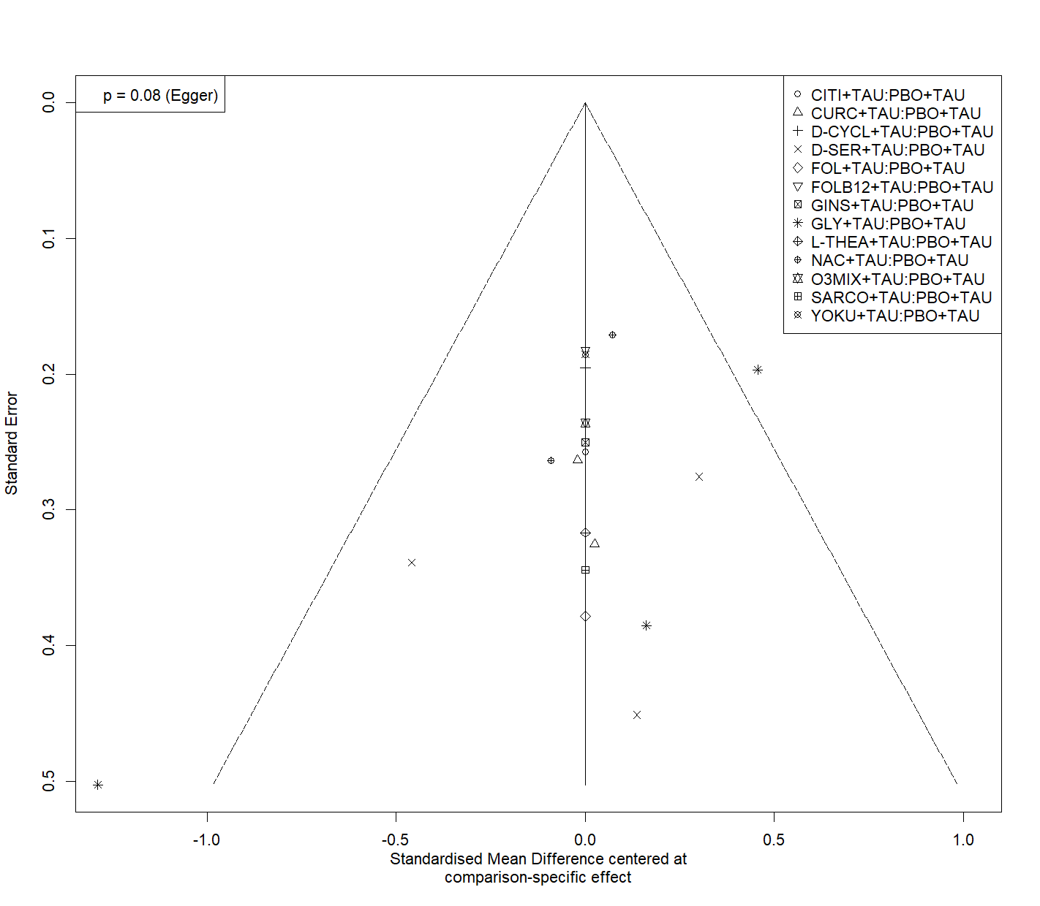
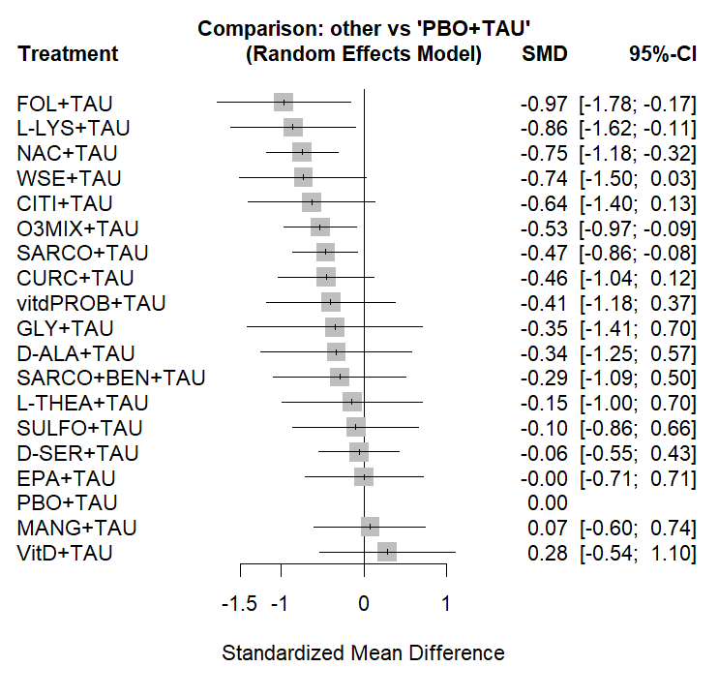
e-figure 21. Network plot, forest plot and cumulative ranking of nutraceuticals and phytoceuticals for change in general psychopathology, all phases of disease. SUCRA is intended to present the molecules ranked from the most effective to the least effective agent for general psychopathology reduction.
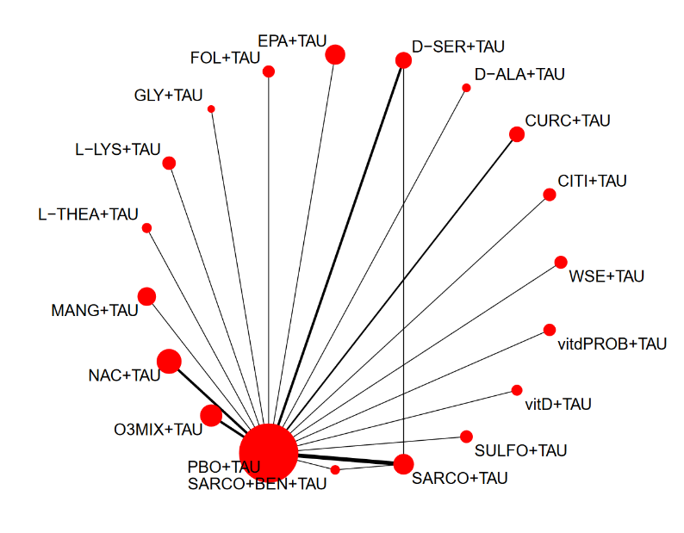

SUCRA
FOL+TAU | 0.8494
L-LYS+TAU | 0.8016
NAC+TAU | 0.7864
WSE+TAU | 0.7428
CITI+TAU | 0.6766
O3MIX+TAU | 0.6372
SARCO+TAU | 0.5891
CURC+TAU | 0.5745
vitdPROB+TAU | 0.5407
GLY+TAU | 0.4969
D-ALA+TAU | 0.4906
SARCO+BEN+TAU | 0.4479
L-THEA+TAU | 0.3671
SULFO+TAU | 0.3383
D-SER+TAU | 0.2959
EPA+TAU | 0.2659
PBO+TAU | 0.227
MANG+TAU | 0.2254
VitD+TAU | 0.1465

e-figure 22. Funnel plot for change in general psychopathology, all phases of disease.
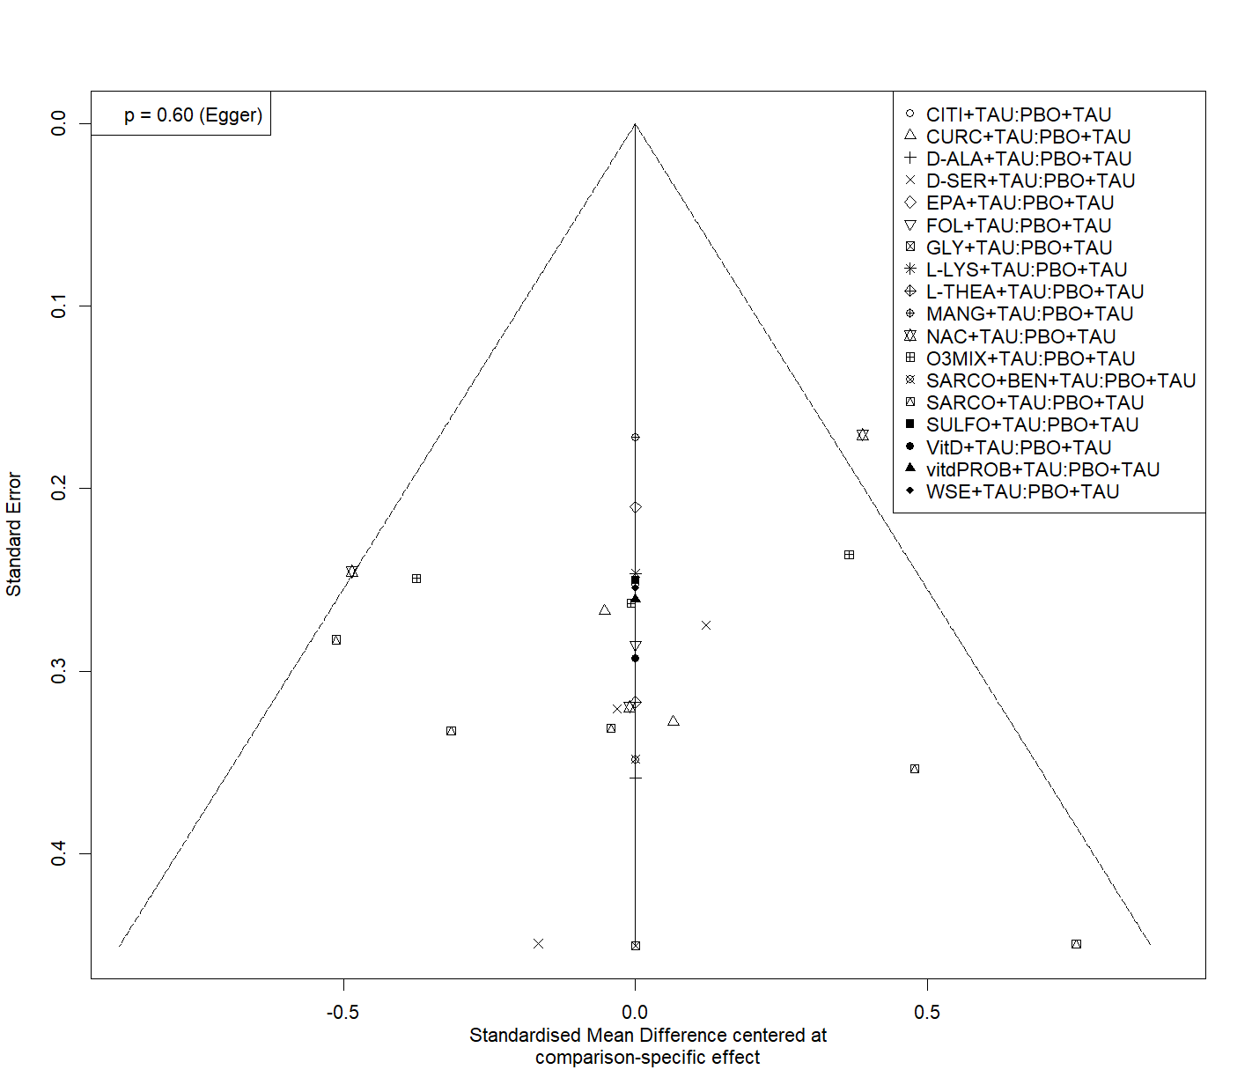

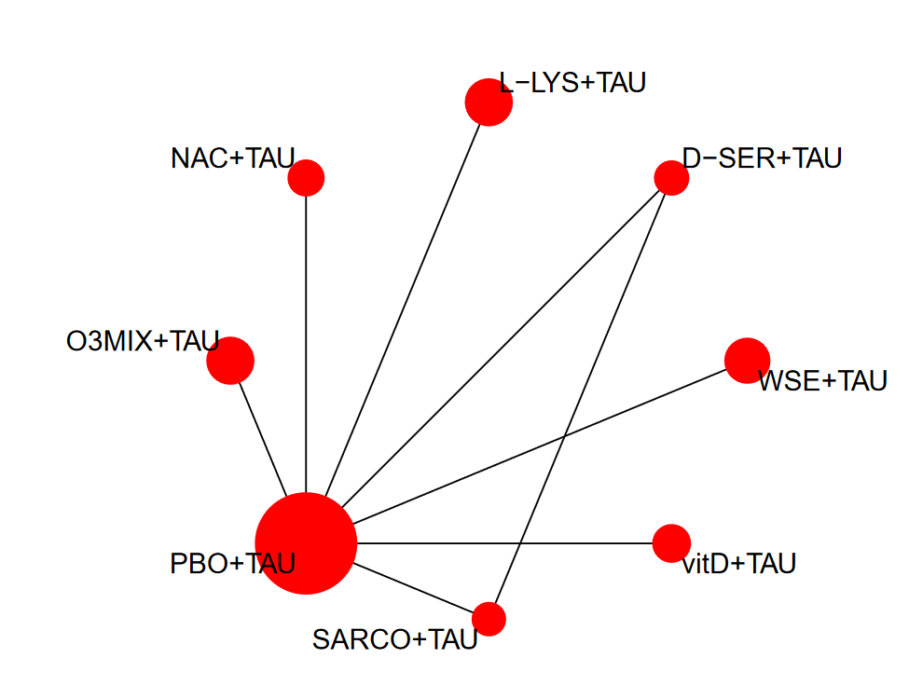
e-figure 23. Network plot, forest plot and cumulative ranking of nutraceuticals and phytoceuticals for change in general psychopathology, acute phase studies. SUCRA is intended to present the molecules ranked from the most effective to the least effective agent for general psychopathology reduction.
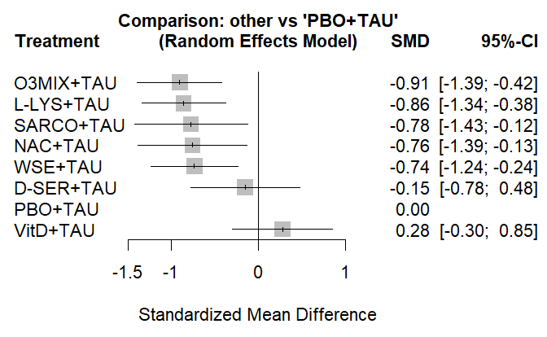

SUCRA
O3MIX+TAU | 0.7867
L-LYS+TAU | 0.7496
SARCO+TAU | 0.6787
NAC+TAU | 0.6619
WSE+TAU | 0.6441
D-SER+TAU | 0.2661
PBO+TAU | 0.1624
VitD+TAU | 0.0504

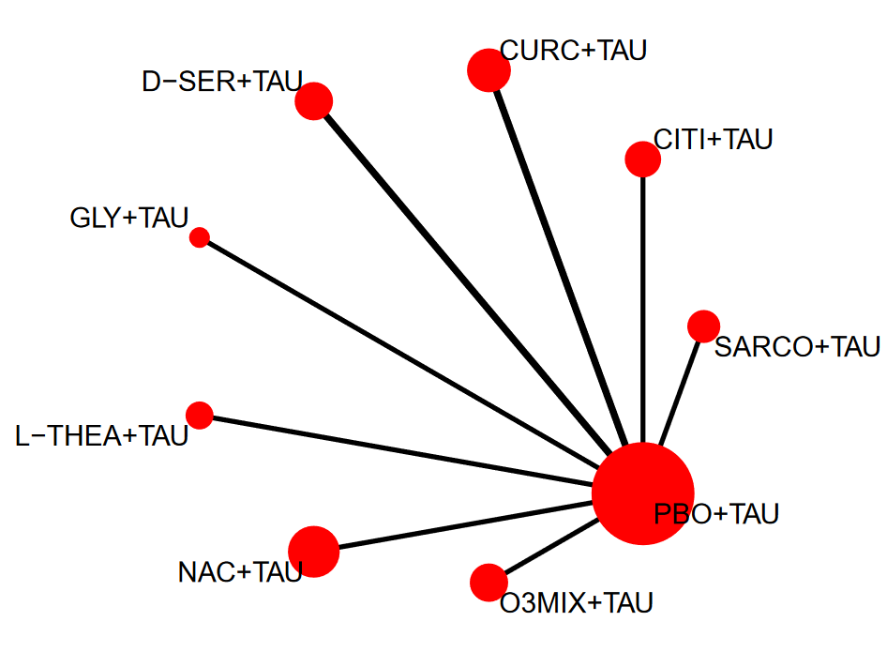
e-figure 24. Network plot, forest plot and cumulative ranking of nutraceuticals and phytoceuticals for change in general psychopathology, studies with clinically stable patients. SUCRA is intended to present the molecules ranked from the most effective to the least effective agent for general psychopathology reduction.
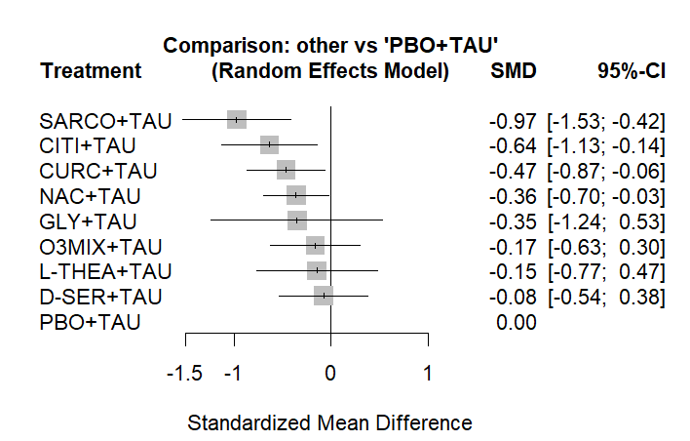

SUCRA
SARCO+TAU | 0.9454
CITI+TAU | 0.7698
CURC+TAU | 0.6322
NAC+TAU | 0.5562
GLY+TAU | 0.4981
O3MIX+TAU | 0.3504
L-THEA+TAU | 0.3384
D-SER+TAU | 0.2571
PBO+TAU | 0.1524
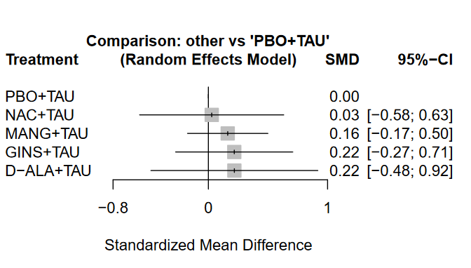
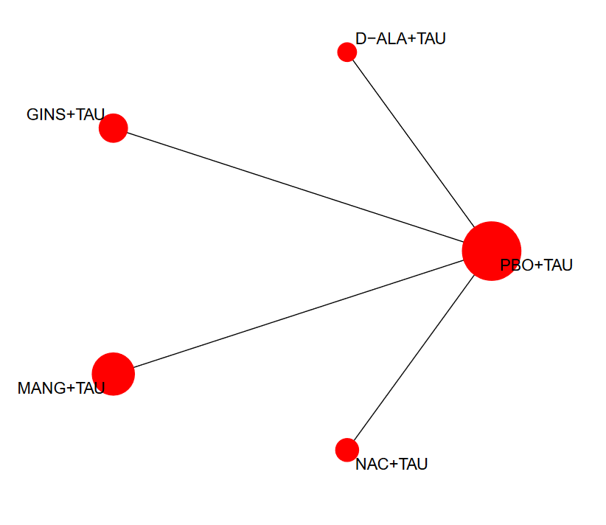
e-figure 25. Network plot, forest plot and cumulative ranking of nutraceuticals and phytoceuticals for change in depressive symptoms, all phases of disease. SUCRA is intended to present the molecules ranked from the most effective to the least effective agent.
SUCRA
PBO+TAU | 0.7245
NAC+TAU | 0.6165
MANG+TAU | 0.4095
D-ALA+TAU | 0.3882
GINS+TAU | 0.3612

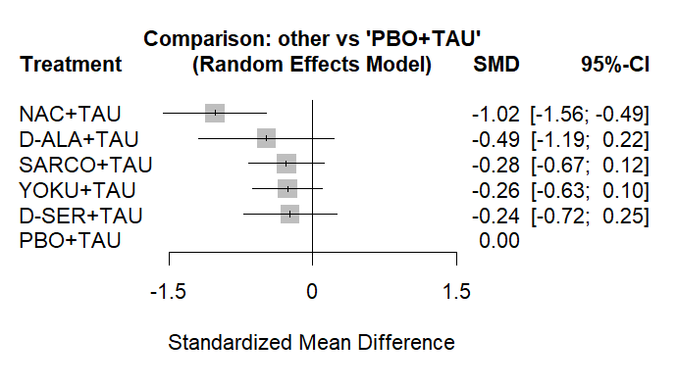
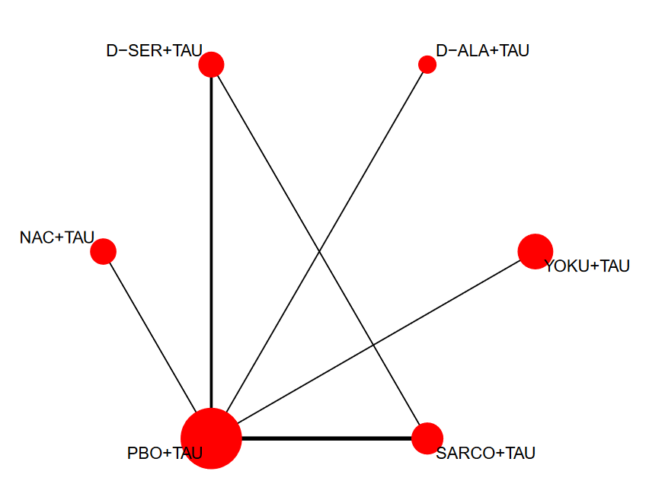
e-figure 26. Network plot, forest plot and cumulative ranking of nutraceuticals and phytoceuticals for change in cognitive symptoms, all phases of disease. SUCRA is intended to present the molecules ranked from the most effective to the least effective agent.

SUCRA
NAC+TAU | 0.9728
D-ALA+TAU | 0.6224
SARCO+TAU | 0.4664
YOKU+TAU | 0.4386
D-SER+TAU | 0.417
PBO+TAU | 0.0828
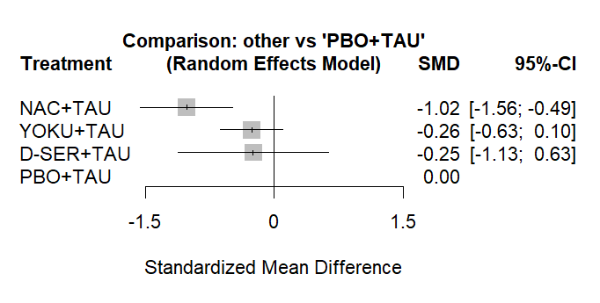
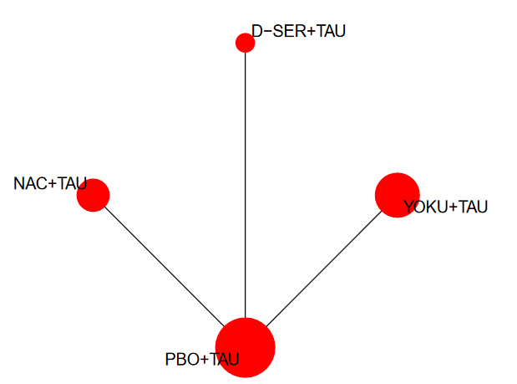
e-figure 27. Network plot, forest plot and cumulative ranking of nutraceuticals and phytoceuticals for change in cognitive symptoms, studies with clinically stable patients. SUCRA is intended to present the molecules ranked from the most effective to the least effective agent.

SUCRA
NAC+TAU | 0.9737
YOKU+TAU | 0.4773
D-SER+TAU | 0.4207
PBO+TAU | 0.1283

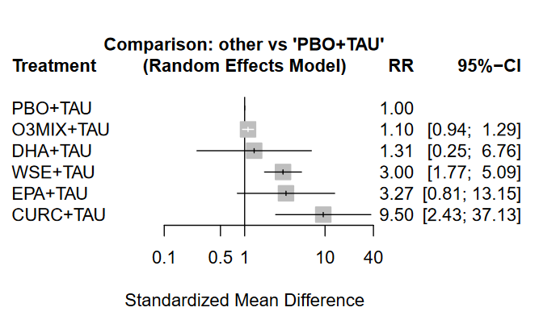
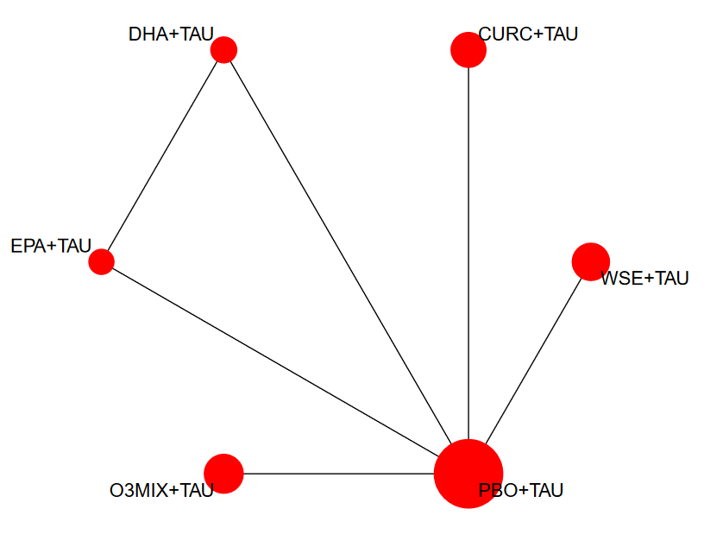
e-figure 28. Network plot, forest plot and cumulative ranking of nutraceuticals and phytoceuticals for response rate, all phases of disease. SUCRA is intended to present the molecules ranked from the most effective to the least effective agent.

SUCRA
CURC+TAU | 0.9528
EPA+TAU | 0.693
WSE+TAU | 0.6716
DHA+TAU | 0.3124
O3MIX+TAU | 0.2144
PBO+TAU | 0.1558

e-figure 29. Network plot and cumulative ranking of nutraceuticals and phytoceuticals for acceptability (drop-out for any cause). SUCRA is intended to present the molecules ranked from the most protective to the most related agent for the outcome in point (drop-out).
SUCRA
CURC+TAU | 0.8931
YOKU+TAU | 0.8574
vitC+TAU | 0.8488
MANG+TAU | 0.6824
D-ALA+TAU | 0.6721
SARCO+BEN+TAU | 0.6377
CITI+TAU | 0.5958
SARCO+TAU | 0.5663
VitD+TAU | 0.5326
D-SER+TAU | 0.5301
D-CYCL+TAU | 0.5242
vitdPROB+TAU | 0.5237
SARSA+TAU | 0.5203
PBO+TAU | 0.5178
L-LYS+TAU | 0.5083
NAC+TAU | 0.4922
GLY+TAU | 0.4313
L-THEA+TAU | 0.4183
EPA+TAU | 0.4012
O3MIX+TAU | 0.3911
CERLYS+TAU | 0.379
TAU | 0.284
GINKGO+TAU | 0.2209
WSE+TAU | 0.2152
FOLB12+TAU | 0.1869
FOL+TAU | 0.1692
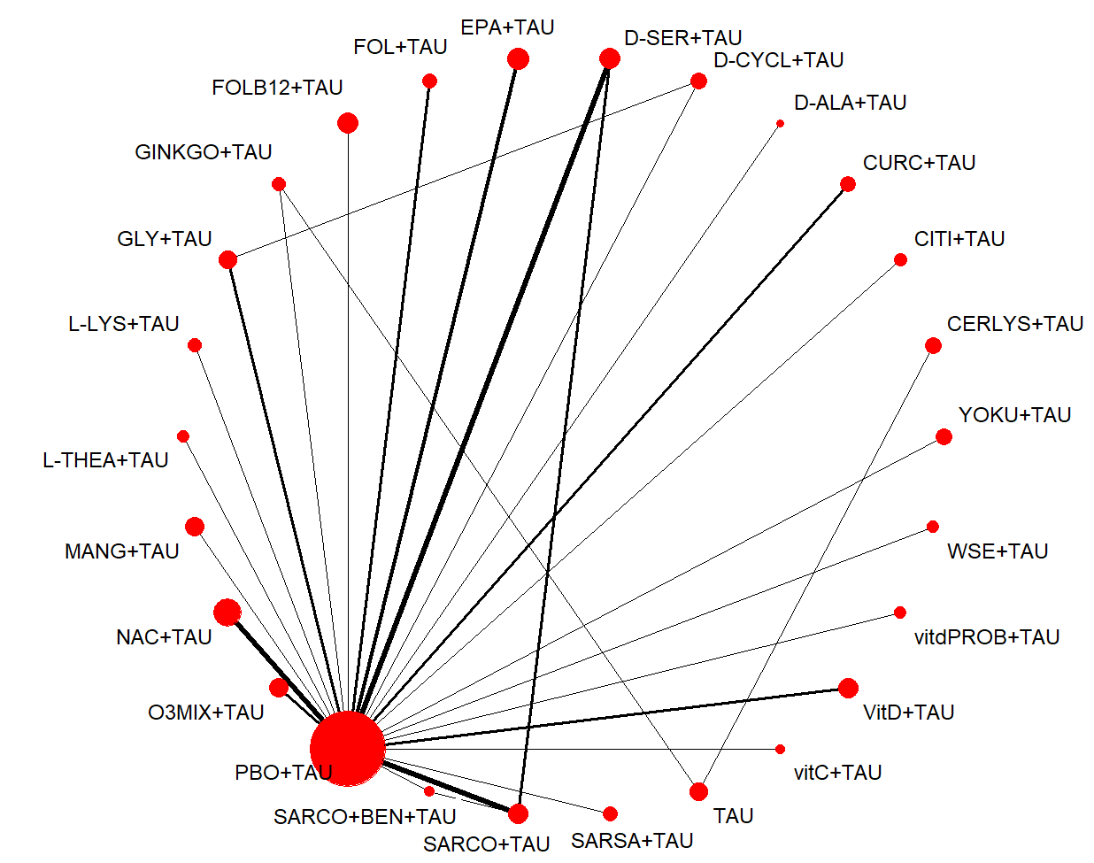

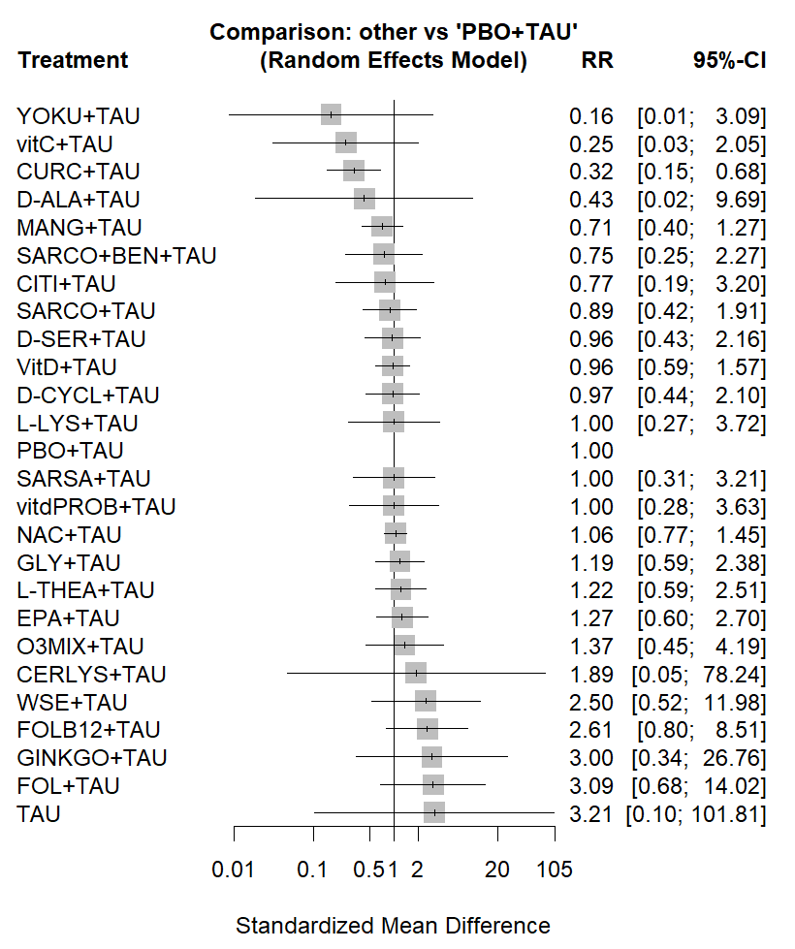
e-figure 30. Funnel plot for acceptability.
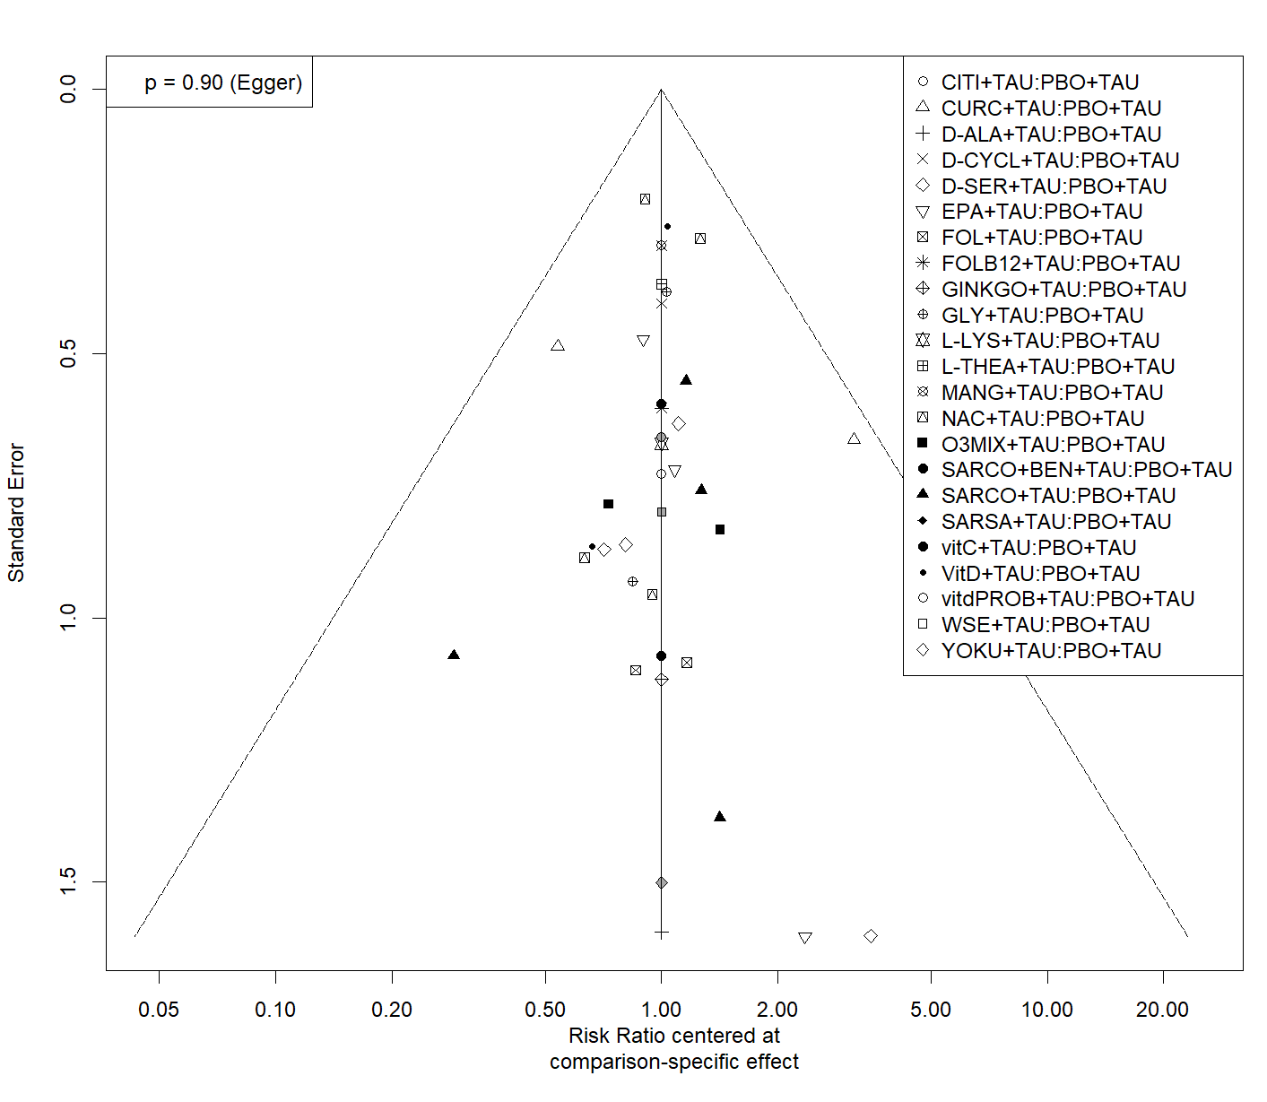
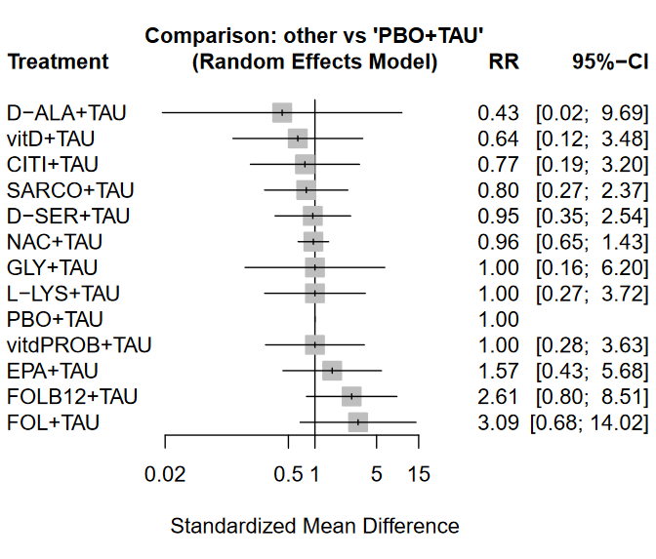
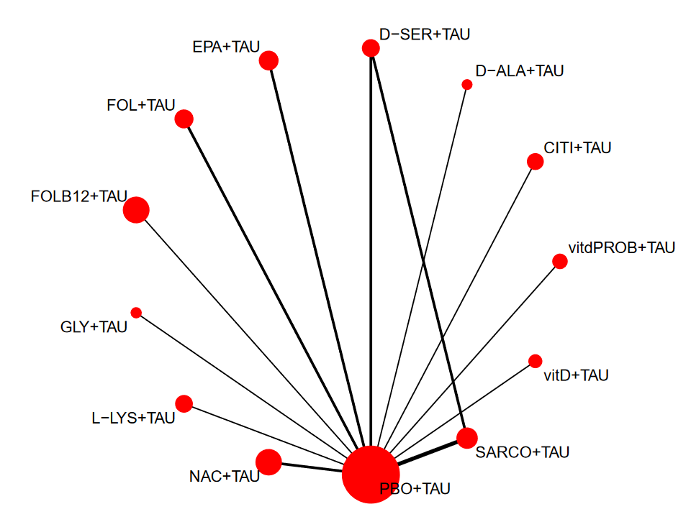
e-figure 31. Network plot and cumulative ranking of nutraceuticals and phytoceuticals for acceptability (drop-out for any cause), sensitivity analysis without high RoB studies. SUCRA is intended to present the molecules ranked from the most protective to the most related agent for the outcome in point (drop-out).

SUCRA
D-ALA+TAU | 0.7167
vitD+TAU | 0.6737
CITI+TAU | 0.6324
SARCO+TAU | 0.6264
D-SER+TAU | 0.5608
NAC+TAU | 0.5498
L-LYS+TAU | 0.5294
PBO+TAU | 0.5258
GLY+TAU | 0.5212
vitdPROB+TAU | 0.5054
EPA+TAU | 0.3514
FOLB12+TAU | 0.1752
FOL+TAU | 0.1318

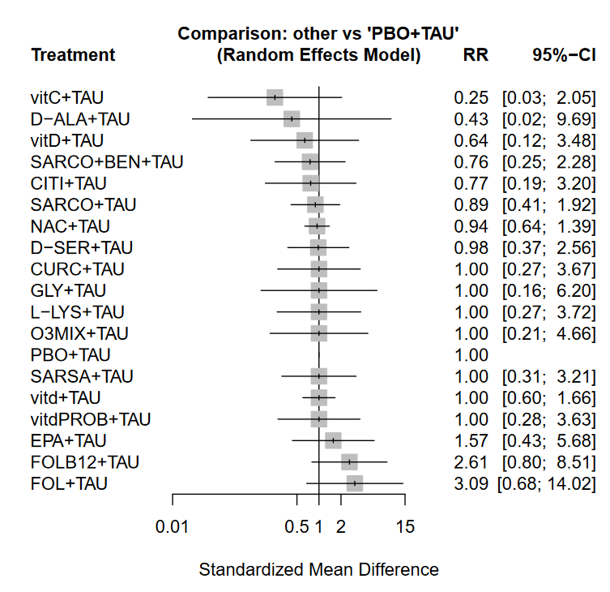
e-figure 32. Network plot and cumulative ranking of nutraceuticals and phytoceuticals for acceptability (drop-out due to any cause), sensitivity analysis with SCZ patients only. SUCRA is intended to present the molecules ranked from the most protective to the most related agent for the outcome in point (drop-out).
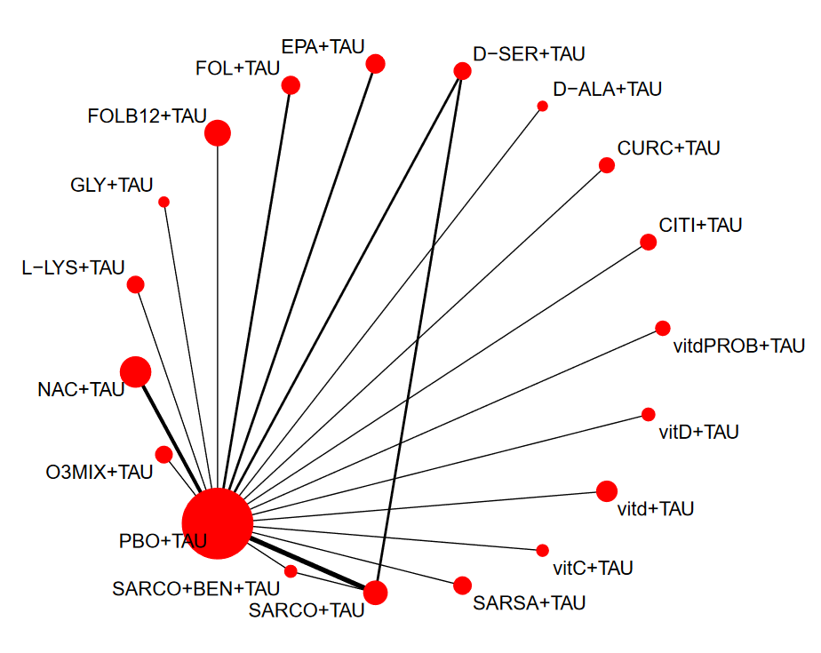
SUCRA
vitC+TAU | 0.8546
D-ALA+TAU | 0.6784
vitD+TAU | 0.65
SARCO+BEN+TAU | 0.6232
CITI+TAU | 0.595
SARCO+TAU | 0.5476
NAC+TAU | 0.5217
D-SER+TAU | 0.5067
O3MIX+TAU | 0.5053
SARSA+TAU | 0.5018
GLY+TAU | 0.4992
CURC+TAU | 0.4955
vitdPROB+TAU | 0.4866
PBO+TAU | 0.4818
vitd+TAU | 0.4798
L-LYS+TAU | 0.4743
EPA+TAU | 0.3203
FOLB12+TAU | 0.1407
FOL+TAU | 0.1374

e-figure 33. Network plot, forest plot and cumulative ranking of nutraceuticals and phytoceuticals for tolerability (drop-out due to adverse events). SUCRA is intended to present the molecules ranked from the most protective to the most related agent for the outcome in point (drop-out).
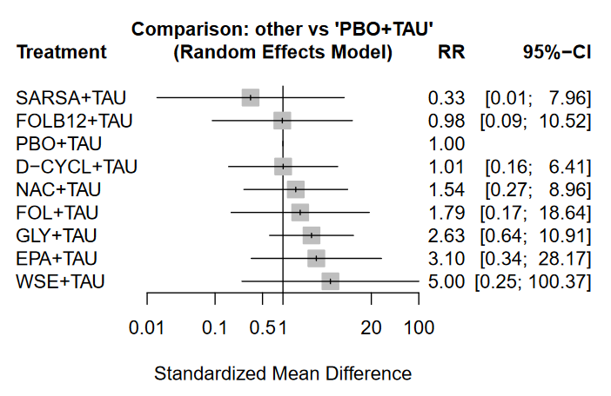
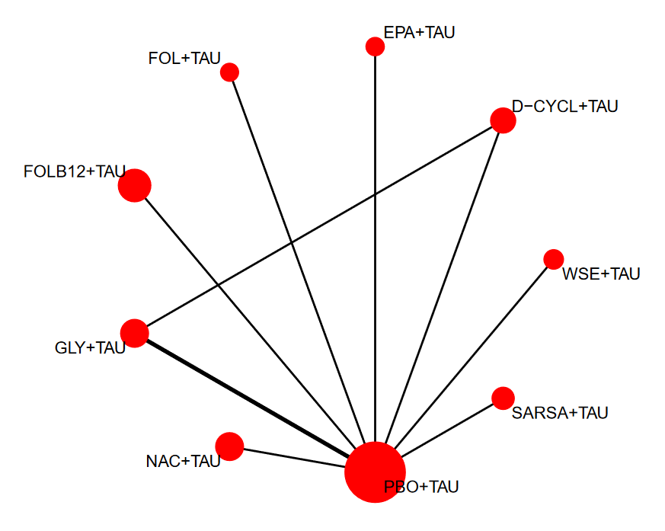

SUCRA
SARSA+TAU | 0.7959
PBO+TAU | 0.6502
D-CYCL+TAU | 0.6124
FOLB12+TAU | 0.6041
NAC+TAU | 0.4899
FOL+TAU | 0.4596
EPA+TAU | 0.331
GLY+TAU | 0.3085
WSE+TAU | 0.2484

Section 4 (S4) - League tables
e-table 2. Standardized mean differences and 95% confidence intervals of nutraceuticals and phytoceuticals on change in total symptomatology, all studies. Direct and indirect comparisons are shown in the top right and bottom left areas—direct and indirect comparisons with statistically significant differences, in bold. In the upper triangle negative values favor row molecules whereas in the lower triangle negative values favor column compounds.
L-LYS+TAU | . | . | . | . | . | . | . | . | . | . | . | . | . | . | . | . | . | . | . | -1.04 [-1.84; -0.25] | . | .
0.00 [-1.13; 1.14] | CITI+TAU | . | . | . | . | . | . | . | . | . | . | . | . | . | . | . | . | . | . | -1.05 [-1.85; -0.24] | . | .
-0.17 [-1.06; 0.71] | -0.18 [-1.08; 0.72] | NAC+TAU | . | . | . | . | . | . | . | . | . | . | . | . | . | . | . | . | . | -0.87 [-1.27; -0.47] | . | .
-0.22 [-1.47; 1.02] | -0.23 [-1.48; 1.03] | -0.05 [-1.09; 0.99] | D-ALA+TAU | . | . | . | . | . | . | . | . | . | . | . | . | . | . | . | . | -0.82 [-1.78; 0.14] | . | .
-0.33 [-1.46; 0.80] | -0.33 [-1.47; 0.80] | -0.15 [-1.05; 0.74] | -0.10 [-1.35; 1.14] | WSE+TAU | . | . | . | . | . | . | . | . | . | . | . | . | . | . | . | -0.71 [-1.51; 0.08] | . | .
-0.54 [-1.42; 0.34] | -0.54 [-1.43; 0.35] | -0.37 [-0.91; 0.18] | -0.32 [-1.34; 0.71] | -0.21 [-1.09; 0.67] | SARCO+TAU | . | . | . | . | -0.03 [-0.95; 0.90] | . | . | . | -0.33 [-0.97; 0.31] | . | . | . | . | . | -0.51 [-0.89; -0.14] | . | .
-0.49 [-1.59; 0.62] | -0.49 [-1.60; 0.63] | -0.31 [-1.18; 0.55] | -0.26 [-1.49; 0.97] | -0.16 [-1.26; 0.95] | 0.05 [-0.80; 0.91] | SARSA+TAU | . | . | . | . | . | . | . | . | . | . | . | . | . | -0.56 [-1.32; 0.21] | . | .
-0.63 [-1.76; 0.50] | -0.63 [-1.77; 0.51] | -0.45 [-1.35; 0.45] | -0.40 [-1.66; 0.85] | -0.30 [-1.43; 0.84] | -0.09 [-0.97; 0.80] | -0.14 [-1.25; 0.97] | vitdPROB+TAU | . | . | . | . | . | . | . | . | . | . | . | . | -0.42 [-1.22; 0.39] | . | .
-0.73 [-1.81; 0.34] | -0.73 [-1.82; 0.35] | -0.56 [-1.38; 0.27] | -0.51 [-1.71; 0.69] | -0.40 [-1.48; 0.67] | -0.19 [-1.00; 0.62] | -0.25 [-1.30; 0.81] | -0.10 [-1.19; 0.98] | YOKU+TAU | . | . | . | . | . | . | . | . | . | . | . | -0.31 [-1.03; 0.41] | . | .
-0.79 [-1.79; 0.20] | -0.79 [-1.80; 0.21] | -0.62 [-1.34; 0.10] | -0.57 [-1.70; 0.56] | -0.46 [-1.46; 0.54] | -0.25 [-0.96; 0.45] | -0.31 [-1.28; 0.67] | -0.16 [-1.17; 0.84] | -0.06 [-1.00; 0.88] | CURC+TAU | . | . | . | . | . | . | . | . | . | . | -0.25 [-0.85; 0.35] | . | .
-0.79 [-1.93; 0.35] | -0.79 [-1.95; 0.36] | -0.62 [-1.53; 0.29] | -0.57 [-1.83; 0.69] | -0.46 [-1.61; 0.68] | -0.25 [-1.07; 0.57] | -0.31 [-1.43; 0.82] | -0.16 [-1.31; 0.99] | -0.06 [-1.15; 1.03] | 0.00 [-1.02; 1.02] | SARCO+BEN+TAU | . | . | . | . | . | . | . | . | . | -0.03 [-0.95; 0.90] | . | .
-0.82 [-1.70; 0.07] | -0.82 [-1.72; 0.08] | -0.64 [-1.20; -0.08] | -0.59 [-1.63; 0.44] | -0.49 [-1.38; 0.40] | -0.28 [-0.82; 0.27] | -0.33 [-1.19; 0.53] | -0.19 [-1.09; 0.71] | -0.08 [-0.91; 0.74] | -0.02 [-0.74; 0.69] | -0.02 [-0.93; 0.89] | O3MIX+TAU | . | . | . | . | . | . | . | . | -0.23 [-0.62; 0.17] | . | .
-0.85 [-1.74; 0.05] | -0.85 [-1.76; 0.06] | -0.67 [-1.25; -0.10] | -0.62 [-1.67; 0.42] | -0.52 [-1.42; 0.38] | -0.31 [-0.86; 0.24] | -0.36 [-1.23; 0.51] | -0.22 [-1.13; 0.68] | -0.12 [-0.95; 0.71] | -0.06 [-0.79; 0.67] | -0.06 [-0.97; 0.86] | -0.03 [-0.60; 0.54] | EPA+TAU | . | . | . | . | . | . | . | -0.19 [-0.61; 0.22] | . | -0.38 [-1.32; 0.56]
-0.90 [-1.91; 0.11] | -0.90 [-1.93; 0.12] | -0.73 [-1.47; 0.01] | -0.68 [-1.82; 0.47] | -0.57 [-1.59; 0.44] | -0.36 [-1.09; 0.37] | -0.42 [-1.41; 0.57] | -0.27 [-1.30; 0.75] | -0.17 [-1.13; 0.79] | -0.11 [-0.98; 0.76] | -0.11 [-1.14; 0.92] | -0.09 [-0.83; 0.65] | -0.05 [-0.80; 0.70] | FOL+TAU | . | . | . | . | . | . | -0.14 [-0.77; 0.49] | . | .
-0.91 [-1.83; 0.02] | -0.91 [-1.85; 0.03] | -0.73 [-1.35; -0.11] | -0.68 [-1.75; 0.39] | -0.58 [-1.51; 0.35] | -0.36 [-0.89; 0.16] | -0.42 [-1.32; 0.48] | -0.28 [-1.22; 0.66] | -0.17 [-1.04; 0.69] | -0.11 [-0.88; 0.65] | -0.11 [-1.04; 0.81] | -0.09 [-0.71; 0.53] | -0.06 [-0.69; 0.58] | -0.00 [-0.79; 0.79] | D-SER+TAU | . | . | . | . | . | -0.13 [-0.64; 0.38] | . | .
-0.93 [-2.01; 0.16] | -0.93 [-2.02; 0.17] | -0.75 [-1.59; 0.09] | -0.70 [-1.91; 0.51] | -0.60 [-1.68; 0.49] | -0.38 [-1.21; 0.44] | -0.44 [-1.50; 0.62] | -0.30 [-1.39; 0.79] | -0.19 [-1.22; 0.84] | -0.13 [-1.08; 0.82] | -0.13 [-1.23; 0.97] | -0.11 [-0.94; 0.73] | -0.08 [-0.92; 0.77] | -0.02 [-0.99; 0.94] | -0.02 [-0.90; 0.86] | CERLYS+TAU | . | . | . | . | -0.12 [-0.85; 0.62] | . | .
-1.03 [-2.09; 0.04] | -1.03 [-2.10; 0.05] | -0.85 [-1.66; -0.04] | -0.80 [-1.99; 0.39] | -0.70 [-1.76; 0.37] | -0.49 [-1.28; 0.31] | -0.54 [-1.58; 0.50] | -0.40 [-1.47; 0.68] | -0.29 [-1.31; 0.72] | -0.23 [-1.16; 0.70] | -0.23 [-1.32; 0.85] | -0.21 [-1.02; 0.60] | -0.18 [-1.00; 0.64] | -0.12 [-1.07; 0.82] | -0.12 [-0.98; 0.74] | -0.10 [-1.12; 0.92] | MANG+TAU | . | . | . | -0.02 [-0.73; 0.69] | . | .
-1.05 [-2.17; 0.07] | -1.05 [-2.18; 0.08] | -0.87 [-1.76; 0.01] | -0.83 [-2.07; 0.42] | -0.72 [-1.85; 0.40] | -0.51 [-1.38; 0.37] | -0.56 [-1.67; 0.54] | -0.42 [-1.55; 0.71] | -0.32 [-1.39; 0.76] | -0.26 [-1.25; 0.74] | -0.26 [-1.40; 0.88] | -0.23 [-1.12; 0.65] | -0.20 [-1.09; 0.69] | -0.15 [-1.16; 0.86] | -0.14 [-1.07; 0.78] | -0.12 [-1.21; 0.96] | -0.02 [-1.09; 1.04] | SULFO+TAU | . | . | 0.01 [-0.79; 0.80] | . | .
-1.06 [-2.13; 0.01] | -1.06 [-2.14; 0.02] | -0.88 [-1.70; -0.06] | -0.83 [-2.03; 0.36] | -0.73 [-1.80; 0.34] | -0.52 [-1.32; 0.29] | -0.57 [-1.62; 0.48] | -0.43 [-1.51; 0.65] | -0.33 [-1.34; 0.69] | -0.27 [-1.20; 0.67] | -0.27 [-1.36; 0.82] | -0.24 [-1.06; 0.58] | -0.21 [-1.04; 0.62] | -0.16 [-1.11; 0.80] | -0.15 [-1.02; 0.71] | -0.13 [-1.16; 0.90] | -0.03 [-1.04; 0.98] | -0.01 [-1.08; 1.06] | FOLB12+TAU | . | 0.02 [-0.70; 0.73] | . | .
-1.13 [-2.39; 0.13] | -1.13 [-2.40; 0.14] | -0.95 [-2.01; 0.10] | -0.90 [-2.27; 0.47] | -0.80 [-2.06; 0.46] | -0.59 [-1.63; 0.46] | -0.64 [-1.89; 0.60] | -0.50 [-1.77; 0.77] | -0.40 [-1.61; 0.82] | -0.34 [-1.48; 0.81] | -0.34 [-1.61; 0.94] | -0.31 [-1.37; 0.74] | -0.28 [-1.34; 0.78] | -0.23 [-1.39; 0.94] | -0.22 [-1.31; 0.87] | -0.20 [-1.43; 1.02] | -0.10 [-1.31; 1.11] | -0.08 [-1.34; 1.18] | -0.07 [-1.28; 1.14] | GLY+TAU | 0.09 [-0.89; 1.06] | . | .
-1.04 [-1.84; -0.25] | -1.05 [-1.85; -0.24] | -0.87 [-1.27; -0.47] | -0.82 [-1.78; 0.14] | -0.71 [-1.51; 0.08] | -0.50 [-0.87; -0.13] | -0.56 [-1.32; 0.21] | -0.42 [-1.22; 0.39] | -0.31 [-1.03; 0.41] | -0.25 [-0.85; 0.35] | -0.25 [-1.07; 0.57] | -0.23 [-0.62; 0.17] | -0.19 [-0.61; 0.22] | -0.14 [-0.77; 0.49] | -0.14 [-0.62; 0.34] | -0.12 [-0.85; 0.62] | -0.02 [-0.73; 0.69] | 0.01 [-0.79; 0.80] | 0.02 [-0.70; 0.73] | 0.09 [-0.89; 1.06] | PBO+TAU | -0.12 [-0.97; 0.72] | -0.13 [-1.08; 0.82]
-1.17 [-2.33; -0.01] | -1.17 [-2.34; 0.00] | -0.99 [-1.93; -0.06] | -0.94 [-2.22; 0.34] | -0.84 [-2.00; 0.33] | -0.63 [-1.55; 0.30] | -0.68 [-1.82; 0.46] | -0.54 [-1.71; 0.63] | -0.43 [-1.55; 0.68] | -0.37 [-1.41; 0.66] | -0.37 [-1.55; 0.80] | -0.35 [-1.28; 0.58] | -0.32 [-1.26; 0.62] | -0.26 [-1.32; 0.79] | -0.26 [-1.23; 0.71] | -0.24 [-1.36; 0.88] | -0.14 [-1.24; 0.96] | -0.12 [-1.28; 1.04] | -0.11 [-1.22; 1.00] | -0.04 [-1.33; 1.26] | -0.12 [-0.97; 0.72] | VitD+TAU | .
-1.20 [-2.36; -0.04] | -1.20 [-2.37; -0.04] | -1.03 [-1.96; -0.10] | -0.98 [-2.25; 0.30] | -0.87 [-2.03; 0.29] | -0.66 [-1.58; 0.26] | -0.72 [-1.86; 0.42] | -0.57 [-1.74; 0.59] | -0.47 [-1.58; 0.64] | -0.41 [-1.45; 0.62] | -0.41 [-1.59; 0.77] | -0.39 [-1.32; 0.54] | -0.35 [-1.19; 0.49] | -0.30 [-1.35; 0.75] | -0.30 [-1.27; 0.67] | -0.28 [-1.40; 0.84] | -0.18 [-1.28; 0.92] | -0.15 [-1.31; 1.00] | -0.14 [-1.25; 0.96] | -0.07 [-1.37; 1.22] | -0.16 [-1.00; 0.68] | -0.04 [-1.23; 1.16] | DHA+TAU

e-table 3. Standardized mean differences and 95% confidence intervals of nutraceuticals and phytoceuticals on change in total symptomatology, acute phase studies. Direct and indirect comparisons are shown in the top right and bottom left areas—direct and indirect comparisons with statistically significant differences, in bold. In the upper triangle negative values favor row molecules whereas in the lower triangle negative values favor column compounds.
NAC+TAU | . | . | . | . | . | -1.10 [-2.67; 0.47] | .
-0.04 [-2.22; 2.14] | L-LYS+TAU | . | . | . | . | -1.05 [-2.57; 0.46] | .
-0.39 [-2.57; 1.80] | -0.34 [-2.48; 1.80] | WSE+TAU | . | . | . | -0.71 [-2.23; 0.80] | .
-0.72 [-2.93; 1.50] | -0.67 [-2.85; 1.51] | -0.33 [-2.51; 1.85] | SARCO+TAU | . | . | -0.38 [-1.95; 1.18] | -0.57 [-2.15; 1.00]
-0.82 [-2.72; 1.08] | -0.77 [-2.62; 1.08] | -0.43 [-2.29; 1.42] | -0.10 [-2.00; 1.79] | O3MIX+TAU | . | -0.28 [-1.35; 0.79] | .
-1.22 [-3.42; 0.98] | -1.18 [-3.34; 0.98] | -0.84 [-3.00; 1.32] | -0.51 [-2.70; 1.69] | -0.40 [-2.28; 1.47] | vitD+TAU | 0.12 [-1.42; 1.66] | .
-1.10 [-2.67; 0.47] | -1.05 [-2.57; 0.46] | -0.71 [-2.23; 0.80] | -0.38 [-1.95; 1.18] | -0.28 [-1.35; 0.79] | 0.12 [-1.42; 1.66] | PBO+TAU | -0.19 [-1.75; 1.37]
-1.29 [-3.51; 0.92] | -1.25 [-3.42; 0.93] | -0.91 [-3.08; 1.27] | -0.57 [-2.15; 1.00] | -0.47 [-2.36; 1.42] | -0.07 [-2.26; 2.13] | -0.19 [-1.75; 1.37] | D-SER+TAU

e-table 4. standardized mean differences and 95% confidence intervals of nutraceuticals and phytoceuticals on change in total symptomatology, studies with clinically stable patients. Direct and indirect comparisons are shown in the top right and bottom left areas—direct and indirect comparisons with statistically significant differences, in bold. In the upper triangle negative values favor row molecules whereas in the lower triangle negative values favor column compounds.
SARCO+TAU | . | . | . | . | . | . | . | -1.26 [-1.91; -0.60] | . | .
-0.21 [-1.10; 0.68] | CITI+TAU | . | . | . | . | . | . | -1.05 [-1.65; -0.44] | . | .
-0.70 [-1.45; 0.05] | -0.49 [-1.20; 0.21] | NAC+TAU | . | . | . | . | . | -0.55 [-0.92; -0.19] | . | .
-0.95 [-1.76; -0.13] | -0.73 [-1.51; 0.04] | -0.24 [-0.85; 0.36] | YOKU+TAU | . | . | . | . | -0.31 [-0.79; 0.17] | . | .
-0.99 [-1.79; -0.19] | -0.78 [-1.54; -0.02] | -0.29 [-0.88; 0.30] | -0.05 [-0.71; 0.62] | CURC+TAU | . | . | . | -0.27 [-0.73; 0.20] | . | .
-1.10 [-1.96; -0.24] | -0.89 [-1.71; -0.07] | -0.40 [-1.07; 0.27] | -0.16 [-0.90; 0.58] | -0.11 [-0.84; 0.61] | O3MIX+TAU | . | . | -0.15 [-0.71; 0.41] | . | .
-1.19 [-2.09; -0.28] | -0.97 [-1.84; -0.11] | -0.48 [-1.21; 0.24] | -0.24 [-1.03; 0.55] | -0.19 [-0.97; 0.58] | -0.08 [-0.92; 0.75] | D-SER+TAU | . | -0.07 [-0.69; 0.55] | . | .
-1.27 [-2.08; -0.46] | -1.06 [-1.83; -0.29] | -0.57 [-1.17; 0.03] | -0.33 [-1.00; 0.35] | -0.28 [-0.94; 0.38] | -0.17 [-0.90; 0.57] | -0.09 [-0.87; 0.70] | FOLB12+TAU | 0.02 [-0.46; 0.49] | . | .
-1.26 [-1.91; -0.60] | -1.05 [-1.65; -0.44] | -0.55 [-0.92; -0.19] | -0.31 [-0.79; 0.17] | -0.27 [-0.73; 0.20] | -0.15 [-0.71; 0.41] | -0.07 [-0.69; 0.55] | 0.02 [-0.46; 0.49] | PBO+TAU | -0.09 [-0.90; 0.73] | -0.21 [-1.01; 0.60]
-1.34 [-2.39; -0.29] | -1.13 [-2.15; -0.11] | -0.64 [-1.54; 0.26] | -0.40 [-1.35; 0.55] | -0.35 [-1.29; 0.59] | -0.24 [-1.23; 0.75] | -0.16 [-1.18; 0.87] | -0.07 [-1.02; 0.88] | -0.09 [-0.90; 0.73] | GLY+TAU | .
-1.46 [-2.50; -0.43] | -1.25 [-2.26; -0.24] | -0.76 [-1.65; 0.13] | -0.52 [-1.46; 0.42] | -0.47 [-1.40; 0.46] | -0.36 [-1.34; 0.62] | -0.28 [-1.30; 0.74] | -0.19 [-1.13; 0.74] | -0.21 [-1.01; 0.60] | -0.12 [-1.27; 1.03] | FOL+TAU

e-table 5. standardized mean differences and 95% confidence intervals of nutraceuticals and phytoceuticals on change in total symptomatology, all phases of disease, sensitivity analysis without high RoB studies. Direct and indirect comparisons are shown in the top right and bottom left areas—direct and indirect comparisons with statistically significant differences, in bold. In the upper triangle negative values favor row molecules whereas in the lower triangle negative values favor column compounds.
L-LYS+TAU | . | . | . | . | . | . | . | . | . | . | . | . | . | . | . | -1.04 [-1.83; -0.26] | .
0.00 [-1.12; 1.12] | CITI+TAU | . | . | . | . | . | . | . | . | . | . | . | . | . | . | -1.05 [-1.84; -0.25] | .
-0.22 [-1.46; 1.01] | -0.23 [-1.47; 1.02] | D-ALA+TAU | . | . | . | . | . | . | . | . | . | . | . | . | . | -0.82 [-1.77; 0.13] | .
-0.33 [-1.24; 0.58] | -0.33 [-1.25; 0.59] | -0.10 [-1.16; 0.95] | NAC+TAU | . | . | . | . | . | . | . | . | . | . | . | . | -0.72 [-1.17; -0.26] | .
-0.33 [-1.44; 0.78] | -0.33 [-1.45; 0.79] | -0.10 [-1.34; 1.13] | -0.00 [-0.91; 0.91] | WSE+TAU | . | . | . | . | . | . | . | . | . | . | . | -0.71 [-1.50; 0.07] | .
-0.45 [-1.33; 0.44] | -0.45 [-1.34; 0.45] | -0.22 [-1.25; 0.81] | -0.12 [-0.73; 0.49] | -0.12 [-1.00; 0.77] | SARCO+TAU | . | . | . | -0.33 [-0.97; 0.30] | . | . | . | . | . | . | -0.60 [-1.01; -0.19] | .
-0.53 [-1.49; 0.43] | -0.53 [-1.50; 0.44] | -0.30 [-1.40; 0.80] | -0.20 [-0.92; 0.52] | -0.20 [-1.16; 0.77] | -0.08 [-0.77; 0.61] | O3MIX+TAU | . | . | . | . | . | . | . | . | . | -0.52 [-1.07; 0.04] | .
-0.63 [-1.75; 0.49] | -0.63 [-1.76; 0.50] | -0.40 [-1.64; 0.84] | -0.30 [-1.22; 0.62] | -0.30 [-1.42; 0.82] | -0.18 [-1.08; 0.71] | -0.10 [-1.07; 0.87] | vitdPROB+TAU | . | . | . | . | . | . | . | . | -0.42 [-1.21; 0.38] | .
-0.73 [-1.79; 0.33] | -0.73 [-1.80; 0.34] | -0.51 [-1.70; 0.68] | -0.40 [-1.25; 0.44] | -0.40 [-1.47; 0.66] | -0.29 [-1.11; 0.53] | -0.20 [-1.11; 0.70] | -0.10 [-1.17; 0.97] | YOKU+TAU | . | . | . | . | . | . | . | -0.31 [-1.02; 0.40] | .
-0.83 [-1.81; 0.15] | -0.83 [-1.82; 0.16] | -0.60 [-1.72; 0.51] | -0.50 [-1.24; 0.24] | -0.50 [-1.48; 0.49] | -0.38 [-0.97; 0.21] | -0.30 [-1.11; 0.51] | -0.20 [-1.19; 0.79] | -0.10 [-1.02; 0.83] | D-SER+TAU | . | . | . | . | . | . | -0.17 [-0.81; 0.47] | .
-0.86 [-1.77; 0.04] | -0.86 [-1.78; 0.05] | -0.64 [-1.69; 0.41] | -0.53 [-1.17; 0.11] | -0.53 [-1.44; 0.37] | -0.42 [-1.02; 0.19] | -0.33 [-1.05; 0.38] | -0.23 [-1.15; 0.68] | -0.13 [-0.97; 0.71] | -0.04 [-0.78; 0.71] | EPA+TAU | . | . | . | . | . | -0.18 [-0.63; 0.27] | .
-2.24 [-3.23; -1.24] | -0.91 [-1.91; 0.09] | -0.90 [-1.92; 0.11] | -0.68 [-1.81; 0.46] | -0.57 [-1.34; 0.20] | -0.57 [-1.58; 0.43] | -0.46 [-1.20; 0.29] | -0.37 [-1.21; 0.46] | -0.27 [-1.28; 0.74] | -0.07 [-0.93; 0.78] | -0.04 [-0.81; 0.73] | FOL+TAU | . | . | . | . | -0.14 [-0.76; 0.48] | .
-2.38 [-3.56; -1.21] | -1.06 [-2.24; 0.12] | -1.05 [-2.24; 0.14] | -0.82 [-2.12; 0.47] | -0.72 [-1.71; 0.27] | -0.72 [-1.90; 0.46] | -0.60 [-1.58; 0.37] | -0.52 [-1.56; 0.52] | -0.42 [-1.61; 0.77] | -0.22 [-1.28; 0.84] | -0.19 [-1.18; 0.81] | -0.15 [-1.23; 0.93] | CURC+TAU | . | . | . | 0.00 [-0.88; 0.89] | .
-2.36 [-3.40; -1.32] | -1.04 [-2.09; 0.01] | -1.03 [-2.09; 0.03] | -0.80 [-1.98; 0.38] | -0.70 [-1.53; 0.13] | -0.70 [-1.75; 0.36] | -0.58 [-1.39; 0.23] | -0.50 [-1.39; 0.40] | -0.40 [-1.46; 0.66] | -0.20 [-1.11; 0.71] | -0.16 [-0.99; 0.67] | -0.12 [-1.06; 0.81] | 0.02 [-1.10; 1.15] | MANG+TAU | . | . | -0.02 [-0.72; 0.68] | .
-2.39 [-3.44; -1.34] | -1.07 [-2.13; -0.01] | -1.06 [-2.13; 0.01] | -0.83 [-2.02; 0.35] | -0.73 [-1.57; 0.11] | -0.73 [-1.79; 0.33] | -0.61 [-1.43; 0.20] | -0.53 [-1.43; 0.37] | -0.43 [-1.50; 0.64] | -0.23 [-1.15; 0.69] | -0.20 [-1.03; 0.64] | -0.16 [-1.10; 0.78] | -0.01 [-1.14; 1.12] | -0.03 [-1.03; 0.96] | FOLB12+TAU | . | 0.02 [-0.69; 0.72] | .
-2.46 [-3.71; -1.22] | -1.14 [-2.39; 0.11] | -1.13 [-2.39; 0.13] | -0.90 [-2.26; 0.46] | -0.80 [-1.87; 0.27] | -0.80 [-2.05; 0.45] | -0.68 [-1.74; 0.37] | -0.60 [-1.72; 0.52] | -0.50 [-1.76; 0.76] | -0.30 [-1.44; 0.84] | -0.27 [-1.34; 0.81] | -0.23 [-1.38; 0.93] | -0.08 [-1.39; 1.23] | -0.10 [-1.30; 1.09] | -0.07 [-1.27; 1.13] | GLY+TAU | 0.09 [-0.89; 1.06] | .
-2.38 [-3.15; -1.60] | -1.05 [-1.84; -0.27] | -1.05 [-1.84; -0.25] | -0.82 [-1.77; 0.13] | -0.72 [-1.17; -0.26] | -0.71 [-1.50; 0.07] | -0.60 [-1.01; -0.19] | -0.52 [-1.07; 0.04] | -0.42 [-1.21; 0.38] | -0.22 [-0.81; 0.37] | -0.18 [-0.63; 0.27] | -0.14 [-0.76; 0.48] | 0.00 [-0.88; 0.89] | -0.02 [-0.72; 0.68] | 0.02 [-0.69; 0.72] | 0.09 [-0.89; 1.06] | PBO+TAU | -0.12 [-0.96; 0.71]
-2.50 [-3.64; -1.36] | -1.18 [-2.33; -0.03] | -1.17 [-2.33; -0.01] | -0.94 [-2.21; 0.32] | -0.84 [-1.79; 0.11] | -0.84 [-1.99; 0.31] | -0.72 [-1.65; 0.21] | -0.64 [-1.64; 0.37] | -0.54 [-1.70; 0.62] | -0.34 [-1.36; 0.68] | -0.30 [-1.26; 0.65] | -0.27 [-1.31; 0.78] | -0.12 [-1.34; 1.10] | -0.14 [-1.23; 0.95] | -0.11 [-1.21; 0.99] | -0.04 [-1.32; 1.24] | -0.12 [-0.96; 0.71] | vitD+TAU

e-table 6. standardized mean differences and 95% confidence intervals of nutraceuticals and phytoceuticals on change in total symptomatology, acute phase studies, sensitivity analysis without high RoB studies. Direct and indirect comparisons are shown in the top right and bottom left areas—direct and indirect comparisons with statistically significant differences, in bold. In the upper triangle negative values favor row molecules whereas in the lower triangle negative values favor column compounds.
NAC+TAU | . | . | . | . | -1.10 [-1.75; -0.45] | . | .
-0.04 [-0.86; 0.77] | L-LYS+TAU | . | . | . | -1.05 [-1.55; -0.56] | . | .
-0.27 [-1.08; 0.54] | -0.23 [-0.92; 0.46] | O3MIX+TAU | . | . | -0.83 [-1.31; -0.34] | . | .
-0.39 [-1.20; 0.43] | -0.34 [-1.04; 0.36] | -0.11 [-0.81; 0.58] | WSE+TAU | . | -0.71 [-1.21; -0.22] | . | .
-0.72 [-1.63; 0.20] | -0.67 [-1.48; 0.14] | -0.44 [-1.25; 0.36] | -0.33 [-1.14; 0.48] | SARCO+TAU | -0.38 [-1.02; 0.26] | . | -0.57 [-1.23; 0.08]
-1.10 [-1.75; -0.45] | -1.05 [-1.55; -0.56] | -0.83 [-1.31; -0.34] | -0.71 [-1.21; -0.22] | -0.38 [-1.02; 0.26] | PBO+TAU | -0.12 [-0.70; 0.45] | -0.19 [-0.82; 0.44]
-1.22 [-2.09; -0.36] | -1.18 [-1.93; -0.42] | -0.95 [-1.70; -0.20] | -0.84 [-1.60; -0.08] | -0.51 [-1.37; 0.35] | -0.12 [-0.70; 0.45] | vitD+TAU | .
-1.29 [-2.19; -0.39] | -1.25 [-2.05; -0.45] | -1.02 [-1.81; -0.22] | -0.91 [-1.71; -0.10] | -0.57 [-1.23; 0.08] | -0.19 [-0.82; 0.44] | -0.07 [-0.92; 0.78] | D-SER+TAU

e-table 7. standardized mean differences and 95% confidence intervals of nutraceuticals and phytoceuticals on change in total symptomatology, studies with clinically stable patients, sensitivity analysis without high RoB studies. Direct and indirect comparisons are shown in the top right and bottom left areas—direct and indirect comparisons with statistically significant differences, in bold. In the upper triangle negative values favor row molecules whereas in the lower triangle negative values favor column compounds.
SARCO+TAU | . | . | . | . | -1.26 [-1.92; -0.60] | . | . | .
-0.21 [-1.11; 0.69] | CITI+TAU | . | . | . | -1.05 [-1.66; -0.43] | . | . | .
-0.70 [-1.46; 0.06] | -0.49 [-1.21; 0.23] | NAC+TAU | . | . | -0.56 [-0.93; -0.18] | . | . | .
-0.95 [-1.77; -0.12] | -0.73 [-1.52; 0.05] | -0.24 [-0.86; 0.37] | YOKU+TAU | . | -0.31 [-0.80; 0.18] | . | . | .
-1.26 [-2.24; -0.29] | -1.05 [-1.99; -0.11] | -0.56 [-1.37; 0.25] | -0.32 [-1.18; 0.55] | CURC+TAU | 0.00 [-0.71; 0.72] | . | . | .
-1.26 [-1.92; -0.60] | -1.05 [-1.66; -0.43] | -0.56 [-0.93; -0.18] | -0.31 [-0.80; 0.18] | 0.00 [-0.71; 0.72] | PBO+TAU | -0.02 [-0.50; 0.47] | -0.09 [-0.91; 0.74] | -0.21 [-1.02; 0.61]
-1.27 [-2.09; -0.45] | -1.06 [-1.84; -0.28] | -0.57 [-1.18; 0.04] | -0.33 [-1.02; 0.36] | -0.01 [-0.88; 0.85] | -0.02 [-0.50; 0.47] | FOLB12+TAU | . | .
-1.34 [-2.40; -0.29] | -1.13 [-2.16; -0.10] | -0.64 [-1.55; 0.26] | -0.40 [-1.36; 0.56] | -0.08 [-1.17; 1.01] | -0.09 [-0.91; 0.74] | -0.07 [-1.03; 0.89] | GLY+TAU | .
-1.46 [-2.51; -0.42] | -1.25 [-2.27; -0.24] | -0.76 [-1.66; 0.13] | -0.52 [-1.47; 0.43] | -0.20 [-1.28; 0.88] | -0.21 [-1.02; 0.61] | -0.19 [-1.14; 0.75] | -0.12 [-1.28; 1.04] | FOL+TAU

e-table 8. standardized mean differences and 95% confidence intervals of nutraceuticals and phytoceuticals on change in total symptomatology, all phases, sensitivity analysis with SCZ patients only. Direct and indirect comparisons are shown in the top right and bottom left areas—direct and indirect comparisons with statistically significant differences, in bold. In the upper triangle negative values favor row molecules whereas in the lower triangle negative values favor column compounds.
L-LYS+TAU | . | . | . | . | . | . | . | . | . | . | . | . | . | . | . | -1.04 [-1.84; -0.24] | . | .
0.00 [-1.14; 1.14] | CITI+TAU | . | . | . | . | . | . | . | . | . | . | . | . | . | . | -1.05 [-1.86; -0.23] | . | .
-0.16 [-1.08; 0.77] | -0.16 [-1.09; 0.78] | NAC+TAU | . | . | . | . | . | . | . | . | . | . | . | . | . | -0.89 [-1.35; -0.43] | . | .
-0.22 [-1.47; 1.03] | -0.23 [-1.48; 1.03] | -0.07 [-1.13; 1.00] | D-ALA+TAU | . | . | . | . | . | . | . | . | . | . | . | . | -0.82 [-1.78; 0.14] | . | .
-0.43 [-1.33; 0.46] | -0.43 [-1.34; 0.47] | -0.28 [-0.89; 0.33] | -0.21 [-1.25; 0.84] | SARCO+TAU | . | . | . | . | -0.03 [-0.96; 0.90] | -0.33 [-0.98; 0.31] | . | . | . | . | . | -0.62 [-1.02; -0.21] | . | .
-0.49 [-1.60; 0.62] | -0.49 [-1.61; 0.63] | -0.33 [-1.23; 0.57] | -0.26 [-1.49; 0.97] | -0.06 [-0.93; 0.82] | SARSA+TAU | . | . | . | . | . | . | . | . | . | . | -0.56 [-1.33; 0.21] | . | .
-0.58 [-1.72; 0.56] | -0.58 [-1.73; 0.57] | -0.42 [-1.36; 0.51] | -0.35 [-1.62; 0.91] | -0.15 [-1.06; 0.76] | -0.09 [-1.22; 1.03] | CURC+TAU | . | . | . | . | . | . | . | . | . | -0.46 [-1.28; 0.35] | . | .
-0.63 [-1.77; 0.51] | -0.63 [-1.78; 0.52] | -0.47 [-1.40; 0.46] | -0.40 [-1.66; 0.85] | -0.20 [-1.10; 0.71] | -0.14 [-1.26; 0.98] | -0.05 [-1.20; 1.10] | vitdPROB+TAU | . | . | . | . | . | . | . | . | -0.42 [-1.23; 0.40] | . | .
-0.74 [-1.68; 0.20] | -0.74 [-1.69; 0.21] | -0.59 [-1.26; 0.09] | -0.52 [-1.60; 0.56] | -0.31 [-0.95; 0.33] | -0.25 [-1.17; 0.66] | -0.16 [-1.12; 0.79] | -0.11 [-1.06; 0.84] | EPA+TAU | . | . | . | . | . | . | . | -0.30 [-0.80; 0.19] | -0.38 [-1.33; 0.57] | .
-0.74 [-1.89; 0.41] | -0.74 [-1.90; 0.42] | -0.58 [-1.53; 0.36] | -0.51 [-1.78; 0.76] | -0.31 [-1.13; 0.52] | -0.25 [-1.38; 0.88] | -0.16 [-1.32; 1.00] | -0.11 [-1.27; 1.05] | 0.00 [-0.96; 0.97] | SARCO+BEN+TAU | . | . | . | . | . | . | -0.03 [-0.96; 0.90] | . | .
-0.82 [-1.82; 0.18] | -0.82 [-1.83; 0.19] | -0.66 [-1.42; 0.09] | -0.60 [-1.73; 0.54] | -0.39 [-0.98; 0.21] | -0.33 [-1.31; 0.64] | -0.24 [-1.25; 0.77] | -0.19 [-1.20; 0.81] | -0.08 [-0.85; 0.70] | -0.08 [-1.06; 0.89] | D-SER+TAU | . | . | . | . | . | -0.17 [-0.82; 0.48] | . | .
-0.90 [-1.92; 0.11] | -0.90 [-1.93; 0.12] | -0.75 [-1.53; 0.03] | -0.68 [-1.83; 0.47] | -0.47 [-1.22; 0.28] | -0.42 [-1.41; 0.58] | -0.32 [-1.35; 0.71] | -0.27 [-1.30; 0.75] | -0.16 [-0.96; 0.64] | -0.17 [-1.20; 0.87] | -0.08 [-0.95; 0.78] | FOL+TAU | . | . | . | . | -0.14 [-0.77; 0.49] | . | .
-0.93 [-2.01; 0.16] | -0.93 [-2.03; 0.17] | -0.77 [-1.64; 0.10] | -0.70 [-1.91; 0.51] | -0.49 [-1.34; 0.35] | -0.44 [-1.51; 0.63] | -0.35 [-1.45; 0.76] | -0.30 [-1.40; 0.80] | -0.18 [-1.07; 0.71] | -0.19 [-1.30; 0.92] | -0.11 [-1.06; 0.84] | -0.02 [-0.99; 0.95] | CERLYS+TAU | . | . | . | -0.12 [-0.86; 0.62] | . | .
-1.02 [-1.94; -0.10] | -1.02 [-1.95; -0.09] | -0.86 [-1.51; -0.21] | -0.79 [-1.86; 0.27] | -0.59 [-1.20; 0.02] | -0.53 [-1.43; 0.37] | -0.44 [-1.37; 0.50] | -0.39 [-1.32; 0.54] | -0.28 [-0.95; 0.40] | -0.28 [-1.22; 0.67] | -0.20 [-0.95; 0.55] | -0.11 [-0.89; 0.67] | -0.09 [-0.96; 0.78] | O3MIX+TAU | . | . | -0.03 [-0.49; 0.43] | . | .
-1.06 [-2.14; 0.02] | -1.06 [-2.15; 0.03] | -0.90 [-1.76; -0.05] | -0.83 [-2.04; 0.37] | -0.63 [-1.46; 0.20] | -0.57 [-1.63; 0.49] | -0.48 [-1.57; 0.61] | -0.43 [-1.52; 0.66] | -0.32 [-1.19; 0.56] | -0.32 [-1.42; 0.78] | -0.24 [-1.17; 0.70] | -0.16 [-1.11; 0.80] | -0.13 [-1.17; 0.90] | -0.04 [-0.90; 0.81] | FOLB12+TAU | . | 0.02 [-0.71; 0.74] | . | .
-1.13 [-2.39; 0.14] | -1.13 [-2.41; 0.14] | -0.97 [-2.06; 0.11] | -0.90 [-2.28; 0.47] | -0.70 [-1.76; 0.36] | -0.64 [-1.89; 0.61] | -0.55 [-1.83; 0.73] | -0.50 [-1.77; 0.77] | -0.39 [-1.49; 0.71] | -0.39 [-1.68; 0.89] | -0.31 [-1.46; 0.84] | -0.23 [-1.39; 0.94] | -0.20 [-1.43; 1.03] | -0.11 [-1.20; 0.97] | -0.07 [-1.29; 1.15] | GLY+TAU | 0.09 [-0.90; 1.07] | . | .
-1.04 [-1.84; -0.24] | -1.05 [-1.86; -0.23] | -0.89 [-1.35; -0.43] | -0.82 [-1.78; 0.14] | -0.61 [-1.02; -0.21] | -0.56 [-1.33; 0.21] | -0.46 [-1.28; 0.35] | -0.42 [-1.23; 0.40] | -0.30 [-0.80; 0.19] | -0.31 [-1.13; 0.52] | -0.22 [-0.82; 0.37] | -0.14 [-0.77; 0.49] | -0.12 [-0.86; 0.62] | -0.03 [-0.49; 0.43] | 0.02 [-0.71; 0.74] | 0.09 [-0.90; 1.07] | PBO+TAU | -0.13 [-1.09; 0.82] | -0.12 [-0.97; 0.73]
-1.15 [-2.32; 0.02] | -1.15 [-2.33; 0.03] | -0.99 [-1.96; -0.02] | -0.92 [-2.21; 0.36] | -0.72 [-1.66; 0.23] | -0.66 [-1.81; 0.49] | -0.57 [-1.75; 0.62] | -0.52 [-1.70; 0.66] | -0.41 [-1.26; 0.45] | -0.41 [-1.60; 0.78] | -0.33 [-1.37; 0.72] | -0.24 [-1.31; 0.82] | -0.22 [-1.36; 0.91] | -0.13 [-1.10; 0.84] | -0.09 [-1.21; 1.03] | -0.02 [-1.32; 1.28] | -0.10 [-0.96; 0.75] | DHA+TAU | .
-1.17 [-2.33; 0.00] | -1.17 [-2.35; 0.01] | -1.01 [-1.98; -0.05] | -0.94 [-2.23; 0.34] | -0.74 [-1.68; 0.21] | -0.68 [-1.83; 0.47] | -0.59 [-1.77; 0.59] | -0.54 [-1.71; 0.64] | -0.43 [-1.41; 0.56] | -0.43 [-1.62; 0.76] | -0.35 [-1.39; 0.69] | -0.26 [-1.32; 0.79] | -0.24 [-1.37; 0.89] | -0.15 [-1.12; 0.82] | -0.11 [-1.22; 1.01] | -0.04 [-1.34; 1.26] | -0.12 [-0.97; 0.73] | -0.02 [-1.23; 1.19] | VitD+TAU

e-table 9. standardized mean differences and 95% confidence intervals of nutraceuticals and phytoceuticals on change in total symptomatology, acute phase studies, sensitivity analysis with SCZ patients only. Direct and indirect comparisons are shown in the top right and bottom left areas—direct and indirect comparisons with statistically significant differences, in bold. In the upper triangle negative values favor row molecules whereas in the lower triangle negative values favor column compounds.
NAC+TAU | . | . | -1.10 [-1.75; -0.45] | . | . | .
-0.04 [-0.86; 0.77] | L-LYS+TAU | . | -1.05 [-1.55; -0.56] | . | . | .
-0.72 [-1.63; 0.20] | -0.67 [-1.48; 0.14] | SARCO+TAU | -0.38 [-1.02; 0.26] | . | -0.57 [-1.23; 0.08] | .
-1.10 [-1.75; -0.45] | -1.05 [-1.55; -0.56] | -0.38 [-1.02; 0.26] | PBO+TAU | -0.12 [-0.70; 0.45] | -0.19 [-0.82; 0.44] | -0.26 [-0.74; 0.22]
-1.22 [-2.09; -0.36] | -1.18 [-1.93; -0.42] | -0.51 [-1.37; 0.35] | -0.12 [-0.70; 0.45] | vitD+TAU | . | .
-1.29 [-2.19; -0.39] | -1.25 [-2.05; -0.45] | -0.57 [-1.23; 0.08] | -0.19 [-0.82; 0.44] | -0.07 [-0.92; 0.78] | D-SER+TAU | .
-1.36 [-2.17; -0.55] | -1.32 [-2.01; -0.63] | -0.65 [-1.45; 0.16] | -0.26 [-0.74; 0.22] | -0.14 [-0.89; 0.61] | -0.07 [-0.86; 0.72] | O3MIX+TAU

e-table 10. standardized mean differences and 95% confidence intervals of nutraceuticals and phytoceuticals on change in total symptomatology, studies with clinically stable patients, sensitivity analysis with SCZ patients only. Direct and indirect comparisons are shown in the top right and bottom left areas—direct and indirect comparisons with statistically significant differences, in bold. In the upper triangle negative values favor row molecules whereas in the lower triangle negative values favor column compounds.
SARCO+TAU | . | . | . | . | -1.26 [-1.83; -0.68] | . | . | .
-0.21 [-0.98; 0.56] | CITI+TAU | . | . | . | -1.05 [-1.56; -0.53] | . | . | .
-0.79 [-1.57; -0.02] | -0.58 [-1.31; 0.15] | CURC+TAU | . | . | -0.46 [-0.99; 0.06] | . | . | .
-0.85 [-1.51; -0.18] | -0.63 [-1.25; -0.02] | -0.05 [-0.67; 0.57] | NAC+TAU | . | -0.41 [-0.75; -0.08] | . | . | .
-1.10 [-1.84; -0.37] | -0.89 [-1.58; -0.20] | -0.31 [-1.01; 0.39] | -0.26 [-0.83; 0.31] | O3MIX+TAU | -0.15 [-0.62; 0.31] | . | . | .
-1.26 [-1.83; -0.68] | -1.05 [-1.56; -0.53] | -0.46 [-0.99; 0.06] | -0.41 [-0.75; -0.08] | -0.15 [-0.62; 0.31] | PBO+TAU | -0.02 [-0.37; 0.34] | -0.09 [-0.84; 0.67] | -0.21 [-0.95; 0.54]
-1.27 [-1.95; -0.60] | -1.06 [-1.69; -0.43] | -0.48 [-1.11; 0.15] | -0.43 [-0.91; 0.06] | -0.17 [-0.75; 0.41] | -0.02 [-0.37; 0.34] | FOLB12+TAU | . | .
-1.34 [-2.29; -0.39] | -1.13 [-2.04; -0.22] | -0.55 [-1.47; 0.37] | -0.50 [-1.32; 0.33] | -0.24 [-1.12; 0.65] | -0.09 [-0.84; 0.67] | -0.07 [-0.90; 0.76] | GLY+TAU | .
-1.46 [-2.40; -0.53] | -1.25 [-2.16; -0.35] | -0.67 [-1.58; 0.24] | -0.62 [-1.43; 0.20] | -0.36 [-1.24; 0.51] | -0.21 [-0.95; 0.54] | -0.19 [-1.02; 0.63] | -0.12 [-1.18; 0.94] | FOL+TAU

e-table 11. standardized mean differences and 95% confidence intervals of nutraceuticals and phytoceuticals on change in positive symptoms, all studies. Direct and indirect comparisons are shown in the top right and bottom left areas—direct and indirect comparisons with statistically significant differences, in bold. In the upper triangle negative values favor row molecules whereas in the lower triangle negative values favor column compounds.

SARSA+TAU | . | . | . | . | . | . | . | . | . | . | . | . | . | . | . | . | . | . | . | . | -0.50 [-1.16; 0.15] | . | . | . | . | .
0.05 [-1.03; 1.12] | D-ALA+TAU | . | . | . | . | . | . | . | . | . | . | . | . | . | . | . | . | . | . | . | -0.55 [-1.41; 0.31] | . | . | . | . | .
-0.09 [-1.04; 0.86] | -0.13 [-1.23; 0.96] | WSE+TAU | . | . | . | . | . | . | . | . | . | . | . | . | . | . | . | . | . | . | -0.41 [-1.10; 0.27] | . | . | . | . | .
-0.12 [-1.09; 0.85] | -0.16 [-1.28; 0.95] | -0.03 [-1.02; 0.96] | GLY+TAU | . | . | . | . | . | . | . | . | . | . | . | . | . | . | . | . | . | -0.39 [-1.10; 0.33] | . | . | . | . | .
-0.23 [-1.13; 0.67] | -0.27 [-1.33; 0.78] | -0.14 [-1.06; 0.78] | -0.11 [-1.05; 0.83] | CERLYS+TAU | . | . | . | . | . | . | . | . | . | . | . | . | . | . | . | . | -0.28 [-0.90; 0.34] | . | . | . | . | .
-0.25 [-1.19; 0.70] | -0.29 [-1.39; 0.80] | -0.16 [-1.12; 0.81] | -0.13 [-1.11; 0.86] | -0.02 [-0.94; 0.90] | CITI+TAU | . | . | . | . | . | . | . | . | . | . | . | . | . | . | . | -0.26 [-0.94; 0.42] | . | . | . | . | .
-0.26 [-1.29; 0.76] | -0.31 [-1.47; 0.86] | -0.17 [-1.22; 0.87] | -0.14 [-1.20; 0.92] | -0.03 [-1.04; 0.97] | -0.02 [-1.06; 1.02] | L-THEA+TAU | . | . | . | . | . | . | . | . | . | . | . | . | . | . | -0.24 [-1.03; 0.54] | . | . | . | . | .
-0.33 [-1.17; 0.51] | -0.37 [-1.38; 0.64] | -0.24 [-1.10; 0.63] | -0.21 [-1.10; 0.68] | -0.10 [-0.91; 0.72] | -0.08 [-0.94; 0.78] | -0.06 [-1.01; 0.88] | CURC+TAU | . | . | . | . | . | . | . | . | . | . | . | . | . | -0.18 [-0.71; 0.35] | . | . | . | . | .
-0.34 [-1.09; 0.41] | -0.39 [-1.31; 0.54] | -0.25 [-1.02; 0.52] | -0.22 [-1.02; 0.58] | -0.11 [-0.83; 0.60] | -0.09 [-0.86; 0.68] | -0.08 [-0.94; 0.79] | -0.01 [-0.65; 0.63] | SARCO+TAU | . | . | . | . | . | . | . | -0.00 [-0.83; 0.83] | . | . | . | . | -0.12 [-0.49; 0.24] | . | . | -0.51 [-1.32; 0.30] | . | .
-0.33 [-1.26; 0.60] | -0.38 [-1.46; 0.71] | -0.24 [-1.20; 0.71] | -0.21 [-1.19; 0.76] | -0.10 [-1.01; 0.81] | -0.08 [-1.04; 0.87] | -0.07 [-1.10; 0.96] | -0.00 [-0.85; 0.85] | 0.01 [-0.75; 0.77] | L-LYS+TAU | . | . | . | . | . | . | . | . | . | . | . | -0.17 [-0.84; 0.49] | . | . | . | . | .
-0.38 [-1.27; 0.51] | -0.42 [-1.47; 0.63] | -0.29 [-1.20; 0.62] | -0.26 [-1.19; 0.67] | -0.15 [-1.01; 0.71] | -0.13 [-1.04; 0.78] | -0.11 [-1.10; 0.88] | -0.05 [-0.85; 0.75] | -0.04 [-0.74; 0.66] | -0.05 [-0.94; 0.85] | YOKU+TAU | . | . | . | . | . | . | . | . | . | . | -0.13 [-0.73; 0.47] | . | . | . | . | .
-0.39 [-1.27; 0.49] | -0.43 [-1.47; 0.60] | -0.30 [-1.20; 0.60] | -0.27 [-1.19; 0.65] | -0.16 [-1.01; 0.69] | -0.14 [-1.04; 0.76] | -0.13 [-1.11; 0.85] | -0.06 [-0.85; 0.73] | -0.05 [-0.74; 0.64] | -0.06 [-0.95; 0.83] | -0.01 [-0.85; 0.83] | MANG+TAU | . | . | . | . | . | . | . | . | . | -0.11 [-0.70; 0.47] | . | . | . | . | .
-0.40 [-1.13; 0.34] | -0.44 [-1.36; 0.48] | -0.31 [-1.07; 0.45] | -0.28 [-1.07; 0.51] | -0.17 [-0.87; 0.53] | -0.15 [-0.91; 0.61] | -0.14 [-0.99; 0.72] | -0.07 [-0.70; 0.55] | -0.06 [-0.55; 0.43] | -0.07 [-0.81; 0.68] | -0.02 [-0.71; 0.67] | -0.01 [-0.68; 0.66] | NAC+TAU | . | . | . | . | . | . | . | . | -0.11 [-0.44; 0.23] | . | . | . | . | .
-0.41 [-1.15; 0.33] | -0.46 [-1.38; 0.47] | -0.32 [-1.08; 0.44] | -0.29 [-1.08; 0.50] | -0.18 [-0.89; 0.52] | -0.16 [-0.92; 0.60] | -0.15 [-1.00; 0.71] | -0.08 [-0.71; 0.55] | -0.07 [-0.56; 0.42] | -0.08 [-0.83; 0.67] | -0.03 [-0.72; 0.66] | -0.02 [-0.70; 0.66] | -0.01 [-0.49; 0.46] | O3MIX+TAU | . | . | . | . | . | . | . | -0.09 [-0.43; 0.25] | . | . | . | . | .
-0.42 [-1.38; 0.53] | -0.47 [-1.57; 0.64] | -0.33 [-1.31; 0.64] | -0.30 [-1.30; 0.69] | -0.20 [-1.13; 0.74] | -0.18 [-1.15; 0.80] | -0.16 [-1.21; 0.89] | -0.10 [-0.97; 0.78] | -0.08 [-0.87; 0.70] | -0.09 [-1.06; 0.87] | -0.05 [-0.97; 0.87] | -0.03 [-0.94; 0.88] | -0.02 [-0.80; 0.75] | -0.01 [-0.79; 0.76] | vitdPROB+TAU | . | . | . | . | . | . | -0.08 [-0.78; 0.62] | . | . | . | . | .
-0.43 [-1.31; 0.46] | -0.47 [-1.52; 0.57] | -0.34 [-1.24; 0.57] | -0.31 [-1.24; 0.62] | -0.20 [-1.06; 0.66] | -0.18 [-1.08; 0.73] | -0.16 [-1.15; 0.82] | -0.10 [-0.90; 0.70] | -0.09 [-0.78; 0.61] | -0.10 [-0.99; 0.80] | -0.05 [-0.90; 0.80] | -0.04 [-0.87; 0.80] | -0.03 [-0.71; 0.66] | -0.01 [-0.70; 0.67] | -0.00 [-0.92; 0.92] | FOLB12+TAU | . | . | . | . | . | -0.08 [-0.68; 0.52] | . | . | . | . | .
-0.44 [-1.43; 0.55] | -0.48 [-1.62; 0.65] | -0.35 [-1.36; 0.66] | -0.32 [-1.35; 0.71] | -0.21 [-1.18; 0.76] | -0.19 [-1.20; 0.82] | -0.17 [-1.26; 0.91] | -0.11 [-1.02; 0.80] | -0.10 [-0.84; 0.64] | -0.11 [-1.10; 0.89] | -0.06 [-1.02; 0.89] | -0.05 [-0.99; 0.90] | -0.04 [-0.85; 0.77] | -0.03 [-0.84; 0.79] | -0.01 [-1.03; 1.00] | -0.01 [-0.96; 0.94] | SARCO+BEN+TAU | . | . | . | . | 0.03 [-0.80; 0.87] | . | . | . | . | .
-0.46 [-1.43; 0.51] | -0.51 [-1.62; 0.61] | -0.37 [-1.36; 0.62] | -0.34 [-1.35; 0.67] | -0.23 [-1.18; 0.71] | -0.21 [-1.20; 0.77] | -0.20 [-1.26; 0.86] | -0.13 [-1.02; 0.76] | -0.12 [-0.92; 0.68] | -0.13 [-1.11; 0.85] | -0.08 [-1.02; 0.85] | -0.07 [-0.99; 0.85] | -0.06 [-0.85; 0.73] | -0.05 [-0.84; 0.74] | -0.04 [-1.03; 0.96] | -0.03 [-0.97; 0.90] | -0.02 [-1.05; 1.01] | FOL+TAU | . | . | . | -0.04 [-0.76; 0.67] | . | . | . | . | .
-0.46 [-1.29; 0.37] | -0.50 [-1.50; 0.50] | -0.37 [-1.22; 0.49] | -0.34 [-1.22; 0.54] | -0.23 [-1.03; 0.57] | -0.21 [-1.06; 0.64] | -0.19 [-1.13; 0.74] | -0.13 [-0.87; 0.61] | -0.12 [-0.74; 0.51] | -0.13 [-0.97; 0.71] | -0.08 [-0.87; 0.71] | -0.07 [-0.85; 0.71] | -0.06 [-0.67; 0.55] | -0.05 [-0.66; 0.57] | -0.03 [-0.90; 0.83] | -0.03 [-0.82; 0.75] | -0.02 [-0.92; 0.88] | 0.00 [-0.88; 0.88] | EPA+TAU | . | . | -0.05 [-0.56; 0.46] | . | . | . | -0.58 [-1.44; 0.28] | .
-0.47 [-1.29; 0.35] | -0.52 [-1.51; 0.47] | -0.38 [-1.23; 0.46] | -0.35 [-1.22; 0.52] | -0.24 [-1.04; 0.55] | -0.22 [-1.07; 0.62] | -0.21 [-1.14; 0.72] | -0.14 [-0.87; 0.58] | -0.13 [-0.74; 0.48] | -0.14 [-0.97; 0.69] | -0.09 [-0.87; 0.68] | -0.08 [-0.85; 0.69] | -0.07 [-0.67; 0.52] | -0.06 [-0.66; 0.54] | -0.05 [-0.90; 0.81] | -0.05 [-0.82; 0.73] | -0.03 [-0.93; 0.86] | -0.01 [-0.88; 0.86] | -0.01 [-0.73; 0.70] | GINKGO+TAU | . | -0.03 [-0.53; 0.46] | . | . | . | . | -4.38 [-5.80; -2.95]
-0.52 [-1.46; 0.43] | -0.56 [-1.66; 0.54] | -0.43 [-1.40; 0.54] | -0.40 [-1.39; 0.59] | -0.29 [-1.21; 0.63] | -0.27 [-1.24; 0.70] | -0.25 [-1.30; 0.79] | -0.19 [-1.06; 0.68] | -0.18 [-0.95; 0.60] | -0.19 [-1.14; 0.77] | -0.14 [-1.05; 0.77] | -0.13 [-1.03; 0.77] | -0.12 [-0.88; 0.64] | -0.11 [-0.87; 0.66] | -0.09 [-1.07; 0.88] | -0.09 [-1.00; 0.82] | -0.08 [-1.09; 0.93] | -0.06 [-1.05; 0.93] | -0.06 [-0.92; 0.80] | -0.05 [-0.89; 0.80] | SULFO+TAU | 0.01 [-0.67; 0.70] | . | . | . | . | .
-0.50 [-1.16; 0.15] | -0.55 [-1.41; 0.31] | -0.41 [-1.10; 0.27] | -0.39 [-1.10; 0.33] | -0.28 [-0.90; 0.34] | -0.26 [-0.94; 0.42] | -0.24 [-1.03; 0.54] | -0.18 [-0.71; 0.35] | -0.16 [-0.52; 0.19] | -0.17 [-0.84; 0.49] | -0.13 [-0.73; 0.47] | -0.11 [-0.70; 0.47] | -0.11 [-0.44; 0.23] | -0.09 [-0.43; 0.25] | -0.08 [-0.78; 0.62] | -0.08 [-0.68; 0.52] | -0.07 [-0.81; 0.68] | -0.04 [-0.76; 0.67] | -0.05 [-0.56; 0.46] | -0.03 [-0.53; 0.46] | 0.01 [-0.67; 0.70] | PBO+TAU | -0.05 [-0.54; 0.44] | -0.11 [-0.80; 0.58] | -0.10 [-0.57; 0.37] | -0.33 [-1.19; 0.54] | .
-0.56 [-1.37; 0.26] | -0.60 [-1.59; 0.39] | -0.47 [-1.31; 0.37] | -0.44 [-1.30; 0.43] | -0.33 [-1.12; 0.46] | -0.31 [-1.15; 0.53] | -0.29 [-1.22; 0.63] | -0.23 [-0.95; 0.49] | -0.22 [-0.82; 0.39] | -0.23 [-1.05; 0.60] | -0.18 [-0.96; 0.60] | -0.17 [-0.93; 0.60] | -0.16 [-0.75; 0.43] | -0.15 [-0.74; 0.45] | -0.13 [-0.99; 0.72] | -0.13 [-0.90; 0.64] | -0.12 [-1.01; 0.77] | -0.10 [-0.96; 0.77] | -0.10 [-0.81; 0.61] | -0.09 [-0.78; 0.61] | -0.04 [-0.88; 0.80] | -0.05 [-0.54; 0.44] | VitD+TAU | . | . | . | .
-0.61 [-1.56; 0.33] | -0.66 [-1.76; 0.44] | -0.52 [-1.49; 0.44] | -0.49 [-1.48; 0.49] | -0.39 [-1.31; 0.54] | -0.37 [-1.33; 0.60] | -0.35 [-1.39; 0.69] | -0.29 [-1.15; 0.58] | -0.27 [-1.05; 0.50] | -0.28 [-1.24; 0.67] | -0.24 [-1.15; 0.67] | -0.22 [-1.13; 0.68] | -0.22 [-0.98; 0.55] | -0.20 [-0.97; 0.56] | -0.19 [-1.17; 0.79] | -0.19 [-1.10; 0.72] | -0.18 [-1.19; 0.83] | -0.15 [-1.14; 0.84] | -0.16 [-1.01; 0.70] | -0.14 [-0.99; 0.70] | -0.10 [-1.07; 0.87] | -0.11 [-0.80; 0.58] | -0.06 [-0.90; 0.79] | GINS+TAU | . | . | .
-0.61 [-1.41; 0.19] | -0.66 [-1.63; 0.31] | -0.52 [-1.34; 0.30] | -0.49 [-1.34; 0.35] | -0.38 [-1.15; 0.38] | -0.36 [-1.18; 0.45] | -0.35 [-1.26; 0.56] | -0.28 [-0.98; 0.41] | -0.27 [-0.80; 0.26] | -0.28 [-1.09; 0.52] | -0.23 [-0.99; 0.52] | -0.22 [-0.96; 0.52] | -0.21 [-0.78; 0.35] | -0.20 [-0.77; 0.37] | -0.19 [-1.02; 0.64] | -0.19 [-0.94; 0.56] | -0.17 [-1.03; 0.68] | -0.15 [-1.00; 0.69] | -0.15 [-0.84; 0.53] | -0.14 [-0.81; 0.53] | -0.09 [-0.92; 0.73] | -0.11 [-0.56; 0.35] | -0.06 [-0.72; 0.61] | 0.00 [-0.82; 0.82] | D-SER+TAU | . | .
-0.94 [-1.96; 0.09] | -0.98 [-2.15; 0.18] | -0.85 [-1.89; 0.20] | -0.82 [-1.88; 0.24] | -0.71 [-1.71; 0.29] | -0.69 [-1.73; 0.35] | -0.67 [-1.79; 0.44] | -0.61 [-1.56; 0.34] | -0.60 [-1.46; 0.27] | -0.61 [-1.64; 0.42] | -0.56 [-1.55; 0.43] | -0.55 [-1.53; 0.43] | -0.54 [-1.39; 0.32] | -0.53 [-1.38; 0.33] | -0.51 [-1.57; 0.54] | -0.51 [-1.50; 0.48] | -0.50 [-1.58; 0.58] | -0.48 [-1.54; 0.59] | -0.48 [-1.27; 0.31] | -0.47 [-1.40; 0.46] | -0.42 [-1.46; 0.62] | -0.43 [-1.22; 0.35] | -0.38 [-1.31; 0.55] | -0.32 [-1.37; 0.72] | -0.33 [-1.24; 0.58] | DHA+TAU | .
-4.85 [-6.49; -3.21] | -4.90 [-6.63; -3.16] | -4.76 [-6.42; -3.10] | -4.73 [-6.40; -3.06] | -4.62 [-6.25; -2.99] | -4.60 [-6.26; -2.95] | -4.59 [-6.29; -2.89] | -4.52 [-6.12; -2.92] | -4.51 [-6.06; -2.96] | -4.52 [-6.17; -2.87] | -4.47 [-6.10; -2.85] | -4.46 [-6.08; -2.84] | -4.45 [-6.00; -2.91] | -4.44 [-5.99; -2.89] | -4.43 [-6.09; -2.76] | -4.42 [-6.05; -2.80] | -4.41 [-6.09; -2.73] | -4.39 [-6.06; -2.72] | -4.39 [-5.99; -2.80] | -4.38 [-5.80; -2.95] | -4.33 [-5.99; -2.68] | -4.35 [-5.85; -2.84] | -4.29 [-5.88; -2.71] | -4.24 [-5.89; -2.58] | -4.24 [-5.81; -2.66] | -3.91 [-5.61; -2.21] | TAU

e-table 12. standardized mean differences and 95% confidence intervals of nutraceuticals and phytoceuticals on change in positive symptoms, acute phase studies. Direct and indirect comparisons are shown in the top right and bottom left areas—direct and indirect comparisons with statistically significant differences, in bold. In the upper triangle negative values favor row molecules whereas in the lower triangle negative values favor column compounds.
WSE+TAU | . | . | . | -0.41 [-1.60; 0.78] | . | . | .
-0.24 [-1.92; 1.44] | L-LYS+TAU | . | . | -0.17 [-1.35; 1.01] | . | . | .
-0.29 [-1.75; 1.16] | -0.05 [-1.50; 1.40] | O3MIX+TAU | . | -0.12 [-0.96; 0.72] | . | . | .
-0.41 [-2.15; 1.32] | -0.17 [-1.90; 1.55] | -0.12 [-1.64; 1.39] | SARCO+TAU | -0.00 [-1.26; 1.26] | . | . | -0.51 [-1.78; 0.75]
-0.41 [-1.60; 0.78] | -0.17 [-1.35; 1.01] | -0.12 [-0.96; 0.72] | -0.00 [-1.26; 1.26] | PBO+TAU | -0.16 [-1.39; 1.07] | -0.22 [-1.46; 1.02] | -0.51 [-1.77; 0.75]
-0.58 [-2.29; 1.13] | -0.34 [-2.04; 1.37] | -0.28 [-1.77; 1.20] | -0.16 [-1.92; 1.60] | -0.16 [-1.39; 1.07] | VitD+TAU | . | .
-0.64 [-2.36; 1.09] | -0.39 [-2.11; 1.32] | -0.34 [-1.84; 1.16] | -0.22 [-1.99; 1.55] | -0.22 [-1.46; 1.02] | -0.06 [-1.81; 1.69] | NAC+TAU | .
-0.93 [-2.66; 0.80] | -0.69 [-2.41; 1.04] | -0.63 [-2.15; 0.88] | -0.51 [-1.78; 0.75] | -0.51 [-1.77; 0.75] | -0.35 [-2.11; 1.41] | -0.29 [-2.06; 1.48] | D-SER+TAU

e-table 13. standardized mean differences and 95% confidence intervals of nutraceuticals and phytoceuticals on change in positive symptoms, studies with clinically stable patients. Direct and indirect comparisons are shown in the top right and bottom left areas—direct and indirect comparisons with statistically significant differences, in bold. In the upper triangle negative values favor row molecules whereas in the lower triangle negative values favor column compounds.
GLY+TAU | . | . | . | . | . | . | . | . | . | -0.51 [-1.49; 0.46] | .
-0.26 [-1.77; 1.25] | CITI+TAU | . | . | . | . | . | . | . | . | -0.26 [-1.41; 0.90] | .
-0.27 [-1.83; 1.29] | -0.02 [-1.69; 1.66] | L-THEA+TAU | . | . | . | . | . | . | . | -0.24 [-1.46; 0.98] | .
-0.31 [-1.81; 1.20] | -0.05 [-1.67; 1.57] | -0.03 [-1.71; 1.64] | O3MIX+TAU | . | . | . | . | . | . | -0.21 [-1.35; 0.94] | .
-0.32 [-1.58; 0.94] | -0.07 [-1.47; 1.34] | -0.05 [-1.51; 1.41] | -0.02 [-1.41; 1.38] | NAC+TAU | . | . | . | . | . | -0.19 [-0.99; 0.61] | .
-0.32 [-1.85; 1.20] | -0.06 [-1.71; 1.58] | -0.05 [-1.74; 1.64] | -0.02 [-1.65; 1.62] | 0.00 [-1.42; 1.42] | SARCO+TAU | . | . | . | . | -0.19 [-1.36; 0.98] | .
-0.35 [-1.67; 0.98] | -0.09 [-1.55; 1.37] | -0.08 [-1.59; 1.43] | -0.04 [-1.49; 1.41] | -0.03 [-1.22; 1.17] | -0.03 [-1.50; 1.45] | D-SER+TAU | . | . | . | -0.17 [-1.06; 0.73] | .
-0.36 [-1.65; 0.93] | -0.10 [-1.53; 1.33] | -0.09 [-1.57; 1.40] | -0.05 [-1.48; 1.37] | -0.04 [-1.20; 1.13] | -0.04 [-1.48; 1.41] | -0.01 [-1.24; 1.22] | CURC+TAU | . | . | -0.15 [-1.00; 0.69] | .
-0.39 [-1.86; 1.09] | -0.13 [-1.73; 1.47] | -0.11 [-1.76; 1.53] | -0.08 [-1.67; 1.51] | -0.06 [-1.43; 1.30] | -0.06 [-1.68; 1.55] | -0.04 [-1.46; 1.39] | -0.03 [-1.42; 1.37] | YOKU+TAU | . | -0.13 [-1.24; 0.98] | .
-0.43 [-1.91; 1.04] | -0.18 [-1.78; 1.42] | -0.16 [-1.81; 1.48] | -0.13 [-1.72; 1.46] | -0.11 [-1.48; 1.25] | -0.11 [-1.72; 1.50] | -0.09 [-1.51; 1.33] | -0.08 [-1.47; 1.32] | -0.05 [-1.61; 1.52] | FOLB12+TAU | -0.08 [-1.18; 1.03] | .
-0.51 [-1.49; 0.46] | -0.26 [-1.41; 0.90] | -0.24 [-1.46; 0.98] | -0.21 [-1.35; 0.94] | -0.19 [-0.99; 0.61] | -0.19 [-1.36; 0.98] | -0.17 [-1.06; 0.73] | -0.15 [-1.00; 0.69] | -0.13 [-1.24; 0.98] | -0.08 [-1.18; 1.03] | PBO+TAU | -0.11 [-1.26; 1.05]
-0.62 [-2.14; 0.89] | -0.37 [-2.00; 1.27] | -0.35 [-2.03; 1.33] | -0.32 [-1.94; 1.31] | -0.30 [-1.71; 1.10] | -0.30 [-1.95; 1.34] | -0.27 [-1.74; 1.19] | -0.26 [-1.70; 1.17] | -0.24 [-1.84; 1.36] | -0.19 [-1.79; 1.41] | -0.11 [-1.26; 1.05] | GINS+TAU
e-table 14. standardized mean differences and 95% confidence intervals of nutraceuticals and phytoceuticals on change in negative symptoms, all phases of disease. Direct and indirect comparisons are shown in the top right and bottom left areas—direct and indirect comparisons with statistically significant differences, in bold. In the upper triangle negative values favor row molecules whereas in the lower triangle negative values favor column compounds.
L-LYS+TAU | . | . | . | . | . | . | . | . | . | . | . | . | . | . | . | . | . | . | . | . | . | . | . | -1.06 [-2.09; -0.03] | . | .
-0.15 [-1.31; 1.00] | NAC+TAU | . | . | . | . | . | . | . | . | . | . | . | . | . | . | . | . | . | . | . | . | . | . | -0.90 [-1.42; -0.39] | . | .
-0.21 [-1.67; 1.25] | -0.05 [-1.21; 1.10] | CITI+TAU | . | . | . | . | . | . | . | . | . | . | . | . | . | . | . | . | . | . | . | . | . | -0.85 [-1.89; 0.18] | . | .
-0.23 [-1.78; 1.33] | -0.07 [-1.34; 1.20] | -0.02 [-1.58; 1.53] | D-ALA+TAU | . | . | . | . | . | . | . | . | . | . | . | . | . | . | . | . | . | . | . | . | -0.83 [-1.99; 0.33] | . | .
-0.41 [-1.54; 0.71] | -0.26 [-0.94; 0.43] | -0.20 [-1.33; 0.92] | -0.18 [-1.43; 1.06] | SARCO+TAU | . | . | . | . | -0.34 [-1.13; 0.45] | . | . | -0.15 [-1.29; 0.98] | . | . | . | . | . | . | . | . | . | . | . | -0.60 [-1.07; -0.14] | . | .
-0.49 [-1.76; 0.78] | -0.34 [-1.25; 0.57] | -0.29 [-1.56; 0.99] | -0.27 [-1.65; 1.11] | -0.08 [-0.95; 0.79] | GINKGO+TAU | . | . | . | . | . | . | . | . | . | . | . | . | . | . | . | . | -0.72 [-1.90; 0.45] | . | -0.56 [-1.31; 0.18] | . | .
-0.49 [-1.93; 0.95] | -0.33 [-1.47; 0.80] | -0.28 [-1.73; 1.16] | -0.26 [-1.80; 1.28] | -0.08 [-1.18; 1.03] | 0.01 [-1.25; 1.26] | SARSA+TAU | . | . | . | . | . | . | . | . | . | . | . | . | . | . | . | . | . | -0.57 [-1.58; 0.44] | . | .
-0.63 [-2.08; 0.83] | -0.48 [-1.63; 0.67] | -0.42 [-1.88; 1.03] | -0.40 [-1.95; 1.15] | -0.22 [-1.34; 0.90] | -0.14 [-1.40; 1.13] | -0.14 [-1.58; 1.30] | WSE+TAU | . | . | . | . | . | . | . | . | . | . | . | . | . | . | . | . | -0.43 [-1.46; 0.60] | . | .
-0.64 [-2.10; 0.82] | -0.49 [-1.65; 0.67] | -0.43 [-1.90; 1.03] | -0.41 [-1.97; 1.14] | -0.23 [-1.36; 0.90] | -0.15 [-1.42; 1.13] | -0.15 [-1.60; 1.30] | -0.01 [-1.47; 1.45] | vitdPROB+TAU | . | . | . | . | . | . | . | . | . | . | . | . | . | . | . | -0.42 [-1.46; 0.62] | . | .
-0.72 [-1.85; 0.42] | -0.56 [-1.27; 0.15] | -0.51 [-1.65; 0.63] | -0.49 [-1.75; 0.77] | -0.31 [-0.89; 0.28] | -0.22 [-1.11; 0.67] | -0.23 [-1.35; 0.89] | -0.09 [-1.22; 1.05] | -0.08 [-1.22; 1.07] | D-SER+TAU | . | . | . | . | . | . | . | . | . | . | . | . | . | . | -0.30 [-0.81; 0.20] | . | .
-0.76 [-2.05; 0.54] | -0.60 [-1.54; 0.34] | -0.55 [-1.85; 0.75] | -0.53 [-1.93; 0.87] | -0.35 [-1.25; 0.56] | -0.26 [-1.34; 0.82] | -0.27 [-1.54; 1.01] | -0.13 [-1.42; 1.17] | -0.12 [-1.42; 1.19] | -0.04 [-0.96; 0.88] | FOL+TAU | . | . | . | . | . | . | . | . | . | . | . | . | . | -0.30 [-1.09; 0.48] | . | .
-0.78 [-2.20; 0.63] | -0.63 [-1.73; 0.47] | -0.58 [-2.00; 0.84] | -0.56 [-2.07; 0.96] | -0.37 [-1.44; 0.70] | -0.29 [-1.51; 0.94] | -0.29 [-1.69; 1.11] | -0.15 [-1.57; 1.26] | -0.14 [-1.56; 1.28] | -0.07 [-1.15; 1.02] | -0.03 [-1.27; 1.22] | FOLB12+TAU | . | . | . | . | . | . | . | . | . | . | . | . | -0.28 [-1.25; 0.70] | . | .
-0.80 [-2.24; 0.64] | -0.65 [-1.78; 0.48] | -0.59 [-2.04; 0.85] | -0.57 [-2.11; 0.96] | -0.39 [-1.39; 0.62] | -0.31 [-1.56; 0.95] | -0.31 [-1.73; 1.11] | -0.17 [-1.61; 1.27] | -0.16 [-1.60; 1.29] | -0.08 [-1.18; 1.01] | -0.04 [-1.32; 1.23] | -0.02 [-1.42; 1.38] | SARCO+BEN+TAU | . | . | . | . | . | . | . | . | . | . | . | -0.03 [-1.16; 1.11] | . | .
-0.84 [-2.06; 0.38] | -0.69 [-1.52; 0.15] | -0.63 [-1.86; 0.59] | -0.61 [-1.95; 0.72] | -0.43 [-1.23; 0.37] | -0.35 [-1.34; 0.65] | -0.35 [-1.55; 0.85] | -0.21 [-1.43; 1.01] | -0.20 [-1.43; 1.03] | -0.12 [-0.94; 0.69] | -0.08 [-1.11; 0.94] | -0.06 [-1.23; 1.12] | -0.04 [-1.24; 1.16] | GLY+TAU | . | . | . | . | . | . | 0.15 [-0.83; 1.13] | . | . | . | -0.22 [-0.88; 0.44] | . | .
-0.88 [-2.31; 0.56] | -0.72 [-1.84; 0.40] | -0.67 [-2.10; 0.76] | -0.65 [-2.18; 0.88] | -0.47 [-1.56; 0.63] | -0.38 [-1.62; 0.86] | -0.39 [-1.80; 1.03] | -0.25 [-1.68; 1.18] | -0.24 [-1.67; 1.20] | -0.16 [-1.27; 0.95] | -0.12 [-1.39; 1.15] | -0.09 [-1.48; 1.30] | -0.08 [-1.49; 1.34] | -0.04 [-1.23; 1.16] | EPA+TAU | . | . | . | . | . | . | . | . | . | -0.18 [-1.18; 0.81] | . | .
-0.88 [-2.30; 0.54] | -0.73 [-1.83; 0.38] | -0.67 [-2.09; 0.75] | -0.65 [-2.17; 0.86] | -0.47 [-1.54; 0.61] | -0.38 [-1.61; 0.84] | -0.39 [-1.79; 1.01] | -0.25 [-1.67; 1.17] | -0.24 [-1.66; 1.19] | -0.16 [-1.25; 0.93] | -0.12 [-1.37; 1.13] | -0.10 [-1.47; 1.28] | -0.08 [-1.48; 1.32] | -0.04 [-1.21; 1.14] | -0.00 [-1.39; 1.39] | YOKU+TAU | . | . | . | . | . | . | . | . | -0.18 [-1.15; 0.79] | . | .
-0.88 [-2.16; 0.40] | -0.72 [-1.64; 0.19] | -0.67 [-1.95; 0.61] | -0.65 [-2.04; 0.73] | -0.47 [-1.35; 0.42] | -0.38 [-1.45; 0.68] | -0.39 [-1.65; 0.87] | -0.25 [-1.53; 1.03] | -0.24 [-1.52; 1.05] | -0.16 [-1.06; 0.74] | -0.12 [-1.21; 0.97] | -0.10 [-1.33; 1.14] | -0.08 [-1.34; 1.18] | -0.04 [-1.04; 0.97] | -0.00 [-1.25; 1.25] | 0.00 [-1.23; 1.24] | CURC+TAU | . | . | . | . | . | . | . | -0.18 [-0.94; 0.58] | . | .
-0.93 [-2.43; 0.57] | -0.78 [-1.99; 0.44] | -0.72 [-2.23; 0.78] | -0.70 [-2.30; 0.89] | -0.52 [-1.71; 0.67] | -0.44 [-1.76; 0.89] | -0.44 [-1.93; 1.05] | -0.30 [-1.80; 1.20] | -0.29 [-1.80; 1.22] | -0.21 [-1.41; 0.99] | -0.17 [-1.52; 1.17] | -0.15 [-1.61; 1.32] | -0.13 [-1.62; 1.36] | -0.09 [-1.37; 1.19] | -0.05 [-1.53; 1.43] | -0.05 [-1.52; 1.42] | -0.05 [-1.39; 1.28] | L-THEA+TAU | . | . | . | . | . | . | -0.13 [-1.22; 0.97] | . | .
-0.91 [-2.06; 0.24] | -0.76 [-1.49; -0.03] | -0.71 [-1.86; 0.45] | -0.69 [-1.96; 0.58] | -0.50 [-1.19; 0.18] | -0.42 [-1.32; 0.48] | -0.43 [-1.56; 0.71] | -0.28 [-1.43; 0.86] | -0.27 [-1.43; 0.88] | -0.20 [-0.90; 0.51] | -0.16 [-1.09; 0.78] | -0.13 [-1.23; 0.97] | -0.11 [-1.24; 1.01] | -0.07 [-0.91; 0.76] | -0.04 [-1.16; 1.08] | -0.03 [-1.14; 1.07] | -0.04 [-0.95; 0.88] | 0.02 [-1.19; 1.23] | O3MIX+TAU | . | . | . | . | . | -0.14 [-0.66; 0.37] | . | .
-0.93 [-2.19; 0.34] | -0.78 [-1.67; 0.12] | -0.72 [-1.99; 0.54] | -0.70 [-2.08; 0.67] | -0.52 [-1.38; 0.34] | -0.44 [-1.48; 0.61] | -0.44 [-1.69; 0.81] | -0.30 [-1.56; 0.96] | -0.29 [-1.56; 0.98] | -0.21 [-1.09; 0.67] | -0.17 [-1.25; 0.90] | -0.15 [-1.36; 1.07] | -0.13 [-1.37; 1.11] | -0.09 [-1.07; 0.89] | -0.05 [-1.29; 1.18] | -0.05 [-1.27; 1.17] | -0.05 [-1.11; 1.00] | 0.00 [-1.32; 1.32] | -0.02 [-0.91; 0.88] | VitD+TAU | . | . | . | . | -0.13 [-0.86; 0.60] | . | .
-0.95 [-2.32; 0.43] | -0.80 [-1.84; 0.25] | -0.74 [-2.12; 0.64] | -0.72 [-2.20; 0.75] | -0.54 [-1.56; 0.48] | -0.46 [-1.63; 0.72] | -0.46 [-1.82; 0.90] | -0.32 [-1.69; 1.05] | -0.31 [-1.69; 1.07] | -0.23 [-1.27; 0.80] | -0.19 [-1.39; 1.01] | -0.17 [-1.50; 1.17] | -0.15 [-1.51; 1.21] | -0.11 [-1.02; 0.80] | -0.07 [-1.42; 1.28] | -0.07 [-1.40; 1.26] | -0.07 [-1.26; 1.11] | -0.02 [-1.44; 1.41] | -0.04 [-1.08; 1.01] | -0.02 [-1.19; 1.15] | D-CYCL+TAU | . | . | . | 0.15 [-0.83; 1.13] | . | .
-1.02 [-2.44; 0.41] | -0.87 [-1.98; 0.25] | -0.81 [-2.24; 0.62] | -0.79 [-2.31; 0.73] | -0.61 [-1.69; 0.48] | -0.53 [-1.76; 0.71] | -0.53 [-1.94; 0.88] | -0.39 [-1.81; 1.03] | -0.38 [-1.81; 1.05] | -0.30 [-1.40; 0.80] | -0.26 [-1.52; 1.00] | -0.24 [-1.62; 1.15] | -0.22 [-1.63; 1.19] | -0.18 [-1.36; 1.00] | -0.14 [-1.54; 1.26] | -0.14 [-1.53; 1.24] | -0.14 [-1.38; 1.10] | -0.09 [-1.56; 1.39] | -0.11 [-1.22; 1.00] | -0.09 [-1.32; 1.14] | -0.07 [-1.41; 1.27] | CERLYS+TAU | . | . | -0.04 [-1.02; 0.95] | . | .
-1.22 [-2.95; 0.51] | -1.06 [-2.55; 0.42] | -1.01 [-2.75; 0.72] | -0.99 [-2.80; 0.82] | -0.81 [-2.27; 0.66] | -0.72 [-1.90; 0.45] | -0.73 [-2.45; 0.99] | -0.59 [-2.32; 1.14] | -0.58 [-2.31; 1.16] | -0.50 [-1.98; 0.97] | -0.46 [-2.06; 1.14] | -0.44 [-2.13; 1.26] | -0.42 [-2.14; 1.30] | -0.38 [-1.92; 1.16] | -0.34 [-2.05; 1.37] | -0.34 [-2.04; 1.36] | -0.34 [-1.92; 1.25] | -0.29 [-2.06; 1.49] | -0.30 [-1.79; 1.18] | -0.29 [-1.86; 1.28] | -0.27 [-1.93; 1.40] | -0.20 [-1.90; 1.51] | TAU | . | . | . | .
-1.17 [-2.62; 0.29] | -1.01 [-2.16; 0.14] | -0.96 [-2.42; 0.50] | -0.94 [-2.49; 0.61] | -0.76 [-1.88; 0.37] | -0.67 [-1.94; 0.60] | -0.68 [-2.12; 0.76] | -0.54 [-1.99; 0.92] | -0.53 [-1.99; 0.94] | -0.45 [-1.59; 0.69] | -0.41 [-1.70; 0.88] | -0.38 [-1.80; 1.03] | -0.37 [-1.81; 1.07] | -0.33 [-1.55; 0.89] | -0.29 [-1.72; 1.14] | -0.29 [-1.70; 1.13] | -0.29 [-1.57; 0.99] | -0.24 [-1.74; 1.27] | -0.25 [-1.40; 0.90] | -0.24 [-1.50; 1.03] | -0.22 [-1.59; 1.16] | -0.15 [-1.57; 1.28] | 0.05 [-1.68; 1.78] | GINS+TAU | 0.11 [-0.92; 1.14] | . | .
-1.06 [-2.09; -0.03] | -0.90 [-1.42; -0.39] | -0.85 [-1.89; 0.18] | -0.83 [-1.99; 0.33] | -0.65 [-1.10; -0.19] | -0.56 [-1.31; 0.18] | -0.57 [-1.58; 0.44] | -0.43 [-1.46; 0.60] | -0.42 [-1.46; 0.62] | -0.34 [-0.83; 0.14] | -0.30 [-1.09; 0.48] | -0.28 [-1.25; 0.70] | -0.26 [-1.26; 0.75] | -0.22 [-0.88; 0.44] | -0.18 [-1.18; 0.81] | -0.18 [-1.15; 0.79] | -0.18 [-0.94; 0.58] | -0.13 [-1.22; 0.97] | -0.14 [-0.66; 0.37] | -0.13 [-0.86; 0.60] | -0.11 [-1.02; 0.80] | -0.04 [-1.02; 0.95] | 0.16 [-1.23; 1.55] | 0.11 [-0.92; 1.14] | PBO+TAU | -0.16 [-1.19; 0.87] | -0.15 [-1.12; 0.81]
-1.21 [-2.67; 0.24] | -1.06 [-2.21; 0.09] | -1.01 [-2.47; 0.45] | -0.99 [-2.54; 0.56] | -0.80 [-1.93; 0.32] | -0.72 [-1.99; 0.55] | -0.73 [-2.17; 0.71] | -0.59 [-2.04; 0.87] | -0.58 [-2.04; 0.89] | -0.50 [-1.64; 0.64] | -0.46 [-1.75; 0.83] | -0.43 [-1.85; 0.98] | -0.42 [-1.85; 1.02] | -0.38 [-1.60; 0.84] | -0.34 [-1.77; 1.09] | -0.34 [-1.75; 1.08] | -0.34 [-1.62; 0.94] | -0.28 [-1.79; 1.22] | -0.30 [-1.45; 0.85] | -0.29 [-1.55; 0.98] | -0.27 [-1.64; 1.11] | -0.20 [-1.62; 1.23] | 0.00 [-1.73; 1.73] | -0.05 [-1.50; 1.41] | -0.16 [-1.19; 0.87] | SULFO+TAU | .
-1.21 [-2.62; 0.20] | -1.05 [-2.15; 0.04] | -1.00 [-2.42; 0.41] | -0.98 [-2.49; 0.53] | -0.80 [-1.86; 0.27] | -0.71 [-1.93; 0.50] | -0.72 [-2.12; 0.68] | -0.58 [-1.99; 0.83] | -0.57 [-1.99; 0.85] | -0.49 [-1.57; 0.59] | -0.45 [-1.70; 0.79] | -0.43 [-1.80; 0.94] | -0.41 [-1.80; 0.98] | -0.37 [-1.54; 0.80] | -0.33 [-1.72; 1.05] | -0.33 [-1.70; 1.04] | -0.33 [-1.56; 0.90] | -0.28 [-1.74; 1.18] | -0.29 [-1.39; 0.80] | -0.28 [-1.49; 0.93] | -0.26 [-1.59; 1.07] | -0.19 [-1.57; 1.19] | 0.01 [-1.68; 1.70] | -0.04 [-1.45; 1.37] | -0.15 [-1.12; 0.81] | 0.01 [-1.40; 1.42] | MANG+TAU

e-table 15. standardized mean differences and 95% confidence intervals of nutraceuticals and phytoceuticals on change in negative symptoms, acute phase studies. Direct and indirect comparisons are shown in the top right and bottom left areas—direct and indirect comparisons with statistically significant differences, in bold. In the upper triangle negative values favor row molecules whereas in the lower triangle negative values favor column compounds.
NAC+TAU | . | . | . | . | . | -1.18 [-1.83; -0.52] | .
-0.12 [-0.94; 0.70] | L-LYS+TAU | . | . | . | . | -1.06 [-1.55; -0.56] | .
-0.75 [-1.56; 0.07] | -0.63 [-1.32; 0.07] | WSE+TAU | . | . | . | -0.43 [-0.92; 0.06] | .
-0.88 [-1.79; 0.04] | -0.76 [-1.57; 0.05] | -0.13 [-0.93; 0.67] | SARCO+TAU | . | . | -0.30 [-0.94; 0.34] | -0.50 [-1.15; 0.15]
-0.93 [-1.66; -0.19] | -0.81 [-1.41; -0.21] | -0.18 [-0.77; 0.41] | -0.05 [-0.77; 0.67] | O3MIX+TAU | . | -0.25 [-0.58; 0.09] | .
-0.93 [-1.80; -0.06] | -0.81 [-1.57; -0.05] | -0.18 [-0.94; 0.57] | -0.05 [-0.91; 0.81] | -0.00 [-0.67; 0.66] | vitD+TAU | -0.25 [-0.82; 0.33] | .
-1.18 [-1.83; -0.52] | -1.06 [-1.55; -0.56] | -0.43 [-0.92; 0.06] | -0.30 [-0.94; 0.34] | -0.25 [-0.58; 0.09] | -0.25 [-0.82; 0.33] | PBO+TAU | -0.20 [-0.83; 0.43]
-1.38 [-2.28; -0.47] | -1.26 [-2.06; -0.46] | -0.63 [-1.42; 0.17] | -0.50 [-1.15; 0.15] | -0.45 [-1.16; 0.26] | -0.45 [-1.30; 0.40] | -0.20 [-0.83; 0.43] | D-SER+TAU

e-table 16. standardized mean differences and 95% confidence intervals of nutraceuticals and phytoceuticals on change in negative symptoms, studies with clinically stable patients. Direct and indirect comparisons are shown in the top right and bottom left areas—direct and indirect comparisons with statistically significant differences, in bold. In the upper triangle negative values favor row molecules whereas in the lower triangle negative values favor column compounds.
SARCO+TAU | . | . | . | . | . | . | . | . | . | . | -2.30 [-3.26; -1.34] | . | .
-1.44 [-2.72; -0.16] | CITI+TAU | . | . | . | . | . | . | . | . | . | -0.85 [-1.70; 0.00] | . | .
-1.78 [-2.89; -0.67] | -0.34 [-1.36; 0.67] | D-SER+TAU | . | . | . | . | . | . | . | . | -0.51 [-1.07; 0.04] | . | .
-1.81 [-2.92; -0.69] | -0.36 [-1.38; 0.66] | -0.02 [-0.82; 0.77] | NAC+TAU | . | . | . | . | . | . | . | -0.49 [-1.06; 0.08] | . | .
-2.02 [-3.25; -0.79] | -0.58 [-1.72; 0.57] | -0.24 [-1.19; 0.71] | -0.21 [-1.17; 0.74] | FOLB12+TAU | . | . | . | . | . | . | -0.28 [-1.05; 0.49] | . | .
-2.11 [-3.26; -0.97] | -0.67 [-1.73; 0.39] | -0.33 [-1.17; 0.51] | -0.31 [-1.16; 0.54] | -0.10 [-1.09; 0.90] | CURC+TAU | . | . | . | . | . | -0.18 [-0.81; 0.45] | . | .
-2.12 [-3.35; -0.88] | -0.67 [-1.82; 0.48] | -0.33 [-1.29; 0.62] | -0.31 [-1.27; 0.65] | -0.10 [-1.19; 1.00] | -0.00 [-1.00; 1.00] | YOKU+TAU | . | . | . | . | -0.18 [-0.95; 0.59] | . | .
-2.13 [-3.24; -1.03] | -0.69 [-1.70; 0.32] | -0.35 [-1.13; 0.43] | -0.33 [-1.12; 0.46] | -0.11 [-1.06; 0.83] | -0.02 [-0.86; 0.82] | -0.02 [-0.97; 0.93] | GLY+TAU | . | . | 0.15 [-0.64; 0.93] | -0.16 [-0.71; 0.39] | . | .
-2.17 [-3.50; -0.84] | -0.72 [-1.98; 0.53] | -0.38 [-1.46; 0.69] | -0.36 [-1.45; 0.72] | -0.15 [-1.35; 1.05] | -0.05 [-1.17; 1.06] | -0.05 [-1.26; 1.15] | -0.03 [-1.11; 1.04] | L-THEA+TAU | . | . | -0.13 [-1.05; 0.80] | . | .
-2.18 [-3.45; -0.92] | -0.74 [-1.92; 0.44] | -0.40 [-1.39; 0.60] | -0.38 [-1.38; 0.63] | -0.16 [-1.29; 0.97] | -0.07 [-1.11; 0.97] | -0.07 [-1.20; 1.06] | -0.05 [-1.04; 0.94] | -0.01 [-1.25; 1.22] | O3MIX+TAU | . | -0.11 [-0.94; 0.71] | . | .
-2.21 [-3.42; -1.01] | -0.77 [-1.89; 0.35] | -0.43 [-1.35; 0.49] | -0.41 [-1.34; 0.52] | -0.20 [-1.26; 0.87] | -0.10 [-1.07; 0.87] | -0.10 [-1.16; 0.97] | -0.08 [-0.81; 0.65] | -0.05 [-1.22; 1.13] | -0.03 [-1.14; 1.07] | D-CYCL+TAU | 0.15 [-0.64; 0.93] | . | .
-2.30 [-3.26; -1.34] | -0.85 [-1.70; -0.00] | -0.51 [-1.07; 0.04] | -0.49 [-1.06; 0.08] | -0.28 [-1.05; 0.49] | -0.18 [-0.81; 0.45] | -0.18 [-0.95; 0.59] | -0.16 [-0.71; 0.39] | -0.13 [-1.05; 0.80] | -0.11 [-0.94; 0.71] | -0.08 [-0.81; 0.65] | PBO+TAU | -0.11 [-0.95; 0.73] | -0.15 [-1.16; 0.86]
-2.40 [-3.68; -1.13] | -0.96 [-2.15; 0.23] | -0.62 [-1.63; 0.39] | -0.60 [-1.61; 0.42] | -0.38 [-1.52; 0.76] | -0.29 [-1.34; 0.76] | -0.29 [-1.43; 0.85] | -0.27 [-1.27; 0.74] | -0.24 [-1.48; 1.01] | -0.22 [-1.40; 0.96] | -0.19 [-1.30; 0.93] | -0.11 [-0.95; 0.73] | GINS+TAU | .
-2.44 [-3.84; -1.05] | -1.00 [-2.32; 0.32] | -0.66 [-1.81; 0.49] | -0.64 [-1.80; 0.52] | -0.42 [-1.69; 0.84] | -0.33 [-1.52; 0.86] | -0.33 [-1.60; 0.94] | -0.31 [-1.46; 0.84] | -0.28 [-1.64; 1.09] | -0.26 [-1.56; 1.04] | -0.23 [-1.48; 1.02] | -0.15 [-1.16; 0.86] | -0.04 [-1.35; 1.27] | FOL+TAU

e-table 17. standardized mean differences and 95% confidence intervals of nutraceuticals and phytoceuticals on change in general psychopathology, all phases of disease. Direct and indirect comparisons are shown in the top right and bottom left areas—direct and indirect comparisons with statistically significant differences, in bold. In the upper triangle negative values favor row molecules whereas in the lower triangle negative values favor column compounds.
FOL+TAU | . | . | . | . | . | . | . | . | . | . | . | . | . | . | . | -0.97 [-1.78; -0.17] | . | .
-0.11 [-1.22; 0.99] | L-LYS+TAU | . | . | . | . | . | . | . | . | . | . | . | . | . | . | -0.86 [-1.62; -0.11] | . | .
-0.22 [-1.14; 0.69] | -0.11 [-0.98; 0.76] | NAC+TAU | . | . | . | . | . | . | . | . | . | . | . | . | . | -0.75 [-1.18; -0.32] | . | .
-0.24 [-1.35; 0.88] | -0.12 [-1.20; 0.95] | -0.01 [-0.89; 0.87] | WSE+TAU | . | . | . | . | . | . | . | . | . | . | . | . | -0.74 [-1.50; 0.03] | . | .
-0.34 [-1.45; 0.77] | -0.23 [-1.30; 0.85] | -0.11 [-0.99; 0.76] | -0.10 [-1.18; 0.98] | CITI+TAU | . | . | . | . | . | . | . | . | . | . | . | -0.64 [-1.40; 0.13] | . | .
-0.44 [-1.36; 0.48] | -0.33 [-1.20; 0.54] | -0.22 [-0.83; 0.40] | -0.21 [-1.09; 0.68] | -0.10 [-0.99; 0.78] | O3MIX+TAU | . | . | . | . | . | . | . | . | . | . | -0.53 [-0.97; -0.09] | . | .
-0.51 [-1.40; 0.39] | -0.39 [-1.24; 0.46] | -0.28 [-0.86; 0.30] | -0.27 [-1.13; 0.59] | -0.17 [-1.03; 0.69] | -0.06 [-0.65; 0.53] | SARCO+TAU | . | . | . | . | 0.07 [-0.83; 0.97] | . | . | -0.62 [-1.50; 0.25] | . | -0.46 [-0.86; -0.06] | . | .
-0.52 [-1.51; 0.48] | -0.40 [-1.36; 0.55] | -0.29 [-1.01; 0.43] | -0.28 [-1.24; 0.68] | -0.18 [-1.14; 0.78] | -0.07 [-0.80; 0.66] | -0.01 [-0.71; 0.69] | CURC+TAU | . | . | . | . | . | . | . | . | -0.46 [-1.04; 0.12] | . | .
-0.57 [-1.69; 0.55] | -0.46 [-1.54; 0.63] | -0.35 [-1.23; 0.54] | -0.33 [-1.42; 0.76] | -0.23 [-1.32; 0.86] | -0.13 [-1.02; 0.76] | -0.06 [-0.93; 0.80] | -0.05 [-1.02; 0.91] | vitdPROB+TAU | . | . | . | . | . | . | . | -0.41 [-1.18; 0.37] | . | .
-0.62 [-1.95; 0.71] | -0.51 [-1.81; 0.79] | -0.40 [-1.54; 0.75] | -0.38 [-1.69; 0.92] | -0.28 [-1.59; 1.02] | -0.18 [-1.32; 0.97] | -0.12 [-1.24; 1.01] | -0.11 [-1.31; 1.10] | -0.05 [-1.36; 1.26] | GLY+TAU | . | . | . | . | . | . | -0.35 [-1.41; 0.70] | . | .
-0.63 [-1.85; 0.58] | -0.52 [-1.71; 0.66] | -0.41 [-1.42; 0.60] | -0.40 [-1.59; 0.79] | -0.30 [-1.49; 0.89] | -0.19 [-1.20; 0.82] | -0.13 [-1.12; 0.86] | -0.12 [-1.20; 0.96] | -0.07 [-1.26; 1.13] | -0.01 [-1.41; 1.38] | D-ALA+TAU | . | . | . | . | . | -0.34 [-1.25; 0.57] | . | .
-0.68 [-1.82; 0.46] | -0.57 [-1.67; 0.53] | -0.46 [-1.36; 0.45] | -0.44 [-1.55; 0.66] | -0.34 [-1.45; 0.76] | -0.24 [-1.15; 0.67] | -0.17 [-0.97; 0.62] | -0.17 [-1.15; 0.82] | -0.11 [-1.22; 1.00] | -0.06 [-1.38; 1.27] | -0.05 [-1.26; 1.17] | SARCO+BEN+TAU | . | . | . | . | -0.05 [-0.95; 0.85] | . | .
-0.83 [-2.00; 0.35] | -0.71 [-1.85; 0.42] | -0.60 [-1.56; 0.35] | -0.59 [-1.73; 0.56] | -0.49 [-1.63; 0.65] | -0.38 [-1.34; 0.57] | -0.32 [-1.26; 0.62] | -0.31 [-1.34; 0.72] | -0.26 [-1.41; 0.89] | -0.21 [-1.56; 1.15] | -0.19 [-1.44; 1.06] | -0.15 [-1.31; 1.02] | L-THEA+TAU | . | . | . | -0.15 [-1.00; 0.70] | . | .
-0.87 [-1.98; 0.23] | -0.76 [-1.83; 0.31] | -0.65 [-1.53; 0.23] | -0.64 [-1.72; 0.44] | -0.54 [-1.61; 0.54] | -0.43 [-1.31; 0.45] | -0.37 [-1.22; 0.49] | -0.36 [-1.32; 0.60] | -0.30 [-1.39; 0.78] | -0.25 [-1.56; 1.05] | -0.24 [-1.43; 0.95] | -0.19 [-1.30; 0.91] | -0.05 [-1.19; 1.09] | SULFO+TAU | . | . | -0.10 [-0.86; 0.66] | . | .
-0.91 [-1.86; 0.03] | -0.80 [-1.70; 0.10] | -0.69 [-1.34; -0.03] | -0.67 [-1.58; 0.23] | -0.57 [-1.48; 0.33] | -0.47 [-1.13; 0.19] | -0.41 [-0.98; 0.17] | -0.40 [-1.16; 0.36] | -0.34 [-1.26; 0.57] | -0.29 [-1.46; 0.88] | -0.28 [-1.31; 0.76] | -0.23 [-1.15; 0.69] | -0.08 [-1.07; 0.90] | -0.04 [-0.94; 0.87] | D-SER+TAU | . | -0.12 [-0.63; 0.39] | . | .
-0.97 [-2.05; 0.10] | -0.86 [-1.90; 0.18] | -0.75 [-1.58; 0.09] | -0.74 [-1.78; 0.31] | -0.63 [-1.68; 0.41] | -0.53 [-1.37; 0.31] | -0.47 [-1.28; 0.35] | -0.46 [-1.38; 0.46] | -0.40 [-1.46; 0.65] | -0.35 [-1.63; 0.92] | -0.34 [-1.50; 0.82] | -0.29 [-1.36; 0.78] | -0.15 [-1.26; 0.96] | -0.10 [-1.14; 0.94] | -0.06 [-0.93; 0.80] | EPA+TAU | -0.00 [-0.71; 0.71] | . | .
-0.97 [-1.78; -0.17] | -0.86 [-1.62; -0.11] | -0.75 [-1.18; -0.32] | -0.74 [-1.50; 0.03] | -0.64 [-1.40; 0.13] | -0.53 [-0.97; -0.09] | -0.47 [-0.86; -0.08] | -0.46 [-1.04; 0.12] | -0.41 [-1.18; 0.37] | -0.35 [-1.41; 0.70] | -0.34 [-1.25; 0.57] | -0.29 [-1.09; 0.50] | -0.15 [-1.00; 0.70] | -0.10 [-0.86; 0.66] | -0.06 [-0.55; 0.43] | -0.00 [-0.71; 0.71] | PBO+TAU | -0.07 [-0.74; 0.60] | -0.28 [-1.10; 0.54]
-1.04 [-2.09; 0.01] | -0.93 [-1.94; 0.08] | -0.82 [-1.62; -0.02] | -0.81 [-1.83; 0.21] | -0.71 [-1.72; 0.31] | -0.60 [-1.40; 0.20] | -0.54 [-1.32; 0.24] | -0.53 [-1.42; 0.36] | -0.47 [-1.50; 0.55] | -0.42 [-1.68; 0.83] | -0.41 [-1.54; 0.72] | -0.36 [-1.41; 0.68] | -0.22 [-1.30; 0.87] | -0.17 [-1.18; 0.85] | -0.13 [-0.96; 0.70] | -0.07 [-1.05; 0.91] | -0.07 [-0.74; 0.60] | MANG+TAU | .
-1.25 [-2.40; -0.10] | -1.14 [-2.25; -0.03] | -1.03 [-1.95; -0.10] | -1.01 [-2.14; 0.11] | -0.91 [-2.03; 0.20] | -0.81 [-1.74; 0.12] | -0.75 [-1.65; 0.16] | -0.74 [-1.74; 0.27] | -0.68 [-1.81; 0.44] | -0.63 [-1.97; 0.71] | -0.62 [-1.84; 0.61] | -0.57 [-1.72; 0.57] | -0.43 [-1.61; 0.76] | -0.38 [-1.49; 0.74] | -0.34 [-1.29; 0.61] | -0.28 [-1.36; 0.81] | -0.28 [-1.10; 0.54] | -0.21 [-1.27; 0.85] | VitD+TAU

e-table 18. standardized mean differences and 95% confidence intervals of nutraceuticals and phytoceuticals on change in general psychopathology, acute phase studies. Direct and indirect comparisons are shown in the top right and bottom left areas—direct and indirect comparisons with statistically significant differences, in bold. In the upper triangle negative values favor row molecules whereas in the lower triangle negative values favor column compounds.
O3MIX+TAU | . | . | . | . | . | -0.91 [-1.39; -0.42] | .
-0.04 [-0.73; 0.64] | L-LYS+TAU | . | . | . | . | -0.86 [-1.34; -0.38] | .
-0.13 [-0.95; 0.69] | -0.09 [-0.90; 0.73] | SARCO+TAU | . | . | -0.62 [-1.28; 0.03] | -0.78 [-1.43; -0.12] | .
-0.15 [-0.94; 0.65] | -0.10 [-0.89; 0.69] | -0.02 [-0.92; 0.89] | NAC+TAU | . | . | -0.76 [-1.39; -0.13] | .
-0.17 [-0.87; 0.53] | -0.12 [-0.82; 0.57] | -0.04 [-0.86; 0.78] | -0.02 [-0.82; 0.78] | WSE+TAU | . | -0.74 [-1.24; -0.24] | .
-0.75 [-1.55; 0.04] | -0.71 [-1.50; 0.08] | -0.62 [-1.28; 0.03] | -0.61 [-1.50; 0.28] | -0.58 [-1.39; 0.22] | D-SER+TAU | -0.15 [-0.78; 0.48] | .
-0.91 [-1.39; -0.42] | -0.86 [-1.34; -0.38] | -0.78 [-1.43; -0.12] | -0.76 [-1.39; -0.13] | -0.74 [-1.24; -0.24] | -0.15 [-0.78; 0.48] | PBO+TAU | -0.28 [-0.85; 0.30]
-1.18 [-1.94; -0.43] | -1.14 [-1.89; -0.39] | -1.05 [-1.92; -0.18] | -1.04 [-1.89; -0.19] | -1.01 [-1.78; -0.25] | -0.43 [-1.28; 0.42] | -0.28 [-0.85; 0.30] | VitD+TAU

e-table 19. standardized mean differences and 95% confidence intervals of nutraceuticals and phytoceuticals on change in general psychopathology, clinically stable patients. Direct and indirect comparisons are shown in the top right and bottom left areas—direct and indirect comparisons with statistically significant differences, in bold. In the upper triangle negative values favor row molecules whereas in the lower triangle negative values favor column compounds.
SARCO+TAU | . | . | . | . | . | . | . | -0.97 [-1.53; -0.42]
-0.34 [-1.08; 0.41] | CITI+TAU | . | . | . | . | . | . | -0.64 [-1.13; -0.14]
-0.51 [-1.20; 0.18] | -0.17 [-0.81; 0.47] | CURC+TAU | . | . | . | . | . | -0.47 [-0.87; -0.06]
-0.61 [-1.26; 0.03] | -0.28 [-0.87; 0.32] | -0.10 [-0.63; 0.42] | NAC+TAU | . | . | . | . | -0.36 [-0.70; -0.03]
-0.62 [-1.66; 0.42] | -0.28 [-1.30; 0.73] | -0.11 [-1.08; 0.86] | -0.01 [-0.95; 0.94] | GLY+TAU | . | . | . | -0.35 [-1.24; 0.53]
-0.81 [-1.53; -0.09] | -0.47 [-1.15; 0.21] | -0.30 [-0.92; 0.32] | -0.20 [-0.77; 0.38] | -0.19 [-1.18; 0.81] | O3MIX+TAU | . | . | -0.17 [-0.63; 0.30]
-0.83 [-1.66; 0.01] | -0.49 [-1.28; 0.31] | -0.32 [-1.06; 0.42] | -0.21 [-0.92; 0.49] | -0.21 [-1.29; 0.87] | -0.02 [-0.79; 0.76] | L-THEA+TAU | . | -0.15 [-0.77; 0.47]
-0.90 [-1.62; -0.18] | -0.56 [-1.23; 0.12] | -0.39 [-1.00; 0.23] | -0.28 [-0.85; 0.28] | -0.27 [-1.27; 0.72] | -0.09 [-0.74; 0.56] | -0.07 [-0.84; 0.70] | D-SER+TAU | -0.08 [-0.54; 0.38]
-0.97 [-1.53; -0.42] | -0.64 [-1.13; -0.14] | -0.47 [-0.87; -0.06] | -0.36 [-0.70; -0.03] | -0.35 [-1.24; 0.53] | -0.17 [-0.63; 0.30] | -0.15 [-0.77; 0.47] | -0.08 [-0.54; 0.38] | PBO+TAU

e-table 20. standardized mean differences and 95% confidence intervals of nutraceuticals and phytoceuticals on change in depressive symptoms, all studies. Direct and indirect comparisons are shown in the top right and bottom left areas—direct and indirect comparisons with statistically significant differences, in bold. In the upper triangle negative values favor row molecules whereas in the lower triangle negative values favor column compounds.
PBO+TAU | -0.03 [-0.63; 0.58] | -0.16 [-0.50; 0.17] | -0.22 [-0.92; 0.48] | -0.22 [-0.71; 0.27]
-0.03 [-0.63; 0.58] | NAC+TAU | . | . | .
-0.16 [-0.50; 0.17] | -0.13 [-0.83; 0.56] | MANG+TAU | . | .
-0.22 [-0.92; 0.48] | -0.19 [-1.12; 0.74] | -0.06 [-0.83; 0.72] | D-ALA+TAU | .
-0.22 [-0.71; 0.27] | -0.19 [-0.97; 0.59] | -0.05 [-0.65; 0.54] | 0.00 [-0.85; 0.86] | GINS+TAU

e-table 21. standardized mean differences and 95% confidence intervals of nutraceuticals and phytoceuticals on change in cognitive symptoms, all studies. Direct and indirect comparisons are shown in the top right and bottom left areas—direct and indirect comparisons with statistically significant differences, in bold. In the upper triangle negative values favor row molecules whereas in the lower triangle negative values favor column compounds.
NAC+TAU | . | . | . | . | -1.02 [-1.56; -0.49]
-0.54 [-1.43; 0.35] | D-ALA+TAU | . | . | . | -0.49 [-1.19; 0.22]
-0.75 [-1.42; -0.08] | -0.21 [-1.02; 0.60] | SARCO+TAU | . | -0.06 [-0.70; 0.59] | -0.28 [-0.68; 0.13]
-0.76 [-1.41; -0.11] | -0.22 [-1.02; 0.58] | -0.01 [-0.55; 0.53] | YOKU+TAU | . | -0.26 [-0.63; 0.10]
-0.79 [-1.51; -0.06] | -0.25 [-1.11; 0.61] | -0.04 [-0.57; 0.50] | -0.03 [-0.63; 0.58] | D-SER+TAU | -0.25 [-0.76; 0.26]
-1.02 [-1.56; -0.49] | -0.49 [-1.19; 0.22] | -0.28 [-0.67; 0.12] | -0.26 [-0.63; 0.10] | -0.24 [-0.72; 0.25] | PBO+TAU

e-table 22. standardized mean differences and 95% confidence intervals of nutraceuticals and phytoceuticals on change in cognitive symptoms, studies with clinically stable patients. Direct and indirect comparisons are shown in the top right and bottom left areas—direct and indirect comparisons with statistically significant differences, in bold. In the upper triangle negative values favor row molecules whereas in the lower triangle negative values favor column compounds.
NAC+TAU | . | . | -1.02 [-1.56; -0.49]
-0.76 [-1.41; -0.11] | YOKU+TAU | . | -0.26 [-0.63; 0.10]
-0.78 [-1.81; 0.25] | -0.02 [-0.97; 0.93] | D-SER+TAU | -0.25 [-1.13; 0.63]
-1.02 [-1.56; -0.49] | -0.26 [-0.63; 0.10] | -0.25 [-1.13; 0.63] | PBO+TAU

e-table 23. standardized mean differences and 95% confidence intervals of nutraceuticals and phytoceuticals on response rate, all studies. Direct and indirect comparisons are shown in the top right and bottom left areas—direct and indirect comparisons with statistically significant differences, in bold. In the upper triangle negative values favor row molecules whereas in the lower triangle negative values favor column compounds.

CURC+TAU | . | . | . | . | 9.50 [2.43; 37.13]
2.91 [0.41; 20.41] | EPA+TAU | . | 2.49 [0.78; 7.90] | . | 3.27 [0.81; 13.15]
3.17 [0.73; 13.66] | 1.09 [0.25; 4.83] | WSE+TAU | . | . | 3.00 [1.77; 5.09]
7.24 [0.86; 61.02] | 2.49 [0.78; 7.90] | 2.29 [0.41; 12.79] | DHA+TAU | . | 1.31 [0.25; 6.76]
8.62 [2.19; 34.00] | 2.96 [0.73; 12.04] | 2.72 [1.57; 4.73] | 1.19 [0.23; 6.18] | O3MIX+TAU | 1.10 [0.94; 1.29]
9.50 [2.43; 37.13] | 3.27 [0.81; 13.15] | 3.00 [1.77; 5.09] | 1.31 [0.25; 6.76] | 1.10 [0.94; 1.29] | PBO+TAU

e-table 24. Risk ratios and 95% confidence intervals of nutraceuticals and phytoceuticals for acceptability (drop-out for any cause). Direct and indirect comparisons are shown in the top right and bottom left areas—direct and indirect comparisons with statistically significant differences, in bold. In the upper triangle negative values favor row molecules whereas in the lower triangle negative values favor column compounds.
CURC+TAU | . | . | . | . | . | . | . | . | . | . | 0.32 [0.15; 0.68] | . | . | . | . | . | . | . | . | . | . | . | . | . | .
1.94 [0.09; 40.67] | YOKU+TAU | . | . | . | . | . | . | . | . | . | 0.16 [0.01; 3.09] | . | . | . | . | . | . | . | . | . | . | . | . | . | .
1.27 [0.14; 11.89] | 0.65 [0.02; 24.24] | vitC+TAU | . | . | . | . | . | . | . | . | 0.25 [0.03; 2.05] | . | . | . | . | . | . | . | . | . | . | . | . | . | .
0.44 [0.17; 1.16] | 0.23 [0.01; 4.58] | 0.35 [0.04; 3.10] | MANG+TAU | . | . | . | . | . | . | . | 0.71 [0.40; 1.27] | . | . | . | . | . | . | . | . | . | . | . | . | . | .
0.75 [0.03; 18.65] | 0.38 [0.01; 28.05] | 0.59 [0.01; 25.42] | 1.68 [0.07; 40.35] | D-ALA+TAU | . | . | . | . | . | . | 0.43 [0.02; 9.69] | . | . | . | . | . | . | . | . | . | . | . | . | . | .
0.42 [0.11; 1.61] | 0.22 [0.01; 5.00] | 0.33 [0.03; 3.55] | 0.95 [0.27; 3.29] | 0.56 [0.02; 15.50] | SARCO+BEN+TAU | . | 0.80 [0.25; 2.57] | . | . | . | 0.80 [0.25; 2.57] | . | . | . | . | . | . | . | . | . | . | . | . | . | .
0.41 [0.08; 2.08] | 0.21 [0.01; 5.56] | 0.32 [0.03; 4.11] | 0.93 [0.20; 4.31] | 0.55 [0.02; 17.13] | 0.98 [0.16; 5.93] | CITI+TAU | . | . | . | . | 0.77 [0.19; 3.20] | . | . | . | . | . | . | . | . | . | . | . | . | . | .
0.36 [0.12; 1.05] | 0.18 [0.01; 3.82] | 0.28 [0.03; 2.62] | 0.80 [0.31; 2.09] | 0.48 [0.02; 11.92] | 0.85 [0.28; 2.55] | 0.87 [0.17; 4.35] | SARCO+TAU | . | . | 0.74 [0.20; 2.77] | 0.86 [0.40; 1.87] | . | . | . | . | . | . | . | . | . | . | . | . | . | .
0.33 [0.13; 0.82] | 0.17 [0.01; 3.33] | 0.26 [0.03; 2.24] | 0.74 [0.35; 1.58] | 0.44 [0.02; 10.43] | 0.78 [0.23; 2.61] | 0.80 [0.18; 3.60] | 0.92 [0.37; 2.28] | VitD+TAU | . | . | 0.96 [0.59; 1.57] | . | . | . | . | . | . | . | . | . | . | . | . | . | .
0.33 [0.11; 0.98] | 0.17 [0.01; 3.54] | 0.26 [0.03; 2.43] | 0.74 [0.28; 1.95] | 0.44 [0.02; 11.03] | 0.78 [0.20; 3.01] | 0.80 [0.16; 4.04] | 0.92 [0.31; 2.73] | 1.00 [0.40; 2.49] | D-CYCL+TAU | . | 0.98 [0.44; 2.17] | . | . | . | . | 0.80 [0.38; 1.70] | . | . | . | . | . | . | . | . | .
0.33 [0.11; 1.01] | 0.17 [0.01; 3.58] | 0.26 [0.03; 2.47] | 0.74 [0.27; 2.01] | 0.44 [0.02; 11.16] | 0.78 [0.21; 2.94] | 0.80 [0.16; 4.12] | 0.93 [0.34; 2.49] | 1.00 [0.39; 2.57] | 1.00 [0.33; 3.08] | D-SER+TAU | 0.90 [0.39; 2.08] | . | . | . | . | . | . | . | . | . | . | . | . | . | .
0.32 [0.15; 0.68] | 0.16 [0.01; 3.09] | 0.25 [0.03; 2.05] | 0.71 [0.40; 1.27] | 0.43 [0.02; 9.69] | 0.75 [0.25; 2.27] | 0.77 [0.19; 3.20] | 0.89 [0.42; 1.91] | 0.96 [0.59; 1.57] | 0.97 [0.44; 2.10] | 0.96 [0.43; 2.16] | PBO+TAU | 1.00 [0.31; 3.21] | 1.00 [0.28; 3.63] | 1.00 [0.27; 3.72] | 0.95 [0.69; 1.30] | 0.84 [0.42; 1.69] | 0.82 [0.40; 1.68] | 0.79 [0.37; 1.67] | . | 0.73 [0.24; 2.24] | . | 0.33 [0.04; 2.97] | 0.40 [0.08; 1.92] | 0.38 [0.12; 1.25] | 0.32 [0.07; 1.47]
0.32 [0.08; 1.28] | 0.16 [0.01; 3.86] | 0.25 [0.02; 2.77] | 0.71 [0.19; 2.63] | 0.43 [0.02; 11.96] | 0.75 [0.15; 3.76] | 0.77 [0.12; 4.86] | 0.89 [0.22; 3.59] | 0.96 [0.27; 3.41] | 0.97 [0.24; 3.93] | 0.96 [0.23; 3.98] | 1.00 [0.31; 3.21] | SARSA+TAU | . | . | . | . | . | . | . | . | . | . | . | . | .
0.32 [0.07; 1.42] | 0.16 [0.01; 4.05] | 0.25 [0.02; 2.94] | 0.71 [0.17; 2.94] | 0.43 [0.01; 12.51] | 0.75 [0.14; 4.12] | 0.77 [0.11; 5.27] | 0.89 [0.20; 3.98] | 0.96 [0.24; 3.83] | 0.97 [0.21; 4.36] | 0.96 [0.21; 4.41] | 1.00 [0.28; 3.63] | 1.00 [0.18; 5.70] | vitdPROB+TAU | . | . | . | . | . | . | . | . | . | . | . | .
0.32 [0.07; 1.45] | 0.16 [0.01; 4.09] | 0.25 [0.02; 2.98] | 0.71 [0.17; 3.00] | 0.43 [0.01; 12.63] | 0.75 [0.14; 4.20] | 0.77 [0.11; 5.36] | 0.89 [0.19; 4.07] | 0.96 [0.24; 3.91] | 0.97 [0.21; 4.45] | 0.96 [0.21; 4.51] | 1.00 [0.27; 3.72] | 1.00 [0.17; 5.80] | 1.00 [0.16; 6.31] | L-LYS+TAU | . | . | . | . | . | . | . | . | . | . | .
0.30 [0.13; 0.69] | 0.15 [0.01; 2.97] | 0.24 [0.03; 1.98] | 0.68 [0.35; 1.31] | 0.40 [0.02; 9.31] | 0.71 [0.23; 2.25] | 0.73 [0.17; 3.14] | 0.84 [0.37; 1.92] | 0.91 [0.51; 1.63] | 0.91 [0.39; 2.12] | 0.91 [0.38; 2.17] | 0.95 [0.69; 1.30] | 0.95 [0.28; 3.17] | 0.95 [0.25; 3.57] | 0.95 [0.24; 3.66] | NAC+TAU | . | . | . | . | . | . | . | . | . | .
0.27 [0.09; 0.75] | 0.14 [0.01; 2.82] | 0.21 [0.02; 1.93] | 0.60 [0.24; 1.49] | 0.36 [0.01; 8.81] | 0.64 [0.17; 2.34] | 0.65 [0.13; 3.17] | 0.75 [0.27; 2.10] | 0.81 [0.35; 1.89] | 0.81 [0.39; 1.71] | 0.81 [0.28; 2.35] | 0.84 [0.42; 1.69] | 0.84 [0.22; 3.27] | 0.84 [0.19; 3.65] | 0.84 [0.19; 3.73] | 0.89 [0.42; 1.91] | GLY+TAU | . | . | . | . | . | . | . | . | .
0.26 [0.09; 0.74] | 0.13 [0.01; 2.76] | 0.20 [0.02; 1.89] | 0.58 [0.23; 1.47] | 0.35 [0.01; 8.60] | 0.62 [0.17; 2.31] | 0.63 [0.13; 3.11] | 0.73 [0.26; 2.08] | 0.79 [0.33; 1.88] | 0.79 [0.27; 2.28] | 0.79 [0.27; 2.33] | 0.82 [0.40; 1.68] | 0.82 [0.21; 3.23] | 0.82 [0.19; 3.59] | 0.82 [0.18; 3.67] | 0.86 [0.39; 1.90] | 0.97 [0.36; 2.64] | L-THEA+TAU | . | . | . | . | . | . | . | .
0.25 [0.08; 0.73] | 0.13 [0.01; 2.67] | 0.20 [0.02; 1.83] | 0.56 [0.22; 1.45] | 0.33 [0.01; 8.32] | 0.59 [0.16; 2.25] | 0.61 [0.12; 3.03] | 0.70 [0.24; 2.04] | 0.76 [0.31; 1.85] | 0.76 [0.26; 2.24] | 0.76 [0.25; 2.28] | 0.79 [0.37; 1.67] | 0.79 [0.20; 3.15] | 0.79 [0.18; 3.50] | 0.79 [0.17; 3.57] | 0.83 [0.37; 1.88] | 0.93 [0.34; 2.59] | 0.96 [0.34; 2.72] | EPA+TAU | . | . | . | . | . | . | .
0.17 [0.00; 7.49] | 0.09 [0.00; 9.89] | 0.13 [0.00; 9.48] | 0.38 [0.01; 16.30] | 0.22 [0.00; 28.98] | 0.40 [0.01; 19.33] | 0.41 [0.01; 21.89] | 0.47 [0.01; 20.99] | 0.51 [0.01; 21.71] | 0.51 [0.01; 22.85] | 0.51 [0.01; 22.91] | 0.53 [0.01; 21.82] | 0.53 [0.01; 26.09] | 0.53 [0.01; 27.12] | 0.53 [0.01; 27.34] | 0.56 [0.01; 23.38] | 0.63 [0.01; 27.62] | 0.65 [0.01; 28.58] | 0.67 [0.02; 29.96] | CERLYS+TAU | . | 0.59 [0.15; 2.34] | . | . | . | .
0.23 [0.06; 0.90] | 0.12 [0.01; 2.78] | 0.18 [0.02; 1.98] | 0.52 [0.15; 1.84] | 0.31 [0.01; 8.61] | 0.55 [0.11; 2.66] | 0.56 [0.09; 3.45] | 0.65 [0.17; 2.52] | 0.70 [0.21; 2.39] | 0.71 [0.18; 2.76] | 0.70 [0.18; 2.80] | 0.73 [0.24; 2.24] | 0.73 [0.15; 3.69] | 0.73 [0.13; 4.04] | 0.73 [0.13; 4.11] | 0.77 [0.24; 2.47] | 0.87 [0.23; 3.24] | 0.89 [0.24; 3.39] | 0.93 [0.24; 3.59] | 1.38 [0.03; 67.47] | O3MIX+TAU | . | . | . | . | .
0.10 [0.00; 3.40] | 0.05 [0.00; 4.74] | 0.08 [0.00; 4.44] | 0.22 [0.01; 7.39] | 0.13 [0.00; 13.97] | 0.23 [0.01; 8.83] | 0.24 [0.01; 10.07] | 0.28 [0.01; 9.53] | 0.30 [0.01; 9.83] | 0.30 [0.01; 10.38] | 0.30 [0.01; 10.41] | 0.31 [0.01; 9.85] | 0.31 [0.01; 11.94] | 0.31 [0.01; 12.44] | 0.31 [0.01; 12.55] | 0.33 [0.01; 10.57] | 0.37 [0.01; 12.54] | 0.38 [0.01; 12.97] | 0.40 [0.01; 13.61] | 0.59 [0.15; 2.34] | 0.43 [0.01; 16.08] | TAU | 1.07 [0.07; 15.54] | . | . | .
0.11 [0.01; 1.07] | 0.05 [0.00; 2.13] | 0.08 [0.00; 1.73] | 0.24 [0.02; 2.29] | 0.14 [0.00; 6.44] | 0.25 [0.02; 2.92] | 0.26 [0.02; 3.50] | 0.30 [0.03; 3.01] | 0.32 [0.03; 3.02] | 0.32 [0.03; 3.28] | 0.32 [0.03; 3.31] | 0.33 [0.04; 2.97] | 0.33 [0.03; 3.98] | 0.33 [0.03; 4.23] | 0.33 [0.03; 4.28] | 0.35 [0.04; 3.21] | 0.40 [0.04; 3.93] | 0.41 [0.04; 4.08] | 0.42 [0.04; 4.29] | 0.63 [0.03; 12.81] | 0.46 [0.04; 5.32] | 1.07 [0.07; 15.54] | GINKGO+TAU | . | . | .
0.13 [0.02; 0.73] | 0.07 [0.00; 1.83] | 0.10 [0.01; 1.38] | 0.29 [0.05; 1.52] | 0.17 [0.01; 5.62] | 0.30 [0.04; 2.05] | 0.31 [0.04; 2.56] | 0.36 [0.06; 2.03] | 0.39 [0.07; 1.99] | 0.39 [0.07; 2.22] | 0.38 [0.07; 2.25] | 0.40 [0.08; 1.92] | 0.40 [0.06; 2.82] | 0.40 [0.05; 3.05] | 0.40 [0.05; 3.09] | 0.42 [0.09; 2.09] | 0.47 [0.09; 2.64] | 0.49 [0.09; 2.74] | 0.51 [0.09; 2.90] | 0.76 [0.01; 42.95] | 0.55 [0.08; 3.75] | 1.29 [0.03; 57.14] | 1.20 [0.08; 17.70] | WSE+TAU | . | .
0.12 [0.03; 0.50] | 0.06 [0.00; 1.49] | 0.10 [0.01; 1.07] | 0.27 [0.07; 1.02] | 0.16 [0.01; 4.61] | 0.29 [0.06; 1.46] | 0.30 [0.05; 1.88] | 0.34 [0.08; 1.39] | 0.37 [0.10; 1.32] | 0.37 [0.09; 1.52] | 0.37 [0.09; 1.54] | 0.38 [0.12; 1.25] | 0.38 [0.07; 2.02] | 0.38 [0.07; 2.20] | 0.38 [0.07; 2.24] | 0.40 [0.12; 1.38] | 0.45 [0.12; 1.79] | 0.47 [0.12; 1.87] | 0.49 [0.12; 1.98] | 0.73 [0.01; 36.00] | 0.52 [0.10; 2.67] | 1.23 [0.03; 47.48] | 1.15 [0.10; 13.82] | 0.96 [0.13; 6.82] | FOLB12+TAU | .
0.10 [0.02; 0.56] | 0.05 [0.00; 1.44] | 0.08 [0.01; 1.08] | 0.23 [0.05; 1.17] | 0.14 [0.00; 4.44] | 0.24 [0.04; 1.59] | 0.25 [0.03; 2.00] | 0.29 [0.05; 1.57] | 0.31 [0.06; 1.53] | 0.31 [0.06; 1.72] | 0.31 [0.06; 1.73] | 0.32 [0.07; 1.47] | 0.32 [0.05; 2.19] | 0.32 [0.04; 2.37] | 0.32 [0.04; 2.40] | 0.34 [0.07; 1.61] | 0.38 [0.07; 2.03] | 0.40 [0.07; 2.12] | 0.41 [0.08; 2.24] | 0.61 [0.01; 34.07] | 0.44 [0.07; 2.91] | 1.04 [0.02; 45.27] | 0.97 [0.07; 13.90] | 0.81 [0.09; 7.15] | 0.85 [0.12; 5.77] | FOL+TAU
e-table 25. Risk ratios and 95% confidence intervals of nutraceuticals and phytoceuticals for acceptability (drop-out for any cause), sensitivity analysis without high RoB studies. Direct and indirect comparisons are shown in the top right and bottom left areas—direct and indirect comparisons with statistically significant differences, in bold. In the upper triangle negative values favor row molecules whereas in the lower triangle negative values favor column compounds.
D-ALA+TAU | . | . | . | . | . | . | 0.43 [0.02; 9.69] | . | . | . | . | .
0.67 [0.02; 23.31] | vitD+TAU | . | . | . | . | . | 0.64 [0.12; 3.48] | . | . | . | . | .
0.53 [0.02; 14.60] | 0.80 [0.11; 6.01] | SARCO+TAU | . | . | 0.74 [0.20; 2.77] | . | 0.74 [0.24; 2.24] | . | . | . | . | .
0.55 [0.02; 17.13] | 0.83 [0.09; 7.59] | 1.03 [0.17; 6.21] | CITI+TAU | . | . | . | 0.77 [0.19; 3.20] | . | . | . | . | .
0.44 [0.02; 10.35] | 0.67 [0.12; 3.80] | 0.83 [0.26; 2.64] | 0.80 [0.18; 3.52] | NAC+TAU | . | . | 0.96 [0.65; 1.43] | . | . | . | . | .
0.45 [0.02; 11.92] | 0.68 [0.09; 4.80] | 0.84 [0.25; 2.81] | 0.81 [0.14; 4.61] | 1.01 [0.35; 2.94] | D-SER+TAU | . | 0.90 [0.33; 2.43] | . | . | . | . | .
0.43 [0.01; 12.51] | 0.64 [0.08; 5.38] | 0.80 [0.15; 4.31] | 0.77 [0.11; 5.27] | 0.96 [0.25; 3.70] | 0.95 [0.19; 4.81] | vitdPROB+TAU | 1.00 [0.28; 3.63] | . | . | . | . | .
0.43 [0.02; 9.69] | 0.64 [0.12; 3.48] | 0.80 [0.27; 2.37] | 0.77 [0.19; 3.20] | 0.96 [0.65; 1.43] | 0.95 [0.35; 2.54] | 1.00 [0.28; 3.63] | PBO+TAU | 1.00 [0.27; 3.72] | 1.00 [0.16; 6.20] | 0.64 [0.18; 2.31] | 0.38 [0.12; 1.25] | 0.32 [0.07; 1.47]
0.43 [0.01; 12.63] | 0.64 [0.07; 5.46] | 0.80 [0.14; 4.39] | 0.77 [0.11; 5.36] | 0.96 [0.24; 3.79] | 0.95 [0.18; 4.90] | 1.00 [0.16; 6.31] | 1.00 [0.27; 3.72] | L-LYS+TAU | . | . | . | .
0.43 [0.01; 15.87] | 0.64 [0.05; 7.71] | 0.80 [0.10; 6.67] | 0.77 [0.08; 7.81] | 0.96 [0.15; 6.21] | 0.95 [0.12; 7.54] | 1.00 [0.11; 9.34] | 1.00 [0.16; 6.20] | 1.00 [0.11; 9.48] | GLY+TAU | . | . | .
0.27 [0.01; 7.96] | 0.41 [0.05; 3.42] | 0.51 [0.09; 2.74] | 0.49 [0.07; 3.35] | 0.61 [0.16; 2.35] | 0.60 [0.12; 3.05] | 0.64 [0.10; 3.94] | 0.64 [0.18; 2.31] | 0.64 [0.10; 4.01] | 0.64 [0.07; 5.94] | EPA+TAU | . | .
0.16 [0.01; 4.61] | 0.24 [0.03; 1.93] | 0.31 [0.06; 1.52] | 0.30 [0.05; 1.88] | 0.37 [0.11; 1.28] | 0.36 [0.08; 1.69] | 0.38 [0.07; 2.20] | 0.38 [0.12; 1.25] | 0.38 [0.07; 2.24] | 0.38 [0.04; 3.37] | 0.60 [0.10; 3.45] | FOLB12+TAU | .
0.14 [0.00; 4.44] | 0.21 [0.02; 2.01] | 0.26 [0.04; 1.67] | 0.25 [0.03; 2.00] | 0.31 [0.07; 1.49] | 0.31 [0.05; 1.87] | 0.32 [0.04; 2.37] | 0.32 [0.07; 1.47] | 0.32 [0.04; 2.40] | 0.32 [0.03; 3.47] | 0.51 [0.07; 3.71] | 0.85 [0.12; 5.77] | FOL+TAU

e-table 26. Risk ratios and 95% confidence intervals of nutraceuticals and phytoceuticals for acceptability (drop-out for any cause), sensitivity analysis with SCZ patients only. Direct and indirect comparisons are shown in the top right and bottom left areas—direct and indirect comparisons with statistically significant differences, in bold. In the upper triangle negative values favor row molecules whereas in the lower triangle negative values favor column compounds.
vitC+TAU | . | . | . | . | . | . | . | . | . | . | . | . | . | . | 0.25 [0.03; 2.05] | . | . | .
0.59 [0.01; 25.42] | D-ALA+TAU | . | . | . | . | . | . | . | . | . | . | . | . | . | 0.43 [0.02; 9.69] | . | . | .
0.39 [0.03; 5.82] | 0.67 [0.02; 23.31] | vitD+TAU | . | . | . | . | . | . | . | . | . | . | . | . | 0.64 [0.12; 3.48] | . | . | .
0.33 [0.03; 3.55] | 0.56 [0.02; 15.48] | 0.84 [0.11; 6.39] | SARCO+BEN+TAU | . | 0.80 [0.25; 2.57] | . | . | . | . | . | . | . | . | . | 0.80 [0.25; 2.57] | . | . | .
0.32 [0.03; 4.11] | 0.55 [0.02; 17.13] | 0.83 [0.09; 7.59] | 0.98 [0.16; 5.95] | CITI+TAU | . | . | . | . | . | . | . | . | . | . | 0.77 [0.19; 3.20] | . | . | .
0.28 [0.03; 2.62] | 0.48 [0.02; 11.90] | 0.72 [0.11; 4.60] | 0.85 [0.28; 2.55] | 0.86 [0.17; 4.35] | SARCO+TAU | . | 0.74 [0.20; 2.77] | . | . | . | . | . | . | . | 0.86 [0.40; 1.87] | . | . | .
0.27 [0.03; 2.25] | 0.45 [0.02; 10.53] | 0.68 [0.12; 3.86] | 0.80 [0.25; 2.58] | 0.82 [0.19; 3.58] | 0.95 [0.40; 2.24] | NAC+TAU | . | . | . | . | . | . | . | . | 0.94 [0.64; 1.39] | . | . | .
0.26 [0.03; 2.57] | 0.43 [0.02; 11.43] | 0.65 [0.09; 4.58] | 0.77 [0.19; 3.14] | 0.79 [0.14; 4.39] | 0.91 [0.31; 2.68] | 0.96 [0.34; 2.71] | D-SER+TAU | . | . | . | . | . | . | . | 0.90 [0.33; 2.43] | . | . | .
0.25 [0.02; 4.04] | 0.43 [0.01; 15.87] | 0.64 [0.05; 7.71] | 0.76 [0.09; 6.38] | 0.77 [0.08; 7.81] | 0.89 [0.12; 6.47] | 0.94 [0.15; 6.09] | 0.98 [0.12; 7.70] | GLY+TAU | . | . | . | . | . | . | 1.00 [0.16; 6.20] | . | . | .
0.25 [0.02; 3.38] | 0.43 [0.01; 13.86] | 0.64 [0.06; 6.31] | 0.76 [0.11; 5.02] | 0.77 [0.09; 6.28] | 0.89 [0.16; 4.99] | 0.94 [0.19; 4.61] | 0.98 [0.16; 6.01] | 1.00 [0.09; 10.88] | O3MIX+TAU | . | . | . | . | . | 1.00 [0.21; 4.66] | . | . | .
0.25 [0.02; 2.98] | 0.43 [0.01; 12.63] | 0.64 [0.07; 5.46] | 0.76 [0.14; 4.21] | 0.77 [0.11; 5.36] | 0.89 [0.19; 4.09] | 0.94 [0.24; 3.71] | 0.98 [0.19; 4.99] | 1.00 [0.11; 9.48] | 1.00 [0.13; 7.57] | L-LYS+TAU | . | . | . | . | 1.00 [0.27; 3.72] | . | . | .
0.25 [0.02; 2.96] | 0.43 [0.01; 12.56] | 0.64 [0.08; 5.41] | 0.76 [0.14; 4.16] | 0.77 [0.11; 5.30] | 0.89 [0.20; 4.04] | 0.94 [0.24; 3.66] | 0.98 [0.19; 4.93] | 1.00 [0.11; 9.39] | 1.00 [0.13; 7.49] | 1.00 [0.16; 6.35] | CURC+TAU | . | . | . | 1.00 [0.27; 3.67] | . | . | .
0.25 [0.02; 2.94] | 0.43 [0.01; 12.51] | 0.64 [0.08; 5.38] | 0.76 [0.14; 4.13] | 0.77 [0.11; 5.27] | 0.89 [0.20; 4.01] | 0.94 [0.25; 3.63] | 0.98 [0.20; 4.89] | 1.00 [0.11; 9.34] | 1.00 [0.13; 7.45] | 1.00 [0.16; 6.31] | 1.00 [0.16; 6.24] | vitdPROB+TAU | . | . | 1.00 [0.28; 3.63] | . | . | .
0.25 [0.02; 2.77] | 0.43 [0.02; 11.96] | 0.64 [0.08; 5.00] | 0.76 [0.15; 3.77] | 0.77 [0.12; 4.86] | 0.89 [0.22; 3.61] | 0.94 [0.28; 3.22] | 0.98 [0.22; 4.44] | 1.00 [0.11; 8.72] | 1.00 [0.14; 6.90] | 1.00 [0.17; 5.80] | 1.00 [0.17; 5.73] | 1.00 [0.18; 5.70] | SARSA+TAU | . | 1.00 [0.31; 3.21] | . | . | .
0.25 [0.03; 2.17] | 0.43 [0.02; 10.09] | 0.64 [0.11; 3.75] | 0.76 [0.22; 2.55] | 0.77 [0.17; 3.50] | 0.89 [0.36; 2.24] | 0.94 [0.50; 1.78] | 0.98 [0.33; 2.90] | 1.00 [0.15; 6.64] | 1.00 [0.20; 5.05] | 1.00 [0.24; 4.09] | 1.00 [0.25; 4.03] | 1.00 [0.25; 4.00] | 1.00 [0.28; 3.57] | vitd+TAU | 1.00 [0.60; 1.66] | . | . | .
0.25 [0.03; 2.05] | 0.43 [0.02; 9.69] | 0.64 [0.12; 3.48] | 0.76 [0.25; 2.28] | 0.77 [0.19; 3.20] | 0.89 [0.41; 1.92] | 0.94 [0.64; 1.39] | 0.98 [0.37; 2.56] | 1.00 [0.16; 6.20] | 1.00 [0.21; 4.66] | 1.00 [0.27; 3.72] | 1.00 [0.27; 3.67] | 1.00 [0.28; 3.63] | 1.00 [0.31; 3.21] | 1.00 [0.60; 1.66] | PBO+TAU | 0.64 [0.18; 2.31] | 0.38 [0.12; 1.25] | 0.32 [0.07; 1.47]
0.16 [0.01; 1.87] | 0.27 [0.01; 7.96] | 0.41 [0.05; 3.42] | 0.48 [0.09; 2.62] | 0.49 [0.07; 3.35] | 0.57 [0.13; 2.55] | 0.60 [0.16; 2.30] | 0.62 [0.13; 3.11] | 0.64 [0.07; 5.94] | 0.64 [0.09; 4.74] | 0.64 [0.10; 4.01] | 0.64 [0.10; 3.96] | 0.64 [0.10; 3.94] | 0.64 [0.11; 3.62] | 0.64 [0.16; 2.54] | 0.64 [0.18; 2.31] | EPA+TAU | . | .
0.10 [0.01; 1.07] | 0.16 [0.01; 4.61] | 0.24 [0.03; 1.93] | 0.29 [0.06; 1.46] | 0.30 [0.05; 1.88] | 0.34 [0.08; 1.40] | 0.36 [0.10; 1.25] | 0.38 [0.08; 1.72] | 0.38 [0.04; 3.37] | 0.38 [0.06; 2.67] | 0.38 [0.07; 2.24] | 0.38 [0.07; 2.22] | 0.38 [0.07; 2.20] | 0.38 [0.07; 2.02] | 0.38 [0.11; 1.39] | 0.38 [0.12; 1.25] | 0.60 [0.10; 3.45] | FOLB12+TAU | .
0.08 [0.01; 1.08] | 0.14 [0.00; 4.44] | 0.21 [0.02; 2.01] | 0.24 [0.04; 1.59] | 0.25 [0.03; 2.00] | 0.29 [0.05; 1.58] | 0.31 [0.06; 1.46] | 0.32 [0.05; 1.90] | 0.32 [0.03; 3.47] | 0.32 [0.04; 2.80] | 0.32 [0.04; 2.40] | 0.32 [0.04; 2.38] | 0.32 [0.04; 2.37] | 0.32 [0.05; 2.19] | 0.32 [0.07; 1.60] | 0.32 [0.07; 1.47] | 0.51 [0.07; 3.71] | 0.85 [0.12; 5.77] | FOL+TAU

e-table 27. Risk ratios and 95% confidence intervals of nutraceuticals and phytoceuticals for tolerability (drop-out for adverse events). Direct and indirect comparisons are shown in the top right and bottom left areas—direct and indirect comparisons with statistically significant differences, in bold. In the upper triangle negative values favor row molecules whereas in the lower triangle negative values favor column compounds.

SARSA+TAU | 0.33 [0.01; 7.96] | . | . | . | . | . | . | .
0.33 [0.01; 7.96] | PBO+TAU | 1.02 [0.15; 6.98] | 1.02 [0.10; 10.98] | 0.65 [0.11; 3.76] | 0.56 [0.05; 5.80] | 0.32 [0.04; 2.93] | 0.38 [0.09; 1.57] | 0.20 [0.01; 4.01]
0.33 [0.01; 13.04] | 0.99 [0.16; 6.32] | D-CYCL+TAU | . | . | . | . | 0.39 [0.08; 1.90] | .
0.34 [0.01; 17.93] | 1.02 [0.10; 10.98] | 1.03 [0.05; 20.87] | FOLB12+TAU | . | . | . | . | .
0.22 [0.01; 8.13] | 0.65 [0.11; 3.76] | 0.65 [0.05; 8.37] | 0.63 [0.03; 12.17] | NAC+TAU | . | . | . | .
0.19 [0.00; 9.59] | 0.56 [0.05; 5.80] | 0.56 [0.03; 11.10] | 0.55 [0.02; 15.32] | 0.86 [0.05; 16.09] | FOL+TAU | . | . | .
0.11 [0.00; 5.13] | 0.32 [0.04; 2.93] | 0.32 [0.02; 5.78] | 0.32 [0.01; 8.07] | 0.50 [0.03; 8.37] | 0.58 [0.02; 14.44] | EPA+TAU | . | .
0.13 [0.00; 4.10] | 0.38 [0.09; 1.57] | 0.38 [0.08; 1.86] | 0.37 [0.02; 5.91] | 0.59 [0.06; 5.62] | 0.68 [0.04; 10.53] | 1.18 [0.09; 16.24] | GLY+TAU | .
0.07 [0.00; 5.25] | 0.20 [0.01; 4.01] | 0.20 [0.01; 6.83] | 0.20 [0.00; 8.98] | 0.31 [0.01; 9.99] | 0.36 [0.01; 16.11] | 0.62 [0.01; 25.68] | 0.53 [0.02; 14.56] | WSE+TAU

Section 5 (S5) - Evaluation of heterogeneity and inconsistency
e-table 28. Between study variance and heterogeneity. Global consistency under the assumption of a full design-by-treatment interaction model.

Outcome | Phase of disease | Number of studies | Sample size | Between study variance (tau²) | Heterogeneity assessment (I²%) | Q (df) | p-value
Primary outcomes
PANSS total score | All phases | 36 | 2,384 | 0.10 | 55.9 | 40.79 (18) | 0.0016
PANSS total score | Acute phase | 7 | 422 | 0.53 | 89.8 | 9.76 (1) | 0.0018
PANSS total score | Clinically stable phase | 12 | 850 | 0.026 | 28.6 | 2.8 (2) | 0.25
Acceptability | All phases | 37 | 2,636 | 0 | 0 | 9.33 (15) | 0.86
Secondary outcomes
Positive symptoms | All phases | 40 | 2,555 | 0.06 | 42.9 | 29.77 (17) | 0.0281
Positive symptoms | Acute phase | 7 | 422 | 0.307 | 83.8 | 6.15 (1) | 0.0131
Positive symptoms | Clinically stable phase | 15 | 966 | 0.285 | 75.7 | 16.49 (4) | 0.0024
Negative symptoms | All phases | 43 | 2,785 | 0.213 | 70.8 | 71.89 (21) | <0.0001
Negative symptoms | Acute phase | 7 | 422 | 0 | 0 | 0.44 (1) | 0.506
Negative symptoms | Clinically stable phase | 18 | 1,190 | 0.12 | 56.7 | 13.87 (6) | 0.0311
PANSS general | All phases | 27 | 1,626 | 0.088 | 51 | 22.46 (11) | 0.02
PANSS general | Acute phase | 6 | 355 | NA | NA | 0 (0) | NA
PANSS general | Clinically stable phase | 10 | 563 | 0 | 0 | 0.37 (2) | 0.83
PANSS cognitive | All phases | 7 | 344 | 0 | 0 | 0.9 (3) | 0.826
PANSS cognitive | Clinically stable phase | 3 | 197 | NA | NA | 0 (0) | NA
Depressive symptoms | All phases | 4 | 274 | NA | NA | 0 (0) | NA
Response | All phases | 4 | 240 | NA | NA | 0 (0) | NA
Tolerability | All phases | 8 | 747 | 0 | 0 | 0.01 (1) | 0.93
Sensitivity analysis
PANSS total score, schizophrenia only | All phases | 26 | 1,672 | 0.10 | 55.4 | 26.88 (12) | 0.008
Acceptability, schizophrenia only | All phases | 23 | 1,542 | 0 | 0 | 2.4 (8) | 0.96
PANSS total score, no high RoB | All phases | 26 | 1,716 | 0.097 | 54.2 | 24 (11) | 0.013
Acceptability, no high RoB | All phases | 16 | 1,001 | 0 | 0 | 2.15 (6) | 0.91

Section 6 (S6) - Evaluating confidence in NMA

6.1 CINeMA methods and reasoning
The decisions about the domain rating for single studies and whole analysis were undertaken according to the CINeMA methodological guide (10.1371/journal.pmed.1003082).
Within study bias. Studies were assessed for randomization, allocation concealment, blinding, missing data, selective reporting, carryover effect and measure appropriateness, through the Cochrane risk-of-bias tool for randomized trials (RoB 2) (cross-over). Each study was rated as low, unclear or high risk of bias, considering an overall rating. All unclearly randomized and studies with unclear potential of carryover effect were excluded to avoid hindering the transitivity assumption. The overall ‘within study bias’ reflects the average risk of bias for each comparison.
Risk of bias is summarized in netgraphs and contribution bar charts, showing study contributions to risk of bias of single intervention and each comparison. Low, unclear and high risk of bias are respectively showed in green, yellow, and red. Nodes’ colors reflect the proportion of studies with each level of risk of bias. Edges’ color reflect the average risk of bias within each comparison.
Reporting bias. Our decisions about reporting bias reflected the small-study effect as per funnel plot visual inspection and Egger’s p-value and the search strategy broadness. We set the reporting bias to ‘suspected’ when a significant publication bias emerged from the analyses.
Indirectness. Each study was assessed according to its relevance to the research question and comparability to other studies, regarding study setting and clinical characteristics. Indirectness information for each comparison is provided in a contribution bar chart. Low, moderate and high indirectness are respectively showed in green, yellow, and red. The overall ‘indirectness’ judgement reflects the average indirectness for each comparison.
Range of equivalence for imprecision and heterogeneity. We assumed a small clinically important effect as <-0.3 and >0.3 in SMD-based analyses. We assumed a small clinically important effect as <0.8 and >1.2 in RR-based analyses.
Overall rating. We downgraded the confidence in evidence by one point for each domain with ‘some concerns’ rating and by two points for each domain with ‘major concerns’ rating. Considering that imprecision, heterogeneity and incoherence are interconnected, we downgraded the evidence by one/two points only once whenever multiple domains showed ‘some/major concerns’, according to CINeMA methodological guide.

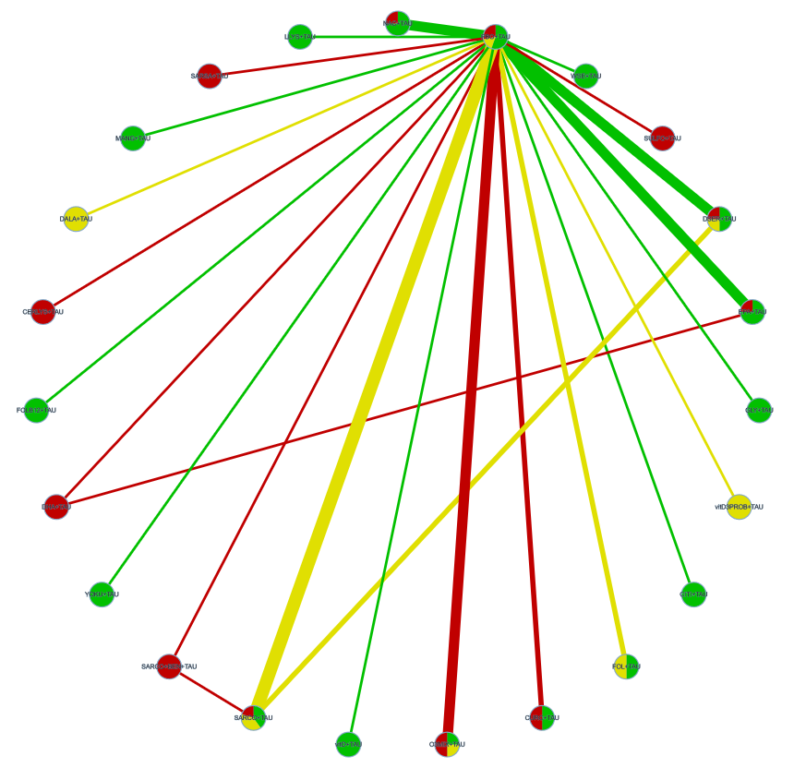
e-figure 34. Netgraph for PANSS total score analysis. Nodes are represented according to the proportion of studies with each level of risk of bias. Edges are described according to the majority risk of bias within the comparison. Node size is equal due to graphical reasons. Edges’ width is proportional to the sample size. Red stands for high risk of bias, yellow for unclear, and green for low risk of bias.

e-table 29. CINeMA GRADE evaluation of the efficacy of nutraceuticals and phytoceutical for PANSS total symptom reduction.
Comparison | Number of studies | Within-study bias | Reporting bias | Indirectness | Imprecision | Heterogeneity | Incoherence | Confidence rating
CERLYS+TAU:PBO+TAU | 1 | Major concerns | Suspected | No concerns | Major concerns | No concerns | No concerns | Very low
CITI+TAU:PBO+TAU | 1 | No concerns | Suspected | Some concerns | No concerns | No concerns | No concerns | Low
CURC+TAU:PBO+TAU | 2 | Major concerns | Suspected | Some concerns | Major concerns | No concerns | No concerns | Very low
DALA+TAU:PBO+TAU | 1 | Some concerns | Suspected | No concerns | Some concerns | Some concerns | No concerns | Very low
DHA+TAU:EPA+TAU | 1 | Major concerns | Suspected | No concerns | Major concerns | No concerns | No concerns | Very low
DHA+TAU:PBO+TAU | 1 | Major concerns | Suspected | No concerns | Major concerns | No concerns | No concerns | Very low
DSER+TAU:PBO+TAU | 4 | No concerns | Suspected | No concerns | Major concerns | No concerns | No concerns | Very low
DSER+TAU:SARCO+TAU | 2 | No concerns | Suspected | No concerns | Some concerns | Some concerns | No concerns | Low
EPA+TAU:PBO+TAU | 4 | No concerns | Suspected | No concerns | Some concerns | Some concerns | No concerns | Low
FOL+TAU:PBO+TAU | 2 | No concerns | Suspected | No concerns | Major concerns | No concerns | No concerns | Very low
FOLB12+TAU:PBO+TAU | 1 | No concerns | Suspected | Some concerns | Major concerns | No concerns | No concerns | Very low
GLY+TAU:PBO+TAU | 1 | No concerns | Suspected | No concerns | Major concerns | No concerns | No concerns | Very low
LLYS+TAU:PBO+TAU | 1 | No concerns | Suspected | Some concerns | No concerns | No concerns | No concerns | Low
MANG+TAU:PBO+TAU | 1 | No concerns | Suspected | No concerns | Major concerns | No concerns | No concerns | Very low
NAC+TAU:PBO+TAU | 4 | No concerns | Suspected | Some concerns | No concerns | No concerns | No concerns | Low
O3MIX+TAU:PBO+TAU | 4 | Major concerns | Suspected | Some concerns | Some concerns | Some concerns | No concerns | Very low
PBO+TAU:SARCO+BEN+TAU | 1 | Major concerns | Suspected | Some concerns | Major concerns | No concerns | No concerns | Very low
PBO+TAU:SARCO+TAU | 5 | Some concerns | Suspected | No concerns | No concerns | Some concerns | No concerns | Very low
PBO+TAU:SARSA+TAU | 1 | Major concerns | Suspected | No concerns | Some concerns | Some concerns | No concerns | Very low
PBO+TAU:SULFO+TAU | 1 | Major concerns | Suspected | No concerns | Major concerns | No concerns | No concerns | Very low
PBO+TAU:WSE+TAU | 1 | No concerns | Suspected | Some concerns | Some concerns | Some concerns | No concerns | Very low
PBO+TAU:YOKU+TAU | 1 | No concerns | Suspected | Some concerns | Major concerns | No concerns | No concerns | Very low
PBO+TAU:vitD+TAU | 1 | No concerns | Suspected | Major concerns | Major concerns | No concerns | No concerns | Very low
PBO+TAU:vitD3PROB+TAU | 1 | Some concerns | Suspected | No concerns | Major concerns | No concerns | No concerns | Very low
SARCO+BEN+TAU:SARCO+TAU | 1 | Major concerns | Suspected | Some concerns | Major concerns | No concerns | No concerns | Very low
CERLYS+TAU:CITI+TAU | 0 | No concerns | Suspected | No concerns | Some concerns | Some concerns | No concerns | Low
CERLYS+TAU:CURC+TAU | 0 | Major concerns | Suspected | No concerns | Major concerns | No concerns | No concerns | Very low
CERLYS+TAU:DALA+TAU | 0 | Some concerns | Suspected | No concerns | Major concerns | No concerns | No concerns | Very low
CERLYS+TAU:DHA+TAU | 0 | Major concerns | Suspected | No concerns | Major concerns | No concerns | No concerns | Very low
CERLYS+TAU:DSER+TAU | 0 | Major concerns | Suspected | No concerns | Major concerns | No concerns | No concerns | Very low
CERLYS+TAU:EPA+TAU | 0 | Major concerns | Suspected | No concerns | Major concerns | No concerns | No concerns | Very low
CERLYS+TAU:FOL+TAU | 0 | Major concerns | Suspected | No concerns | Major concerns | No concerns | No concerns | Very low
CERLYS+TAU:FOLB12+TAU | 0 | No concerns | Suspected | No concerns | Major concerns | No concerns | No concerns | Very low
CERLYS+TAU:GLY+TAU | 0 | No concerns | Suspected | No concerns | Major concerns | No concerns | No concerns | Very low
CERLYS+TAU:LLYS+TAU | 0 | No concerns | Suspected | No concerns | Some concerns | Some concerns | No concerns | Low
CERLYS+TAU:MANG+TAU | 0 | No concerns | Suspected | No concerns | Major concerns | No concerns | No concerns | Very low
CERLYS+TAU:NAC+TAU | 0 | Major concerns | Suspected | No concerns | Some concerns | Some concerns | No concerns | Low
CERLYS+TAU:O3MIX+TAU | 0 | Major concerns | Suspected | No concerns | Major concerns | No concerns | No concerns | Very low
CERLYS+TAU:SARCO+BEN+TAU | 0 | Major concerns | Suspected | No concerns | Major concerns | No concerns | No concerns | Very low
CERLYS+TAU:SARCO+TAU | 0 | Major concerns | Suspected | No concerns | Major concerns | No concerns | No concerns | Very low
CERLYS+TAU:SARSA+TAU | 0 | Major concerns | Suspected | No concerns | Major concerns | No concerns | No concerns | Very low
CERLYS+TAU:SULFO+TAU | 0 | Major concerns | Suspected | No concerns | Major concerns | No concerns | No concerns | Very low
CERLYS+TAU:WSE+TAU | 0 | No concerns | Suspected | No concerns | Major concerns | No concerns | No concerns | Very low
CERLYS+TAU:YOKU+TAU | 0 | No concerns | Suspected | No concerns | Major concerns | No concerns | No concerns | Very low
CERLYS+TAU:vitD+TAU | 0 | No concerns | Suspected | No concerns | Major concerns | No concerns | No concerns | Very low
CERLYS+TAU:vitD3PROB+TAU | 0 | Some concerns | Suspected | No concerns | Major concerns | No concerns | No concerns | Very low
CITI+TAU:CURC+TAU | 0 | No concerns | Suspected | Some concerns | Some concerns | Some concerns | No concerns | Very low
CITI+TAU:DALA+TAU | 0 | No concerns | Suspected | No concerns | Major concerns | No concerns | No concerns | Very low
CITI+TAU:DHA+TAU | 0 | No concerns | Suspected | No concerns | No concerns | Some concerns | No concerns | Low
CITI+TAU:DSER+TAU | 0 | No concerns | Suspected | Some concerns | No concerns | Some concerns | No concerns | Very low
CITI+TAU:EPA+TAU | 0 | No concerns | Suspected | No concerns | Some concerns | No concerns | No concerns | Low
CITI+TAU:FOL+TAU | 0 | No concerns | Suspected | Some concerns | Some concerns | Some concerns | No concerns | Very low
CITI+TAU:FOLB12+TAU | 0 | No concerns | Suspected | Some concerns | No concerns | Some concerns | No concerns | Very low
CITI+TAU:GLY+TAU | 0 | No concerns | Suspected | No concerns | Some concerns | Some concerns | No concerns | Low
CITI+TAU:LLYS+TAU | 0 | No concerns | Suspected | Some concerns | Major concerns | No concerns | No concerns | Very low
CITI+TAU:MANG+TAU | 0 | No concerns | Suspected | No concerns | No concerns | Some concerns | No concerns | Low
CITI+TAU:NAC+TAU | 0 | No concerns | Suspected | Some concerns | Major concerns | No concerns | No concerns | Very low
CITI+TAU:O3MIX+TAU | 0 | No concerns | Suspected | Some concerns | Some concerns | No concerns | No concerns | Very low
CITI+TAU:SARCO+BEN+TAU | 0 | No concerns | Suspected | Some concerns | Major concerns | No concerns | No concerns | Very low
CITI+TAU:SARCO+TAU | 0 | No concerns | Suspected | Some concerns | Major concerns | No concerns | No concerns | Very low
CITI+TAU:SARSA+TAU | 0 | No concerns | Suspected | No concerns | Major concerns | No concerns | No concerns | Very low
CITI+TAU:SULFO+TAU | 0 | No concerns | Suspected | No concerns | Some concerns | No concerns | No concerns | Low
CITI+TAU:WSE+TAU | 0 | No concerns | Suspected | Some concerns | Major concerns | No concerns | No concerns | Very low
CITI+TAU:YOKU+TAU | 0 | No concerns | Suspected | Some concerns | Some concerns | Some concerns | No concerns | Very low
CITI+TAU:vitD+TAU | 0 | No concerns | Suspected | Some concerns | No concerns | Some concerns | No concerns | Very low
CITI+TAU:vitD3PROB+TAU | 0 | No concerns | Suspected | No concerns | Major concerns | No concerns | No concerns | Very low
CURC+TAU:DALA+TAU | 0 | Some concerns | Suspected | No concerns | Major concerns | No concerns | No concerns | Very low
CURC+TAU:DHA+TAU | 0 | Major concerns | Suspected | No concerns | Major concerns | No concerns | No concerns | Very low
CURC+TAU:DSER+TAU | 0 | No concerns | Suspected | Some concerns | Major concerns | No concerns | No concerns | Very low
CURC+TAU:EPA+TAU | 0 | No concerns | Suspected | No concerns | Major concerns | No concerns | No concerns | Very low
CURC+TAU:FOL+TAU | 0 | No concerns | Suspected | Some concerns | Major concerns | No concerns | No concerns | Very low
CURC+TAU:FOLB12+TAU | 0 | No concerns | Suspected | Some concerns | Major concerns | No concerns | No concerns | Very low
CURC+TAU:GLY+TAU | 0 | No concerns | Suspected | No concerns | Major concerns | No concerns | No concerns | Very low
CURC+TAU:LLYS+TAU | 0 | No concerns | Suspected | Some concerns | Some concerns | Some concerns | No concerns | Very low
CURC+TAU:MANG+TAU | 0 | No concerns | Suspected | No concerns | Major concerns | No concerns | No concerns | Very low
CURC+TAU:NAC+TAU | 0 | No concerns | Suspected | Some concerns | Some concerns | Some concerns | No concerns | Very low
CURC+TAU:O3MIX+TAU | 0 | Major concerns | Suspected | Some concerns | Major concerns | No concerns | No concerns | Very low
CURC+TAU:SARCO+BEN+TAU | 0 | Major concerns | Suspected | Some concerns | Major concerns | No concerns | No concerns | Very low
CURC+TAU:SARCO+TAU | 0 | No concerns | Suspected | Some concerns | Major concerns | No concerns | No concerns | Very low
CURC+TAU:SARSA+TAU | 0 | Major concerns | Suspected | No concerns | Major concerns | No concerns | No concerns | Very low
CURC+TAU:SULFO+TAU | 0 | Major concerns | Suspected | No concerns | Major concerns | No concerns | No concerns | Very low
CURC+TAU:WSE+TAU | 0 | No concerns | Suspected | Some concerns | Major concerns | No concerns | No concerns | Very low
CURC+TAU:YOKU+TAU | 0 | No concerns | Suspected | Some concerns | Major concerns | No concerns | No concerns | Very low
CURC+TAU:vitD+TAU | 0 | No concerns | Suspected | Some concerns | Major concerns | No concerns | No concerns | Very low
CURC+TAU:vitD3PROB+TAU | 0 | Some concerns | Suspected | No concerns | Major concerns | No concerns | No concerns | Very low
DALA+TAU:DHA+TAU | 0 | Major concerns | Suspected | No concerns | Some concerns | Some concerns | No concerns | Very low
DALA+TAU:DSER+TAU | 0 | Some concerns | Suspected | No concerns | Major concerns | No concerns | No concerns | Very low
DALA+TAU:EPA+TAU | 0 | Some concerns | Suspected | No concerns | Major concerns | No concerns | No concerns | Very low
DALA+TAU:FOL+TAU | 0 | Some concerns | Suspected | No concerns | Major concerns | No concerns | No concerns | Very low
DALA+TAU:FOLB12+TAU | 0 | No concerns | Suspected | No concerns | Major concerns | No concerns | No concerns | Very low
DALA+TAU:GLY+TAU | 0 | No concerns | Suspected | No concerns | Major concerns | No concerns | No concerns | Very low
DALA+TAU:LLYS+TAU | 0 | No concerns | Suspected | No concerns | Major concerns | No concerns | No concerns | Very low
DALA+TAU:MANG+TAU | 0 | No concerns | Suspected | No concerns | Major concerns | No concerns | No concerns | Very low
DALA+TAU:NAC+TAU | 0 | Some concerns | Suspected | No concerns | Major concerns | No concerns | No concerns | Very low
DALA+TAU:O3MIX+TAU | 0 | Some concerns | Suspected | No concerns | Major concerns | No concerns | No concerns | Very low
DALA+TAU:SARCO+BEN+TAU | 0 | Some concerns | Suspected | No concerns | Major concerns | No concerns | No concerns | Very low
DALA+TAU:SARCO+TAU | 0 | Some concerns | Suspected | No concerns | Major concerns | No concerns | No concerns | Very low
DALA+TAU:SARSA+TAU | 0 | Some concerns | Suspected | No concerns | Major concerns | No concerns | No concerns | Very low
DALA+TAU:SULFO+TAU | 0 | Some concerns | Suspected | No concerns | Major concerns | No concerns | No concerns | Very low
DALA+TAU:WSE+TAU | 0 | No concerns | Suspected | No concerns | Major concerns | No concerns | No concerns | Very low
DALA+TAU:YOKU+TAU | 0 | No concerns | Suspected | No concerns | Major concerns | No concerns | No concerns | Very low
DALA+TAU:vitD+TAU | 0 | No concerns | Suspected | No concerns | Major concerns | No concerns | No concerns | Very low
DALA+TAU:vitD3PROB+TAU | 0 | Some concerns | Suspected | No concerns | Major concerns | No concerns | No concerns | Very low
DHA+TAU:DSER+TAU | 0 | Major concerns | Suspected | No concerns | Major concerns | No concerns | No concerns | Very low
DHA+TAU:FOL+TAU | 0 | Major concerns | Suspected | No concerns | Major concerns | No concerns | No concerns | Very low
DHA+TAU:FOLB12+TAU | 0 | No concerns | Suspected | No concerns | Major concerns | No concerns | No concerns | Very low
DHA+TAU:GLY+TAU | 0 | No concerns | Suspected | No concerns | Major concerns | No concerns | No concerns | Very low
DHA+TAU:LLYS+TAU | 0 | No concerns | Suspected | No concerns | No concerns | Some concerns | No concerns | Low
DHA+TAU:MANG+TAU | 0 | No concerns | Suspected | No concerns | Major concerns | No concerns | No concerns | Very low
DHA+TAU:NAC+TAU | 0 | Major concerns | Suspected | No concerns | No concerns | Some concerns | No concerns | Very low
DHA+TAU:O3MIX+TAU | 0 | Major concerns | Suspected | No concerns | Major concerns | No concerns | No concerns | Very low
DHA+TAU:SARCO+BEN+TAU | 0 | Major concerns | Suspected | No concerns | Major concerns | No concerns | No concerns | Very low
DHA+TAU:SARCO+TAU | 0 | Major concerns | Suspected | No concerns | Some concerns | Some concerns | No concerns | Very low
DHA+TAU:SARSA+TAU | 0 | Major concerns | Suspected | No concerns | Major concerns | No concerns | No concerns | Very low
DHA+TAU:SULFO+TAU | 0 | Major concerns | Suspected | No concerns | Major concerns | No concerns | No concerns | Very low
DHA+TAU:WSE+TAU | 0 | No concerns | Suspected | No concerns | Some concerns | Some concerns | No concerns | Low
DHA+TAU:YOKU+TAU | 0 | No concerns | Suspected | No concerns | Major concerns | No concerns | No concerns | Very low
DHA+TAU:vitD+TAU | 0 | No concerns | Suspected | No concerns | Major concerns | No concerns | No concerns | Very low
DHA+TAU:vitD3PROB+TAU | 0 | Major concerns | Suspected | No concerns | Major concerns | No concerns | No concerns | Very low
DSER+TAU:EPA+TAU | 0 | No concerns | Suspected | No concerns | Major concerns | No concerns | No concerns | Very low
DSER+TAU:FOL+TAU | 0 | No concerns | Suspected | No concerns | Major concerns | No concerns | No concerns | Very low
DSER+TAU:FOLB12+TAU | 0 | No concerns | Suspected | Some concerns | Major concerns | No concerns | No concerns | Very low
DSER+TAU:GLY+TAU | 0 | No concerns | Suspected | No concerns | Major concerns | No concerns | No concerns | Very low
DSER+TAU:LLYS+TAU | 0 | No concerns | Suspected | Some concerns | No concerns | Some concerns | No concerns | Very low
DSER+TAU:MANG+TAU | 0 | No concerns | Suspected | No concerns | Major concerns | No concerns | No concerns | Very low
DSER+TAU:NAC+TAU | 0 | No concerns | Suspected | No concerns | No concerns | Some concerns | No concerns | Low
DSER+TAU:O3MIX+TAU | 0 | Major concerns | Suspected | No concerns | Major concerns | No concerns | No concerns | Very low
DSER+TAU:SARCO+BEN+TAU | 0 | Major concerns | Suspected | Some concerns | Major concerns | No concerns | No concerns | Very low
DSER+TAU:SARSA+TAU | 0 | Major concerns | Suspected | No concerns | Major concerns | No concerns | No concerns | Very low
DSER+TAU:SULFO+TAU | 0 | Major concerns | Suspected | No concerns | Major concerns | No concerns | No concerns | Very low
DSER+TAU:WSE+TAU | 0 | No concerns | Suspected | Some concerns | Some concerns | Some concerns | No concerns | Very low
DSER+TAU:YOKU+TAU | 0 | No concerns | Suspected | Some concerns | Major concerns | No concerns | No concerns | Very low
DSER+TAU:vitD+TAU | 0 | No concerns | Suspected | Major concerns | Major concerns | No concerns | No concerns | Very low
DSER+TAU:vitD3PROB+TAU | 0 | Some concerns | Suspected | No concerns | Major concerns | No concerns | No concerns | Very low
EPA+TAU:FOL+TAU | 0 | No concerns | Suspected | No concerns | Major concerns | No concerns | No concerns | Very low
EPA+TAU:FOLB12+TAU | 0 | No concerns | Suspected | No concerns | Major concerns | No concerns | No concerns | Very low
EPA+TAU:GLY+TAU | 0 | No concerns | Suspected | No concerns | Major concerns | No concerns | No concerns | Very low
EPA+TAU:LLYS+TAU | 0 | No concerns | Suspected | No concerns | No concerns | Some concerns | No concerns | Low
EPA+TAU:MANG+TAU | 0 | No concerns | Suspected | No concerns | Major concerns | No concerns | No concerns | Very low
EPA+TAU:NAC+TAU | 0 | No concerns | Suspected | No concerns | No concerns | Some concerns | No concerns | Low
EPA+TAU:O3MIX+TAU | 0 | No concerns | Suspected | No concerns | Major concerns | No concerns | No concerns | Very low
EPA+TAU:SARCO+BEN+TAU | 0 | Major concerns | Suspected | No concerns | Major concerns | No concerns | No concerns | Very low
EPA+TAU:SARCO+TAU | 0 | No concerns | Suspected | No concerns | Some concerns | Some concerns | No concerns | Low
EPA+TAU:SARSA+TAU | 0 | Major concerns | Suspected | No concerns | Major concerns | No concerns | No concerns | Very low
EPA+TAU:SULFO+TAU | 0 | Major concerns | Suspected | No concerns | Major concerns | No concerns | No concerns | Very low
EPA+TAU:WSE+TAU | 0 | No concerns | Suspected | No concerns | Major concerns | No concerns | No concerns | Very low
EPA+TAU:YOKU+TAU | 0 | No concerns | Suspected | No concerns | Major concerns | No concerns | No concerns | Very low
EPA+TAU:vitD+TAU | 0 | No concerns | Suspected | No concerns | Major concerns | No concerns | No concerns | Very low
EPA+TAU:vitD3PROB+TAU | 0 | Some concerns | Suspected | No concerns | Major concerns | No concerns | No concerns | Very low
FOLB12+TAU:FOL+TAU | 0 | No concerns | Suspected | Some concerns | Major concerns | No concerns | No concerns | Very low
FOL+TAU:GLY+TAU | 0 | No concerns | Suspected | No concerns | Major concerns | No concerns | No concerns | Very low
FOL+TAU:LLYS+TAU | 0 | No concerns | Suspected | Some concerns | Some concerns | Some concerns | No concerns | Very low
FOL+TAU:MANG+TAU | 0 | No concerns | Suspected | No concerns | Major concerns | No concerns | No concerns | Very low
FOL+TAU:NAC+TAU | 0 | No concerns | Suspected | Some concerns | No concerns | Some concerns | No concerns | Very low
FOL+TAU:O3MIX+TAU | 0 | No concerns | Suspected | Some concerns | Major concerns | No concerns | No concerns | Very low
FOL+TAU:SARCO+BEN+TAU | 0 | Major concerns | Suspected | Some concerns | Major concerns | No concerns | No concerns | Very low
FOL+TAU:SARCO+TAU | 0 | No concerns | Suspected | No concerns | Some concerns | Some concerns | No concerns | Low
FOL+TAU:SARSA+TAU | 0 | Major concerns | Suspected | No concerns | Major concerns | No concerns | No concerns | Very low
FOL+TAU:SULFO+TAU | 0 | Major concerns | Suspected | No concerns | Major concerns | No concerns | No concerns | Very low
FOL+TAU:WSE+TAU | 0 | No concerns | Suspected | Some concerns | Major concerns | No concerns | No concerns | Very low
FOL+TAU:YOKU+TAU | 0 | No concerns | Suspected | Some concerns | Major concerns | No concerns | No concerns | Very low
FOL+TAU:vitD+TAU | 0 | No concerns | Suspected | Major concerns | Major concerns | No concerns | No concerns | Very low
FOL+TAU:vitD3PROB+TAU | 0 | Some concerns | Suspected | No concerns | Major concerns | No concerns | No concerns | Very low
FOLB12+TAU:GLY+TAU | 0 | No concerns | Suspected | No concerns | Major concerns | No concerns | No concerns | Very low
FOLB12+TAU:LLYS+TAU | 0 | No concerns | Suspected | Some concerns | No concerns | Some concerns | No concerns | Very low
FOLB12+TAU:MANG+TAU | 0 | No concerns | Suspected | No concerns | Major concerns | No concerns | No concerns | Very low
FOLB12+TAU:NAC+TAU | 0 | No concerns | Suspected | Some concerns | No concerns | Some concerns | No concerns | Very low
FOLB12+TAU:O3MIX+TAU | 0 | No concerns | Suspected | Some concerns | Major concerns | No concerns | No concerns | Very low
FOLB12+TAU:SARCO+BEN+TAU | 0 | No concerns | Suspected | Some concerns | Major concerns | No concerns | No concerns | Very low
FOLB12+TAU:SARCO+TAU | 0 | No concerns | Suspected | Some concerns | Some concerns | Some concerns | No concerns | Very low
FOLB12+TAU:SARSA+TAU | 0 | No concerns | Suspected | No concerns | Major concerns | No concerns | No concerns | Very low
FOLB12+TAU:SULFO+TAU | 0 | No concerns | Suspected | No concerns | Major concerns | No concerns | No concerns | Very low
FOLB12+TAU:WSE+TAU | 0 | No concerns | Suspected | Some concerns | Some concerns | Some concerns | No concerns | Very low
FOLB12+TAU:YOKU+TAU | 0 | No concerns | Suspected | Some concerns | Major concerns | No concerns | No concerns | Very low
FOLB12+TAU:vitD+TAU | 0 | No concerns | Suspected | Some concerns | Major concerns | No concerns | No concerns | Very low
FOLB12+TAU:vitD3PROB+TAU | 0 | No concerns | Suspected | No concerns | Major concerns | No concerns | No concerns | Very low
GLY+TAU:LLYS+TAU | 0 | No concerns | Suspected | No concerns | Some concerns | Some concerns | No concerns | Low
GLY+TAU:MANG+TAU | 0 | No concerns | Suspected | No concerns | Major concerns | No concerns | No concerns | Very low
GLY+TAU:NAC+TAU | 0 | No concerns | Suspected | No concerns | Some concerns | Some concerns | No concerns | Low
GLY+TAU:O3MIX+TAU | 0 | No concerns | Suspected | No concerns | Major concerns | No concerns | No concerns | Very low
GLY+TAU:SARCO+BEN+TAU | 0 | No concerns | Suspected | No concerns | Major concerns | No concerns | No concerns | Very low
GLY+TAU:SARCO+TAU | 0 | No concerns | Suspected | No concerns | Major concerns | No concerns | No concerns | Very low
GLY+TAU:SARSA+TAU | 0 | No concerns | Suspected | No concerns | Major concerns | No concerns | No concerns | Very low
GLY+TAU:SULFO+TAU | 0 | No concerns | Suspected | No concerns | Major concerns | No concerns | No concerns | Very low
GLY+TAU:WSE+TAU | 0 | No concerns | Suspected | No concerns | Major concerns | No concerns | No concerns | Very low
GLY+TAU:YOKU+TAU | 0 | No concerns | Suspected | No concerns | Major concerns | No concerns | No concerns | Very low
GLY+TAU:vitD+TAU | 0 | No concerns | Suspected | No concerns | Major concerns | No concerns | No concerns | Very low
GLY+TAU:vitD3PROB+TAU | 0 | No concerns | Suspected | No concerns | Major concerns | No concerns | No concerns | Very low
LLYS+TAU:MANG+TAU | 0 | No concerns | Suspected | No concerns | No concerns | Some concerns | No concerns | Low
LLYS+TAU:NAC+TAU | 0 | No concerns | Suspected | Some concerns | Major concerns | No concerns | No concerns | Very low
LLYS+TAU:O3MIX+TAU | 0 | No concerns | Suspected | Some concerns | Some concerns | No concerns | No concerns | Very low
LLYS+TAU:SARCO+BEN+TAU | 0 | No concerns | Suspected | Some concerns | Major concerns | No concerns | No concerns | Very low
LLYS+TAU:SARCO+TAU | 0 | No concerns | Suspected | Some concerns | Major concerns | No concerns | No concerns | Very low
LLYS+TAU:SARSA+TAU | 0 | No concerns | Suspected | No concerns | Major concerns | No concerns | No concerns | Very low
LLYS+TAU:SULFO+TAU | 0 | No concerns | Suspected | No concerns | Some concerns | No concerns | No concerns | Low
LLYS+TAU:WSE+TAU | 0 | No concerns | Suspected | Some concerns | Major concerns | No concerns | No concerns | Very low
LLYS+TAU:YOKU+TAU | 0 | No concerns | Suspected | Some concerns | Some concerns | Some concerns | No concerns | Very low
LLYS+TAU:vitD+TAU | 0 | No concerns | Suspected | Some concerns | No concerns | Some concerns | No concerns | Very low
LLYS+TAU:vitD3PROB+TAU | 0 | No concerns | Suspected | No concerns | Major concerns | No concerns | No concerns | Very low
MANG+TAU:NAC+TAU | 0 | No concerns | Suspected | No concerns | No concerns | Some concerns | No concerns | Low
MANG+TAU:O3MIX+TAU | 0 | No concerns | Suspected | No concerns | Major concerns | No concerns | No concerns | Very low
MANG+TAU:SARCO+BEN+TAU | 0 | No concerns | Suspected | No concerns | Major concerns | No concerns | No concerns | Very low
MANG+TAU:SARCO+TAU | 0 | No concerns | Suspected | No concerns | Some concerns | Some concerns | No concerns | Low
MANG+TAU:SARSA+TAU | 0 | No concerns | Suspected | No concerns | Major concerns | No concerns | No concerns | Very low
MANG+TAU:SULFO+TAU | 0 | No concerns | Suspected | No concerns | Major concerns | No concerns | No concerns | Very low
MANG+TAU:WSE+TAU | 0 | No concerns | Suspected | No concerns | Major concerns | No concerns | No concerns | Very low
MANG+TAU:YOKU+TAU | 0 | No concerns | Suspected | No concerns | Major concerns | No concerns | No concerns | Very low
MANG+TAU:vitD+TAU | 0 | No concerns | Suspected | No concerns | Major concerns | No concerns | No concerns | Very low
MANG+TAU:vitD3PROB+TAU | 0 | No concerns | Suspected | No concerns | Major concerns | No concerns | No concerns | Very low
NAC+TAU:O3MIX+TAU | 0 | No concerns | Suspected | Some concerns | No concerns | Some concerns | No concerns | Very low
NAC+TAU:SARCO+BEN+TAU | 0 | Major concerns | Suspected | Some concerns | Major concerns | No concerns | No concerns | Very low
NAC+TAU:SARCO+TAU | 0 | No concerns | Suspected | Some concerns | Some concerns | Some concerns | No concerns | Very low
NAC+TAU:SARSA+TAU | 0 | Major concerns | Suspected | No concerns | Major concerns | No concerns | No concerns | Very low
NAC+TAU:SULFO+TAU | 0 | Major concerns | Suspected | No concerns | No concerns | Some concerns | No concerns | Very low
NAC+TAU:WSE+TAU | 0 | No concerns | Suspected | Some concerns | Major concerns | No concerns | No concerns | Very low
NAC+TAU:YOKU+TAU | 0 | No concerns | Suspected | Some concerns | Some concerns | Some concerns | No concerns | Very low
NAC+TAU:vitD+TAU | 0 | No concerns | Suspected | Major concerns | No concerns | Some concerns | No concerns | Very low
NAC+TAU:vitD3PROB+TAU | 0 | Some concerns | Suspected | No concerns | Major concerns | No concerns | No concerns | Very low
O3MIX+TAU:SARCO+BEN+TAU | 0 | Major concerns | Suspected | Some concerns | Major concerns | No concerns | No concerns | Very low
O3MIX+TAU:SARCO+TAU | 0 | Major concerns | Suspected | Some concerns | Some concerns | Some concerns | No concerns | Very low
O3MIX+TAU:SARSA+TAU | 0 | Major concerns | Suspected | No concerns | Major concerns | No concerns | No concerns | Very low
O3MIX+TAU:SULFO+TAU | 0 | Major concerns | Suspected | No concerns | Major concerns | No concerns | No concerns | Very low
O3MIX+TAU:WSE+TAU | 0 | No concerns | Suspected | Some concerns | Major concerns | No concerns | No concerns | Very low
O3MIX+TAU:YOKU+TAU | 0 | No concerns | Suspected | Some concerns | Major concerns | No concerns | No concerns | Very low
O3MIX+TAU:vitD+TAU | 0 | No concerns | Suspected | Major concerns | Major concerns | No concerns | No concerns | Very low
O3MIX+TAU:vitD3PROB+TAU | 0 | Some concerns | Suspected | No concerns | Major concerns | No concerns | No concerns | Very low
SARCO+BEN+TAU:SARSA+TAU | 0 | Major concerns | Suspected | No concerns | Major concerns | No concerns | No concerns | Very low
SARCO+BEN+TAU:SULFO+TAU | 0 | Major concerns | Suspected | No concerns | Major concerns | No concerns | No concerns | Very low
SARCO+BEN+TAU:WSE+TAU | 0 | No concerns | Suspected | Some concerns | Major concerns | No concerns | No concerns | Very low
SARCO+BEN+TAU:YOKU+TAU | 0 | No concerns | Suspected | Some concerns | Major concerns | No concerns | No concerns | Very low
SARCO+BEN+TAU:vitD+TAU | 0 | No concerns | Suspected | Some concerns | Major concerns | No concerns | No concerns | Very low
SARCO+BEN+TAU:vitD3PROB+TAU | 0 | Some concerns | Suspected | No concerns | Major concerns | No concerns | No concerns | Very low
SARCO+TAU:SARSA+TAU | 0 | Major concerns | Suspected | No concerns | Major concerns | No concerns | No concerns | Very low
SARCO+TAU:SULFO+TAU | 0 | Major concerns | Suspected | No concerns | Some concerns | Some concerns | No concerns | Very low
SARCO+TAU:WSE+TAU | 0 | No concerns | Suspected | Some concerns | Major concerns | No concerns | No concerns | Very low
SARCO+TAU:YOKU+TAU | 0 | No concerns | Suspected | Some concerns | Major concerns | No concerns | No concerns | Very low
SARCO+TAU:vitD+TAU | 0 | No concerns | Suspected | Major concerns | Some concerns | Some concerns | No concerns | Very low
SARCO+TAU:vitD3PROB+TAU | 0 | Some concerns | Suspected | No concerns | Major concerns | No concerns | No concerns | Very low
SARSA+TAU:SULFO+TAU | 0 | Major concerns | Suspected | No concerns | Major concerns | No concerns | No concerns | Very low
SARSA+TAU:WSE+TAU | 0 | No concerns | Suspected | No concerns | Major concerns | No concerns | No concerns | Very low
SARSA+TAU:YOKU+TAU | 0 | No concerns | Suspected | No concerns | Major concerns | No concerns | No concerns | Very low
SARSA+TAU:vitD+TAU | 0 | No concerns | Suspected | No concerns | Major concerns | No concerns | No concerns | Very low
SARSA+TAU:vitD3PROB+TAU | 0 | Some concerns | Suspected | No concerns | Major concerns | No concerns | No concerns | Very low
SULFO+TAU:WSE+TAU | 0 | No concerns | Suspected | No concerns | Major concerns | No concerns | No concerns | Very low
SULFO+TAU:YOKU+TAU | 0 | No concerns | Suspected | No concerns | Major concerns | No concerns | No concerns | Very low
SULFO+TAU:vitD+TAU | 0 | No concerns | Suspected | No concerns | Major concerns | No concerns | No concerns | Very low
SULFO+TAU:vitD3PROB+TAU | 0 | Some concerns | Suspected | No concerns | Major concerns | No concerns | No concerns | Very low
WSE+TAU:YOKU+TAU | 0 | No concerns | Suspected | Some concerns | Major concerns | No concerns | No concerns | Very low
vitD+TAU:WSE+TAU | 0 | No concerns | Suspected | Some concerns | Some concerns | Some concerns | No concerns | Very low
vitD3PROB+TAU:WSE+TAU | 0 | No concerns | Suspected | No concerns | Major concerns | No concerns | No concerns | Very low
vitD+TAU:YOKU+TAU | 0 | No concerns | Suspected | Some concerns | Major concerns | No concerns | No concerns | Very low
vitD3PROB+TAU:YOKU+TAU | 0 | No concerns | Suspected | No concerns | Major concerns | No concerns | No concerns | Very low
vitD3PROB+TAU:vitD+TAU | 0 | No concerns | Suspected | No concerns | Major concerns | No concerns | No concerns | Very low
CERLYS+TAU:PBO+TAU | 1 | Major concerns | Suspected | No concerns | Major concerns | No concerns | No concerns | Very low
CITI+TAU:PBO+TAU | 1 | No concerns | Suspected | Some concerns | No concerns | No concerns | No concerns | Low
CURC+TAU:PBO+TAU | 2 | Major concerns | Suspected | Some concerns | Major concerns | No concerns | No concerns | Very low
DALA+TAU:PBO+TAU | 1 | Some concerns | Suspected | No concerns | Some concerns | Some concerns | No concerns | Very low
DHA+TAU:EPA+TAU | 1 | Major concerns | Suspected | No concerns | Major concerns | No concerns | No concerns | Very low
DHA+TAU:PBO+TAU | 1 | Major concerns | Suspected | No concerns | Major concerns | No concerns | No concerns | Very low
DSER+TAU:PBO+TAU | 4 | No concerns | Suspected | No concerns | Major concerns | No concerns | No concerns | Very low
DSER+TAU:SARCO+TAU | 2 | No concerns | Suspected | No concerns | Some concerns | Some concerns | No concerns | Low
EPA+TAU:PBO+TAU | 4 | No concerns | Suspected | No concerns | Some concerns | Some concerns | No concerns | Low
FOL+TAU:PBO+TAU | 2 | No concerns | Suspected | No concerns | Major concerns | No concerns | No concerns | Very low
FOLB12+TAU:PBO+TAU | 1 | No concerns | Suspected | Some concerns | Major concerns | No concerns | No concerns | Very low
GLY+TAU:PBO+TAU | 1 | No concerns | Suspected | No concerns | Major concerns | No concerns | No concerns | Very low
LLYS+TAU:PBO+TAU | 1 | No concerns | Suspected | Some concerns | No concerns | No concerns | No concerns | Low
MANG+TAU:PBO+TAU | 1 | No concerns | Suspected | No concerns | Major concerns | No concerns | No concerns | Very low
NAC+TAU:PBO+TAU | 4 | No concerns | Suspected | Some concerns | No concerns | No concerns | No concerns | Low
O3MIX+TAU:PBO+TAU | 4 | Major concerns | Suspected | Some concerns | Some concerns | Some concerns | No concerns | Very low
PBO+TAU:SARCO+BEN+TAU | 1 | Major concerns | Suspected | Some concerns | Major concerns | No concerns | No concerns | Very low
PBO+TAU:SARCO+TAU | 5 | Some concerns | Suspected | No concerns | No concerns | Some concerns | No concerns | Very low
PBO+TAU:SARSA+TAU | 1 | Major concerns | Suspected | No concerns | Some concerns | Some concerns | No concerns | Very low
PBO+TAU:SULFO+TAU | 1 | Major concerns | Suspected | No concerns | Major concerns | No concerns | No concerns | Very low
PBO+TAU:WSE+TAU | 1 | No concerns | Suspected | Some concerns | Some concerns | Some concerns | No concerns | Very low
PBO+TAU:YOKU+TAU | 1 | No concerns | Suspected | Some concerns | Major concerns | No concerns | No concerns | Very low
PBO+TAU:vitD+TAU | 1 | No concerns | Suspected | Major concerns | Major concerns | No concerns | No concerns | Very low

e-figure 35. Netgraph for acceptability analysis. Nodes are represented according to the proportion of studies with each level of risk of bias. Edges are described according to the majority risk of bias within the comparison. Node size is equal due to graphical reasons. Edges’ width is proportional to the sample size. Red stands for high risk of bias, yellow for unclear, and green for low risk of bias.
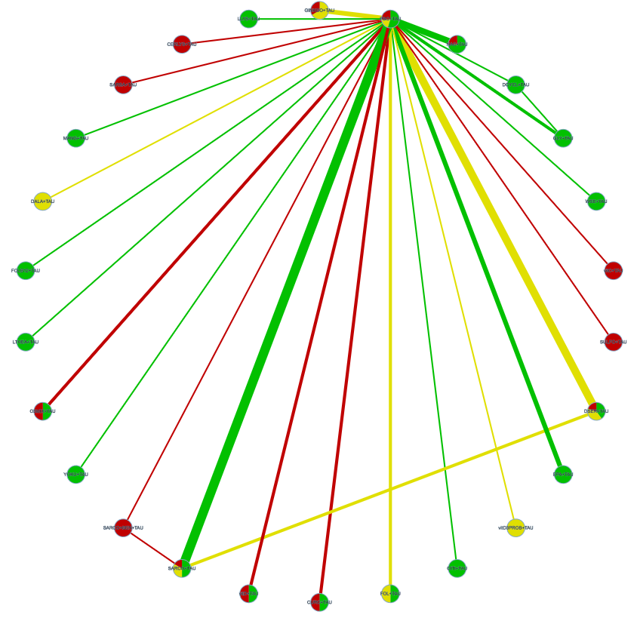

e-table 30. CINeMA GRADE evaluation of the acceptability of nutraceuticals and phytoceutical.
Comparison | Number of studies | Within-study bias | Reporting bias | Indirectness | Imprecision | Heterogeneity | Incoherence | Confidence rating
CERLYS+TAU:PBO+TAU | 1 | Major concerns | Low risk | No concerns | Major concerns | No concerns | No concerns | Very Low
CITI+TAU:PBO+TAU | 1 | No concerns | Low risk | Some concerns | Major concerns | No concerns | No concerns | Very Low
CURC+TAU:PBO+TAU | 2 | Major concerns | Low risk | Some concerns | Major concerns | No concerns | No concerns | Very Low
DALA+TAU:PBO+TAU | 1 | Some concerns | Low risk | No concerns | Major concerns | No concerns | No concerns | Very Low
DCYCL+TAU:GLY+TAU | 1 | No concerns | Low risk | No concerns | Major concerns | No concerns | No concerns | Low
DCYCL+TAU:PBO+TAU | 1 | No concerns | Low risk | No concerns | Major concerns | No concerns | No concerns | Low
DSER+TAU:PBO+TAU | 5 | No concerns | Low risk | No concerns | Major concerns | No concerns | No concerns | Low
DSER+TAU:SARCO+TAU | 2 | Some concerns | Low risk | No concerns | Major concerns | No concerns | No concerns | Very Low
EPA+TAU:PBO+TAU | 3 | No concerns | Low risk | No concerns | Major concerns | No concerns | No concerns | Low
FOL+TAU:PBO+TAU | 2 | No concerns | Low risk | No concerns | Major concerns | No concerns | No concerns | Low
FOLB12+TAU:PBO+TAU | 1 | No concerns | Low risk | Some concerns | Major concerns | No concerns | No concerns | Very Low
GINKGO+TAU:PBO+TAU | 3 | Major concerns | Low risk | No concerns | Major concerns | No concerns | No concerns | Very Low
GLY+TAU:PBO+TAU | 2 | No concerns | Low risk | No concerns | Major concerns | No concerns | No concerns | Low
LLYS+TAU:PBO+TAU | 1 | No concerns | Low risk | Some concerns | Major concerns | No concerns | No concerns | Very Low
LTHEA+TAU:PBO+TAU | 1 | No concerns | Low risk | Some concerns | Major concerns | No concerns | No concerns | Very Low
MANG+TAU:PBO+TAU | 1 | No concerns | Low risk | Some concerns | Major concerns | No concerns | No concerns | Very Low
NAC+TAU:PBO+TAU | 4 | No concerns | Low risk | Some concerns | Major concerns | No concerns | No concerns | Very Low
O3MIX+TAU:PBO+TAU | 2 | Major concerns | Low risk | Some concerns | Major concerns | No concerns | No concerns | Very Low
PBO+TAU:SARCO+BEN+TAU | 1 | Major concerns | Low risk | Some concerns | Major concerns | No concerns | No concerns | Very Low
PBO+TAU:SARCO+TAU | 6 | Major concerns | Low risk | Some concerns | Major concerns | No concerns | No concerns | Very Low
PBO+TAU:SARSA+TAU | 1 | Major concerns | Low risk | No concerns | Major concerns | No concerns | No concerns | Very Low
PBO+TAU:SULFO+TAU | 1 | Major concerns | Low risk | No concerns | Major concerns | No concerns | No concerns | Very Low
PBO+TAU:WSE+TAU | 1 | No concerns | Low risk | Some concerns | Major concerns | No concerns | No concerns | Very Low
PBO+TAU:YOKU+TAU | 1 | No concerns | Low risk | Some concerns | Major concerns | No concerns | No concerns | Very Low
PBO+TAU:vitC+TAU | 1 | Major concerns | Low risk | Some concerns | Major concerns | No concerns | No concerns | Very Low
PBO+TAU:vitD+TAU | 2 | Major concerns | Low risk | No concerns | Major concerns | No concerns | No concerns | Very Low
PBO+TAU:vitD3PROB+TAU | 1 | Some concerns | Low risk | No concerns | Major concerns | No concerns | No concerns | Very Low
SARCO+BEN+TAU:SARCO+TAU | 1 | Major concerns | Low risk | Some concerns | Major concerns | No concerns | No concerns | Very Low
CERLYS+TAU:CITI+TAU | 0 | No concerns | Low risk | No concerns | Major concerns | No concerns | No concerns | Low
CERLYS+TAU:CURC+TAU | 0 | Major concerns | Low risk | No concerns | Major concerns | No concerns | No concerns | Very Low
CERLYS+TAU:DALA+TAU | 0 | Some concerns | Low risk | No concerns | Major concerns | No concerns | No concerns | Very Low
CERLYS+TAU:DCYCL+TAU | 0 | No concerns | Low risk | No concerns | Major concerns | No concerns | No concerns | Low
CERLYS+TAU:DSER+TAU | 0 | Major concerns | Low risk | No concerns | Major concerns | No concerns | No concerns | Very Low
CERLYS+TAU:EPA+TAU | 0 | No concerns | Low risk | No concerns | Major concerns | No concerns | No concerns | Low
CERLYS+TAU:FOL+TAU | 0 | Major concerns | Low risk | No concerns | Major concerns | No concerns | No concerns | Very Low
CERLYS+TAU:FOLB12+TAU | 0 | No concerns | Low risk | No concerns | Major concerns | No concerns | No concerns | Low
CERLYS+TAU:GINKGO+TAU | 0 | Major concerns | Low risk | No concerns | Major concerns | No concerns | No concerns | Very Low
CERLYS+TAU:GLY+TAU | 0 | No concerns | Low risk | No concerns | Major concerns | No concerns | No concerns | Low
CERLYS+TAU:LLYS+TAU | 0 | No concerns | Low risk | No concerns | Major concerns | No concerns | No concerns | Low
CERLYS+TAU:LTHEA+TAU | 0 | No concerns | Low risk | No concerns | Major concerns | No concerns | No concerns | Low
CERLYS+TAU:MANG+TAU | 0 | No concerns | Low risk | No concerns | Major concerns | No concerns | No concerns | Low
CERLYS+TAU:NAC+TAU | 0 | Major concerns | Low risk | No concerns | Major concerns | No concerns | No concerns | Very Low
CERLYS+TAU:O3MIX+TAU | 0 | Major concerns | Low risk | No concerns | Major concerns | No concerns | No concerns | Very Low
CERLYS+TAU:SARCO+BEN+TAU | 0 | Major concerns | Low risk | No concerns | Major concerns | No concerns | No concerns | Very Low
CERLYS+TAU:SARCO+TAU | 0 | Major concerns | Low risk | No concerns | Major concerns | No concerns | No concerns | Very Low
CERLYS+TAU:SARSA+TAU | 0 | Major concerns | Low risk | No concerns | Major concerns | No concerns | No concerns | Very Low
CERLYS+TAU:SULFO+TAU | 0 | Major concerns | Low risk | No concerns | Major concerns | No concerns | No concerns | Very Low
CERLYS+TAU:WSE+TAU | 0 | No concerns | Low risk | No concerns | Major concerns | No concerns | No concerns | Low
CERLYS+TAU:YOKU+TAU | 0 | No concerns | Low risk | No concerns | Major concerns | No concerns | No concerns | Low
CERLYS+TAU:vitC+TAU | 0 | Major concerns | Low risk | No concerns | Major concerns | No concerns | No concerns | Very Low
CERLYS+TAU:vitD+TAU | 0 | Major concerns | Low risk | No concerns | Major concerns | No concerns | No concerns | Very Low
CERLYS+TAU:vitD3PROB+TAU | 0 | Some concerns | Low risk | No concerns | Major concerns | No concerns | No concerns | Very Low
CITI+TAU:CURC+TAU | 0 | No concerns | Low risk | Some concerns | Major concerns | No concerns | No concerns | Very Low
CITI+TAU:DALA+TAU | 0 | No concerns | Low risk | No concerns | Major concerns | No concerns | No concerns | Low
CITI+TAU:DCYCL+TAU | 0 | No concerns | Low risk | No concerns | Major concerns | No concerns | No concerns | Low
CITI+TAU:DSER+TAU | 0 | No concerns | Low risk | Some concerns | Major concerns | No concerns | No concerns | Very Low
CITI+TAU:EPA+TAU | 0 | No concerns | Low risk | No concerns | Major concerns | No concerns | No concerns | Low
CITI+TAU:FOL+TAU | 0 | No concerns | Low risk | Some concerns | Major concerns | No concerns | No concerns | Very Low
CITI+TAU:FOLB12+TAU | 0 | No concerns | Low risk | Some concerns | Major concerns | No concerns | No concerns | Very Low
CITI+TAU:GINKGO+TAU | 0 | No concerns | Low risk | Some concerns | Major concerns | No concerns | No concerns | Very Low
CITI+TAU:GLY+TAU | 0 | No concerns | Low risk | No concerns | Major concerns | No concerns | No concerns | Low
CITI+TAU:LLYS+TAU | 0 | No concerns | Low risk | Some concerns | Major concerns | No concerns | No concerns | Very Low
CITI+TAU:LTHEA+TAU | 0 | No concerns | Low risk | Some concerns | Major concerns | No concerns | No concerns | Very Low
CITI+TAU:MANG+TAU | 0 | No concerns | Low risk | Some concerns | Major concerns | No concerns | No concerns | Very Low
CITI+TAU:NAC+TAU | 0 | No concerns | Low risk | Some concerns | Major concerns | No concerns | No concerns | Very Low
CITI+TAU:O3MIX+TAU | 0 | No concerns | Low risk | Some concerns | Major concerns | No concerns | No concerns | Very Low
CITI+TAU:SARCO+BEN+TAU | 0 | Major concerns | Low risk | Some concerns | Major concerns | No concerns | No concerns | Very Low
CITI+TAU:SARCO+TAU | 0 | No concerns | Low risk | Some concerns | Major concerns | No concerns | No concerns | Very Low
CITI+TAU:SARSA+TAU | 0 | No concerns | Low risk | No concerns | Major concerns | No concerns | No concerns | Low
CITI+TAU:SULFO+TAU | 0 | No concerns | Low risk | No concerns | Major concerns | No concerns | No concerns | Low
CITI+TAU:WSE+TAU | 0 | No concerns | Low risk | Some concerns | Major concerns | No concerns | No concerns | Very Low
CITI+TAU:YOKU+TAU | 0 | No concerns | Low risk | Some concerns | Major concerns | No concerns | No concerns | Very Low
CITI+TAU:vitC+TAU | 0 | No concerns | Low risk | Some concerns | Major concerns | No concerns | No concerns | Very Low
CITI+TAU:vitD+TAU | 0 | No concerns | Low risk | Some concerns | Major concerns | No concerns | No concerns | Very Low
CITI+TAU:vitD3PROB+TAU | 0 | No concerns | Low risk | No concerns | Major concerns | No concerns | No concerns | Low
CURC+TAU:DALA+TAU | 0 | Some concerns | Low risk | No concerns | Major concerns | No concerns | No concerns | Very Low
CURC+TAU:DCYCL+TAU | 0 | No concerns | Low risk | No concerns | Major concerns | No concerns | No concerns | Low
CURC+TAU:DSER+TAU | 0 | Major concerns | Low risk | Some concerns | Major concerns | No concerns | No concerns | Very Low
CURC+TAU:EPA+TAU | 0 | No concerns | Low risk | No concerns | Major concerns | No concerns | No concerns | Low
CURC+TAU:FOL+TAU | 0 | No concerns | Low risk | Some concerns | Major concerns | No concerns | No concerns | Very Low
CURC+TAU:FOLB12+TAU | 0 | No concerns | Low risk | Some concerns | Major concerns | No concerns | No concerns | Very Low
CURC+TAU:GINKGO+TAU | 0 | Major concerns | Low risk | Some concerns | Major concerns | No concerns | No concerns | Very Low
CURC+TAU:GLY+TAU | 0 | No concerns | Low risk | No concerns | Major concerns | No concerns | No concerns | Low
CURC+TAU:LLYS+TAU | 0 | No concerns | Low risk | Some concerns | Major concerns | No concerns | No concerns | Very Low
CURC+TAU:LTHEA+TAU | 0 | No concerns | Low risk | Some concerns | Major concerns | No concerns | No concerns | Very Low
CURC+TAU:MANG+TAU | 0 | No concerns | Low risk | Some concerns | Major concerns | No concerns | No concerns | Very Low
CURC+TAU:NAC+TAU | 0 | No concerns | Low risk | Some concerns | Major concerns | No concerns | No concerns | Very Low
CURC+TAU:O3MIX+TAU | 0 | Major concerns | Low risk | Some concerns | Major concerns | No concerns | No concerns | Very Low
CURC+TAU:SARCO+BEN+TAU | 0 | Major concerns | Low risk | Some concerns | Major concerns | No concerns | No concerns | Very Low
CURC+TAU:SARCO+TAU | 0 | Major concerns | Low risk | Some concerns | Major concerns | No concerns | No concerns | Very Low
CURC+TAU:SARSA+TAU | 0 | Major concerns | Low risk | No concerns | Major concerns | No concerns | No concerns | Very Low
CURC+TAU:SULFO+TAU | 0 | Major concerns | Low risk | No concerns | Major concerns | No concerns | No concerns | Very Low
CURC+TAU:WSE+TAU | 0 | No concerns | Low risk | Some concerns | Major concerns | No concerns | No concerns | Very Low
CURC+TAU:YOKU+TAU | 0 | No concerns | Low risk | Some concerns | Major concerns | No concerns | No concerns | Very Low
CURC+TAU:vitC+TAU | 0 | Major concerns | Low risk | Some concerns | Major concerns | No concerns | No concerns | Very Low
CURC+TAU:vitD+TAU | 0 | Major concerns | Low risk | Some concerns | Major concerns | No concerns | No concerns | Very Low
CURC+TAU:vitD3PROB+TAU | 0 | Some concerns | Low risk | No concerns | Major concerns | No concerns | No concerns | Very Low
DALA+TAU:DCYCL+TAU | 0 | No concerns | Low risk | No concerns | Major concerns | No concerns | No concerns | Low
DALA+TAU:DSER+TAU | 0 | Some concerns | Low risk | No concerns | Major concerns | No concerns | No concerns | Very Low
DALA+TAU:EPA+TAU | 0 | No concerns | Low risk | No concerns | Major concerns | No concerns | No concerns | Low
DALA+TAU:FOL+TAU | 0 | Some concerns | Low risk | No concerns | Major concerns | No concerns | No concerns | Very Low
DALA+TAU:FOLB12+TAU | 0 | No concerns | Low risk | No concerns | Major concerns | No concerns | No concerns | Low
DALA+TAU:GINKGO+TAU | 0 | Some concerns | Low risk | No concerns | Major concerns | No concerns | No concerns | Very Low
DALA+TAU:GLY+TAU | 0 | No concerns | Low risk | No concerns | Major concerns | No concerns | No concerns | Low
DALA+TAU:LLYS+TAU | 0 | No concerns | Low risk | No concerns | Major concerns | No concerns | No concerns | Low
DALA+TAU:LTHEA+TAU | 0 | No concerns | Low risk | No concerns | Major concerns | No concerns | No concerns | Low
DALA+TAU:MANG+TAU | 0 | No concerns | Low risk | No concerns | Major concerns | No concerns | No concerns | Low
DALA+TAU:NAC+TAU | 0 | Some concerns | Low risk | No concerns | Major concerns | No concerns | No concerns | Very Low
DALA+TAU:O3MIX+TAU | 0 | Some concerns | Low risk | No concerns | Major concerns | No concerns | No concerns | Very Low
DALA+TAU:SARCO+BEN+TAU | 0 | Major concerns | Low risk | No concerns | Major concerns | No concerns | No concerns | Very Low
DALA+TAU:SARCO+TAU | 0 | Some concerns | Low risk | No concerns | Major concerns | No concerns | No concerns | Very Low
DALA+TAU:SARSA+TAU | 0 | Some concerns | Low risk | No concerns | Major concerns | No concerns | No concerns | Very Low
DALA+TAU:SULFO+TAU | 0 | Some concerns | Low risk | No concerns | Major concerns | No concerns | No concerns | Very Low
DALA+TAU:WSE+TAU | 0 | No concerns | Low risk | No concerns | Major concerns | No concerns | No concerns | Low
DALA+TAU:YOKU+TAU | 0 | No concerns | Low risk | No concerns | Major concerns | No concerns | No concerns | Low
DALA+TAU:vitC+TAU | 0 | Some concerns | Low risk | No concerns | Major concerns | No concerns | No concerns | Very Low
DALA+TAU:vitD+TAU | 0 | Some concerns | Low risk | No concerns | Major concerns | No concerns | No concerns | Very Low
DALA+TAU:vitD3PROB+TAU | 0 | Some concerns | Low risk | No concerns | Major concerns | No concerns | No concerns | Very Low
DCYCL+TAU:DSER+TAU | 0 | No concerns | Low risk | No concerns | Major concerns | No concerns | No concerns | Low
DCYCL+TAU:EPA+TAU | 0 | No concerns | Low risk | No concerns | Major concerns | No concerns | No concerns | Low
DCYCL+TAU:FOL+TAU | 0 | No concerns | Low risk | No concerns | Major concerns | No concerns | No concerns | Low
DCYCL+TAU:FOLB12+TAU | 0 | No concerns | Low risk | No concerns | Major concerns | No concerns | No concerns | Low
DCYCL+TAU:GINKGO+TAU | 0 | No concerns | Low risk | No concerns | Major concerns | No concerns | No concerns | Low
DCYCL+TAU:LLYS+TAU | 0 | No concerns | Low risk | No concerns | Major concerns | No concerns | No concerns | Low
DCYCL+TAU:LTHEA+TAU | 0 | No concerns | Low risk | No concerns | Major concerns | No concerns | No concerns | Low
DCYCL+TAU:MANG+TAU | 0 | No concerns | Low risk | No concerns | Major concerns | No concerns | No concerns | Low
DCYCL+TAU:NAC+TAU | 0 | No concerns | Low risk | No concerns | Major concerns | No concerns | No concerns | Low
DCYCL+TAU:O3MIX+TAU | 0 | No concerns | Low risk | No concerns | Major concerns | No concerns | No concerns | Low
DCYCL+TAU:SARCO+BEN+TAU | 0 | No concerns | Low risk | No concerns | Major concerns | No concerns | No concerns | Low
DCYCL+TAU:SARCO+TAU | 0 | No concerns | Low risk | No concerns | Major concerns | No concerns | No concerns | Low
DCYCL+TAU:SARSA+TAU | 0 | No concerns | Low risk | No concerns | Major concerns | No concerns | No concerns | Low
DCYCL+TAU:SULFO+TAU | 0 | No concerns | Low risk | No concerns | Major concerns | No concerns | No concerns | Low
DCYCL+TAU:WSE+TAU | 0 | No concerns | Low risk | No concerns | Major concerns | No concerns | No concerns | Low
DCYCL+TAU:YOKU+TAU | 0 | No concerns | Low risk | No concerns | Major concerns | No concerns | No concerns | Low
DCYCL+TAU:vitC+TAU | 0 | No concerns | Low risk | No concerns | Major concerns | No concerns | No concerns | Low
DCYCL+TAU:vitD+TAU | 0 | No concerns | Low risk | No concerns | Major concerns | No concerns | No concerns | Low
DCYCL+TAU:vitD3PROB+TAU | 0 | No concerns | Low risk | No concerns | Major concerns | No concerns | No concerns | Low
DSER+TAU:EPA+TAU | 0 | No concerns | Low risk | No concerns | Major concerns | No concerns | No concerns | Low
DSER+TAU:FOL+TAU | 0 | No concerns | Low risk | No concerns | Major concerns | No concerns | No concerns | Low
DSER+TAU:FOLB12+TAU | 0 | No concerns | Low risk | Some concerns | Major concerns | No concerns | No concerns | Very Low
DSER+TAU:GINKGO+TAU | 0 | Major concerns | Low risk | No concerns | Major concerns | No concerns | No concerns | Very Low
DSER+TAU:GLY+TAU | 0 | No concerns | Low risk | No concerns | Major concerns | No concerns | No concerns | Low
DSER+TAU:LLYS+TAU | 0 | No concerns | Low risk | Some concerns | Major concerns | No concerns | No concerns | Very Low
DSER+TAU:LTHEA+TAU | 0 | No concerns | Low risk | Some concerns | Major concerns | No concerns | No concerns | Very Low
DSER+TAU:MANG+TAU | 0 | No concerns | Low risk | Some concerns | Major concerns | No concerns | No concerns | Very Low
DSER+TAU:NAC+TAU | 0 | No concerns | Low risk | Some concerns | Major concerns | No concerns | No concerns | Very Low
DSER+TAU:O3MIX+TAU | 0 | No concerns | Low risk | Some concerns | Major concerns | No concerns | No concerns | Very Low
DSER+TAU:SARCO+BEN+TAU | 0 | Major concerns | Low risk | Some concerns | Major concerns | No concerns | No concerns | Very Low
DSER+TAU:SARSA+TAU | 0 | Major concerns | Low risk | No concerns | Major concerns | No concerns | No concerns | Very Low
DSER+TAU:SULFO+TAU | 0 | Major concerns | Low risk | No concerns | Major concerns | No concerns | No concerns | Very Low
DSER+TAU:WSE+TAU | 0 | No concerns | Low risk | Some concerns | Major concerns | No concerns | No concerns | Very Low
DSER+TAU:YOKU+TAU | 0 | No concerns | Low risk | Some concerns | Major concerns | No concerns | No concerns | Very Low
DSER+TAU:vitC+TAU | 0 | Major concerns | Low risk | Some concerns | Major concerns | No concerns | No concerns | Very Low
DSER+TAU:vitD+TAU | 0 | Major concerns | Low risk | No concerns | Major concerns | No concerns | No concerns | Very Low
DSER+TAU:vitD3PROB+TAU | 0 | Some concerns | Low risk | No concerns | Major concerns | No concerns | No concerns | Very Low
EPA+TAU:FOL+TAU | 0 | No concerns | Low risk | No concerns | Major concerns | No concerns | No concerns | Low
EPA+TAU:FOLB12+TAU | 0 | No concerns | Low risk | No concerns | Major concerns | No concerns | No concerns | Low
EPA+TAU:GINKGO+TAU | 0 | No concerns | Low risk | No concerns | Major concerns | No concerns | No concerns | Low
EPA+TAU:GLY+TAU | 0 | No concerns | Low risk | No concerns | Major concerns | No concerns | No concerns | Low
EPA+TAU:LLYS+TAU | 0 | No concerns | Low risk | No concerns | Major concerns | No concerns | No concerns | Low
EPA+TAU:LTHEA+TAU | 0 | No concerns | Low risk | No concerns | Major concerns | No concerns | No concerns | Low
EPA+TAU:MANG+TAU | 0 | No concerns | Low risk | No concerns | Major concerns | No concerns | No concerns | Low
EPA+TAU:NAC+TAU | 0 | No concerns | Low risk | No concerns | Major concerns | No concerns | No concerns | Low
EPA+TAU:O3MIX+TAU | 0 | No concerns | Low risk | No concerns | Major concerns | No concerns | No concerns | Low
EPA+TAU:SARCO+BEN+TAU | 0 | Major concerns | Low risk | No concerns | Major concerns | No concerns | No concerns | Very Low
EPA+TAU:SARCO+TAU | 0 | No concerns | Low risk | No concerns | Major concerns | No concerns | No concerns | Low
EPA+TAU:SARSA+TAU | 0 | No concerns | Low risk | No concerns | Major concerns | No concerns | No concerns | Low
EPA+TAU:SULFO+TAU | 0 | No concerns | Low risk | No concerns | Major concerns | No concerns | No concerns | Low
EPA+TAU:WSE+TAU | 0 | No concerns | Low risk | No concerns | Major concerns | No concerns | No concerns | Low
EPA+TAU:YOKU+TAU | 0 | No concerns | Low risk | No concerns | Major concerns | No concerns | No concerns | Low
EPA+TAU:vitC+TAU | 0 | No concerns | Low risk | No concerns | Major concerns | No concerns | No concerns | Low
EPA+TAU:vitD+TAU | 0 | No concerns | Low risk | No concerns | Major concerns | No concerns | No concerns | Low
EPA+TAU:vitD3PROB+TAU | 0 | No concerns | Low risk | No concerns | Major concerns | No concerns | No concerns | Low
FOLB12+TAU:FOL+TAU | 0 | No concerns | Low risk | Some concerns | Major concerns | No concerns | No concerns | Very Low
FOL+TAU:GINKGO+TAU | 0 | Some concerns | Low risk | No concerns | Major concerns | No concerns | No concerns | Very Low
FOL+TAU:GLY+TAU | 0 | No concerns | Low risk | No concerns | Major concerns | No concerns | No concerns | Low
FOL+TAU:LLYS+TAU | 0 | No concerns | Low risk | Some concerns | Major concerns | No concerns | No concerns | Very Low
FOL+TAU:LTHEA+TAU | 0 | No concerns | Low risk | Some concerns | Major concerns | No concerns | No concerns | Very Low
FOL+TAU:MANG+TAU | 0 | No concerns | Low risk | Some concerns | Some concerns | Some concerns | No concerns | Low
FOL+TAU:NAC+TAU | 0 | No concerns | Low risk | Some concerns | Major concerns | No concerns | No concerns | Very Low
FOL+TAU:O3MIX+TAU | 0 | No concerns | Low risk | Some concerns | Major concerns | No concerns | No concerns | Very Low
FOL+TAU:SARCO+BEN+TAU | 0 | Major concerns | Low risk | Some concerns | Major concerns | No concerns | No concerns | Very Low
FOL+TAU:SARCO+TAU | 0 | Some concerns | Low risk | Some concerns | Major concerns | No concerns | No concerns | Very Low
FOL+TAU:SARSA+TAU | 0 | Major concerns | Low risk | No concerns | Major concerns | No concerns | No concerns | Very Low
FOL+TAU:SULFO+TAU | 0 | Major concerns | Low risk | No concerns | Major concerns | No concerns | No concerns | Very Low
FOL+TAU:WSE+TAU | 0 | No concerns | Low risk | Some concerns | Major concerns | No concerns | No concerns | Very Low
FOL+TAU:YOKU+TAU | 0 | No concerns | Low risk | Some concerns | Major concerns | No concerns | No concerns | Very Low
FOL+TAU:vitC+TAU | 0 | Major concerns | Low risk | Some concerns | Some concerns | Some concerns | No concerns | Very Low
FOL+TAU:vitD+TAU | 0 | Major concerns | Low risk | No concerns | Major concerns | No concerns | No concerns | Very Low
FOL+TAU:vitD3PROB+TAU | 0 | Some concerns | Low risk | No concerns | Major concerns | No concerns | No concerns | Very Low
FOLB12+TAU:GINKGO+TAU | 0 | No concerns | Low risk | Some concerns | Major concerns | No concerns | No concerns | Very Low
FOLB12+TAU:GLY+TAU | 0 | No concerns | Low risk | No concerns | Major concerns | No concerns | No concerns | Very Low
FOLB12+TAU:LLYS+TAU | 0 | No concerns | Low risk | Some concerns | Major concerns | No concerns | No concerns | Very Low
FOLB12+TAU:LTHEA+TAU | 0 | No concerns | Low risk | Some concerns | Major concerns | No concerns | No concerns | Very Low
FOLB12+TAU:MANG+TAU | 0 | No concerns | Low risk | Some concerns | Some concerns | No concerns | No concerns | Low
FOLB12+TAU:NAC+TAU | 0 | No concerns | Low risk | Some concerns | Major concerns | No concerns | No concerns | Very Low
FOLB12+TAU:O3MIX+TAU | 0 | No concerns | Low risk | Some concerns | Major concerns | No concerns | No concerns | Very Low
FOLB12+TAU:SARCO+BEN+TAU | 0 | Major concerns | Low risk | Some concerns | Major concerns | No concerns | No concerns | Very Low
FOLB12+TAU:SARCO+TAU | 0 | No concerns | Low risk | Some concerns | Major concerns | No concerns | No concerns | Very Low
FOLB12+TAU:SARSA+TAU | 0 | No concerns | Low risk | No concerns | Major concerns | No concerns | No concerns | Low
FOLB12+TAU:SULFO+TAU | 0 | No concerns | Low risk | No concerns | Major concerns | No concerns | No concerns | Low
FOLB12+TAU:WSE+TAU | 0 | No concerns | Low risk | Some concerns | Major concerns | No concerns | No concerns | Very Low
FOLB12+TAU:YOKU+TAU | 0 | No concerns | Low risk | Some concerns | Major concerns | No concerns | No concerns | Very Low
FOLB12+TAU:vitC+TAU | 0 | No concerns | Low risk | Some concerns | Some concerns | Some concerns | No concerns | Low
FOLB12+TAU:vitD+TAU | 0 | No concerns | Low risk | Some concerns | Major concerns | No concerns | No concerns | Very Low
FOLB12+TAU:vitD3PROB+TAU | 0 | No concerns | Low risk | No concerns | Major concerns | No concerns | No concerns | Low
GINKGO+TAU:GLY+TAU | 0 | No concerns | Low risk | No concerns | Major concerns | No concerns | No concerns | Low
GINKGO+TAU:LLYS+TAU | 0 | No concerns | Low risk | Some concerns | Major concerns | No concerns | No concerns | Very Low
GINKGO+TAU:LTHEA+TAU | 0 | No concerns | Low risk | Some concerns | Major concerns | No concerns | No concerns | Very Low
GINKGO+TAU:MANG+TAU | 0 | No concerns | Low risk | Some concerns | Major concerns | No concerns | No concerns | Very Low
GINKGO+TAU:NAC+TAU | 0 | No concerns | Low risk | No concerns | Major concerns | No concerns | No concerns | Low
GINKGO+TAU:O3MIX+TAU | 0 | Major concerns | Low risk | No concerns | Major concerns | No concerns | No concerns | Very Low
GINKGO+TAU:SARCO+BEN+TAU | 0 | Major concerns | Low risk | Some concerns | Major concerns | No concerns | No concerns | Very Low
GINKGO+TAU:SARCO+TAU | 0 | Major concerns | Low risk | No concerns | Major concerns | No concerns | No concerns | Very Low
GINKGO+TAU:SARSA+TAU | 0 | Major concerns | Low risk | No concerns | Major concerns | No concerns | No concerns | Very Low
GINKGO+TAU:SULFO+TAU | 0 | Major concerns | Low risk | No concerns | Major concerns | No concerns | No concerns | Very Low
GINKGO+TAU:WSE+TAU | 0 | No concerns | Low risk | Some concerns | Major concerns | No concerns | No concerns | Very Low
GINKGO+TAU:YOKU+TAU | 0 | No concerns | Low risk | Some concerns | Major concerns | No concerns | No concerns | Very Low
GINKGO+TAU:vitC+TAU | 0 | Major concerns | Low risk | Some concerns | Major concerns | No concerns | No concerns | Very Low
GINKGO+TAU:vitD+TAU | 0 | Major concerns | Low risk | No concerns | Major concerns | No concerns | No concerns | Very Low
GINKGO+TAU:vitD3PROB+TAU | 0 | Some concerns | Low risk | No concerns | Major concerns | No concerns | No concerns | Very Low
GLY+TAU:LLYS+TAU | 0 | No concerns | Low risk | No concerns | Major concerns | No concerns | No concerns | Low
GLY+TAU:LTHEA+TAU | 0 | No concerns | Low risk | No concerns | Major concerns | No concerns | No concerns | Low
GLY+TAU:MANG+TAU | 0 | No concerns | Low risk | No concerns | Major concerns | No concerns | No concerns | Low
GLY+TAU:NAC+TAU | 0 | No concerns | Low risk | No concerns | Major concerns | No concerns | No concerns | Low
GLY+TAU:O3MIX+TAU | 0 | No concerns | Low risk | No concerns | Major concerns | No concerns | No concerns | Low
GLY+TAU:SARCO+BEN+TAU | 0 | No concerns | Low risk | No concerns | Major concerns | No concerns | No concerns | Low
GLY+TAU:SARCO+TAU | 0 | No concerns | Low risk | No concerns | Major concerns | No concerns | No concerns | Low
GLY+TAU:SARSA+TAU | 0 | No concerns | Low risk | No concerns | Major concerns | No concerns | No concerns | Low
GLY+TAU:SULFO+TAU | 0 | No concerns | Low risk | No concerns | Major concerns | No concerns | No concerns | Low
GLY+TAU:WSE+TAU | 0 | No concerns | Low risk | No concerns | Major concerns | No concerns | No concerns | Low
GLY+TAU:YOKU+TAU | 0 | No concerns | Low risk | No concerns | Major concerns | No concerns | No concerns | Low
GLY+TAU:vitC+TAU | 0 | No concerns | Low risk | No concerns | Major concerns | No concerns | No concerns | Low
GLY+TAU:vitD+TAU | 0 | No concerns | Low risk | No concerns | Major concerns | No concerns | No concerns | Low
GLY+TAU:vitD3PROB+TAU | 0 | No concerns | Low risk | No concerns | Major concerns | No concerns | No concerns | Low
LLYS+TAU:LTHEA+TAU | 0 | No concerns | Low risk | Some concerns | Major concerns | No concerns | No concerns | Very Low
LLYS+TAU:MANG+TAU | 0 | No concerns | Low risk | Some concerns | Major concerns | No concerns | No concerns | Very Low
LLYS+TAU:NAC+TAU | 0 | No concerns | Low risk | Some concerns | Major concerns | No concerns | No concerns | Very Low
LLYS+TAU:O3MIX+TAU | 0 | No concerns | Low risk | Some concerns | Major concerns | No concerns | No concerns | Very Low
LLYS+TAU:SARCO+BEN+TAU | 0 | Major concerns | Low risk | Some concerns | Major concerns | No concerns | No concerns | Very Low
LLYS+TAU:SARCO+TAU | 0 | No concerns | Low risk | Some concerns | Major concerns | No concerns | No concerns | Very Low
LLYS+TAU:SARSA+TAU | 0 | No concerns | Low risk | No concerns | Major concerns | No concerns | No concerns | Low
LLYS+TAU:SULFO+TAU | 0 | No concerns | Low risk | No concerns | Major concerns | No concerns | No concerns | Low
LLYS+TAU:WSE+TAU | 0 | No concerns | Low risk | Some concerns | Major concerns | No concerns | No concerns | Very Low
LLYS+TAU:YOKU+TAU | 0 | No concerns | Low risk | Some concerns | Major concerns | No concerns | No concerns | Very Low
LLYS+TAU:vitC+TAU | 0 | No concerns | Low risk | Some concerns | Major concerns | No concerns | No concerns | Very Low
LLYS+TAU:vitD+TAU | 0 | No concerns | Low risk | Some concerns | Major concerns | No concerns | No concerns | Very Low
LLYS+TAU:vitD3PROB+TAU | 0 | No concerns | Low risk | No concerns | Major concerns | No concerns | No concerns | Low
LTHEA+TAU:MANG+TAU | 0 | No concerns | Low risk | Some concerns | Major concerns | No concerns | No concerns | Very Low
LTHEA+TAU:NAC+TAU | 0 | No concerns | Low risk | Some concerns | Major concerns | No concerns | No concerns | Very Low
LTHEA+TAU:O3MIX+TAU | 0 | No concerns | Low risk | Some concerns | Major concerns | No concerns | No concerns | Very Low
LTHEA+TAU:SARCO+BEN+TAU | 0 | Major concerns | Low risk | Some concerns | Major concerns | No concerns | No concerns | Very Low
LTHEA+TAU:SARCO+TAU | 0 | No concerns | Low risk | Some concerns | Major concerns | No concerns | No concerns | Very Low
LTHEA+TAU:SARSA+TAU | 0 | No concerns | Low risk | No concerns | Major concerns | No concerns | No concerns | Low
LTHEA+TAU:SULFO+TAU | 0 | No concerns | Low risk | No concerns | Major concerns | No concerns | No concerns | Low
LTHEA+TAU:WSE+TAU | 0 | No concerns | Low risk | Some concerns | Major concerns | No concerns | No concerns | Very Low
LTHEA+TAU:YOKU+TAU | 0 | No concerns | Low risk | Some concerns | Major concerns | No concerns | No concerns | Very Low
LTHEA+TAU:vitC+TAU | 0 | No concerns | Low risk | Some concerns | Major concerns | No concerns | No concerns | Very Low
LTHEA+TAU:vitD+TAU | 0 | No concerns | Low risk | Some concerns | Major concerns | No concerns | No concerns | Very Low
LTHEA+TAU:vitD3PROB+TAU | 0 | No concerns | Low risk | No concerns | Major concerns | No concerns | No concerns | Low
MANG+TAU:NAC+TAU | 0 | No concerns | Low risk | Some concerns | Major concerns | No concerns | No concerns | Very Low
MANG+TAU:O3MIX+TAU | 0 | No concerns | Low risk | Some concerns | Major concerns | No concerns | No concerns | Very Low
MANG+TAU:SARCO+BEN+TAU | 0 | Major concerns | Low risk | Some concerns | Major concerns | No concerns | No concerns | Very Low
MANG+TAU:SARCO+TAU | 0 | No concerns | Low risk | Some concerns | Major concerns | No concerns | No concerns | Very Low
MANG+TAU:SARSA+TAU | 0 | No concerns | Low risk | No concerns | Major concerns | No concerns | No concerns | Low
MANG+TAU:SULFO+TAU | 0 | No concerns | Low risk | No concerns | Major concerns | No concerns | No concerns | Low
MANG+TAU:WSE+TAU | 0 | No concerns | Low risk | Some concerns | Major concerns | No concerns | No concerns | Very Low
MANG+TAU:YOKU+TAU | 0 | No concerns | Low risk | Some concerns | Major concerns | No concerns | No concerns | Very Low
MANG+TAU:vitC+TAU | 0 | No concerns | Low risk | Some concerns | Major concerns | No concerns | No concerns | Very Low
MANG+TAU:vitD+TAU | 0 | No concerns | Low risk | Some concerns | Major concerns | No concerns | No concerns | Very Low
MANG+TAU:vitD3PROB+TAU | 0 | No concerns | Low risk | No concerns | Major concerns | No concerns | No concerns | Low
NAC+TAU:O3MIX+TAU | 0 | No concerns | Low risk | Some concerns | Major concerns | No concerns | No concerns | Very Low
NAC+TAU:SARCO+BEN+TAU | 0 | Major concerns | Low risk | Some concerns | Major concerns | No concerns | No concerns | Very Low
NAC+TAU:SARCO+TAU | 0 | No concerns | Low risk | Some concerns | Major concerns | No concerns | No concerns | Very Low
NAC+TAU:SARSA+TAU | 0 | Major concerns | Low risk | No concerns | Major concerns | No concerns | No concerns | Very Low
NAC+TAU:SULFO+TAU | 0 | Major concerns | Low risk | No concerns | Major concerns | No concerns | No concerns | Very Low
NAC+TAU:WSE+TAU | 0 | No concerns | Low risk | Some concerns | Major concerns | No concerns | No concerns | Very Low
NAC+TAU:YOKU+TAU | 0 | No concerns | Low risk | Some concerns | Major concerns | No concerns | No concerns | Very Low
NAC+TAU:vitC+TAU | 0 | Major concerns | Low risk | Some concerns | Major concerns | No concerns | No concerns | Very Low
NAC+TAU:vitD+TAU | 0 | No concerns | Low risk | No concerns | Major concerns | No concerns | No concerns | Low
NAC+TAU:vitD3PROB+TAU | 0 | Some concerns | Low risk | No concerns | Major concerns | No concerns | No concerns | Very Low
O3MIX+TAU:SARCO+BEN+TAU | 0 | Major concerns | Low risk | Some concerns | Major concerns | No concerns | No concerns | Very Low
O3MIX+TAU:SARCO+TAU | 0 | Major concerns | Low risk | Some concerns | Major concerns | No concerns | No concerns | Very Low
O3MIX+TAU:SARSA+TAU | 0 | Major concerns | Low risk | No concerns | Major concerns | No concerns | No concerns | Very Low
O3MIX+TAU:SULFO+TAU | 0 | Major concerns | Low risk | No concerns | Major concerns | No concerns | No concerns | Very Low
O3MIX+TAU:WSE+TAU | 0 | No concerns | Low risk | Some concerns | Major concerns | No concerns | No concerns | Very Low
O3MIX+TAU:YOKU+TAU | 0 | No concerns | Low risk | Some concerns | Major concerns | No concerns | No concerns | Very Low
O3MIX+TAU:vitC+TAU | 0 | Major concerns | Low risk | Some concerns | Major concerns | No concerns | No concerns | Very Low
O3MIX+TAU:vitD+TAU | 0 | Major concerns | Low risk | No concerns | Major concerns | No concerns | No concerns | Very Low
O3MIX+TAU:vitD3PROB+TAU | 0 | Some concerns | Low risk | No concerns | Major concerns | No concerns | No concerns | Very Low
SARCO+BEN+TAU:SARSA+TAU | 0 | Major concerns | Low risk | No concerns | Major concerns | No concerns | No concerns | Very Low
SARCO+BEN+TAU:SULFO+TAU | 0 | Major concerns | Low risk | No concerns | Major concerns | No concerns | No concerns | Very Low
SARCO+BEN+TAU:WSE+TAU | 0 | Major concerns | Low risk | Some concerns | Major concerns | No concerns | No concerns | Very Low
SARCO+BEN+TAU:YOKU+TAU | 0 | Major concerns | Low risk | Some concerns | Major concerns | No concerns | No concerns | Very Low
SARCO+BEN+TAU:vitC+TAU | 0 | Major concerns | Low risk | Some concerns | Major concerns | No concerns | No concerns | Very Low
SARCO+BEN+TAU:vitD+TAU | 0 | Major concerns | Low risk | Some concerns | Major concerns | No concerns | No concerns | Very Low
SARCO+BEN+TAU:vitD3PROB+TAU | 0 | Major concerns | Low risk | No concerns | Major concerns | No concerns | No concerns | Very Low
SARCO+TAU:SARSA+TAU | 0 | Major concerns | Low risk | No concerns | Major concerns | No concerns | No concerns | Very Low
SARCO+TAU:SULFO+TAU | 0 | Major concerns | Low risk | No concerns | Major concerns | No concerns | No concerns | Very Low
SARCO+TAU:WSE+TAU | 0 | No concerns | Low risk | Some concerns | Major concerns | No concerns | No concerns | Very Low
SARCO+TAU:YOKU+TAU | 0 | No concerns | Low risk | Some concerns | Major concerns | No concerns | No concerns | Very Low
SARCO+TAU:vitC+TAU | 0 | Major concerns | Low risk | Some concerns | Major concerns | No concerns | No concerns | Very Low
SARCO+TAU:vitD+TAU | 0 | Major concerns | Low risk | No concerns | Major concerns | No concerns | No concerns | Very Low
SARCO+TAU:vitD3PROB+TAU | 0 | Some concerns | Low risk | No concerns | Major concerns | No concerns | No concerns | Very Low
SARSA+TAU:SULFO+TAU | 0 | Major concerns | Low risk | No concerns | Major concerns | No concerns | No concerns | Very Low
SARSA+TAU:WSE+TAU | 0 | No concerns | Low risk | No concerns | Major concerns | No concerns | No concerns | Low
SARSA+TAU:YOKU+TAU | 0 | No concerns | Low risk | No concerns | Major concerns | No concerns | No concerns | Low
SARSA+TAU:vitC+TAU | 0 | Major concerns | Low risk | No concerns | Major concerns | No concerns | No concerns | Very Low
SARSA+TAU:vitD+TAU | 0 | Major concerns | Low risk | No concerns | Major concerns | No concerns | No concerns | Very Low
SARSA+TAU:vitD3PROB+TAU | 0 | Some concerns | Low risk | No concerns | Major concerns | No concerns | No concerns | Very Low
SULFO+TAU:WSE+TAU | 0 | No concerns | Low risk | No concerns | Major concerns | No concerns | No concerns | Low
SULFO+TAU:YOKU+TAU | 0 | No concerns | Low risk | No concerns | Major concerns | No concerns | No concerns | Low
SULFO+TAU:vitC+TAU | 0 | Major concerns | Low risk | No concerns | Major concerns | No concerns | No concerns | Very Low
SULFO+TAU:vitD+TAU | 0 | Major concerns | Low risk | No concerns | Major concerns | No concerns | No concerns | Very Low
SULFO+TAU:vitD3PROB+TAU | 0 | Some concerns | Low risk | No concerns | Major concerns | No concerns | No concerns | Very Low
WSE+TAU:YOKU+TAU | 0 | No concerns | Low risk | Some concerns | Major concerns | No concerns | No concerns | Very Low
vitC+TAU:WSE+TAU | 0 | No concerns | Low risk | Some concerns | Major concerns | No concerns | No concerns | Very Low
vitD+TAU:WSE+TAU | 0 | No concerns | Low risk | Some concerns | Major concerns | No concerns | No concerns | Very Low
vitD3PROB+TAU:WSE+TAU | 0 | No concerns | Low risk | No concerns | Major concerns | No concerns | No concerns | Low
vitC+TAU:YOKU+TAU | 0 | No concerns | Low risk | Some concerns | Major concerns | No concerns | No concerns | Very Low
vitD+TAU:YOKU+TAU | 0 | No concerns | Low risk | Some concerns | Major concerns | No concerns | No concerns | Very Low
vitD3PROB+TAU:YOKU+TAU | 0 | No concerns | Low risk | No concerns | Major concerns | No concerns | No concerns | Low
vitC+TAU:vitD+TAU | 0 | Major concerns | Low risk | Some concerns | Major concerns | No concerns | No concerns | Very Low
vitC+TAU:vitD3PROB+TAU | 0 | Some concerns | Low risk | No concerns | Major concerns | No concerns | No concerns | Very Low
vitD3PROB+TAU:vitD+TAU | 0 | Some concerns | Low risk | No concerns | Major concerns | No concerns | No concerns | Very Low

Section 7 (S7) - Amendments to the protocol

The original protocol is registered in PROSPERO (CRD42022375946).
Since response rates and tolerability were not consistently documented across the appraised studies, such outcome shifted from primary to secondary. Similarly, “remission” could not be consistently appraised, thus being removed from the final outcomes. The appraised outcomes were expanded to included specific psychopathological secondary outcomes, namely, mean change in the score for positive, negative, cognitive, and depressive symptoms, and general psychopathology.

Section 8 (S8) - List of excluded studies after full-text assessment, with reason(s)

(Allott, McGorry et al. 2019) | no schizophrenia diagnosis
(Alqarni, Mitchell et al. 2020) | no schizophrenia diagnosis
(Amminger, Schäfer et al. 2010) | no schizophrenia diagnosis
(Amminger, Chanen et al. 2013) | no schizophrenia diagnosis
(Amminger, Schäfer et al. 2015) | no schizophrenia diagnosis
(Bentsen, Osnes et al. 2013) | lack of quantitative data on the outcomes of interest
(Bentsen and Landrø 2018) | lack of quantitative data on the outcomes of interest
(Berger, Proffitt et al. 2007) | no schizophrenia diagnosis
(Berger, Wood et al. 2008) | lack of quantitative data on the outcomes of interest
(Berk, Munib et al. 2011) | unrelated to our topic
(Bošković, Vovk et al. 2016) | lack of quantitative data on the outcomes of interest
(Conus, Seidman et al. 2018) | no schizophrenia diagnosis
(Deutsch, Rosse et al. 1994) | no pre-crossover data
(Downing, Kinon et al. 2014) | no nutraceutical/phytoceutical treatment
(Emsley, Niehaus et al. 2008) | extension phase of a previous study
(Fadai, Mousavi et al. 2014) | lack of quantitative data on the outcomes of interest
(Frangou, Lewis et al. 2006) | not a representative sample size: at least one study arm <10
(Gannon, Brar et al. 2019) | unrelated to our topic
(Gaughran, Stringer et al. 2021) | no schizophrenia diagnosis
(Godfrey, Toone et al. 1990) | lack of quantitative data on the outcomes of interest
(Golightly, Lloyd et al. 2001) | no nutraceutical/phytoceutical treatment
(Heresco-Levy, Javitt et al. 1996) | no pre-crossover data
(Heresco-Levy, Javitt et al. 1999) | no pre-crossover data
(Heresco-Levy, Ermilov et al. 2004) | not a representative sample size: at least one study arm <10
(Hirashima, Parow et al. 2004) | not a representative sample size: at least one study arm <10
(Javitt, Zylberman et al. 1994) | not a representative sample size: at least one study arm <10
(Javitt, Silipo et al. 2001) | no pre-crossover data
(Kantrowitz, Woods et al. 2015) | no schizophrenia diagnosis
(Kantrowitz, Epstein et al. 2018) | no pre-crossover data
(Kardashev, Ratner et al. 2018) | no nutraceutical/phytoceutical treatment
(Kemperman, Veurink et al. 2006) | lack of quantitative data on the outcomes of interest
(Kim, Jhon et al. 2016) | no schizophrenia diagnosis
(Klauser, Xin et al. 2018) | unrelated to our topic
(Koçyiğit, Yoca et al. 2018) | not a representative sample size: at least one study arm <10
(Kucukgoncu, Guloksuz et al. 2019) | not a representative sample size: at least one study arm <10
(Lane, Liu et al. 2008) | no control group
(Lyall, Nägele et al. 2021) | secondary analysis of a previous study
(Magelund, Gerlach et al. 1979) | no pre-crossover data
(Markulev, McGorry et al. 2017) | protocol
(McGorry, Nelson et al. 2017) | no schizophrenia diagnosis
(Mehl-Madrona and Mainguy 2017) | not stratified results
(Meltzer, Arvanitis et al. 2004) | no nutraceutical/phytoceutical treatment
(Miodownik, Maayan et al. 2011) | secondary analysis of a previous study
(Mishra, Reeta et al. 2022) | not a representative sample size: at least one study arm <10
(Mossaheb, Schäfer et al. 2013) | no schizophrenia diagnosis
(Mullier, Roine et al. 2019) | unrelated to our topic
Murphy et al., 2014 | not a representative sample size: at least one study arm <10
(O'Donnell, Allott et al. 2016) | no schizophrenia diagnosis
(Pawełczyk, Grancow et al. 2015) | protocol
(Pawełczyk, Grancow-Grabka et al. 2017) | secondary analysis of a previous study
(Pawełczyk, Piątkowska-Janko et al. 2018) | secondary analysis of a previous study
(Pawełczyk, Grancow-Grabka et al. 2019) | secondary analysis of a previous study
(Pawełczyk, Grancow-Grabka et al. 2021) | secondary analysis of a previous study
(Potkin, Jin et al. 1999) | not a representative sample size: at least one study arm <10
(Qurashi, Chaudhry et al. 2017) | no schizophrenia diagnosis
(Rapado-Castro, Berk et al. 2015) | secondary analysis of a previous study
(Rapado-Castro, Dodd et al. 2017) | secondary analysis of a previous study
(Robinson, Gallego et al. 2019) | not stratified results
(Rossell, Francis et al. 2016) | protocol
(Smesny, Milleit et al. 2017) | no schizophrenia diagnosis
(Stauffer, Millen et al. 2013) | no nutraceutical/phytoceutical treatment
(Strzelecki, Kałużyńska et al. 2016) | lack of quantitative data on the outcomes of interest
(Strous, Ritsner et al. 2009) | not a representative sample size: at least one study arm <10
(Strzelecki, Podgórski et al. 2015) | secondary analysis of a previous study
(Strzelecki, Podgórski et al. 2015) | secondary analysis of a previous study
(Strzelecki, Kałużyńska et al. 2016) | secondary analysis of a previous study
(Strzelecki, Kotlicka-Antczak et al. 2021) | secondary analysis of a previous study
(Szeszko, McNamara et al. 2021) | not stratified results
(van Rensburg, Smuts et al. 2009) | lack of quantitative data on the outcomes of interest
(Vaughan and McConaghy 1999) | lack of quantitative data on the outcomes of interest
(Wass, Klamer et al. 2011) | no pre-crossover data
(Wood, Cocchi et al. 2010) | unrelated to our topic
(Woods, Walsh et al. 2013) | no schizophrenia diagnosis
(Wyatt, Vaughan et al. 1972) | unrelated to our topic
(Xu, Fan et al. 2019) | lack of quantitative data on the outcomes of interest
(Zhang, Zhou et al. 2006) | lack of quantitative data on the outcomes of interest

Section 9 (S9) - References
Allott, K., P. D. McGorry, H. P. Yuen, J. Firth, T.-M. Proffitt, G. Berger, P. Maruff, M. K. O’Regan, A. Papas and T. C. Stephens (2019). "The vitamins in psychosis study: a randomized, double-blind, placebo-controlled trial of the effects of vitamins B12, B6, and folic acid on symptoms and neurocognition in first-episode psychosis." Biological Psychiatry 86(1): 35-44.
Alqarni, A., T. W. Mitchell, P. D. McGorry, B. Nelson, C. Markulev, H. P. Yuen, M. R. Schäfer, M. Berger, N. Mossaheb, M. Schlögelhofer, S. Smesny, I. B. Hickie, G. E. Berger, E. Y. H. Chen, L. de Haan, D. H. Nieman, M. Nordentoft, A. Riecher-Rössler, S. Verma, A. Thompson, A. R. Yung, B. J. Meyer and G. P. Amminger (2020). "Supplementation with the omega-3 long chain polyunsaturated fatty acids: Changes in the concentrations of omega-3 index, fatty acids and molecular phospholipids of people at ultra high risk of developing psychosis." Schizophr Res 226: 52-60.
Amminger, G. P., A. M. Chanen, S. Ohmann, C. M. Klier, N. Mossaheb, A. Bechdolf, B. Nelson, A. Thompson, P. D. McGorry, A. R. Yung and M. R. Schäfer (2013). "Omega-3 fatty acid supplementation in adolescents with borderline personality disorder and ultra-high risk criteria for psychosis: a post hoc subgroup analysis of a double-blind, randomized controlled trial." Can J Psychiatry 58(7): 402-408.
Amminger, G. P., M. R. Schäfer, K. Papageorgiou, C. M. Klier, S. M. Cotton, S. M. Harrigan, A. Mackinnon, P. D. McGorry and G. E. Berger (2010). "Long-chain omega-3 fatty acids for indicated prevention of psychotic disorders: a randomized, placebo-controlled trial." Arch Gen Psychiatry 67(2): 146-154.
Amminger, G. P., M. R. Schäfer, M. Schlögelhofer, C. M. Klier and P. D. McGorry (2015). "Longer-term outcome in the prevention of psychotic disorders by the Vienna omega-3 study." Nat Commun 6: 7934.
Bentsen, H. and N. I. Landrø (2018). "Neurocognitive effects of an omega-3 fatty acid and vitamins E+C in schizophrenia: A randomised controlled trial." Prostaglandins Leukot Essent Fatty Acids 136: 57-66.
Bentsen, H., K. Osnes, H. Refsum, D. Solberg and T. Bøhmer (2013). "A randomized placebo-controlled trial of an omega-3 fatty acid and vitamins E+ C in schizophrenia." Translational psychiatry 3(12): e335-e335.
Berger, G. E., T. M. Proffitt, M. McConchie, H. Yuen, S. J. Wood, G. P. Amminger, W. Brewer and P. D. McGorry (2007). "Ethyl-eicosapentaenoic acid in first-episode psychosis: a randomized, placebo-controlled trial." J Clin Psychiatry 68(12): 1867-1875.
Berger, G. E., S. J. Wood, R. M. Wellard, T. M. Proffitt, M. McConchie, G. P. Amminger, G. D. Jackson, D. Velakoulis, C. Pantelis and P. D. McGorry (2008). "Ethyl-eicosapentaenoic acid in first-episode psychosis. A 1H-MRS study." Neuropsychopharmacology 33(10): 2467-2473.
Berk, M., A. Munib, O. Dean, G. S. Malhi, K. Kohlmann, I. Schapkaitz, S. Jeavons, F. Katz, M. Anderson-Hunt, P. Conus, B. Hanna, R. Otmar, F. Ng, D. L. Copolov and A. I. Bush (2011). "Qualitative methods in early-phase drug trials: broadening the scope of data and methods from an RCT of N-acetylcysteine in schizophrenia." J Clin Psychiatry 72(7): 909-913.
Bošković, M., T. Vovk, J. Koprivšek, B. K. Plesničar and I. Grabnar (2016). "Vitamin E and essential polyunsaturated fatty acids supplementation in schizophrenia patients treated with haloperidol." Nutr Neurosci 19(4): 156-161.
Conus, P., L. J. Seidman, M. Fournier, L. Xin, M. Cleusix, P. S. Baumann, C. Ferrari, A. Cousins, L. Alameda, M. Gholam-Rezaee, P. Golay, R. Jenni, T. W. Woo, M. S. Keshavan, C. B. Eap, J. Wojcik, M. Cuenod, T. Buclin, R. Gruetter and K. Q. Do (2018). "N-acetylcysteine in a Double-Blind Randomized Placebo-Controlled Trial: Toward Biomarker-Guided Treatment in Early Psychosis." Schizophr Bull 44(2): 317-327.
Deutsch, S. I., R. B. Rosse, B. L. Schwartz, M. Banay-Schwartz, M. F. McCarthy and S. K. Johri (1994). "L-tyrosine pharmacotherapy of schizophrenia: preliminary data." Clin Neuropharmacol 17(1): 53-62.
Downing, A. M., B. J. Kinon, B. A. Millen, L. Zhang, L. Liu, M. A. Morozova, R. Brenner, T. J. Rayle, L. Nisenbaum, F. Zhao and J. C. Gomez (2014). "A Double-Blind, Placebo-Controlled Comparator Study of LY2140023 monohydrate in patients with schizophrenia." BMC Psychiatry 14: 351.
Emsley, R., D. J. Niehaus, P. P. Oosthuizen, L. Koen, B. Ascott-Evans, B. Chiliza, S. J. van Rensburg and R. M. Smit (2008). "Safety of the omega-3 fatty acid, eicosapentaenoic acid (EPA) in psychiatric patients: results from a randomized, placebo-controlled trial." Psychiatry Res 161(3): 284-291.
Fadai, F., B. Mousavi, Z. Ashtari, N. Ali beigi, S. Farhang, S. Hashempour, N. Shahhamzei and S. Z. Bathaie (2014). "Saffron aqueous extract prevents metabolic syndrome in patients with schizophrenia on olanzapine treatment: a randomized triple blind placebo controlled study." Pharmacopsychiatry 47(4-5): 156-161.
Frangou, S., M. Lewis and P. McCrone (2006). "Efficacy of ethyl-eicosapentaenoic acid in bipolar depression: randomised double-blind placebo-controlled study." Br J Psychiatry 188: 46-50.
Gannon, J. M., J. Brar, A. Rai and K. N. R. Chengappa (2019). "Effects of a standardized extract of Withania somnifera (Ashwagandha) on depression and anxiety symptoms in persons with schizophrenia participating in a randomized, placebo-controlled clinical trial." Ann Clin Psychiatry 31(2): 123-129.
Gaughran, F., D. Stringer, G. Wojewodka, S. Landau, S. Smith, P. Gardner-Sood, D. Taylor, H. Jordan, E. Whiskey, A. Krivoy, S. Ciufolini, B. Stubbs, C. Casetta, J. Williams, S. Moore, L. Allen, S. Rathod, A. Boardman, R. Khalifa, M. Firdosi, P. McGuire, M. Berk and J. McGrath (2021). "Effect of Vitamin D Supplementation on Outcomes in People With Early Psychosis: The DFEND Randomized Clinical Trial." JAMA Netw Open 4(12): e2140858.
Godfrey, P. S., B. K. Toone, M. W. Carney, T. G. Flynn, T. Bottiglieri, M. Laundy, I. Chanarin and E. H. Reynolds (1990). "Enhancement of recovery from psychiatric illness by methylfolate." Lancet 336(8712): 392-395.
Golightly, K. L., J. A. Lloyd, J. E. Hobson, P. Gallagher, G. Mercer and A. H. Young (2001). "Acute tryptophan depletion in schizophrenia." Psychol Med 31(1): 75-84.
Heresco-Levy, U., M. Ermilov, P. Lichtenberg, G. Bar and D. C. Javitt (2004). "High-dose glycine added to olanzapine and risperidone for the treatment of schizophrenia." Biol Psychiatry 55(2): 165-171.
Heresco-Levy, U., D. C. Javitt, M. Ermilov, C. Mordel, A. Horowitz and D. Kelly (1996). "Double-blind, placebo-controlled, crossover trial of glycine adjuvant therapy for treatment-resistant schizophrenia." Br J Psychiatry 169(5): 610-617.
Heresco-Levy, U., D. C. Javitt, M. Ermilov, C. Mordel, G. Silipo and M. Lichtenstein (1999). "Efficacy of high-dose glycine in the treatment of enduring negative symptoms of schizophrenia." Arch Gen Psychiatry 56(1): 29-36.
Hirashima, F., A. M. Parow, A. L. Stoll, C. M. Demopulos, K. E. Damico, M. L. Rohan, J. G. Eskesen, C. S. Zuo, B. M. Cohen and P. F. Renshaw (2004). "Omega-3 fatty acid treatment and T(2) whole brain relaxation times in bipolar disorder." Am J Psychiatry 161(10): 1922-1924.
Javitt, D. C., G. Silipo, A. Cienfuegos, A. M. Shelley, N. Bark, M. Park, J. P. Lindenmayer, R. Suckow and S. R. Zukin (2001). "Adjunctive high-dose glycine in the treatment of schizophrenia." Int J Neuropsychopharmacol 4(4): 385-391.
Javitt, D. C., I. Zylberman, S. R. Zukin, U. Heresco-Levy and J. P. Lindenmayer (1994). "Amelioration of negative symptoms in schizophrenia by glycine." Am J Psychiatry 151(8): 1234-1236.
Kantrowitz, J. T., M. L. Epstein, M. Lee, N. Lehrfeld, K. A. Nolan, C. Shope, E. Petkova, G. Silipo and D. C. Javitt (2018). "Improvement in mismatch negativity generation during d-serine treatment in schizophrenia: Correlation with symptoms." Schizophr Res 191: 70-79.
Kantrowitz, J. T., S. W. Woods, E. Petkova, B. Cornblatt, C. M. Corcoran, H. Chen, G. Silipo and D. C. Javitt (2015). "D-serine for the treatment of negative symptoms in individuals at clinical high risk of schizophrenia: a pilot, double-blind, placebo-controlled, randomised parallel group mechanistic proof-of-concept trial." Lancet Psychiatry 2(5): 403-412.
Kardashev, A., Y. Ratner and M. S. Ritsner (2018). "Add-On Pregnenolone with L-Theanine to Antipsychotic Therapy Relieves Negative and Anxiety Symptoms of Schizophrenia: An 8-Week, Randomized, Double-Blind, Placebo-Controlled Trial." Clin Schizophr Relat Psychoses 12(1): 31-41.
Kemperman, R. F., M. Veurink, T. van der Wal, H. Knegtering, R. Bruggeman, M. R. Fokkema, I. P. Kema, J. Korf and F. A. Muskiet (2006). "Low essential fatty acid and B-vitamin status in a subgroup of patients with schizophrenia and its response to dietary supplementation." Prostaglandins Leukot Essent Fatty Acids 74(2): 75-85.
Kim, S. W., M. Jhon, J. M. Kim, S. Smesny, S. Rice, M. Berk, C. M. Klier, P. D. McGorry, M. R. Schäfer and G. P. Amminger (2016). "Relationship between Erythrocyte Fatty Acid Composition and Psychopathology in the Vienna Omega-3 Study." PLoS One 11(3): e0151417.
Klauser, P., L. Xin, M. Fournier, A. Griffa, M. Cleusix, R. Jenni, M. Cuenod, R. Gruetter, P. Hagmann, P. Conus, P. S. Baumann and K. Q. Do (2018). "N-acetylcysteine add-on treatment leads to an improvement of fornix white matter integrity in early psychosis: a double-blind randomized placebo-controlled trial." Transl Psychiatry 8(1): 220.
Koçyiğit, Y., G. Yoca, S. Karahan, Y. Ayhan and M. K. Yazıcı (2018). "[L-Arginine Add-On Treatment for Schizophrenia: A Randomized,Double-Blind, Placebo-Controlled, Crossover Study]." Turk Psikiyatri Derg 29(3): 147-153.
Kucukgoncu, S., S. Guloksuz and C. Tek (2019). "Effects of Curcumin on Cognitive Functioning and Inflammatory State in Schizophrenia: A Double-Blind, Placebo-Controlled Pilot Trial." J Clin Psychopharmacol 39(2): 182-184.
Lane, H. Y., Y. C. Liu, C. L. Huang, Y. C. Chang, C. H. Liau, C. H. Perng and G. E. Tsai (2008). "Sarcosine (N-methylglycine) treatment for acute schizophrenia: a randomized, double-blind study." Biol Psychiatry 63(1): 9-12.
Lyall, A. E., F. L. Nägele, O. Pasternak, J. A. Gallego, A. K. Malhotra, R. K. McNamara, M. Kubicki, B. D. Peters, D. G. Robinson and P. R. Szeszko (2021). "A 16-week randomized placebo-controlled trial investigating the effects of omega-3 polyunsaturated fatty acid treatment on white matter microstructure in recent-onset psychosis patients concurrently treated with risperidone." Psychiatry Res Neuroimaging 307: 111219.
Magelund, G., J. Gerlach and D. E. Casey (1979). "Neuroleptic-potentiating effect of alpha-methyl-p-tyrosine compared with haloperidol and placebo in a double-blind cross-over trial." Acta Psychiatr Scand 60(2): 185-189.
Markulev, C., P. D. McGorry, B. Nelson, H. P. Yuen, M. Schaefer, A. R. Yung, A. Thompson, G. Berger, N. Mossaheb, M. Schlögelhofer, S. Smesny, L. de Haan, A. Riecher-Rössler, M. Nordentoft, E. Y. H. Chen, S. Verma, I. Hickie and G. P. Amminger (2017). "NEURAPRO-E study protocol: a multicentre randomized controlled trial of omega-3 fatty acids and cognitive-behavioural case management for patients at ultra high risk of schizophrenia and other psychotic disorders." Early Interv Psychiatry 11(5): 418-428.
McGorry, P. D., B. Nelson, C. Markulev, H. P. Yuen, M. R. Schäfer, N. Mossaheb, M. Schlögelhofer, S. Smesny, I. B. Hickie, G. E. Berger, E. Y. Chen, L. de Haan, D. H. Nieman, M. Nordentoft, A. Riecher-Rössler, S. Verma, A. Thompson, A. R. Yung and G. P. Amminger (2017). "Effect of ω-3 Polyunsaturated Fatty Acids in Young People at Ultrahigh Risk for Psychotic Disorders: The NEURAPRO Randomized Clinical Trial." JAMA Psychiatry 74(1): 19-27.
Mehl-Madrona, L. and B. Mainguy (2017). "Adjunctive Treatment of Psychotic Disorders with Micronutrients." J Altern Complement Med 23(7): 526-533.
Meltzer, H. Y., L. Arvanitis, D. Bauer and W. Rein (2004). "Placebo-controlled evaluation of four novel compounds for the treatment of schizophrenia and schizoaffective disorder." Am J Psychiatry 161(6): 975-984.
Miodownik, C., R. Maayan, Y. Ratner, V. Lerner, L. Pintov, M. Mar, A. Weizman and M. S. Ritsner (2011). "Serum levels of brain-derived neurotrophic factor and cortisol to sulfate of dehydroepiandrosterone molar ratio associated with clinical response to L-theanine as augmentation of antipsychotic therapy in schizophrenia and schizoaffective disorder patients." Clin Neuropharmacol 34(4): 155-160.
Mishra, A., K. H. Reeta, S. C. Sarangi, R. Maiti and M. Sood (2022). "Effect of add-on alpha lipoic acid on psychopathology in patients with treatment-resistant schizophrenia: a pilot randomized double-blind placebo-controlled trial." Psychopharmacology (Berl) 239(11): 3525-3535.
Mossaheb, N., M. R. Schäfer, M. Schlögelhofer, C. M. Klier, S. M. Cotton, P. D. McGorry and G. P. Amminger (2013). "Effect of omega-3 fatty acids for indicated prevention of young patients at risk for psychosis: when do they begin to be effective?" Schizophr Res 148(1-3): 163-167.
Mullier, E., T. Roine, A. Griffa, L. Xin, P. S. Baumann, P. Klauser, M. Cleusix, R. Jenni, Y. Alemàn-Gómez, R. Gruetter, P. Conus, K. Q. Do and P. Hagmann (2019). "N-Acetyl-Cysteine Supplementation Improves Functional Connectivity Within the Cingulate Cortex in Early Psychosis: A Pilot Study." Int J Neuropsychopharmacol 22(8): 478-487.
O'Donnell, C. P., K. A. Allott, B. P. Murphy, H. P. Yuen, T. M. Proffitt, A. Papas, J. Moral, T. Pham, M. K. O'Regan, C. Phassouliotis, R. Simpson and P. D. McGorry (2016). "Adjunctive Taurine in First-Episode Psychosis: A Phase 2, Double-Blind, Randomized, Placebo-Controlled Study." J Clin Psychiatry 77(12): e1610-e1617.
Pawełczyk, T., M. Grancow-Grabka, E. Trafalska, J. Szemraj and A. Pawełczyk (2017). "Oxidative stress reduction related to the efficacy of n-3 polyunsaturated fatty acids in first episode schizophrenia: Secondary outcome analysis of the OFFER randomized trial." Prostaglandins Leukot Essent Fatty Acids 121: 7-13.
Pawełczyk, T., M. Grancow-Grabka, E. Trafalska, J. Szemraj, N. Żurner and A. Pawełczyk (2019). "An increase in plasma brain derived neurotrophic factor levels is related to n-3 polyunsaturated fatty acid efficacy in first episode schizophrenia: secondary outcome analysis of the OFFER randomized clinical trial." Psychopharmacology (Berl) 236(9): 2811-2822.
Pawełczyk, T., M. Grancow-Grabka, N. Żurner and A. Pawełczyk (2021). "Omega-3 fatty acids reduce cardiometabolic risk in first-episode schizophrenia patients treated with antipsychotics: Findings from the OFFER randomized controlled study." Schizophr Res 230: 61-68.
Pawełczyk, T., M. Grancow, M. Kotlicka-Antczak, E. Trafalska, P. Gębski, J. Szemraj, N. Żurner and A. Pawełczyk (2015). "Omega-3 fatty acids in first-episode schizophrenia - a randomized controlled study of efficacy and relapse prevention (OFFER): rationale, design, and methods." BMC Psychiatry 15: 97.
Pawełczyk, T., E. Piątkowska-Janko, P. Bogorodzki, P. Gębski, M. Grancow-Grabka, E. Trafalska, N. Żurner and A. Pawełczyk (2018). "Omega-3 fatty acid supplementation may prevent loss of gray matter thickness in the left parieto-occipital cortex in first episode schizophrenia: A secondary outcome analysis of the OFFER randomized controlled study." Schizophr Res 195: 168-175.
Potkin, S. G., Y. Jin, B. G. Bunney, J. Costa and B. Gulasekaram (1999). "Effect of clozapine and adjunctive high-dose glycine in treatment-resistant schizophrenia." Am J Psychiatry 156(1): 145-147.
Qurashi, I., I. B. Chaudhry, A. B. Khoso, S. Farooque, S. Lane, M. O. Husain, S. Chu, J. Sarginson, M. Hamarani, H. A. Naqvi, B. Razzaque, F. A. Minhas, A. R. Yung, J. F. W. Deakin and N. Husain (2017). "A randomised, double-blind, placebo-controlled trial of minocycline and/or omega-3 fatty acids added to treatment as usual for at-risk mental states (NAYAB): study protocol." Trials 18(1): 524.
Rapado-Castro, M., M. Berk, K. Venugopal, A. I. Bush, S. Dodd and O. M. Dean (2015). "Towards stage specific treatments: effects of duration of illness on therapeutic response to adjunctive treatment with N-acetyl cysteine in schizophrenia." Prog Neuropsychopharmacol Biol Psychiatry 57: 69-75.
Rapado-Castro, M., S. Dodd, A. I. Bush, G. S. Malhi, D. R. Skvarc, Z. X. On, M. Berk and O. M. Dean (2017). "Cognitive effects of adjunctive N-acetyl cysteine in psychosis." Psychol Med 47(5): 866-876.
Robinson, D. G., J. A. Gallego, M. John, L. A. Hanna, J. P. Zhang, M. L. Birnbaum, J. Greenberg, M. Naraine, B. D. Peters, R. K. McNamara, A. K. Malhotra and P. R. Szeszko (2019). "A potential role for adjunctive omega-3 polyunsaturated fatty acids for depression and anxiety symptoms in recent onset psychosis: Results from a 16 week randomized placebo-controlled trial for participants concurrently treated with risperidone." Schizophr Res 204: 295-303.
Rossell, S. L., P. S. Francis, C. Galletly, A. Harris, D. Siskind, M. Berk, K. Bozaoglu, F. Dark, O. Dean, D. Liu, D. Meyer, E. Neill, A. Phillipou, J. Sarris and D. J. Castle (2016). "N-acetylcysteine (NAC) in schizophrenia resistant to clozapine: a double blind randomised placebo controlled trial targeting negative symptoms." BMC Psychiatry 16(1): 320.
Smesny, S., B. Milleit, M. R. Schaefer, J. Hesse, M. Schlögelhofer, K. Langbein, U. C. Hipler, M. Berger, D. R. Cotter, H. Sauer, P. D. McGorry and G. P. Amminger (2017). "Effects of omega-3 PUFA on immune markers in adolescent individuals at ultra-high risk for psychosis - Results of the randomized controlled Vienna omega-3 study." Schizophr Res 188: 110-117.
Stauffer, V. L., B. A. Millen, S. Andersen, B. J. Kinon, L. Lagrandeur, J. P. Lindenmayer and J. C. Gomez (2013). "Pomaglumetad methionil: no significant difference as an adjunctive treatment for patients with prominent negative symptoms of schizophrenia compared to placebo." Schizophr Res 150(2-3): 434-441.
Strous, R. D., M. S. Ritsner, S. Adler, Y. Ratner, R. Maayan, M. Kotler, H. Lachman and A. Weizman (2009). "Improvement of aggressive behavior and quality of life impairment following S-adenosyl-methionine (SAM-e) augmentation in schizophrenia." Eur Neuropsychopharmacol 19(1): 14-22.
Strzelecki, D., O. Kałużyńska, J. Szyburska and A. Wysokiński (2016). "MMP-9 Serum Levels in Schizophrenic Patients during Treatment Augmentation with Sarcosine (Results of the PULSAR Study)." Int J Mol Sci 17(7).
Strzelecki, D., O. Kałużyńska and A. Wysokiński (2016). "BDNF serum levels in schizophrenic patients during treatment augmentation with sarcosine (results of the PULSAR study)." Psychiatry Res 242: 54-60.
Strzelecki, D., M. Kotlicka-Antczak, B. Kaczmarek, H. Jerczyńska and A. Wysokiński (2021). "Serum levels of neuropeptide Y in patients with chronic schizophrenia during treatment augmentation with sarcosine (results of the double-blind randomized controlled PULSAR study)." Hum Psychopharmacol 36(3): e2770.
Strzelecki, D., M. Podgórski, O. Kałużyńska, O. Gawlik-Kotelnicka, L. Stefańczyk, M. Kotlicka-Antczak, A. Gmitrowicz and P. Grzelak (2015). "Supplementation of Antipsychotic Treatment with the Amino Acid Sarcosine Influences Proton Magnetic Resonance Spectroscopy Parameters in Left Frontal White Matter in Patients with Schizophrenia." Nutrients 7(10): 8767-8782.
Strzelecki, D., M. Podgórski, O. Kałużyńska, L. Stefańczyk, M. Kotlicka-Antczak, A. Gmitrowicz and P. Grzelak (2015). "Adding Sarcosine to Antipsychotic Treatment in Patients with Stable Schizophrenia Changes the Concentrations of Neuronal and Glial Metabolites in the Left Dorsolateral Prefrontal Cortex." Int J Mol Sci 16(10): 24475-24489.
Szeszko, P. R., R. K. McNamara, J. A. Gallego, A. K. Malhotra, U. Govindarajulu, B. D. Peters and D. G. Robinson (2021). "Longitudinal investigation of the relationship between omega-3 polyunsaturated fatty acids and neuropsychological functioning in recent-onset psychosis: A randomized clinical trial." Schizophr Res 228: 180-187.
van Rensburg, S. J., C. M. Smuts, D. Hon, M. Kidd, S. van der Merwe, C. Myburgh, P. Oosthuizen and R. Emsley (2009). "Changes in erythrocyte membrane fatty acids during a clinical trial of eicosapentaenoic acid (EPA) supplementation in schizophrenia." Metab Brain Dis 24(4): 659-672.
Vaughan, K. and N. McConaghy (1999). "Megavitamin and dietary treatment in schizophrenia: a randomised, controlled trial." Aust N Z J Psychiatry 33(1): 84-88.
Wass, C., D. Klamer, E. Katsarogiannis, E. Pålsson, L. Svensson, K. Fejgin, I. B. Bogren, J. A. Engel and B. Rembeck (2011). "L-lysine as adjunctive treatment in patients with schizophrenia: a single-blinded, randomized, cross-over pilot study." BMC Med 9: 40.
Wood, S. J., L. Cocchi, T. M. Proffitt, M. McConchie, G. D. Jackson, T. Takahashi, C. Pantelis, P. D. McGorry and G. E. Berger (2010). "Neuroprotective effects of ethyl-eicosapentaenoic acid in first episode psychosis: a longitudinal T2 relaxometry pilot study." Psychiatry Res 182(2): 180-182.
Woods, S. W., B. C. Walsh, K. A. Hawkins, T. J. Miller, J. R. Saksa, D. C. D'Souza, G. D. Pearlson, D. C. Javitt, T. H. McGlashan and J. H. Krystal (2013). "Glycine treatment of the risk syndrome for psychosis: report of two pilot studies." Eur Neuropsychopharmacol 23(8): 931-940.
Wyatt, R. J., T. Vaughan, M. Galanter, J. Kaplan and R. Green (1972). "Behavioral changes of chronic schizophrenic patients given L-5-hydroxytryptophan." Science 177(4054): 1124-1126.
Xu, F., W. Fan, W. Wang, W. Tang, F. Yang, Y. Zhang, J. Cai, L. Song and C. Zhang (2019). "Effects of omega-3 fatty acids on metabolic syndrome in patients with schizophrenia: a 12-week randomized placebo-controlled trial." Psychopharmacology (Berl) 236(4): 1273-1279.
Zhang, X. Y., D. F. Zhou, L. Y. Cao and G. Y. Wu (2006). "The effects of Ginkgo biloba extract added to haloperidol on peripheral T cell subsets in drug-free schizophrenia: a double-blind, placebo-controlled trial." Psychopharmacology (Berl) 188(1): 12-17.

Section 10 (S10) - PRISMA NMA Checklist of Items to Include When Reporting A Systematic Review Involving a Network Meta-analysis

Section/Topic | Item # |  | Checklist Item | Reported on Page #
TITLE
Title | 1 |  | Identify the report as a systematic review incorporating a network meta-analysis (or related form of meta-analysis). | 1
ABSTRACT
Structured summary | 2 |  | Provide a structured summary including, as applicable:  Background: main objectives  Methods: data sources; study eligibility criteria, participants, and interventions; study appraisal; and synthesis methods, such as network meta-analysis.  Results: number of studies and participants identified; summary estimates with corresponding confidence/credible intervals; treatment rankings may also be discussed. Authors may choose to summarize pairwise comparisons against a chosen treatment included in their analyses for brevity.  Discussion/Conclusions: limitations; conclusions and implications of findings.  Other: primary source of funding; systematic review registration number with registry name. | 2
INTRODUCTION
Rationale | 3 |  | Describe the rationale for the review in the context of what is already known, including mention of why a network meta-analysis has been conducted. | 3
Objectives | 4 |  | Provide an explicit statement of questions being addressed, with reference to participants, interventions, comparisons, outcomes, and study design (PICOS). | 3
METHODS
Protocol and registration | 5 |  | Indicate whether a review protocol exists and if and where it can be accessed (e.g., Web address); and, if available, provide registration information, including registration number. | 4
Eligibility criteria | 6 |  | Specify study characteristics (e.g., PICOS, length of follow-up) and report characteristics (e.g., years considered, language, publication status) used as criteria for eligibility, giving rationale. Clearly describe eligible treatments included in the treatment network and note whether any have been clustered or merged into the same node (with justification). | 4-5
Information sources | 7 |  | Describe all information sources (e.g., databases with dates of coverage, contact with study authors to identify additional studies) in the search and date last searched. | 4
Search | 8 |  | Present full electronic search strategy for at least one database, including any limits used, such that it could be repeated. | 4 and Appendix S1
Study selection | 9 |  | State the process for selecting studies (i.e., screening, eligibility, included in systematic review, and, if applicable, included in the meta-analysis). | Figure 1
Data collection process | 10 |  | Describe method of data extraction from reports (e.g., piloted forms, independently, in duplicate) and any processes for obtaining and confirming data from investigators. | 5
Data items | 11 |  | List and define all variables for which data were sought (e.g., PICOS, funding sources) and any assumptions and simplifications made. | 5
Geometry of the network | S1 |  | Describe methods used to explore the geometry of the treatment network under study and potential biases related to it. This should include how the evidence base has been graphically summarized for presentation, and what characteristics were compiled and used to describe the evidence base to readers. | 6
Risk of bias within individual studies | 12 |  | Describe methods used for assessing risk of bias of individual studies (including specification of whether this was done at the study or outcome level), and how this information is to be used in any data synthesis. | 5
Summary measures | 13 |  | State the principal summary measures (e.g., risk ratio, difference in means). Also describe the use of additional summary measures assessed, such as treatment rankings and surface under the cumulative ranking curve (SUCRA) values, as well as modified approaches used to present summary findings from meta-analyses. | 5
Planned methods of analysis | 14 |  | Describe the methods of handling data and combining results of studies for each network meta-analysis. This should include, but not be limited to:  - Handling of multi-arm trials;  - Selection of variance structure;  - Selection of prior distributions in Bayesian analyses; and  - Assessment of model fit. | 5-6
Assessment of Inconsistency | S2 |  | Describe the statistical methods used to evaluate the agreement of direct and indirect evidence in the treatment network(s) studied. Describe efforts taken to address its presence when found. | 6
Risk of bias across studies | 15 |  | Specify any assessment of risk of bias that may affect the cumulative evidence (e.g., publication bias, selective reporting within studies). | 5 and Appendix S2
Additional analyses | 16 |  | Describe methods of additional analyses if done, indicating which were pre-specified. This may include, but not be limited to, the following:  - Sensitivity or subgroup analyses;  - Meta-regression analyses;  - Alternative formulations of the treatment network; and  - Use of alternative prior distributions for Bayesian analyses | 6 and Appendix S3
RESULTS†
Study selection | 17 |  | Give numbers of studies screened, assessed for eligibility, and included in the review, with reasons for exclusions at each stage, ideally with a flow diagram. | 7 and Figure 1
Presentation of network structure | S3 |  | Provide a network graph of the included studies to enable visualization of the geometry of the treatment network. | Figures 2-4
Summary of network geometry | S4 |  | Provide a brief overview of characteristics of the treatment network. This may include commentary on the abundance of trials and randomized patients for the different interventions and pairwise comparisons in the network, gaps of evidence in the treatment network, and potential biases reflected by the network structure. | 8 and Appendix S3
Study characteristics | 18 |  | For each study, present characteristics for which data were extracted (e.g., study size, PICOS, follow-up period) and provide the citations. | Table 1
Risk of bias within studies | 19 |  | Present data on risk of bias of each study and, if available, any outcome level assessment. | 7
Results of individual studies | 20 |  | For all outcomes considered (benefits or harms), present, for each study: 1) simple summary data for each intervention group, and 2) effect estimates and confidence intervals. Modified approaches may be needed to deal with information from larger networks. | Table 1
Synthesis of results | 21 |  | Present results of each meta-analysis done, including confidence/credible intervals. In larger networks, authors may focus on comparisons versus a particular comparator (e.g. placebo or standard care), with full findings presented in an appendix. League tables and forest plots may be considered to summarize pairwise comparisons. If additional summary measures were explored (such as treatment rankings), these should also be presented. | 8-12, Appendix S3
Exploration for inconsistency | S5 |  | Describe results from investigations of inconsistency. This may include such information as measures of model fit to compare consistency and inconsistency models, P values from statistical tests, or summary of inconsistency estimates from different parts of the treatment network. | 8-12 and Appendix S5
Risk of bias across studies | 22 |  | Present results of any assessment of risk of bias across studies for the evidence base being studied. | 7, Appendix S2
Results of additional analyses | 23 |  | Give results of additional analyses, if done (e.g., sensitivity or subgroup analyses, meta-regression analyses, alternative network geometries studied, alternative choice of prior distributions for Bayesian analyses, and so forth). | 8-12 and Appendix S3
DISCUSSION
Summary of evidence | 24 |  | Summarize the main findings, including the strength of evidence for each main outcome; consider their relevance to key groups (e.g., healthcare providers, users, and policy-makers). | 14-15
Limitations | 25 |  | Discuss limitations at study and outcome level (e.g., risk of bias), and at review level (e.g., incomplete retrieval of identified research, reporting bias). Comment on the validity of the assumptions, such as transitivity and consistency. Comment on any concerns regarding network geometry (e.g., avoidance of certain comparisons). | 16
Conclusions | 26 |  | Provide a general interpretation of the results in the context of other evidence, and implications for future research. | 15
FUNDING
Funding | 27 |  | Describe sources of funding for the systematic review and other support (e.g., supply of data); role of funders for the systematic review. This should also include information regarding whether funding has been received from manufacturers of treatments in the network and/or whether some of the authors are content experts with professional conflicts of interest that could affect use of treatments in the network. | 17

PICOS = population, intervention, comparators, outcomes, study design.
* Text in italics indicates wording specific to reporting of network meta-analyses that has been added to guidance from the PRISMA statement.
† Authors may wish to plan for use of appendices to present all relevant information in full detail for items in this section.

