Supplementary materials
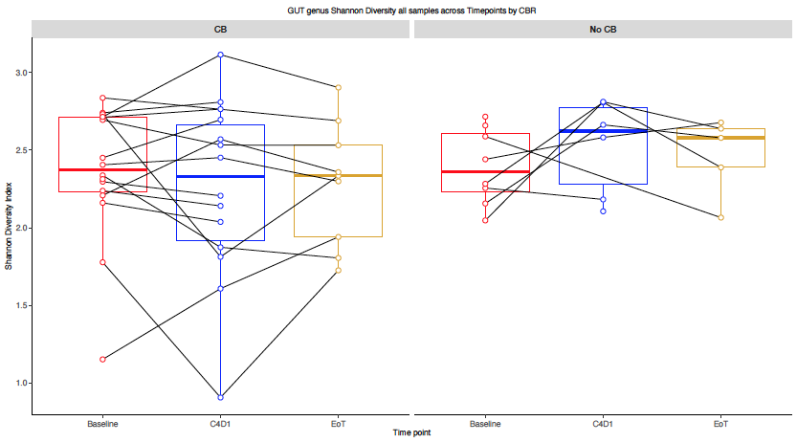
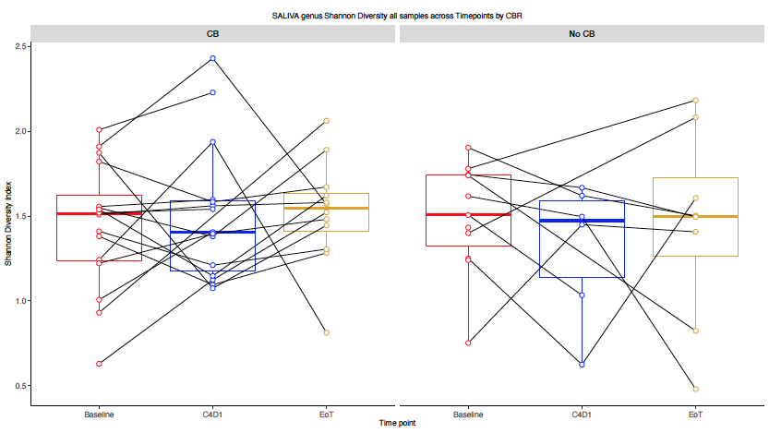
S.Figure 1: Study treatment does not confer microbiota toxicity. No significant changes in the gut alpha diversity, at genus level, were detected in patients who experienced a clinical benefit (CB) (A). Those patients who did not experience a CB showed a trend towards increasing gut alpha diversity, though not significant. This trend was not observed in the oral alpha diversity, also at genus level (B).
S.Figure 2: Number of hits of Cytochrome P450 genes within each CALADRIO metagenome, stratified by clinical parameters: CB (clinical benefit), NLR (neutrophil-to-lymphocyte-ratio), PDL1 (programmed cell-death ligand 1).

Acidovorax | Desulfovibrio | Methylobacterium
Acinetobacter | Enterobacter | Mobiluncus
Actinomyces | Enterococcus | Mogibacterium
Aggregatibacter | Faecalibacterium | Mycoplasma
Agrobacterium | Filifactor | Neisseria
Bacillus | Flavobacterium | Odoribacter
Bacteroides | Fusobacterium | Paenibacillus
Bifidobacterium | Gemella | Paracoccus
Blautia | Geobacillus | Porphyromonas
Brevibacillus | Haemophilus | Prevotella
Bulleidia | Klebsiella | Pseudomonas
Butyrivibrio | Lachnospira | Ruminococcus
Campylobacter | Lactobacillus | Shewanella
Capnocytophaga | Lactococcus | Sphingomonas
Chryseobacterium | Lautropia | Staphylococcus
Clostridium | Leptotrichia | Stenotrophomonas
Coprococcus | Leuconostoc | Streptococcus
Desulfobulbus | Macrococcus | Treponema
Desulfomicrobium | Methanobrevibacter | Weissella
S. Table 1: 57 common genera between the oral and gut microbiota.
(A)
(B)
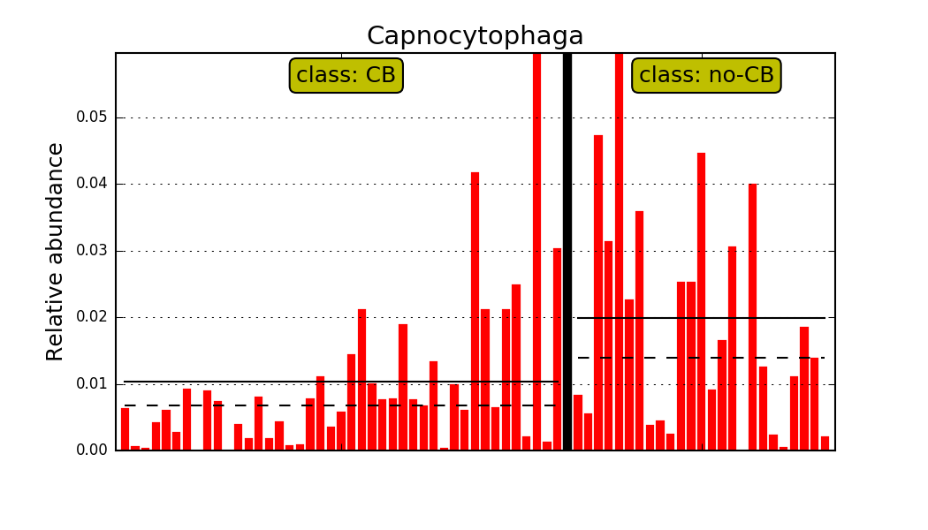
S.Figure 3: Differential features determined by LEfSe for (A) gut and (B) oral microbiota.

