Supplementary Information

PHOTO-CURABLE THIOL-ENE / NANOCELLULOSE ELASTOMERIC COMPOSITES FOR BIO-INSPIRED AND FLUORINE-FREE SUPERHYDROPHOBIC SURFACES

Alper Balkan ‡, Enrico Sola ‡, Feyza Karasu and Yves Leterrier*
Address: Laboratory for Processing of Advanced Composites (LPAC), École Polytechnique Fédérale de Lausanne (EPFL), CH-1015 Lausanne, Switzerland
‡Equal contributors
*Corresponding author, yves.leterrier@epfl.ch

Chemical structures of materials
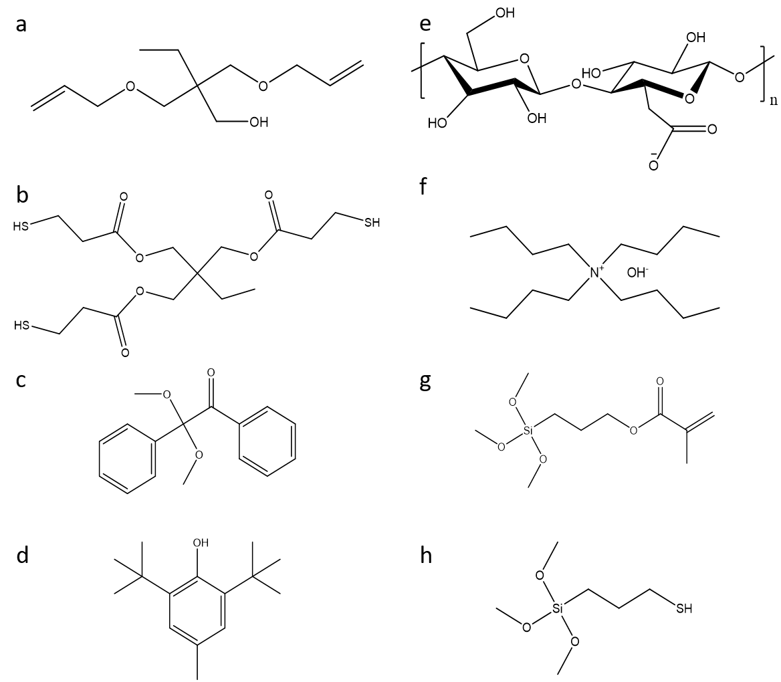
Figure S1: Molecular structures of resin components including (a) TMPDE, (b) TMPTMP, (c) DMPA, (d) BHT, (e) TOCNF without counter cation, (f) Bu₄NOH, (g) MPS, (h) MPTMS.

Pre-hydrolysis of surface modifiers
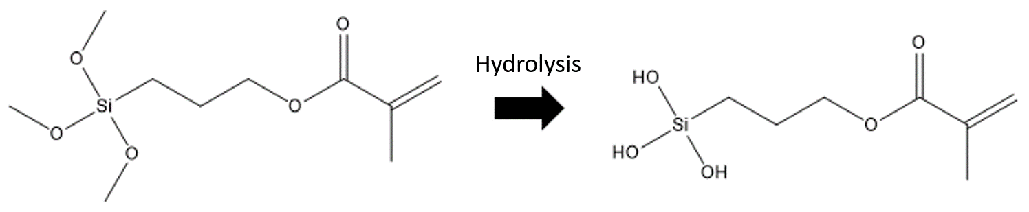
Figure S2: Schematic representation of the change in the molecular structure due to the hydrolysis step of MPS; specifically, CH₃ groups are replaced by OH groups.

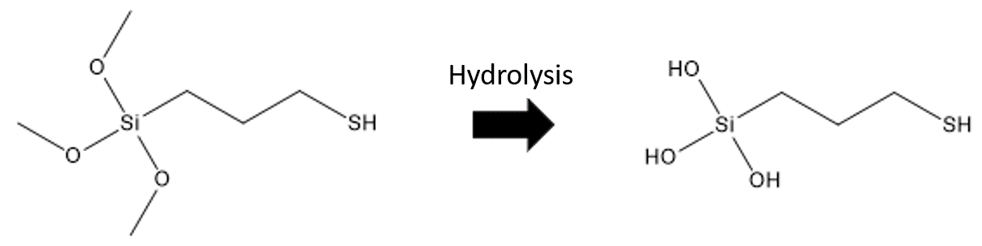
Figure S3: Schematic representation of the change in the molecular structure due to the hydrolysis step of MPTMS; specifically, CH₃ groups are replaced by OH groups.

Improvement in particle dispersion following cation exchange
For further investigation regarding the Bu₄NOH surface modification of TOCNFs, zeta potential (Table S1) measurements were performed. The decrease in the modulus of the zeta potential following surface modification with Bu₄NOH indicates that the modified cellulose nanofibrils exhibited a lower repelling power and thus lower stability in the aqueous medium. In contrast, dispersion in a hydrophobic medium, such as the resin used in this project (Figure 2), has yielded a more transparent and viscous resin in agreement with the estimations based on zeta potential. However, the zeta potential value of the Bu₄NOH-TOCNF water suspension may not have been quantitatively accurate as it had a basic pH, unlike the neutral water suspension with TOCNF, which also had an influence on the zeta potential. Thus, the results could be evaluated only qualitatively.
Table S1: Obtained zeta-potentials concerning TOCNF and Bu₄NOH-TOCNF water suspensions (0.1 wt.%).
Particle type | Medium | Concentration [wt.%] | Zeta potential [mV] | Literature reference [mV]
TOCNF | water | 0.1 | -54.5 | -55.8 [1]
Bu₄NOH-TOCNF | water | 0.1 | -39 | -

Photopolymerization of thiol-ene reference resin
FT-IR analysis (Figure S4) was used to evaluate the thiol-ene photochemical reaction between TMPDE and TMPTMP, following the photoinitiation by the Norrish I type photoinitiator 2,2-dimethoxy-2-phenylacetophenone. By comparing the FT-IR spectra of the different chemical species, the disappearance of the C=C (920, 1645 and 3080 cm⁻¹) and S-H (2565 cm⁻¹) groups, which are solely present in monomers, was evident and confirmed the photo-cross-linking reaction.
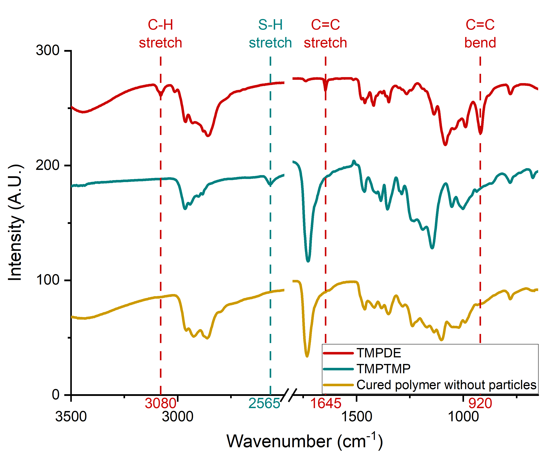
Figure S4: FT-IR spectra of TMPDE, TMPTMP and UV-cured reference resin.

Photo-curing of composite resins with changing viscosity and heat flow
Figure S5 displays the viscosity increase in resins during photo-curing with respect to the irradiation duration and includes also the control samples, which were separately prepared for repeatability. These samples showed negligible to minor deviations from the initial tests.
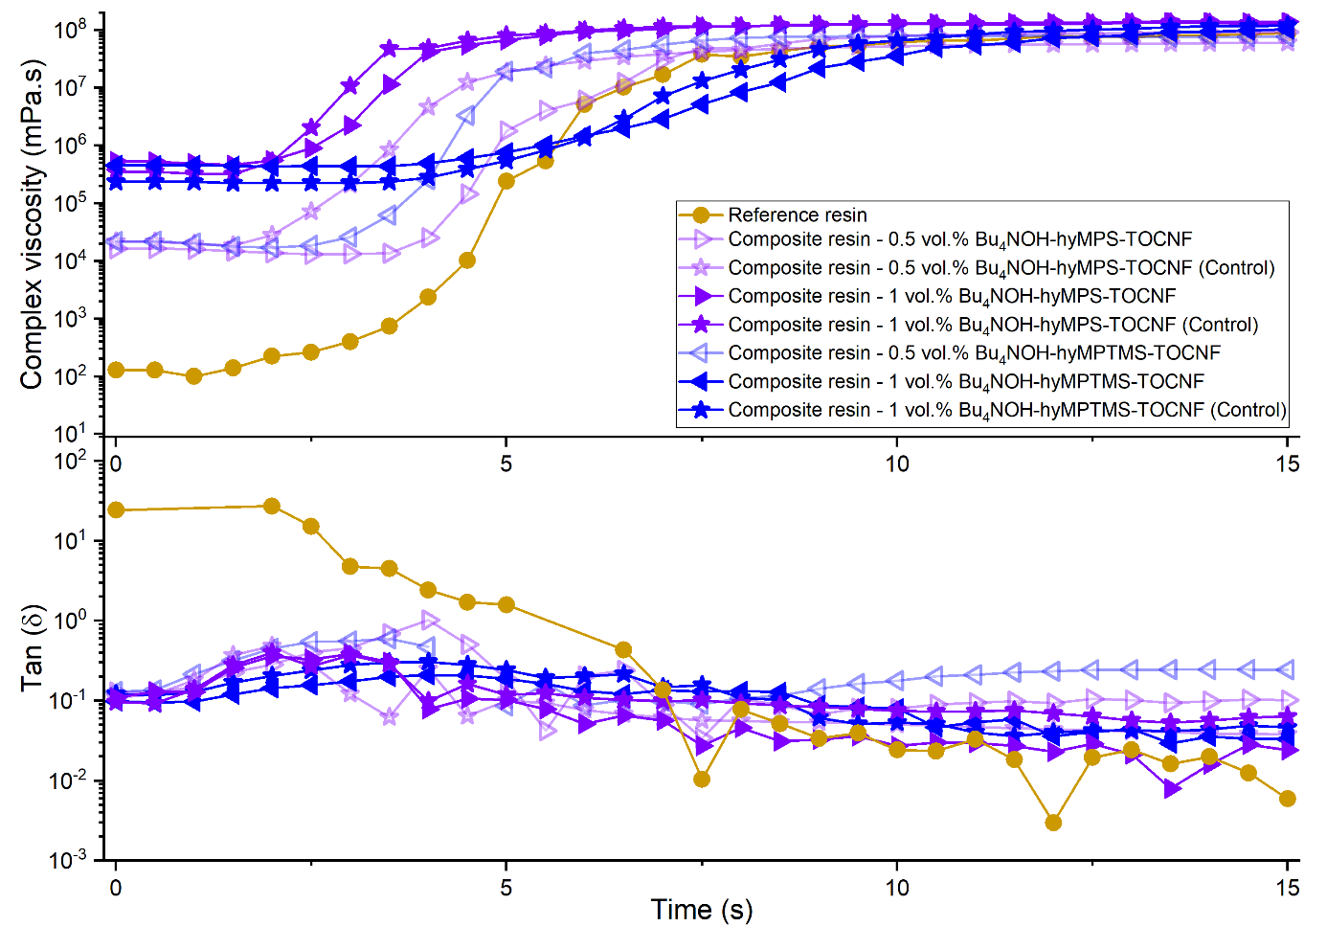
Figure S5: Photo-rheometry curves of reference and nanocomposite resins with different compositions, subjected to ~ 15 mW/cm² light intensity at time t = 0 s to analyze the photo-cross-linking kinetics.

In Figure S6, it can be seen that the photo-DSC measurements had a decent repeatability insofar as showing distinguishable trends between resins with varying filler concentration and surface modification type. Moreover, the composite resins with 0.5 vol.% MPTMS-grafted CNFs also showed reduced photo-curing speeds but to a lesser extent in comparison with resins having 1 vol.% of MPTMS-grafted CNFs.
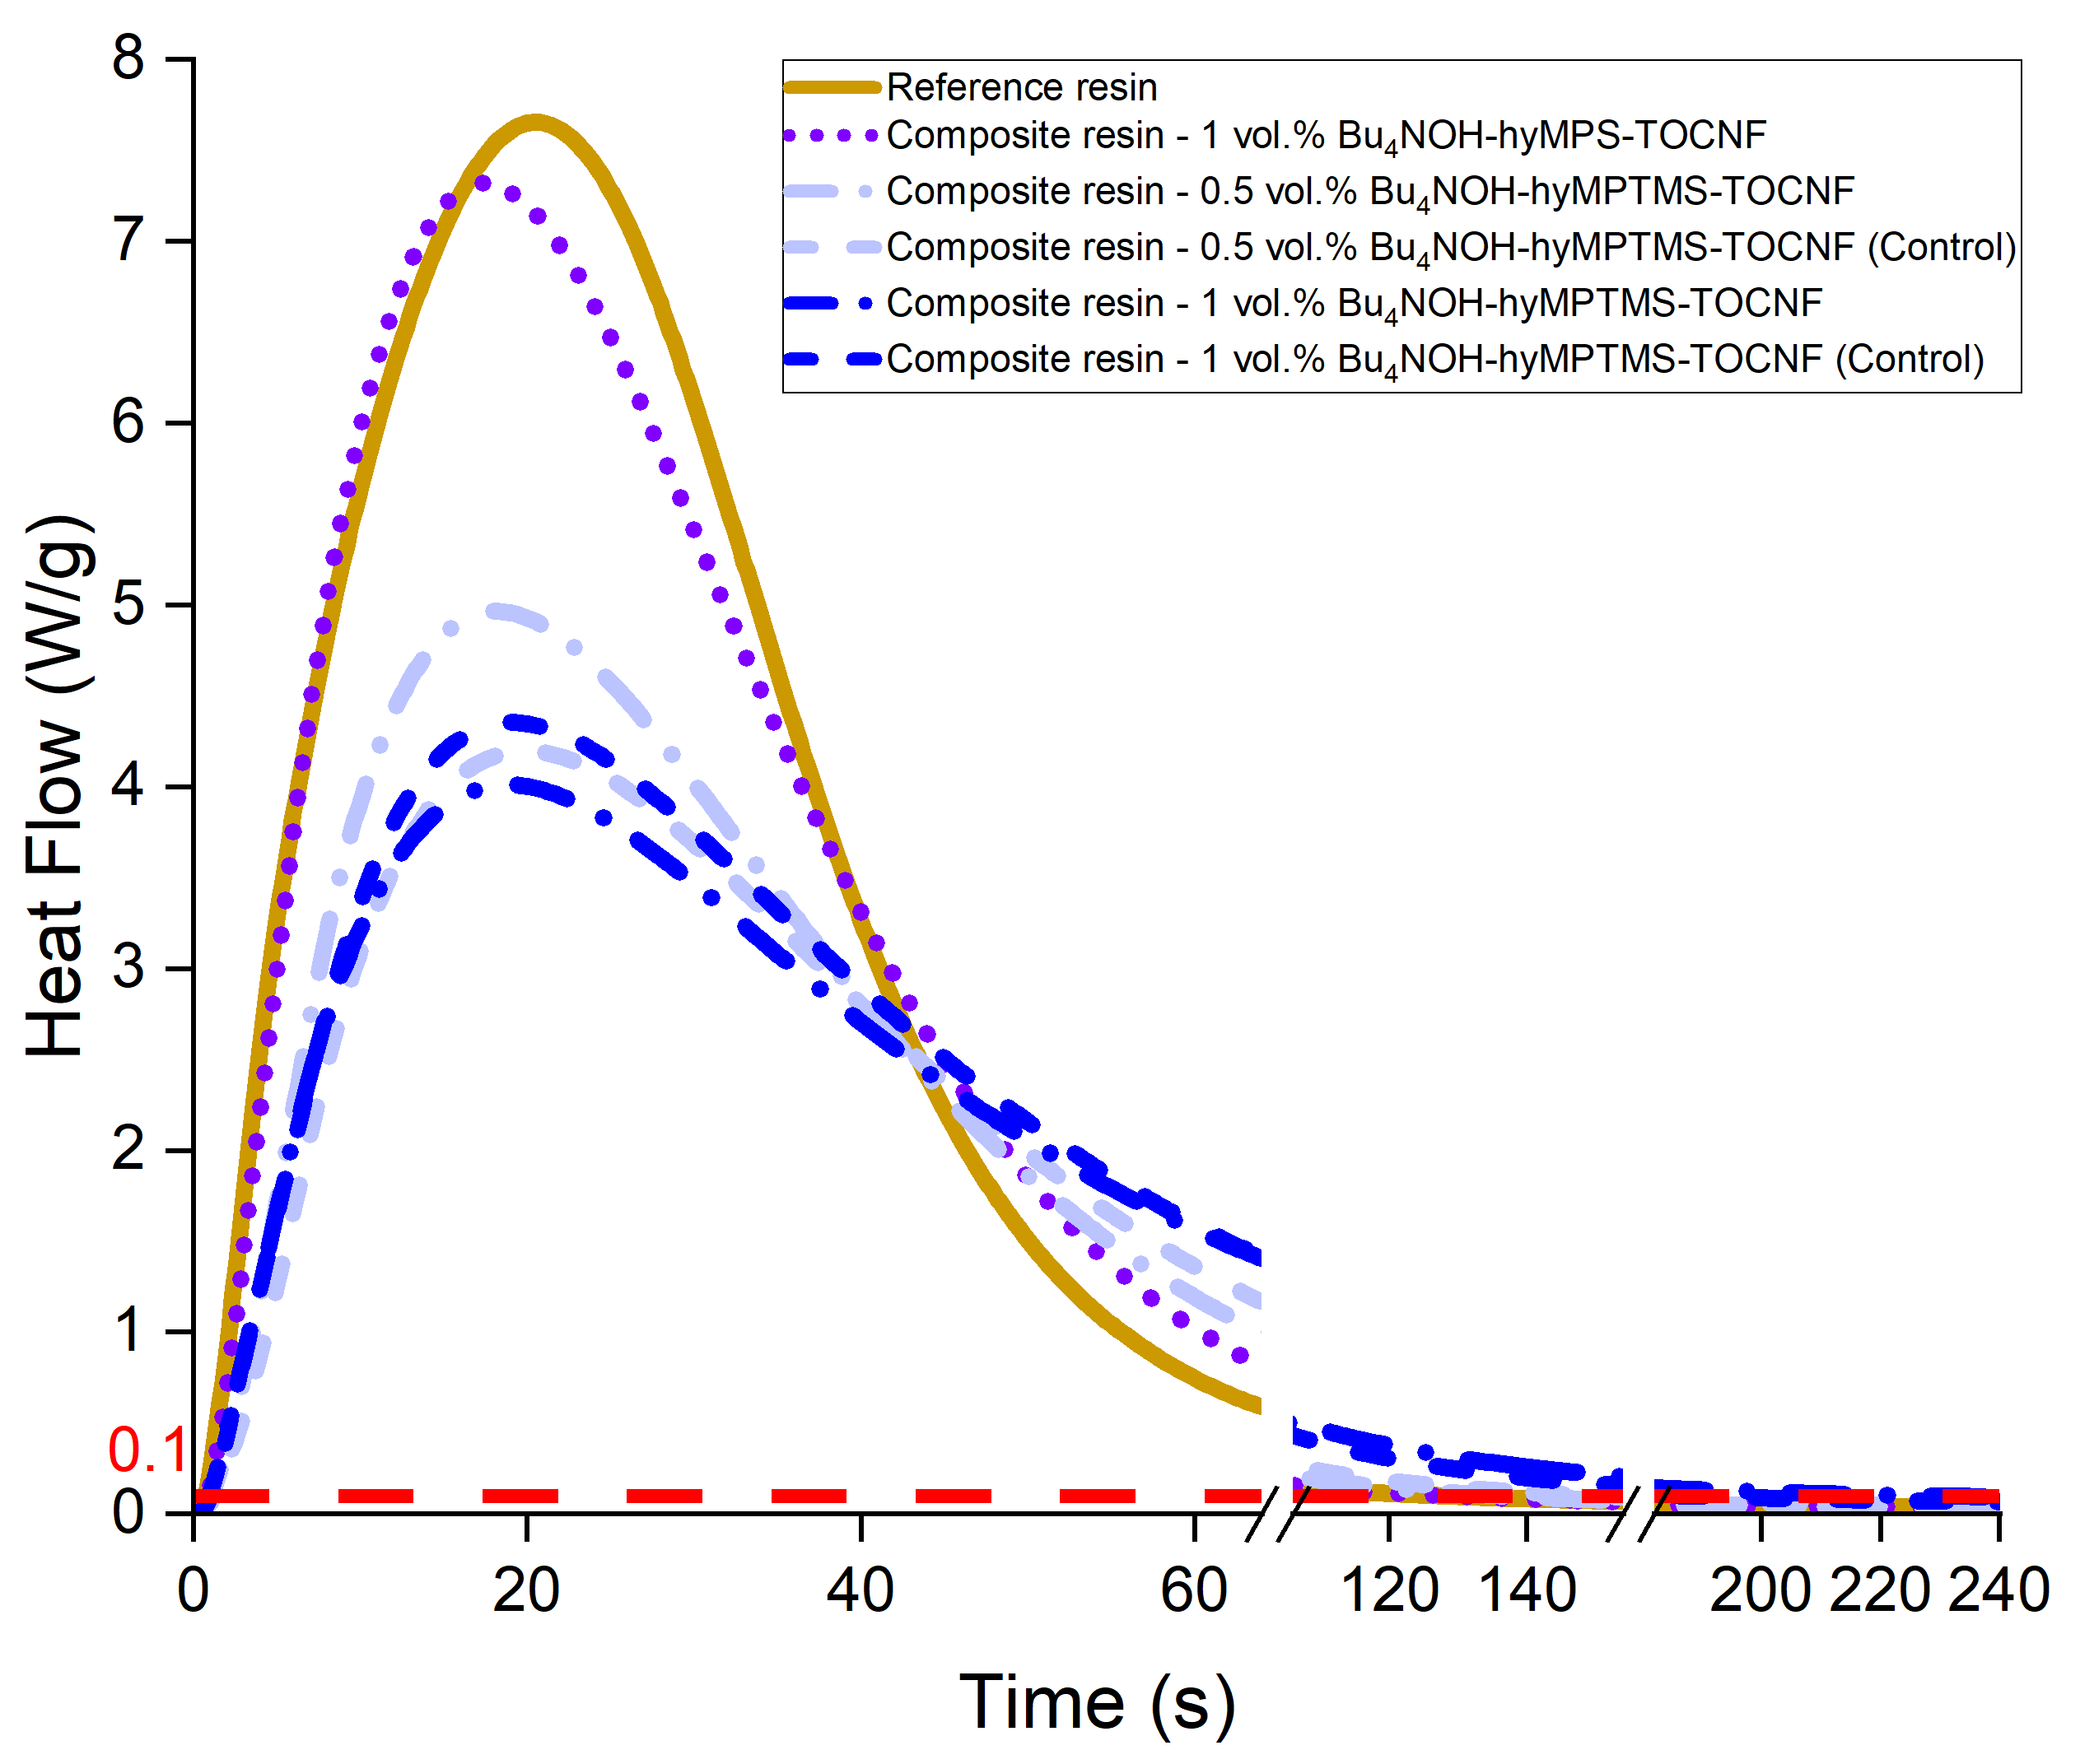
Figure S6: Photo-DSC measurements with additional curves demonstrating repeatability of resin curing behavior as well as the effect of reduced particle loading on reaction speed.

Thermal degradation of as received TOCNF
Dehydration, depolymerization, decomposition of glycosyl units and the residual char formation [2] are shown in Figure S7 with the main onsets of the weight graph given as dashed reference lines. The depolymerization involved the degradation of sodium anhydroglucuronate units (the decarboxylation step) [3] and two main depolymerization regions with DTG peaks at ~ 240 and ~ 290 °C. These peaks could be ascribed to the degradation of the oxidized (which begins with decarboxylation) and the original cellulose [3,4].
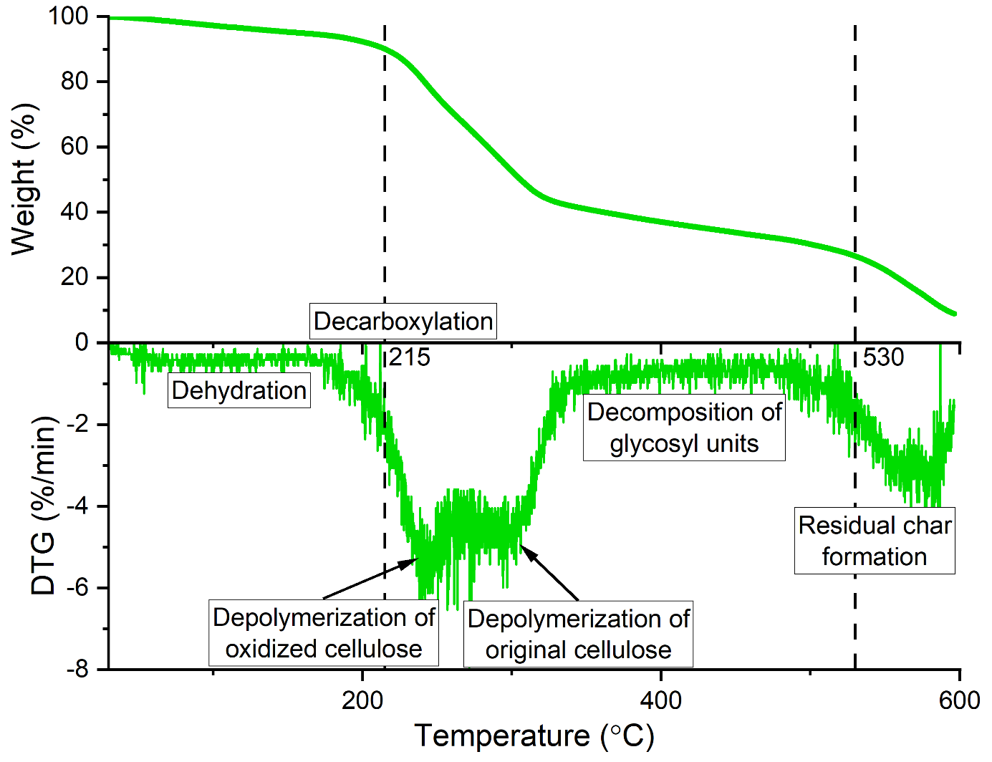
Figure S7: TGA and derivative TGA curves of dried TOCNF powder tested in air between 30 - 600 °C with a constant rate of 10 °C /min with the thermal degradation steps.

Tribological analysis of the composite coatings
The reference and 0.5 vol.% Bu₄NOH-hyMPS-TOCNF loaded composite were tested 3 times for reproducibility with parameters 10, 20 mN and 1, 5 Hz. Figure S8 displays the two-step CoF reduction of the reference material with the second decrease occurring only after ~ 1000 cycles.
Figure S8: Coefficient of friction graphs of the reference material and the 0.5 vol.% Bu₄NOH-hyMPS-TOCNF loaded composite with 10mN normal force and 1 Hz frequency.

Figure S9 shows the coefficient of friction and wear volume loss of the reference coating together with the 0.5 vol.% Bu₄NOH-hyMPTMS-TOCNF loaded composite obtained after 5000 cycles of oscillatory wearing against a steel ball.
Figure S9: Wear volume against the coefficient of friction of the reference material against the 0.5 vol.% Bu₄NOH-hyMPS-TOCNF loaded composite.
Figure S10: Wear loss results with changing parameters of material type, concentration, normal force and frequencies. Error bars are only given for the tests that were performed three times for repeatability.

Contaminated UVNIL pattern template surface following polymer film peel off
As shown in the SEM image (Figure S11), a portion of the cured film remained attached to the PDMS mold leading to an imperfect replication and rendering the mold incapable for repeated use.
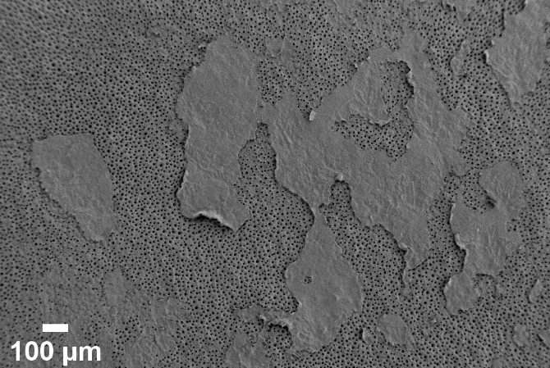
Figure S11: SEM image of a PDMS mold surface after UVNIL imprinting of 1 vol.% Bu₄NOH-hyMPS-TOCNF nanocomposite resin showing residues of the imprinted cured film following the polymer film peel off.

Variation in light transmittance based on filler concentration
The cured nanocomposite films had highly differing surface roughness values as the concentration of fillers vary (Figure S12) with lowest roughness observed belonging to the sample with the lowest filler concentration.
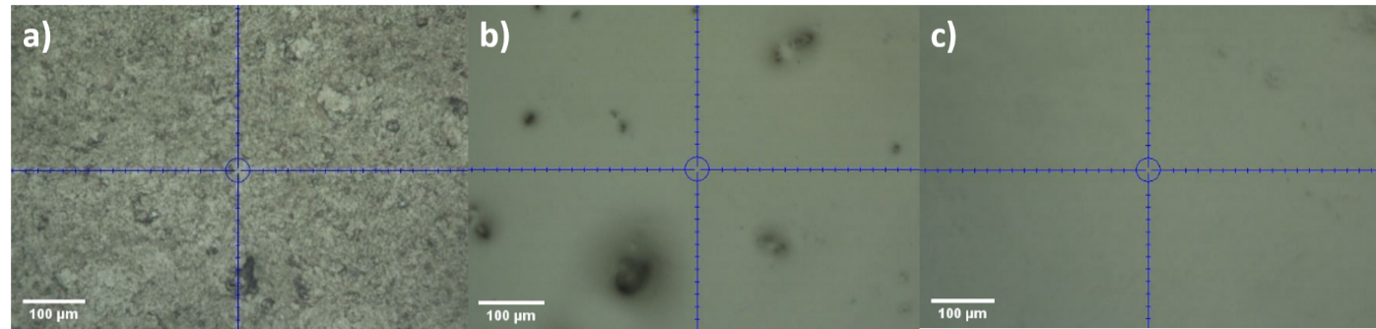
Figure S12: Optical microscopy images showing the surface roughness of cured nanocomposite films containing a) 10 vol.% Bu₄NOH-hyMPS-TOCNF, b) 5 vol.% Bu₄NOH-hyMPS-TOCNF and c) 1 vol.% Bu₄NOH-hyMPS-TOCNF.
The low roughness contributed to the high transmittance of cured films on glass slides (Figure S13).
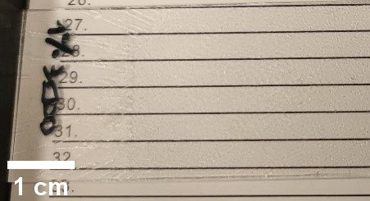
Figure S13: Transparent UV-cured nanocomposite film with 1 vol.% Bu₄NOH-hyMPS-TOCNF on a glass slide.
Nanocomposite films with 85-90% transmittance within visible wavelength range (Figure S14), were prepared and measured by UV-Vis method. The high transmittance of these films could be considered similar to the cured reference resin above approx. 380 nm. If the concentration of TOCNFs was sufficiently low (in particular ≤ 1 vol.%) and surface modifications were applied, the formulation could lead to well-dispersed fillers inside the polymer matrix. The final transmittance of the films nevertheless also depended on the chosen processing method and its parameters which ultimately controlled the filler dispersion level and the cured film surface roughness. Thus, only a few selected UV-Vis graphs are displayed in Figure S10 to support the composite film transparency claims, which were obtained by doctor blading (~ 200 μm) prior to UV curing.
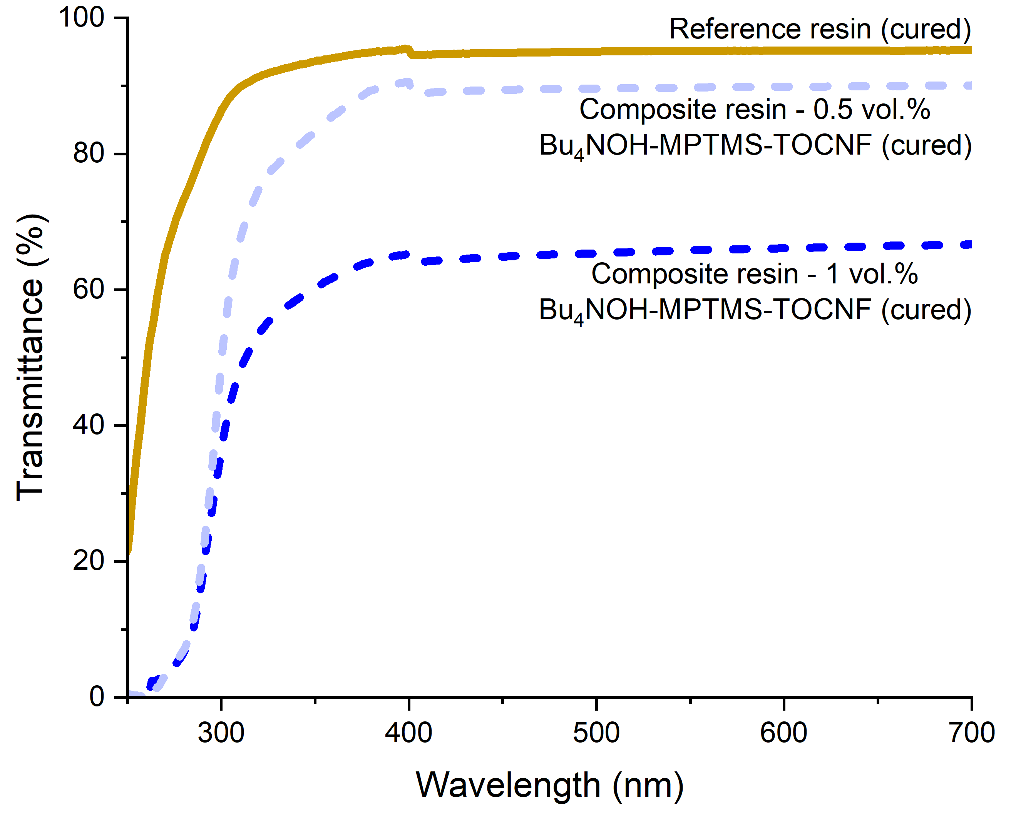
Figure S14: UV-Vis spectra of UV-cured nanocomposite films with different compositions compared to UV-cured reference resin film with visible-to-UV lamp switch occurring at 400 nm.

References
[1] J. Wei, Y. Chen, H. Liu, C. Du, H. Yu, Z. Zhou, Thermo-responsive and compression properties of TEMPO-oxidized cellulose nanofiber-modified PNIPAm hydrogels, Carbohydrate Polymers. 147 (2016) 201–207. https://doi.org/10.1016/j.carbpol.2016.04.015.
[2] A. Kumar, Y.S. Negi, V. Choudhary, N.K. Bhardwaj, Characterization of Cellulose Nanocrystals Produced by Acid-Hydrolysis from Sugarcane Bagasse as Agro-Waste, Journal of Materials Physics and Chemistry. 2 (2014) 1–8. https://doi.org/10.12691/jmpc-2-1-1.
[3] H. Fukuzumi, T. Saito, Y. Okita, A. Isogai, Thermal stabilization of TEMPO-oxidized cellulose, Polymer Degradation and Stability. 95 (2010) 1502–1508. https://doi.org/10.1016/j.polymdegradstab.2010.06.015.
[4] S. Jonasson, A. Bünder, T. Niittylä, K. Oksman, Isolation and characterization of cellulose nanofibers from aspen wood using derivatizing and non-derivatizing pretreatments, Cellulose. 27 (2020) 185–203. https://doi.org/10.1007/s10570-019-02754-w.

