FIG-3
COL1A1
COL1A1-GAPDH

α-SMA
α-SMA-GAPDH
E-CAD
E-CAD-GAPDH
FIG-4
Total-P- FOXO3a
Total- FOXO3a
GAPDH
Nuclear FOXO3a
Nuclear FOXO3a-Lamin B

Total p-AKT
Total AKT
Total GAPDH
Nuclear P-AKT
Nuclear P-AKT-Lamin B
Total-CAPN1
Total-CAPN1-GAPDH
Nuclear CAPN1
Nuclear CAPN1-Lamin B
FIG-5
E-CAD
E-CAD-GAPDH
α-SMA
α-SMA-GAPDH
Total CAPN1
Total CAPN1-GAPDH
Nuclear CAPN1
Nuclear CAPN1-Lamin B
Nuclear FOXO3a
Nuclear FOXO3a-Lamin B
P-FOXO3A
P-FOXO3A-GAPDH
Fig-6
E-CAD
E-CAD+GAPDH
α-SMA
α-SMA+GAPDH
FOXO3A
FOXO3A-Lamin B
P-FOXO3a
P-FOXO3a-Lamin B
CAPN1
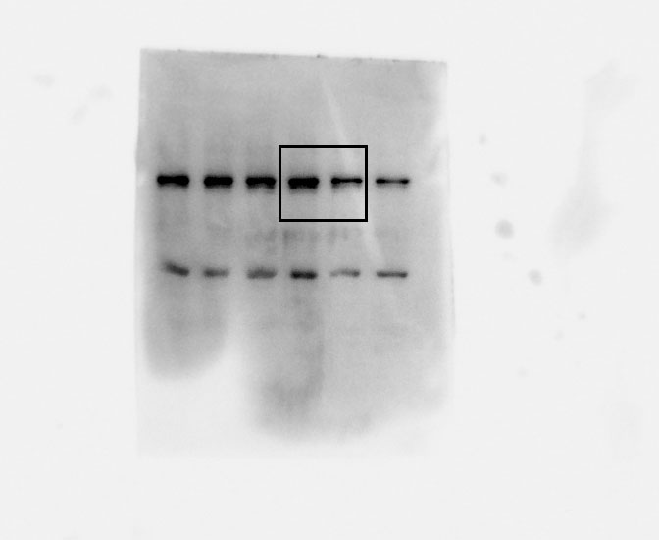
CAPN1-Lamin B
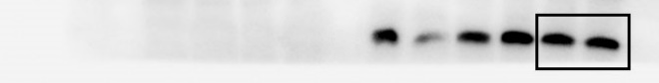
Flag
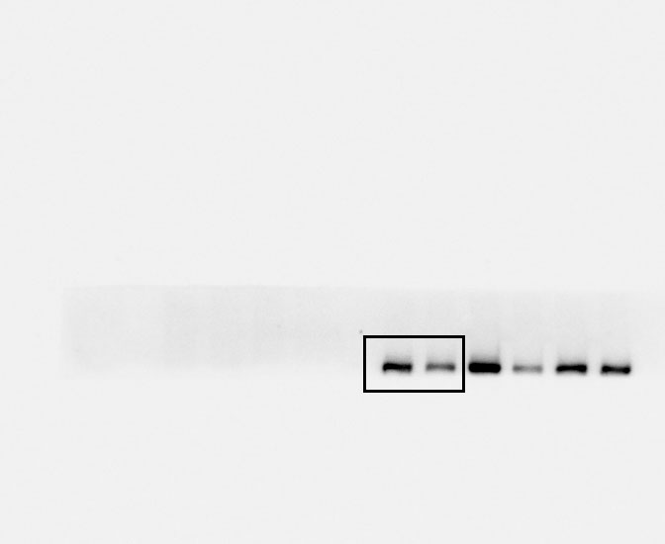
Flag-Lamin B
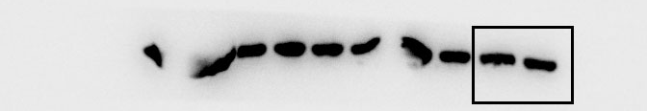
p-AKT
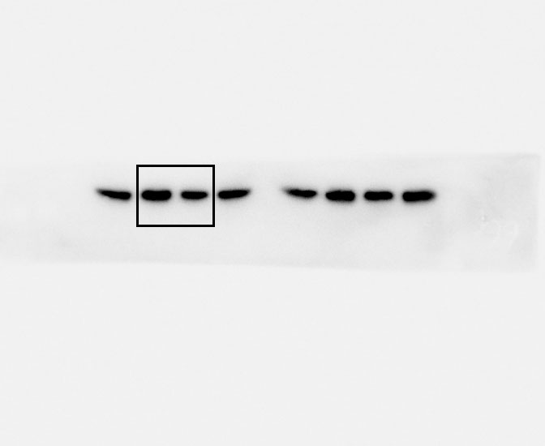
P-AKT
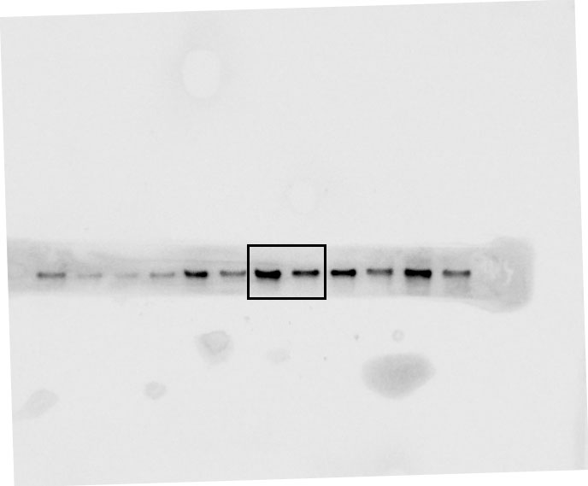
P-AKT-Lamin B
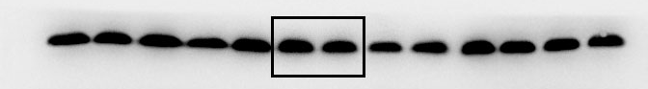
Fig7A
P-AKT
P-AKT-GAPDH
P-FOXO3a
P-FOXO3a-GAPDH
E-CAD
E-CAD-GAPDH
α-SMA
α-SMA-GAPDH
Fig7B
FOXO3a
FOXO3a-GAPDH
p-FOXO3a
p-FOXO3a-GAPDH
E-CAD
ECAD-GAPDH
α-SMA
α-SMA-GAPDH

