Additional file 1

Elucidating the cellular response of silver nanoparticles as a potential combinatorial agent for cisplatin chemotherapy

Renata Rank Mirandaª, Micaella Pereira da Fonsecaª, Barbara Korzeniowskaª, Lilian Skytte^{b}, Kaare Lund Rasmussen^{b} and Frank Kjeldsenª

ªDepartment of Biochemistry and Molecular Biology, University of Southern Denmark, Odense, Denmark
^{b}Department of Physics, Chemistry and Pharmacy, University of Southern Denmark, Odense, Denmark

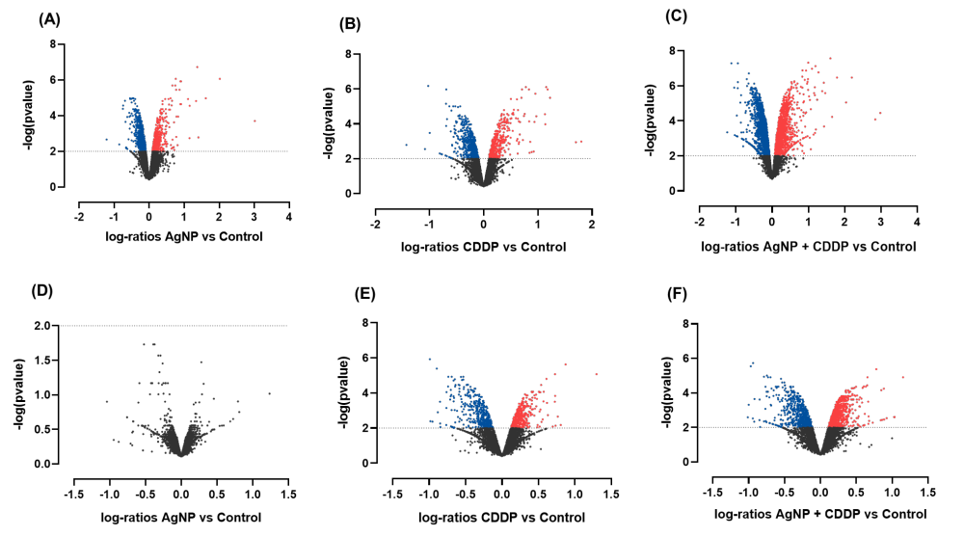

Figure 1. Volcano plots of the comparisons between control and treatment groups in HepG2 (A-C) and THLE2 (D-F) cells. X-axis: mean log-ratios. Y-axis: statistical significance, p-values on the negative log10 scale. The dashed line represents the p-value cutoff of 0.01. Blue dots represent significantly downregulated proteins in comparison to control, while pink dots represent significantly upregulated proteins in comparison to control.

Table 2. Glycolysis related proteins differentially deregulated after 24 h-treatment to AgNP, CDDP or AgNP + CDDP in HepG2 and THLE2 cells. Results express experimental group vs control mean log-ratio of three independent experiments. Table extracted from IPA
Symbol | Gene name | Accession number | HepG2 |  |  | THLE2
Symbol | Gene name | Accession number | AgNP | CDDP | AGNP + CDDP | CDDP | AGNP + CDDP
GPI | Glucose 6 phosphate isomerase | P06744 | -0.18 |  | -0.22
PFKL | Phosphofructokinase 1 | P17858 |  |  | -0.18
ALDO C | Fructose-bisphosphate aldolase C | P09972 | -0.17 |  | -0.23
TPI | Triphosphate isomerase | P60174 | -0.19 |  | -0.18 | 0.36 | 0.23
GAPDHS | Glyceraldehyde-3-phosphate dehydrogenase | O14556 | -0.17 |  | -0.18
ENO1 | Alpha enolase | P06733 |  |  | -0.26
PKLR | Pyruvate kinase | P30613 | -0.33 |  | -0.44

Table 3. NER pathway related proteins differentially deregulated after 24 h-treatment to AgNP + CDDP in HepG2 and THLE2 cells. Results express experimental group vs control mean log-ratio of three independent experiments. Table extracted from IPA
Symbol | Gene name | Accession number | AgNP + CDDP
Symbol | Gene name | Accession number | HepG2 | THLE2
CCNH |  | P51946 | 0.34
  Cyclin H
CETN2 | Centrin 2 | P41208 | -0.169 |  | 0.21
COPS5 |  | Q92905 | -0.176
  Signalosome subunit 5
COPS8 | Signalosome subunit 8 | Q99627 | -0.126
CUL4A |  | Q13619 | -0.096
  Cullin 4ª
DDB1 | Damage specific DNA binding protein 1 | Q16531 | -0.172
DDB2 | Damage specific DNA binding protein 2 | Q92466 | 0.393 |  | 0.49
GTF2H1 | General transcription factor IIH subunit 1 | P32780 |  |  | 0.239
NEDD8 | NEDD8 ubiquitin like modifier | Q15843 | -0.262
PCNA | Proliferating cell nuclear antigen | P12004 | 0.126
POLA2 |  | Q14181 | -0.173
  DNA polymerase alpha 2, accessory subunit
POLD2 | DNA polymerase delta 2, accessory subunit | P49005 | -0.341
POLE | DNA polymerase epsilon, catalytic subunit | Q07864 | -0.277
POLE3 | DNA polymerase epsilon 3, accessory subunit | Q9NRF9 | -0.155
POLR2H | RNA polymerase II subunit H | P52434 | -0.403 |  | -0.346
POLR2I | RNA polymerase II subunit I | P36954 |  |  | -0.317
POLR2J | RNA polymerase II subunit J | P52435 | 0.332
PRIM1 | DNA primase subunit 1 | P49642 | -0.196 |  | -0.184
RAD23B | RAD23 homolog B | P54727 | -0.26 |  | -0.425
TOP2A | DNA topoisomerase II alpha | P11388 | 0.69 |  | 0.358
TOP2B | DNA topoisomerase II beta | Q02880 | 0.436
UBE2I | Ubiquitin conjugating enzyme E2 I | P63279 | -0.189
UBE2N | Ubiquitin conjugating enzyme E2 N | P61088 | -0.321
XPC | XPC complex subunit | Q01831 | 0.374 |  | 0.652

Table 4. Oxidative stress response pathway related proteins differentially deregulated after 24 h-treatment to AgNP + CDDP in HepG2 and THLE2 cells. Results express experimental group vs control mean log-ratio of three independent experiments. Table extracted from IPA.
Symbol | Gene name | Accesion number | HepG2 |  |  | THLE2
Symbol | Gene name | Accesion number | AgNP | CDDP | AGNP + CDDP | CDDP | AGNP + CDDP
ABCC1 | ATP binding cassette subfamily C member 1 | P33527 | 0.254
AKR1A1 | aldo-keto reductase family 1 member A1 | P14550 | -0.204 |  | -0.203
AKR7A2 | aldo-keto reductase family 7 member A2 | O43488 |  |  | -0.204 | 0.182
AKT1 | AKT serine/threonine kinase 1 | P31749 | -0.145 |  | -0.15
CAT | Catalase | P04040 |  |  |  |  | 0.259
CBR1 | carbonyl reductase 1 | P16152 |  |  | -0.155
CCT7 | chaperonin containing TCP1 subunit 7 | Q99832 |  |  | -0.132
CDC34 | cell division cycle 34 | P49427 |  | 0.133 | 0.29
CLPP | caseinolytic mitochondrial matrix peptidase proteolytic subunit | Q16740 | 0.173 |  | 0.28
DNAJB1 | DnaJ heat shock protein family (Hsp40) member B1 | P25685 | 0.744 |  | 0.934 |  | 0.28
DNAJB11 | DnaJ heat shock protein family (Hsp40) member B11 | Q9UBS4 |  |  | 0.122
DNAJB12 | DnaJ heat shock protein family (Hsp40) member B12 | Q9NXW2-2 | 0.278
DNAJB2 | DnaJ heat shock protein family (Hsp40) member B2 | P25686-3 | 0.316 | 0.408 | 0.478
DNAJB4 | DnaJ heat shock protein family (Hsp40) member B4 | Q9UDY4 | 0.77 |  | 1.193
DNAJB6 | DnaJ heat shock protein family (Hsp40) member B6 | O75190 |  |  |  |  | -0.283
DNAJB6 | DnaJ heat shock protein family (Hsp40) member B6 | O75190 |  |  |  |  | -0.283
DNAJC1 | DnaJ heat shock protein family (Hsp40) member C1 | Q96KC8 |  |  |  |  | -0.113
DNAJC10 | DnaJ heat shock protein family (Hsp40) member C10 | Q8IXB1 |  | -0.118
DNAJC15 | DnaJ heat shock protein family (Hsp40) member C15 | Q9Y5T4 | 0.309 | -0.695 | -0.583
DNAJC19 | DnaJ heat shock protein family (Hsp40) member C19 | Q96DA6 |  |  | 0.398 |  | 0.384
DNAJC3 | DnaJ heat shock protein family (Hsp40) member C3 | Q13217 | 0.125
DNAJC7 | DnaJ heat shock protein family (Hsp40) member C7 | Q99615-1 |  |  | 0.117
EIF2AK3 | eukaryotic translation initiation factor 2 alpha kinase 3 | Q9NZJ5 |  | -0.222 | -0.305
EPHX1 | epoxide hydrolase 1 | P07099 | 0.161 | 0.244 | 0.445 | 0.249 | 0.333
ERP29 | endoplasmic reticulum protein 29 | P30040 |  |  | 0.186
FTH1 | ferritin heavy chain 1 | P02794 |  |  | 0.377 |  | 0.368
FTL | ferritin light chain | P02792 | 0.262 | 0.311 | 0.761 | 0.467 | 0.604
GCLC | glutamate-cysteine ligase catalytic subunit | P48506 | 0.381 |  | 0.189
GCLM | glutamate-cysteine ligase modifier subunit | P48507 | 0.909 |  | 1.098
GPX2 | glutathione peroxidase 2 | P18283 | -0.395 |  | -0.354
GSR | glutathione-disulfide reductase | P00390 |  |  | -0.092
GSTA1 | glutathione S-transferase alpha 1 | P08263 | -0.502 |  | -0.468
GSTK1 | glutathione S-transferase kappa 1 | Q9Y2Q3 |  |  | 0.246
GSTM2 | glutathione S-transferase mu 2 | P28161 | -0.202
GSTM2 | glutathione S-transferase mu 2 | P28161 |  |  |  | 0.198
GSTM3 | glutathione S-transferase mu 3 | P21266 | -0.165 |  | -0.208
GSTO1 | glutathione S-transferase omega 1 | P78417 | -0.297 |  | -0.414 | 0.194
GSTP1 | glutathione S-transferase pi 1 | P09211 |  |  |  | 0.222
HACD3 | 3-hydroxyacyl-CoA dehydratase 3 | Q9P035 |  |  | 0.159
HERPUD1 | homocysteine inducible ER protein with ubiquitin like domain 1 | Q15011-1 |  | -0.783 | -0.686
HMOX1 | heme oxygenase 1 | P09601 | 1.109 |  | 1.422 | -0.177 | 0.236
HSPB8 | heat shock protein family B (small) member 8 | Q9UJY1 |  |  |  |  | 0.377
KEAP1 | kelch like ECH associated protein 1 | Q14145 | 0.134 | 0.132 | 0.174
MAFF | MAF bZIP transcription factor F | Q9ULX9 | 0.467 |  | 1.243 | 0.617 | 0.885
MAFG | MAF bZIP transcription factor G | O15525 | 0.715 |  | 1.206
MAP2K1 | mitogen-activated protein kinase kinase 1 | Q02750 |  |  | -0.321
MAP2K2 | mitogen-activated protein kinase kinase 2 | P36507 |  |  | -0.128
MAPK1 | mitogen-activated protein kinase 1 | P28482 | -0.272 |  | -0.349
MAPK3 | mitogen-activated protein kinase 3 | P27361-1 | -0.233 |  | -0.156
MGST1 | microsomal glutathione S-transferase 1 | P10620 |  |  | 0.286
MGST2 | microsomal glutathione S-transferase 2 | Q99735 |  |  | 0.09
NQO1 | NAD(P)H quinone dehydrogenase 1 | P15559-1 |  |  |  | 0.201 | 0.217
NQO2 | N-ribosyldihydronicotinamide:quinone reductase 2 | P16083 |  |  |  | 0.225
PMF1/PMF1-BGLAP | polyamine modulated factor 1 | Q6P1K2-2 |  |  | -0.4
PPIB | peptidylprolyl isomerase B | P23284 |  |  | 0.136 |  | 0.18
PRDX1 | peroxiredoxin 1 | Q06830 |  |  |  | 0.24 | 0.153
PRKCA | protein kinase C alpha | P17252 |  | -0.378 | -0.131 |  | -0.27
PRKCD | protein kinase C delta | Q05655 |  |  | 0.1
RALA | RAS like proto-oncogene A | P11233 |  |  | 0.13
RALB | RAS like proto-oncogene B | P11234-2 | 0.208 | 0.246 | 0.355
RAP2B | RAP2B, member of RAS oncogene family | P61225 |  | 0.437 | 0.213
RRAS2 | RAS related 2 | P62070-4 | 0.343 |  | 0.363
SCARB1 | scavenger receptor class B member 1 | Q8WTV0-2 | -0.167 |  | -0.126
SOD2 | superoxide dismutase 2 | P04179 |  | 0.346 | 0.419
SOD2 | superoxide dismutase 2 | P04179 |  |  |  | 0.284 | 0.358
STIP1 |  | P31948-2 |  |  |  |  | -0.17
TXN | thioredoxin | P10599-1 |  |  | -0.227
TXNRD1 | thioredoxin reductase 1 | Q16881 | 0.246
USP14 | ubiquitin specific peptidase 14 | P54578 |  |  | -0.134

