Appendix A
Environmental pollution as a result of a vacuum deficit in the working areas during asbestos removal work

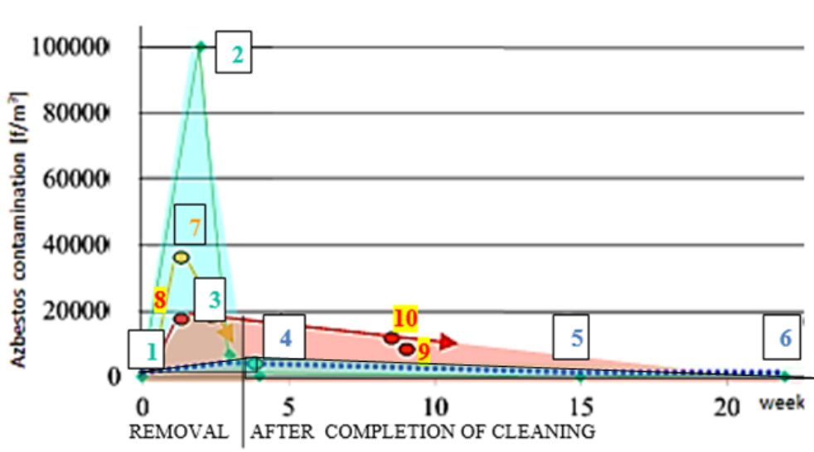

Fig. A1 Differences in exposure levels for people inside and outside the work zone on a time scale in the "LIPSK" building during asbestos removal.
- At a constant negative pressure of 8-16 Pa inside the work zone: outside the work zone - blue graph and (personal measurement) inside the work zone - green graph.
- At negative pressure of 2 Pa inside the work zone during work only: orange diagram inside the work zone. In that work zone, there were total vacuum losses for about 8 hours between work shifts (power cuts). Red graph - measurements taken on another floor where no asbestos removal works were being carried out at the time. (All measurements were taken using the PCM technique).
Legend to point in the green chart in Fig. A1 At a constant negative pressure of 8-16 Pa inside the work zone
1. Contamination before the commencement of preliminary disassembly works <100 f/m³.
2. Max value during disassembly, in the work area (acceptable value 100,000 f/m³).
3. During disassembly work, outside the work area (leakage) 4,700 - 6000 f/m.³
4. Contamination 3 weeks after completion of works 3,000 f/m^{3.}
5. Contamination 15 weeks after completion of work 1,000 f/m.³
6. Contamination 22 weeks after completion of works.
Legend to point in the yellow and pink chart in Fig. A1 At negative pressure of 2 Pa inside the work zone
7. During disassembly work, inside the work area, the negative pressure in the work zone disappeared between work shifts (39,000 f/m³ ).
8. Contamination of indoor air in the same building in rooms where asbestos removal has not taken place. The result of leakage from the work zone and the accumulation of contaminants when the negative pressure in the work zone disappeared between work shifts. (18,700 f/m³).
9 and 10 Contamination of indoor air in the same building in rooms after 8 weeks (3000 - 4500 f/m³).

Table A1 Asbestos fibre concentrations in different volume objects during the same activities depend on volume Measurements were made using PCM + PLM
Object in which a-c plates were removed | The volume of the “work zone” [m³] | Fibre concentration range [f/m³]
Sports hall (inside), case no.3 | ≈ 100,000 | 390 - 7,100
One-story, small house (inside) | 120 | 10,000 - 40,000
Duct encased in panels | 30 | ≈ 45,000 - 60,000

"Work zone" - the internal space of the building constituting its cubature, which has not been separated by airtight zones of works.

Table A2 Asbestos dust concentrations measured at various distances from the emission source
(range and mean value) - historical data from 2000 to 2010. Measured PCM + PLM

Dust source | Action, type of ACM damage, work carried out outdoors of the buildings  (External source of asbestos airborne fibres) | Distance from emission source [m] | Numb.  of measure. | Dust concentration range, average [F/m³] | σ  [F/m³]
Dismantling of wet asbestos cement corrugated sheets used as a sprinkler in a cooling tower  (ACM nonfriable), outdoor | Manual transport of dismantled, damaged panels | ≈5–10 | 1 | 1,300 | -
 | Dropping plates from a height of 8 m onto the bottom of a sprinkler in a cold store for time 180 min. | 2.5–3 | 1 | 2,500 | -
 | Transport of panels by lift and unloading | 15 | 2 | 500  - 800 average 650 | 200
 | Manual loading of panels onto a small truck | 10 | 2 | 850 - 1,000  average 930 | 110
 | Loading crushed panels onto a big truck | 2 | 1 | 1,800 | -
 | As above, plates dried out | 2 | 1 | 3,000 -  4,000  average 3,500 | 710
 | Untouched pile of broken panels after drying | 0.5 | 1 | 4,000 | -
 | Breaking off fireproof insulation sprayed on steel structures of the building (dry, with local dust extraction), measurement outside the work area | 3-6 | 3 | average 633,000 | 321,460
Waste containing asbestos in the friable form | Landfill for asbestos-cement panels (broken sheet) | 3 | 4 | 17,000, 26 000, 34000, 47,000 average 31,000 | 12,730
Waste containing asbestos in the friable form | Settling tank at the a-c panel production plant-filled  chrysotile pulp, 5–8 % asbestos content | 3 -5 | 2 | 15,000 – 25,000  average 20,000 | 7,070
Waste containing asbestos in the friable form | Illegal, uncover, disused small “wild” landfill for asbestos waste | 5 | 2 | 4,000 – 6,000  average 5,000 | 1,400
Waste containing asbestos in the friable form | Soil road contaminated with friable asbestos waste. Content asbestos in soil 0.05–0.1 %. Measurements taken while vehicles were traveling on the road from time to time | 2 | 2 | 6,000 –70,000  average 38,000 | 45,260
Waste containing asbestos in the friable form | As above, continuous vehicle movement | 4 | 2 | 60,000 - 200,000  Average 130,000 | 99,000
Waste containing asbestos in the friable form | Industrial landfills of post-production waste of plants producing asbestos-cement plates after cursory reclamation | 6- 10 | 4 | 2,000, 4500, 2000, 6,000 average 3,630 | 1,970

Table A3 Work and result. Dust concentration comparison during window removal in an asbestos-containing building. Measured PCM + PLM.
The object containing an a-c facade | Characteristic of measuring place | Fibre concentration range before asbestos removal [f/m³] | Fibre concentration range during asbestos removal [f/m³]
Replacement of 2 windows in a building with an asbestos-cement (a-c) facade. Measurement after exterior damage to the fragments of a-c boards fixed to the window frame. Tests were taken at the same time, at the same distance from the replaced window. | Volume room 50 [m³] | inside the room
 | Volume room 50 [m³] | ≈ 300 | 4,000–5,000
 | 1,5 m from the window | outside the window
 | 1,5 m from the window | ≈ 300 | 300 - 1000
 | 5 m from the window | < 300 | < 300

