Appendix B, Fig. B3

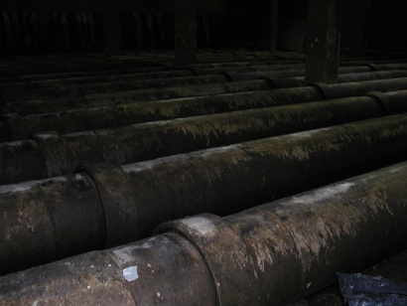 a 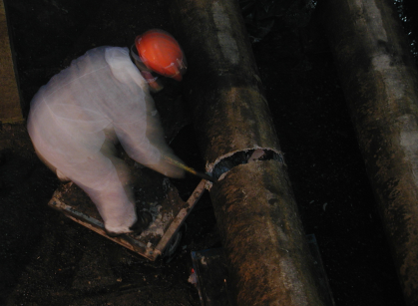 b
Fig. B 3 Shredding and pipe removal: a) large room with many pipes for removal; b) No work zone separation.

