Appendix B, Fig. B4

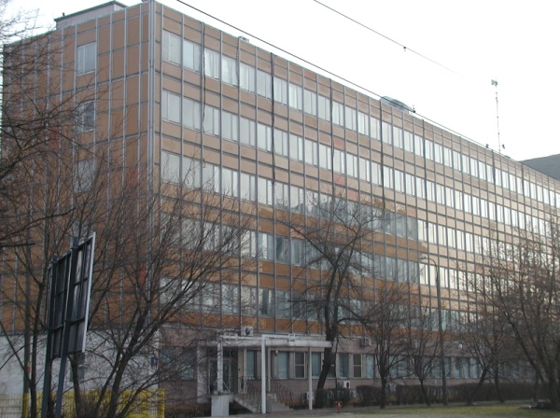 a 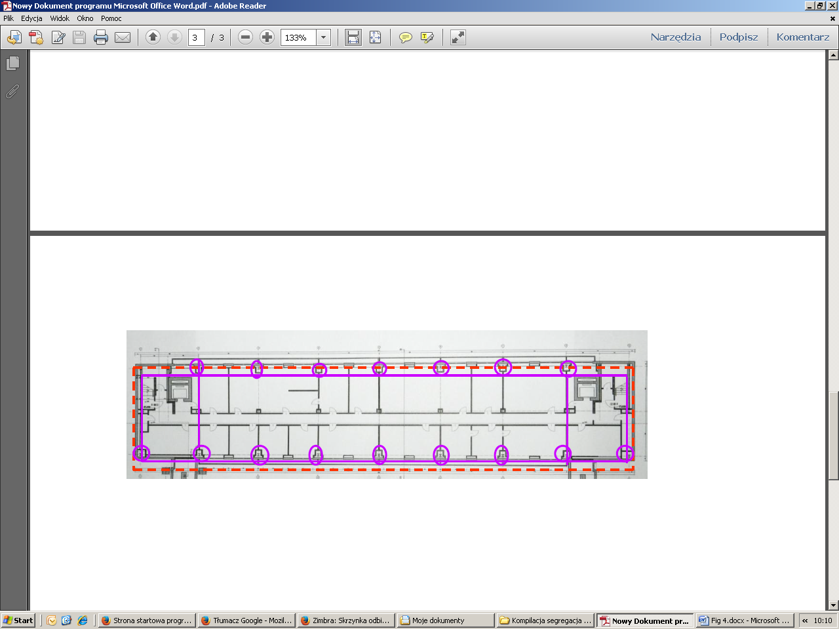 b
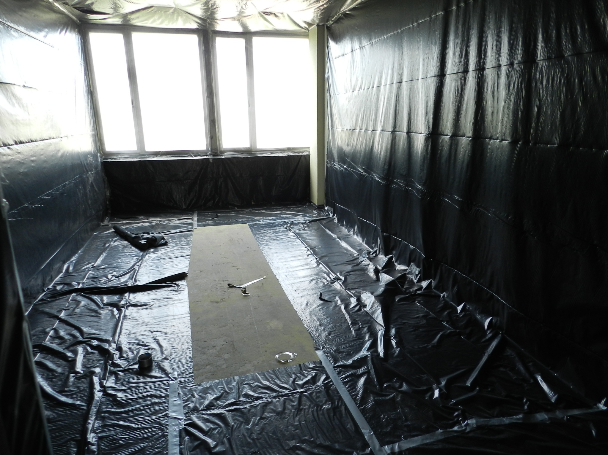 c 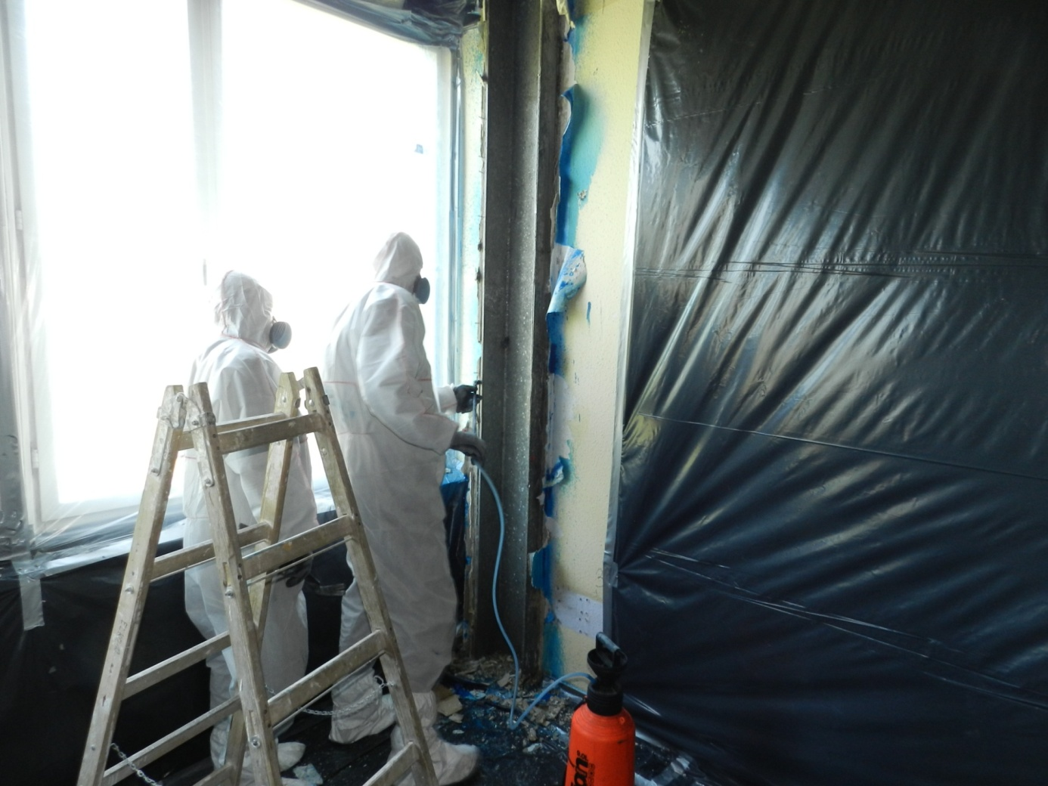 d
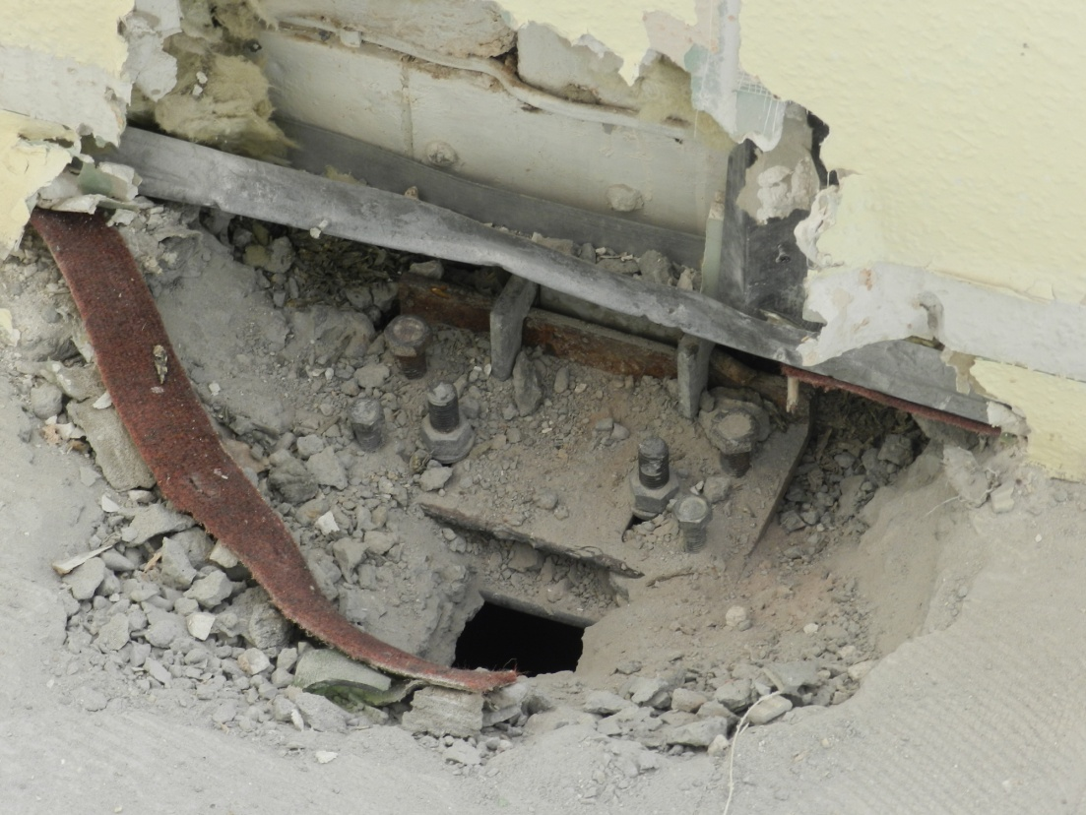 e 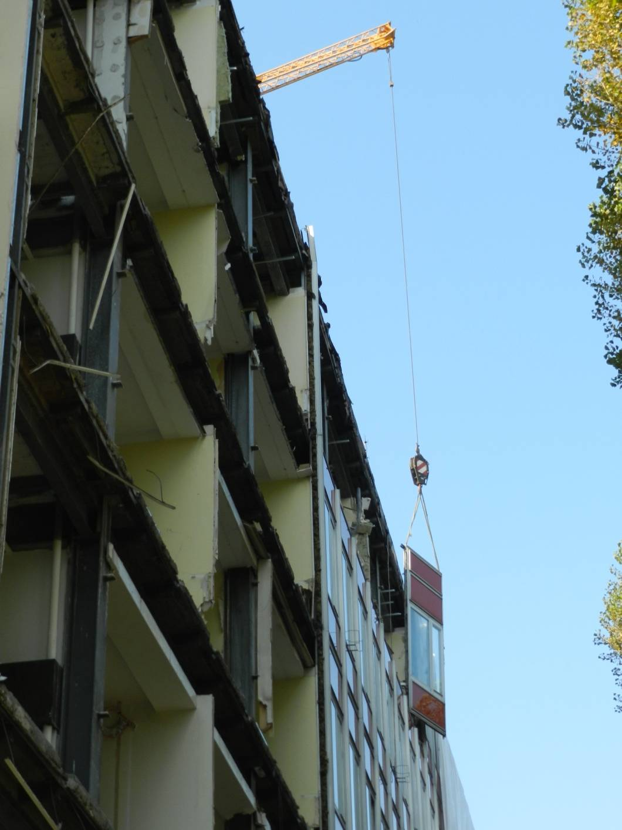 f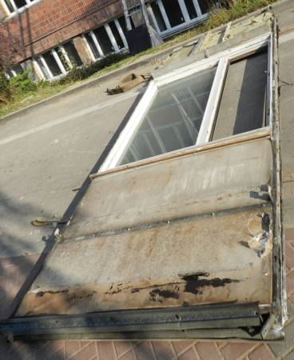 g
Fig. B 4 Phases of asbestos removal from the "LIPSK" type building and the accompanying problems
a) General appearance of the "LIPSK" type building;
b) Typical floor plan: as a friable ACM (“SOKALIT” board), as a non-friable ACM;
c) and d)The problem of sealing the working area when removing non-friable ACM On each floor the space over the rooms, above the suspended ceiling, is common. It makes it difficult to airtight the rooms. Pollution from one of them is spread throughout the building (especially when the negative pressure drops in the contaminated work zone e.g. as a result of power failure)
e) After partial removal of non-friable ACM on structural elements, disassembly of wall panel fasteners. Breaking the ceilings at the point of their connection with the sandwich curtain wall;
f) and g) Removal of curtain wall panels, "SOKALIT" ( friable and non-friable ACM) boards remain inside removable panels.
g) The inside of the wall panel. In the under-window element visible soft fire-resistant board – “SOKALIT”

