Appendix B, Fig. B1

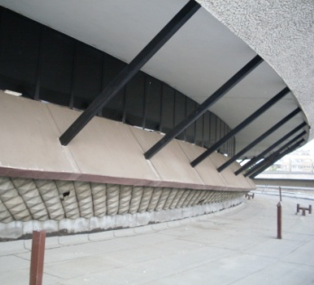a 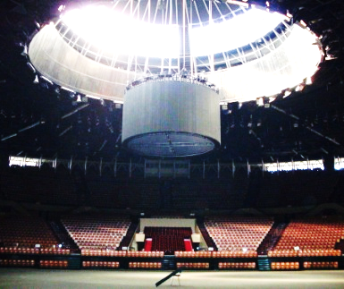 b 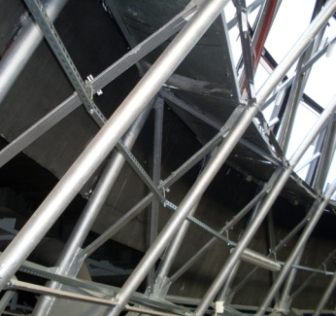c

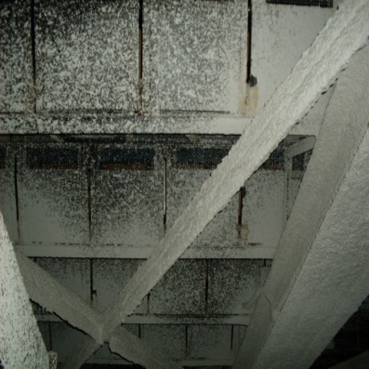 d 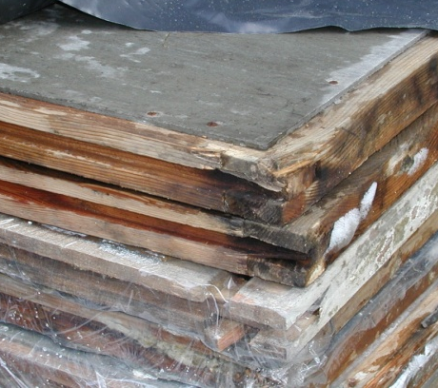 e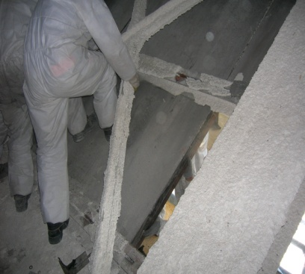 f

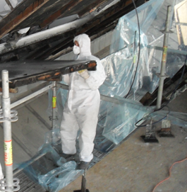g 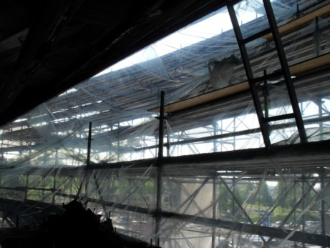 h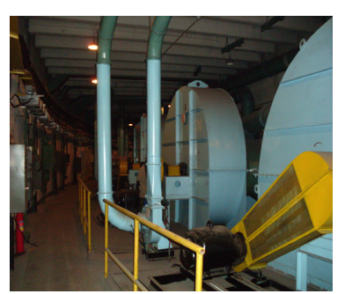i

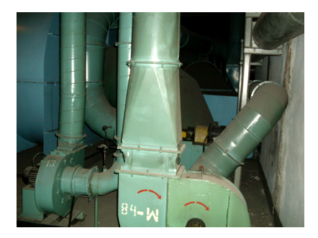j 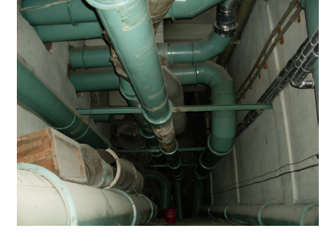k

.
Fig. B1 A sports and recreation facility that was built in the 1970s.
a) Fragment of the external building part, the lower part, a trapezoidal shell forming the facade (asbestos-cement panels). PW3/A sandwich question above metal supports.
b) General view of the sports hall interior.
c) PW3/A panels visible from inside the building behind the steel support structure.
d)Asbestos-containing PW3A asbestos-cement boards in the technical space (under the stands) before disassembly
e) PW3A boards after dismantling
f) PW3A boards when being pulled out of the fixing place
g) Failure to seal the work zone.
h) Failure to divide the large work zone into smaller areas where asbestos dust emissions can be controlled. Deficiencies in special equipment were replaced by a large amount of PE film, which in the absence of a vacuum does not do its job
i) Basement, ventilation room and types of equipment with asbestos rope seals. They were not subject to asbestos removal
j) Basement and ventilation systems with asbestos cord seals. These materials were not subject to asbestos removal
k) Ventilation ducts in the technical space under the stands, seals of joints made of asbestos cord (they were not removed during the disassembly of construction products

