Appendix B, Fig. B2

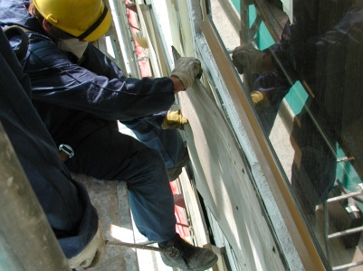 a 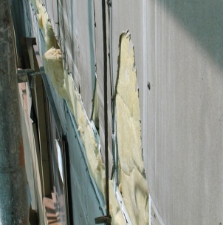 b

Fig. B 2 Uncontrolled destruction of the facade: a) Narrow construction scaffolding forces the asbestos-cement boards to break; b) The entire facade surface looks like this.

