Supplementary Figure 1
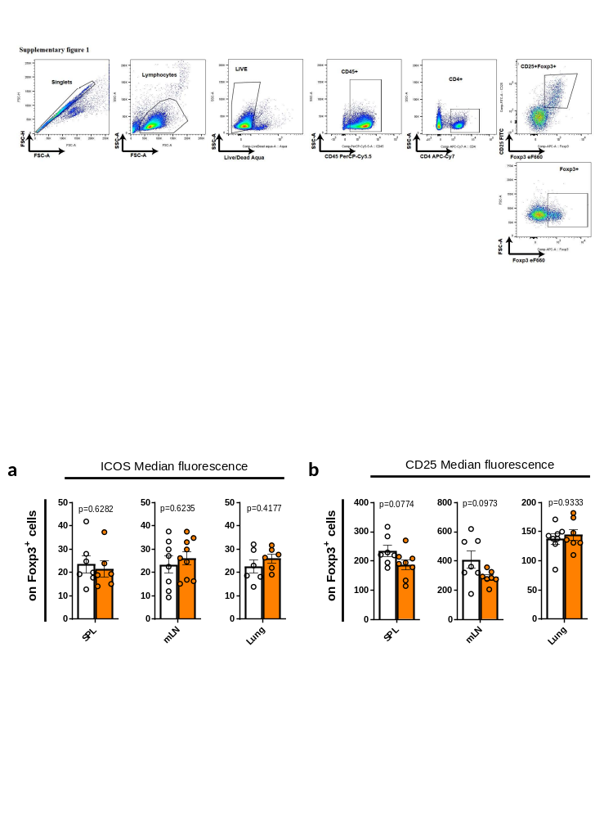
Supplementary figure 1. Flow cytometric gating strategy for the analysis of CD4+ T cells. Gating strategy to identify CD4⁺T-cells and regulatory T cells (CD25⁺ Foxp3⁺). Different surface receptors (CD25, ST2, GITR and KLRG1) and transcription factors (FoxP3 and GATA3) were analyzed on these subsets. Color dot plot of a representative subject. Approximately 20.000 events on CD4⁺ T cells were measured for each sample.
Supplementary Figure 2
Supplementary figure 2. CD83cKO mice show a higher activation status and an impaired non-lymphoid-tissue (NLT) function. FACS analysis of Tregs from spleen (SPL) mesenteric lymph node- (mLN), and lungs of 8–12-week-old mice: a surface receptor expression of ICOS and b CD25 on Tregs. (Ctrl n=4-10, CD83cKO n=4-10, pool of 3 independent experiments). In all graphs, data are represented as mean ± SEM and two-tailed Mann–Whitney U-test was used to analyze the data.

Supplementary Figure 3
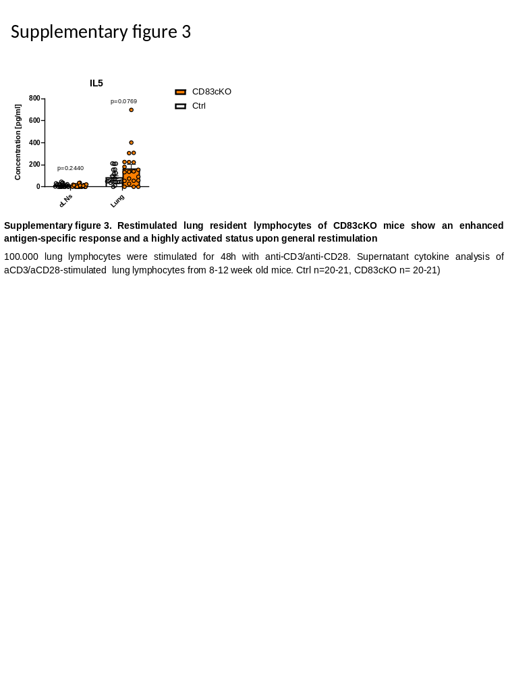
Supplementary figure 3. Lung resident lymphocytes of CD83cKO mice show escalating cytokine responses. Lung and cervical lymph node (cLNs) derived lymphocytes were stimulated for 48 h with anti-CD3/anti-CD28. Supernatant cytokine analysis of stimulated lung and cLN lymphocytes from 8–12-week-old mice. (Ctrl n=20-21, CD83cKO n= 20-21, pool of 6 independent experiments). In all graphs, data are represented as mean ± SEM and two-tailed Mann–Whitney U-test was used to analyze the data.
Supplementary Figure 4
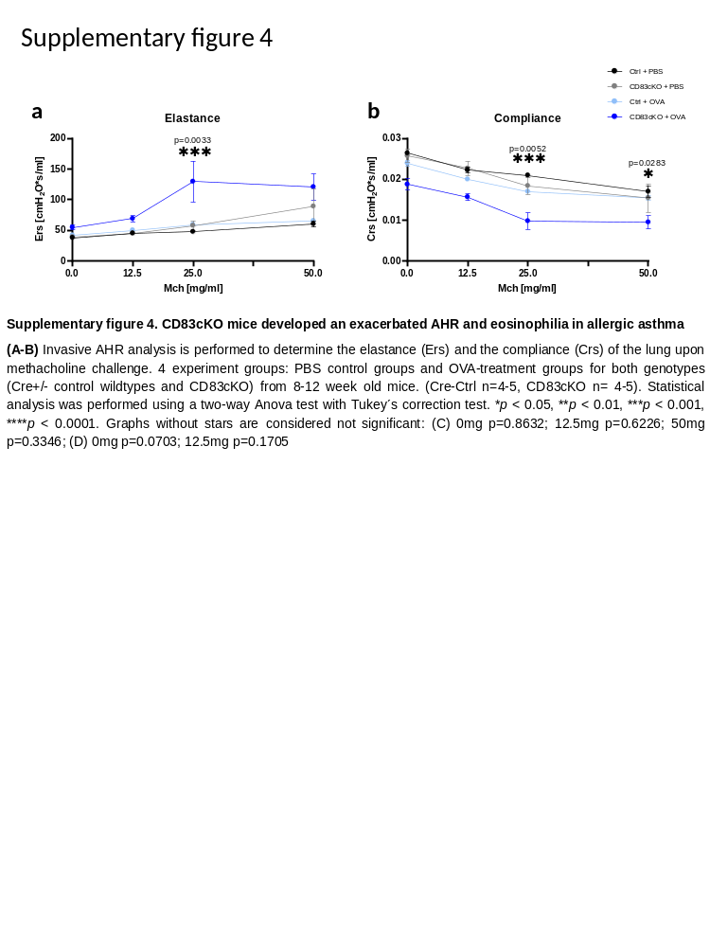
Supplementary figure 4. CD83cKO mice developed an exacerbated AHR in allergic asthma. Invasive AHR analysis was performed and the resistance (Rrs) of the lung was calculated upon methacholine challenge: a the elastance (Ers) (0mg p=0.8632; 12.5mg p=0.6226; 50mg p=0.3346) and b the compliance (Crs) of the lung upon methacholine challenge (0mg p=0.0703; 12.5mg p=0.1705. Statistical analysis of AHR data was performed using a two-way ANOVA test with Tukey´s correction test. (Ctrl n=4-5, CD83cKO n= 4-5, one representative experiment out of two)

Supplementary Figure 5
Supplementary figure 5 CD83cKO mice showed pathological changes in lung morphology. Complete section of displayed histological features in Figure 3 d.

Supplementary Figure 6
Supplementary Figure 6. CD83cKO mice showed pathological changes in lung morphology. Representative hematoxylin and eosin (H&E) stainings of lung tissue from PBS or OVA-treated Ctrl and CD83cKO mice. Green arrows demonstrate the bronchial epithelium, red arrows demonstrate smooth muscle tissue changes and red stars show peribronchial and perivascular infiltration of lymphocytes.

Supplementary Figure 7
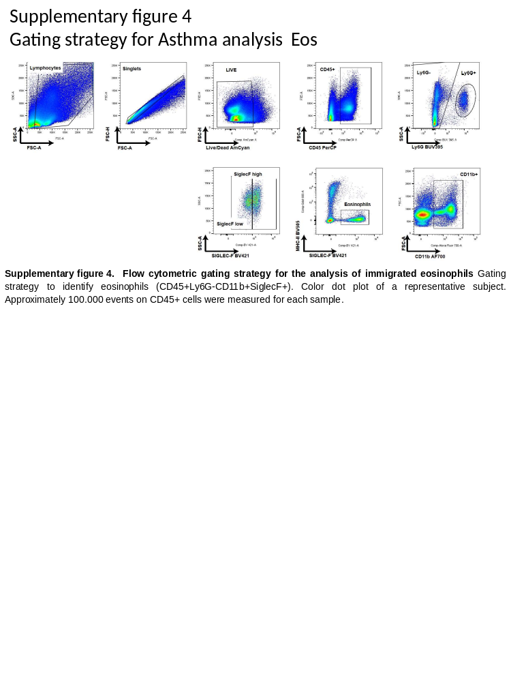
Supplementary figure 7. Flow cytometric gating strategy for the analysis of immigrated eosinophils. Gating strategy to identify eosinophils (CD45⁺Ly6G⁻CD11b⁺SiglecF⁺). Color dot plot of a representative subject. Approximately 100.000 events on CD45⁺ cells were measured for each sample.

Supplementary Figure 8
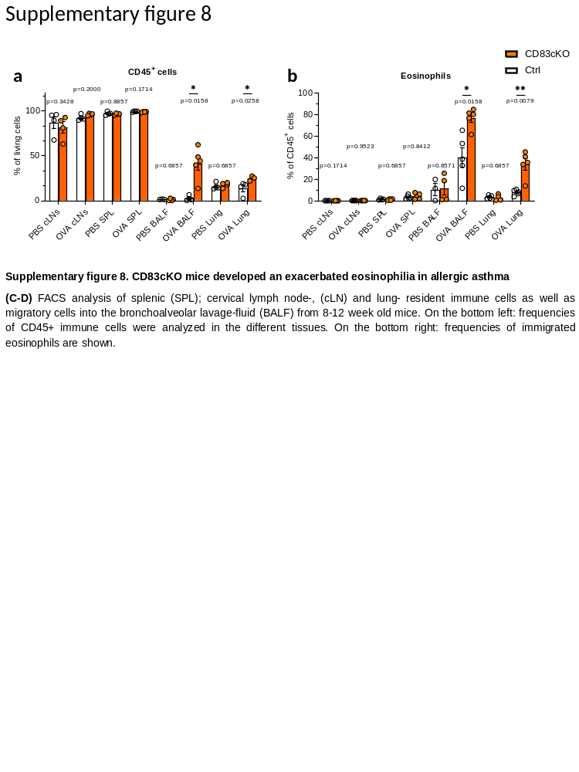
Supplementary figure 8. CD83cKO mice developed an exacerbated eosinophilia in allergic asthma FACS analysis of Tregs from spleen (SPL) cervical lymph node- (cLN), immune cells in the bronchoalveolar lavage-fluid (BALF) and lung tissue from asthmatic and control mice. a Frequencies of CD45⁺ immune cells and b total CD11b⁺ cells. (Ctrl n=4-5, CD83cKO n= 4-5, one representative experiment out of two). In all graphs, data are represented as mean ± SEM and two-tailed Mann–Whitney U-test was used to analyze the data.

Supplementary Figure 9
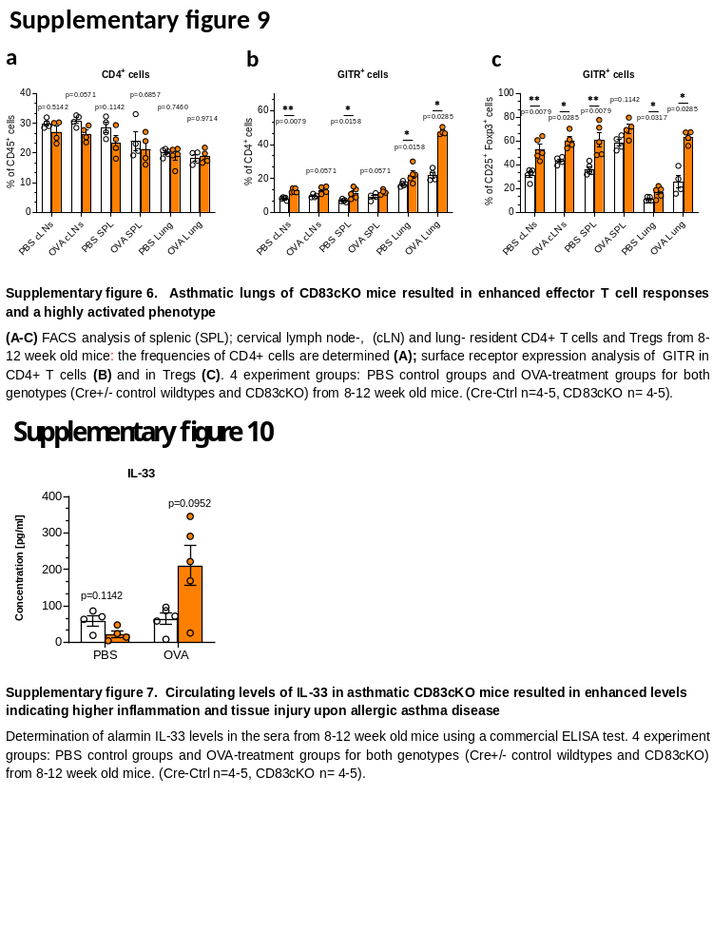
Supplementary figure 9. Asthmatic lungs derived from CD83cKO mice resulted in enhanced Th2 effector T cell responses and a highly activated phenotype. a-c FACS analysis of lung-resident CD4⁺ T cells and Tregs from asthmatic and control mice: a CD4⁺ T cell frequencies. Percentage of GITR⁺ cells among b CD4⁺ T cells and c on Tregs. In all graphs, data are represented as mean ± SEM and two-tailed Mann–Whitney U-test was used to analyze the data. (Ctrl n=4-5, CD83cKO n= 4-5, one representative experiment out of two).

Supplementary Figure 10
Supplementary figure 10. Circulating levels of IL-33 in asthmatic CD83cKO mice resulted in enhanced levels indicating higher inflammation and tissue injury upon allergic asthma disease. Determination of alarmin IL-33 levels in the sera from 8–12-week-old mice. Data is represented as mean ± SEM and two-tailed Mann–Whitney U-test was used to analyze the data. (Ctrl n=4-5, CD83cKO n= 4-5, one representative experiment out of two).

Supplementary Figure 11
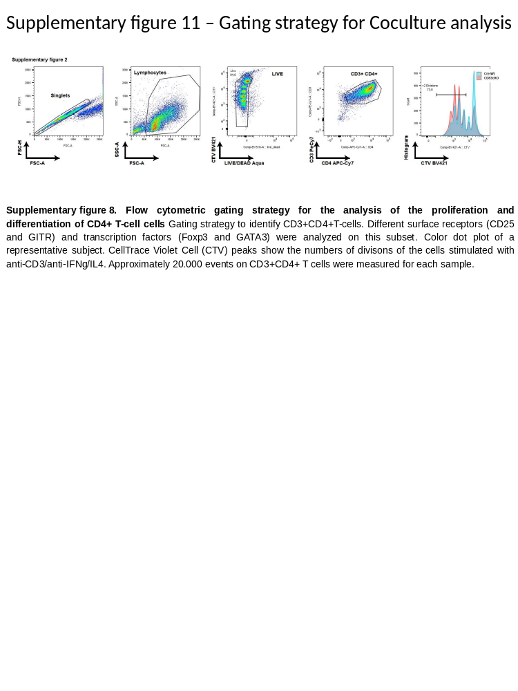
Supplementary figure 11. Flow cytometric gating strategy for the analysis of the proliferation and differentiation of CD4+ T-cell cells. Gating strategy to identify CD3+CD4+T-cells. Different surface receptors (CD25 and GITR) and transcription factors (Foxp3 and GATA3) were analyzed on this subset. Color dot plot of a representative subject. CellTrace Violet Cell (CTV) peaks show the numbers of divisions of the cells stimulated with anti-CD3/anti-IFNg/IL4. Approximately 20.000 events on CD3+CD4+ T cells were measured for each sample.

Supplementary Figure 12
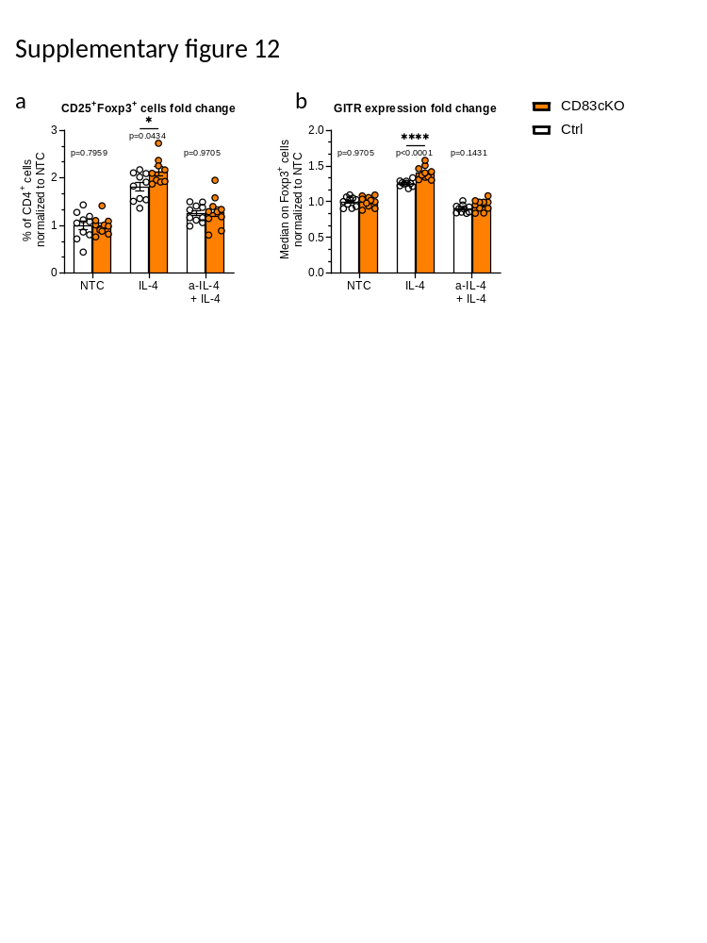
Supplementary figure 12. splenic Tregs derived from CD83cKO mice show an enhanced IL-4 responsiveness and an increased GITR expression. a FACS analysis of splenic Tregs without any treatment (non-treated controls, NTC), after stimulation with IL-4 for 24 h or anti-IL-4 pre-treated controls for 30 minutes (aIL-4+IL-4). b Percentage of Tregs and b Median fluorescence of GITR on Foxp3⁺ Tregs in relation to NTCs. (Ctrl n=10, CD83cKO n=10, pool of 3 independent experiments). In all graphs, data are represented as mean ± SEM and two-tailed Mann–Whitney U-test was used to analyze the data.

