Transient performance analysis of centrifugal Left Ventricular Assist Devices coupled with Windkessel model: LES study on Continuous and Pulsatile Flow operation
Antonio Gilª, Roberto Navarroª, Pedro Quinteroª and Andrea Maresª

a CMT-Clean Mobility & Thermofluids, Universitat Politècnica de València, Camino de Vera, s/n, València, 46022, Spain

- SUPPLEMENTARY MATERIAL
This Appendix presents videos of velocity and Q-criterion fields for both HVAD and HM3 operating under pulsatile-flow (PF) conditions and coupled to the 2-element Windkessel model (WK2). These videos extend from the time instant in which the pulse begins to the time instant in which the pulse finishes.

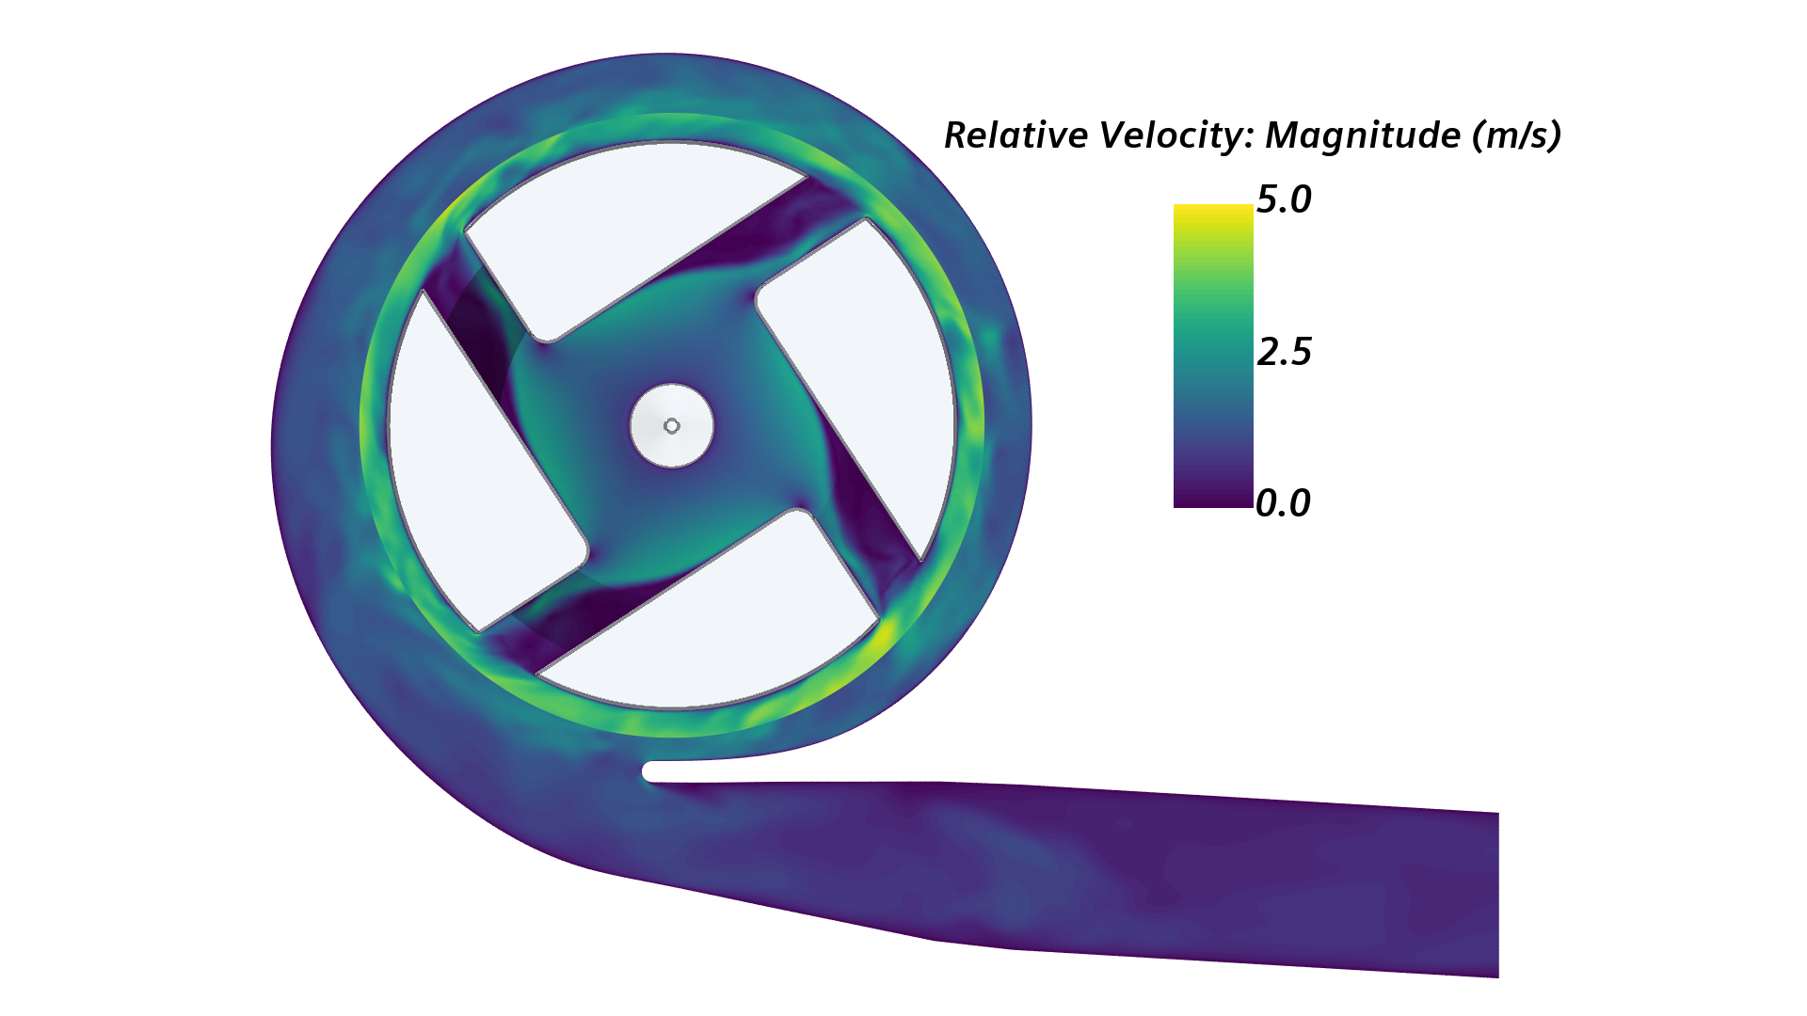
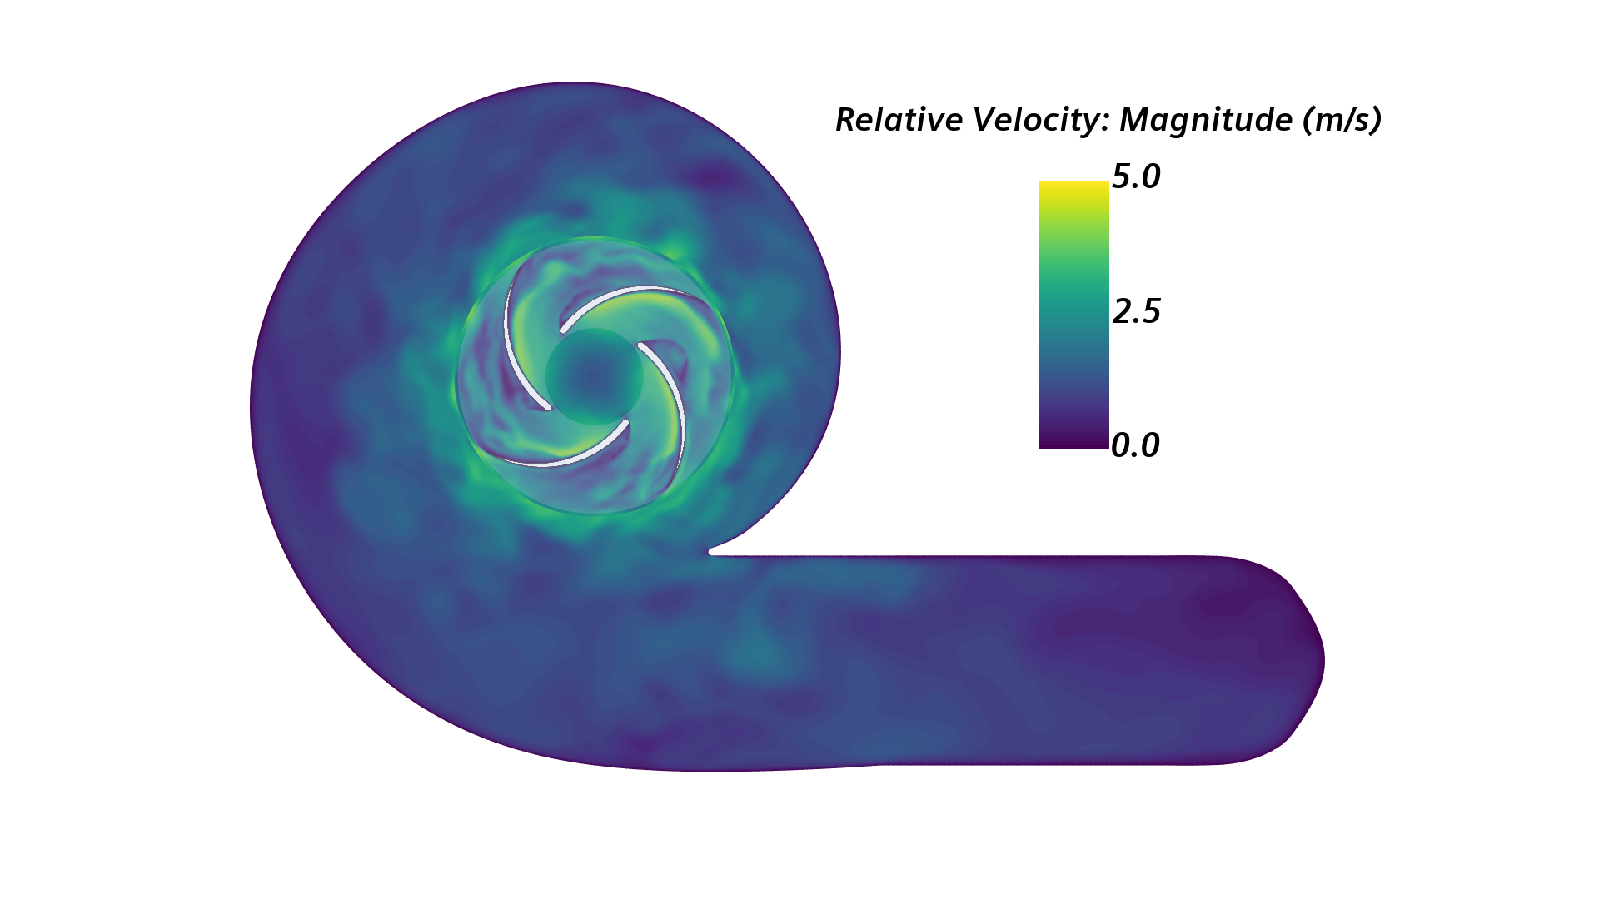
(a)
(b)
Video 1 Velocity field within (a) HVAD and (b) HM3 operating under PF conditions and coupled to the WK2 model
► 00_HVAD_WK2_PF_Velocity.mp4
► 00_HM3_WK2_PF_Velocity.mp4
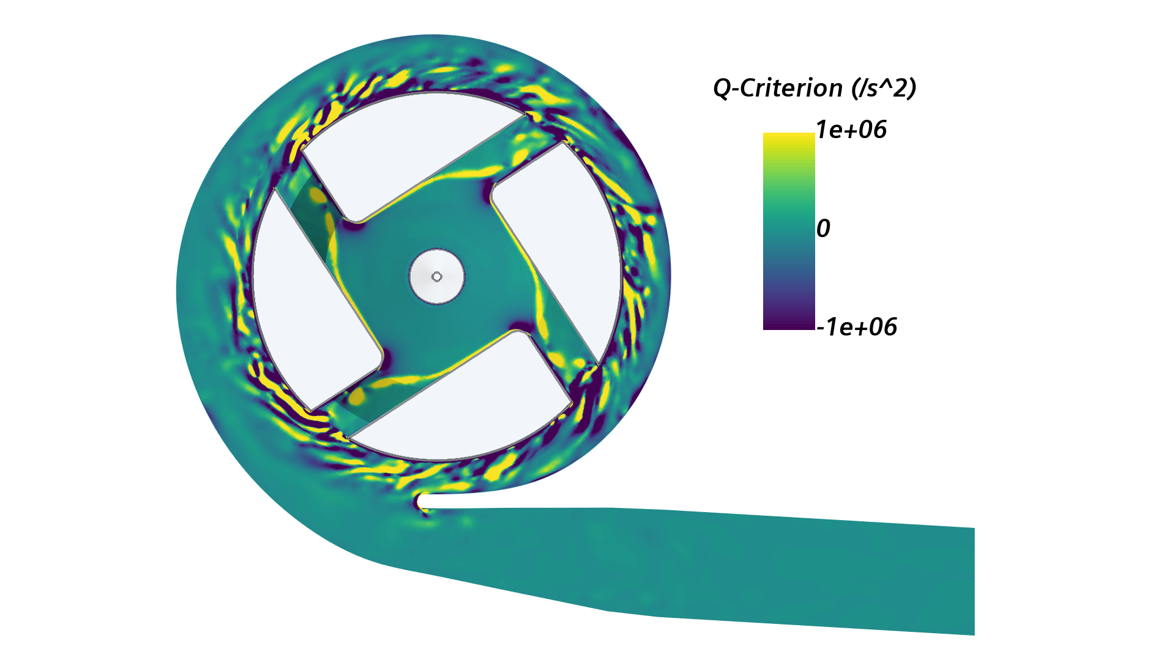
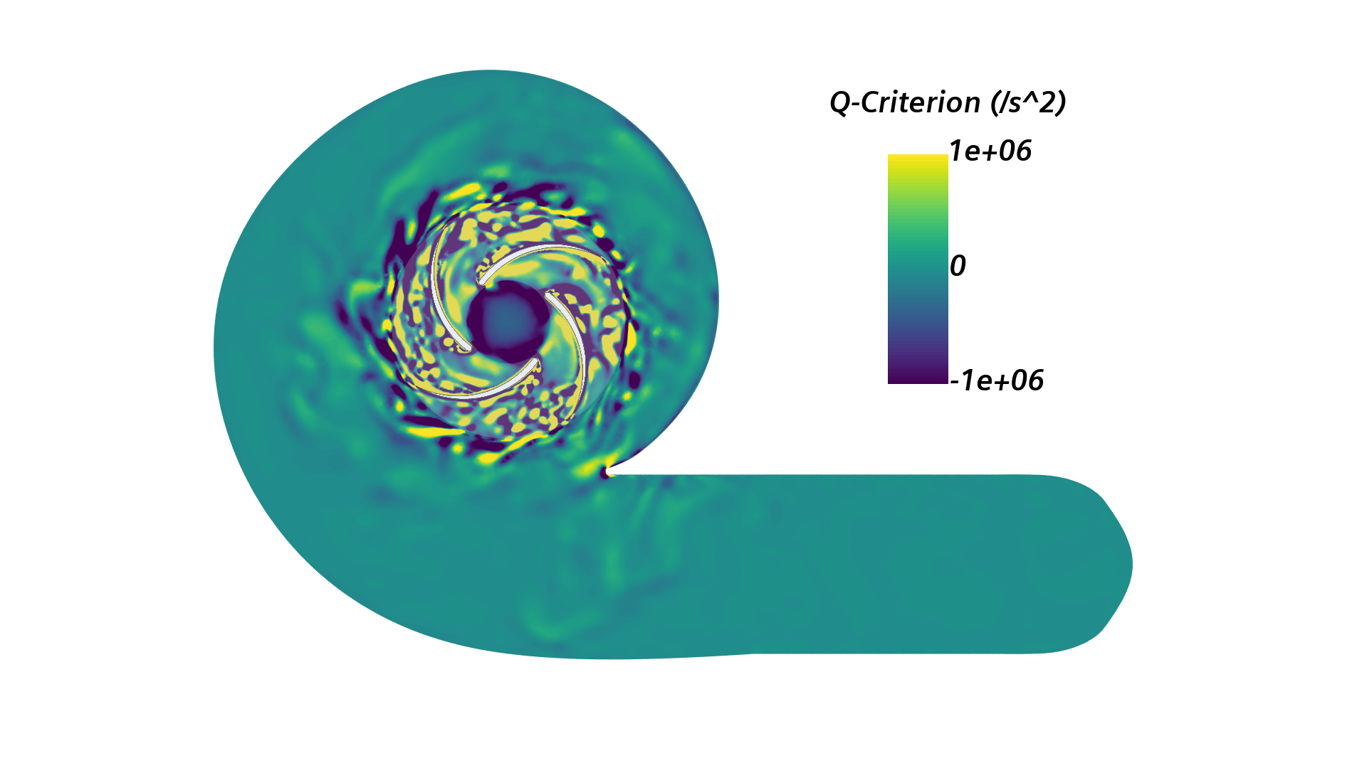
(a)
(b)
Video 2 Q-criterion field within (a) HVAD and (b) HM3 operating under PF conditions and coupled to the WK2 model
► 00_HVAD_WK2_PF_Qcriteria.mp4
► 00_HM3_WK2_PF_Qcriteria.mp4

1 Corresponding author: anmabo4@mot.upv.es (Mares, Andrea). ORCID: 0000-0002-3720-6710

