Sterol-targeted laboratory evolution allows the isolation of thermotolerant and respiratory-competent clones of the industrial yeast Saccharomyces cerevisiae

Isabel-Elena Sánchez-Adriá¹, Jose A. Prieto¹, Gemma Sanmartín¹, Miguel Morard¹, Francisco Estruch² and Francisca Randez-Gil¹*

¹Department of Biotechnology, Instituto de Agroquímica y Tecnología de los Alimentos, Consejo Superior de Investigaciones Científicas, Avda. Agustín Escardino, 7. 46980-Paterna, Valencia, Spain
²Departament of Biochemistry and Molecular Biology, Universitat de València, Dr. Moliner 50, Burjassot 46100, Spain

Contents:
Table S1. Sequencing and bioinformatic data analysis.
Figure S1. Acetic-driven evolved populations show increased myriocin tolerance.
Figure S2. Fermentative power of evolved populations.

Table S1. Ploidy level of the strains under study.
 | Likelihood ploidy
Chr. | LH03 | Clone 5 | Clone 6 | Clone 7 | Clon 10 | Clone 14 | Clone 15
I | di | tri | di | tri | tri | tri | tri
II | tetra | tetra | tetra | tetra | tetra | tetra | tetra
III | tri | tri | tri | tri | tri | tri | tri
IV | tri | tri | tri | tri | tri | tri* | tri
V | tri | tri | tri | tri | tri | tri | tri
VI | tetra | tetra | tetra | tetra | tetra | tetra | tetra
VII | tetra | tetra | tetra | tetra | tetra | tetra | tetra
VIII | tetra | tetra | tetra | tetra | tetra | tetra | tetra
IX | tetra | tetra | tetra | tri | tetra | tetra | tri
X | tri | tri | tri | tri | tri | tri | tri
XI | tetra | tri | tri* | tri | tri | tri | tri
XII | tri | tri | tri | tri | tri | tri | tri
XIII | tri | tri | tri | tri | tri | tri | tri
XIV | tri | tri | tetra | tri | tetra* | tri | tri
XV | tetra | tetra | tetra | tetra | tetra | tetra | tetra
XVI | tri | tri | tri | tri | tri | tetra | tri
Ploidyª | 3.78n | 3.13n | 3.57n | 3.44n | 3.54n | 3.66n | 3.88n
ª ploidy estimated by flow cytometry; * contains fragment amplifications

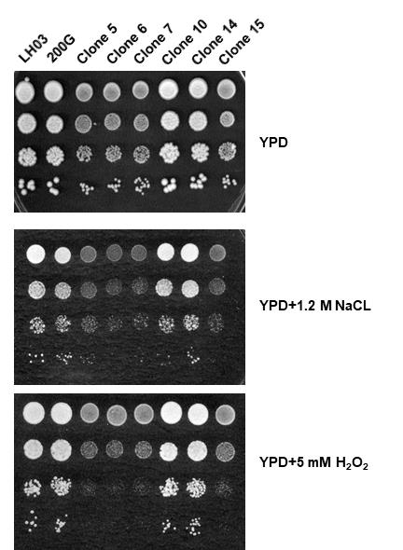

Figure S1. The respiratory-deficient evolved clones, show decreased oxidative stress tolerance. A drop test assay was used to evaluate the osmotic and oxidative stress tolerance of parental and evolved clones from the 200G-evolved population generated by FCNZ-driven experimental evolution of the parental LH03 strain. Saturated cultures of yeast cells grown at 30ºC in liquid YPD were diluted (10⁻¹–10⁻²) and 3 μl aliquots of each dilution were applied over solid YPD lacking or containing 1.2 M NaCl or 5 mM H₂O₂. Plates were incubated at 30ºC and inspected for growth after 2-4 days of incubation.

Figure S2. Loss of mtDNA increases fluconazole tolerance. Cell samples of the parental (LH03) and isolated clones from the 200G-evolved population generated by flucoconazole (FCNZ)-driven experimental evolution were examined for drug tolerance in YPD solid medium lacking or containing the indicated FCNZ concentrations. Saturated cultures were diluted and cells were applied onto plates as described in Fig. S1. Colony growth was inspected after 2-4 days of incubation at 30ºC. For more details see the Materials and Methods section.

