Supplementary figures
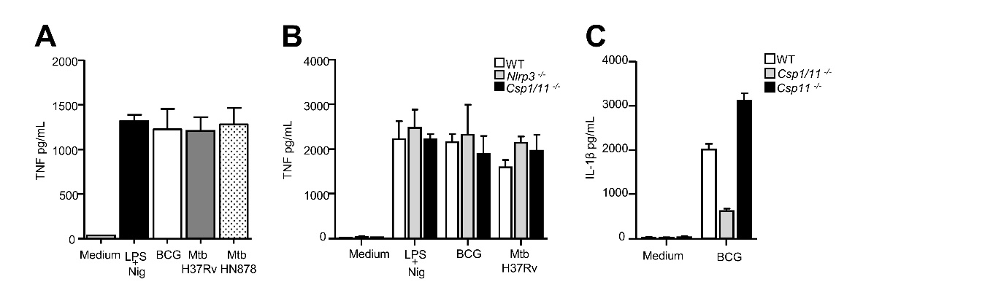

Fig. S1. TNF production by neutrophils infected with mycobacteria and involvement of caspase 1 for IL-1β secretion in vitro (A, B) TNF produced by WT, Nlrp3^{-/-}, and Csp1/11^{-/-} bone marrow neutrophils determined by ELISA after overnight stimulation with LPS/nigericin or infection with BCG (MOI 10), Mtb H37Rv, or Mtb HN878 (MOI 1). (C) Mature IL-1β produced by WT, Csp1/11^{-/-}, or Csp11^{-/-} bone marrow neutrophils determined by ELISA after overnight infection with BCG MOI 10. (A) Pooled data from three independent experiments, n = 6 mice; (B) data are representative of three independent experiments, n = 3; (C) data are representative of two independent experiments, n = 3. Data are presented as medians with ranges. ∗p < 0.05, ∗∗p < 0.01, and ∗∗∗p < 0.001 by the Mann-Whitney test (A) and two-way ANOVA with a Bonferroni post-test (B-D).

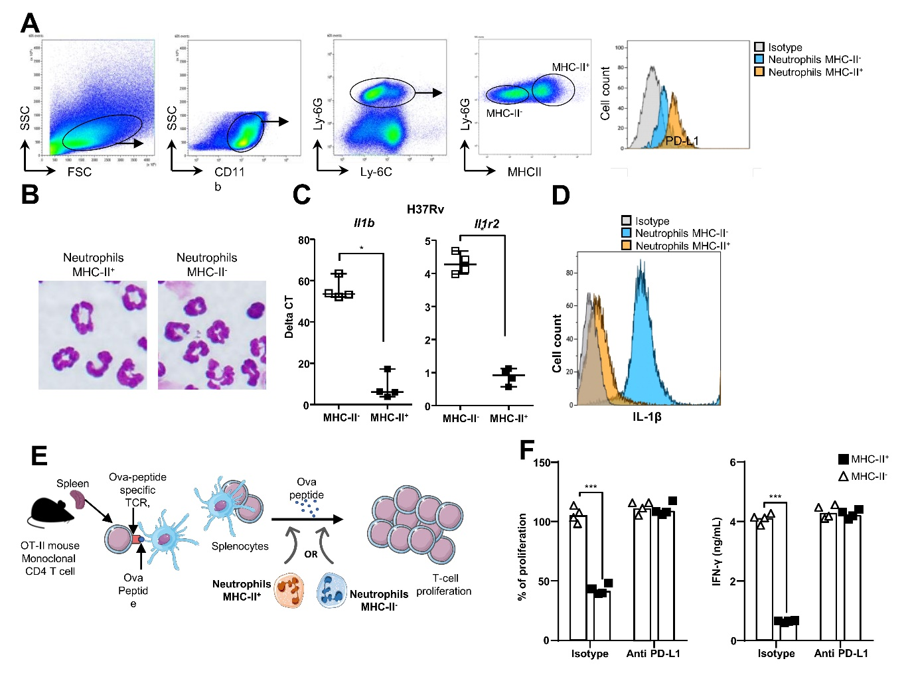
Fig. S2. Functional characterization of inflammatory and regulatory neutrophils. (A) Gating strategy to identify and purify lung neutrophil subsets by flow cytometry. (B) May-Grünwald-Giemsa staining of the two cytocentrifuged neutrophil subsets separated by flow cytometry based on MHC-II surface expression from the lungs of BCG infected mice. (C) Comparison of the level of expression of the Il1b and Il1r2 genes between inflammatory MHC-II⁻ and regulatory MHC-II⁺ neutrophils from H37Rv infected mouse lungs positively selected using magnetic beads. (D) Mean fluorescence intensity of intracellular mature IL-1β (Ab Rockland) measured by flow cytometry in the two neutrophil subsets from the lungs of C57BL/6 mice on day 21 after infection with H37Rv. (E) Schematic representation of the OT-II cell suppression assay used to measure regulatory neutrophil function. Splenocytes from OT-II mice carrying the T-cell receptor for the Ova 323-329 peptide are stimulated with this peptide and mixed with 99% pure MHC-II⁺ or MHC-II⁻ neutrophils sorted from syngeneic C57BL/6 mice at a ratio of 1 neutrophil/10 splenocytes. Proliferation was measured by the CyQUANT assay and IFN-γ production in the supernatants by ELISA after three days. Maximum (100%) T-cell proliferation and IFN-γ production by OT-II splenocytes was that observed following addition of the Ova peptide only. (F) Suppression of T-cell proliferation and IFN-γ production by the two neutrophil subsets sorted from the lungs of BCG-infected mice on day 21 and treated for 1 h with anti-PD-L1 Ab (atezolizumab) or an isotype control. (A) Images from one representative experiment of 10, (C) four positive magnetic selection experiments from a pool of five infected animals each time; (F) pooled data of two independent experiments (n = 4). Data are presented as individual data points and medians. ∗p < 0.05 and ∗∗∗p < 0.001 by the Mann-Whitney test (B) and two-way ANOVA with a Bonferroni post-test (F).

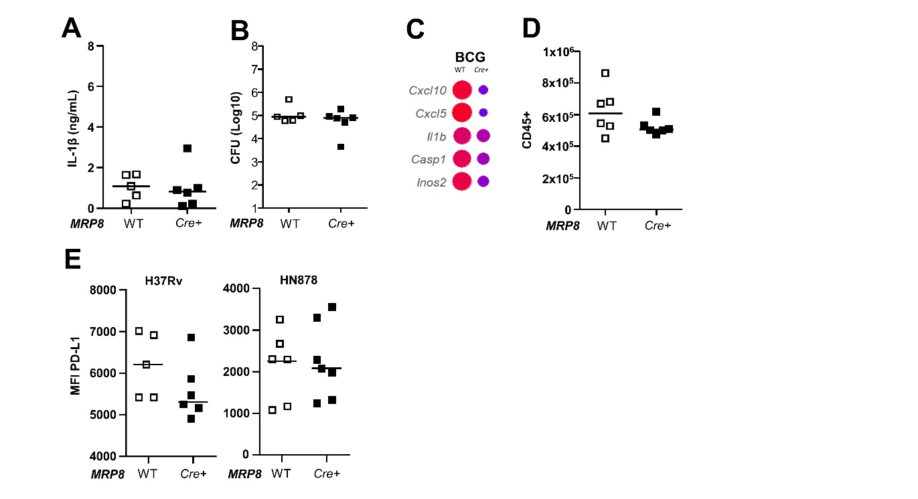
Fig. S3. BCG does not activate the inflammasome in lung neutrophils in vivo and caspase-1-dependent IL-1β production in neutrophils does not have a direct impact on PD-L1 expression by regulatory neutrophils. (A-D) MRP8^{Cre+}Csp1^{flox} or MRP8^{WT}Csp1^{flox} mice were infected with BCG and euthanized on day 21 for comparison of the response in the lungs (n = 5-6 mice per group,). (A) IL-1β production quantified by ELISA in lung tissue homogenates. (B) Number (Log₁₀) of CFUs for each animal. (C) Expression of a set of 48 genes quantified using a Fluidigm Biomark and differential gene expression between the two mouse genotypes normalized to uninfected controls and compared. Data are the median of n = 5-6 mice per group (2 independent experiments). (D) Total CD45⁺ leukocytes analyzed by flow cytometry. (E) MRP8^{Cre+}Csp1^{flox} or MRP8^{WT}Csp1^{flox} mice were infected with H37Rv or HN878 and the neutrophils analyzed in the lungs 21 days later. Mean fluorescence intensity of PD-L1 expression on the surface of the two lung neutrophil subsets. Data are presented as individual data points and medians.

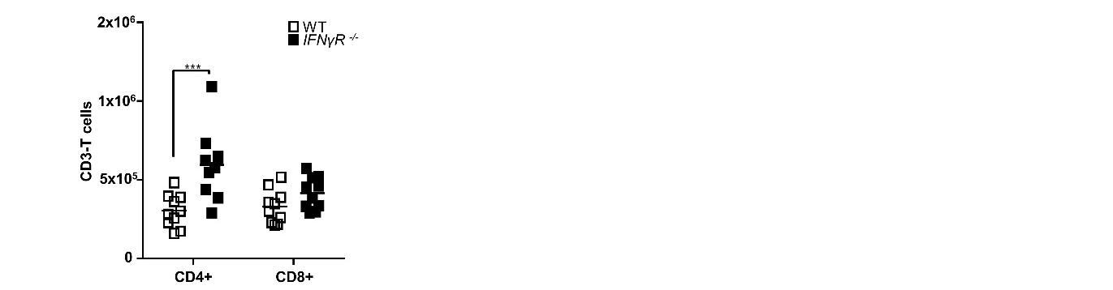
Fig. S4. CD4 but not CD8 T lymphocyte recruitment is exacerbated in Mtb-infected IFN-γR^{-/-} mice. Data were obtained for cells from the lungs of C56BL/6 WT or IFN-γR^{-/-} mice 21 days post H37Rv infection. CD4 and CD8 T lymphocytes were analyzed by flow cytometry on CD3⁺ CD45⁺ gated cells. Pooled data from two independent experiments, n = 10. Data are presented as individual data points and medians. ∗∗∗p < 0.001 by two-way ANOVA with a Bonferroni post-test.

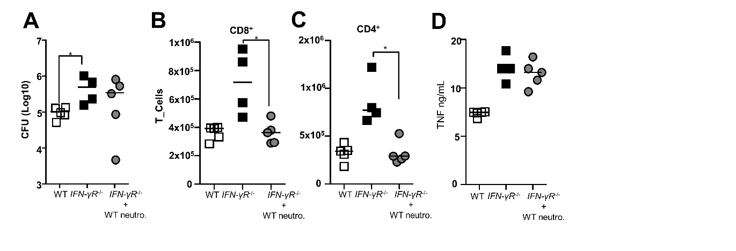
Fig. S5. Transfer of WT regulatory neutrophils into IFN-γR^{-/-} Mtb-infected mice alleviates T-cell recruitment to the lungs. [MHC-II⁺, PD-L1^{high}] regulatory neutrophils harvested on day 21 from the lungs of BCG-infected C57BL/6 WT mice were transferred into IFN-γR^{-/-} mice that were infected with H37Rv 18 days earlier. The control groups were C57BL/6 WT mice and mock-treated IFN-γR^{-/-} mice. (A) Number (Log₁₀) of CFUs for each animal. (B-D) Cell recruitment to and cytokine production in the lung tissue were analyzed on day 21. Number of (B) CD8 and (C) CD4 T cells analyzed by flow cytometry and (D) TNF production analyzed by ELISA in lung tissue homogenates. Data from one experiment, n = 4-5. Data are presented as individual data points and medians. ∗p < 0.05 by the Mann-Whitney test.

Supplementary Tables

Target | Clone | Supplier | Isotype | Dye
CD45 | 30-F11 | BioLegend | Rat IgG_{2b, κ} | BV605
CD45 | 30-F11 | BD Biosciences | Rat IgG_{2b, κ} | PerCP-Cy5.5
CD11b | M1/70 | BD Biosciences | Rat IgG_{2b, κ} | V450
CD11c | REA754 | Miltenyi | REAffinity | APC
Ly-6G | 1A8 | BD Biosciences | Rat IgG_{2a, κ} | PE
Ly-6C | AL-21 | BD Biosciences | Rat IgM | APC
MHC-II | 2G9 | BD Biosciences | Rat IgG_{2a, κ} | FITC
MHC-II | 2G9 | BD Biosciences | Rat IgG_{2a, κ} | PE
CD274(PD-L1) | MIH5 | BD Biosciences | Rat IgG_{2a, I} | BV711
CD3 | 17A2 | BioLegend | Rat IgG_{2b, κ} | PerCP-Cy5.5
CD4 | RM4-4 | BioLegend | Rat IgG_{2b, κ} | FITC
CD8 | 53-6.7 | BioLegend | Rat IgG_{2a, κ} | BV510
Mature IL-1β | - | Rockland | Rabbit IgG | Biotin
Cleaved IL-1 β | E7V2A | Cell Signaling technology | Rabbit IgG | -
Pro- IL-1β | D3H1Z | Cell Signaling technology | Rabbit IgG | -
GAPDH | D16H11 | Cell Signaling technology | Rabbit IgG | -
Streptavidin | - | BD Biosciences | - | FITC
Viability dye | - | eBiosciences | - | eFluor 780
Anti-Rabbit IgG | - | Cell Signaling technology | Goat IgG | HRP
Table S1. list of antibodies used in this study

Gene | Forward | Reverse
Adgre1 | CAGCCAGAGGGGACAAGATGA | TCCTGGGGCCCCTGTAGAT
Aim2 | TGGGTGGCGTCAGGAAGTTT | GGCCGGTCAACAACAGCATTT
Arg1 | TAGAGAAAGGCCCTGCAGCA | TCAACAAAGGCCAGGTCCCC
Atg7 | CCTGACCTTCGCGGACCTAA | GCCTTCGGCTCGACACAGAT
Casp1 | GGCATGCCGTGGAGAGAAAC | TGGGCCTTCTTAATGCCATCATC
Casp3 | GAGCTTGGAACGGTACGCTAAG | GTCCACTGACTTGCTCCCATGTA
Casp4 | TCCCAGATGCCCACCATTGA | TCAGTTGCTTGTTGCTTTGTTCTC
Casp8 | CCACAGACCCCAGACAGAGAA | AGAGGTAGAAGAGCTGTAACCTTAT
Cat | AGATTGCCTTCTCCGGGTGG | CCCGACTGTCCGACATGGTG
Ccl20 | CTTCCTTCCAGAGCTATTGTGG | TCATCCATTGGACAAGTCCACTG
Ccl5 | TCTCTGCAGCTGCCCTCACC | TCTTGAACCCACTTCTTCTC
Ccl7 | CCTGGGAAGCTGTTATCTTCAA | CCTCCTCGACCCACTTCTGAT
Ccl8 | ACGCTAGCCTTCACTCCAAAATC | GGCTGACAGGGACAGCTATGA
Ccr1 | CTCTGGAAACACAGACTCACTGTC | TTGGCATGGAGTGGAGTCCC
Cd14 | AAGCCCGTGGAACCTGGAAG | CACGCTCCATGGTCGGTAGA
Cd209a | ACAGTCAAGTCCCCTTGGCA | AGTCGATCTACGCCAGCCTTC
Cd28 | TGGCTCTTTGTGTTATCTGGACAAA | GGGCGTAGGGCTGGTAAGG
Cd40 | TCACCATTTTCGGGGTGTTTCT | CCGCAGGGGGTAAGATCTCATT
Cd74 | TGGATGGCGTGAACTGGAAGA | TCCTGGCACTTGGTCAGTACTTT
Cd80 | CGACTCGCAACCACACCATTA | GGAGGGTCTTCTGGGGGTTTT
Cd86 | CGCGTAAGAGTGGCTCCTGTA | CCAAGCCCATGGTGCATCT
Mb21d1 (Cgas) | AAGGCTGGCTGGGCACAAA | CGCCAGGTCTCTCCTTGAAAA
Clec7a | GGGGATCAGAGAAAGGAAGCCA | CAGCACTGCAGCAACCACTAC
Col1a1 | GCTACTACCGGGCCGATGAT | CGATCCAGTACTCTCCGCTCTT
Col3a1 | ACCCAGAGGAGTAGCTGGAGAA | TCCGGGCATACCCCGTATC
Ctla4 | GTCTGTGTGGGTTCAAACACATCT | AGGTCCTCAGGGAGCAGAGTAA
Ctsg | AATGTGCGCCAATCGCTTCC | GAATCACCCCTGAAGGCAGAC
Ctsk | CCCATATGTGGGCCAGGATGAAA | TTCTCGTTCCCCACAGGAATCT
Cxcl1 | CGCTCGCTTCTCTGTGCAGC | GTGGCTATGACTTCGGTTTGG
Cxcl10 | CACGTGTTGAGATCATTGCCA | GCGTGGCTTCACTCCAGTTA
Cxcl2 | GCTGCTGGCCACCAACCACC | TGAGAGTGGCTATGACTTCTG
Cxcl5 | CCCTACGGTGGAAGTCATAGCTAAA | GCCGTTCTTTCCACTGCGAG
Cxcr1 | CCAGCTGGTGCCTCAGATCAAA | TGGGCAGCATTCCCGTGATA
Cxcr2 | TCAACCAGCCCTGACAGCTC | ACTTAATCCTGCAGTAGTTCTACGA
Cxcr3 | CCAAGCCATGTACCTTGAGGTTAGT | AGTCGCTCTCGTTTTCCCCATA
Cybb | TGGGATGAATCTCAGGCCAATCA | CCAGTTGGGCCGTCCATACA
Ela2 | TCAGCAGCCCACTGTGTGAA | AGAAGGTCTGTCGAGTGCGC
Fcgr1 | TGATTCTTACCAGCTTTGGAGATGA | CCACCGACTGGAACCCAAAG
Gmcsf | TGCAGACCCGCCTGAAGATA | GGCCTGGGCTTCCTCATTTT
Gsdmd | TCCCGGGTTGAGCAGACAAT | CGATGGCATGGTCCTCGATTT
Hprt1 | CAGTCCCAGCGTCGTGATTA | TGGCCTCCCATCTCCTTCAT
Ifi204 | GCTGATTCTGGATTGGGCAAACT | CAGTGATGTTTCTCCTGTTACTTCT
Ifna | CTCCTAGACTCATTCTGCAATGA | GGGCTCTCCAGACTTCTGCTCTG
Ifnar1 | CTCCCCGCAGTATTGATGAGTTTT | CTCAGGCGCGTGCTTTACTT
Ifnar2 | CACCGTCTGCTTTTGATGGGTAT | GGTGGGCCAGACTTGTTCTC
Ifnb1 | AAGCAGCTCCAGCTCCAAGAA | TGGATGGCAAAGGCAGTGTAAC
Ifng | TCTTCTTGGATATCTGGAGGAA | AGCTCATTGAATGCTTGGCGCTG
Ifngr1 | GGTGCCTGTACCGACGAATG | GGTGCCTGTACCGACGAATG
Ifnlr1 | GGTGCCTGTACCGACGAATG | CAGTCCAGGAACCCGAATACAC
Il10 | ATGCTGCCTGCTCTTACTGAC | CTGGGGCATCACTTCTACCAG
Il10rb | CGAGCCCGCAGCTGTTT | GATCTTGGAAAGACCTGTAACTTTC
IL12p40 | CTCACATCTGCTGCTCCACAA | GACGCCATTCCACATGTCACT
Il17 | TCCAGAAGGCCCTCAGACTA | AGCATCTTCTCGACCCTGAA
Il18 | CCTCTTGGCCCAGGAACAATG | ACAGTGAAGTCGGCCAAAGTT
Il18r1 | CACAACGATCCTGAAAACAAGAGAT | AAGGTTCTCCCTCTACCACATGAA
Il18rap | CCAGTCTCAGCTGCCAAAGT | AGGAAGTAGTCTTCCATCCTTGTA
Il1a | CGCTTGAGTCGGCAAAGAAATCA | TGCAAGTCTCATGAAGTGAGCCA
Il1b | TCTAATGCCTTCCCCAGGGC | GACCTGTCTTGGCCGAGGAC
Il1r1 | ACCGTGAACAACACAAATGGAGAA | ATGGTGTCGCCGTGCATTTT
Il1r2 | GGAGACCCCACACGCCTATT | GGGTTCCGTGGTTGTTCCTTTG
Il1rn | GGAAGACCTTGTGTCCTGTTTAG | GGCACCATGTCTATCTTTTCTTC
Il33 | GCTGCGTCTGTTGACACATT | GACTTGCAGGACAGGGAGAC
Il4 | ACGGAGATGGATGTGCCAAACGTC | AACTTTCCAGGAAGTCTTTCAG
Il6 | GAGGATACCACTCCCAACAGACC | AAGTGCATCATCGTTGTTCATACA
Il6ra | CAACACCACCAACGGGAAGA | GGATCCGGCTGCACCATTTTT
Inos2 | GCCACCTTGGTGAAGGGACT | ACGTTCTCCGTTCTCTTGCAGT
Irf1 | CCAGCATCTCGGGCATCTTT | GAGTGATTGGCATGGTGGCTTTG
Irf3 | CAATTCCTCCCCTGGCTAGA | AGATGCCAAAGTCAGCCATCTG
Irf7 | GGTCCAGCGAGTGCTGTTTG | CACAGCCCAGGCCTTGAAGA
Irf9 | TCAGGCCCTGCCCATTTCTTC | TTTGCCTGAGGCCATCCTTCT
Itgam | GCTCTCATCACTGCTGGCCT | GTTACTGAGGTGGGGCGTCT
Ly6g | CCCTGCTGTATAGGCACCCC | ATGCCTCCAGGGTCAAGAGC
MhcII | GGAGCAAGATGTTGAGCGGC | GCCTCGAGGTCCTTTCTGAC
Mki67 | CATCATTGACCGCTCCTTTAGGTAT | GGTATCTTGACCTTCCCCATCAG
Mlkl | GTCTTTCTGGCAGAGAACGAATCT | TACACCTTCTTGTCCGTGGATTCT
Mmp7 | TTTGATGGGCCAGGGAACACTCTA | ATGGGTGGCAGCAAACAGGAAGT
Mmp8 | ACAGGGAACCCAGCACCTATT | TGGGGTTGTCTGAAGGTCCATAG
MMP9 | ACCACCACCACCACACACAA | CTGCCTCCACTCCTTCCCAG
Mpo | TGTCCGTGTCAAGTGGCTGT | GGGGCTTCGTCTGTTGTTGC
Myd88 | CACTCGCAGTTTGTTGGATG | CGCAGGATACTGGGAAAGTC
Nfkb | CCACGAGGCAGCACATAGATGA | GCAGTGGGCTGTCTCCAGTA
Nlrc4 | GACGCTTTGACTCACCACAATGAA | CTGCTCCAAGGGCTCACAGTA
Nlrp3 | TGCGTGTTCTCTGTATACCACATCT | GGGCTTAGGTCCACACAGAAAGT
Oas1 | GGTCAAGGGCAAAGGCACCA | TCTCATGCTGAACCTCGCACA
Oasl2 | CCCACCAACAACCTGGGAAGA | ACATCCCTCGCTCGCTGTA
Orl1 | GGCTGAGGTCCTCGACTGTTTC | GGAAGAAAGCAAATGCAGACCTTTA
P2rx7 | CGGATCCAGAGCACGAATTATGG | CGCTCACCAAAGCAAAGCTAATGT
Pdcd1 | CTGGAGCAGAGCTCGTGGTAA | AGCTCCTCTGGCCTCTGACATA
Pdl1 | GCAGGCGTTTACTGCTGCAT | TGCGGTATGGGGCATTGACT
Ppia | GCTGGACCAAACACAAACGG | CCAAAGACCACATGCTTGCC
Prtn3 | AGCAGGCATATGCTTCGGAGA | CCCCGCAGCACGTTTTGAAT
Ptgs2 | AGCCAGGCAGCAAATCCTTG | ACTGTGTTTGGGGTGGGCTT
Rpl4 | GACCAGTGCTGAGTCTTGGG | GTATTCACTCTGCGGTGCCA
S100a8 | TCCTTTGTAAGCTCCGTCTTC | CTTCTCCAGTTGAGACGGCA
S100a9 | GTGGAAGCACAGTTGGCAAC | TGGGTTGTTCTCATGCAGCT
Slc11a1 | TGGCCATTGGGGCTCAGAT | TCCAGCTTGCGCAAACCATAG
Socs1 | GACGCCTGCGGCTTCTATTG | GACTGTCGCGCACCAAGAA
Socs2 | CTGGAGCCTCCGGGAATG | TCCCCAGTACCATCCTGTTTGA
Socs3 | CGCGGGCACCTTTCTTATCC | GGGTCACTCTGCAGCGAAAA
Sod2 | TGAGCCCTAAGGGTGGTGGA | ACGGCTGTCAGCTTCTCCTT
Stat1 | TCAAGCTGAGACTGTTGGTGA | TGTGTGCGTACCCAAGATGT
Stat2 | AGCATTTGGCTACCTGGATTGA | GCCATTGGGAAAGGTCTGAAT
Stat3 | GCTGCCCCGTACCTGAAGA | TGTCAAACGTGAGCGACTCAAA
Tbk1 | TCAGGCTGGCCACCAGAAA | TCTCTTGGATGCGTGCCTTCT
Timp1 | TCCTAGAGACACACCAGAGCAGAT | GGGAACCCATGAATTTAGCCCTTAT
Tlr2 | GCATCCGAATTGCATCACCG | CATCACACACCCCAGAAGCA
Tlr4 | TTATCCAGGTGTGAAATTGAAAC | GCCACATTGAGTTTCTTTAAGG
Tmem173 (sting) | GGTCTAGGAAGCAGAAGATGCCATA | TCAGGCTGGCCACCAGAAA
Tnfa | ATGAGCACAGAAAGCATGATC | TACAGCCTTGTCACTCGAATT
Zpb1 | CGCCAAGGCTCTGGGAATGA | TGTGTGACTCCAGAATGAGCTATGT
Table S2: list of primers used for transcriptomic analysis (qRT-PCR and medium throughput)

