Supplementary materials

Development of a novel prognostic score combining clinicopathologic variables, gene expression and mutation profiles for lung adenocarcinoma

Guofeng Li¹, Guangsuo Wang¹, Yanhua Guo², Shixuan Li¹, Youlong Zhang³, Jialu Li³*, Bin Peng¹*

1 Department of Thoracic Surgery, Shenzhen People's Hospital, Second Clinical Medical College of Jinan University
2 Department of Thoracic Surgery, Shanghai Pulmonary Hospital, School of Medicine, Tongji University
3 Department of Biostatistics, HuaJia Biomedical Intelligence

Correspondence to:
Jialu Li, PhD, Department of Biostatistics, HuaJia Biomedical Intelligence, Shenzhen Overseas Chinese High-Tech Venture Park, Nanshan district, Shenzhen, China, 518057. Email: Jialu.li@huajiabio.com
Or to
Bin Peng, MD, Department of Thoracic Surgery, Shenzhen People's Hospital, Luohu district, Shenzhen, China, 518020. Email: 183672297@qq.com

Contents
Supplementary Tables 3
Supplementary Figures 9

Supplementary Tables
Table S1: Summary of distribution and EFS association of clinicopathologic variables and genes with top 10 mutation frequencies used in the study.
Variables | Distribution | p-value
Tobacco smoking status | 408 (100%) | /
lifelong non-smoker | 64 (15.7%) | 0.324
current smoker | 99 (24.3%) | 0.137
current reformed smoker | 245 (60%) | 0.512
AJCC pathologic tumor stage | 408 (100%) | <0.001
stage I | 229 (56.1%) | /
stage II, III, IV | 179 (43.9%) | /
Adjuvant radiation treatment | 408 (100%) | <0.001
yes | 52 (12.7%) | /
no | 356 (87.3%) | /
Adjuvant pharmaceutical treatment | 408 (100%) | 0.022
yes | 137 (33.6%) | /
no | 271 (66.4%) | /
Age at diagnosis | 398 (97.5%) | 0.091
mean/std | 65.1/10.2 | /
Gender | 408 (100%) | 0.652
male | 181 (44.4%) | /
female | 227 (55.6%) | /
History of other malignancies | 408 (100%) | 0.382
yes | 77 (18.9%) | /
no | 331 (81.1%) | /
Anatomic organ subdivision | 400 (98%) | /
left lower | 59 (14.8%) | 0.576
left upper | 95 (23.8%) | 0.393
right lower and middle | 90 (22.5%) | 0.760
right upper | 153 (38.2%) | 0.430
TP53 | 199 (48.8%) | 0.563
TTN | 189 (46.3%) | 0.491
MUC16 | 163 (40%) | 0.771
CSMD3 | 158 (38.7%) | 0.179
RYR2 | 150 (36.8%) | 0.445
LRP1B | 132 (32.4%) | 0.780
ZFHX4 | 127 (31.1%) | 0.648
USH2A | 126 (30.9%) | 0.965
KRAS | 110 (27%) | 0.779
FLG | 101 (24.8%) | 0.128

Table S2: Description of input feature sets and the size of feature space.
Items | Feature sets | Mean number
single type features | clinicopathologic variables (cln.) | 8
single type features | gene expression after pre-filtering (expf.) | 7401
single type features | gene mutation after pre-filtering (mutf.) | 271
single type features | gene expression after univariate feature pre-selection (exps.) | 23
single type features | gene mutation after univariate feature pre-selection (muts.) | 22
combined features | clinicopathologic variables and pre-selected gene expression (cln. & exps.) | 31
combined features | clinicopathologic variables and pre-selected gene mutation (cln. & muts.) | 30
combined features | Pre-selected gene expression and mutation (exps. & muts.) | 45
combined features | clinicopathologic variables, pre-selected gene expression and mutation (cln. & exps. & muts.) | 53
combined and interaction features | clinicopathologic variables and pre-selected gene expression, with I2 (cln. : exps.) | ~496
combined and interaction features | clinicopathologic variables and pre-selected gene mutation, with I2 (cln. : muts.) | ~485
combined and interaction features | pre-selected gene expression and mutation, with I2 (exps. : muts.) | ~945
combined and interaction features | clinicopathologic variables, pre-selected gene expression and mutation, with I2 (cln. : exps. : muts.) | ~1431
combined and interaction features | clinicopathologic variables, pre-selected gene expression and mutation, with I2 and I3  (cln. :: exps. :: muts.) | ~4100
The “&” represents combination; the “:” represents the intra-type and inter-type interaction; the “::” indicates adding the inter-type interaction of three types of data to “:”; the “~” represents that there might be a slight change on the counts because of unbalanced variables generated by the interaction. I2, the interaction features generated by multiplication of any two features within each type of data or between different types of data; I3, I2 and the interaction features generated by multiplication of any three features between different types of data.

Table S3: The summary of C-index, related to Figure S2.
Feature sets | cv1se |  | Testing
Feature sets | Mean | Standard error | Mean | Standard error
cln. | 0.628 | 0.019 | 0.624 | 0.028
expf. | 0.564 | 0.029 | 0.549 | 0.039
mutf. | 0.551 | 0.032 | 0.537 | 0.037
exps. | 0.634 | 0.021 | 0.578 | 0.035
muts. | 0.649 | 0.038 | 0.550 | 0.038
cln.&exps. | 0.679 | 0.02 | 0.633 | 0.031
cln.&muts. | 0.686 | 0.022 | 0.631 | 0.033
exps.&muts. | 0.69 | 0.025 | 0.588 | 0.037
cln.&exps.&muts. | 0.714 | 0.022 | 0.639 | 0.033
cln.:exps. | 0.675 | 0.02 | 0.624 | 0.032
cln.:muts. | 0.686 | 0.023 | 0.633 | 0.032
exps.:muts. | 0.682 | 0.025 | 0.582 | 0.037
cln.:exps.:muts. | 0.705 | 0.023 | 0.627 | 0.035
cln.::exps.::muts. | 0.704 | 0.024 | 0.628 | 0.033

Table S4: The name and coefficient of features of the selected combinatorial model.
Feature types | Feature names | Coefficients
gene  expression | UBXN11 | -0.023
gene  expression | AL691432.2 | -0.157
gene  expression | CES4A | -0.080
gene  expression | SGPP1 | 0.355
gene  expression | FRMD6 | 0.067
gene  expression | CD109 | 0.045
gene  expression | ARFGAP1 | -0.127
gene  expression | DKK1 | 0.087
gene  expression | AC025181.2 | -0.149
gene  expression | ZMYND12 | -0.099
gene  expression | ARMH1 | -0.083
gene  expression | VEGFC | 0.041
gene  expression | CCL20 | 0.088
gene  mutation | AHNAK | 0.087
gene  mutation | BIRC6 | 0.205
gene  mutation | PKHD1 | -0.024
gene  mutation | ABCA13 | -0.069
gene  mutation | CTNNA2 | -0.190
gene  mutation | DNAH5 | -0.043
gene  mutation | ZNF521 | 0.167
gene  mutation | CSMD3 | -0.124
gene  mutation | EPHA3 | -0.186
gene  mutation | KMT2C | 0.209
clinicopathologic  variables | tobacco_smoking_history_indicator.2* | -0.176
clinicopathologic  variables | ajcc_pathologic_tumor_stage& | 0.432
clinicopathologic  variables | radiation_treatment_adjuvant | 0.388
*The tobacco_smoking_history_indicator.2 is a binary variable with 1 for current smoker and 0 others;
&The ajcc_pathologic_tumor_stage is a binary variable with 1 for stage≥III and 0 for stage<III.

Table S5: Summary of p values of the coefficients in models fitted with single or multiple risk scores on the testing datasets.
Model types | cln-score | mul-score
univariate Cox | 0.0007 | 0.0003
multivariate Cox | 0.1697 | 0.0478

Table S6: Summary of model fitting results (likelihood ratio test) and median survival time (in days) of higher- and lower-risk subgroups within each sets of patients.
Risk scores | Terms | All  (209/408) | Testing set  (62/123) | Stage IA  (39/114) | Stage IB  (53/110) | Stage IIB  (37/56) | Stage IIIA  (34/53)
cln-score | LR | 42.23 | 10.7 | 0.91 | 5.18 | 3.27 | 5.28
cln-score | LR p | 8.00E-11 | 0.001 | 0.3 | 0.02 | 0.07 | 0.02
cln-score | Lower-risk | 1447  (1194, 1798) | 1773  (1009, NA) | 1798  (950, NA) | 1268  (883, 1653) | 578  (395, 1340) | 772  (419, NA)
cln-score | Higher-risk | 497  (441, 688) | 502  (379, 772) | 1255  (697, NA) | 772  (478, NA) | 396  (305, NA) | 414  (231, 795)
mul-score | LR | 119.7 | 12.81 | 15.23 | 22.38 | 12.3 | 11.74
mul-score | LR p | <2e-16 | 3.00E-04 | 1.00E-04 | 2.00E-06 | 5.00E-04 | 6.00E-04
mul-score | Lower-risk | 1632  (1258, 2218) | 1773  (772, NA) | 2218  (1798, NA) | 1653  (1447, NA) | 1146  (545, NA) | 879  (414, NA)
mul-score | Higher-risk | 477  (424, 568) | 545  (414, 987) | 702  (524, NA) | 772  (545, 1194) | 379  (258, 692) | 418  (252, 625)
The LR and LR p represent likelihood ratio test statistic and its p value, respectively. The Stage represents the AJCC pathologic tumor stage. The number of events and patients were summarized like “(209/408)” in the first row. The 95% confidence interval of median survival time was summarized like “(1194, 1798)”. We only analyzed the pathology-defined sets with a sample size greater than 50.

Table S7: Summary of 12 immune-related genes commonly identified as differentially expressed within all patients, stage IIB and IIIA subgroups.
Symbol | EntrezID | logFC | logCPM | FDR p-value
STRA6 | 64220 | -0.719 | 4.208 | 4.87E-18
MSR1 | 4481 | 0.406 | 7.416 | 9.63E-09
HSP90AB1 | 3326 | 0.524 | 6.041 | 1.67E-08
PREP | 5550 | 0.317 | 6.311 | 1.05E-07
IL1RL2 | 8808 | 0.263 | 5.120 | 1.61E-07
ACVR1B | 91 | -0.556 | 4.314 | 2.36E-06
PSMC1 | 5700 | 0.278 | 5.851 | 5.98E-06
PTGDS | 5730 | 0.253 | 5.479 | 8.04E-06
THADA | 63892 | 0.260 | 5.135 | 0.00021611
FGF12 | 2257 | 0.391 | 5.193 | 0.00079846
CACYBP | 27101 | 0.214 | 5.114 | 0.00122791
NFYA | 4800 | -0.290 | 11.744 | 0.00636691

Supplementary Figures

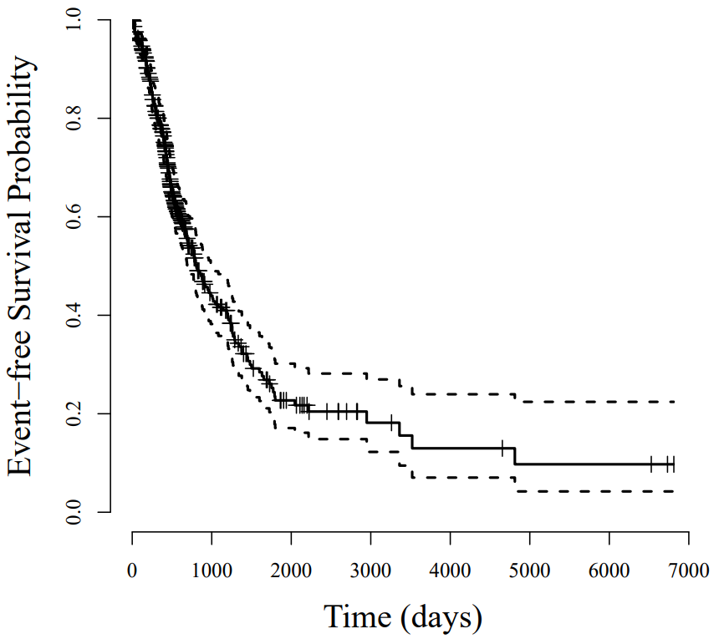
Figure S1: The Kaplan-Meier curve for EFS of 408 patients enrolled in this study.

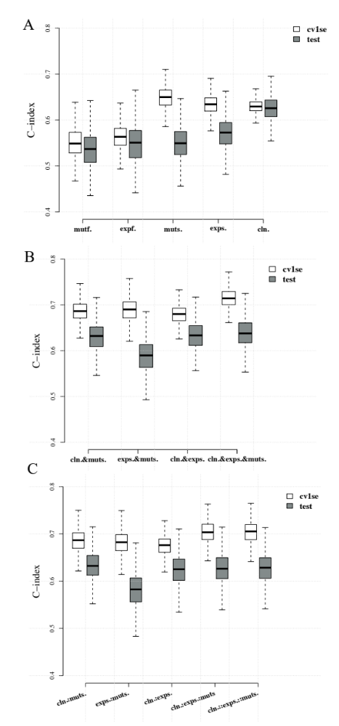
Figure S2: The C-index of models developed based on single type of data (A) combined feature sets (B) and models with interaction covariates (C). The white box summarized C-index for models selected from cross-validation (1 standard error rule), while the gray box for those from testing. Abbreviations can be referred to Table S2.

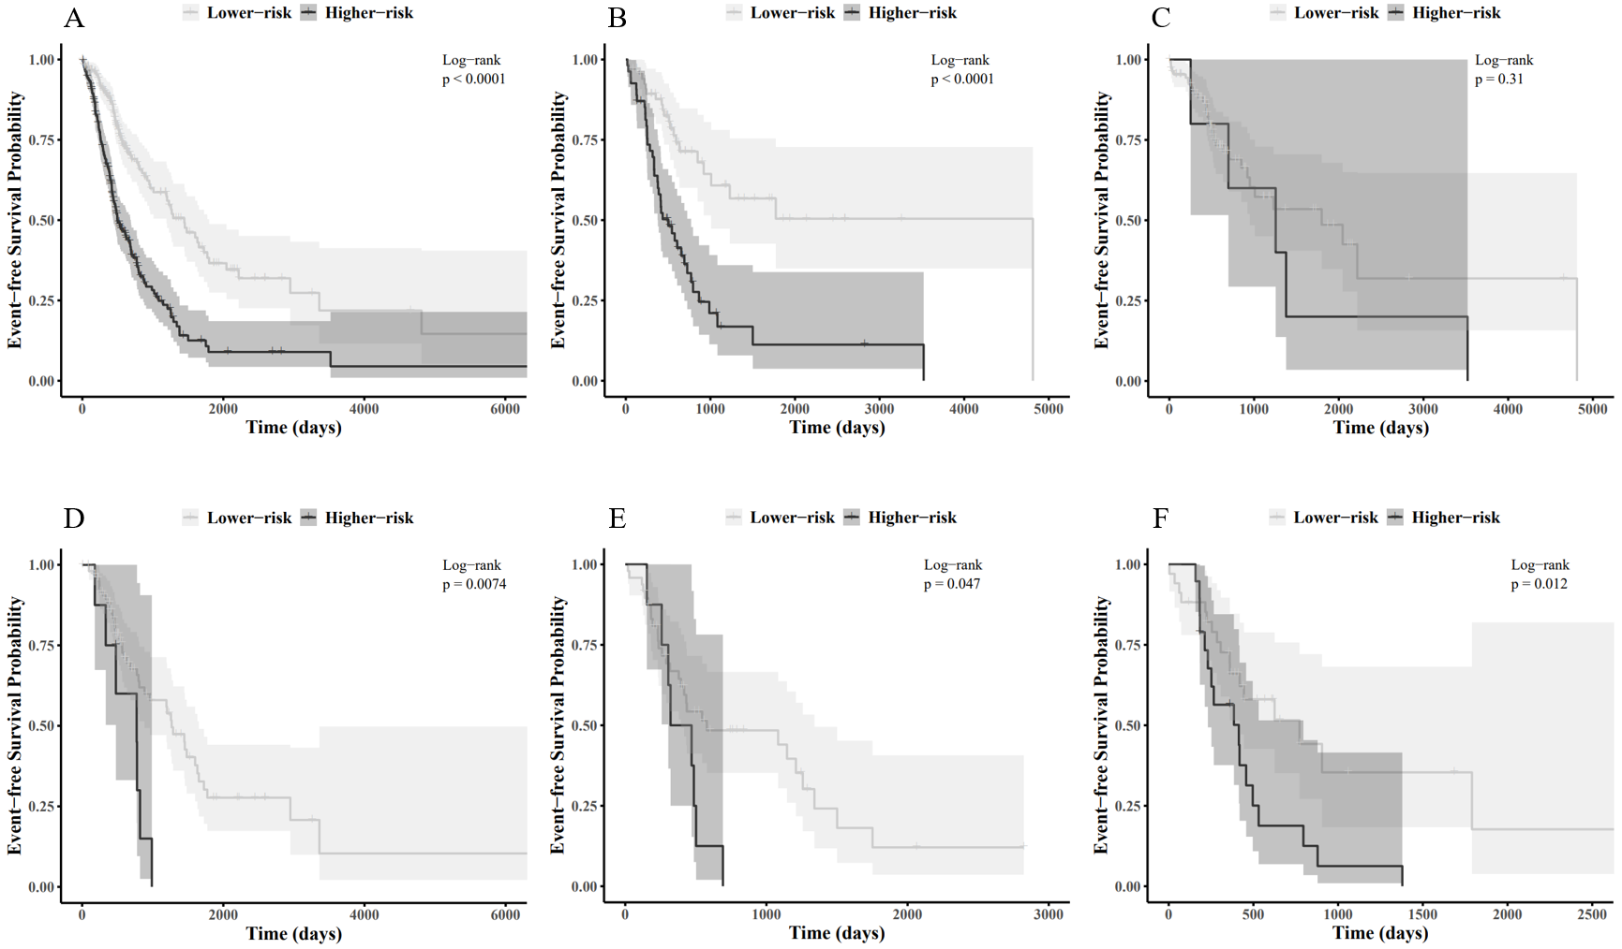
Figure S3: Kaplan-Meier curve of higher- and lower-risk subgroups stratified by cln-score within different sets of patients. The sets from A to F are: A, all patients; B, testing set; C, patients in AJCC pathologic tumor stage IA; D, patients in AJCC pathologic tumor stage IB; E, patients in AJCC pathologic tumor stage IIB; F, patients in AJCC pathologic tumor stage IIIA.

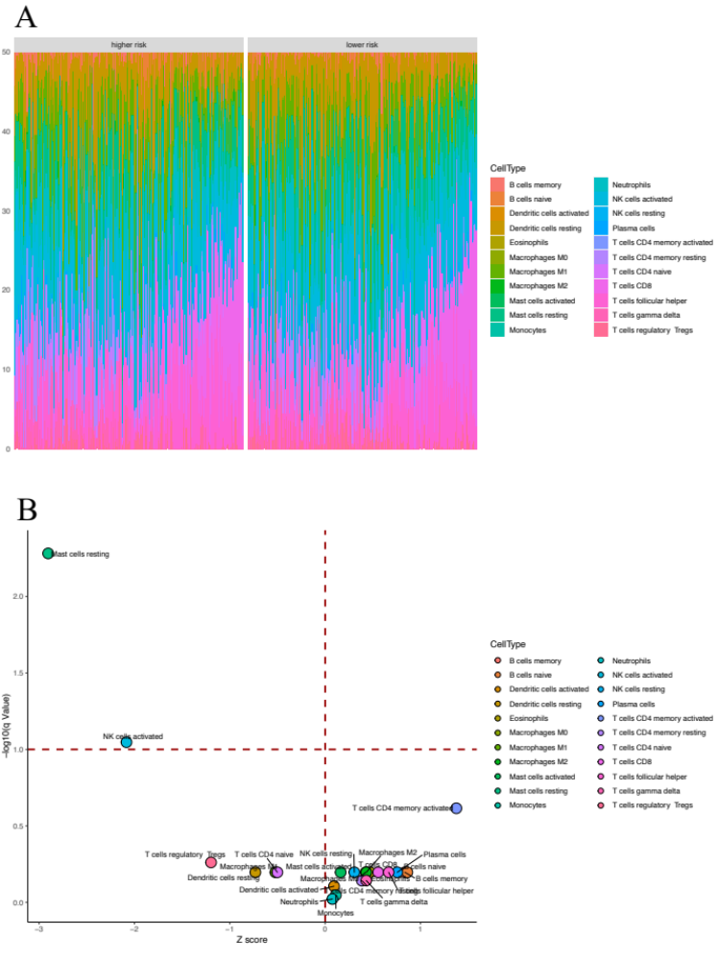
Figure S4: Barplot summary of inferred relative fractions of cell types (A) and volcano plot summary for the significance of difference in immune cellular compositions between the higher and lower-risk subgroup patients (B).

