Supplementary Material
CELLULOSE

A new recognition of the binding of cellulose fibrils in papermaking by probing interaction between nanocellulose and cationic hemicellulose

Xingyu Lanª, Shiyu Fu^{*,a}, Yi Kongª
a. State Key Laboratory of Pulp & Paper Engineering, South China University of Technology, Guangzhou, PR China 510640
*Corresponding author: shyfu@scut.edu.cn

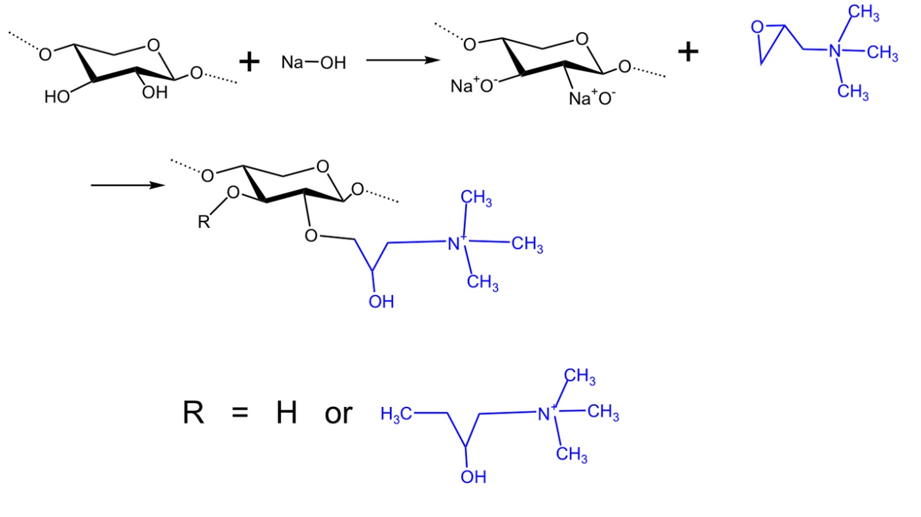
Figure S1. Synthesis of cationic hemicellulose (cationic xylan) from eucalyptus wood

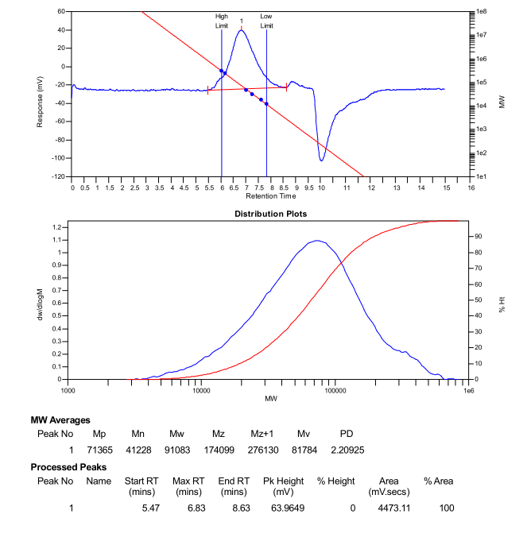
Figure S2. GPC data for unmodified hemicellulose (Hr)
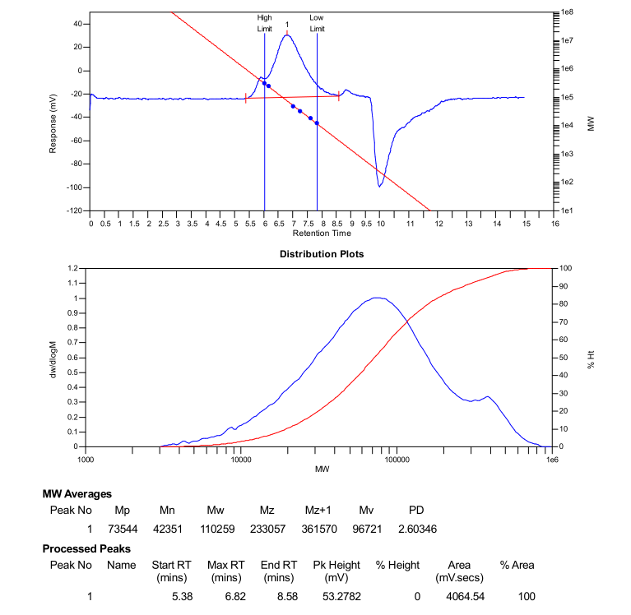
Figure S3. GPC data of cationic hemicellulose (CH1, DS=0.095)
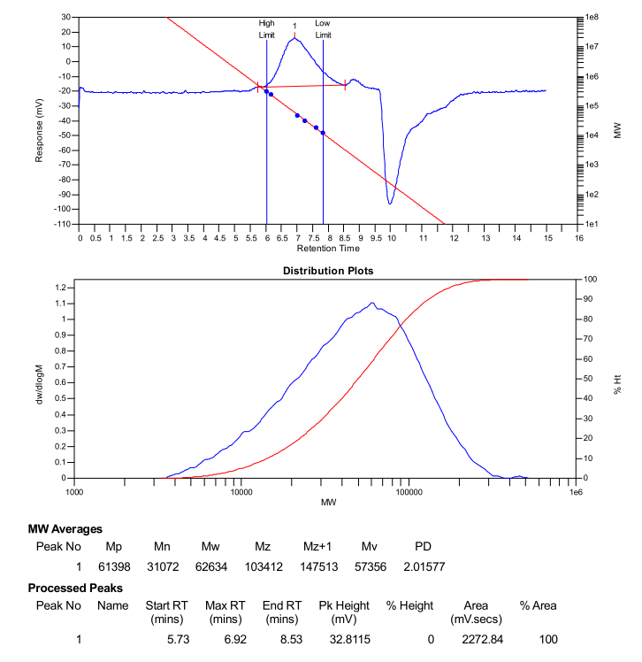
Figure S4. GPC data of cationic hemicellulose (CH2, DS=0.146)
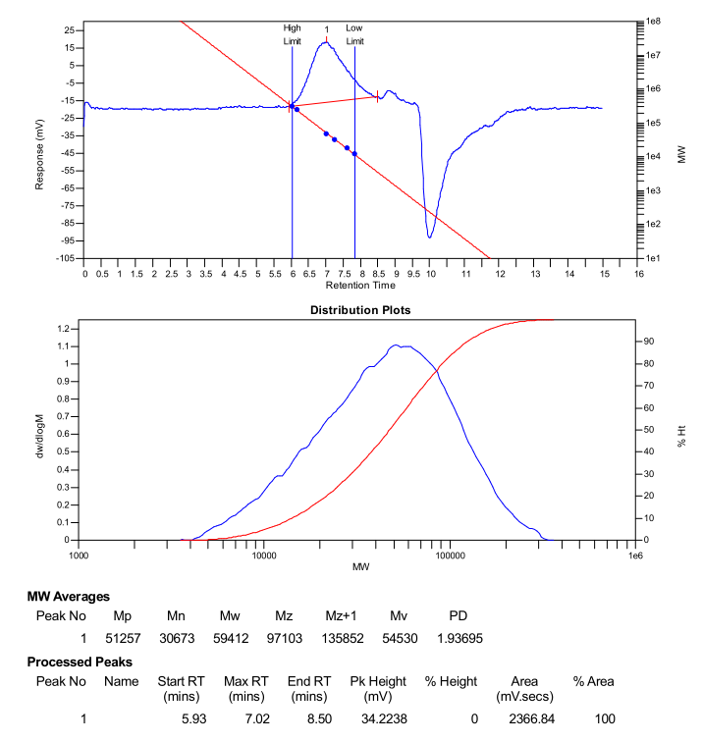
Figure S5. GPC data of cationic hemicellulose (CH3, DS=0.177)
Figure S6. GPC data of cationic hemicellulose (CH4, DS=0.254)

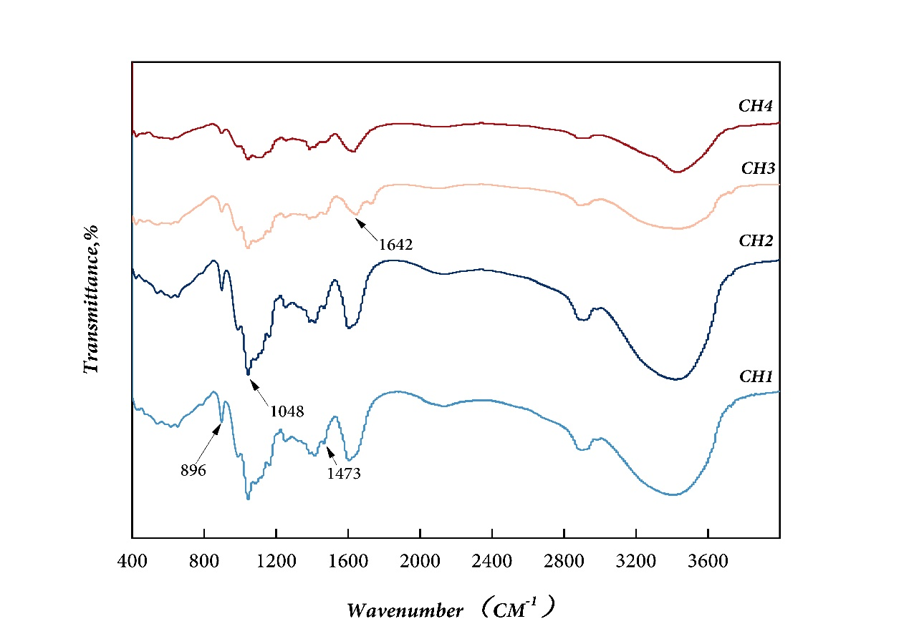
Figure S7. FT-IR spectrum of the cationic hemicellulose (in KBr).

No typical lignin aromatic ring vibration-related peaks were observed between 1600 and 1500 cm⁻¹; the strong band at 897 cm⁻¹ is attributed to the glycosidic bonding of xylose, and the peak intensity of cationic hemicellulose decreases significantly with increasing DS; the spectra of the cationic hemicellulose samples provide etherification through characteristic peaks at 1048 and 1473 cm⁻¹. etherification, with the strong band at 1642 cm⁻¹ originating from water absorbed in the cationic hemicellulose;

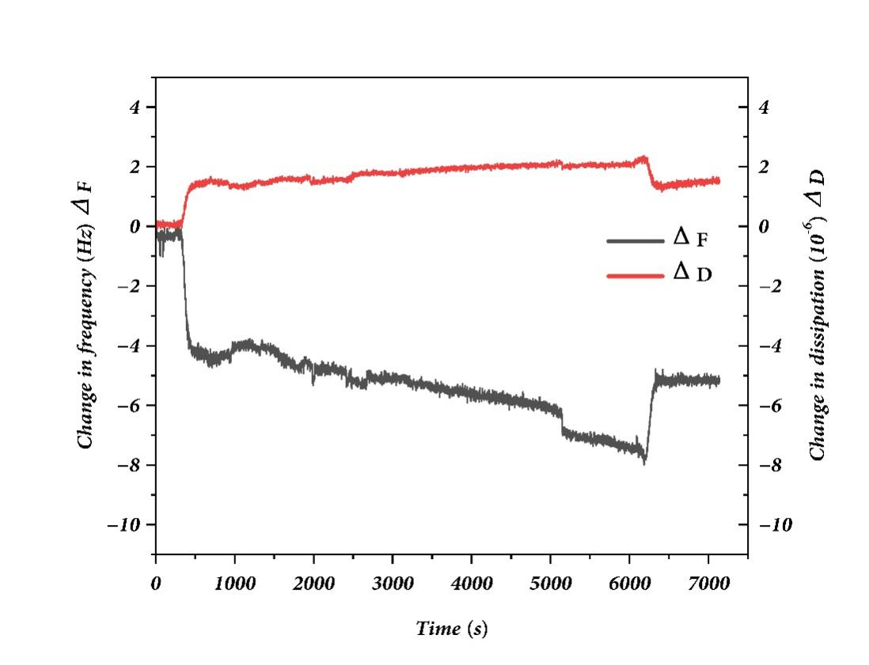
Figure S8. The QCM-D data (3rd overtone) show the change in frequency (ΔF) and dissipation (ΔD) of unmodified hemicellulose (Hr) upon adsorption on the CNF-sensor surface.
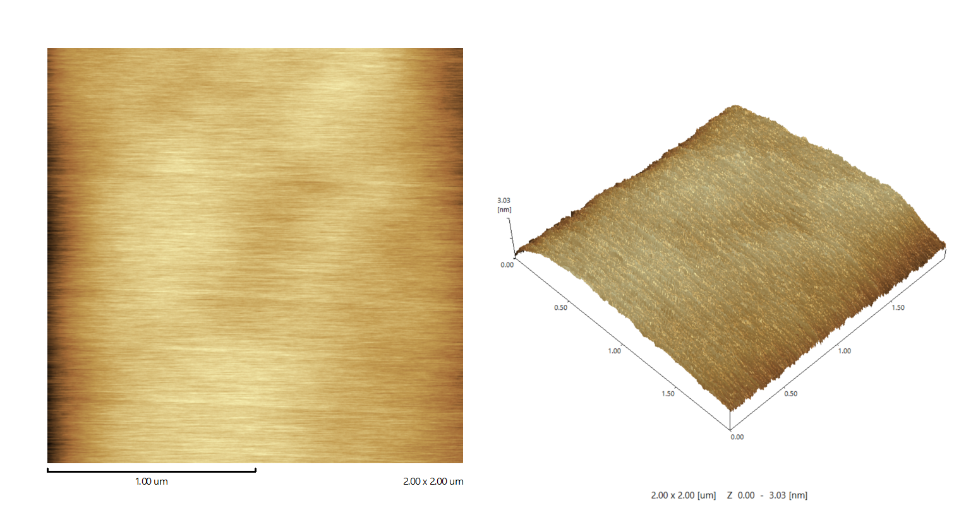
Figure S9. Morphology of the silica-coated sensor chip, its surface is very uniform and flat, the water contact angle is about 95 degrees, can be well adapted to the requirements of the QCM-D experiment.
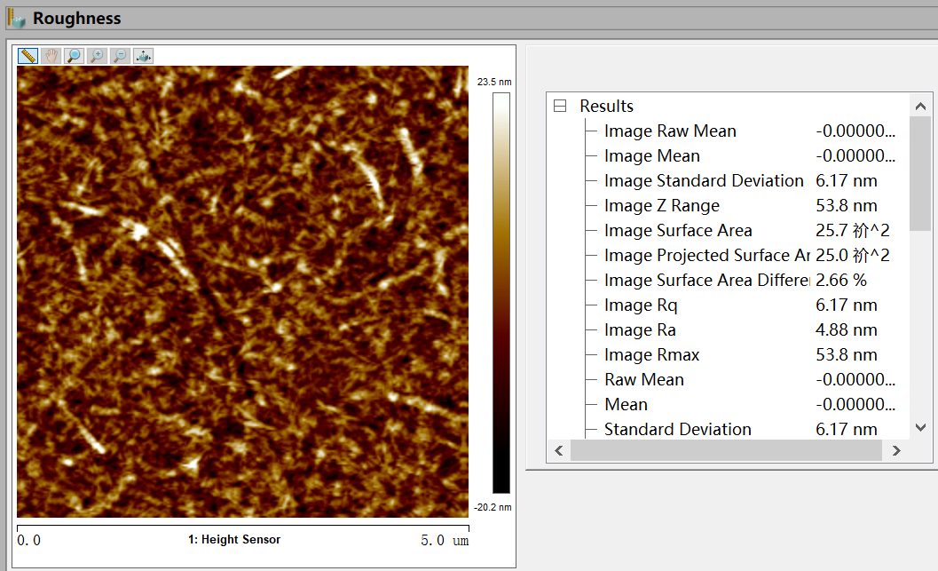
Figure S10. The roughness Ra of the CNF-coated sensor surface was 4.88 nm and the image size was 5 × 5 μm².
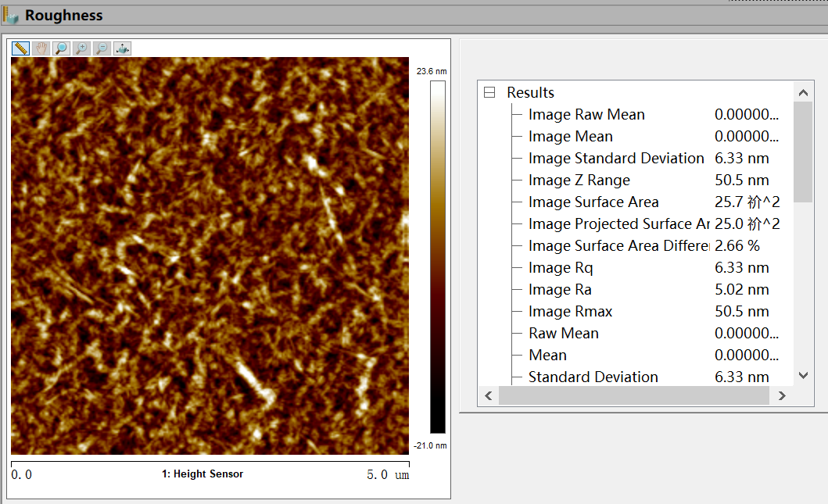
Figure S11. The roughness Ra of the CH1-coated sensor surface was 5.02 nm and the image size was 5 × 5 μm².
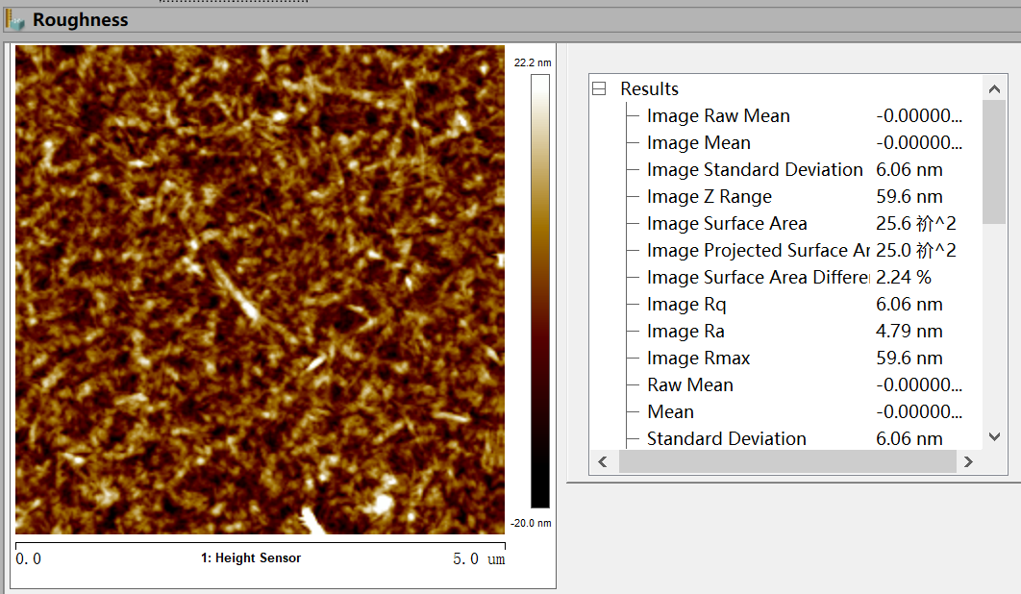

Figure S12. The roughness Ra of the CH4-coated sensor surface was 4.79 nm and the image size was 5 × 5 μm².

