Supplementary Materials

A Prediction of Hepatocellular Carcinoma-Associated Cachexia: The Value of a Nomogram Based on Magnetic Resonance Imaging and Serum Characterisitcs

Table of contents
Supplementary methods………………………………….………..…………………2
Table S1………………………………………………....………...….…………........5
Table S2……………………………………….………....…..…………………….....6
Table S3……………………………………….………....…..…………………….....7
Table S4……………………………………….………....…..…………………….....8
Fig. S1……………..………………….……..…………..……………………..…......9
Fig. S2……………..…………………..……….……….....…………………….…...10
Supplementary references……………………………......……………………….....12

Supplementary materials
Descriptions of magnetic resonance imaging features
The details of magnetic resonance imaging (MRI) features used in this work were as follows: 1) tumor size, the largest dimension (outer-edge to outer-edge) of the main lesion on the T2-weigted imaging; 2) multifocality, two or more HCC lesions in the liver; 3) homogeneity; 4) substantial necrosis, indicating noncontrast-enhancing tumor regions with high-signal intensity on the T2-weigted imaging that covered more than 20% of the tumor's greatest area; 5) blood products in mass, referring to amorphous or geographic areas of the high signal found on T1WI but without signal loss on the out-of-phase or fat-suppressed image; 6) intralesional fat, indicating a greater signal loss on the out-of-phase image when compared with the in-phase image; 7) signal intensity on pre-contrast T1WI, including hypointense, isointense, or hyperintense; 8) signal intensity on T2WI, including hypointense, isointense, or mild-moderate hyperintensity; 9) tumor capsule, including complete capsule, incomplete capsule, and none; 10) hepatic capsular retraction, such as invagination or focal flattening of the normal convex hepatic contour caused by HCC; 11) ill-defined tumor margin, indicating the margin that was not clearly circumscribed; 12) corona enhancement, the peritumoral enhancement in the late arterial or portal venous phase; 13) nodule-in-nodule, referring to the smaller inner nodule within a large nodule with different imaging characteristics when compared with the larger outer nodule; 14) mosaic architecture, indicating randomly distributed internal nodules or compartments, usually with different imaging characteristics; 15) portal vein tumor thrombus, indicating tumor in the portal vein in accordance with primary HCC signal intensity; 16) intratumoral artery, indicating discrete arteries within the tumor observed on arterial phase images; 17) rim arterial phase hyperenhancement, referring to the spatially defined subtype of APHE in which arterial phase enhancement is most pronounced in observation periphery; 18) arterial phase peritumoral enhancement, indicating a crescent or polygonal enhancement outside the tumor margin but adjacent to it as seen in the arterial phase, which becomes isointense with background liver parenchyma in the delayed or transitional phase; 19) nonperipheral washout, indicating a visually-assessed temporal reduction in enhancement in whole or in part relative to the composite liver parenchyma in the portal/delayed phase for gadopentetate dimeglumine or portal phase for gadoxetic acid disodium; 20) delayed/transitional phase, including hypointense, isointense, or hyperintense; 21) extrahepatic metastasis, suggesting metastasis was found outside the liver; 22) restricted diffusion, indicating an unequivocally higher signal intensity on diffusion weighted imaging and/or lower on apparent diffusion coefficient in the tumor than liver parenchyma; 23) ascites, a igh-signal intensity on fat-suppressed T2WI.

The levels of interobserver agreement
We assessed the interobserver agreement for categorical variables by the κ statistic according to the following criteria: 0.20 or less, poor agreement; 0.21-0.40, fair agreement; 0.41-0.60, moderate agreement; 0.61-0.80, good agreement; and 0.80-1.00, excellent agreement. The interobserver agreement for continuous variables was assessed by the intraclass correlation coefficient, on the following standards: 0-0.49, poor agreement; 0.50-0.75, moderate agreement; 0.76-0.90, good agreement; 0.91-1.00, excellent agreement.

Table S1. Magnetic resonance imaging parameters of the two centers
Institution A
Scanner Model | Parameters | Dual-echo T1-weighted GRE | T1-weighted 3D GRE | T2-weighted FSE | DWI
Trio Tim | Matrix | 179 × 256 | 320 × 195 | 256 × 141 | 128 × 86
(n = 391) | Field of View (mm) | 380 × 332 | 380 × 309 | 390 × 268 | 380 × 285
 | Section Thickness (mm) | 6.0 | 2.5 | 6.0 | 5.0
 | Intersection Gap (mm) | 1.2 | 0 | 6.0 | 5.0
 | Repetition Time (msec) | 193 | 4.07 | 1000 | 5111
 | Echo Time (msec) | 1.55 and 3.06 | 1.86 | 98 | 73
 | Flip Angle (°) | 88 | 9 | 120 | 90
Discovery MR750 | Matrix | 256 × 268 | 256 × 268 | 256 × 384 | 130 × 110
(n = 8) | Field of View (mm) | 380 × 380 | 380 × 315 | 380 × 351 | 380 × 380
 | Section Thickness (mm) | 5.0 | 5.0 | 5.0 | 5.0
 | Intersection Gap (mm) | 1.0 | 0 | 5.0 | 5.0
 | Repetition Time (msec) | 5.61 | 5.61 | 1346.88 | 11250
 | Echo Time (msec) | 1.27 and 2.52 | 1.89 | 83.1 | 63.4
 | Flip Angle (°) | 12 | 12 | 90 | 90
3D, three-dimensional; GRE, gradient recalled echo; FSE, fast spin echo; DWI, diffusion-weighted imaging.

Institution B
Scanner Model | Parameters | Dual-echo T1-weighted GRE | T1-weighted 3D GRE | T2-weighted FSE | DWI
MAGNETOM Vida | Matrix | 320 × 195 | 320 × 185 | 192 × 320 | 134 × 108
(n = 48) | Field of View (mm) | 260 × 320 | 264 × 320 | 480 × 640 | 216 × 268
 | Section Thickness (mm) | 3.0 | 3.0 | 5.0 | 6.0
 | Intersection Gap (mm) | 0 | 0 | 6.0 | 7.5
 | Repetition Time (msec) | 3.97 | 3.11 | 2500 | 5600
 | Echo Time (msec) | 1.29 and 2.52 | 1.05 | 91 | 46
 | Flip Angle (°) | 9 | 15 | 160 | 90
Ingenia | Matrix | 252 × 221 | 268 × 266 | 268 × 72 | 127 × 124
(n = 42) | Field of View (mm) | 448 × 448 | 480 × 480 | 432 × 432 | 448 × 448
 | Section Thickness (mm) | 4.0 | 4.0 | 6.0 | 6.0
 | Intersection Gap (mm) | 2.0 | 2.0 | 7.0 | 7.0
 | Repetition Time (msec) | 3.64 | 3.75 | 2725 | 1394.47
 | Echo Time (msec) | 1.19 and 2.37 | 0 | 76.42 | 56.11
 | Flip Angle (°) | 10 | 10 | 90 | 90
3D, three-dimensional; GRE, gradient recalled echo; FSE, fast spin echo; DWI, diffusion-weighted imaging.

Table S2. Interobserver agreement on identifying MRI features of tumors in the three cohorts
MRI Features | Interobserver Agreement*
MRI Features | Training cohort | Internal validation cohort | External validation cohort
Tumor size (cm) | 0.90 (0.87, 0.92) | 0.94 (0.91, 0.96) | 0.94 (0.90, 0.96)
Multifocality | 0.74 (0.65, 0.82) | 0.83 (0.73, 0.93) | 0.77 (0.64, 0.90)
Homogeneity | 0.62 (0.52, 0.72) | 0.79 (0.67, 0.91) | 0.83 (0.70, 0.96)
Substantial necrosis | 0.81 (0.73, 0.88) | 0.89 (0.80, 0.98) | 0.70 (0.55, 0.85)
Blood products | 0.83 (0.77, 0.90) | 0.93 (0.86, 1.00) | 0.76 (0.62, 0.90)
Intralesional fat | 0.87 (0.80, 0.95) | 0.93 (0.85, 1.00) | 0.79 (0.65, 0.93)
Pre-constrast T1-weighted imaging | 0.78 (0.69, 0.86) | 0.74 (0.57, 0.90) | 0.71 (0.55, 0.87)
T2-weighted imaging | 0.79 (0.71, 0.87) | 0.71 (0.55, 0.88) | 0.70 (0.52, 0.88)
Tumor capsule | 0.83 (0.77, 0.89) | 0.71 (0.56, 0.85) | 0.71 (0.56, 0.87)
Hepatic capsular retraction | 0.71 (0.63, 0.79) | 0.73 (0.61, 0.85) | 0.84 (0.73, 0.95)
Ill-defined tumor margin | 0.83 (0.77, 0.90) | 0.81 (0.71, 0.92) | 0.66 (0.51, 0.82)
Corona enhancement | 0.73 (0.65, 0.82) | 0.65 (0.50, 0.80) | 0.58 (0.38, 0.78)
Nodule-in-nodule | 0.83 (0.76, 0.91) | 0.78 (0.66, 0.91) | 0.49 (0.28, 0.69)
Mosaic architecture | 0.70 (0.62, 0.79) | 0.85 (0.76, 0.94) | 0.87 (0.77, 0.97)
Portal vein tumor thrombus | 0.94 (0.90, 0.99) | 0.88 (0.78, 0.98) | 0.78 (0.64, 0.93)
Intratumoral artery | 0.70 (0.62, 0.79) | 0.87 (0.78, 0.96) | 0.84 (0.73, 0.95)
Rim APHE | 0.63 (0.53, 0.72) | 0.73 (0.61, 0.85) | 0.87 (0.76, 0.97)
Arterial phase peritumoralenhancement | 0.81 (0.77, 0.89) | 0.67 (0.54, 0.80) | 0.85 (0.74, 0.97)
Nonperipheral washout | 0.80 (0.73, 0.87) | 0.81 (0.70, 0.92) | 0.88 (0.78, 0.98)
Delayed or transitional phase | 0.78 (0.70, 0.86) | 0.74 (0.60, 0.88) | 0.73 (0.51, 0.95)
Extrahepatic metastatic | 0.88 (0.79, 0.98) | 0.79 (0.65, 0.93) | 0.76 (0.58, 0.94)
Restricted diffusion | 0.80 (0.72, 0.88) | 0.86 (0.75, 0.97) | 0.83 (0.69, 0.96)
Ascites | 0.92 (0.87, 0.97) | 0.67 (0.52, 0.82) | 0.59 (0.42, 0.76)
Data in parentheses are 95% CIs. APHE, arterial phase hyperenhancement. * Categorical variables were analyzed using κ statistics and continuous variables were analyzed using intraclass correlation coefficient.

Table S3 Clinical characteristics and MRI features associated with cachexia in the training cohort: univariable analysis
Clinical characteristics | Univariable analysis |  | MRI features | Univariable analysis
Clinical characteristics | OR (95% CI) | P value | MRI features | OR (95% CI) | P value
Age (years) | 0.99 (0.97, 1.02) | 0.55 | Tumor size>5 cm | 5.53 (3.30, 9.27) | < 0.001
Sex (males: females) | 1.37 (0.74, 2.55) | 0.32 | Multifocality | 0.68 (0.42, 1.10) | 0.11
BMI, kg/m² | 1.02 (0.94, 1.09) | 0.65 | Homogeneity | 0.51 (0.28, 0.92) | 0.03
Etiology |  |  | Substantial necrosis | 0.68 (0.42, 1.10) | 0.11
Hepatitis B |  | Reference | Blood products | 0.66 (0.41, 1.08) | 0.10
Hepatitis C | 1.04 (0.43, 2.49) | 0.94 | Intralesional fat | 0.34 (0.18, 0.66) | 0.001
Alcoholism | 0.34 (0.06, 2.04) | 0.24 | Pre-contrast T1WI | 0.76 (0.44, 1.31) | 0.32
Unknown | 1.2 (0.14, 10.12) | 0.87 | T2WI | 1.32 (0.75, 2.31) | 0.34
Treatment |  |  | Tumor capsule
Surgical resection |  | Reference | Complete |  | Reference
TACE/TARE | 0.95 (0.13, 6.98) | 0.96 | Imcomplete | 1.19 (0.61, 2.30) | 0.61
Local ablation | 0.72 (0.10, 5.29) | 0.75 | None | 1.37 (0.81, 2.30) | 0.24
Systemic therapy | 0.61 (0.08, 4.98) | 0.65 | Hepatic capsular retraction | 0.55 (0.34, 0.89) | 0.02
NSC | 2.00 (0.20, 19.9) | 0.55 | Ill-defined tumor margin | 0.43 (0.26, 0.71) | 0.001
Child-Pugh |  |  | Corona enhancement | 1.16 (0.69, 1.93) | 0.58
A |  | Reference | Nodule-in-nodule | 0.73 (0.42, 1.29) | 0.28
B | 1.73 (0.16, 19.3) | 0.66 | Mosaic architecture | 0.58 (0.36, 0.94) | 0.03
C | 1.25 (0.10, 15.7) | 0.86 | Portal vein tumor thrombus | 0.22 (0.13, 0.40) | <0.001
AST>45 IU/L | 1.32 (0.83, 2.13) | 0.25 | Intratumoral artery | 0.16 (0.10, 0.28) | <0.001
ALT>50 IU/L | 1.54 (0.91, 2.58) | 0.11 | Nonrim APHE | 0.49 (0.31, 0.80) | 0.004
Albumin>40 g/dL | 0.80 (0.50, 1.28) | 0.35 | AP peritumoral enhancement | 0.49 (0.30, 0.79) | 0.004
Bilirubin> 1 mg/dL | 0.65 (0.39, 1.08) | 0.094 | Nonperipherial washout | 2.24 (0.73, 6.87) | 0.16
Platelet<125 or >350 × 10³/μL | 1.08 (0.67, 1.74) | 0.74 | Delayed or transitional phase | 1.25 (0.73, 2.12) | 0.41
AFP 100 ng/mL | 3.72 (2.26, 6.11) | <0.001 | Extrahepatic metastasis | 0.36 (0.15, 0.86) | 0.02
CA 19-9>37 U/mL | 2.54 (1.57, 4.13) | <0.001 | Restricted diffusion | 1.23 (0.73, 2.10) | 0.44
PT>13.8 sec | 1.07 (0.63, 1.81) | 0.80 | Ascites | 0.98 (0.60, 1.58) | 0.93
PT/INR<0.8 or >1.2 | 0.87 (0.50, 1.50) | 0.61
AFP, α-fetoprotein; ALT, alanine transaminase; AP, arterial phase; AST, aspartate transaminase; BMI, body mass index; NSC, nutritional supportive care; PT/INR, international normalized ratio of prothrombin time; PT, Prothrombin time; T1WI, T1-weighted imaging; T2WI, T2-weighted imaging; TACE, transarterial chemoembolization; TARE, transarterial radioembolization. (+), cachexia; (-), non-cachexia.
Table S4. Performance of the combined model, clinical data only model, and imaging model in predicting cachexia in HCC patients
Index | Training Cohort |  |  |  | Internal validation cohort |  |  |  | External validation cohort
Index | Model 1 | Model 2 | Model 3 |  | Model 1 | Model 2 | Model 3 |  | Model 1 | Model 2 | Model 3
Sensitivity | 0.756 | 0.646 | 0.709 |  | 0.750 | 0.661 | 0.375 |  | 0.959 | 0.653 | 0.898
Specificity | 0.789 | 0.671 | 0.796 |  | 0.781 | 0.672 | 0.937 |  | 0.634 | 0.756 | 0.488
AUC | 0.826 | 0.710 | 0.790 |  | 0.790 | 0.707 | 0.689 |  | 0.850 | 0.759 | 0.722
2.5%CI | 0.776 | 0.649 | 0.736 |  | 0.705 | 0.617 | 0.594 |  | 0.768 | 0.663 | 0.615
97.5%CI | 0.875 | 0.771 | 0.844 |  | 0.874 | 0.798 | 0.784 |  | 0.932 | 0.855 | 0.829
P Value | NA | < 0.001* | 0.031# |  | NA | 0.017* | 0.012# |  | NA | 0.04* | 0.01#
Note. Model 1 = combined model; Model 2 = clinical data only model; Model 3 = imaging model. * represents model 1 vs. model 2. # represents model 1 vs. model 3.

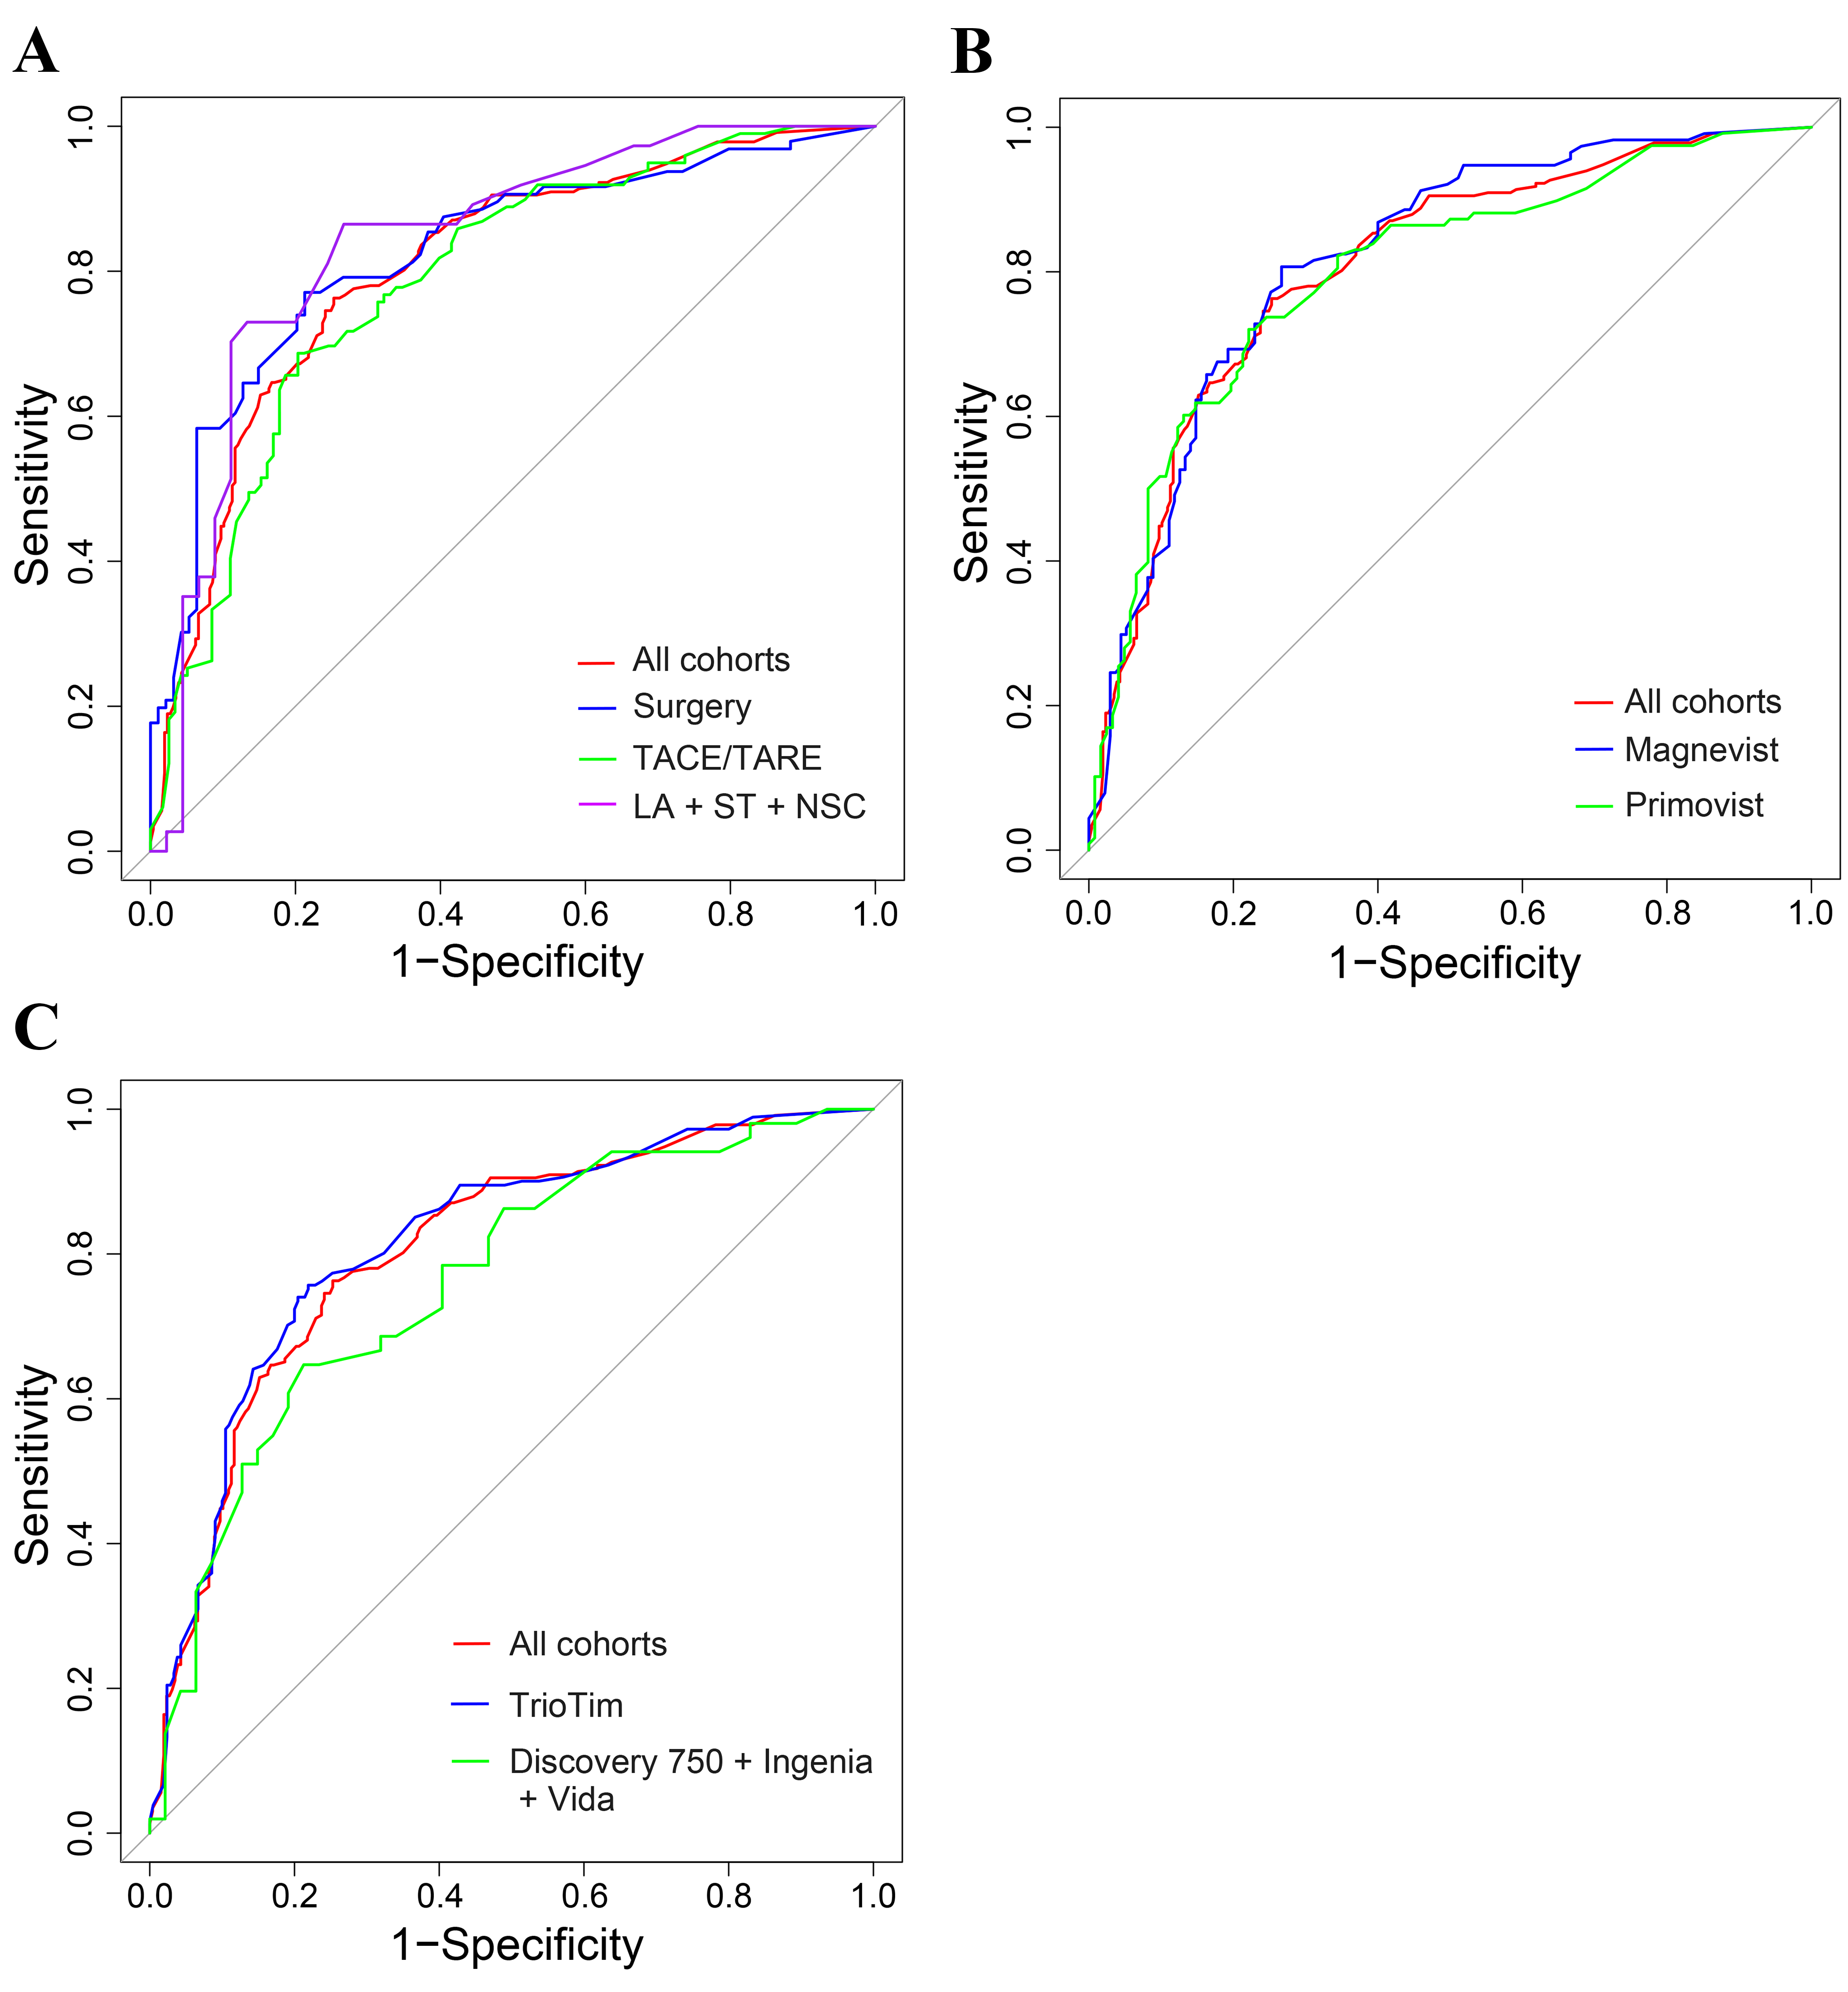
Fig. S1. Stratified analysis for the influence of treatment, media, and MRI scanner on the nomogram. Receiver operating characteristic curves of type of treatment (A), type of contrast agent (B), version of MRI system (C). Red curves represent the result of all cohorts. The blue, green, and purple curves represent different subgroup.

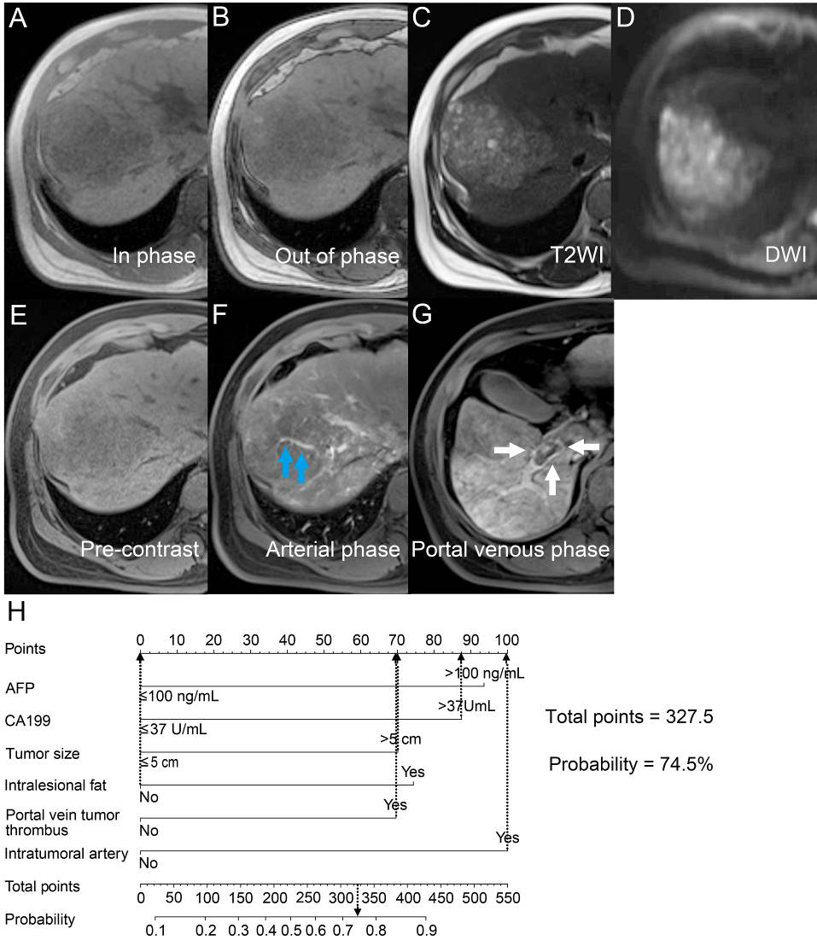
Fig. S2. Liver MRI characteristics of a HCC patient with cachexia. The patient (a 33-year-old man) underwent the TACE after MRI and was diagnosed with cachexia after a 4-month follow-up. The serological test reported α-fetoprotein and carbohydrate antigen 19-9 levels of 9.4 ng/mL and 57.8 U/mL, respectively. A 8.0-cm tumor in the right side of the liver showed low-signal intensity on the T1-weighted image (A and B), moderately high-signal intensity on the T2-weighted image (C), high-signal intensity in the diffusion-weighted image (D, b = 800 s/mm²), and visible intratumoral artery on the the arterial phase (F, blue arrow), and tumor in the right portal vein (G, white arrow). The nomogram of this patient reported a total point of 327.5 (0 + 87.5 + 70 + 0 + 70 + 100 = 327.5), corresponding to a cachexia prediction probability of 74.5% (H). AFP, α-fetoprotein; DWI, diffusion-weighted imaging; T2WI, T2-weighted imaging. TACE, transarterial chemoembolization.

