Supplement A: Prototype alcohol screening tool
The prototype clinical decisions support / screening tool as shown on the following pages was developed by Dr Libby Dai to be a discussion prompt for interviewees. The prototype was provided to each interview participant and discussed during each interview.
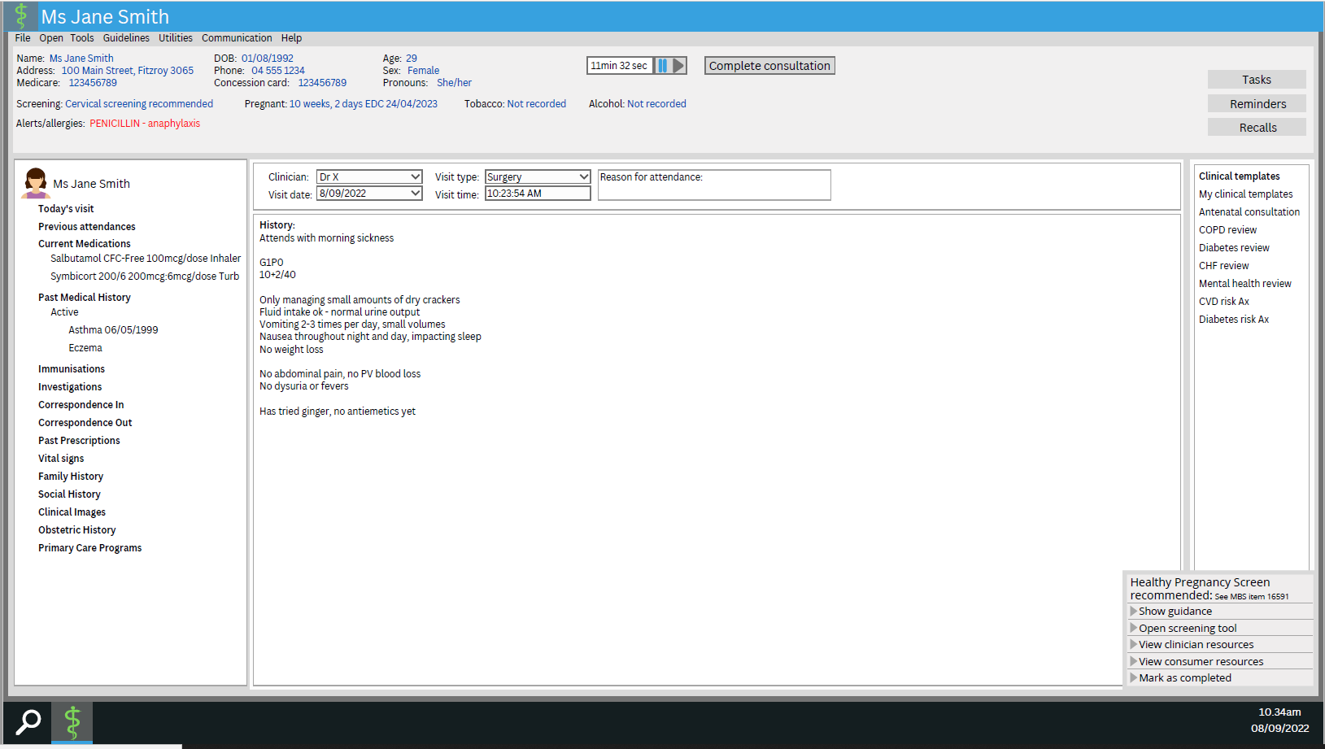

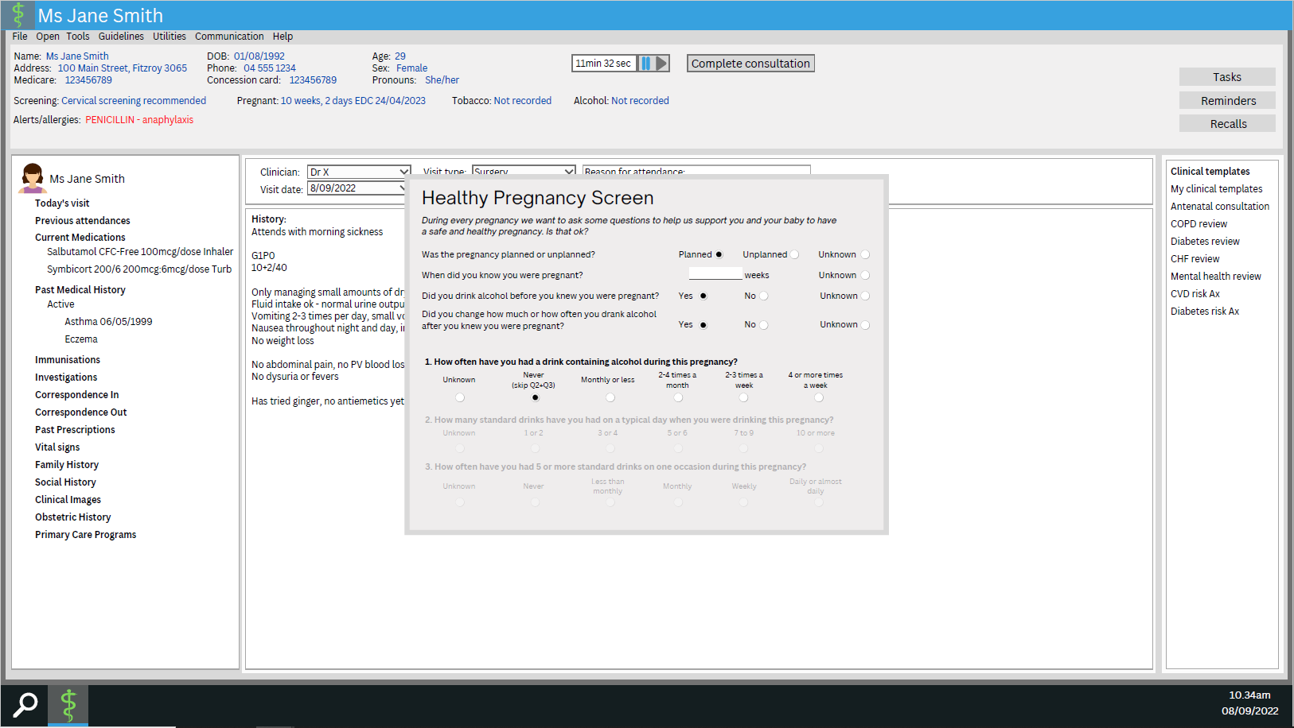

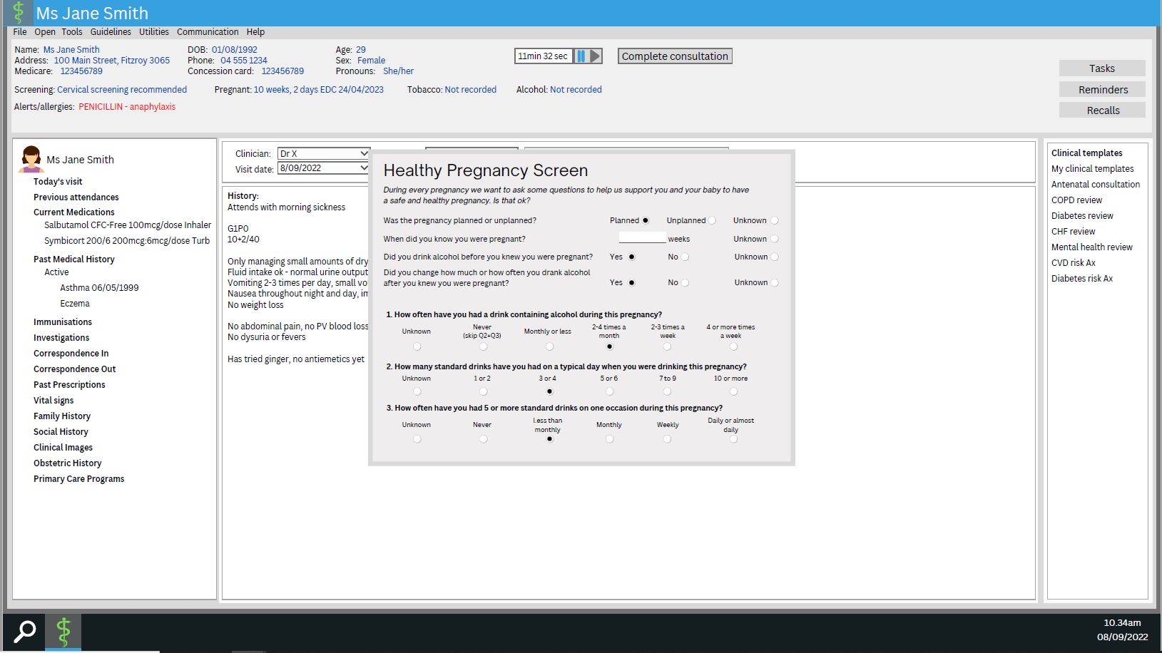

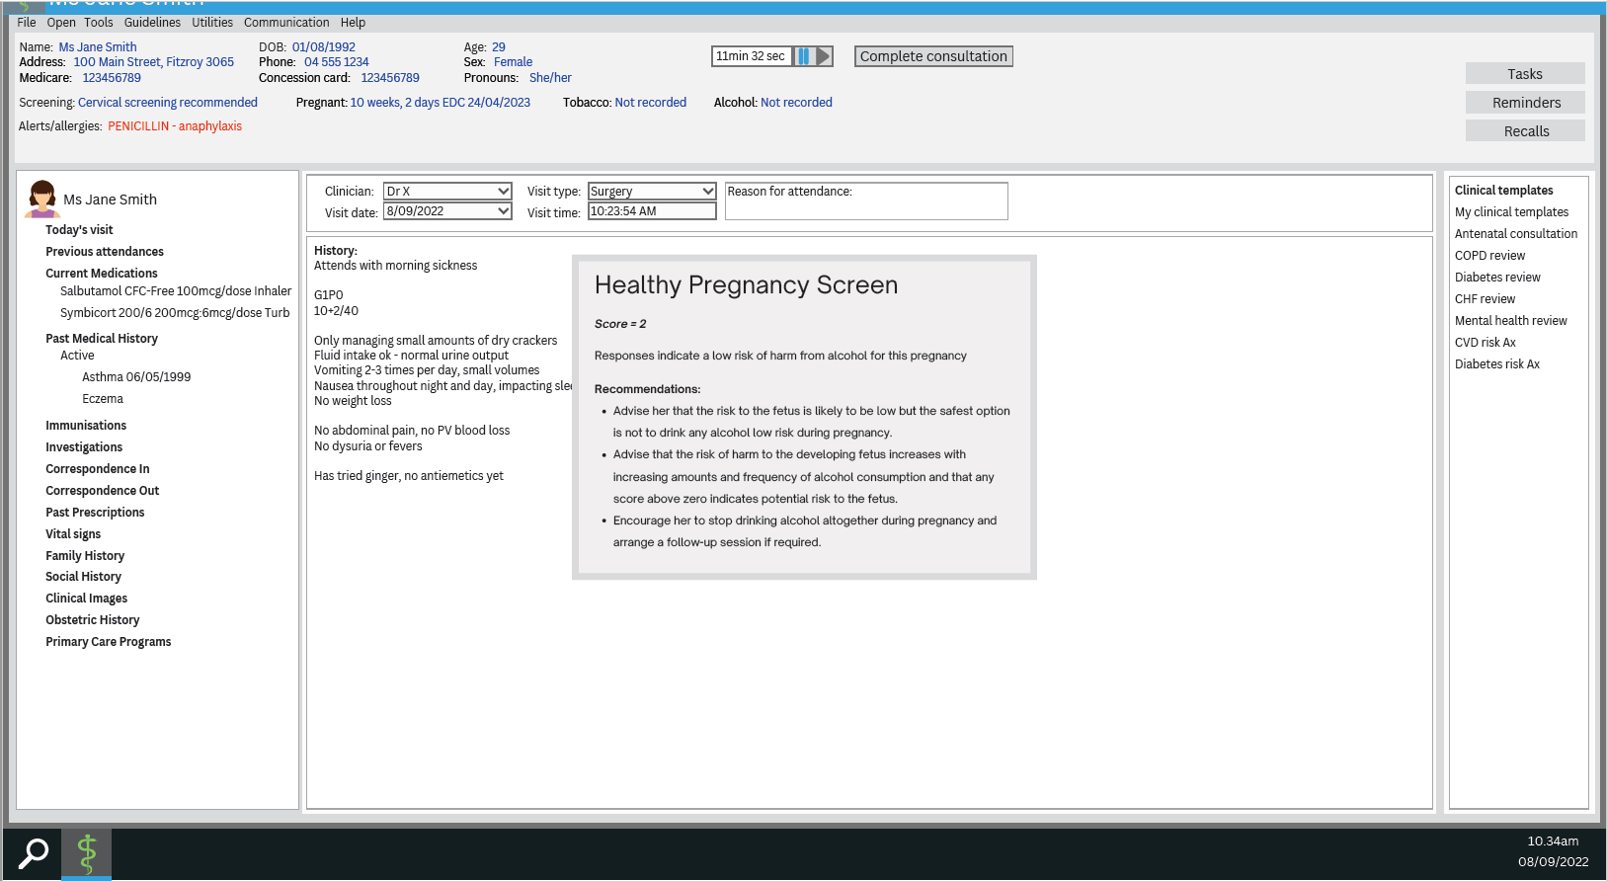

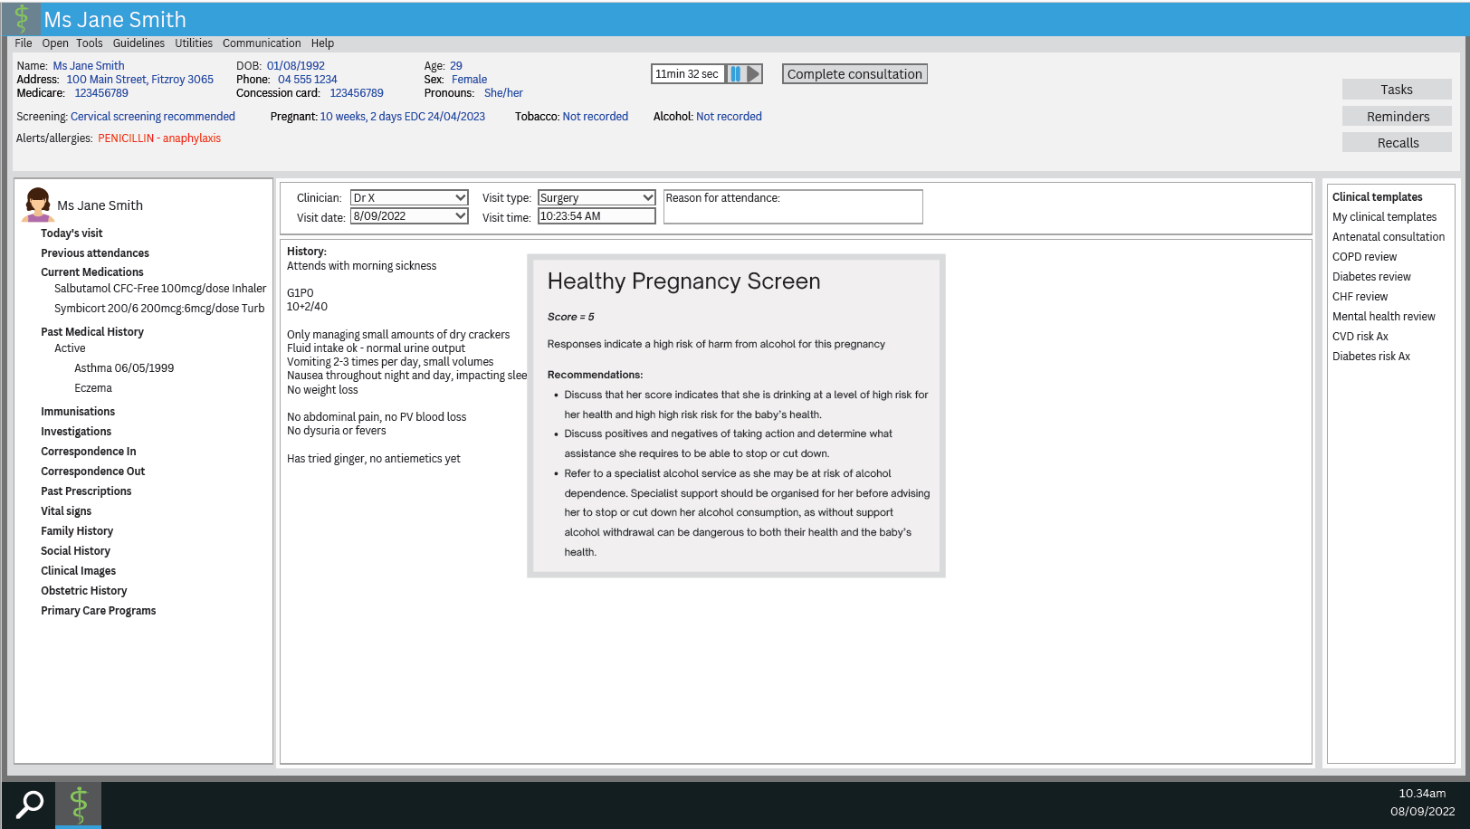

Supplement B: Interview question guide
An overview of relevant interview questions was sent to each participant with the Plain Language Statement, Consent Form and Alcohol Screening Tool prototype.

A: Questions for everyone:
- Briefly: your professional role and the type of organisation you work for.
- Whether you are responding with the viewpoint of the organisation you represent or giving your own personal opinion.
- Overall whether you think the development and deployment tools in clinical software to prompt for alcohol screening among pregnant (or planning) women is a good idea.
- Other ways or ideas around ensuring that more women who are pregnant or planning pregnancy are routinely screened for alcohol use.
- Any other considerations.

B: Questions for primary care clinicians / representative organisations / researchers:
- What clinical software package you use in practice (if in practice).
- Your current use of alcohol screening tools. When? Why? How do you use them?
- Thoughts on available alcohol screening tools – their acceptability, benefits, barriers and pitfalls of their use.
- Criteria you think are appropriate to initiate alcohol screening of women who are pregnant or planning pregnancy (include consideration of marginal communities: CALD, First Nations, LGBTQIA+, etc).
- Perceived benefits and barriers, risks or pitfalls of integrating prompts / decision support tools for this purpose into general practice clinical management software.
- Which clinical management software systems should be the priority to target if prompts for alcohol screening during pregnancy were integrated.

C: Questions for representatives of clinical software management organisations
- Estimated market share of your EMR system in general practice and community care settings.
- Do you have an alcohol screening tool integrated into your EMR? If YES, what prompts clinicians to use it? Do you have any idea how much it is used by clinicians?
- Barriers and enablers to development and implementation of integrated prompts or decision support tools to encourage more routine use of alcohol screening tools.
- The process that would need to be undertaken to integrate the tools.
- Estimate of how long you think it would take to develop and implement prompts for alcohol screening into the GP clinical management software.
  - The caveats to this time estimate
- Estimate of costs associated with the development and implementation of the prompts / tool.

Supplement C: Recommendation feedback tool
Hosted on the University of Melbourne’s instance of Qualtrics, the feedback questionnaire commenced with a consent statement, outlined the objectives of the study, gave information about ethics approval and provided contact details for the researcher and ethics committee.
An eligibility check asked for respondents to choose one of the following as best describing themselves:
- GP
- Practice nurse
- Other primary care clinician
- Practice manager or other non clinical primary care staff
- A representative of a primary care related Professional Association or College
- A representative of an organisation associated with clinical software used in general practice
- A research or health informatician
- None of the above (this option exits you from the survey)
Options 1-4  Option 6  Option 7 | Led to a further question: Do you have a role in an Aboriginal Medical Service?  Led to a further question: Do you provide services/ software to Aboriginal Medical Services?  Led to a further question: Do you have expertise in Aboriginal & Torres Strait Islander health research or data?
The following instruction was then given:
Instruction: In the context of Australian general practice and community care, please select how much you agree or disagree with each overall Recommendation. You may leave additional feedback in the box below each Recommendation.
When you have finished, please click on or tap the arrow at the bottom of the page to submit.
Each of the draft recommendations were then given, followed by a five point Likert scale and a text box for written feedback – as shown:
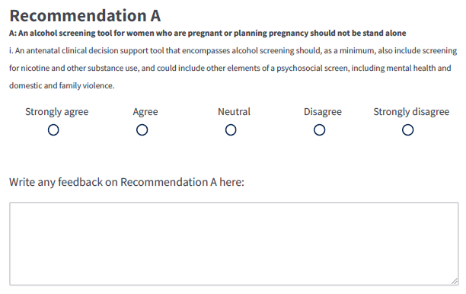
An additional text box was given for capturing ‘Other general comments’.
Lastly, respondents were asked to choose their state, territory or jurisdiction from a drop-down list, which included ‘National’, and then to Submit their feedback.

Supplement D: Screening tool design and implementation recommendations
A total of 54 free-text comments were left by 12 of the 22 ‘sense-testing’ respondents. No respondent left a comment for every recommendation.

Screening tool design recommendations
A | An alcohol screening tool for women who are pregnant or planning pregnancy should be multifunctional and holistic  - An antenatal clinical decision support tool that encompasses alcohol screening should, as a minimum, also include screening for nicotine and other substance use, and could include other elements of a psychosocial screen, including mental health and domestic and family violence.  - As a multi-functional screening tool (including broad psychosocial screening elements) it should have the functionality for users to complete only part of the screen, save progress and return to the screen at another time. (Not relevant for an alcohol only screening tool.)  Sense test results, N=22  Comments from sense testing respondents: “GPs are holistic care providers and not dealing with single issues.” (Strongly agreeing GP)  “Needs to be short enough so alcohol/smoking/vaping/drugs and maybe a couple of screening questions which could then direct more detailed psychosocial/DV assessment.” (Strongly agreeing GP)  “These other issues are important, and for GPs who may be reluctant to explore alcohol due to stigma/cultural concerns, framing alcohol screening within a broader assessment framework will appeal.” (Strongly agreeing GP)  “I think alcohol assessment and advice is part of a holistic assessment of every pregnant person. We don't do this in isolation in clinical practice.” (Strongly agreeing GP)  “While your funders are alcohol-focused, GPs need to look at the big picture.” (Strongly agreeing GP)  “May depend on the patient and might be more useful as a stand-alone tool depending on the scenario.” (Disagreeing GP)
  Strongly agree | Agree | Neutral | Disagree | Strongly disagree
  13 | 5 | 3 | 1 | Nil
  Includes 1 x professional association / College representative |  | 3 x vendors | 1 x GP
B | Indicating ‘Currently pregnant’ in the clinical software triggers automated prompt for alcohol screening (+/- psychosocial screen)  - Documenting a current pregnancy in the electronic medical record is an appropriate trigger point for the software to generate a prompt to consider conducting antenatal screening (e.g. as described at Recommendation A).  Sense test results, N=22  Comments from sense testing respondents: “Busy GPs will appreciate prompts.” (Strongly agreeing GP)  “We already get medication warning if pregnant - often for medications with much much less risk than alcohol. It makes sense this would be an important prompt.” (Strongly agreeing GP)  “This should be repeated as pregnancy can be a time of turmoil.” (Strongly agreeing GP)  “This needs to be tempered as it may not be appropriate to do it when it pops up. It must be able to be ignored or delayed. Otherwise GPs will resent doing it.” (Agreeing GP) Note: This fits with Recommendation Dii.  “I think this may even be too late. We do most of this assessment at the first appointment in which case pregnancy will only be recorded at that appt. So the tool would need to be able to actively read the record during a consultation and recognise that this is a pregnancy appt in real-time. I'm not sure how we could flag it earlier, perhaps if a preconception counselling or pregnancy planning is recorded in the record.” (Disagreeing GP)  Note: The GP who disagreed may not have understood that indicating a woman as pregnant would automatically trigger the decision support tools for alcohol and other antenatal screening. This respondent was strongly approving of Recommendation D.
  Strongly agree | Agree | Neutral | Disagree | Strongly disagree
  10 | 9 | 2 | 1 | Nil
  Includes 1 x professional association / College representative | 1 x vendor | 2 x vendors | 1 x GP
C | Pre-consultation questionnaires may be used in addition to in-consultation screening  - If the in-consultation screening tool includes broader psychosocial screening (e.g., as described at Recommendation A), mechanisms may be developed to offer such screening via pre-consultation questionnaires (enabling GPs to make best use of short consultation times).  Sense test results, N=10 (recommendation added to the feedback survey - seen only by the final 10 respondents):  Comments from sense testing respondents: “I would strongly recommend a software incorporated tool as above. I have a self created tool/questionnaire and hard copy I then give to my patients, which goes through similar issues and I go through it with my pregnant patients at the first appt and then re visit any highlighted concerns throughout the pregnancy.” (Agreeing GP)  “Such a tool should be available via an online booking system that prompts to complete this if not already done when booking an antenatal appointment. E.g. Automed systems or Healthshare” (Strongly agreeing GP)  “This would be very helpful - timewise and for data management.” (Agreeing GP)  “Yes makes sense and streamline the data collection.” (Strongly agreeing GP)  “GPs should be considering all the determinants of poor health.”(Strongly agreeing GP)
  Strongly agree | Agree | Neutral | Disagree | Strongly disagree
  4 | 4 | 2 | Nil | Nil
   |  | 1 x vendor, 1 x other primary care clinician
D | The decision support tool should be easily accessible outside of automated prompting  - The antenatal screening tool should be accessible to be used for opportunistic discussions with non-pregnant patients who are planning pregnancy or are seeking pre-conception advice without the software generating a prompt.  - The prompt to consider antenatal screening should be visible on the clinical desktop and be non-interruptive to clinical workflow; i.e. it should not require the clinician to interact with it unless they choose to.  Sense test results, N=22  Comments from sense testing respondents: “The is a big opportunity to reduce alcohol-related harm during antenatal visits. In addition, there will be times in a consult that automatic prompts need to be closed and then accessed later in the consultation when this assessment is more appropriate. Access at this time would be needed.” (Strongly agreeing GP)  “We need to focus pre-conceptually and also consider the male partners (in heterosexual relationships)” (Strongly agreeing GP)  “Sometimes automated prompting may interrupt the flow of a consult and not be appropriate to use at that particular moment. Having the ability to dismiss it at the time but access it again later, at a more appropriate time, would be very helpful.” (Strongly agreeing GP)  “Agree, this fits with my above comments that an active prompt once pregnancy is recorded might be too late and I do a lot of preconception/fertility appts so starting the assessment and education earlier is better.” (Strongly agreeing GP)
  Strongly agree | Agree | Neutral | Disagree | Strongly disagree
  9 | 13 | Nil | Nil | Nil
   | Includes 3 x vendors, 1 x professional association / College representative
E | Generated risk scores should be informational and incorporated into relevant data fields without overwriting prior scores  - The antenatal screening tool should generate scores to risk-stratify patients and provide advice on clinical management according to the current guidelines.  - Documentation of calculated antenatal screening tool scores should be automatic and encoded in such a way that previous results can be displayed in series to allow clinicians to compare scores at previous timepoints.  Sense test results, N=22:  Comments from sense testing respondents: “We do need to see a timeline.” (Strongly agreeing GP)  “Useful to have a trend.” (Agreeing GP)  “There's too much 'grey' in medicine to be black and white about advice. Advice should include a spectrum of options including guideline recommendations (don't drink) through to harm minimisation recommendations (if you must drink, here's how to reduce harm), plus avenues for referral/support for those screened at high risk/dependence (stopping may be dangerous)” (Agreeing GP)  “I think GPs are not so interested in risk numbers (plus does a validated tool exist I'm not sure). I think GPs much prefer to look at the responses in a holistic sense rather than the total "score". Scores are not holistic.” (Disagreeing GP)
  Strongly agree | Agree | Neutral | Disagree | Strongly disagree
  5 | 13 | 3 | 1 | Nil
   | Includes 2 x vendor, 1 x professional association / College representative | 2 x GP, 1 x vendor | 1 x GP
F | Data collecting and collating should be streamlined to avoid duplication of work in clinical tasks and in quality improvement activities  - The calculated antenatal screening scores should be encoded in such a way that they auto-populate relevant fields in health summaries, electronic referrals and shared maternity care records, with patient consent.  - Data on antenatal screening tool use and outcomes should be readily accessible to clinicians to support quality improvement activities, and to assist them in demonstrating key performance indicators to funders.  Sense test results, N=22  Comments from sense testing respondents: “Yes, doctors are busy enough” (Strongly agreeing GP)  “If it isn’t automated, it won’t happen” (Strongly agreeing GP)  “I like the auto population but not the score, but the actual data about alcohol drugs etc.” (Neutral GP)  “Point (i) I would say this is an optional data field.” (Neutral vendor)  “Not sure whether there is much benefit in ii.” (Disagreeing vendor)
  Strongly agree | Agree | Neutral | Disagree | Strongly disagree
  10 | 6 | 4 | 2
  1 x professional association / College representative |  | 2 x GP, 1 x vendor, 1 x other primary clinician | 1 x vendor, 1 x GP

Development process recommendations
G | Clinical decision support tools should be co-designed with end users  - Digital antenatal screening tools (with reference to Recommendation A) should be co-designed with clinicians working in a range of clinical settings to ensure that they fit well into existing clinical workflows to facilitate greater rates of screening, and collaboratively with primary care clinical software vendors (to ensure technical feasibility) and other experts as appropriate.  - Digital antenatal screening tools should be validated as culturally safe and acceptable to a diverse group of patients including people of Aboriginal and Torres Strait Islander and Culturally and Linguistically Diverse backgrounds.  Sense test results, N=22  Comments from sense testing respondents: “GPs tend not to be too tech- savvy.” (Strongly agreeing GP)  “Absolutely essential. And it should be multiple users in multiple different workplaces to try to get the balance right (it will most likely be different requirements in Aboriginal Health Centres compared with private GP practice compared with private GP Obstetrician practice).” (Strongly agreeing GP)  “Systems generated outside general practice rarely fit well with Australian GP workflow.” (Strongly agreeing GP)  “As long as everyone has some input and a consensus is reached.” (Agreeing vendor)
  Strongly agree | Agree | Neutral | Disagree or | Strongly disagree
  16 | 6 | Nil | Nil | Nil
  1 x professional association / College representative | 3 x vendors
H | Prototype development and testing  - Prototype and pilot the tool(s) in a test environment in collaboration with a clinical software vendor.  This process recommendation that was not sense tested.
I | Ensure appropriate end-user education to encourage uptake  - Implementation of new antenatal screening tools should be accompanied by clinician education to facilitate uptake using existing channels such as education sessions through software vendors, Primary Health Networks and professional bodies including the Royal Australian College of General Practitioners, Australian College of Rural and Remote Medicine and Australian Primary Health Care Nurses Association.  Sense test results, N=22  Comments from sense testing respondents: “Agreed - any funding needs to follow to permit effective education” (Strongly agreeing GP)  “So many times products are implemented without the knowledge of end users.” (Strongly agreeing GP)  “Yes too many resources get created but are not implemented successfully. This should be part of the codesign process.” (Strongly agreeing GP)  “I think any training should also show clinicians why such a tool is useful and the value it adds to their patient's care (such as the conversations the tool can facilitate and any next steps that are recommended after screening).” (Agreeing GP)
  Strongly agree | Agree | Neutral | Disagree or | Strongly disagree
  12 | 9 | 1 | Nil | Nil
  1 x vendor | 1 x vendor  1 x professional association / College representative | 1 x vendor
J | Consultation, funding, support and clear guidance for primary care clinical software vendors  - Following from Recommendation G(i), the specifications for the technical design for a new antenatal screening tool for primary care clinical software should be clearly defined, utilise industry standards, and take into consideration the differences in software interface and architecture across different software packages commonly used in relevant primary or community care settings.  - For consistent and timely integration of a new antenatal screening tool into multiple primary care clinical software packages, an oversight body should contract with the software developers / vendors and provide them with funding, and make available technical support as required (which could be via consultant project managers).  Sense test results, N=22  Comments from sense testing respondents: “Yes, many good ideas don’t get taken up by software developers unless they have good reason to implement them.” (Strongly agreeing GP)  “Yes, integrated assessment not a stand alone tool.” (Strongly agreeing GP)
  Strongly agree | Agree | Neutral | Disagree | Strongly disagree
  8 | 13 | 1 | Nil | Nil
  1 x vendor | 2 x vendors  1 x professional association / College representative | 1 x GP
K | Engagement with vendors to enable development of consistent tools for routine alcohol (+/- psychosocial) screening of women who are pregnant or planning pregnancy  - Consultation with priority clinical software vendors and, if required, third-party developers, to determine the best process forward, noting that some general practice clinical software vendors prefer to outsource to third party developers.  - Priority vendors for engagement are those with the largest market share or those that service high priority populations, but a smaller vendor could be well placed to develop and pilot a prototype.  This process recommendation that was not sense tested.

Reimbursement and guideline reform to remove barriers to routine screening
L | Reform Medicare Benefits Scheme (MBS) rebates to facilitate antenatal and preconception screening to reflect clinical practice guidelines  - Appropriate remuneration for antenatal care is an important facilitator of antenatal and preconception screening that aligns with clinical practice guidelines and should reflect the time burden and clinical complexity of screening and enacting management as indicated by screening results.  - Remuneration for antenatal screening through the MBS should align with the clinical practice guideline recommendations that screening is conducted as early as possible in a pregnancy, and should be repeated at multiple timepoints in a pregnancy, rather than MBS reimbursement being limited to a single episode after 28 weeks of pregnancy.  Sense test results, N=22  Comments from sense testing respondents: “Time is money. GPs already do a lot of work which is not remunerated.” (Strongly agreeing GP)  “Vital. Need to include partners too.” (Strongly agreeing GP)  “Yes but I don't like introduction of new item numbers it is too confusing and complex for GPs to keep up.” (Strongly agreeing GP)  “The MBS needs to support and reflect the intergenerational importance of antenatal screening, throughout pregnancy. This should not be limited to just formal shared care arrangements.” (Strongly agreeing GP)  “I would potentially be concerned about confidentiality if there was a specific antenatal care MBS item - as at times, patients may not want their partners, family members, or other health services to find out that they are pregnant (and this information may be accessible through Medicare if an antenatal item number has been billed). Perhaps this could be done safely, but I think it would need to be carefully considered. Perhaps instead, it would be great if longer consults as are often needed for antenatal care and for discussing complex issues like substance use in pregnancy were remunerated appropriately.” (Neutral GP)
  Strongly agree | Agree | Neutral | Disagree | Strongly disagree
  16 | 4 | 2 | Nil
  1 x vendor | 1 x vendor  1 x professional association / College representative | 1 x vendor  1 x GP

