Supplementary Information
Figure S1 PCR amplification to verify linkages of each type conformation in represents accessions. The numbers above each lane of the gel referred to linkages spanned by the primers in respect to the contigs in Figure 1. (a) PCR verification of possible connections in S. spontaneum S. spon-Type II (accession: Thai No.1) and S. spon-Type III(accession: YC No.1); (b) PCR verification of possible connections in S. officinarum S. off-Type II (accession: NC20) and S. off-Type III(accession: NJ) (c) PCR verification of possible connections in S. robustum S. rob-Type II (accession: NG51-3). The numbers above each lane refer to linkages spanned by the primers in respect to the contig.

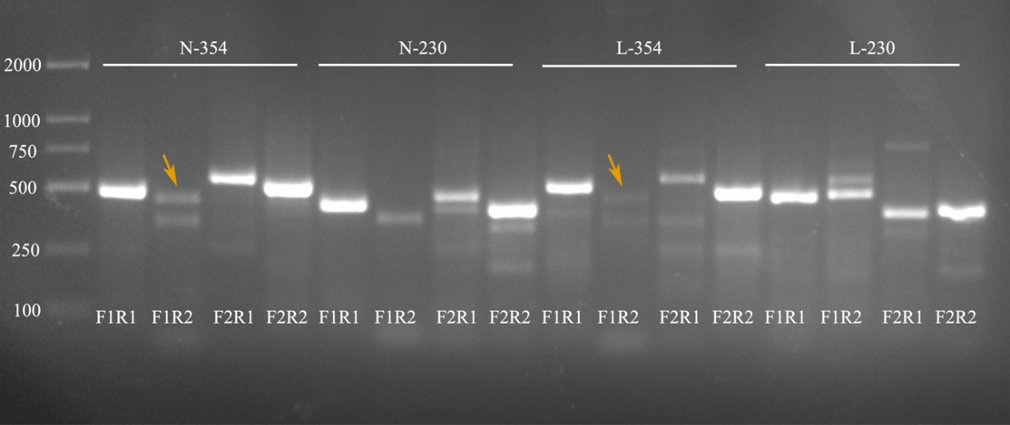
Figure S2 Validation of the homologous recombination mediated by different pair repeats. (a) Schematic of the primer design of direct repeats that could mediate the homologous recombination in the representative circular molecule. (b) PCR production of validation results. Each set of experiments is, from left to right, major conformation 1 (F1R1), alternative conformation 1 (F1R2), alternative conformation 2 (F2R1), and major conformation 2 (F2R2). N stood for S. robustum NG57-208, and L for Loether. Target bands were pointed by the yellow arrows on the lane.

Figure S3 Mitochondrial genome homologous block alignment of the three species in Saccharum (15 accessions).

Figure S4 Gene arrangement in representative species of Sorghum (IS929), S. spontaneum(SP79-9), S. robustum(NG57-208), and S. officinarum (Loether).

Figure S5 Analysis of mt2-like sequence in 15 accession of three Saccharum species. (a) Identification of mt1 (blue) and mt2 (green) sequence distribution from S. robustum and S. officinarum in S. spontaneum by blast in bandage. (b) Homology of the mitochondrial patterning genome of S. spontaneum with S. robustum and S. officinarum mt2-like sequence.
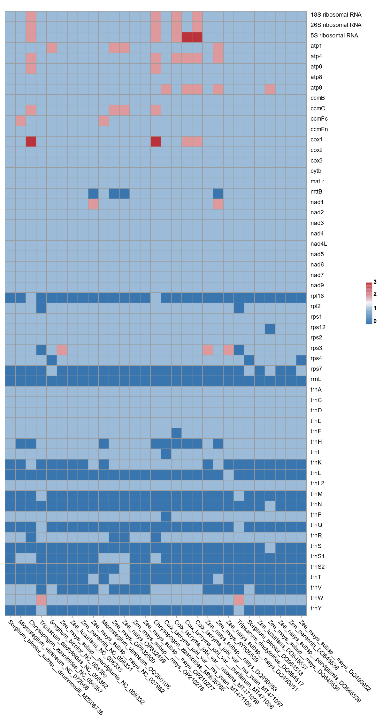
Figure S6 Gene duplication and loss in Andropogonodae mitogenomes

