Table of Contents

TABLE SI-1: Shows the number of articles queried by year from both the Heartland and Elite datasets………………………………………………………………………………………….(2)

FIGURE SI-2: Line chart of the number of articles queried by MediaCloud by day.…………(3)

FIGURE SI-3: Line chart for the percentage of climate-related articles over 60-day averages for both datasets. The data is shown for both the multi-phrase and single-phrase search approach.………………………………………………………………………………………..(4)

EQUATION SI-4: Example percent deviation calculation...…………………………………..(5)

FIGURE SI-5: Percent deviation values for both datasets by year…………………………….(5)

FIGURE SI-6: Lines charts for both Heartland and Elite datasets of the daily percentage of climate-related articles, six-month averages, and three-day percent deviations………………..(6)

FIGURE SI-7: Figure 2 from the main text, calculated only using the search term “climate change.” ………………………………………………………………………………………...(7)

TABLE SI-8: Table 2 from the main text, calculated only using the search term “climate change.” ………………………………………………………………………………………...(7)

FIGURE SI-9: Figure 3 from the main text, calculated only using the search term “climate change.” ………………………………………………………………………………………...(8)

TABLE SI-10: Table 3 from the main text, calculated only using the search term “climate change.” ………………………………………………………………………………………...(8)

TABLE SI-11: Table 4 from the main text, calculated only using the search term “climate change.” ………………………………………………………………………………………...(9)

FIGURE SI-12: Figure 4 from the main text, calculated only using the search term “climate change.” ………………………………………………………………………………………...(9)

 | Heartland - State and Local |  | Heartland - National |  | Elite |  | Totals
Year | Articles Queried | Percentage of Year | Articles Queried | Percentage of Year | Articles Queried | Percentage of Year | Totals
2011 | 837,651 | 35.6% | 1,294,385 | 55.1% | 218,492 | 9.3% | 2,350,528
2012 | 1,037,212 | 40.7% | 1,342,914 | 52.8% | 165,215 | 6.5% | 2,545,341
2013 | 3,299,099 | 59.5% | 2,051,245 | 37.0% | 196,830 | 3.5% | 5,547,174
2014 | 4,439,648 | 63.2% | 2,270,810 | 32.3% | 311,090 | 4.4% | 7,021,548
2015 | 4,846,813 | 61.0% | 2,443,690 | 30.8% | 649,875 | 8.2% | 7,940,378
2016 | 5,717,808 | 63.1% | 2,954,545 | 32.6% | 390,606 | 4.3% | 9,062,959
2017 | 8,253,090 | 70.7% | 3,120,730 | 26.7% | 305,761 | 2.6% | 11,679,581
2018 | 19,760,701 | 85.3% | 3,143,658 | 13.6% | 258,875 | 1.1% | 23,163,234
2019 | 18,542,494 | 86.4% | 2,713,705 | 12.6% | 202,630 | 0.9% | 21,458,829
2020 | 22,139,520 | 85.8% | 3,417,044 | 13.2% | 236,490 | 0.9% | 25,793,054
2021 | 24,436,385 | 87.6% | 3,245,083 | 11.6% | 209,814 | 0.8% | 27,891,282
2022 | 22,921,697 | 88.1% | 2,936,207 | 11.3% | 165,364 | 0.6% | 26,023,268
Totals | 136,232,118 |  | 30,934,016 |  | 3,311,042 |  | 170,477,176

Table SI-1: The number of articles queried, by MediaCloud, by year, from both the Heartland and Elite dataset. All “Elite” sources are technically part of the “U.S. National” dataset under MediaCloud. Heartland is composed of both the “U.S. State and Local” and “U.S. National” datasets from MediaCloud. Many of the national sources are double counted by MediaCloud in the State and Local database. As such, for the sake of this table and analysis in this paper, all “Elite” sources were removed from the National dataset, and all sources from the “U.S. National” dataset that were not used in the Elite set were removed from the State and Local dataset. There is, therefore, no overlap in the categories presented in the table.

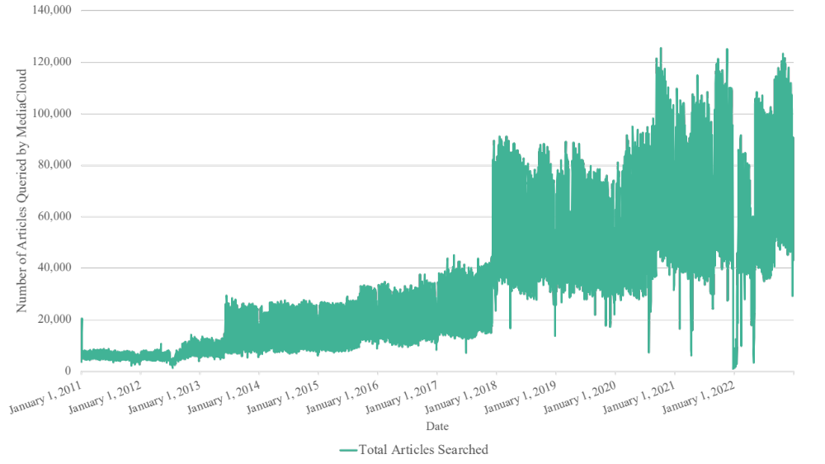

Figure SI-2: The are significant moments in the MediaCloud database where abrupt shifts in the volume of available articles for query shift. In early 2018 there is a large growth in articles queried, presumably as the MediaCloud team added a significant corpus of local news sources to their collection. In early 2002, between Christmas and New Year’s Eve, there was a precipitous drop in the number of articles available for query. While there is a normal drop in news output during the holiday season, the 2022 holiday season is notably aberrant in the drop.

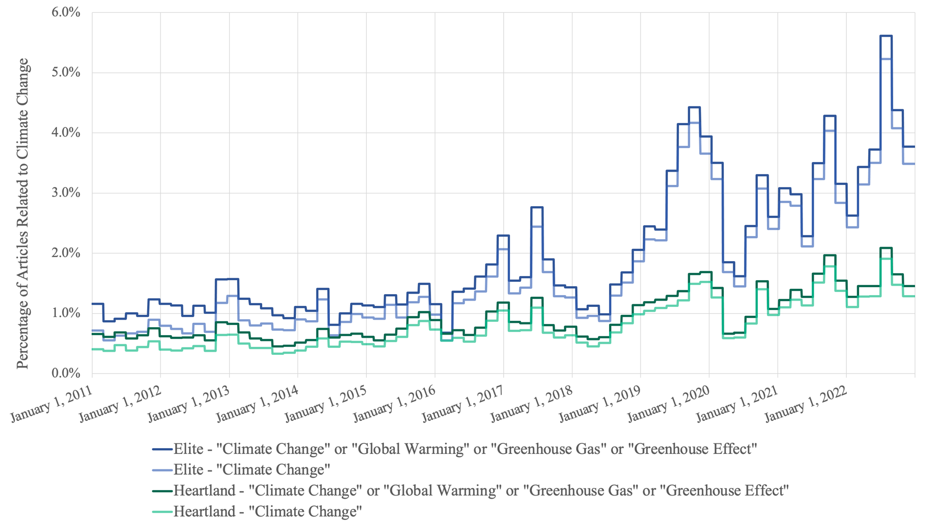

Figure SI-3: This paper opted to use a multi-phrase search approach that was in line with the majority of similarly oriented papers. The figure above demonstrates the difference in results between that result and if the paper had used a single-phrase approach that just used “climate change.” The figure above smooths the data into 60-day averages for ease of analysis. It is clear from the figure that the choice in phrases makes a minor difference in the results of the data. Neither the percentage of articles related to climate change, nor the spikes and drops in coverage, are dramatically impacted by the chosen search terms. This is true for both the Heartland and Elite datasets.

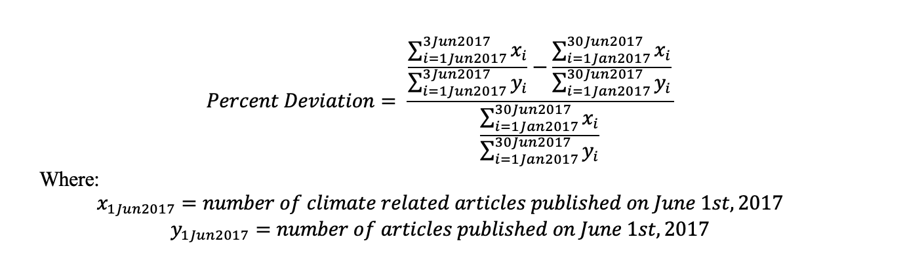

Equation SI-4: The equation above represents an example percent deviation calculation for the three-day period of June 1st, 2017 to June 3rd, 2017as compared to the six-month background average which runs from January 1st, 2017 to June 30th, 2017.

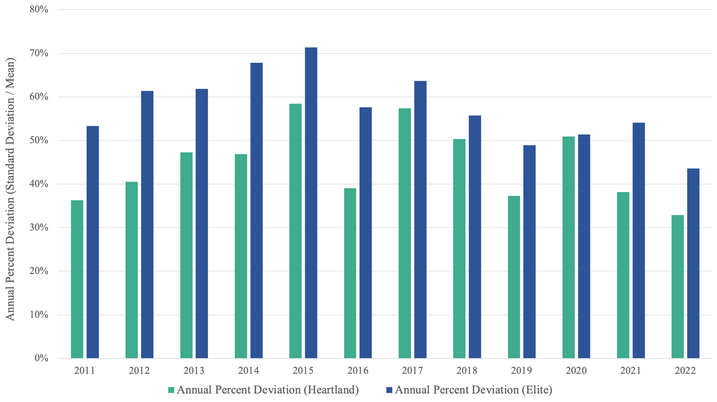

Figure SI-5: On average the Elite dataset had a higher yearly percent deviation (measured as yearly standard deviation over yearly mean). This could be an indication of more reactive media sources, or simply that the Elite dataset, was smaller, allowing for less smoothing out of the noise in the data. There is also a general decline in the percent deviation in both datasets over the years. This is likely caused by the floor of coverage rising over the years. As such, the spikes in coverage became less dramatic as they were not rising as relatively high above the general volume of conversation.

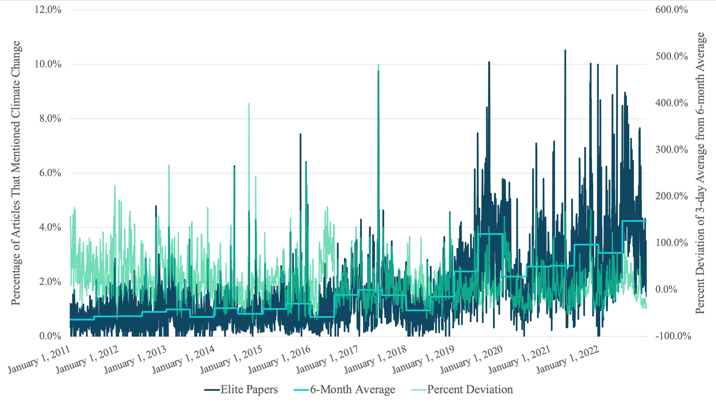

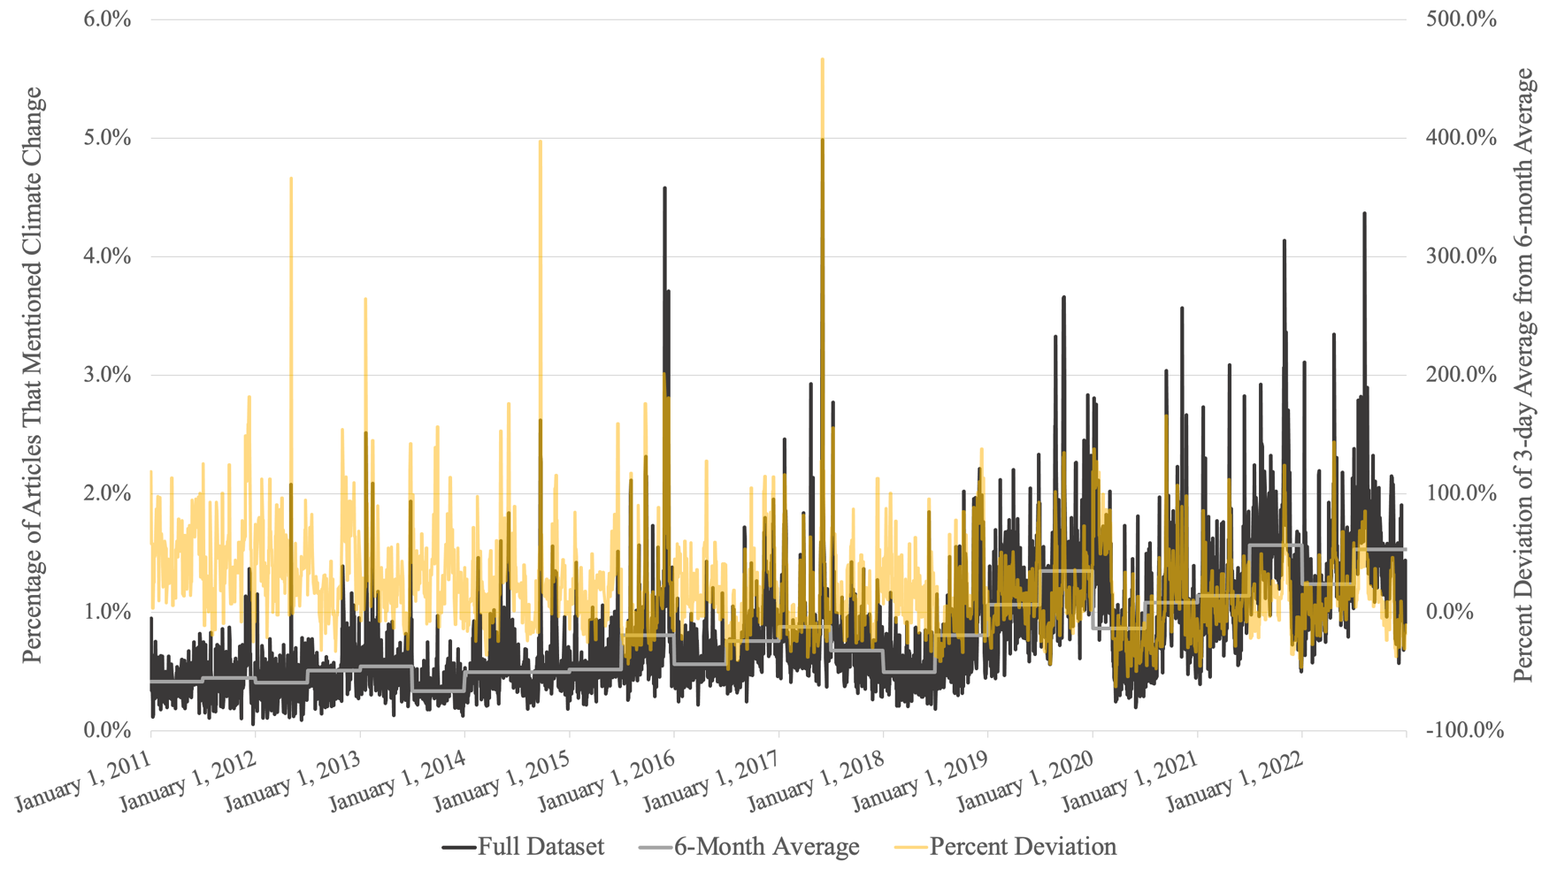

Figure SI-6: The Heartland dataset is on top and the Elite dataset is below. Both datasets share several coverage spikes. The elite dataset has a generally higher floor for climate-related coverage. As such, many “spikes” in coverage are not true spikes when the percent deviation definition is used. Data post 2019 is highly emblematic of this point. Most spikes in coverage are drowned out by the generally high-rate of ambient climate-related coverage.

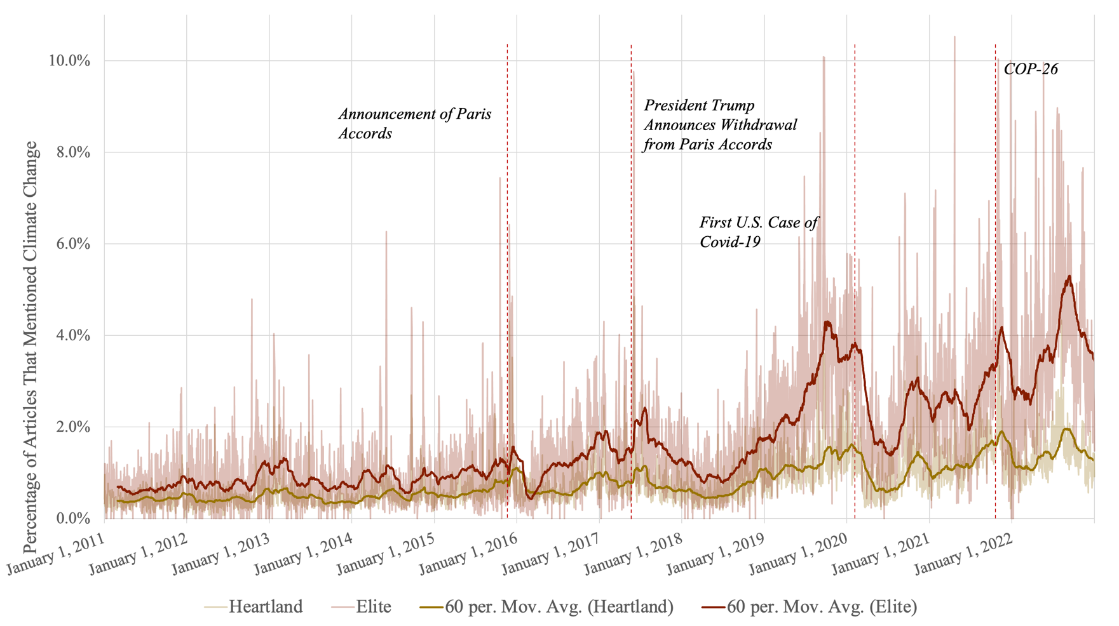

Figure SI-7: Figure 2 from the main text, calculated only using the search term “climate change.”

Table SI-8: Table 2 from the main text, calculated only using the search term “climate change.”

HEARTLAND |  |  |  | ELITE
Year | Median | Mean | Standard Deviation | Year | Median | Mean | Standard Deviation
2011 | 0.004 | 0.004 | 0.002 | 2011 | 0.006 | 0.007 | 0.004
2012 | 0.004 | 0.005 | 0.002 | 2012 | 0.007 | 0.008 | 0.006
2013 | 0.004 | 0.004 | 0.002 | 2013 | 0.007 | 0.008 | 0.006
2014 | 0.005 | 0.005 | 0.003 | 2014 | 0.007 | 0.009 | 0.007
2015 | 0.006 | 0.007 | 0.004 | 2015 | 0.010 | 0.012 | 0.009
2016 | 0.006 | 0.007 | 0.003 | 2016 | 0.011 | 0.010 | 0.007
2017 | 0.007 | 0.008 | 0.005 | 2017 | 0.014 | 0.016 | 0.011
2018 | 0.006 | 0.006 | 0.004 | 2018 | 0.011 | 0.012 | 0.007
2019 | 0.011 | 0.012 | 0.005 | 2019 | 0.028 | 0.030 | 0.015
2020 | 0.009 | 0.010 | 0.005 | 2020 | 0.020 | 0.024 | 0.013
2021 | 0.012 | 0.014 | 0.005 | 2021 | 0.026 | 0.030 | 0.015
2022 | 0.013 | 0.014 | 0.005 | 2022 | 0.035 | 0.037 | 0.017

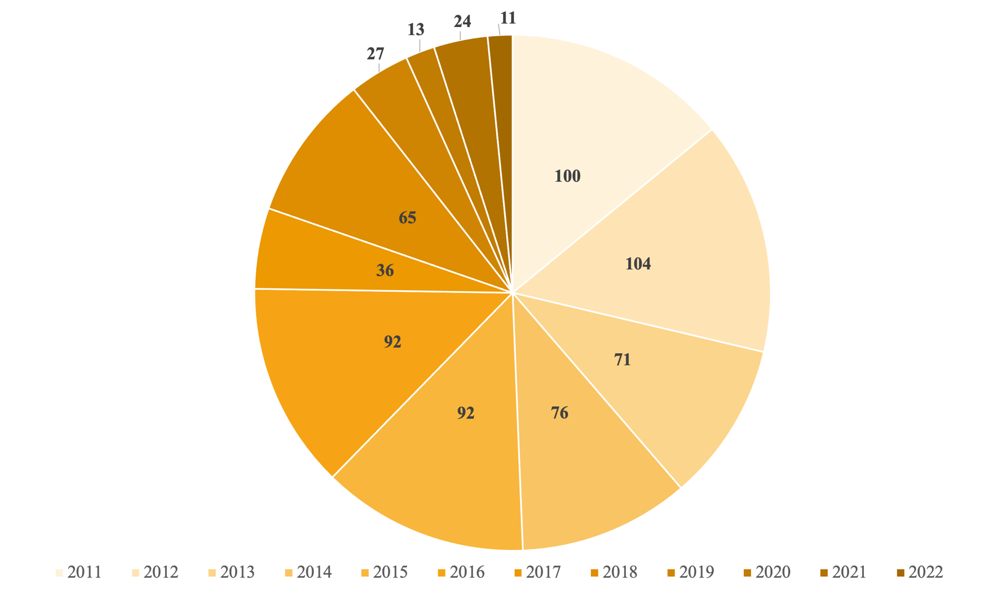

Figure SI-9: Figure 3 from the main text, calculated only using the search term “climate change.”

Table SI-10: Table 3 from the main text, calculated only using the search term “climate change.”

Event | Three-day period (with center date) | Percent deviation from contemporaneous 6-month average
President Trump Announces U.S. Withdrawal from Paris Accords | JUNE 2, 2017 | 421%
2014 UN Climate Summit | SEPTEMBER 22, 2014 | 373%
Heartland Institute Issues Billboard on Climate Change | MAY 5, 2012 | 241%
Barack Obama Second Inaugural Address | JANUARY 21, 2013 | 237%
Opening of Paris COP21 | NOVEMBER 28, 2015 | 179%
Continuing Coverage of COP21 | DECEMBER 1, 2015 | 172%
Conclusion of COP21 | DECEMBER 13, 2015 | 149%
Pope Francis Comments on Climate Change and UN General Assembly Meeting | SEPTEMBER 23, 2015 | 145%
August-Complex Wildfires | SEPTEMBER 14, 2020 | 145%
G20 Summit Following President Trump's Withdrawal from Paris | JULY 8, 2017 | 141%
Pope Francis Comments on Climate Change | JUNE 19, 2015 | 129%
Third National Climate Assessment Published | MAY 7, 2014 | 129%
Glasgow COP26 | NOVEMBER 1, 2012 | 127%
Pope Francis Comments on Climate Change and UN General Assembly Meeting | SEPTEMBER 26, 2015 | 127%
COP24 Conclusion | DECEMBER 9, 2018 | 125%

Table SI-11: Table 4 from the main text, calculated only using the search term “climate change.”
Event | Three-day period (with center date) | Percent deviation from contemporaneous 6-month average
President Trump Announces U.S. Withdrawal from Paris Accords | JUNE 2, 2017 | 432%
2014 UN Climate Summit | SEPTEMBER 22, 2014 | 353%
Barack Obama Second Inaugural Address | JANUARY 21, 2013 | 228%
EPA Proposal to Cut Power Plant Emissions | JUNE 3, 2014 | 218%
Paris COP21 | DECEMBER 1, 2015 | 212%
U.S. and China Agree to Climate Change Deal | NOVEMBER 12, 2014 | 209%
Paris COP21 | DECEMBER 7, 2015 | 189%
Durban COP17 | DECEMBER 7, 2011 | 176%
August-Complex Wildfires | SEPTEMBER 14, 2020 | 161%
Glasgow COP26 | NOVEMBER 2, 2021 | 154%
Paris Climate Deal Signed | APRIL 23, 2016 | 153%
Hurricane Sandy | NOVEMBER 4, 2012 | 149%
Biden Climate Summit + Earth Day | APRIL 21, 2021 | 147%
Lasting Coverage from President Trump’s Withdrawal from Paris Accords | JUNE 5, 2017 | 144%
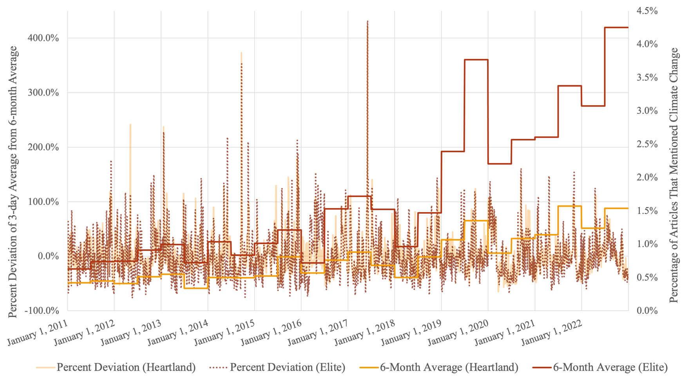

Figure SI-12: Figure 4 from the main text, calculated only using the search term “climate change.”

