Autistic adults have insight into their relative face recognition ability

Bayparvah Kaur Gehdu, Clare Press, Katie L. H. Gray, Richard Cook

Supplementary Material

In the main text, we describe a Matrix Reasoning Task (MRT) that was used to estimate individual differences in participants’ non-verbal intelligence. The MRT consisted of forty items, with scores ranging from 0 to 40 (chance performance = 10). Participants were given 30 seconds to complete each puzzle by selecting the correct answer from 4 options. Participants responded using keyboard number keys (1-4), were given a 5-second warning before the end of each trial, and received no feedback. Each participant attempted all forty items. Participants had to complete 3 practice trials correctly before beginning the test.

To assess the test-retest reliability of this measure, 100 non-autistic participants (M_{age} = 34.90 years, SD_{age} = 10.16 years; 27 males, 73 females) were recruited through www.prolific.co and asked to complete the test twice. The average interval between the first and second attempt was 170.2 days (range: 75 days to 297 days), during which time participants were given no feedback regarding their level of performance. The scores seen at the first attempt (M = 26.07, SD = 5.714) and second attempt (M = 26.13, SD = 6.530) did not differ significantly [t(99) = .131, p = .896]. We observed strong positive correlation (Pearson’s r) between the two sets of scores [N = 100, r_{p} = .727, p < .001] (Figure S1).

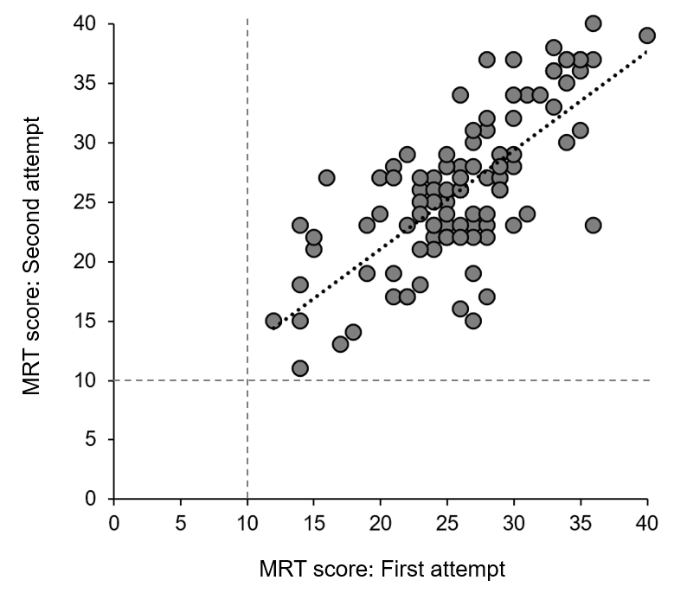
Figure S1. Scatterplot illustrating participants’ scores on the Matrix Reasoning Task (MRT) at the first and second attempt.

