Appendix 1: Focus group participant demographics.

Characteristic | Frequency (%)
Sex
Male | 16 (80)
Female | 4 (20)
Missing | 2
Minority Status
Non-Hispanic White | 15 (75)
Minority | 5 (25)
Missing | 2
Education Level
Some College/Associate Degree | 2 (5)
Bachelor’s Degree | 7 (35)
Master’s Degree | 3 (15)
Doctoral Degree | 8 (40)
Missing | 2

Appendix 2: EMS job characteristics of focus group participants.

Characteristic | Frequency (%)
Primary Role
Administrator | 6 (29)
Educator | 7 (33)
Medical director | 6 (29)
Patient care provider | 2 (10)
Missing | 1
Primary Service Type
9-1-1 response with transport | 9 (47)
Equal mix of 911 response and Medical Transport | 3 (16)
Specialty care transport | 1 (5)
Other | 6 (32)
Missing | 3
Main Agency Type
Air Medical | 1 (6)
Fire Department | 5 (28)
Governmental, non-fire | 6 (33)
Hospital | 2 (11)
Private | 1 (6)
Other | 3 (17)
Missing | 4
Volunteer Role | 5 (28)
Missing | 4
Primary Community Type
Urban (>25,000 people) | 16 (94)
Rural (<24,999 people) | 1 (6)
Missing | 5

Appendix 3: Comparison of clinical judgment Task-KSA matrices for AEMT and paramedic certification levels. For each of the subdomains, there were no tasks or KSAs which were identified as outside of score for the AEMT certification level.

Paramedic Task-KSA  Subdomains | Overall Commonality of  AEMT Task-KSAs with Paramedic  Frequency (%)
Subdomain 1:  Initial Impression | Task: 12/12 (100)  KSA: 75/75 (100)
Subdomain 2:  Refinement and Treatment | Task: 9/9 (100)  KSA: 52/52 (100)
Subdomain 3:  Reassessment | Task: 6/6 (100)  KSA: 16/16 (100)

Appendix 4: Identified tasks for leadership that overlap with clinical judgment.
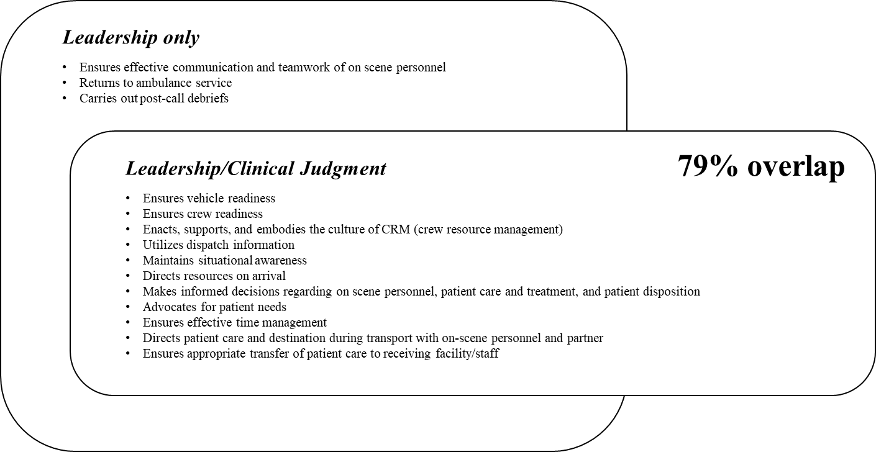

Appendix 5: Identified tasks for communication that overlap with clinical judgment.
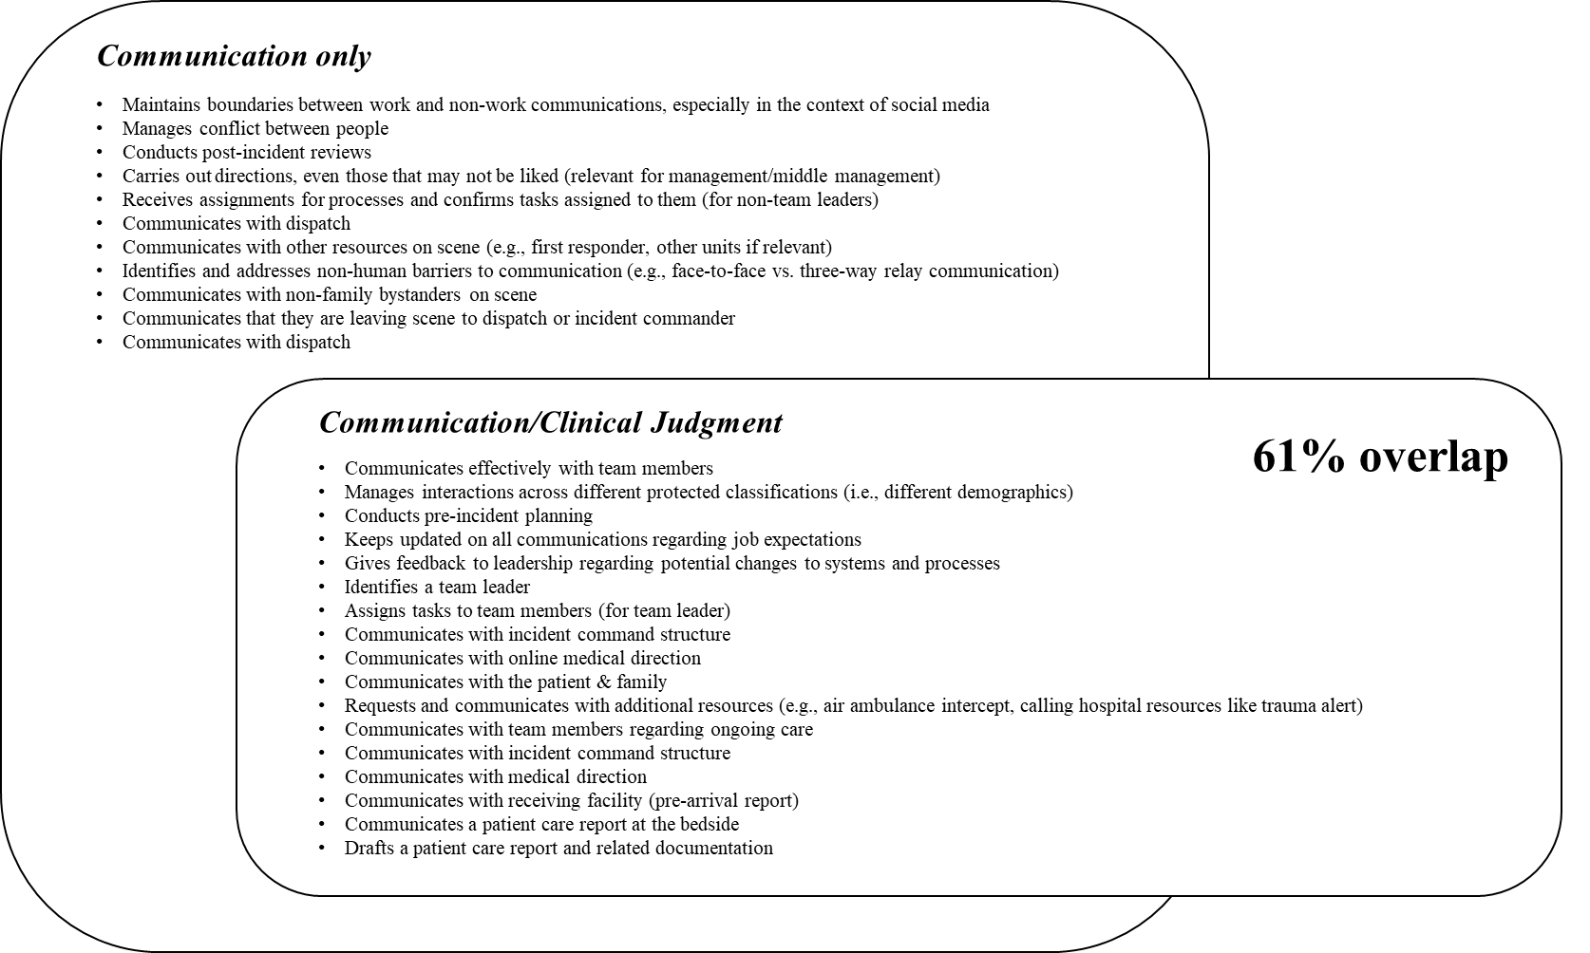
Appendix 6: Comparison of commonality of clinical judgment to leadership domains. The tasks encompassed by clinical judgment are not well represented in the domain of leadership.
 | Sub-domain 1 | Sub-domain 2 | Sub-domain 3 | Overall Commonality with Leadership
Clinical Judgment | Initial Impression  Commonality: 3/12 tasks | Refinement and Treatment  Commonality: 5/8 tasks | Reassessment  Commonality: 2/6 tasks | 10/26 (38%)

Appendix 7: Comparison of commonality of clinical judgment to communication domains. The tasks encompassed by clinical judgment are not well represented in the domain of communication.
 | Sub-domain 1 | Sub-domain 2 | Sub-domain 3 | Overall Commonality with Communication
Clinical Judgment | Initial Impression  Commonality: 6/12 tasks | Refinement and Treatment  Commonality: 4/8 tasks | Reassessment  Commonality: 2/6 tasks | 12/26 (46%)

