Semi-passive pilot scale bioreactors metal removal performance response to seasonal freeze-thaw cycle

Morgane Desmauª, Rachel Simister^{b}, Susan A. Baldwin^{c}, Guillaume Nielsen^{a,*}

ª Yukon University Research Center, 500 College Drive, PO Box 2799, Whitehorse, YT Y1A 5K4, Canada

^{b} 3R Circuits Solutions Inc, 3600 Gilmore way, Burnaby, BC, V5G 4R8, Canada

^{c} Chemical and Biological Engineering, University of British Columbia, 2360 East Mall, Vancouver, BC, V6T 1Z3, Canada

* Corresponding author: gnielsen@yukonu.ca

Supplementary Information

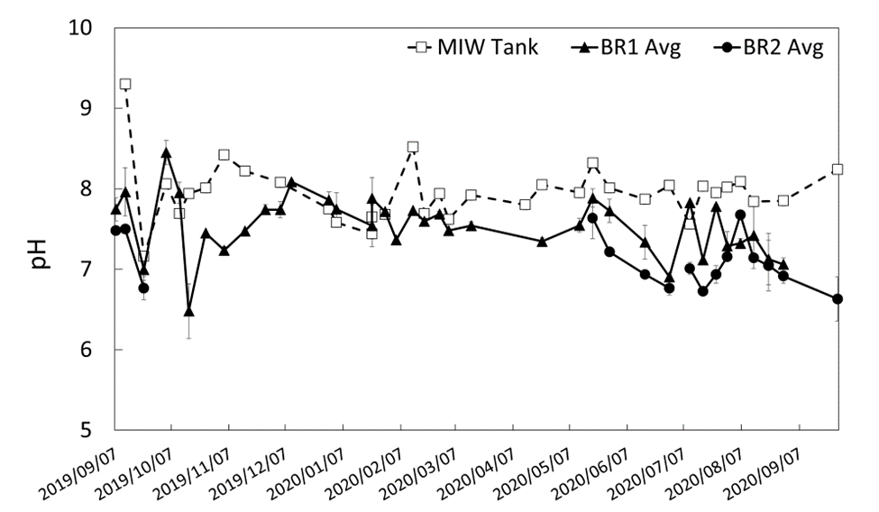
Figure S1: pH of mine impacted water (MIW, empty square and dashed line), average BR1 (BR1 Avg, black triangle and full line) and average BR2 (BR2 Avg, black circle and full line) function of time.
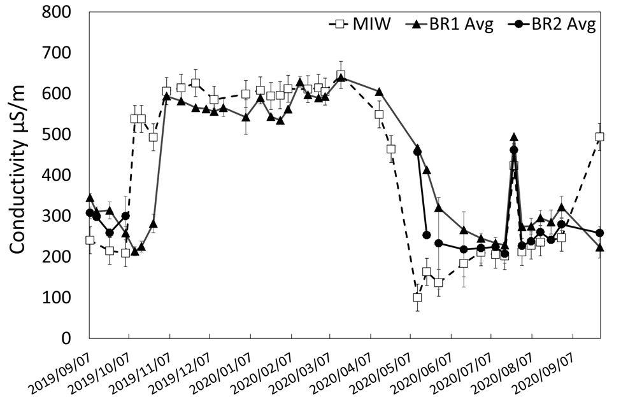
Figure S2: Conductivity, in µS/m, of mine impacted water (MIW, empty square and dashed line), average BR1 (BR1 Avg, black triangle and full line) and average BR2 (BR2 Avg, black cycle and full line) function of time.
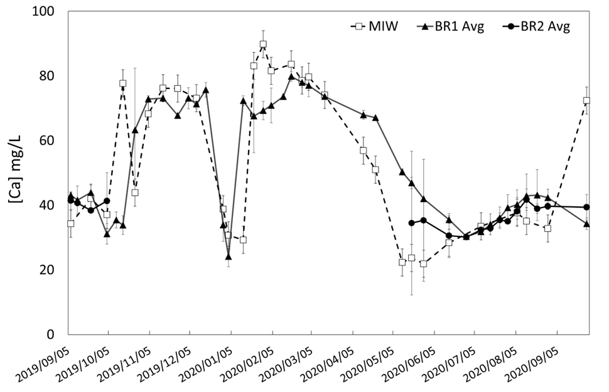
Figure S3: Calcium in mg/L, of mine impacted water (MIW, empty square and dashed line), average BR1 (BR1 Avg, black triangle and full line) and average BR2 (BR2 Avg, black cycle and full line) function of time.
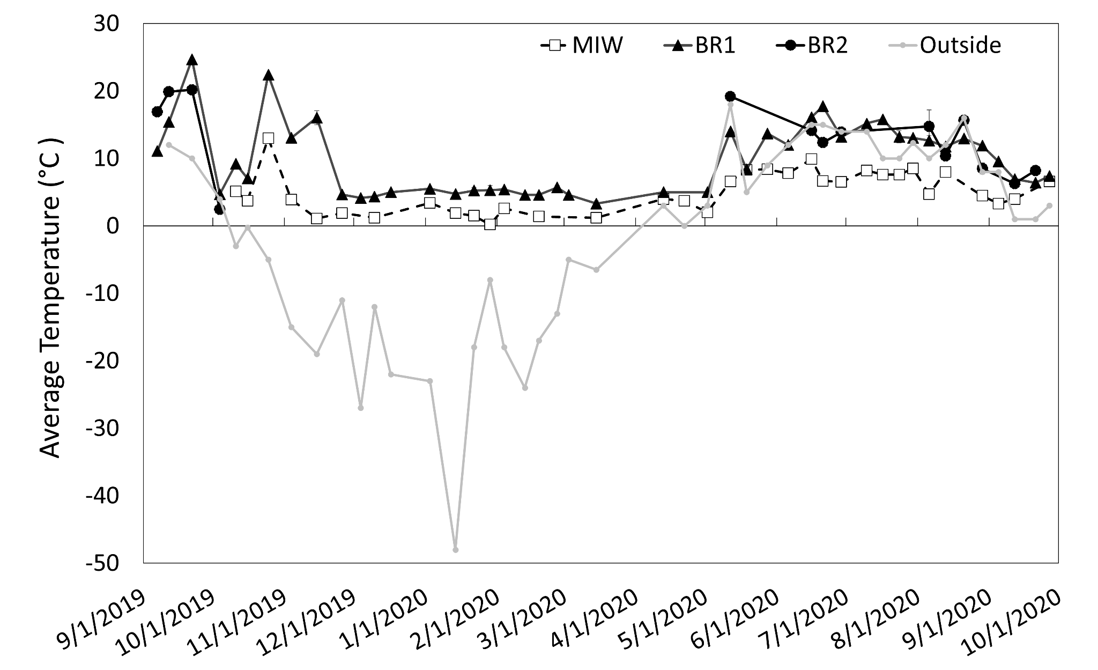
Figure S4: Temperature in degree celsius of mine impacted water (MIW, empty square and dashed line), average BR1 (BR1, black triangle and full line), average BR2 (BR2, black cycle and full line) function of time and outside of the shed (grey line, grey dot).

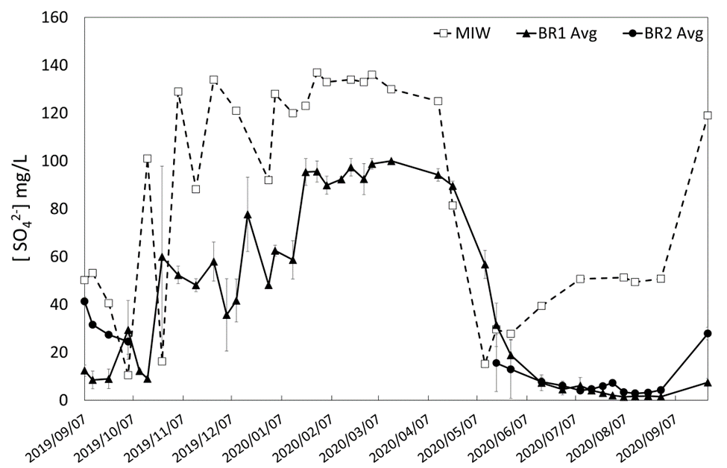
Figure S5: Sulfate concentration in mg/L in mine impacted water (MIW, empty square and dashed line), average BR1 (BR1 Avg, black triangle and full line) and average BR2 (BR2 Avg, black circle and full line) function of time.
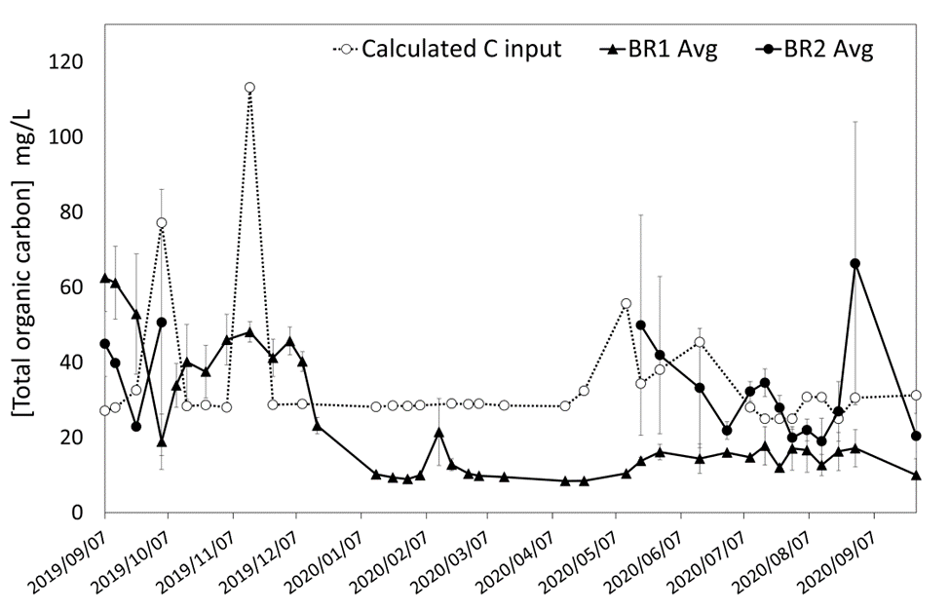
Figure S6: Carbon concentration, in mg/L, in the mine impacted water after molasses addition (calculated C input, empty square and dashed line) and in the effluent of BR1 average BR1 Avg, black triangle and full line) and average BR2 (BR2 Avg, black circle and full line) function of time.

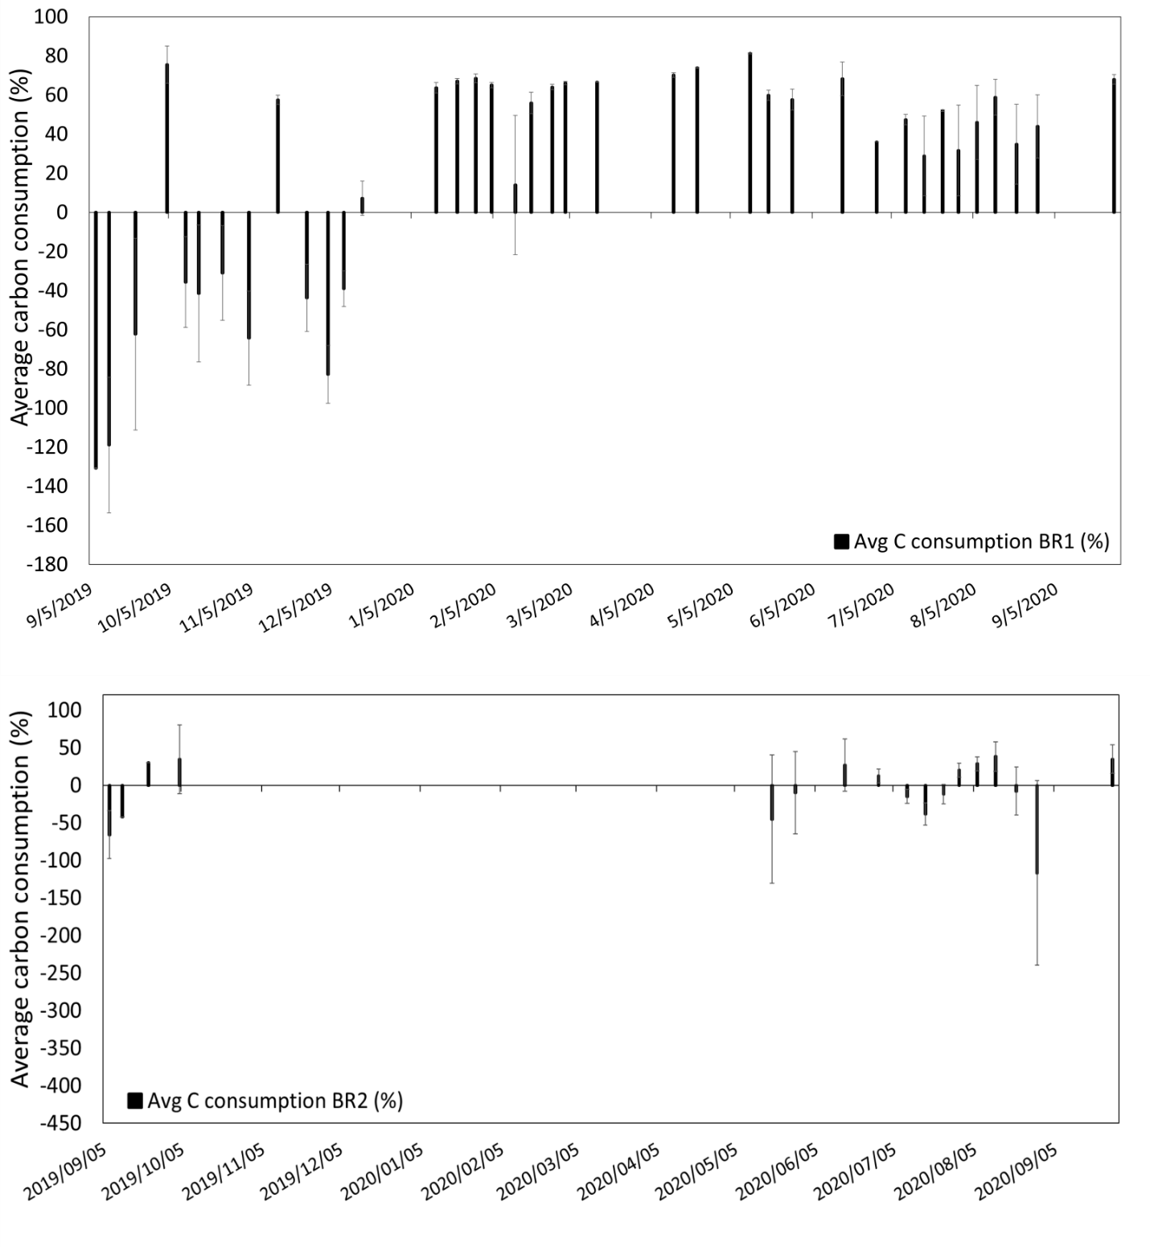
Figure S7: Percentage of carbon removal from BR1 average (top) and BR2 average (bottom) function of time.

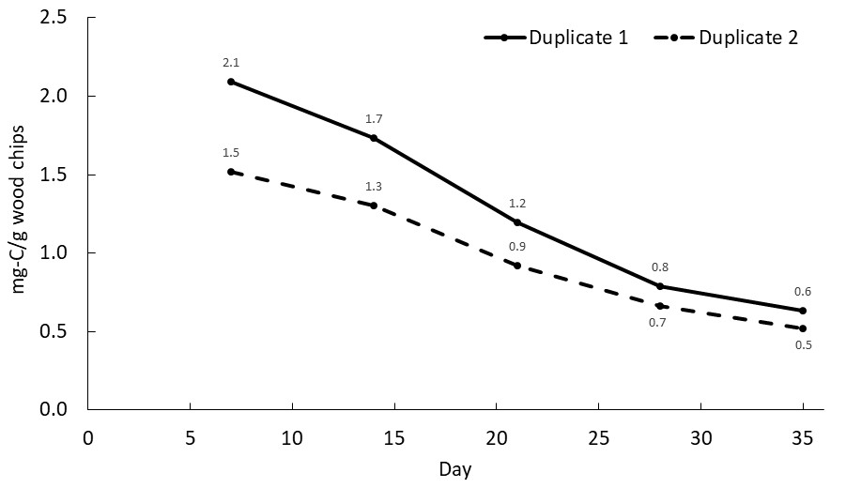
Figure S8: Carbon concentration (mg-C/g wood chips) in the effluent of leaching-column 1 and -column 2, function of time.
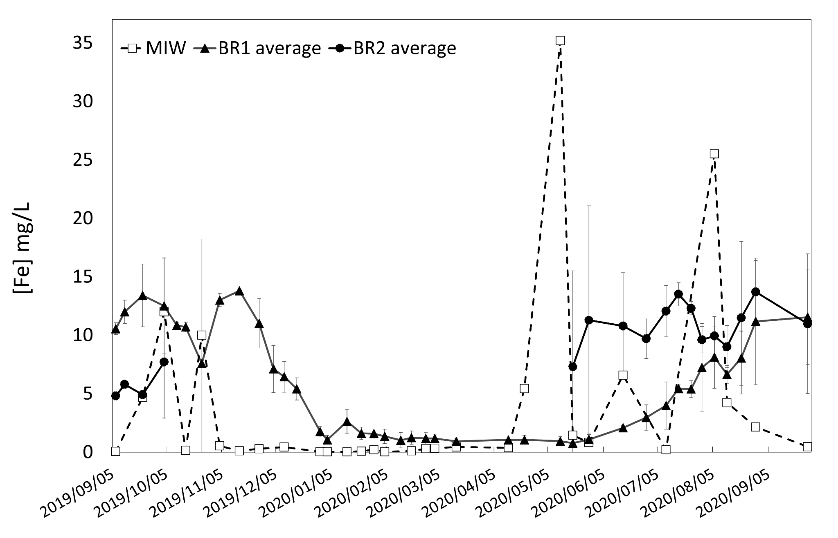
Figure S9: Iron concentration in mg/L in mine impacted water (MIW, empty square and dashed line), average BR1 (BR1 average, black triangle and full line) and average BR2 (BR2 average, black circle and full line) function of time.
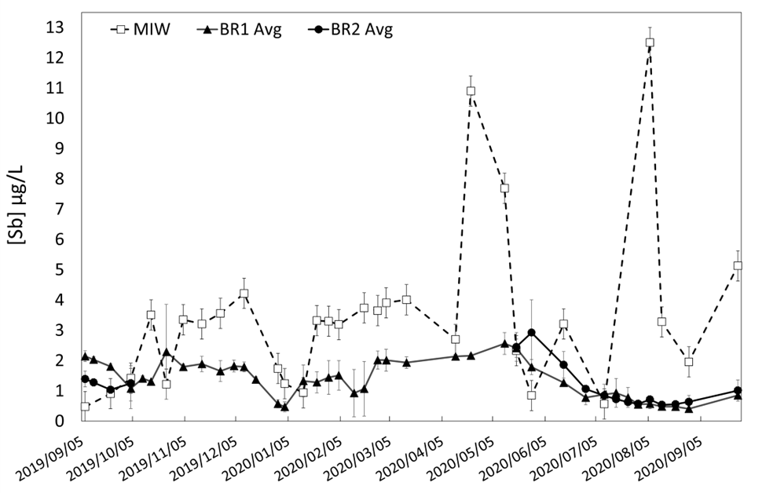
Figure S10: Antimony concentration in µg/L in mine impacted water (MIW, empty square and dashed line), average BR1 (BR1 Avg, black triangle and full line) and average BR2 (BR2 Avg, black circle and full line) function of time.
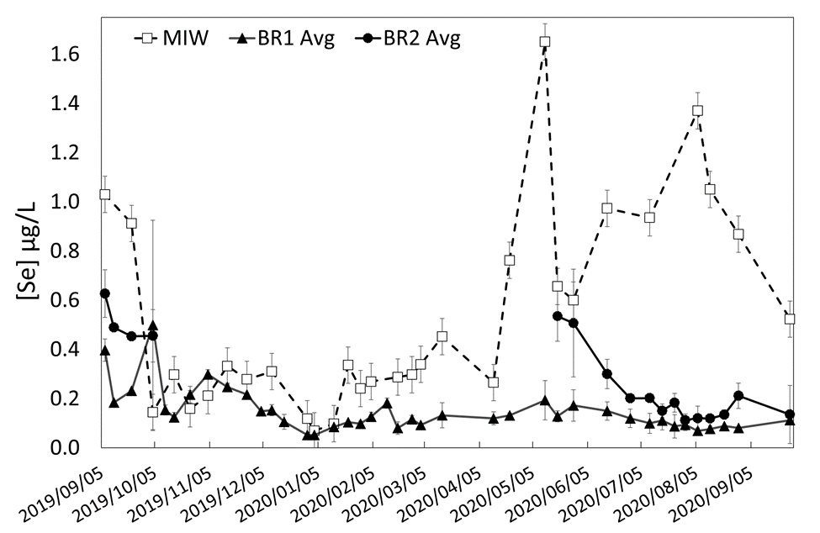
Figure S11: Selenium concentration in µg/L in mine impacted water (MIW, empty square and dashed line), average BR1 (BR1 Avg, black triangle and full line) and average BR2 (BR2 Avg, black circle and full line) function of time.

Table S1: ORP results.
 | BR1 | ΔBR1 | BR2 | ΔBR2
September 2019 | -105 | 7 | -111 | 3
October 2019 | -148 | 12 | -249 | 33
November 2019 | -142 | 19
December 2019 | -104 | 18
January 2020 | -219 | 1
February 2020 | -348 | 90
March 2020 | -321 | 57
April 2020 | -299 | 2
May 2020 | -303 | 5
June 2020 | -279 | 3 | -203 | 1
July 2020 | -266 | 11 | -238 | 5
August 2020 | -276 | 30 | -279 | 19
September 2020 | -297 | 10 | -273 | 5

Table S2: Diversity matrix per sample.
Sample-id | Location | Bioreactor | Season | Date | observed features (ASVs) | pielou evenness | faith pd | shannon_entropy
Y3 | BR1 | Indoor | Fall_2019 | 9/1/2019 | 144 | 0.85 | 18.70 | 6.10
Y125R | BR1b | Indoor | Fall_2019 | 9/1/2019 | 317 | 0.78 | 32.16 | 6.50
Y126R | BR1 | Indoor | Fall_2019 | 10/1/2019 | 332 | 0.75 | 28.23 | 6.25
Y8 | BR1b | Indoor | Fall_2019 | 10/1/2019 | 192 | 0.79 | 22.43 | 5.97
Y11 | BR1 | Indoor | Winter_2019 | 11/1/2019 | 223 | 0.78 | 24.48 | 6.10
Y94 | BR1b | Indoor | Winter_2019 | 11/1/2019 | 331 | 0.73 | 28.16 | 6.07
Y13 | BR1 | Indoor | Winter_2019 | 12/1/2019 | 180 | 0.68 | 19.71 | 5.10
Y127R | BR1b | Indoor | Winter_2019 | 12/1/2019 | 295 | 0.71 | 25.86 | 5.86
Y111R | BR1 | Indoor | Winter_2019 | 1/1/2020 | 263 | 0.68 | 25.08 | 5.47
Y16 | BR1b | Indoor | Winter_2019 | 1/1/2020 | 150 | 0.76 | 17.06 | 5.51
Y17 | BR1 | Indoor | Winter_2019 | 2/1/2020 | 119 | 0.79 | 16.59 | 5.46
Y128R | BR1b | Indoor | Winter_2019 | 2/1/2020 | 215 | 0.74 | 22.93 | 5.73
Y5 | BR2 | Outdoor | Fall_2019 | 9/1/2019 | 141 | 0.80 | 18.28 | 5.72
Y110R | BR2b | Outdoor | Fall_2019 | 9/1/2019 | 300 | 0.73 | 25.97 | 6.02
Y9 | BR2 | Outdoor | Fall_2019 | 10/1/2019 | 192 | 0.82 | 21.17 | 6.20
Y93 | BR2b | Outdoor | Fall_2019 | 10/1/2019 | 355 | 0.79 | 29.74 | 6.72
Y19 | BR1 | Indoor | Spring_2020 | 5/1/2020 | 219 | 0.64 | 23.12 | 4.97
Y20 | BR1b | Indoor | Spring_2020 | 5/1/2020 | 194 | 0.74 | 22.90 | 5.60
Y23 | BR1 | Indoor | Spring_2020 | 6/1/2020 | 154 | 0.84 | 25.48 | 5.10
Y24 | BR1b | Indoor | Spring_2020 | 6/1/2020 | 195 | 0.70 | 24.20 | 5.03
Y27 | BR1 | Indoor | Summer_2020 | 7/1/2020 | 229 | 0.67 | 27.06 | 5.24
Y28 | BR1b | Indoor | Summer_2020 | 7/1/2020 | 202 | 0.67 | 23.89 | 5.14
Y31 | BR1 | Indoor | Summer_2020 | 8/1/2020 | 237 | 0.70 | 29.29 | 5.48
Y32 | BR1b | Indoor | Summer_2020 | 8/1/2020 | 214 | 0.67 | 26.09 | 5.16
Y113R | BR1 | Indoor | Fall_2020 | 9/1/2020 | 371 | 0.71 | 34.70 | 6.03
Y36 | BR1b | Indoor | Fall_2020 | 9/1/2020 | 238 | 0.74 | 28.57 | 5.83
Y21 | BR2 | Outdoor | Spring_2020 | 5/1/2020 | 126 | 0.66 | 17.47 | 5.87
Y129R | BR2 | Outdoor | Spring_2020 | 6/1/2020 | 199 | 0.79 | 20.94 | 6.02
Y130R | BR2b | Outdoor | Spring_2020 | 6/1/2020 | 249 | 0.76 | 26.52 | 6.01
Y29 | BR2 | Outdoor | Summer_2020 | 7/1/2020 | 182 | 0.83 | 22.07 | 6.20
Y112R | BR2b | Outdoor | Summer_2020 | 7/1/2020 | 292 | 0.65 | 30.08 | 5.33
Y131R | BR2 | Outdoor | Summer_2020 | 8/1/2020 | 369 | 0.78 | 36.68 | 6.68
Y34 | BR2b | Outdoor | Summer_2020 | 8/1/2020 | 139 | 0.82 | 19.71 | 5.84
Y37 | BR2 | Outdoor | Fall_2020 | 9/1/2020 | 84 | 0.60 | 14.25 | 3.83
Y114R | BR2b | Outdoor | Fall_2020 | 9/1/2020 | 282 | 0.62 | 30.10 | 5.03

