Video legend
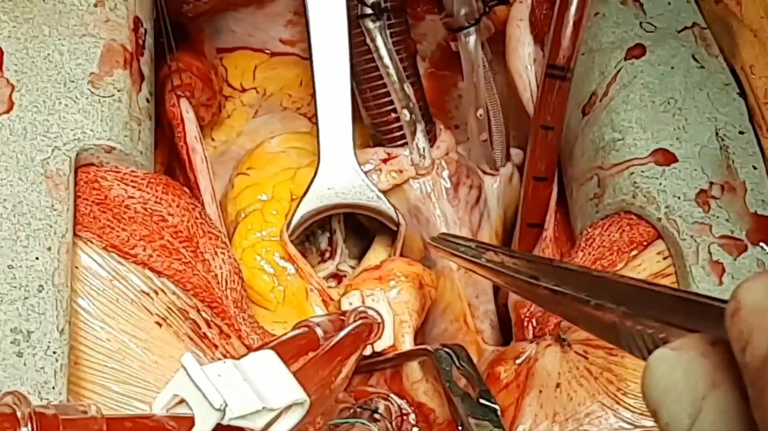

Video-1: Showed black discolored ascending aorta with thin ,fragile calcified and black plaques.

https://uupload.ir/view/untitled_(1)_1_1_1_3rzn.mp4/

