SUPPLEMENTARY FIGURES
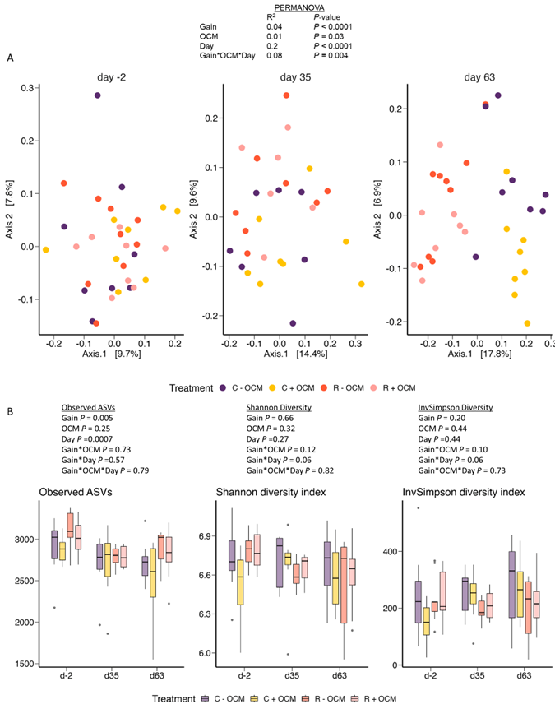
Supplementary Fig. 1. (A) PCoA plot of the Bray Curtis dissimilarities of the ruminal fluid microbiota of heifers compared across OCM treatment groups and timepoint. (B) Alpha diversity indices of the ruminal fluid microbiota of heifers across timepoints. C-OCM (n = 8), C+OCM (n = 8), R-OCM (n = 9), R+OCM (n = 8).
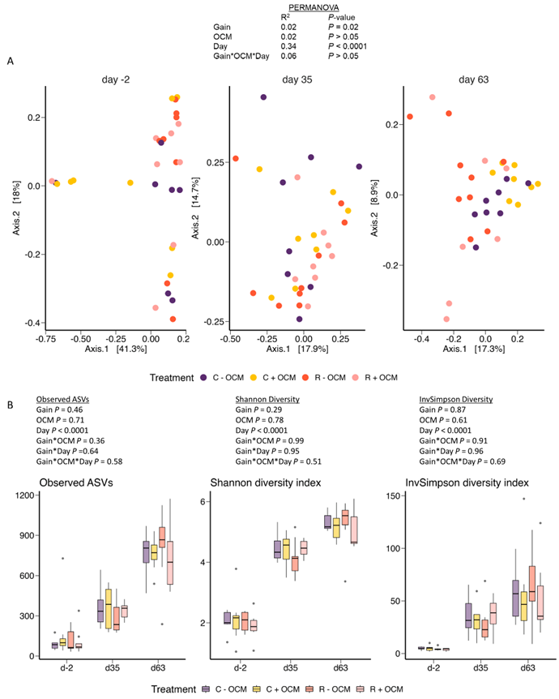
Supplementary Fig. 2. (A) PCoA plot of the Bray Curtis dissimilarities of the vaginal microbiota of heifers compared across OCM treatment groups and timepoint. (B) Alpha diversity indices of the vaginal microbiota of heifers across timepoints. C-OCM (n = 8), C+OCM (n = 8), R-OCM (n = 9), R+OCM (n = 8).

