Supplementary Material 1.
Matrices and maps from the cross-comparison between mangrove maps produced by CONABIO (layer 4) and by Clark Labs (layer 6).

Clark Labs 2014 vs CONABIO 2015
 |  | Clark Labs 2014
 | Class | Others | Mangrove | Total | User accuaracy
CONABIO 2015 | Other | 90756 | 4226 | 94982 | 0.96
CONABIO 2015 | Mangrove | 14338 | 53623 | 67961 | 0.79
 | Total | 105094 | 57849 | 162943
 | Producer accuracy | 0.89 | 0.93

Overall accuracy = 0.89, Kappa coefficient = 0.76

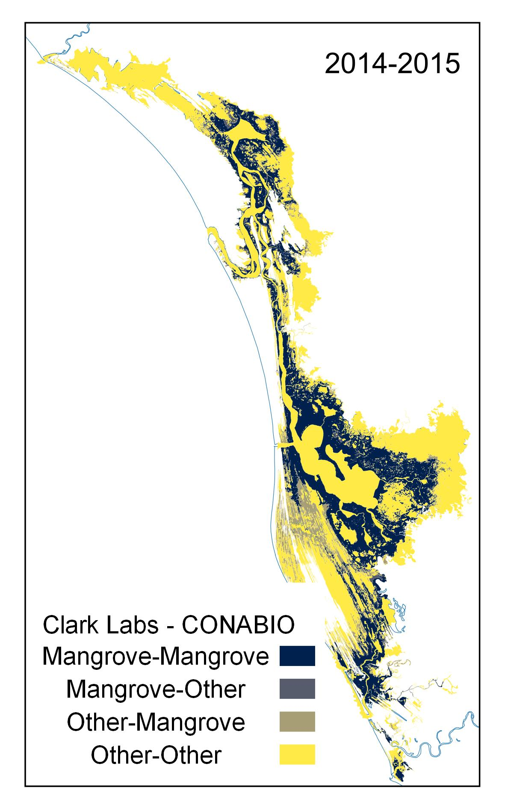

Clark Labs 2020 vs CONABIO 2020
 |  | Clark Labs 2014
 | Class | Others | Mangrove | Total | User accuaracy
CONABIO 2015 | Others | 91234 | 9521 | 100755 | 0.91
CONABIO 2015 | Mangrove | 8578 | 53610 | 62188 | 0.86
 | Total | 99812 | 63131 | 162943
 | Produceraccuracy | 0.91 | 0.85

Overall accuracy = 0.89, Kappa coefficient = 0.77

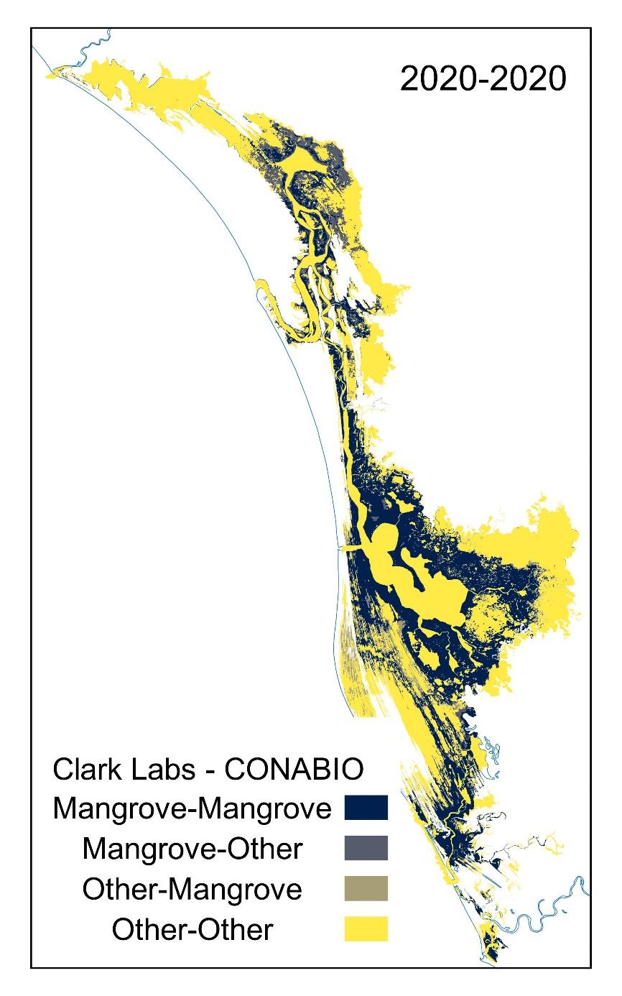

Supplementary Material 1.

Evolution of the artificial channels Laguna Grande-Las Cañas (A) and Cuautla (B) in the Teacapan-Agua Brava Lagoon System, Mexico. False color compositions of Landsat images: 1973 (MSS 753), 1984/1990/1996 (TM 432), 2022 (OLI-2 543)

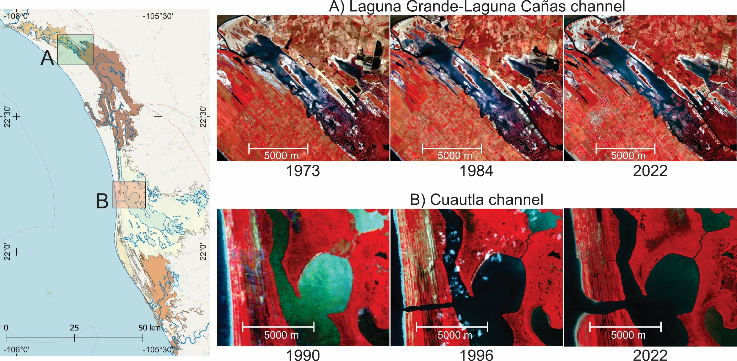

Sources:
Map of the study area: Blanco et al. (2011), Nepita-Villanueva et al. (2019), and Open Street Maps (https://www.openstreetmap.org)
Landsat Images: Google Earth Engine (2003), LANDSAT/LM01/C02/T2, LANDSAT/LT05/C02/T1_L2, LANDSAT/LC09/C02/T1_L2 collections

