Toward optimal fitting parameters for multi-exponential DWI image analysis of the human kidney:
A simulation study comparing different fitting algorithms

J. Jasse¹, H.-J. Wittsack¹, T. A. Thiel¹, R. Zukovs², B. Valentin¹, G. Antoch¹, A. Ljimani¹

¹ Department of Diagnostic and Interventional Radiology, University Hospital Dusseldorf, Medical Faculty, Heinrich-Heine-University Dusseldorf, Dusseldorf, Germany
² Department of Haematology, Oncology and Clinical Immunology, University Hospital Dusseldorf, Medical Faculty, Heinrich-Heine-University Dusseldorf, Dusseldorf, Germany

Corresponding author:
Jonas Jasse
Department of Diagnostic and Interventional Radiology, University Hospital Dusseldorf
Moorenstraße 5, 40225 Dusseldorf, Germany
Email: jonas.jasse@med.uni-duesseldorf.de
Tel.: +49 211 81 18044
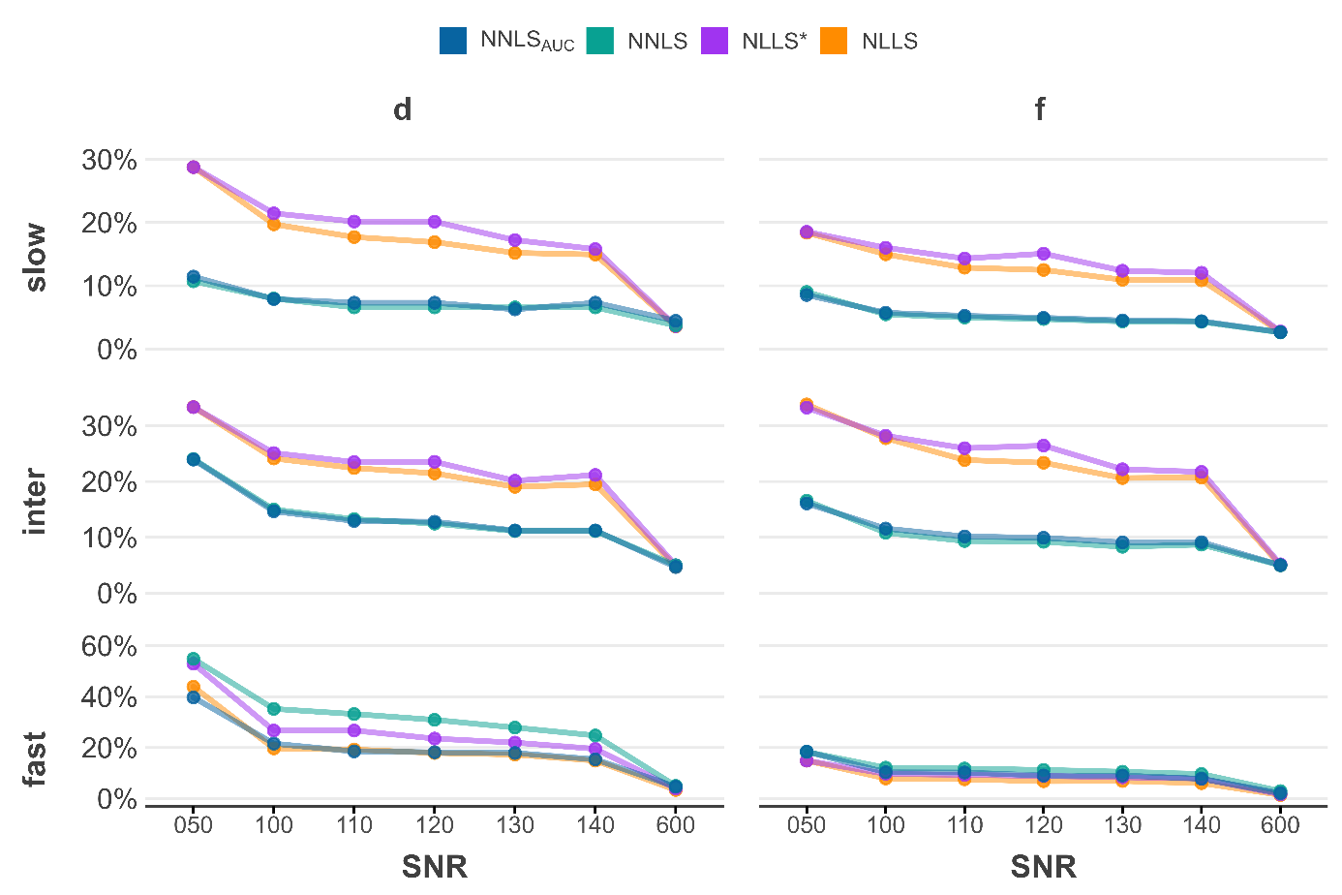
Figure S1 - MAPD trend for diffusion coefficients d and volume fractions f as a function of the SNR.
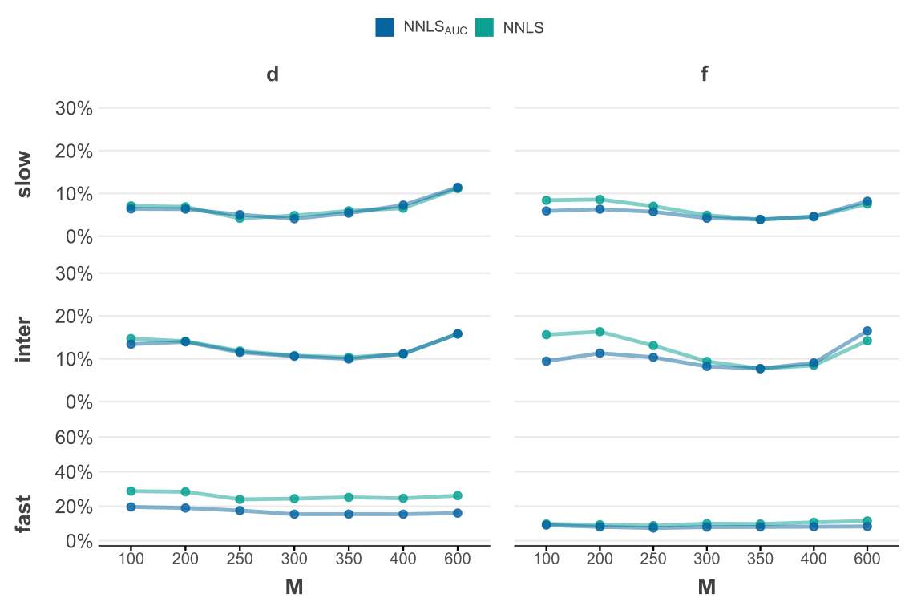
Figure S2 – MAPD trend for diffusion coefficients d and volume fractions f as a function of M.

Table S1 - MAPD for a static simulation (n=1000) with optimal simulation parameters [in %]
method | d_{slow} | d_{inter} | d_{fast} | avg | f_{slow} | f_{inter} | f_{fast} | avg | total
NNLS_{AUC} | 6.7 | 9.9 | 16.2 | 10.9 | 3.8 | 7.5 | 7.9 | 6.4 | 8.65
NNLS | 6.4 | 10.3 | 25.0 | 13.9 | 3.9 | 7.6 | 9.9 | 7.1 | 10.50
NLLS* | 15.7 | 22.4 | 19.5 | 19.2 | 12.3 | 22.1 | 8.0 | 14.1 | 16.65
NLLS | 13.9 | 20.3 | 15.4 | 16.5 | 10.7 | 20.0 | 6.4 | 12.4 | 14.45

