Supplementary Materials

- Otoliths sampling and clustering analysis

Adult otoliths sampling
Adult spring-run otoliths were collected during annual snorkel (Deer Creek) and redd (Mill Creek) surveys by the California Department of Fish and Wildlife¹. Otoliths were retrieved from all salmon carcasses encountered during surveys occurring in the Fall of 2007, 2008, 2012, 2013, 2014 and 2018 (Supplement Tables S1 and S2). A fairly small number of carcasses were recovered each year, due to difficult watershed accessibility and low adult returns. We analyzed samples from the two creeks together because these two watersheds are close geographically and genetically², and similar isotopically³ and hydrologically⁴. A total of 123 otoliths were used for isotope analysis.
Supplement Table S1. Mill and Deer Creek otoliths life history type classification. N = number of otoliths used for isotope analysis. Escapement values represent the number of adult spawners estimated to have returned to Mill and Deer Creek watersheds in a given year. Escapement data comes from GrandTab (https://www.calfish.org/ProgramsData/Species/CDFWAnadromousResourceAssessment.aspx).
Year | Population | N | Escapement | Percent adult analyzed (N/Escapement)*100 | Early migrant (n) | Intermediate migrant (n) | Late migrant (n)
2007 | Deer Creek | 13 | 644 | 2% | 2 | 7 | 4
2008 | Deer Creek | 12 | 140 | 9% | 4 | 5 | 3
2014 | Deer Creek | 3 | 830 | 0.5% | 0 | 1 | 2
2018 | Deer Creek | 34 | 159 | 22% | 1 | 0 | 33
2007 | Mill Creek | 18 | 920 | 2% | 8 | 3 | 7
2012 | Mill Creek | 11 | 768 | 1% | 0 | 0 | 11
2013 | Mill Creek | 22 | 644 | 3% | 9 | 7 | 6
2014 | Mill Creek | 10 | 679 | 1% | 2 | 0 | 8

Supplement Table S2. Mill and Deer Creek juvenile emigration and adult return years summary. AN = Above Normal, BN = Below Normal, W = Wet, D = Dry, C = critical. Orange cells show years of record warm period for the California Current System^{5,6}. Yellow cells show cohort-averaged Sacramento Water Index < 6.5, defining dry freshwater hydrological conditions.
Return years in study | Age at return* | Brood year | Emigration year / Water year ** | Water Year Type | Sacramento Water Index | Mean Sacramento Water Index
2007 | 3 | 2004 | 2005 | AN | 8.5 | 8.0
2007 | 4 | 2003 | 2004 | BN | 7.5
2008 | 3 | 2005 | 2006 | W | 13.2 | 10.8
2008 | 4 | 2004 | 2005 | AN | 8.5
2012 | 3 | 2009 | 2010 | BN | 7.1 | 6.4
2012 | 4 | 2008 | 2009 | D | 5.8
2013 | 3 | 2010 | 2011 | W | 10.5 | 8.8
2013 | 4 | 2009 | 2010 | BN | 7.1
2014 | 3 | 2011 | 2012 | BN | 6.9 | 8.7
2014 | 4 | 2010 | 2011 | W | 10.5
2018 | 3 | 2015 | 2016 | BN | 6.7 | 5.4
2018 | 4 | 2014 | 2015 | C | 4.0
* Most spring run adults return to spawn at ages 3 and 4⁷.
** Most spring run adults spawn around September⁷, and the California Water Year (and Sacramento Water Index) is calculated based on runoff from Oct 1 to Sept 30 (https://cdec.water.ca.gov). Thus, the water year for brood year + 1 incorporates river flows experienced by spring run juveniles from egg incubation through to emigration.

Clustering analysis
We conducted a clustering analysis on the 123 strontium profiles obtained from the otolith isotope analysis (see Methods for details). Because two main changes could be observed among the strontium profiles, one occurring in the 200 – 400 µm region and one in the region after 600 µm we developed a two-step clustering analysis approach. The first clustering analysis focused on the 0 – 400 µm region of the profiles, and the second one was applied on the entire profiles (i.e., 0- 1000 µm). We thus created two separate functional data objects for each profile. We first performed the PCA on the truncated functional objects. The first three harmonics of the PCA were selected for this first cluster analysis, since they were found to explain the majority of the data variance (99%). The best BIC model was the VEE (ellipsoidal, equal shape and orientation) model which identified two main groups (Supplement Figure S1a). We then performed a second PCA on the second group identified during the first cluster analysis (blue profiles in Supplement Figure S1a), because this group included the profiles exhibiting differences in the 600 µm region, and we used the first harmonic of the PCA (which explained 80% of the data variance) for the clustering analysis. The best BIC model was the VEE model and identified two main groups (Supplement Figure S1b). Therefore, three groups emerged from the combined cluster analyses (Supplement Figure S1c), and were used further to characterize the life history diversity of Mill and Deer Creek spring-run Chinook salmon populations.

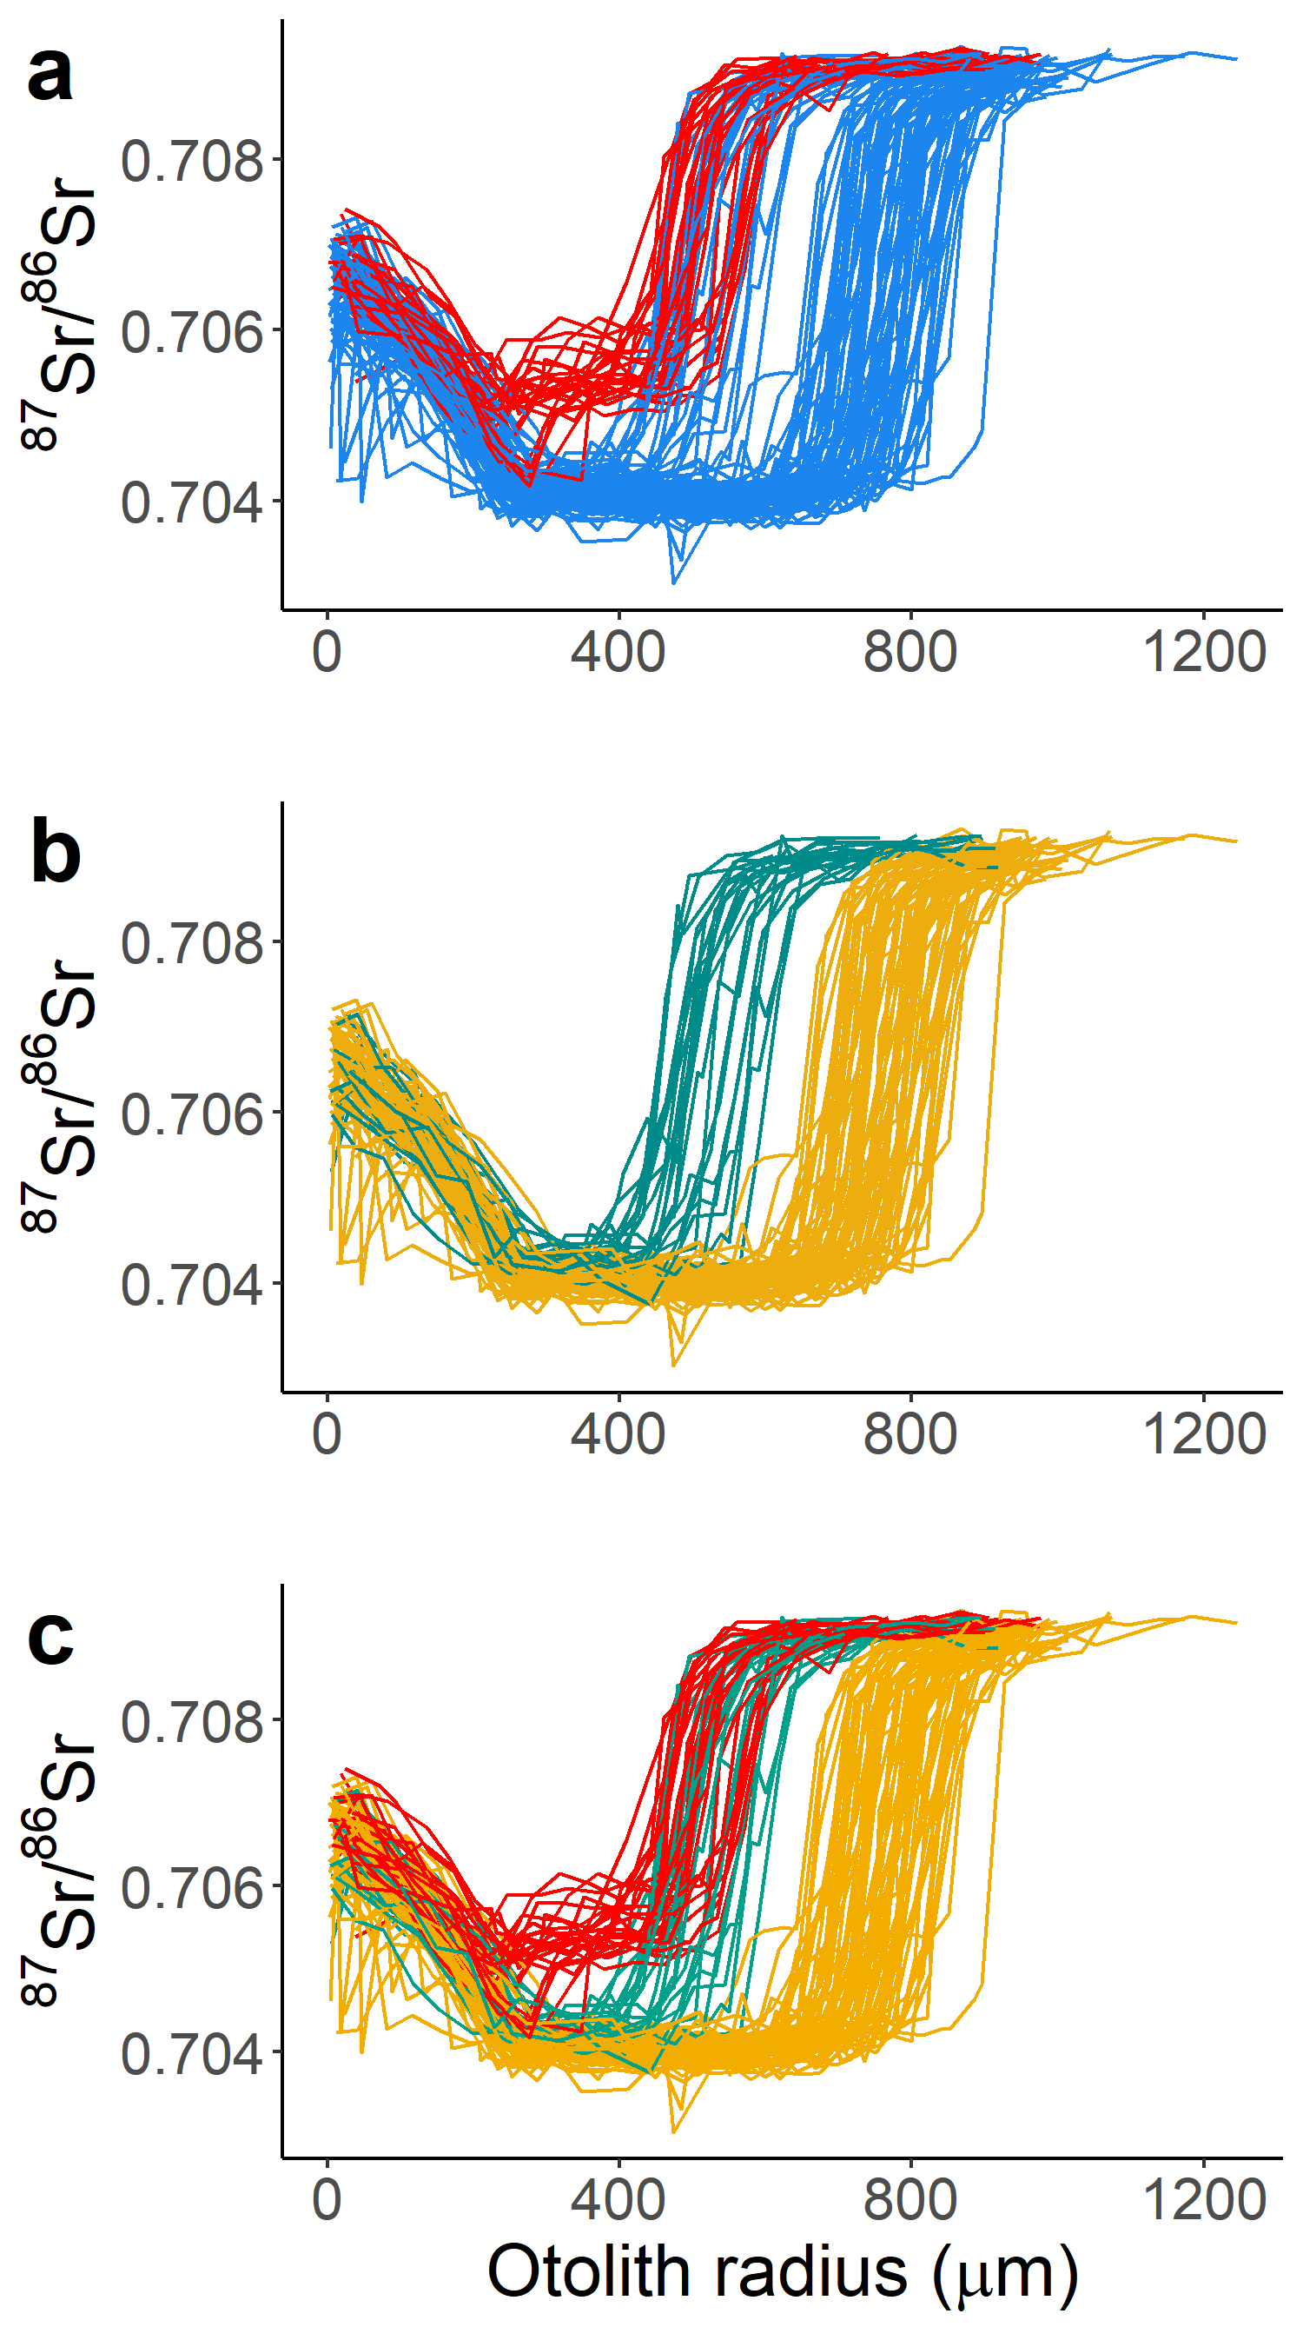
Supplement Figure S1. (a) Strontium profile groups as identified by the first cluster analysis performed on the truncated functional objects. (b) Strontium profile groups as identified by the second cluster analysis. (c) Strontium profile groups as identified by the combined cluster analyses results of (a) and (b).

Reconstruction of fish size and age at natal and freshwater exit and comparison with juvenile trapping data

Rotary screw trap’s juvenile size groups

Raw data of juveniles caught in Mill and Deer creeks’ rotary screw traps between 1995 and 2010 were provided by the California Department of Fish and Wildlife (CDFW). Based on personal communication with M. Johnson (CDFW) and on the general shape of the trap data we defined three juvenile size groups; the early migrant group was composed of fish < 45mm, the late migrant group was defined using the following step function:
- for the months of October, November and December, late migrant = fish > 50mm
- for the months of January and February, late migrant = fish > 60mm
- for the month of March, late migrant = fish > 76mm
- between the 1st and 14th of April, late migrant = fish > 85mm
- between the 15th and 30th of April, late migrant = fish > 95mm
- for the months of May and June, late migrant = fish > 100mm,
and the intermediate migrant group included the rest of the juveniles (i.e., fish between 45mm and 50 - 100mm depending on trapping date; Supplement Figure S2a).

Reconstructed fish size and age
We applied a otolith radius – fork length relationship for Central Valley fall-run Chinook salmon⁸ to reconstruct fish sizes at natal and freshwater exit. While applying otolith-fish size calibration curves across different ESUs can produce spurious size reconstructions⁹, Central Valley fall and spring run Chinook salmon spawn and emigrate at similar sizes and exhibit overlapping geographic distributions. The reconstructed natal exit sizes ranged from 32 to 141mm (Supplement Figure S2b), and the reconstructed size distributions are very similar to those observed in Mill and Deer creeks’ rotary screw traps (Supplement Figure S2a. vs. Figure S2d, respectively), suggesting congruence among datasets.
Otolith increment numbers measured for growth rate estimation give the number of days since emergence and provide a good proxy for fish age. We found that fish size and age at natal exit were significantly smaller for early migrants (262µm ± 43µm SD, or a reconstructed size of 36mm ± 4mm SD, and 15 days ± 14 days SD) than intermediate (454µm ± 52µm SD, or a reconstructed size of 67mm ± 9mm SD, and 84 days ± 27 days SD) and late migrants (714µm ± 58µm SD, or a reconstructed size 111mm ± 10mm SD, and 194 days ± 33 days SD; one-way ANOVA p-values < 2e-16 and Tukey test p-values < 0.05 for both size and age comparison; Supplement Figures S2d and S2f).
Reconstructed freshwater exit sizes ranged from 67 to 147mm (Supplement Figure S2b). Early migrants spent, on average, 89 days (± 19 days SD) in freshwater and had a mean otolith radius at freshwater exit of 524µm (± 45µm SD) or a reconstructed fish size of 79mm (± 8mm SD), while intermediate migrants spent, on average, 108 days (± 29 days SD) in freshwater and had a mean otolith radius at freshwater exit of 542µm (± 48µm SD; equivalent to 82mm ± 8mm SD; Supplement Figures S2e and S2g). Conversely, late migrant juveniles were still larger than the two other groups, with a mean otolith radius at freshwater exit of 783µm (± 53µm SD; equivalent to 123mm ± 9mm SD), and they spent, on average, 214 days (± 39 days SD) in freshwater. Size and age at freshwater exit were significantly different between late and early or intermediate migrants (one-way ANOVA p-value < 2e-16, and Tukey test p-values < 0.05 for both size and age comparison), but not significantly different between early and intermediate migrants (Tukey test p-values = 0.40 and 0.34 for size and age comparison respectively).

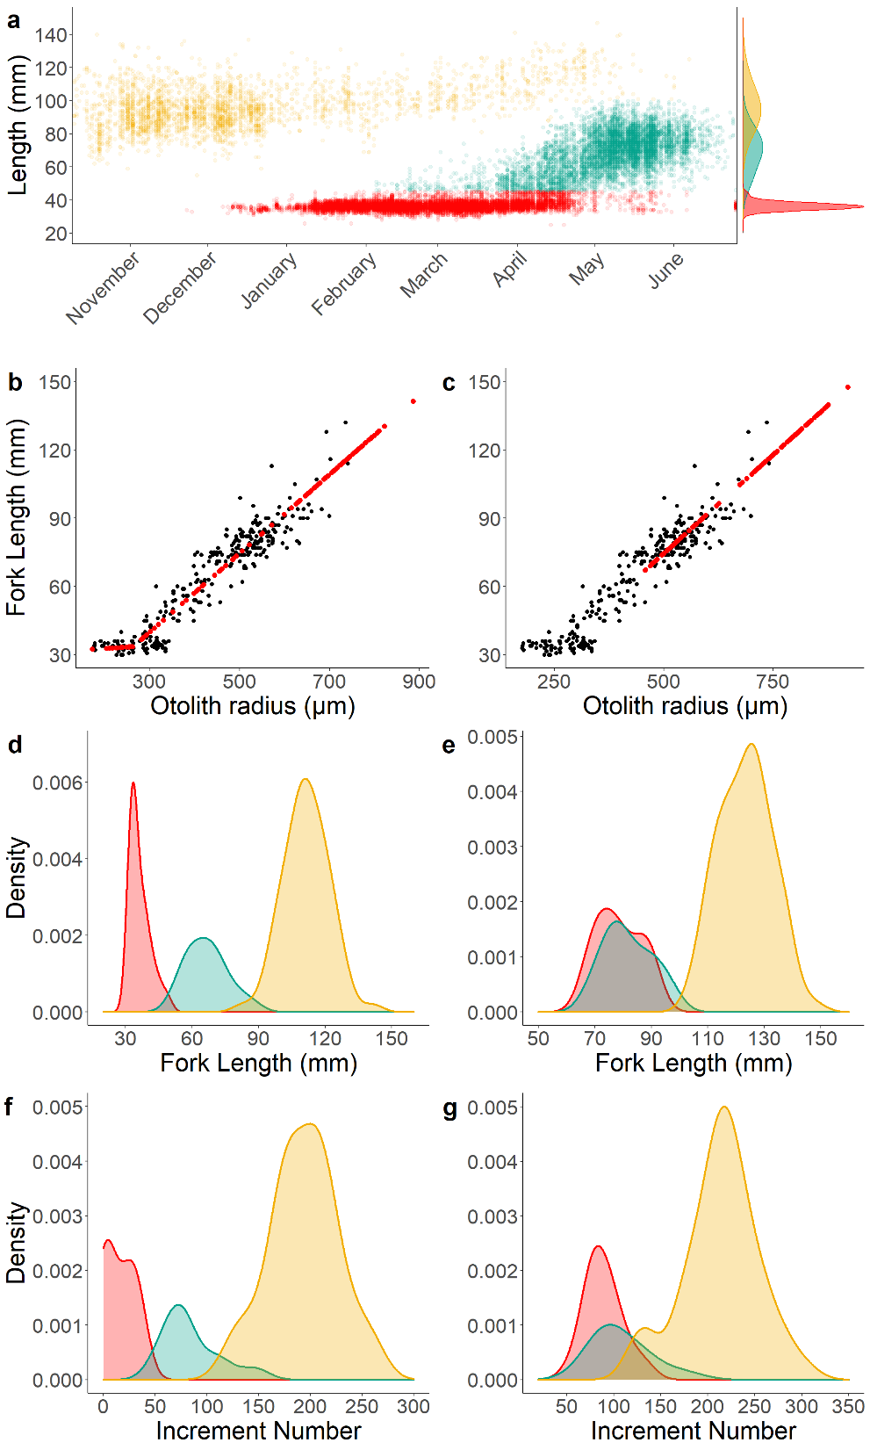




Supplement Figure S2. Raw catch and size distribution of juveniles caught in the Mill and Deer Creek rotary screw traps between 1995 and 2010 (a). Each color represents a life history type based on its size and date at emigration: red = early, green = intermediate, yellow = late migrants. Reconstructed juvenile spring-run fork length (red dots) at (b) natal exit, and (c) freshwater exit, based on the relationship developed in Sturrock et al.⁸. The black dots represent the fall-run fish data used to develop the otolith radius – fork length relationship. Fish size distribution at (d) natal exit, and (e) freshwater exit, for each life history type and all years combined. Increment number (a proxy for fish age) distribution at (f) natal exit, and (g) freshwater exit, for each life history type and all years combined. Note that sample sizes were not identical among years (Supplement Table S1), and fork length and increment number distributions were not standardized by sample size.

- Early-life growth rate and life history relationship
We looked at the relationship between early-life growth and life history type for fish rearing in natal tributaries at least 30 days after emergence. Because the majority of early migrants have migrated downstream by day 30, we only compared intermediate and late migrant growth rates. Similar to what we observed for the first 15 days after emergence, average daily growth (increment width) decreased as a function of the number of days spent in the natal tributary (Supplement Figure S3a). Growth over the first 30 days was faster on average for intermediate (mean cumulative width of first 30 increments = 69 µm) than late migrants (63 µm; Supplement Figure S3b), however the growth difference was not statistically significant (Tukey test p-value = 0.37).

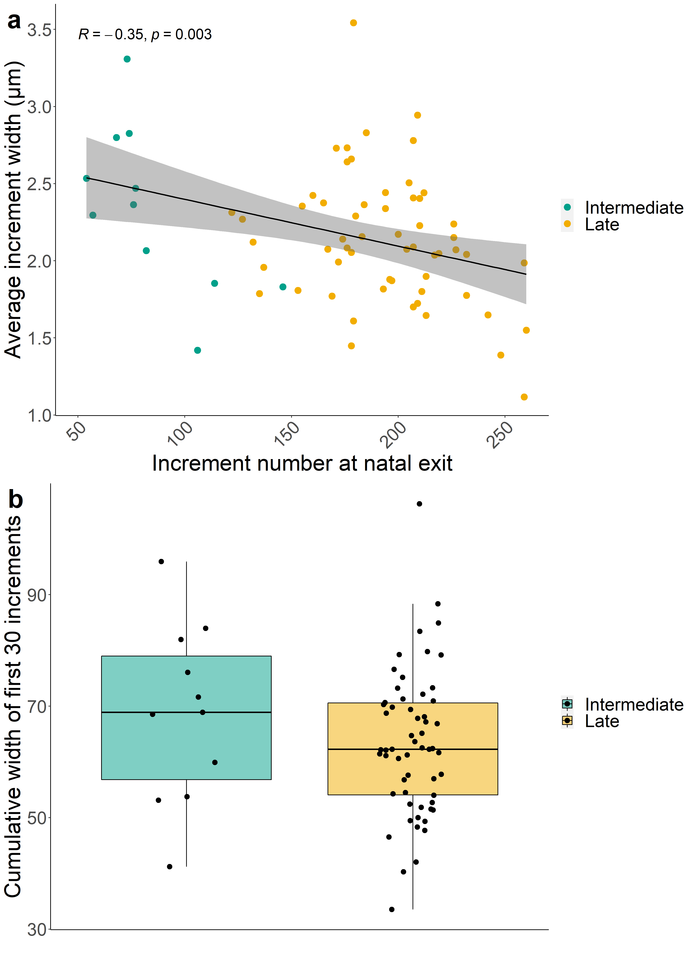

Supplement Figure S3. (a) Intermediate and late migrant’s daily increment width (a proxy for fish growth rate) averaged over the first 30 days after emergence and plotted against the increment number (a proxy for age) at natal exit. A linear regression (using lm R function) is represented by the black line, with the grey shade showing the confidence interval. (b) Boxplot of intermediate and late migrant’s cumulative increment width at day 30 (a proxy for somatic growth achieved in the first 30 days).

- Central Valley temperature mapping predictions
We examined temperature suitability (i.e., < 15°C¹⁰) for early, intermediate and late migrants in May and August 2080 (Supplement Figure S4), to compare with suitability observed during 2005-2015 and 2040 stream temperature conditions (Figure 5). The amount of suitable habitat (in km) for accessible and inaccessible Central Valley stream reaches across the three periods (i.e., 2005-2015, 2040, and 2080) were also estimated for comparison (Supplement Table S3).

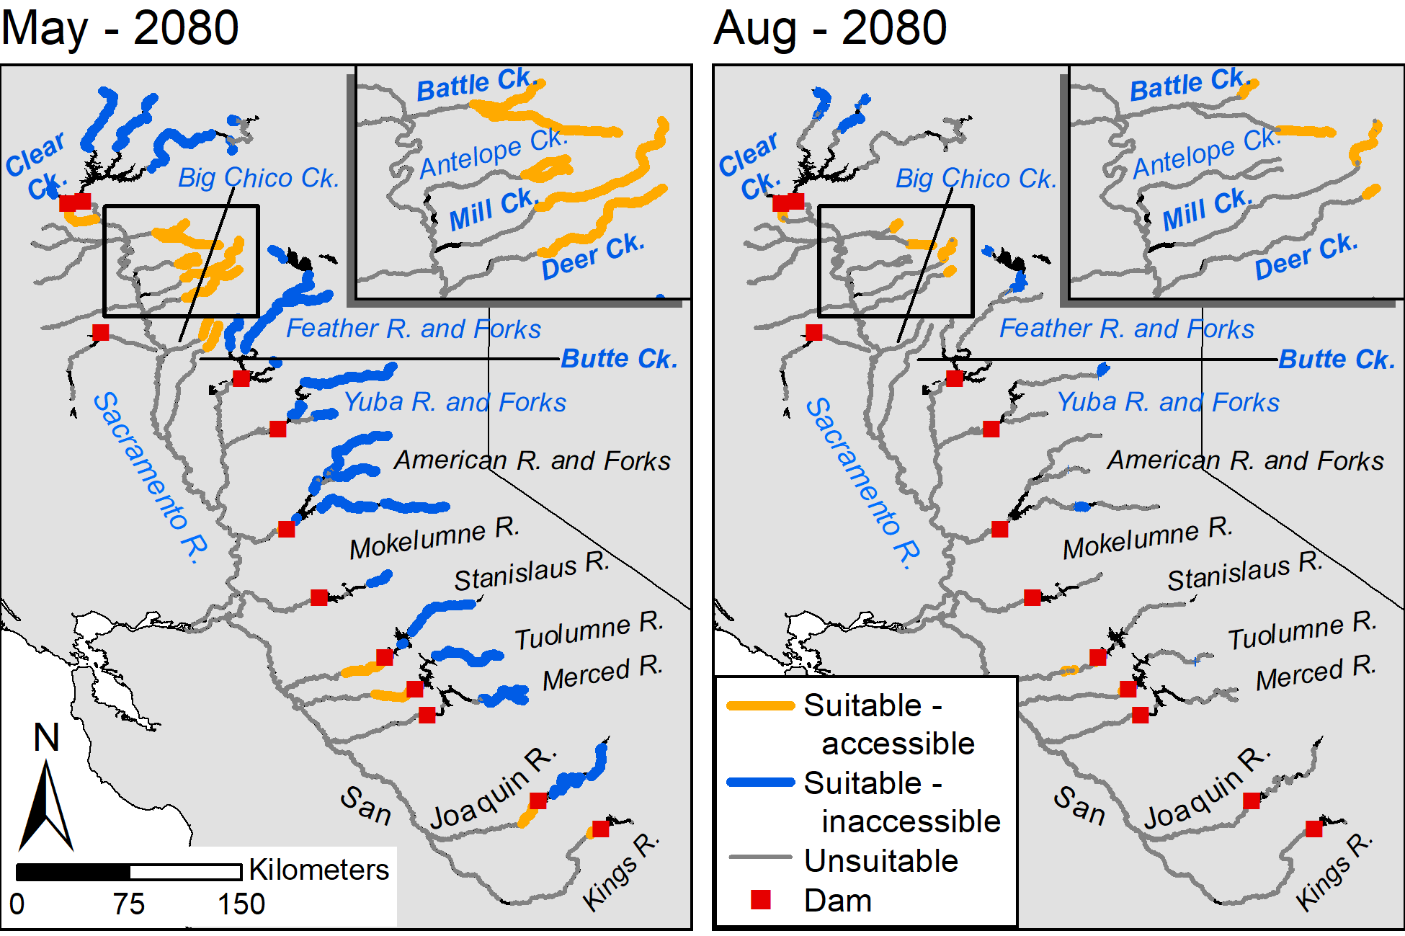
Supplement Figure S4. Rearing temperature suitability (temperature < 15°C¹⁰) in accessible (orange lines) and inaccessible (i.e., blocked by impassable dam; blue lines) river reaches in the California Central Valley, focusing on months when temperature stress is most likely to impact rearing success for early and intermediate migrants (May; left panels) and late migrants (August; right panels). We examined suitability under a climate change scenario for 2080. The inset maps highlight our study streams (Mill and Deer Creeks) and nearby spring-run streams. Major current and historical spring-run streams are labeled, with extirpated populations in black font, and populations at low risk of extirpation¹¹ in bold. The gray lines represent reaches that are thermally unsuitable for rearing (mean monthly temperature > 15°C). The black lines represent reaches where temperatures could not be predicted reliably (e.g., reservoirs). See Methods for details on temperature mapping.

Supplement Table S3. Amount of suitable rearing habitat (km) in accessible only and accessible & inaccessible reaches for Central Valley spring-run Chinook salmon juveniles under 2005-2015 stream temperature conditions and two climate change scenarios (2040 and 2080). Rearing temperature suitability may be bottlenecked for early and intermediate migrants in May and for late migrants in August.
 | May_2005-2015 | May_2040 | May_2080 | Aug_2005-2015 | Aug_2040 | Aug_2080
Accessible | 763 km | 489 km | 418 km | 171 km | 111 km | 76 km
Accessible & Inaccessible | 1950 km | 1637 km | 1500 km | 366 km | 265 km | 201 km

References

1. Killam, D., Johnson, Matt, & Revnak, Ryan. Salmonid Populations of the Upper Sacramento River Basin In 2016. RBFO Technical Report No. 03-2017. 126 (2017).
2. Hedgecock, D. Microsatellite DNA for the management and protection of California’s Central Valley chinook salmon (Oncorhynchus tshawytscha). Final Report for the Amendment to Agreement No. B-59638. Report prepared for California Department of Water Resources. http://www.dwr.water.ca.gov/iep/docs/Hedgecock_2002.pdf (2002).
3. Barnett-Johnson, R., Pearson, T. E., Ramos, F. C., Grimes, C. B. & MacFarlane, R. B. Tracking natal origins of salmon using isotopes, otoliths, and landscape geology. Limnol. Oceanogr. 53, 1633–1642 (2008).
4. Johnson, M. R. & Merrick, K. Juvenile Salmonid Monitoring Using Rotary Screw Traps in Deer Creek and Mill Creek, Tehama County, California Summary Report: 1994 - 2010. RBFO Technical Report No. 04-2012. https://www.calfish.org/ProgramsData/ ConservationandManagement/ CentralValleyMonitoring/ CDFWUpperSacRiverBasinSalmonidMonitoring.aspx (2012).
5. Di Lorenzo, E. & Mantua, N. Multi-year persistence of the 2014/15 North Pacific marine heatwave. Nat. Clim. Change 6, 1042–1047 (2016).
6. Jacox, M. G. et al. Forcing of Multiyear Extreme Ocean Temperatures that Impacted California Current Living Marine Resources in 2016. Bull. Am. Meteorol. Soc. 99, S27–S33 (2018).
7. Fisher, F. W. Past and Present Status of Central Valley Chinook Salmon. Conserv. Biol. 8, 870–873 (1994).
8. Sturrock, A. M. et al. Unnatural selection of salmon life histories in a modified riverscape. Glob. Change Biol. 26, 1235–1247 (2020).
9. Zabel, R. W., Haught, K. & Chittaro, P. M. Variability in fish size/otolith radius relationships among populations of Chinook salmon. Environ. Biol. Fishes 89, 267–278 (2010).
10. Richter, A. & Kolmes, S. A. Maximum Temperature Limits for Chinook, Coho, and Chum Salmon, and Steelhead Trout in the Pacific Northwest. Rev. Fish. Sci. 13, 23–49 (2005).
11. [NMFS] National Marine Fisheries Service. 5-Year Review : Summary and Evaluation of Central Valley Spring-run Chinook Salmon Evolutionarily Significant Unit. https://repository.library.noaa.gov/view/noaa/17018 (2016).

