Supplementary Material
Fig. 1 SM: UWWTD Agglomerations - Big cities/dischargers by treatment type Map
European Environmental Agency thematic page (https://www.eea.europa.eu/themes/water/european-waters/water-use-and-environmental-pressures/uwwtd)
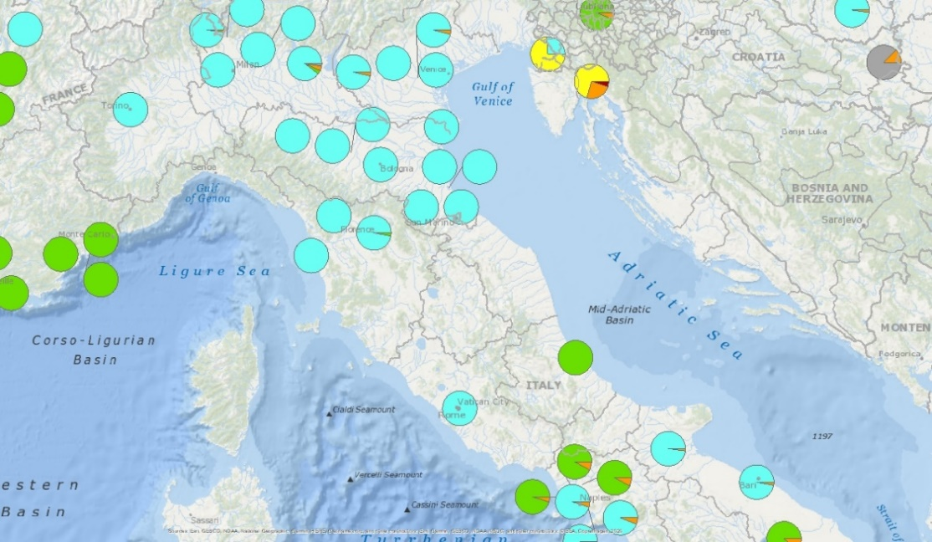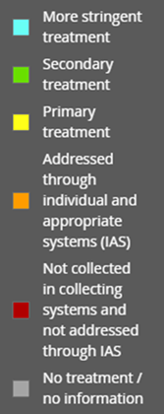
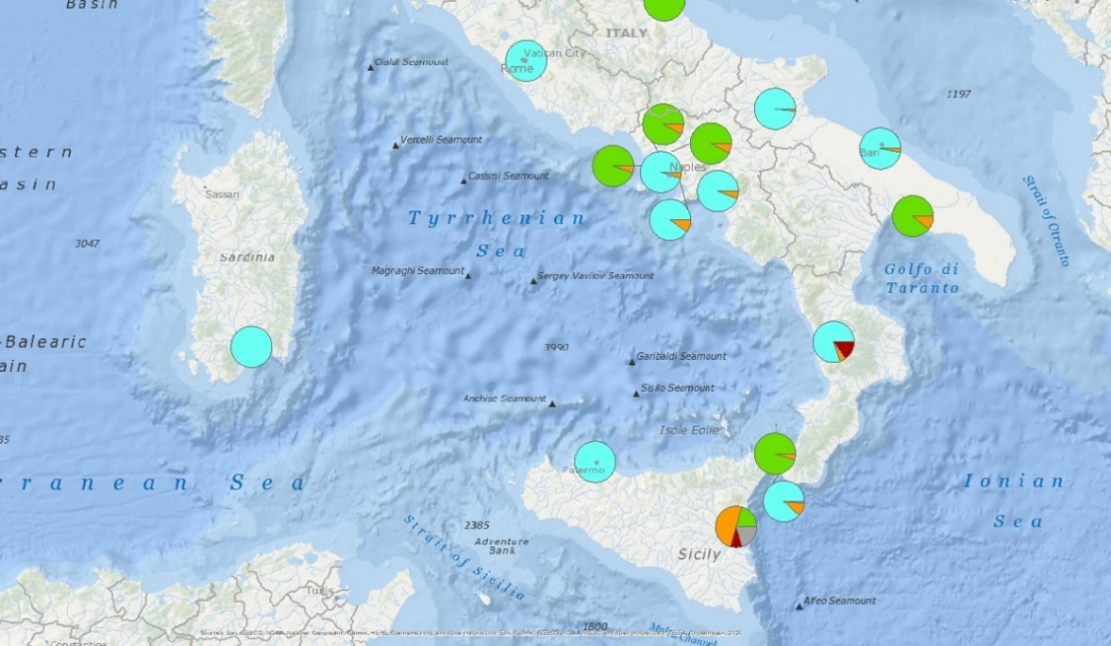

The size of each segment within the pie charts is proportional to the percentage of UWWTPs with specific treatment types, where the total number of UWWTD is 100%. The segments are colored according to treatment type.

Fig. 2 SM: UWWTD plants by treatment type Map
European Environmental Agency thematic page (https://www.eea.europa.eu/themes/water/european-waters/water-use-and-environmental-pressures/uwwtd)

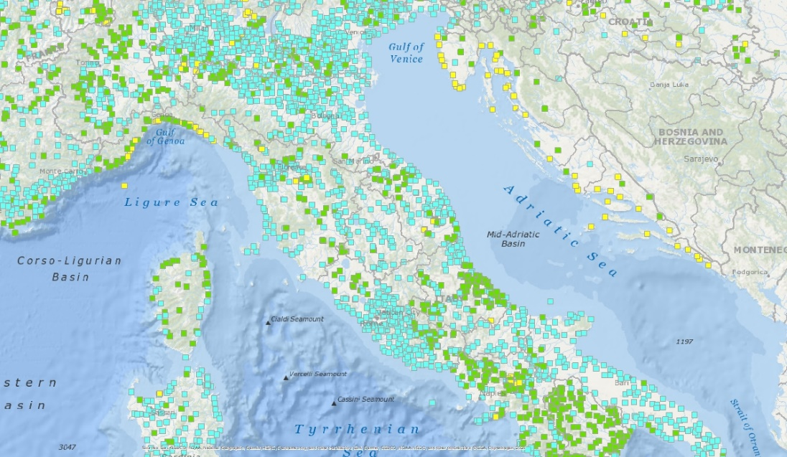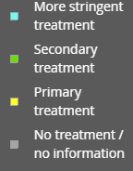

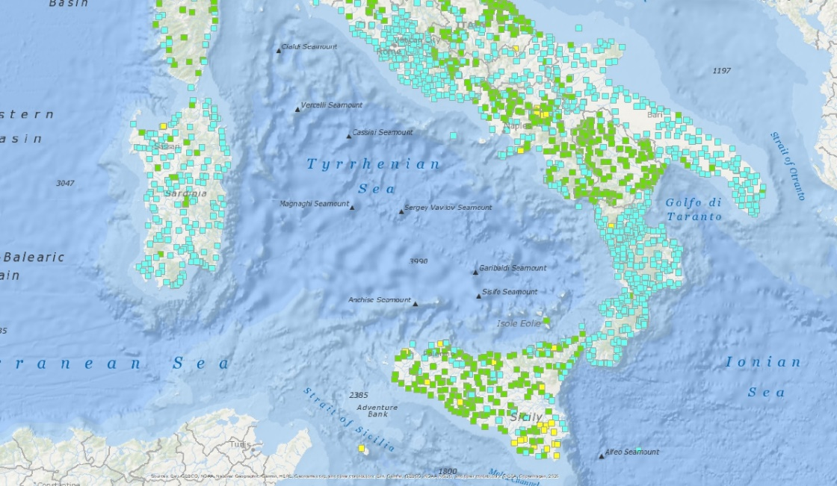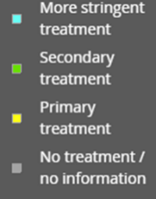

The dots representing the plants in the map are coloured according to treatment type.

Fig. 3 SM: UWWTD plants equipped with additional polishing treatment steps Map
European Environmental Agency thematic page environmental-pressures/uwwtd)

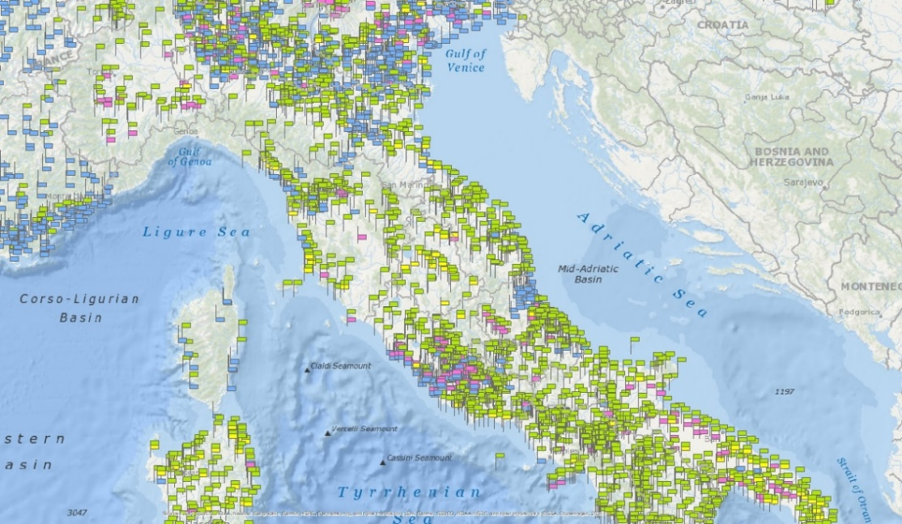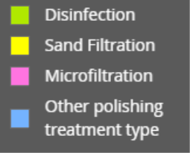

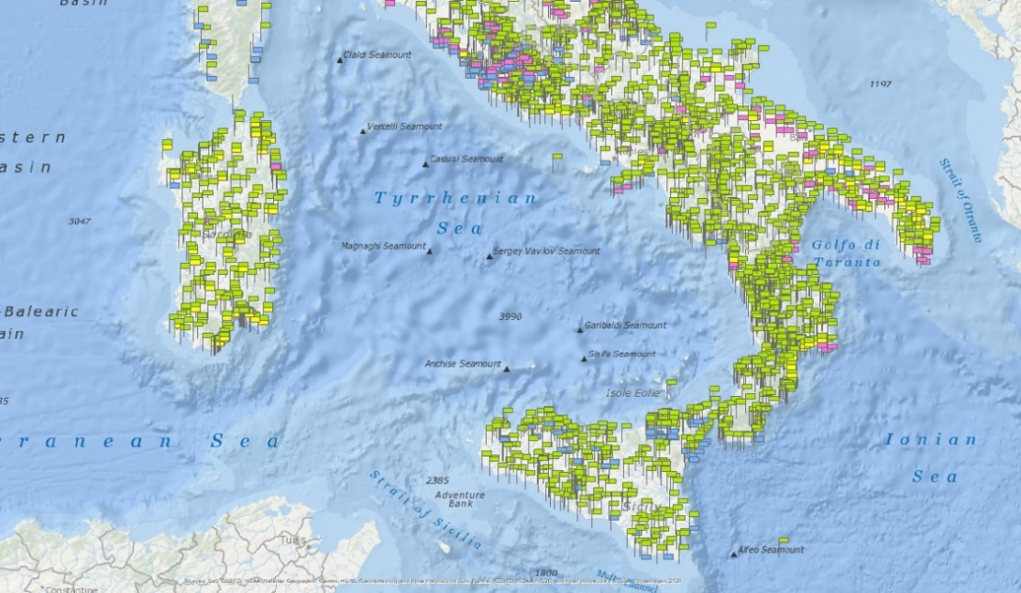

The dots representing the plants in the map are coloured according to treatment type.

Fig. 4 SM: Italian hydrogeological risk’s map.
