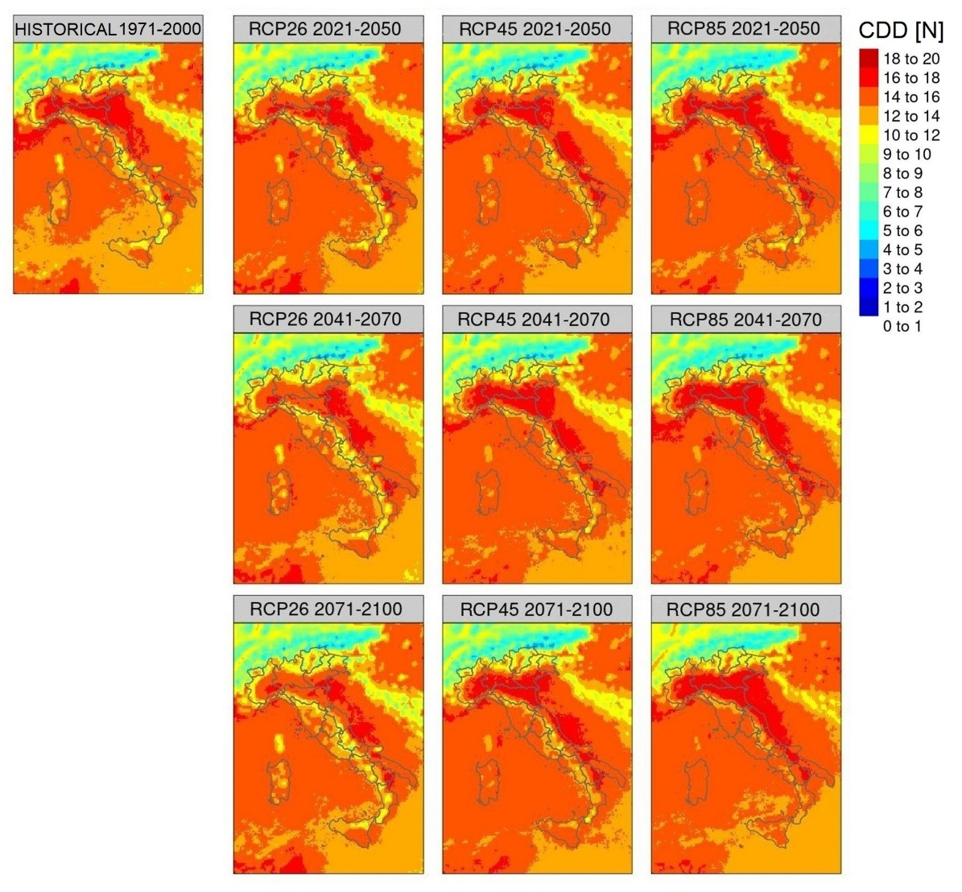
Fig.S1 CDD [N] ensemble mean annual scenario in REF (HISTORICAL panel on the top-left) and under RCP2.6, RCP4.5 and RCP8.5 hypotheses (by column) in the future 2021-2050 (first row), 2041-2070 (second row) and 2071-2100 (third row) (panels on the right).

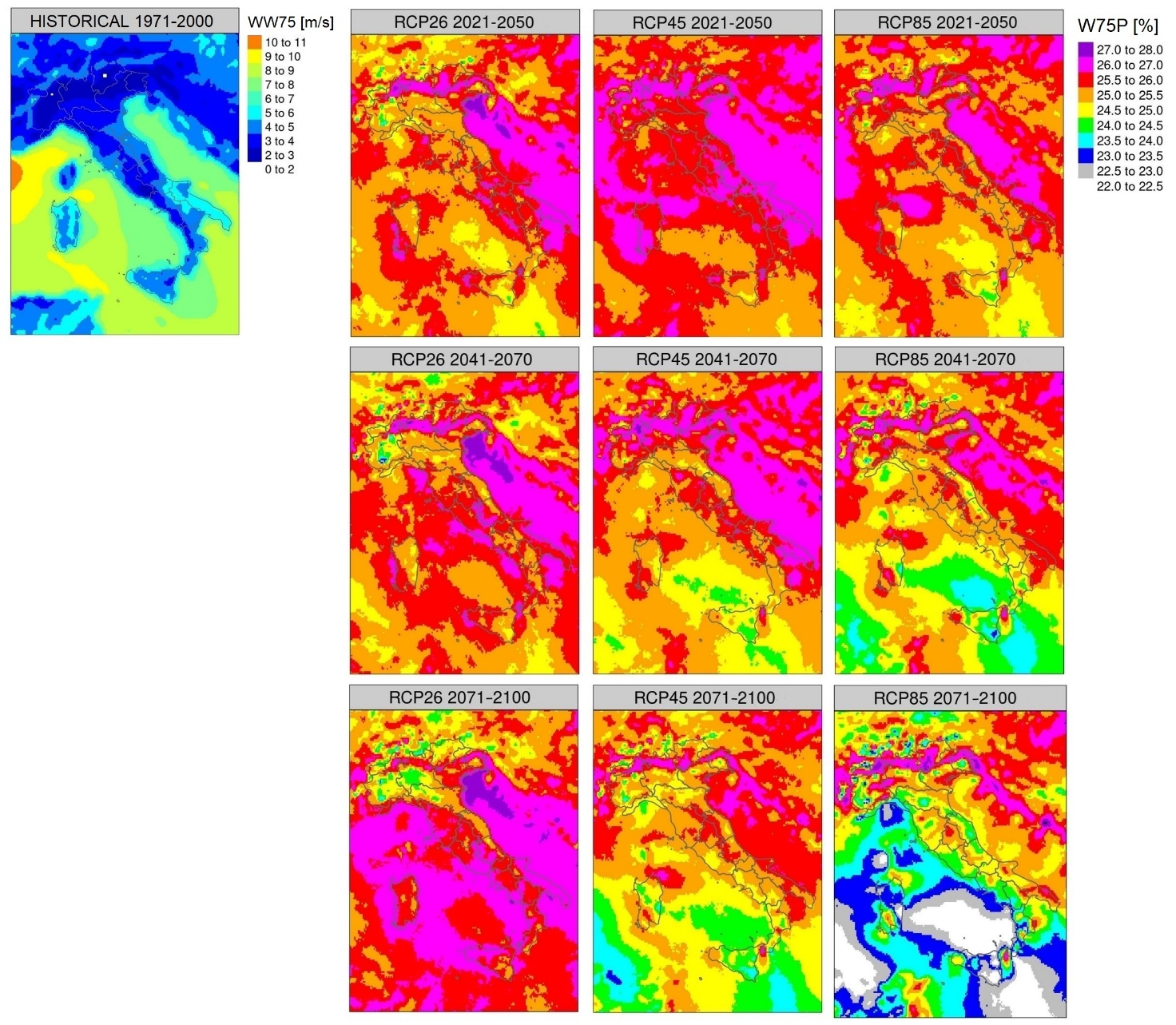
Fig.S2 WW75 [m/s] ensemble mean scenario in REF (HISTORICAL panel on the top-left) and W75P [%] ensemble mean scenarios under RCP2.6, RCP4.5 and RCP8.5 hypotheses (by column) in the future 2021-2050 (first row), 2041-2070 (second row) and 2071-2100 (third row) (panels on the right).

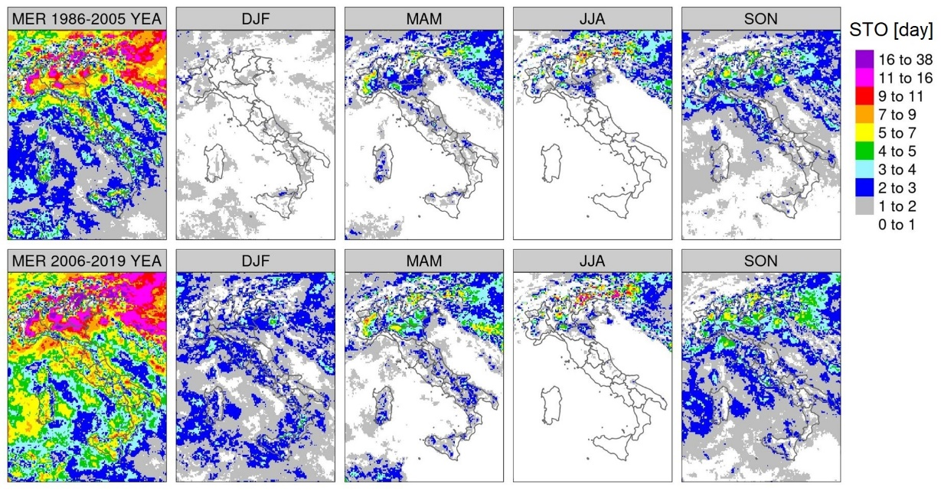
Fig.S3 STO scenarios inferred from MERIDA data at annual and seasonal scale by column in 1986-2005 (top row) and 2006-2019 (bottom row).

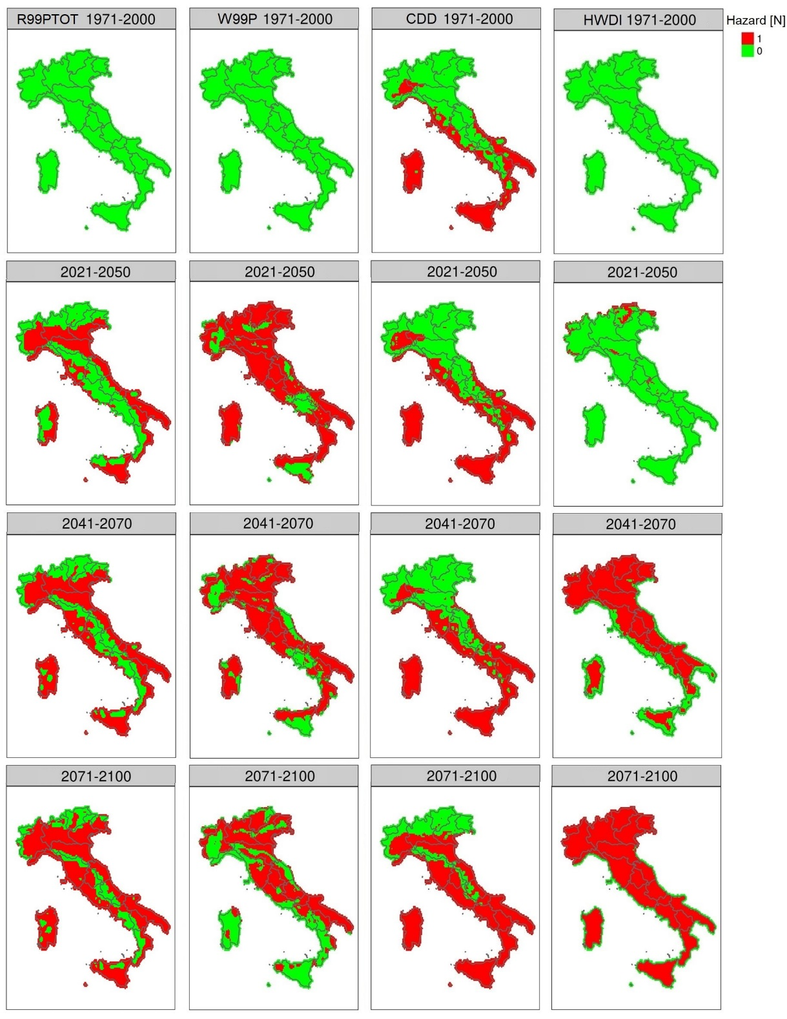
Fig.S4 Ensemble mean scenarios of R99PTOT ≥ 33%, V99P ≥ 3%, CDD ≥ 30 days, and HWDI ≥ 5 N (by column) in REF (first row) and in the future 2021-2050 (second row), 2041-2070 (third row) and 2071-2100 (fourth row). Red and green colours indicate respectively the areas with or without exceedance of the threshold set for each hazard.

