Electronic Supplementary Information for

Computational screening of sodium solid electrolytes through unsupervised learning
Damdae Park^{1†}, Wonsuk Chung^{1†}, Byoung Koun Min^{1,3}, Ung Lee^{1,3,4},
Seungho Yu^{2,4 *} and Kyeongsu Kim^{1,4*}

¹ Clean Energy Research Center, Korea Institute of Science and Technology (KIST), Seoul 02792, Republic of Korea
² Energy Storagte Research Center, Korea Institute of Science and Technology (KIST), Seoul 02792, Republic of Korea
³ Graduate School of Energy and Environment (Green School), Korea University, 145 Anam-ro, Seongbuk-gu, Seoul 02841, Republic of Korea
⁴ Division of Energy and Environmental Technology, KIST school, Korea University of Science and Technology (UST), Seoul 02792, Republic of Korea

† These authors contributed equally to this work.
* These authors contributed equally to this work.

Correspondence should be addressed to Kyeongsu Kim (kyeongsu@kist.re.kr).

Table S1. Descriptors constituting the feature vector. The numbers represent the valid dimensions. Invalid descriptors, namely Chemical ordering (CO), global instability index (GII), and structural variance (SV) descriptors, are omitted.
 | A | A40 | AM | AM40 | CAMN | CAMN40 | CAN | CAN40 | Original | All
R |  |  |  |  |  |  |  |  | 1 | 1
SOAP |  |  |  |  | 60 | 60 |  |  | 60 | 180
V |  |  |  |  |  |  |  |  | 1 | 1
APE |  |  | 5 | 5 | 5 | 5 | 5 | 5 | 5 | 35
BC |  |  | 1 | 1 | 1 | 1 | 1 | 1 |  | 6
BF |  | 9 |  |  | 20 | 21 |  | 10 |  | 60
Density | 3 | 3 | 3 | 3 | 3 | 3 | 3 | 3 |  | 24
EE | 1 | 1 | 1 | 1 | 1 | 1 | 1 | 1 | 1 | 9
END |  |  | 3 | 3 | 5 | 5 | 4 | 4 | 5 | 29
JCFID |  |  |  |  |  | 1529 |  | 1527 |  | 3056
Lattice type |  |  |  |  |  |  |  |  | 1 | 1
MD |  |  | 15 | 15 | 17 | 17 | 16 | 16 | 102 | 198
MPE | 1 | 1 | 1 | 1 | 1 | 1 | 1 | 1 | 1 | 9
OFM | 9 | 9 | 16 |  | 25 | 25 | 16 | 16 | 1025 | 1141
OS | 4 | 4 | 4 | 4 | 4 | 4 | 4 | 4 | 4 | 36
RDF | 92 | 93 | 92 | 94 | 94 | 94 | 94 | 94 | 94 | 841
SC | 2 | 2 | 2 | 2 | 2 | 2 | 2 | 2 | 2 | 18
SCM |  | 9 |  |  | 20 | 21 |  | 10 |  | 60
Space group |  |  |  |  |  |  |  |  | 1 | 1
VO |  |  | 4 | 4 | 4 | 4 | 4 | 4 | 8 | 32
mXRD | 451 | 451 | 451 | 451 | 451 | 451 | 451 | 451 | 451 | 4059
YSS |  |  | 2 | 2 | 2 | 2 | 2 | 2 | 2 | 14
All | 563 | 582 | 600 | 586 | 715 | 2246 | 604 | 2151 | 1764 | 9811

Table S2. Hyperparameter setups for HDBSCAN and PACMAP in clustering. Default values have been used unless otherwise unspecified.
 |  | Group clustering | Subgroup clustering
HDBSCAN  (sklearn v1.3.0) | min_cluster_size | 50
HDBSCAN  (sklearn v1.3.0) | min_samples | 50 | 5
PACMAP  (pacmap v0.7.0) | n_neighboirs | 30

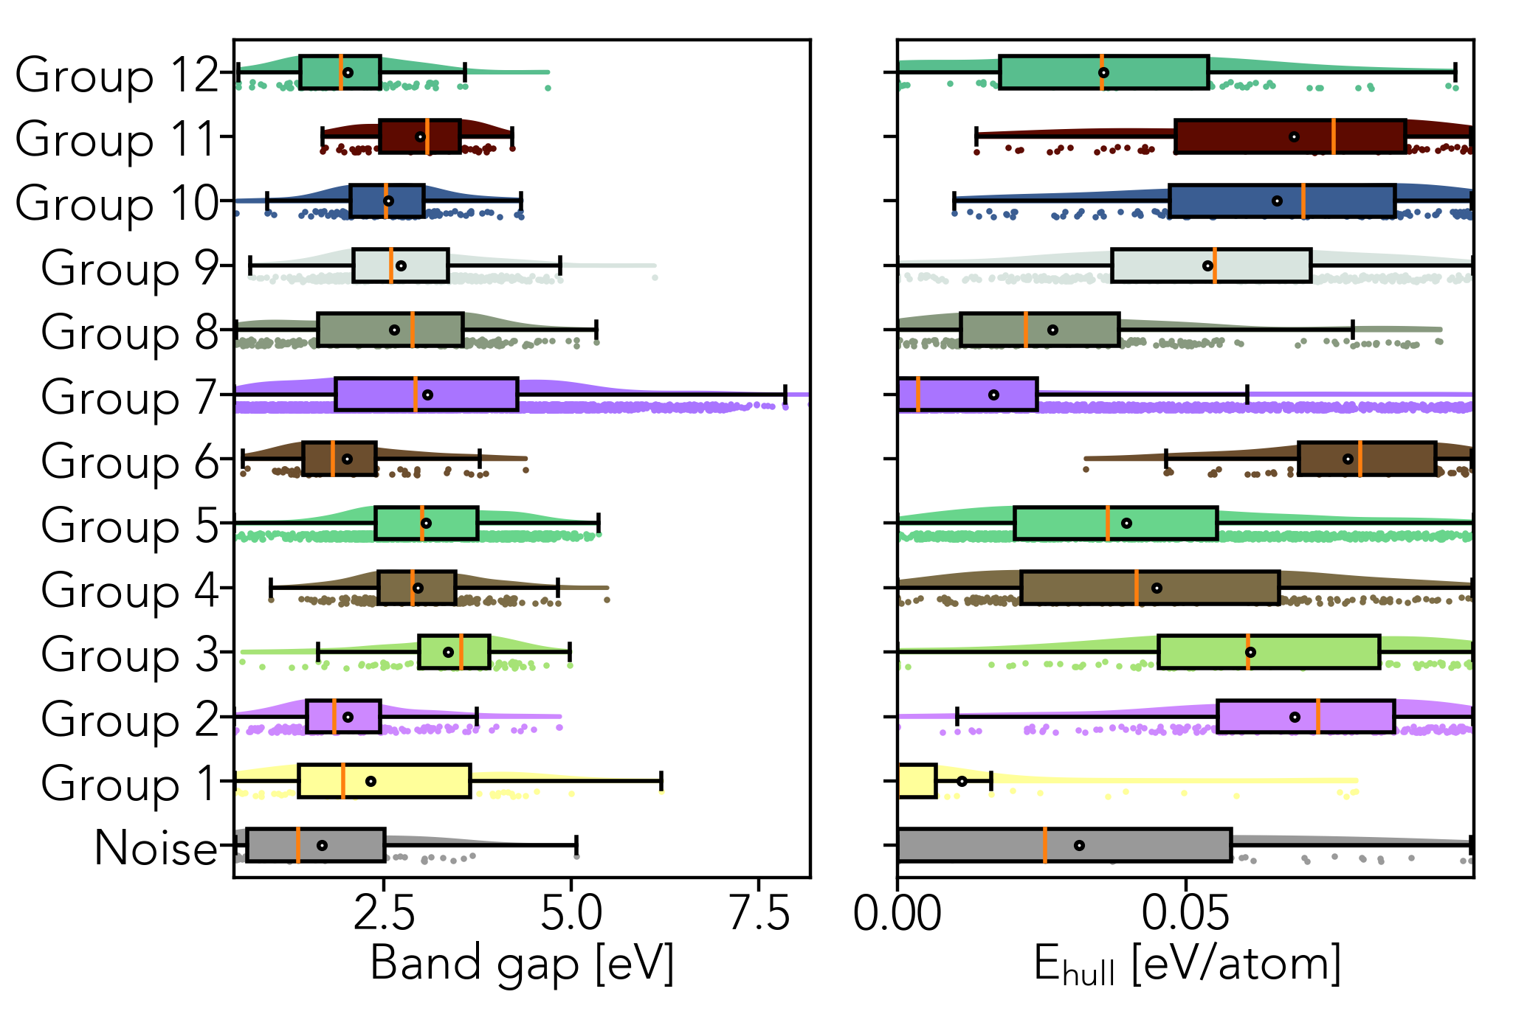
Figure S1. Band gap and E_{hull} distributions over clustered groups.

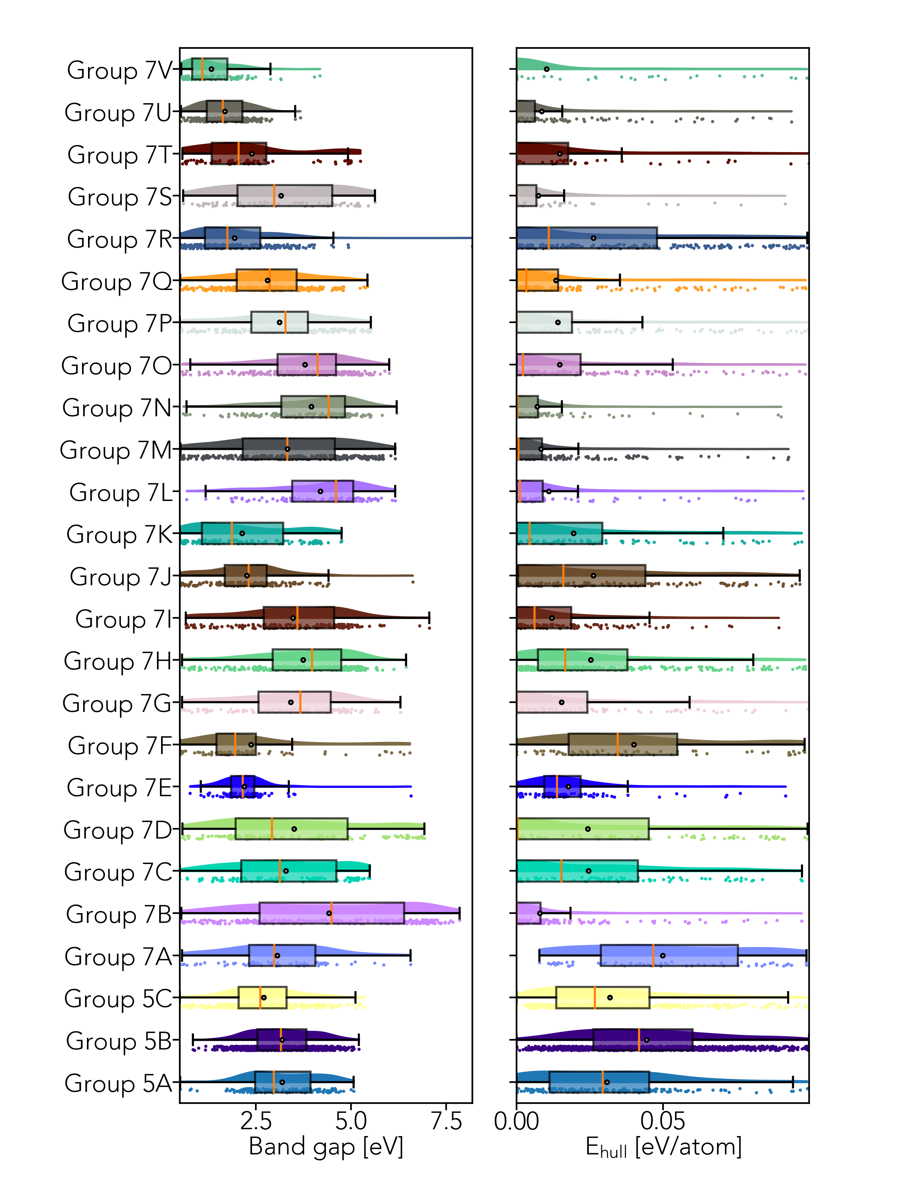
Figure S2. Band gap and E_{hull} distributions over the subgroups within Group 5 and 7.
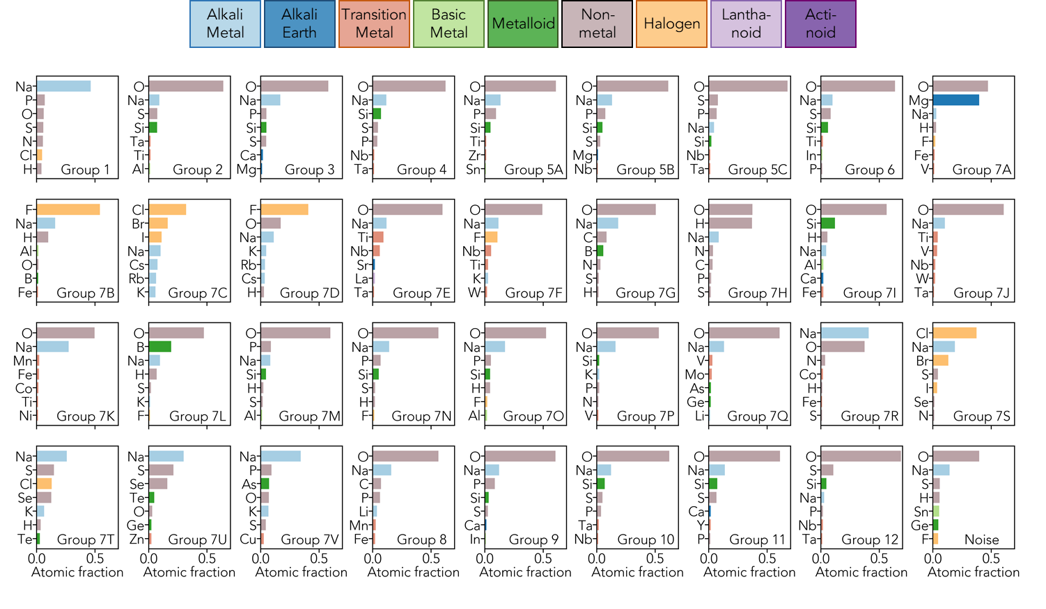
Figure S3. Average atomic fractions over the groups.

Table S3. Ionic conductivity of Na-ion solid-state conductors at room-temperature. ªMaterials that can form different lattice structures.
MP-ID | Formula | Space group | Conductivity  [S cm⁻¹] | Group | Reference
648 | Na₂S | Fm3̅m | 1.00×10⁻⁷ | 1 | Bertheville et al., 1997¹
1266 | Na₂Se | Fm3̅m | 1.00×10⁻¹³ | 1 | Liu et al., 2020²
22862 | NaCl | Fm3̅m | 1.00×10⁻¹³ | 1 | Hooton et al., 1988³
23268 | NaI | Fm3̅m | 2.00×10⁻¹⁰ | 1 | Matsuo et al., 2012⁴
677437 | ªNa₃Zr₂Si₂PO₁₂ | P1 | 6.70×10⁻⁴ | 5A | Zhang et al., 2017⁵
695119 | ªNa₃Zr₂Si₂PO₁₂ | P1 | 6.70×10⁻⁴ | 5A | Zhang et al., 2017⁵
695354 | ªNa₃Zr₂Si₂PO₁₂ | P1 | 6.70×10⁻⁴ | 5A | Zhang et al., 2017⁵
1133351 | ªNa₃Zr₂Si₂PO₁₂ | P1 | 6.70×10⁻⁴ | 5A | Zhang et al., 2017⁵
1221148 | ªNa₃Zr₂Si₂PO₁₂ | C1c1 | 6.70×10⁻⁴ | 5A | Zhang et al., 2017⁵
2713548 | ªNa₃Zr₂Si₂PO₁₂ | C1c1 | 6.70×10⁻⁴ | 5A | Zhang et al., 2017⁵
2713573 | ªNa₃Zr₂Si₂PO₁₂ | C1c1 | 6.70×10⁻⁴ | 5B | Zhang et al., 2017⁵
16956 | ªNa₃Sc₂(PO4)₃ | C1c1 | 3.04×10⁻⁴ | 5A | Rettenwander et al., 2018⁶
1221287 | ªNa₃Sc₂(PO4)₃ | C1c1 | 3.04×10⁻⁴ | 5A | Rettenwander et al., 2018⁶
2715413 | ªNa₃Sc₂(PO4)₃ | C1c1 | 3.04×10⁻⁴ | 5A | Rettenwander et al., 2018⁶
1221280 | ªNa₃Sc₂(PO4)₃ | C12/c1 | 3.04×10⁻⁴ | 5A | Rettenwander et al., 2018⁶
2715518 | ªNa₃Sc₂(PO4)₃ | C1c1 | 3.04×10⁻⁴ | 5B | Rettenwander et al., 2018⁶
555608 | ªNa₃Sc₂(PO4)₃ | R3̅c | 3.04×10⁻⁴ | 5A | Rettenwander et al., 2018⁶
2713249 | Na₃Hf₂Si₂PO₁₂ | C1c1 | 4.59×10⁻⁴ | 5A | Tial et al., 2021⁷
2713308 | Na₃Hf₂Si₂PO₁₂ | C1c1 | 4.59×10⁻⁴ | 5B | Tial et al., 2021⁷
23705 | Na₃AlH₆ | P12₁/c1 | 6.40×10⁻⁷ | 7B | Oguchi et al., 2012⁸
23704 | NaAlH₄ | I4₁/a | 2.00×10⁻¹⁰ | 7B | Oguchi et al., 2012⁸
38725 | ªNaBH₄ | P4₂/nmc | 3.00×10⁻¹⁰ | 7B | Matsuo et al., 2012⁴
1101862 | ªNaBH₄ | P4̅2₁c | 3.00×10⁻¹⁰ | 7B | Matsuo et al., 2012⁴
1190869 | ªNaBH₄ | Pnma | 3.00×10⁻¹⁰ | 7B | Matsuo et al., 2012⁴
1190586 | ªNaBH₄ | P4̅3m | 3.00×10⁻¹⁰ | 7B | Matsuo et al., 2012⁴
2646982 | ªNaBH₄ | Pnma | 3.00×10⁻¹⁰ | 7B | Matsuo et al., 2012⁴
976181 | ªNaBH₄ | F4̅3m | 3.00×10⁻¹⁰ | 7B | Matsuo et al., 2012⁴
24810 | ªNaBH₄ | Pnma | 3.00×10⁻¹⁰ | 7B | Matsuo et al., 2012⁴
23850 | NaNH₂ | Fddd1 | 1.00×10⁻¹⁰ | 7H | Angelova et al., 2012⁹
2646917 | NaCB₉H₁₀ | Pna2_1 | 8.00×10⁻⁵ | 7H | Tang et al., 2016¹⁰
2646947 | NaCB₁₁H₁₂ | Pca2_1 | 4.00×10⁻⁶ | 7L | Tang et al., 2015¹¹
776332 | Na₂B₁₀H₁₀ | P12₁/c1 | 2.00×10⁻⁷ | 7L | Udovic et al., 2014a¹²
978278 | Na₂B₁₂H₁₂ | P12₁/c1 | 6.00×10⁻⁸ | 7L | Udovic et al., 2014b¹³
1020646 | Li₂NaBP₂O₈ | P1̅ | 4.40×10⁻¹⁸ | 7M | Laskowski et al., 2023¹⁴
16283 | KNa₂Li₃Fe₂(Si₂O₅)₆ | P6/mcc | 1.00×10⁻¹⁰ | 7N | Laskowski et al., 2023¹⁴
6783 | NaLiSO₄ | P31c | 8.80×10⁻¹⁰ | 7P | Laskowski et al., 2023¹⁴
28542 | Na₃ErCl₆ | P12₁/c1 | 1.00×10⁻⁹ | 7S | Schlem et al., 2020¹⁵
23363 | NaAlCl₄ | P2_12̅_121̅ | 3.90×10⁻⁶ | 7S | Park et al., 2022¹⁶
1078419 | Na₃PSe₄ | I4̅3m | 1.16×10⁻³ | 7U | Zhang et al., 2015¹⁷
10167 | Na₃SbS₄ | I4̅3m | 1.10×10⁻³ | 7U | Xiong et al., 2018¹⁸
8703 | Na₃SbSe₄ | I4̅3m | 8.50×10⁻⁴ | 7U | Xiong et al., 2018¹⁸
29976 | Na₃BS₃ | C12/c1 | 3.70×10⁻¹⁰ | 7U | Tsuji et al., 2021¹⁹
1193265 | Na₃SbSe₃ | P2_13̅ | 1.00×10⁻¹¹ | 7U | Pompe and Pfitzner, 2012²⁰
4068 | Na₂GeS₃ | C12/c1 | 1.00×10⁻¹³ | 7U | Kassem et al., 2022²¹
29143 | Na₃VS₄ | P4̅2₁c | 1.16×10⁻⁸ | 7U | He et al., 2019²²
29628 | Na₄SnS₄ | P4̅2₁c | 1.00×10⁻¹¹ | 7U | Xiong et al., 2020¹⁸
554395 | Na₅Li₄(TiS4)₂ | C12/c1 | 8.80×10⁻⁶ | 7U | Laskowski et al., 2023¹⁴
28782 | Na₃PS₄ | P4̅2₁c | 3.00×10⁻⁶ | 7V | Hayashi et al., 2012²³
985584 | Na₃PS₄ | I4̅3m | 4.60×10⁻⁴ | 7V | Hayashi et al., 2012²³
1193673 | Na₃SbS₃ | P2_13̅ | 3.00×10⁻⁹ | 7V | Pompe et al., 2013²⁴
Table S4. Summary on clustered groups.
Group | Count | Average E_{hull} [meV/atom] | Average E_{band gap} [eV] | # of available data points | # of data points with conductivity  > 10⁻⁵ S cm⁻¹
1 | 56 | 11.1 | 2.32 | 4 | 0
2 | 226 | 68.9 | 2.02
3 | 101 | 61.2 | 3.36
4 | 211 | 45.0 | 2.96
5A | 166 | 30.9 | 3.19 | 3 | 3
5B | 1084 | 44.4 | 3.19 | 3 | 3
5C | 459 | 31.8 | 2.71
6 | 69 | 78.1 | 2.00
7A | 66 | 50.0 | 3.06
7B | 293 | 8.0 | 4.41 | 3* | 0
7C | 125 | 24.6 | 3.29
7D | 139 | 24.3 | 3.50
7E | 99 | 17.8 | 2.19
7F | 71 | 40.0 | 2.37
7G | 137 | 15.4 | 3.42
7H | 308 | 25.4 | 3.74 | 2 | 1
7I | 177 | 12.1 | 3.47
7J | 184 | 26.3 | 2.26
7K | 128 | 19.5 | 2.13
7L | 109 | 11.0 | 4.19 | 3 | 0
7M | 312 | 8.4 | 3.32 | 1 | 0
7N | 150 | 7.1 | 3.95 | 1 | 0
7O | 256 | 14.7 | 3.79
7P | 237 | 14.1 | 3.12 | 1 | 0
7Q | 272 | 13.5 | 2.80
7R | 282 | 26.3 | 1.94
7S | 84 | 7.5 | 3.16 | 1 | 0
7U | 71 | 14.7 | 2.39 | 9 | 3
7V | 203 | 8.6 | 1.68 | 3 | 1
8 | 112 | 10.3 | 1.33
9 | 310 | 26.9 | 2.64
10 | 410 | 53.8 | 2.73
11 | 133 | 65.8 | 2.56
12 | 73 | 68.8 | 2.98
Noise | 90 | 35.7 | 2.01

Table S5. Representative materials of the clustered groups.
Promising group |  | Materials
7B |  | NaBH₄, NaAlH₄, Na₃AlH₆, NaBF₄, NaAlF₄, Na₃AlF₆
7H |  | NaNH₂, NaCB₉H₁₀, NaB₃H₄O₇, Na₃Ga₇H₁₂S₁₃O₆
7L |  | Na₂B₁₀H₁₀, Na₂B₁₂H₁₂, NaCB₁₁H₁₂*, Na₃B₅S₉
7S |  | Na₃ErCl₆, NaGdCl₄, Na₂ZnBr₄, NaSbCl₆
7U |  | Na₃PSe₄, Na₃SbS₄, Na₃SbSe₄, Na₃VS₄, Na₃BS₃, Na₆Ge₂S₇, Na₄GeSe₄, Na₂PS₃
7V |  | Na₃PS₄ (cubic), Na₃PS₄ (tetragonal), NaMgAs, NaLi₂N, Na₃SbS₃, Na₃BP₂
Group | Materials |  | Group | Materials
1 | NaCl, Na₂O, Na₂S, Na₃OCl, Na₃OBr, Na₄OI₂ |  | 7J | Na₂Mn₃O₇, Na₄Ti₅O₁₂
2 | Na₅FeP₂(O₄F)₂, Na₂Ti₄O₉ |  | 7K | NaErO₂, Na₂FeO₃
3 | Na₁₅Cr₇N₁₉, Na₆GaP₃, Na₄CoO₄ |  | 7M | NaGdH₂S₂O₉, NaGe₄(PO₄)₃
4 | Na₆Mg₇Zr(SO₄)₁₂, Na₃Y(SiO₃)₃ |  | 7N | NaBePO₄, Na₄AlP₂HO₉
5A | Na₃Zr₂Si₂PO₁₂, NaZr₂(PO₄)₃, Na₃Sc₂(PO₄)₃, Na₃Hf₂Si₂PO₁₂ |  | 7O | NaPO₃, Na₄Al₃Si₃NO₁₄
5B | Na₃Zr₂Si₂PO₁₂, Na₃Sc₂(PO4)₃, Na₃Hf₂Si₂PO₁₂, NaNbAl(PO₄)₃, |  | 7P | Na₂SiO₃, NaYGeO₄
5C | NaMgSc(SO₄)₃, NaTa₂Si₂PO₁₂ |  | 7Q | Na₂TeO₄, NaVO₃
6 | Na₂Y₄Ti₄Si₃(S₃O₁₆)₃ |  | 7R | Na₅GaO₄, Na₆ZnO₄
7A | NaGaH₈(NF₃)₂, NaMg₃₀MnO₃₁* |  | 7T | NaHoS₂, Na₂ZrSe₃, NaGdS₂
7C | Na₃TmCl₆, NaCs₂NdBr₆ |  | 8 | Na₂NiPCO₇, Na₃FePCO₇
7D | NaCs₂TlF₆, NaRb₂CoF₆ |  | 9 | Na₂Ca₁₇V₂(PO₄)₁₄, Na₇Mg₂Nb₂Si₃P₃O₂₄
7E | NaTaO₃, NaBi₂Sb₃O₁₁ |  | 10 | Na₂Y₃Nb₅(PO₄)₁₂
7F | Na₁₇(WO₃)₁₉, Na₇(WO₃)₉ |  | 11 | Na₁₄Sc₄Si₉Sn₄S₃O₄₈
7G | NaBO₂, Na₃Sc(BO₃)₂ |  | 12 | Na₂Zr₃Zn₅(SO₄)₁₂, Na₂Ta₅In₃(PO₄)₁₂
7I | NaSc(SiO₃)₂, NaKZrSi₃H₄O₁₁ |  | Noise | NaGe, Na₃TiF₈

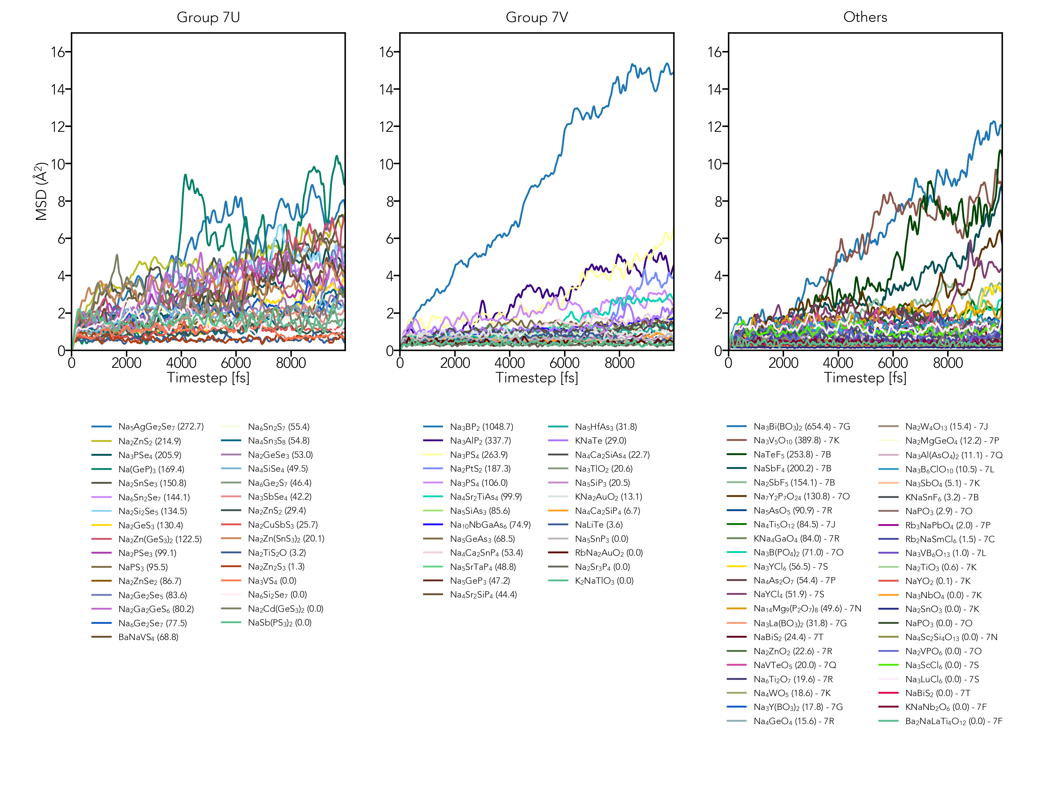
Figure S4. MSD trajectories obtained from 1000K AIMD simulations.
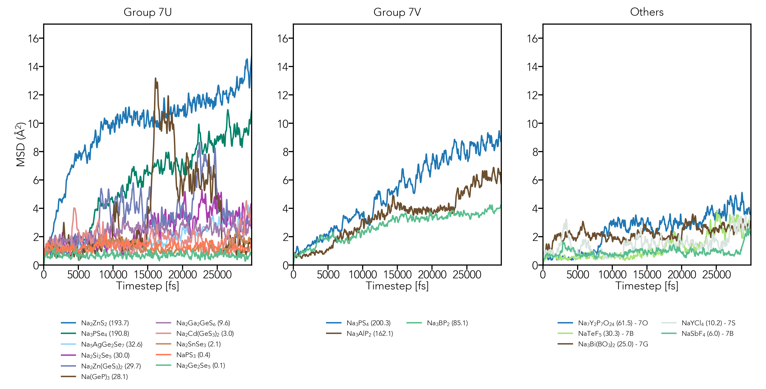
Figure S5. MSD trajectories obtained from 800K AIMD simulations.
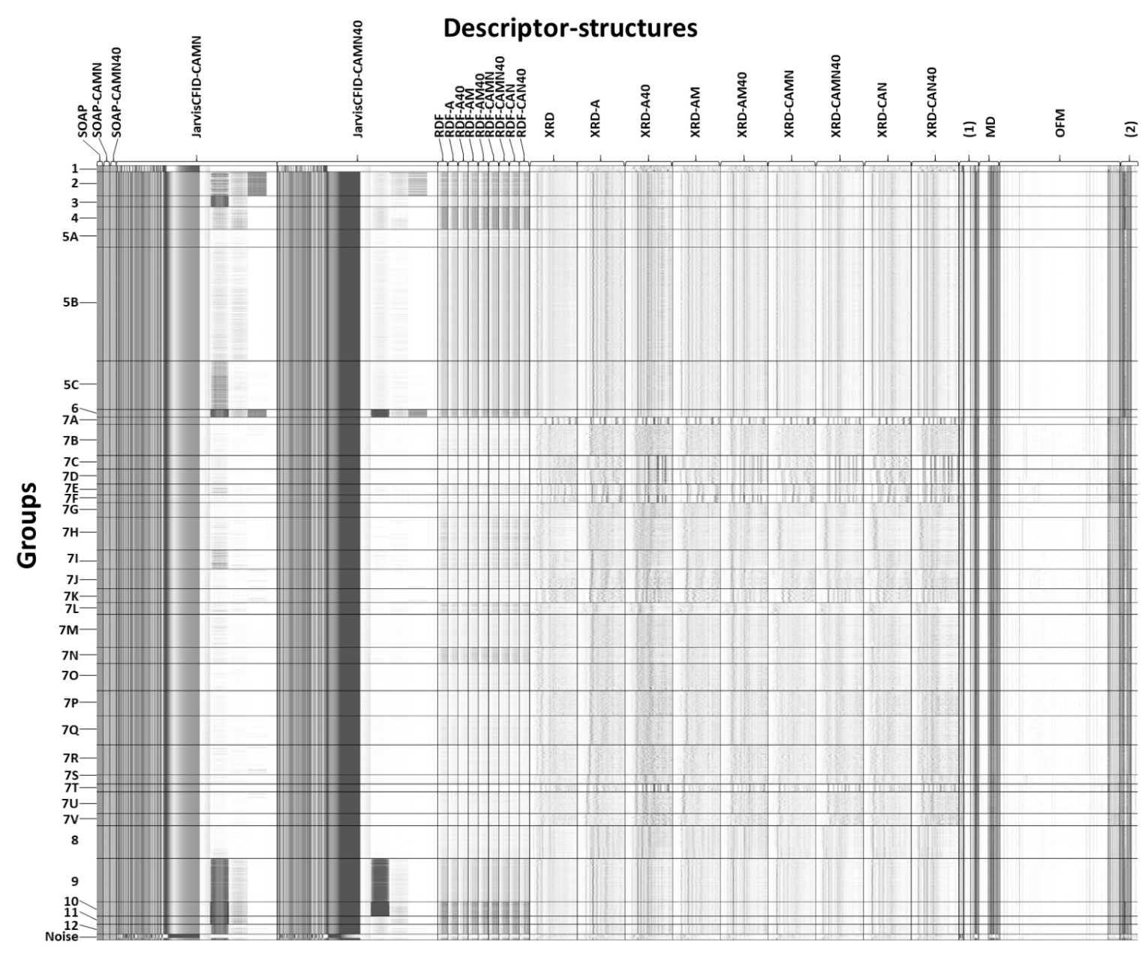
Figure S6. Dataset matrix after clustering. the entire descriptor matrix of which pixel is the relative descriptor value for corresponding material is visualized. In JarvisCFID, AC: average chemical, RCD: radial charge distribution, ADF1: angular distribution function up to 1st neighbor, ADF2: angular distribution function up to 2nd neighbor, DHA: dihedral angles, NN: nearest neighbors. (1) APF, BC, BF, LV, Na-ratio, LT, DF, EE, END, MPE, SG. (2) OS, SC, VO, YSS.

Table S6. Key descriptors of non-promising groups. ADF1: angular distribution function up to 1st neighbor, ADF2: angular distribution function up to 2nd neighbor.
Descriptor | Gini importance
Group 1
JarvisCFID-CAN40 Radial charge distribution | 1
Group 2
JarvisCFID-CAMN40 Dihedral angles | 0.768
JarvisCFID-CAN40 ADF1 | 0.234
Group 3
JarvisCFID-CAN40/CAMN40 ADF1 | 0.997
Group 4
JarvisCFID-CAMN40 ADF1 | 0.486
SC-original | 0.257
SC-CAMN | 0.150
SC-CAMN40 | 0.103
Group 5C
Meredig-CAMN/CAMN40 #103 | 0.714
JarvisCFID-CAN40/CAMN40 ADF1 | 0.286
Group 6
JarvisCFID-CAN40 ADF1 | 0.541
JarvisCFID-CAN40 ADF2 | 0.458
Group 7A
mXRD-A #257~261 | 0.692
OFM-CAMN #84 | 0.297
Group 7B
APE-original #4 | 0.218
END-original #1 | 0.215
APE-original #3 | 0.152
mXRD (overall) | 0.142
OFM-original #267 | 0.082
OFM-original #1293 | 0.079
Group 7C
SOAP-CAMN #10 | 0.906
Group 7D
mXRD (overall) | 0.787
Meredig-original #110 | 0.212
Group 7E
mXRD (overall) | 0.883
OFM-original #1292 | 0.117
Group 7F
mXRD (overall) | 0.978
Group 7G
Meredig-original #4~5 | 0.620
JarvisCFID-CAMN40/CAN40 #1472 (Nearest neighbors) | 0.144
OFM (overall) | 0.106
Group 7HL
OFM-original #71 | 0.235
OFM-original #1319 | 0.233
OFM-original #227 | 0.162
Meredig-original #105 | 0.153
Meredig-original #4 | 0.053
Group 7I
Meredig-original #13 | 0.534
mXRD (overall) | 0.211
OFM-CAMN/CAMN40 #1 | 0.119
OFM-CAMN #34 | 0.098
Group 7J
mXRD (overall) | 0.432
OFM-original #1398 | 0.384
OFM-original #1370 | 0.101
Group 7K
mXRD (overall) | 0.817
Density-CAMN #2 | 0.090
Group 7M
mXRD-CAMN40 #78~83 | 0.404
Meredig-original #14 | 0.325
JarvisCFID-CAMN40 #839 | 0.175
OFM-original #199 | 0.064
Group 7N
RDF #40~43 | 0.512
OFM-original #122 | 0.305
JarvisCFID-CAN40/CAMN40 RDF | 0.101
Group 7O
mXRD-A40/AM40 #241~246 | 0.574
mXRD-CAN40/CAMN40 #60~74 | 0.365
Group 7P
mXRD-CAN40/CAMN40 #257~266 | 0.604
mXRD-A/AM #122~125 | 0.097
Group 7Q
JarvisCFID-CAN40/CAMN40 #841 | 0.259
OS-original #3 | 0.170
OFM-original #696 | 0.167
mXRD-A/AM #126~128 | 0.123
Meredig-original #41 | 0.112
Group 7R
SOAP-original #14 | 0.400
SOAP-CAMN #14 | 0.239
SOAP-original #8 | 0.087
SOAP-CAMN #11 | 0.076
Density-A #0,2 | 0.071
Group 7S
Meredig-original #16,34 | 0.526
OFM (overall) | 0.123
JarvisCFID-CAN40 ADF | 0.077
mXRD (overall) | 0.060
Group 7T
mXRD (overall) | 0.801
Density-CAMN #2 | 0.093
OFM-A40 #1327 | 0.055
OFM-A40 #40 | 0.052
Group 8
Meredig-original #5 | 0.376
mXRD-original #32~33 | 0.351
mXRD-A40 #68~87 | 0.242
Group 9
JarvisCFID-CAN40 ADF1 | 0.693
RDF (overall) | 0.182
SC (overall) | 0.125
Group 10
JarvisCFID-CAN40/CAMN40 ADF1 | 0.755
JarvisCFID-CAN40/CAMN40 ADF2 | 0.244
Group 11
JarvisCFID-CAN40/CAMN40 ADF1 | 0.839
RDF (overall) | 0.161
Group 12
RDF-A40 #82 | 0.632
JarvisCFID-CAMN40 ADF1 | 0.124
RDF-A40 #88 | 0.060

References
1. Bertheville, B., Lovy, D., Bill, H. & Kubel, F. Ionic conductivity of Na2S single crystals between 295 and 1350 K experimental setup and first results. J. Phys. Chem. Solids 58, 1569–1577 (1997).
2. Liu, Z., Hu, W. & Deng, H. Chemistry of Defects in Crystalline Na 2 Se: Implications for the Na–Se Battery. J. Phys. Chem. C 124, 27930–27936 (2020).
3. Hooton, I. E. & Jacobs, P. W. M. Ionic conductivity of pure and doped sodium chloride crystals. Can. J. Chem. 66, 830–835 (1988).
4. Matsuo, M. et al. Sodium ionic conduction in complex hydrides with [BH 4] - and [NH 2] - anions. Appl. Phys. Lett. 100, 2–6 (2012).
5. Zhang, Z. et al. A Self‐Forming Composite Electrolyte for Solid‐State Sodium Battery with Ultralong Cycle Life. Adv. Energy Mater. 7, 1–11 (2017).
6. Rettenwander, D. et al. Arrhenius Behavior of the Bulk Na-Ion Conductivity in Na 3 Sc 2 (PO 4 ) 3 Single Crystals Observed by Microcontact Impedance Spectroscopy. Chem. Mater. 30, 1776–1781 (2018).
7. Zhu, Z., Chu, I. H. & Ong, S. P. Li3Y(PS4)2 and Li5PS4Cl2: New Lithium Superionic Conductors Predicted from Silver Thiophosphates using Efficiently Tiered Ab Initio Molecular Dynamics Simulations. Chem. Mater. 29, 2474–2484 (2017).
8. Oguchi, H., Matsuo, M., Kuromoto, S., Kuwano, H. & Orimo, S. Sodium-ion conduction in complex hydrides NaAlH4 and Na3AlH6. J. Appl. Phys. 111, 4–7 (2012).
9. Matsuo, M. et al. Sodium and magnesium ionic conduction in complex hydrides. J. Alloys Compd. 580, S98–S101 (2013).
10. Tang, W. S. et al. Liquid-Like Ionic Conduction in Solid Lithium and Sodium Monocarba-closo-Decaborates Near or at Room Temperature. Adv. Energy Mater. 6, 1–6 (2016).
11. Tang, W. S. et al. Unparalleled lithium and sodium superionic conduction in solid electrolytes with large monovalent cage-like anions. Energy Environ. Sci. 8, 3637–3645 (2015).
12. Udovic, T. J. et al. Exceptional Superionic Conductivity in Disordered Sodium Decahydro- closo -decaborate. Adv. Mater. 26, 7622–7626 (2014).
13. Udovic, T. J. et al. Sodium superionic conduction in Na 2 B 12 H 12. Chem. Commun. 50, 3750–3752 (2014).
14. Laskowski, F. A. L., McHaffie, D. B. & See, K. A. Identification of potential solid-state Li-ion conductors with semi-supervised learning. Energy Environ. Sci. 16, 1264–1276 (2023).
15. Schlem, R., Banik, A., Eckardt, M., Zobel, M. & Zeier, W. G. Na 3– x Er 1– x Zr x Cl 6 —A Halide-Based Fast Sodium-Ion Conductor with Vacancy-Driven Ionic Transport. ACS Appl. Energy Mater. 3, 10164–10173 (2020).
16. Park, J. et al. NaAlCl 4 : New Halide Solid Electrolyte for 3 V Stable Cost-Effective All-Solid-State Na-Ion Batteries. ACS Energy Lett. 7, 3293–3301 (2022).
17. Zhang, L. et al. Na3PSe4 : A Novel Chalcogenide Solid Electrolyte with High Ionic Conductivity. Adv. Energy Mater. 5, 1501294 (2015).
18. Xiong, S. et al. Na3SbSe4−xS x as Sodium Superionic Conductors. Sci. Rep. 8, 9146 (2018).
19. Tsuji, F. et al. Preparation and characterization of sodium-ion conductive Na 3 BS 3 glass and glass–ceramic electrolytes. Mater. Adv. 2, 1676–1682 (2021).
20. Pompe, C. & Pfitzner, A. Na3SbSe3: Synthesis, crystal structure determination, raman spectroscopy, and ionic conductivity. Zeitschrift fur Anorg. und Allg. Chemie 638, 2158–2162 (2012).
21. Kassem, M. et al. Deciphering Fast Ion Transport in Glasses: A Case Study of Sodium and Silver Vitreous Sulfides. Inorg. Chem. 61, 12870–12885 (2022).
22. He, Y., Lu, F. & Kuang, X. Enhanced sodium ion conductivity in Na 3 VS 4 by P-doping. RSC Adv. 9, 39180–39186 (2019).
23. Hayashi, A., Noi, K., Sakuda, A. & Tatsumisago, M. Superionic glass-ceramic electrolytes for room-temperature rechargeable sodium batteries. Nat. Commun. 3, 856 (2012).
24. Pompe, C. & Pfitzner, A. Na 3 SbS 3 : Single Crystal X‐ray Diffraction, Raman Spectroscopy, and Impedance Measurements. Zeitschrift für Anorg. und Allg. Chemie 639, 296–300 (2013).

