Supplementary material 1 – Mock-ups of example technology
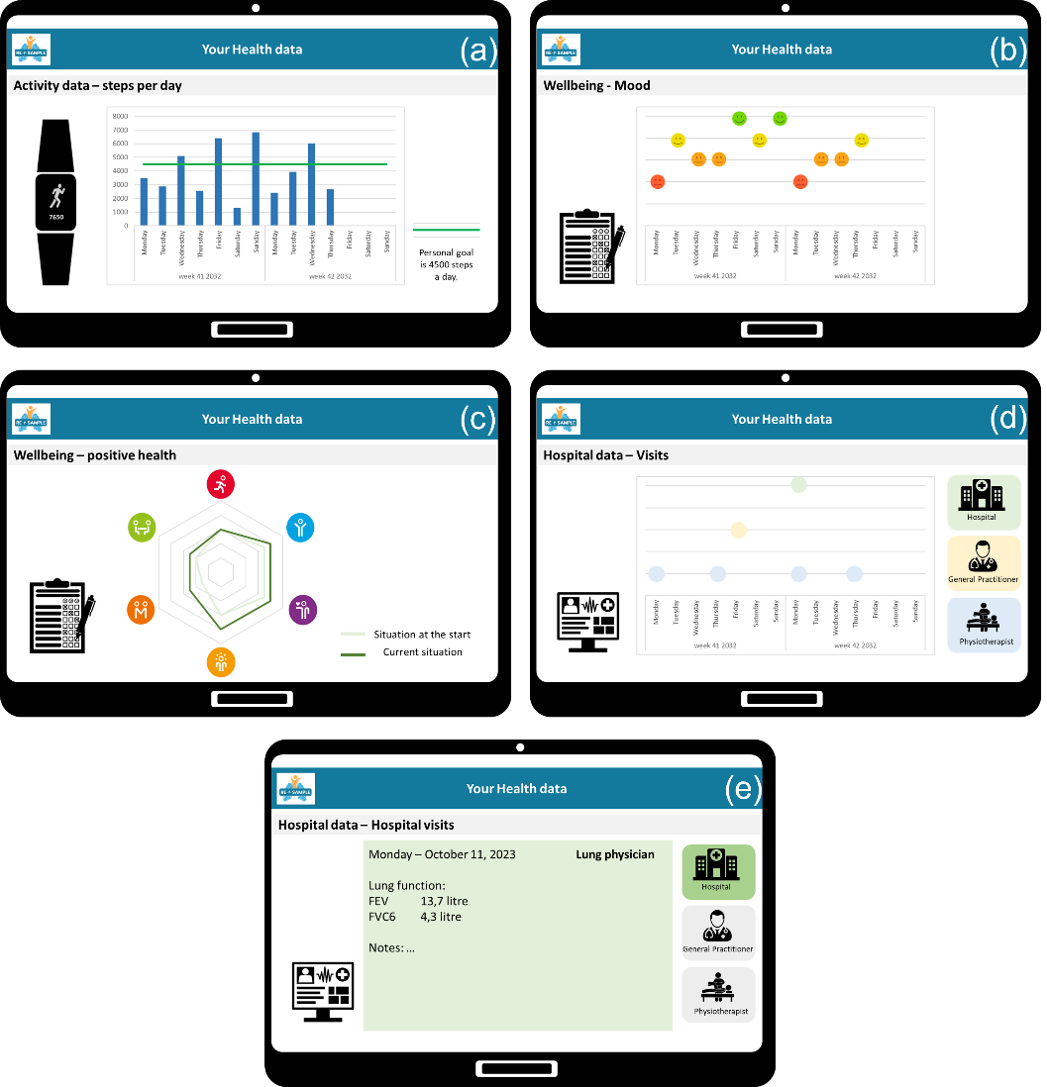
Figure 1. Mock-ups of example technology – part health data collection for health monitoring
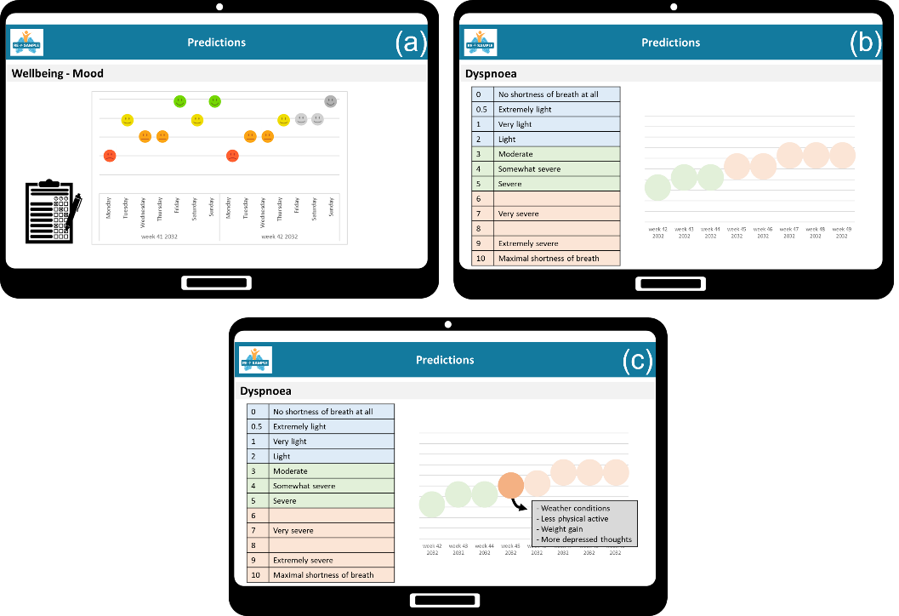
Figure 2. Mock-ups of example technology – part risk predictions
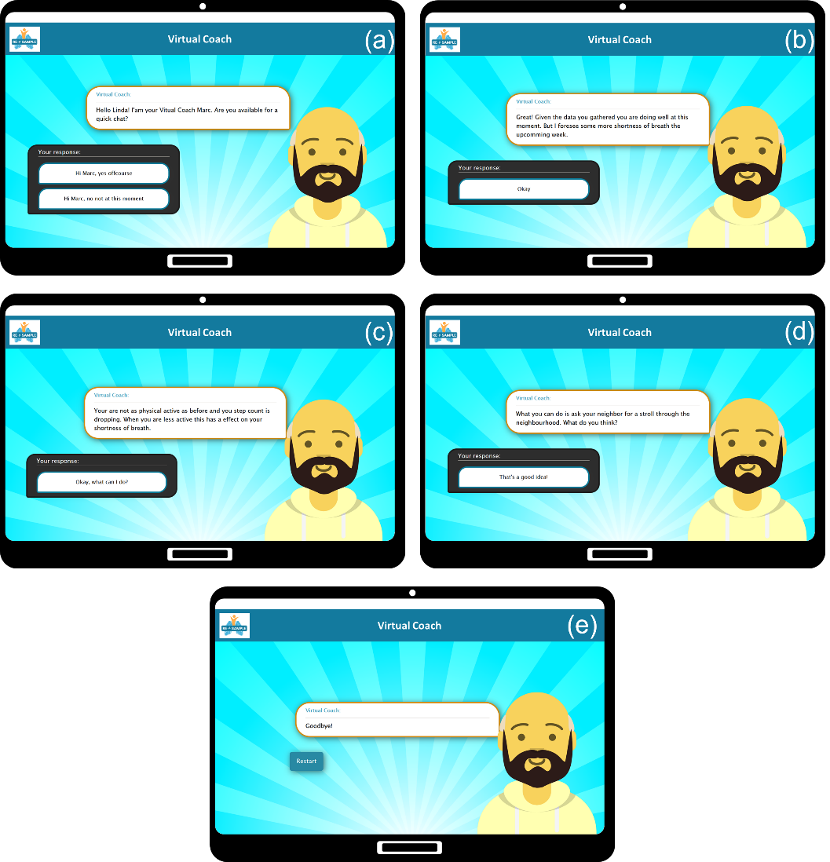
Figure 3. Mock-ups of example technology – part virtual coach

