Supplementary data

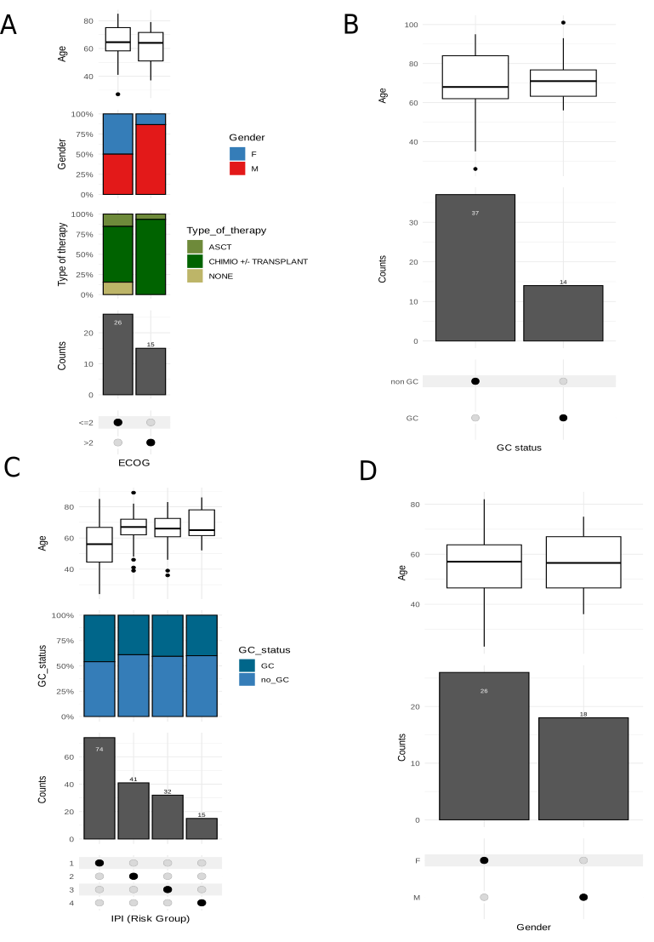
Figure S1: Clinical values description for PCNSL Barcelona dataset (A) DLBCL Rouen dataset (B) DLBCL Morph dataset (C) and DLBCL TCGA dataset (D).

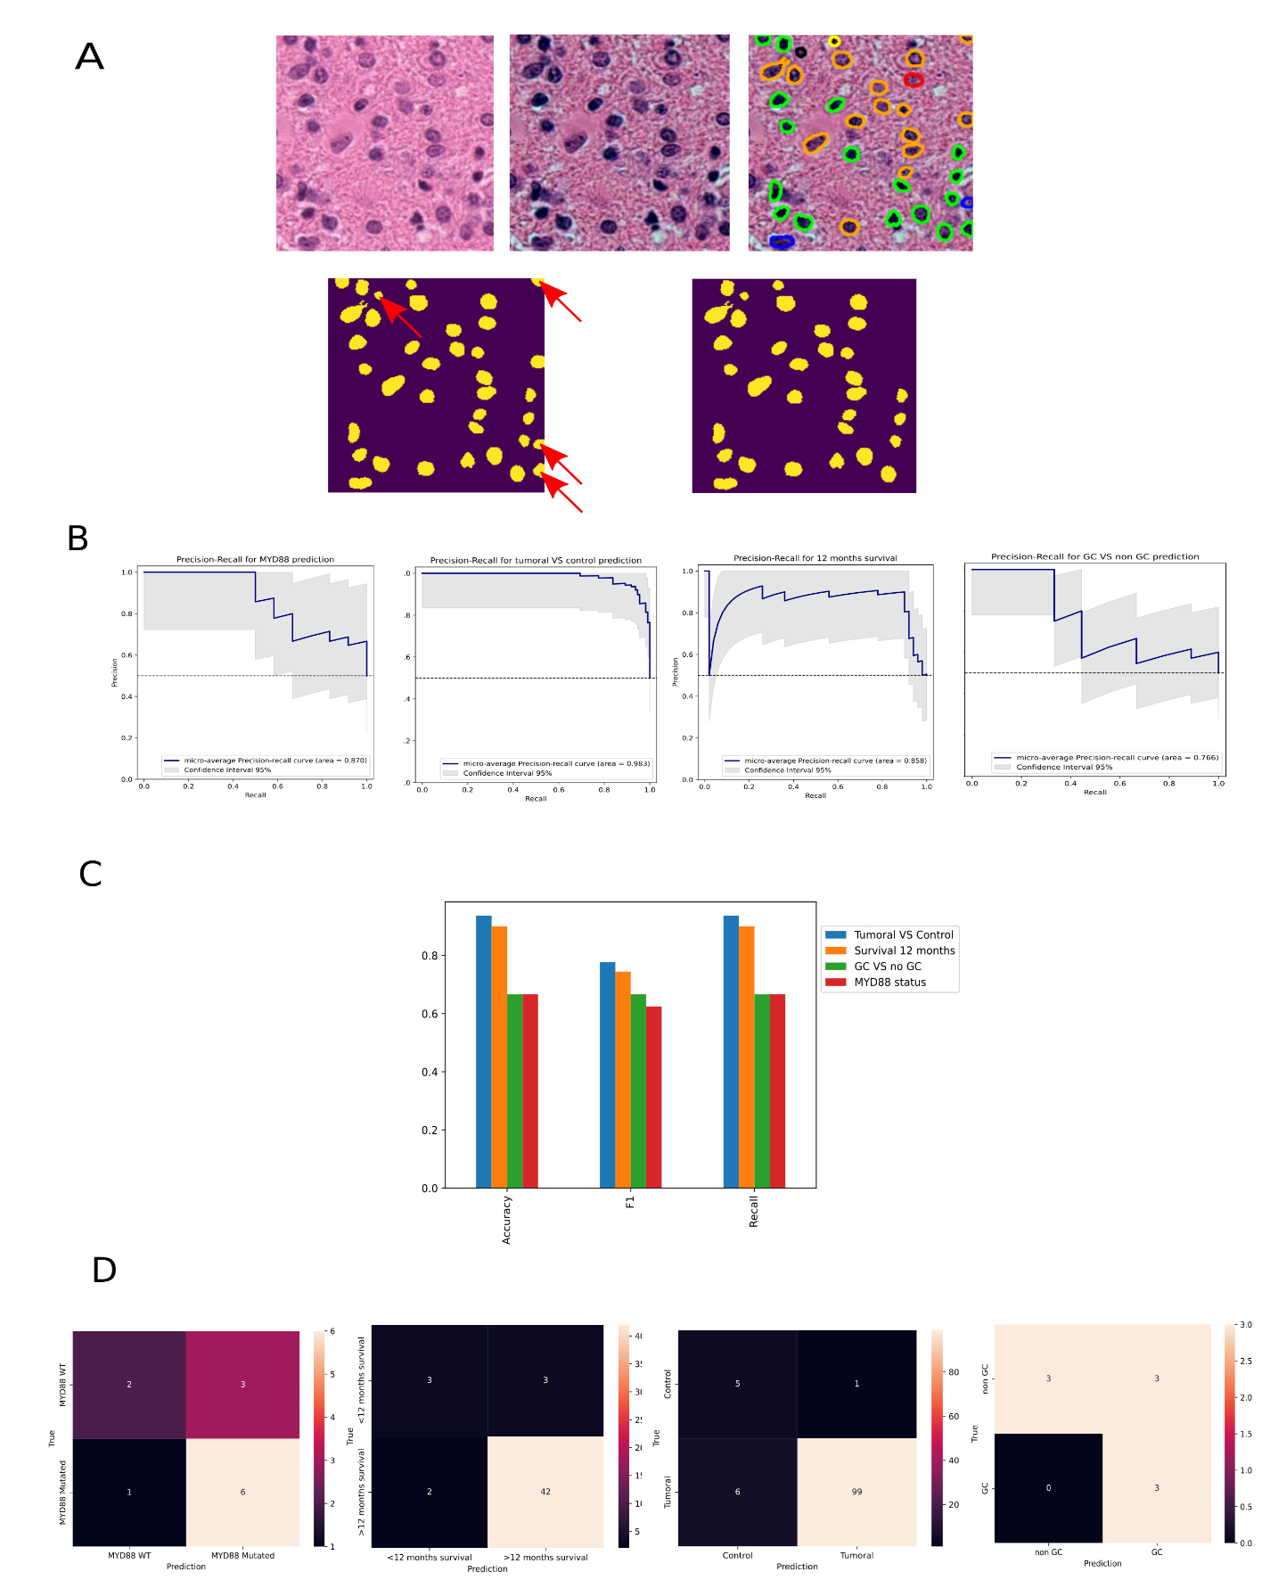
Figure S2: A. Native patch, normalized patch, nuclei segmentation, mask obtained from segmentation and mask obtained after nuclei filtering. Red arrows show nuclei filtered. B. Precision-Recall curves from all the classification tasks with CLAM. C. Metrics for different classification tasks. D. Confusion-matrices from all the classification tasks with
CLAM. 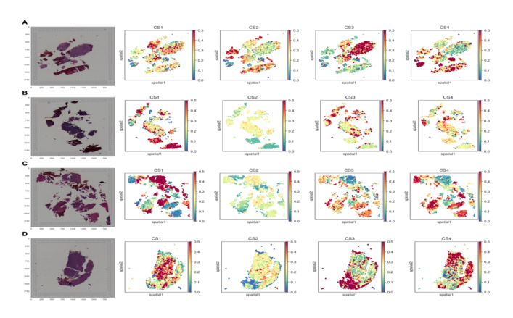
Figure S3: Starfysh Visium 10X spatial transcritomics analysis in four different PCNSL samples (A-D). Each panel represents A, B, C and D one particular sample with the H&E images on the left and distribution of the four molecular groups (CS1-4) according to the starfysh analysis are represented in the different columns showing the co-existence of different clusters throughout all the samples.
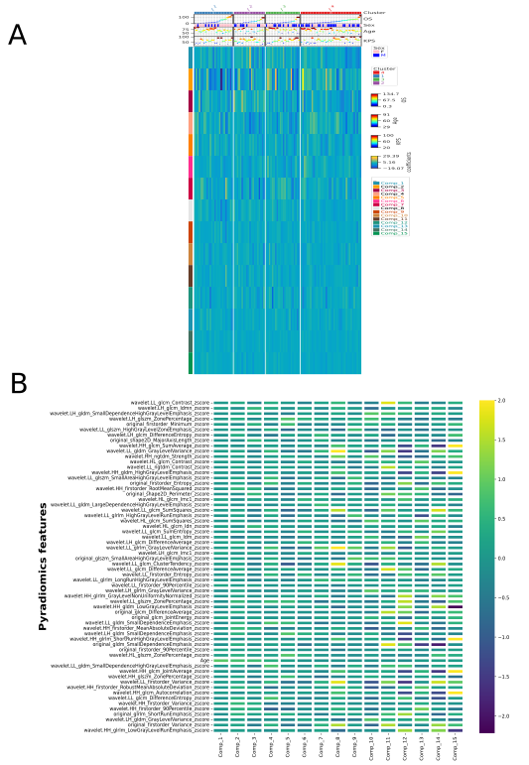

Figure S4: A. The coefficients of the PLS Cox model per each molecular cluster. The samples are ordered according to the overall survival within each cluster B. The five more important features of each PLS Cox component are represented.

