Artificial intelligence classifies and predicts the outcome of primary CNS and nodal large B-cell lymphomas
Supplementary Methods
Pre-processing of WSI
Tissue was detected inside the WSI with Otsu’s thresholding¹. Once the pixels containing tissue were detected, tessellation was performed.
The tessellation step consists of splitting the .ndpi file in several tiles - or patches. The created patches were composed of 224x224 pixels, without overlapping and with a percentage of background of 5%. All the datasets have undergone the same process, with the exception of the dataset DLBCL Morph² for which we've recovered the patches already created.
Afterwards, we normalize the staining of our patches to avoid bias potentially generated by different laboratory techniques or scanning.
We compared the 4 normalizations methods proposed by the Tissue Image Analytics Centre of the University of Warwick TIAToolbox³ (https://github.com/TissueImageAnalytics/tiatoolbox/blob/master/examples/02-stain-normalization.ipynb): Ruifrok, Reinhard, Macenko and Vahadane methods.
The Reihard method⁴ was based on the transfer of color between an image taken as a reference and a color varied image using the statistical mean and variance of the two images. This method transforms the images, in a way that the contrast of the source image is similar to the reference image.
The Ruifrok⁵, Macenko⁶ and Vahadane⁷ methods are considered stain-separation that methods try to separate and normalize each staining channel independently.
The Ruifrok method⁵ proposed to measure the relative proportion for three channels (R, G, and B) with the slides stained by only a single stain reagent (Hematoxylin or Eosin) to estimate stain vectors.
The Macenko method⁶ applied different mathematical methods to compute stain vectors, such as singular value decomposition (SVD) in Optical Density (OD) space.
The method by Vahadane et al.⁷ for color normalization decomposes the image into a sparse and non-negative stain density map. This approach has two steps: stain separation by sparse nonnegative matrix factorization (SNMF), and structure–preserving color normalization. The sparseness added to the optimization equation of nonnegative matrix factorization helps to reduce the solution space; however, it increases the computational complexity. This approach preserves the structure of the source image; however, it does not preserve all the color variations of the source image, and the solution provided for the optimization problem may correspond to local minima rather than global minima.
In order to select the most appropriate normalization, we proceed to a qualitative and a quantitative analysis.
For the qualitative part, a visual control by a neuropathologist was performed. For each dataset, 30 patches have been randomly selected. The neuropathologist was blinded to each method. We observed that we have patches with a lot of cells, patches with artifacts, patches with confusing objects (such as red blood cells). We then performed the four stain normalizations on these 30 patches. We evaluated all the normalized patches and the overlays, with nuclei segmentation were shown to a neuropathologist who evaluated them for a scale between 0 and 100. It was decided to control the correct segmentation, the missing segmentation and the wrong segmentation. The mean of all scores for the 30 patches of each dataset is given below. The patches were submitted to our neuropathologist blindly : she didn’t know the method she was evaluated.
Secondly, a quantitative comparison was performed. We completed our sample with 320 different patches, leading to a total sample of 350 patches using different metrics⁸. In order to have a metric closest to human eye appreciation, we used the multi-layered perceptron regressor (MLPR)-Perceptual Loss⁹. In fact, usual image quality metrics - such as Structural Similarity Index Measure (SSIM)¹⁰ (equation 1), Peak Signal to Noise Ratio (PSNR)¹¹ (equation 2), PCC (Pearson Correlation Coefficient)¹² did not take into account high-level features, such as the lack of objects or clarity, but only low-level features such as luminance or structure. Applying MLPR-Perceptual Loss, the score of these aberrations was very high, highlighting the difference with the other patches. The evaluations of our neuropathologist combined with the comparison of MLPR-Perceptual Loss through the normalization methods led us to choose Reinhard's method⁴ to normalize our patches.
Equations :
(1) $SSIM=\frac{\left(2µ_{x}µ_{y}+c_{1}\right)\left(2σ_{xy}+c_{2}\right)}{\left(µ_{x}^{2}+µ_{y}^{2}+c_{1}\right)\left(σ_{x}^{2}+σ_{y}^{2}+c_{2}\right)}$ The SSIM index evaluates the structural similarity between two images, X and Y, by examining their mean intensity values (µ_{x} and µ_{y}), the variances of their intensity values (σ_{x}² and σ_{y}²), and the covariance between the intensity values of the two images (σ_{xy}). To prevent instability in the division, c₁ and c₂ are utilized as small constants. The SSIM index ranges from -1 to 1, with a score closer to 1 indicating a high degree of structural similarity between the two images.
(2) $PSNR=10\log_{10}\left(\frac{MAX^{2}}{MSE}\right)$ where MAX is the maximum possible pixel value and MSE is the Mean Squared Error between the predicted and ground truth image.
MSE is defined by : $MSE=\frac{1}{n}\sum_{i=1}^{n}{{\left(y_{i}−y_{i}^{′}\right)}^{2}}$ where y_{i} (respectively y_{i}‘) is a the value of the pixel in the original image and y_{i}‘ is the same pixel in the transformed image.
(3) $PCC=\frac{\sum_{i=1}^{n}{\left(x_{i}−\overline{x}\right)\left(y_{i}−\overline{y}\right)}}{\sqrt{\sum_{i=1}^{n}{{\left(x_{i}−\overline{x}\right)}^{2}}}}\frac{}{\sqrt{\sum_{i=1}^{n}{{\left(y_{i}−\overline{y}\right)}^{2}}}}$ Here (x_{i}, y_{i}) are individual paired samples from the data sets X and Y and n is the total number of pairs; $\overline{x}$ and $\overline{y}$ are the mean values of the samples in data sets X and Y¹³.
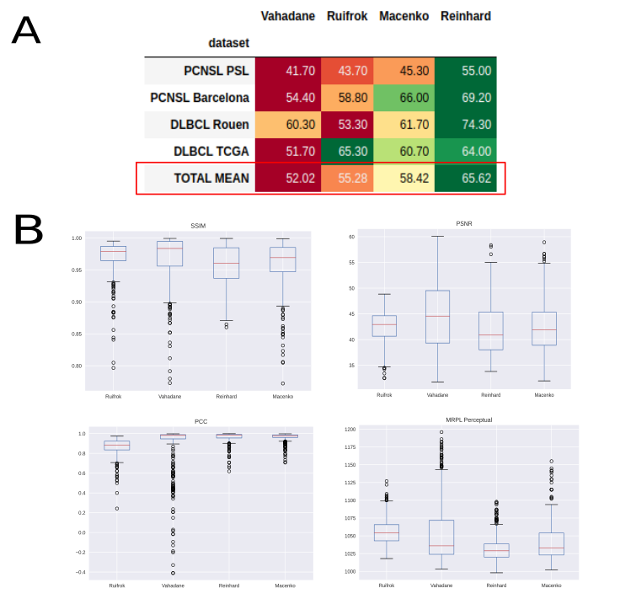
Figure S4: A. Score segmentation obtained by our neuropathologist on 30 patches per dataset (visual control). B. Different metrics on 350 patches per dataset; for SSIM, PSNR and PCC, the higher the metric is, the better the normalization perfoms. Conversely, the MRPL Perceptuel measures a distance; thus, the lower the distance is, the better the normalization perfoms.

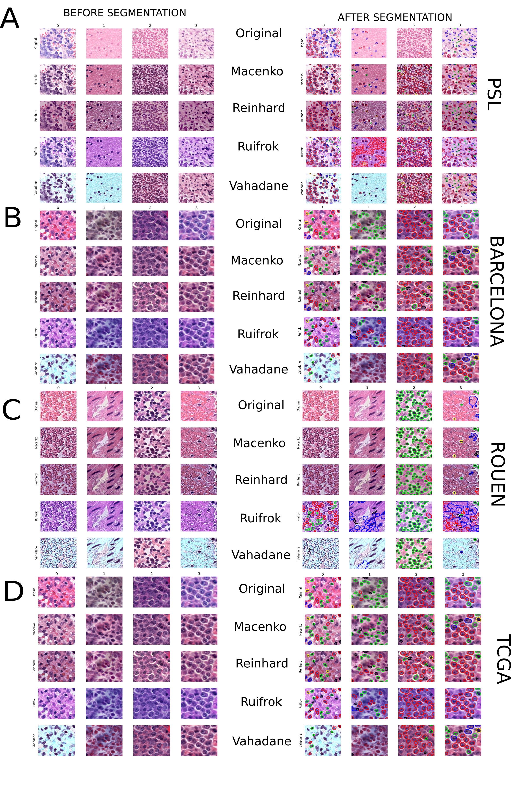
Figure S5: Patches with different normalization methods before HoVer-Net segmentation (left column) and after segmentation (right column) for PSL dataset (A), Barcelona dataset (B), Rouen dataset (C) and TCGA dataset (D). Each column represents a different patch. The color of the segmented cells inside in right-sided patches are the different cell labels included in the Pannuke dataset that were considered for segmentation quality purposes but not included in the final analysis.
HoVer-Net
We used the PyTorch version of HoVer-Net¹⁴ (https://github.com/vqdang/hover_net) with default hyperparameters for 40x magnification. The fast mode was selected as it’s indicated for model checkpoints trained on the PanNuke dataset¹⁵. As we wanted to check the classification part, we chose nr_types = 6. It should be noted that we did not use the output labels in the rest of the pipeline and were only considered for the quality of segmentation.
HoVer-Net¹⁴ is a deep learning model that allows simultaneous instance segmentation and classification. HoVer-Net is constructed using a ResNet with pre-activation residual units Preact-ResNet50¹⁶ implementation, using a down-sampling factor of 8 by using a stride of 1 in the first convolution and removing the subsequent max-pooling operation. Various residual units were applied throughout the network at different down-sampling levels. A series of consecutive residual units was denoted as a residual block. The number of residual units within each residual block was 3, 4, 6 and 3 that are applied at down-sampling levels 1, 2, 4 and 8 respectively. For clarity, a down-sampling level of 2 means that the input had a reduction in the spatial resolution by a factor of 2. Following Preact-ResNet50, we performed nearest neighbor up-sampling via three distinct branches to simultaneously obtain accurate nuclear instance segmentation and classification. The model was divided into three branches: i) nuclear pixel (NP) predicted whether or not a pixel belongs to the nuclei or background ; ii) HoVer branch predicted the horizontal and vertical distances of nuclear pixels to their centers of mass. Then, the nuclear classification (NC) branch predicts the type of nucleus for each pixel. In particular, the NP and HoVer branches jointly achieve nuclear instance segmentation by first separating nuclear pixels from the background (NP branch) and then separating touching nuclei (HoVer branch). The NC branch determines the type of each nucleus by aggregating the pixel-level nuclear type predictions within each instance. However, it should be highlighted that in this study we did not use the label instance as we did not have a previously trained dataset on PCNSL samples.
In the following step, we proceeded with the filtering of nuclei. Two filtering steps have been established : firstly, we removed all the nuclei located on the borders of the patches; if the ROI, defined by a set of coordinates (x_{i}, y_{i}) has one of them with a value of 0 or 223, this ROI was removed. This allowed us to remove truncated nuclei. Secondly, in order to remove wrong segmentations such as blood cells or artifacts, we kept nuclei with pixels between 32 and 350 pixels, as previously described¹⁷. The value of 350 was decided empirically, as 432 was too high to detect some segmentation mistakes.
After nuclei filterings, we made a selection of patches for each patient. We sorted the patches in descending order of the number of filtered nuclei. Then, while the number of nuclei of selected patches did not exceed 5000, we included the first patch in our selection, then the second, etc.
At the end, we obtain between 26 and 681 patches per patient.
PyRadiomics details analysis
PyRadiomics¹⁸ is a Python open-source library to extract radiomics features from medical images. We added the following first-order features. They describe the distribution of voxel intensities within the image region defined by the mask through commonly used and basic metrics (for the set values of the pixels inside the region or interest the, minimum, maximum, mean, median, 10th percentile, 90th percentile, interquartile range, range, mean absolute deviation, robust mean absolute deviation, variance, root mean squared, kurtosis, uniformity, energy, total energy, entropy and skewness are computed).
In addition, we used 2D shape features of the region of interest (ROI) (elongation, majors axis length, maximum diameter, mesh surface, perimeter, perimeter surface ratio, pixel surface and sphericity).
Furthermore we used several texture features like Gray Level Size Zone Matrix (gray level non uniformity, gray level non uniformity normalized, gray level variance, high grey level zone emphasis, large area emphasis, large area high gray level emphasis, large area low gray emphasis, low gray level zone emphasis, size zone non uniformity, size zone non uniformity normalized, size zone non uniformity, size zone non uniformity normalized, small area emphasis, small area high gray level emphasis, small area low gray level emphasis, zone entropy, zone percentage, zone variance), Gray Level Run Length Matrix (Gray level non uniformity, gray level non uniformity normalized, gray level variance, high gray level run emphasis, long run emphasis, long run high gray level emphasis, long run low gray level emphasis, low gray level run emphasis, run entropy, run length non uniformity, run length non uniformity normalized, run percentage, run variance, short run emphasis, short run high gray level emphasis, short run low gray level emphasis), Gray Level Dependance Matrix (dependence entropy, dependence non uniformity, dependence non uniformity normalized, dependence variance, gray level non uniformity, gray level variance, high gray level emphasis, large dependence emphasis, large dependence high gray level emphasis, large dependence low gray level emphasis, low gray level emphasis, small dependence emphasis, small dependence emphasis, small dependence high gray level emphasis, small dependence low gray level emphasis), Neighbouring Gray Tone Difference Matrix (busyness, coarseness, complexity, contrast, strength), Gray Level Co-occurrence Matrix (Autocorrelation, cluster prominence, cluster shade, cluster tendency, contrast, correlation, difference average, difference entropy, difference variance, informational measure of correlation 1, informational measure of correlation 2, inverse difference moment, maximal correlation coefficient, inverse difference moment normalized, inverse difference, inverse difference normalized, inverse variance, joint average, joint energy, joint entropy, maximum probability, sum average, sum entropy, sum squares).
Then, we applied wavelet filtering with either a High or a Low pass filter in each of the two dimensions, using default parameters (Coiflet 1 wavelets).
All the details on each PyRadiomics features can be found https://pyradiomics.readthedocs.io/en/latest/features.html
All these features with the exception of the first order statistics were computed throught these 4 filters. Finally, we obtained 474 radiomics features.
Clustering-constrained Attention Multiple instance learning (CLAM) analysis
CLAM¹⁹ is a deep-learning-based weakly-supervised method that uses attention-based learning to automatically identify sub-regions of high diagnostic value in order to accurately classify the whole slide, while also utilizing instance-level clustering over the representative regions identified to constrain and refine the feature space. For whole slide-level learning without annotation, CLAM uses an attention-based pooling function for aggregating patch-level features into slide-level representations for classification. We used CLAM for different classification tasks: i) the detection of MYD88 L265P mutation on PCNSL samples; ii) the classification of survival with cut-off of either > 12 months or > 36 months (after removing patients who survived less than 3 months), iii) the classification of normal brain (without brain tumor) from PCNSL samples using EBRAINs datasets (https://search.kg.ebrains.eu/instances/Dataset/8fc108ab-e2b4-406f-8999-60269dc1f994, 47 files from the “Control” directory and 59 from the “ Diffuse Large B-cell lymphoma of the CNS” directory) and the classification of GC versus nonGC samples in systemic LBCL for Rouen dataset.
Visium spatial transcriptomics analysis
We downloaded a previously published spatial transcriptomics dataset performed on several PCNSL samples²⁰. We used Starfysh²¹ to analyze Visium 10X spatial transcriptomics. Starfysh is built on scanpy²² and Anndata²³ libraries. We used the expression count file (i.e. filtered_bc_matrix.h5), and a subdirectory with corresponding H&E image and spatial information, as provided by Visium platform. All data was downloaded from (https://www.ncbi.nlm.nih.gov/geo/query/acc.cgi?acc=GSE203552). We used the annotated signatures (marker genes) to define each cluster / molecular group of PCNSL from Table S14. The preprocessing steps take the raw count matrix as input without normalization after filtering out ribosomal and mitochondrial genes. To account for expression sparsity and noise, we selected the top 2,000 highly variable genes including specified marker genes. Then, we performed normalized raw counts by library size and spatial smoothed library size (log-transformed). We estimated anchor spot indices for each cell type and their signature means. Starfysh identified candidates for cell types via archetypal analysis (AA). The underlying assumption was that the geometric “extremes” were identified as the purest cell types, whereas all other spots are mixture of the “archetypes”. We performed integrative inference of expression and the paired histology image using the Products of Expert (PoE) model²⁴, which projects different data modalities into the joint latent space to aid deconvolution with actual spatial information. Finally, we represented the inferred cell-type proportions (spatial map) using different plot functions from scanpy library.
ScRNA analysis
We used the published scRNA PCNSL dataset²⁵ and we implemented the representation of the 4 clusters of PCNSL considering them different cell states, using a similar representation as proposed in Neftel et al²⁶. The downloaded dataset (https://zenodo.org/records/7813151) was analyzed using Seurat pipeline²⁷ with default parameters. We used SCpubr²⁸ for this representation where enrichment scores were computed for all 4 gene sets and the cells were located in the resulting figure according to the list they are most enriched on, towards a given corner. The values were computed as the log2 logarithm of the absolute of the difference in enrichment scores plus 1: log2(abs((CS1 or C2) - (CS3 or CS4)) + 1), where CS1-4 represent the 4 clusters of PCNSL using the gene list of Table S14.
MYD88 L265P somatic mutation detection
In the PSL dataset MYD88 L265P was assessed using digital PCR. Briefly, Digital PCR show that the combination of limiting dilution, end-point PCR, and Poisson statistics could yield an absolute measure of nucleic acid concentration in a sample. Unique method was developed whereby a sample is diluted and partitioned in order to single template molecules can be amplified individually, each in a separate partition, and the products detected using fluorescent probes²⁹.
Tumor DNA is extracted with the Maxwell® RSC DNA FFPE Kit before being used for the detection of MYD88 by digital droplet PCR. We used “ddPCR™ Mutation Assay: MYD88 p.L265P, Human, Homo sapiens” probe where mutant target and wild-type assays are mixed together in a single tube, with the combination of FAM and HEX targeting the mutant and wild-type alleles, respectively. Droplets are generated with QX200 Droplet Generation and readed with the QX200 droplet Reader.
The PCR sample was partitioned into 20,000 droplets. After amplification, droplets containing target sequences were detected by fluorescence and scored as positive, and droplets without fluorescence were scored as negative. Poisson statistical analysis of the numbers of positive and negative droplets yielded absolute quantification of the target sequence. Results were analyzed with QuantaSoft Analysis Pro. We defined a mutant MYD88 sample if more than 1% of the generated droplets are positives. Sequence and coordinates from the reference genome around the assay’s amplicon was: hg19|chr3:38182580-38182702:+ GGGGCAAGGGCCTGATGCCAGCATGGCACCCCTTGGCTTGCAGGTGCCCATCAGAAGCGAC[T/C]GATCCCCATCAAGTACAAGGCAATGAAGAAAGAGTTCCCCAGCATCCTGAGGTTCATCACT.
In the Barcelona cohort, the MYD88 L265P mutation analysis was performed on a PyroMark Q24 platform (Qiagen) following incubation with a forward sequencing primer. Allele frequency was quantified utilizing the PyroMark Software (Qiagen). Primers were designed and synthesized as follows: MYD88-265-forward: 5'-GAATGTGTGCCAGGGGTACTT; MYD88-265-reverse: 5'-Bioin-TCAGGATGCTGGGGAACTC, as previously described³⁰.

Classification metrics
Table S15 Theoretical confusion matrix for a classification, showing the different classification metrics used in the present study
 |  | Predicted condition
 | Total population  = P + N | Positive (PP) | Negative (PN)
Actual condition | Positive (P) | True positive (TP) | False negative (FN) | True positive rate (TPR), recall, sensitivity  = TP/P = 1 − FNR | False negative rate (FNR)  = FN/P = 1 − TPR
Actual condition | Negative (N) | False positive (FP) | True negative (TN), correct rejection | False positive rate (FPR) = FP/N = 1 − TNR | True negative rate (TNR), specificity, selectivity = TN/N = 1 − FPR
 |  | Precision or Positive predictive value (PPV), precision = TP/PP = 1 − FDR | False omission rate (FOR) = FN/PN = 1 − NPV
 | Accuracy (ACC) = TP + TN/P + N | False discovery rate (FDR)  = FP/PP = 1 − PPV | Negative predictive value (NPV) = TN/PN = 1 − FOR
 |  | F1 score = 2 PPV × TPR/PPV + TPR = 2 TP/2 TP + FP + FN
The different classification used at the different tasks are summarized in the Table S8, S10-S12. In addition, the AUROC was estimated as following False Positive Rate (FPR) (x) vs. True Positive Rate (TPR) (y), being TPR = TP / (TP+ FN) and false positive rate (FDR) also known as 1 - specificity) 1 - (TN / (TN + FP). The AUCPR is an average of the precision weighted by the probability of a given threshold.
PLS Cox components
The number of components of the PLS Cox models was obtained with cross-validation (cv = 5). We used the default parameters in the cv.plsRcox function from plsRcox package, using the integrated Song and Zhou’s estimator³¹ of cumulative/dynamic AUC for right-censored time-to-event data (iAUCSH), as it was found to be the best CV criterion for the PLS-Cox in a previous study³². We found 15 the best number of PLS Cox components.
Other functions used to plot the results
The results from PLS Cox model were plotted using R package forestploter v1.1.1 https://github.com/adayim/forestploter to represent the hazard ratio of each component from the PLS Cox model.
The main clinical characteristics of each dataset used in this study were summarized using ComplexUpset R package v1.3.5 https://github.com/krassowski/complex-upset/.
The different heatmaps to represent the correlation and associations of each component from the PLS Cox model were plotted using the Python library PyComplexHeatmap v1.6.1 https://github.com/DingWB/PyComplexHeatmap/tree/main

References
1. Otsu N. A Threshold Selection Method from Gray-Level Histograms. IEEE Trans Syst Man Cybern.9,62–66 (1979).
2. Vrabac D, Smit A, Rojansky R, Natkunam Y, Advani RH, Ng AY, et al. DLBCL-Morph: Morphological features computed using deep learning for an annotated digital DLBCL image set. Sci Data.8,135 (2021).
3. Pocock J, Graham S, Vu QD, Jahanifar M, Deshpande S, Hadjigeorghiou G, et al. TIAToolbox as an end-to-end library for advanced tissue image analytics. Commun Med.2,1–14 (2022).
4. Reinhard E, Adhikhmin M, Gooch B, Shirley P. Color transfer between images. IEEE Comput Graph Appl.21,34–41 (2001).
5. Ruifrok AC, Johnston DA. Quantification of histochemical staining by color deconvolution. Anal Quant Cytol Histol.23,291–299 (2001).
6. Macenko M, Niethammer M, Marron JS, Borland D, Woosley JT, Guan X, et al. A method for normalizing histology slides for quantitative analysis. In 2009 IEEE International Symposium on Biomedical Imaging: From Nano to Macro 2009 [cited October 24, 2023]; 1107–1110. Available at: https://ieeexplore.ieee.org/abstract/document/5193250
7. Vahadane A, Peng T, Sethi A, Albarqouni S, Wang L, Baust M, et al. Structure-Preserving Color Normalization and Sparse Stain Separation for Histological Images. IEEE Trans Med Imaging.35,1962–1971 (2016).
8. Roy S, kumar Jain A, Lal S, Kini J. A study about color normalization methods for histopathology images. Micron.114,42–61 (2018).
9. Dosovitskiy A, Brox T. Generating Images with Perceptual Similarity Metrics based on Deep Networks [Internet]. arXiv 2016 [cited October 23, 2023]. Available at: http://arxiv.org/abs/1602.02644
10. Wang Z, Bovik AC, Sheikh HR, Simoncelli EP. Image quality assessment: from error visibility to structural similarity. IEEE Trans Image Process.13(4):600–612 (2004).
11. Huynh-Thu Q, Ghanbari M. Scope of validity of PSNR in image/video quality assessment. Electron Lett.44,800–801 (2008).
12. SOPER HE, YOUNG AW, CAVE BM, LEE A, PEARSON K. ON THE DISTRIBUTION OF THE CORRELATION COEFFICIENT IN SMALL SAMPLES. APPENDIX II TO THE PAPERS OF “STUDENT” AND R. A. FISHER. A COOPERATIVE STUDY. Biometrika.11,328–413 (1917).
13. Mohapatra S, Weisshaar JC. Modified Pearson correlation coefficient for two-color imaging in spherocylindrical cells. BMC Bioinformatics.19,428 (2018).
14. Graham S, Vu QD, Raza SEA, Azam A, Tsang YW, Kwak JT, et al. Hover-Net: Simultaneous segmentation and classification of nuclei in multi-tissue histology images. Med Image Anal.58,101563 (2019).
15. Gamper J, Koohbanani NA, Benes K, Graham S, Jahanifar M, Khurram SA, et al. PanNuke Dataset Extension, Insights and Baselines [Internet]. arXiv.org. 2020 [cited October 25, 2023]. Available at: https://arxiv.org/abs/2003.10778v7
16. He K, Zhang X, Ren S, Sun J. Identity Mappings in Deep Residual Networks. In Leibe B, Matas J, Sebe N, Welling M (eds): Computer Vision – ECCV 2016 Cham: Springer International Publishing 2016; 630–645. (Lecture Notes in Computer Science).
17. El Hussein S, Chen P, Medeiros LJ, Hazle JD, Wu J, Khoury JD. Artificial intelligence-assisted mapping of proliferation centers allows the distinction of accelerated phase from large cell transformation in chronic lymphocytic leukemia. Mod Pathol Off J U S Can Acad Pathol Inc.35,1121–1125 (2022).
18. van Griethuysen JJM, Fedorov A, Parmar C, Hosny A, Aucoin N, Narayan V, et al. Computational Radiomics System to Decode the Radiographic Phenotype. Cancer Res.77,e104–e107 (2017).
19. Lu MY, Williamson DFK, Chen TY, Chen RJ, Barbieri M, Mahmood F. Data-efficient and weakly supervised computational pathology on whole-slide images. Nat Biomed Eng.5,555–570 (2021).
20. Heming M, Haessner S, Wolbert J, Lu I-N, Li X, Brokinkel B, et al. Intratumor heterogeneity and T cell exhaustion in primary CNS lymphoma. Genome Med.14,109 (2022).
21. He S, Jin Y, Nazaret A, Shi L, Chen X, Rampersaud S, et al. Starfysh reveals heterogeneous spatial dynamics in the breast tumor microenvironment [Internet]. bioRxiv 2022 [cited October 21, 2023]; 2022.11.21.517420. Available at: https://www.biorxiv.org/content/10.1101/2022.11.21.517420v1
22. Wolf FA, Angerer P, Theis FJ. SCANPY: large-scale single-cell gene expression data analysis. Genome Biol.19,15 (2018).
23. Virshup I, Rybakov S, Theis FJ, Angerer P, Wolf FA. anndata: Annotated data [Internet]. bioRxiv 2021 [cited October 23, 2023]; 2021.12.16.473007. Available at: https://www.biorxiv.org/content/10.1101/2021.12.16.473007v1
24. Lee C, Schaar M van der. A Variational Information Bottleneck Approach to Multi-Omics Data Integration. In Proceedings of The 24th International Conference on Artificial Intelligence and Statistics PMLR 2021 [cited October 23, 2023]; 1513–1521. Available at: https://proceedings.mlr.press/v130/lee21a.html
25. Liu N, Jiang C, Yao X, Fang M, Qiao X, Zhu L, et al. Single-cell landscape of primary central nervous system diffuse large B-cell lymphoma. Cell Discov.9,1–17 (2023).
26. Neftel C, Laffy J, Filbin MG, Hara T, Shore ME, Rahme GJ, et al. An Integrative Model of Cellular States, Plasticity, and Genetics for Glioblastoma. Cell. 178,835-849.e21 (2019).
27. Hao Y, Hao S, Andersen-Nissen E, Mauck WM, Zheng S, Butler A, et al. Integrated analysis of multimodal single-cell data. Cell.184,3573-3587.e29 (2021).
28. Blanco-Carmona E. Generating publication ready visualizations for Single Cell transcriptomics using SCpubr [Internet]. bioRxiv 2022 [cited October 23, 2023]; 2022.02.28.482303. Available at: https://www.biorxiv.org/content/10.1101/2022.02.28.482303v1
29. Vogelstein B, Kinzler KW. Digital PCR. Proc Natl Acad Sci U S A.96,9236–9241 (1999).
30. Gebauer N, Bernard V, Röhner C, Krokowski M, Merz H, Feller AC, et al. Pyrosequencing as a Fast and Reliable Method in Detecting the MYD88 p.L265P Mutation in Decalcified Formalin-Fixed and Paraffin-Embedded Tissues. Ann Lab Med.34,170–173 (2014).
31. Song X, Zhou X-H. A Semiparametric Approach for the Covariate Specific Roc Curve with Survival Outcome. Stat Sin.18,947–965 (2008).
32. Bertrand F, Maumy-Bertrand M. Fitting and Cross-Validating Cox Models to Censored Big Data With Missing Values Using Extensions of Partial Least Squares Regression Models. Front Big Data. 2021,684794 (2008).

