Supplementary Information

Table S1 The concepts of phenotypic plasticity, developmental canalization and developmental stability and their definitions, evaluation indexes and calculation formulas (with sources) used in this study.
Concept | Definition | Evaluation | Abbrev. | Calculation
Developmental stability | The tendency of traits to resist the effect of developmental errors (Palmerand Strobeck 1986). | Fluctuating asymmetry -- random deviation from perfect bilateral symmetry (Møllerand Swaddle 1997) | FA | FA₁ = ∑│R - L│/n  FA₂ = ∑[(R - L)/S]/n  FA₁₀ = 0.798×√s²  where s²= (MS_{sj} - MS_{m})/M, R and L were the width of right and left sides of a leaf, n was the total number of leaves, and S (leaf size) was calculated by (R+L)/2) (Palmerand Strobeck 1986; Palmerand Strobeck 2003)
Canalization | The ability of a genotype to produce consistent phenotypes regardless of environmental and genetic variabilities (Waddington 1942). | Coefficient of variation (Woods et al. 1999) | CV | The standard deviation divided by mean value of the trait.
Phenotypic plasticity | The shift in phenotype due to changes in environments (Schlichting 1986). | The difference in a given trait due to environmental effects (Valladares et al. 2006) | PI | PI = (X – Y)/(X + Y)  where X was the adjusted mean trait value of plants in shading or deep depth, and Y was the adjusted mean value in full light or shallow depth (Valladares et al. 2006)

Table S2 All the formulas for FA indexes (Palmer and Strobeck 1986, 1994, 2003) used in this study. R and L were the widths of right and left sides of a leaf, n was the total number of leaves, and LS (leaf size) was calculated by (R+L)/2, MS_{sj} was the mean squares of side × individual interaction, MS_{m} was the mean squares of measurement error, M was the number of replicate measurements per side, from a side × individual ANOVA on untransformed replicate measurements of R and L.
Index | Formula
FA₁ | mean│R - L│
FA₂ | mean (│R - L│/ LS)
FA₃ | mean│R - L│/ mean LS
FA₄ | 0.798 ×√var (R - L)
FA₅ | 0.798 × [ ∑(R - L)² / n]
FA₆ | 0.798×√var [(R - L) / LS]
FA₇ | 0.798×√var (R - L) / mean LS
FA₈ | mean│ln(R/L)│
FA₁₀ | 0.798 × √ (MS_{sj} - MS_{m}) / M

Table S3 F values for three-way ANOVA on mean values of leaf size (LS) and FA indexes with growth stage (GS), population density (PD) and architectural layer (AL) as effects. * P < 0.05, ** P < 0.01, *** P < 0.001.
Source of variation | Df. | LS | PL | PA | FA₁ | FA₂ | FA₄ | FA₅ | FA₆ | FA₈
GS | 1 | 53.43*** | 503.29*** | 226.68*** | 51.13*** | 28.67*** | 0.03 | 28.31*** | 0.17 | 0.17
PD | 2 | 123.80*** | 89.94*** | 14.73*** | 17.75*** | 1.92 | 2.37 | 12.74*** | 3.01* | 3.00
AL | 2 | 8.78*** | 37.74*** | 11.05*** | 8.36*** | 12.01*** | 0.85 | 5.80*** | 0.66 | 0.67
GS × PD | 53 | 2.77 | 12.81*** | 16.03*** | 0.99 | 2.35 | 1.97 | 1.90 | 1.59 | 1.60
GS × AL | 2 | 10.40*** | 1.36 | 3.46** | 3.58** | 6.38**** | 1.67 | 4.16** | 1.88 | 1.87
PD × AL | 2 | 5.49*** | 1.50 | 3.10*** | 0.60 | 0.64 | 1.12 | 0.52 | 1.50 | 1.49
GS × PD × AL | 4 | 1.52 | 1.08 | 1.33 | 0.91 | 1.49 | 1.78 | 0.93 | 1.56 | 1.56

Table S4 F values for one-way ANOVA on mean values of leaf size (LS) and FA indexes showing effects of population density for different layers (AL, L1~L7) of plants at day 50 and 70. N is the number of individual values; * P < 0.05, ** P < 0.01, *** P < 0.001.
Stage | AL | N | LS | PL | PA | FA₁ | FA₂ | FA₄ | FA₅ | FA₆ | FA₈
Day 50 | L1 | 5 | 1.14 | 1.68 | 1.69 |  |  | 0.01
 | L2 | 69 | 25.21** | 33.02*** | 1.09 | 5.71** | 3.69* | 0.51 | 3.60* | 0.40 | 0.40
 | L3 | 89 | 13.26*** | 3.10* | 18.57*** | 2.58 | 0.42 | 0.10 | 1.59 | 0.18 | 0.18
 | L4 | 109 | 22.26*** | 9.44*** | 8.70*** | 1.93 | 0.67 | 2.32 | 1.41 | 2.71 | 2.72
 | L5 | 101 | 7.80*** | 0.80 | 3.55* | 3.62* | 1.55 | 0.94 | 1.35 | 0.62 | 0.62
 | L6 | 62 | 0.49 | 0.08 | 1.93 | 0.51 | 0.39 | 0.85 | 0.49 | 1.07 | 1.07
 | L7 | 21 | 1.21 | 0.18 | 2.75 | 1.70 | 0.62 | 1.27 | 1.83 | 1.69 | 1.69
Day 70 | L1 | 17 | 7.19* | 1.81 | 1.70
 | L2 | 98 | 100.25** | 41.01*** | 2.54 | 2.18 | 0.63 | 1.31 | 2.15 | 2.86 | 2.86
 | L3 | 122 | 70.37*** | 43.91*** | 5.29** | 1.66 | 1.01 | 0.22 | 3.02 | 0.17 | 0.17
 | L4 | 121 | 20.50*** | 26.03*** | 13.63*** | 5.50** | 2.37 | 1.97 | 4.37* | 2.33 | 2.33
 | L5 | 143 | 5.45** | 18.94*** | 1.22 | 2.42 | 2.60 | 3.83* | 3.92* | 3.29* | 3.28*
 | L6 | 39 | 0.44 | 15.00*** | 0.56 | 0.43 | 0.03 | 4.97* | 1.41 | 3.54* | 3.54*

Table S5 F values for one-way ANOVA on mean values of leaf size (LS) and FA indexes showing effects of architectural layer for plants at low (L), medium (M) and high (H) densities (PD) at day 50 and 70. N is the number of individual values; * P < 0.05, ** P < 0.01, *** P < 0.001.
Stage | PD | N | LS | PL | PA | FA₁ | FA₂ | FA₄ | FA₅ | FA₆ | FA₈
Day 50 | L | 170 | 4.05*** | 10.25*** | 1.43 | 1.03 | 1.60 | 1.10 | 1.34 | 1.43 | 1.43
 | M | 148 | 2.11 | 3.89** | 1.94 | 1.01 | 0.71 | 0.53 | 0.89 | 0.48 | 0.48
 | H | 138 | 2.06 | 4.46*** | 2.25 | 0.75 | 0.52 | 0.92 | 0.58 | 1.18 | 1.18
Day 70 | L | 202 | 23.31*** | 11.61*** | 5.08*** | 3.16** | 6.76*** | 0.41 | 3.81** | 0.28 | 0.28
 | M | 189 | 5.80*** | 6.41*** | 7.29*** | 5.48*** | 7.93*** | 1.46 | 4.24** | 1.31 | 1.31
 | H | 149 | 2.70* | 21.12*** | 11.42*** | 2.80* | 2.10 | 4.65** | 3.09* | 4.08** | 4.08**

Table S6 Descriptive statistics of leaf size (LS, calculated as [R+L]/2) and FA for individual leaves from stem base to the top along the vertical direction (L1~L7) of plants at low, medium and high densities at day 50. N is the number of individuals (with multiple leaves per individual); significant values for the slope from regression of |R - L| versus LS and for kurtosis or skew of (R-L) were marked by * (P < 0.05) or ** (P < 0.01). MS_{m} = measurement error mean square, σ_{i}² = non-directional asymmetry, df = approximate degree of freedom for non-directional asymmetry after partitioning out measurement error.
Density | Leaf | N | (R+L)/2  Mean±SE | |R-L| vs. LS  Slope±SE | R - L |  |  | |R-L|=FA₁  Mean±SE | FA₁₀
 |  |  |  |  | Mean±SE | Skew±SE | Kurtosis±SE | |R-L|=FA₁  Mean±SE | MS_{m} | σ_{i}² | df
Low | L1 | 2 | 36.21±1.19 |  | 1.130±0.12 | ± | ± | 1.13±0.12 | 0.0013 | 0.00076 | 0.915
 | L2 | 16 | 56.03±2.31 | 0.044±0.062 | -1.573±1.34 | -1.054±0.41 | 1.468±0.80* | 4.28±0.91 | 0.023 | 488.49 | 31.93
 | L3 | 18 | 64.09±2.78 | 0.003±0.024 | 0.005±0.95 | -0.011±0.39 | -0.691±0.76 | 3.43±0.56 | 0.039 | 152.64 | 35.77
 | L4 | 16 | 69.42±2.85 | 0.003±0.027 | -0.536±0.63 | -0.290±0.43 | 0.241±0.85 | 2.68±0.46 | 0.0035 | 93.20 | 27.98
 | L5 | 14 | 64.47±3.49 | 0.029±0.021 | 0.172±0.55 | 0.336±0.36 | -0.126±0.71 | 2.84±0.33 | 0.131 | 228.74 | 41.28
 | L6 | 7 | 59.48±6.40 | 0.011±0.031 | 1.364±0.87 | -1.281±0.54 | 2.776±1.04 | 2.76±0.62 | 0.007 | 102.18 | 16.98
 | L7 | 2 | 58.29±1.94 | -0.044±0.096 | 1.323±4.44 | -0.122±0.75 | -1.287±1.48 | 5.08±0.91 | 0.113 | 982.16 | 6.95
Medium | L1 | 3 | 31.71±3.36 |  | 1.020±0.87 |  |  | 1.02±0.87 | 0.004 | 5.21 | 1.99
 | L2 | 14 | 47.68±1.96 | 0.013±0.031 | 0.039±0.39 | -0.063±0.46 | -0.625±0.89 | 1.54±0.22 | 0.016 | 13.52 | 24.78
 | L3 | 16 | 53.67±2.17 | 0.086±0.031* | 0.433±0.66 | 0.787±0.42 | 0.920±0.82 | 2.40±0.43 | 0.017 | 103.54 | 29.90
 | L4 | 16 | 55.09±2.24 | 0.036±0.022 | -0.165±0.56 | 0.130±0.34 | -0.104±0.66 | 2.26±0.29 | 0.0099 | 74.73 | 48.89
 | L5 | 7 | 53.92±4.09 | 0.043±0.029 | -1.550±1.07 | -1.037±0.52 | 0.851±1.01 | 2.63±0.80 | 0.048 | 46.88 | 17.75
 | L6 | 5 | 49.48±4.72 | 0.019±0.029 | 0.771±0.52 | -0.046±0.58 | -0.850±1.12 | 2.49±0.15 | 0.214 | 45.30 | 13.15
 | L7 | 1 | 49.70 | -0.077±0.069 | 1.044 | -0.031±1.01 | 5.814±2.62 | 2.46 | 0.006 | 65.42 | 3.00
High | L2 | 9 | 35.24±2.06 | -0.005±0.039 | 0.003±0.33 | -0.720±0.69 | 0.342±1.33 | 0.81±0.17 | 0.021 | 1.70 | 8.71
 | L3 | 16 | 42.52±2.23 | -0.002±0.040 | 0.057±0.50 | 0.151±0.50 | 0.575±0.97 | 1.64±0.28 | 0.031 | 30.43 | 19.78
 | L4 | 18 | 47.25±2.28 | 0.048±0.022* | 0.426±0.66 | -0.097±0.43 | 1.245±0.83 | 2.40±0.41 | 0.106 | 25.31 | 27.814
 | L5 | 15 | 49.28±2.81 | 0.059±0.031 | 1.273±0.80 | 1.803±0.38 | 5.09±0.74** | 2.46±0.69 | 0.0078 | 74.23 | 37.93
 | L6 | 8 | 50.35±2.75 | 0.055±0.031 | 0.077±0.34 | -0.887±0.43 | 1.792±0.85 | 2.15±0.31 | 0.0018 | 75.66 | 27.99
 | L7 | 2 | 45.60±5.04 | -0.040±0.068 | -1.425±0.60 | -1.577±0.72 | 2.955±1.40 | 2.23±0.28 | 0.011 | 84.54 | 7.98

Table S7 Descriptive statistics of leaf size (LS, calculated as [R+L]/2) and FA for individual leaves from stem base to the top along the vertical direction (L1~L7) of plants at low, medium and high densities at day 70. N is the number of individuals (with multiple leaves per individual); significant values for the slope from regression of |R - L| versus LS and for kurtosis or skew of (R-L) were marked by * (P < 0.05) or ** (P < 0.01). MS_{m} = measurement error mean square, σ_{i}² = non-directional asymmetry, df = approximate degree of freedom for non-directional asymmetry after partitioning out measurement error.
Density | Leaf | N | (R+L)/2  Mean±SE | |R-L| vs. LS  Slope±SE | R - L |  |  | |R-L|=FA₁  Mean±SE | FA₁₀
 |  |  |  |  | Mean±SE | Skew±SE | Kurtosis±SE | |R-L|=FA₁  Mean±SE | MS_{m} | σ_{i}² | df
Low | L1 | 6 | 65.42±5.96 | 0.116±0.058 | -0.859±1.42 | -0.178±0.72 | -0.414±1.40 | 3.089±0.934 | 0.0625 | 244.25 | 7.94
 | L2 | 16 | 76.33±2.95 | 0.074±0.027** | 0.325±0.50 | -0.413±0.37 | -0.147±0.72 | 3.012±0.426 | 0.00212 | 203.57 | 39.99
 | L3 | 16 | 78.11±2.90 | 0.030±0.040 | 0.398±0.78 | -0.496±0.37 | 0.487±0.72 | 3.359±0.554 | 0.00698 | 427.30 | 39.97
 | L4 | 17 | 71.69±2.93 | -0.009±0.045 | 1.385±1.27 | 0.156±0.39 | -0.982±0.76 | 4.853±0.665 | 0.500 | 1340.51 | 35.03
 | L5 | 17 | 63.44±3.26 | 0.069±0.032* | 1.356±1.24 | 0.214±0.33 | -0.769±0.64 | 4.923±0.487 | 0.163 | 1307.02 | 51.53
 | L6 | 11 | 46.51±3.97 | 0.025±0.034 | -0.426±1.58 | 0.047±0.50 | -1.104±0.97 | 4.407±0.836 | 0.023 | 326.93 | 19.95
Medium | L1 | 6 | 50.67±1.38 | 0.040±0.082 | 0.220±1.06 | 0.272±0.75 | -1.568±1.48 | 2.025±0.556 | 0.125 | 33.70 | 6.70
 | L2 | 18 | 57.40±1.31 | 0.068±0.051 | -0.359±0.55 | 0.273±0.38 | 0.176±0.75 | 2.360±0.377 | 0.00139 | 97.67 | 39.99
 | L3 | 18 | 60.81±1.39 | 0.018±0.056 | 0.962±0.70 | 0.286±0.37 | 0.318±0.72 | 3.145±0.478 | 0.427 | 136.38 | 38.13
 | L4 | 18 | 60.06±2.24 | -0.100±0.045* | 1.209±0.99 | 0.214±0.36 | 0.085±0.71 | 3.993±0.489 | 0.0237 | 802.69 | 41.93
 | L5 | 15 | 52.67±4.16 | 0.060±0.020** | 0.572±1.33 | -0.507±0.33 | -0.595±0.64 | 4.485±0.502 | 0.145 | 832.35 | 51.48
 | L6 | 2 | 48.99±15.34 | 0.147±0.093 | 0.960±4.76 | -0.054±0.91 | -2.436±2.00 | 4.883±1.085 | 0.00338 | 556.66 | 4.00
High | L2 | 10 | 41.13±2.63 | 0.023±0.033 | 0.873±0.56 | 0.142±0.52 | 0.275±1.01 | 1.980±0.265 | 0.0398 | 23.92 | 17.71
 | L3 | 18 | 48.22±2.42 | 0.034±0.020 | 0.448±0.55 | 0.060±0.38 | -1.039±0.74 | 2.401±0.287 | 0.0433 | 73.23 | 37.62
 | L4 | 17 | 50.43±3.04 | 0.070±0.030* | -0.344±0.55 | 0.034±0.37 | 0.696±0.72 | 2.457±0.354 | 0.117 | 169.08 | 39.29
 | L5 | 13 | 52.06±2.67 | 0.056±0.036 | -1.876±1.01* | 0.435±0.39 | -0.829±0.76 | 3.988±0.458 | 0.238 | 196.09 | 34.80
 | L6 | 6 | 45.48±2.43 | -0.257±0.082* | -3.585±1.45 | 0.777±0.62 | 1.304±1.19 | 4.304±1.039 | 0.000048 | 224.50 | 12.00

Table S8 The results (mean squares [MS] and F-values) of two-way ANOVA for significance of all between-sides variation relative to measurement error, leaf side (S), individual (I), measurement (M) and side and individual interaction (S × I) on the width of leaves for individual leaves from stem base to the top along the vertical direction (L1~L7) of plants at low, medium and high densities at day 50.
Leaf | Sources of variation | Low |  |  |  | Medium |  |  |  | High
Leaf | Sources of variation | Df | MS | F | P | Df | MS | F | P | Df | MS | F | P
L1 | S | 1 | 2.55 | 785.79 | <0.001 | 1 | 3.12 | 873.47 | <0.001
 | I | 1 | 11.23 | 3456.55 | <0.001 | 2 | 135.74 | 37986.78 | <0.001
 | S × I | 1 | 0.029 | 8.862 | 0.059 | 2 | 2.29 | 640.19 | <0.001
 | M | 1 | 0.001 | 0.385 | 0.579 | 1 | 0.004 | 1.13 | 0.337
L2 | S | 1 | 20.59 | 400.44 | <0.001 | 1 | 0.428 | 62.81 | <0.001 | 1 | 0.296 | 38.15 | <0.001
 | I | 32 | 379.53 | 7382.17 | <0.001 | 25 | 217.12 | 31878.59 | <0.001 | 9 | 146.20 | 18853.18 | <0.001
 | S × I | 32 | 22.13 | 430.35 | <0.001 | 25 | 3.69 | 542.24 | <0.001 | 9 | 1.325 | 170.87 | <0.001
 | M | 1 | 0.023 | 0.451 | 0.504 | 1 | 0.016 | 2.35 | 0.132 | 1 | 0.021 | 2.73 | 0.115
L3 | S | 1 | 0.172 | 10.55 | 0.002 | 1 | 2.30 | 98.72 | <0.001 | 1 | 0.183 | 6.60 | 0.014
 | I | 36 | 728.35 | 44748.93 | <0.001 | 30 | 488.98 | 21031.36 | <0.001 | 20 | 300.89 | 10848.06 | <0.001
 | S × I | 36 | 12.39 | 761.45 | <0.001 | 30 | 10.19 | 438.35 | <0.001 | 20 | 5.55 | 199.99 | <0.001
 | M | 1 | 0.039 | 2.39 | 0.126 | 1 | 0.016 | 0.709 | 0.403 | 1 | 0.030 | 1.10 | 0.301
L4 | S | 1 | 20.65 | 519.43 | <0.001 | 1 | 16.48 | 677.69 | <0.001 | 1 | 0.015 | 0.450 | 0.505
 | I | 28 | 796.30 | 20032.42 | <0.001 | 49 | 561.45 | 23088.56 | <0.001 | 36 | 743.38 | 22898.93 | <0.001
 | S × I | 28 | 9.66 | 242.96 | <0.001 | 49 | 8.66 | 355.90 | <0.001 | 36 | 7.90 | 243.23 | <0.001
 | M | 1 | 0.004 | 0.089 | 0.767 | 1 | 0.010 | 0.409 | 0.524 | 1 | 0.075 | 2.31 | 0.133
L5 | S | 1 | 0.234 | 5.86 | 0.018 | 1 | 6.67 | 515.81 | <0.001 | 1 | 17.20 | 469.28 | <0.001
 | I | 42 | 1045.67 | 26135.71 | <0.001 | 18 | 706.02 | 54621.77 | <0.001 | 38 | 545.66 | 14887.43 | <0.001
 | S × I | 42 | 15.26 | 381.30 | <0.001 | 18 | 6.90 | 533.41 | <0.001 | 38 | 8.62 | 235.28 | <0.001
 | M | 1 | 0.131 | 3.28 | 0.074 | 1 | 0.048 | 3.71 | 0.062 | 1 | 0.008 | 0.212 | 0.647
L6 | S | 1 | 32.15 | 1911.72 | <0.001 | 1 | 3.94 | 133.27 | <0.001 | 1 | 1.02 | 69.91 | <0.001
 | I | 17 | 1135.38 | 67519.30 | <0.001 | 14 | 647.56 | 21889.81 | <0.001 | 28 | 555.63 | 38062.30 | <0.001
 | S × I | 17 | 10.12 | 601.58 | <0.001 | 14 | 6.94 | 234.75 | <0.001 | 28 | 8.70 | 596.00 | <0.001
 | M | 1 | 0.007 | 0.416 | 0.523 | 1 | 0.214 | 7.22 | 0.012 | 1 | 0.002 | 0.125 | 0.725
L7 | S | 1 | 23.63 | 1105.76 | <0.001 | 1 | 4.36 | 224.22 | <0.001 | 1 | 16.62 | 1148.85 | <0.001
 | I | 7 | 724.18 | 33883.50 | <0.001 | 3 | 387.42 | 19934.41 | <0.001 | 8 | 696.50 | 48147.25 | <0.001
 | S × I | 7 | 29.53 | 1381.54 | <0.001 | 3 | 8.10 | 416.50 | <0.001 | 8 | 9.21 | 636.33 | <0.001
 | M | 1 | 0.038 | 1.77 | 0.203 | 1 | 0.006 | 0.309 | 0.596 | 1 | 0.011 | 0.738 | 0.402

Table S9 The results (mean squares [MS] and F-values) of two-way ANOVA for significance of all between-sides variation relative to measurement error, leaf side (S), individual (I), measurement (M) and side and individual interaction (S × I) on the width of leaves for individual leaves from stem base to the top along the vertical direction (L1~L7) of plants at low, medium and high densities at day 70.
Leaf | Sources of variation | Low |  |  |  | Medium |  |  |  | High
Leaf | Sources of variation | Df | MS | F | P | Df | MS | F | P | Df | MS | F | P
L1 | S | 1 | 3.39 | 45.32 | <0.001 | 1 | 1.45 | 34.73 | <0.001
 | I | 8 | 594.27 | 7954.83 | <0.001 | 7 | 157.96 | 3774.75 | <0.001
 | S × I | 8 | 15.69 | 210.04 | <0.001 | 7 | 5.93 | 141.71 | <0.001
 | M | 1 | 0.063 | 0.837 | 0.373 | 1 | 0.125 | 2.99 | 0.104
L2 | S | 1 | 1.54 | 23.69 | <0.001 | 1 | 9.99 | 206.39 | <0.001 | 1 | 17.11 | 294.70 | <0.001
 | I | 40 | 551.78 | 8490.45 | <0.001 | 37 | 163.69 | 3383.09 | <0.001 | 17 | 316.87 | 5457.80 | <0.001
 | S × I | 40 | 14.27 | 219.58 | <0.001 | 37 | 9.88 | 204.28 | <0.001 | 17 | 4.93 | 84.92 | <0.001
 | M | 1 | 0.002 | 0.033 | 0.857 | 1 | 0.001 | 0.029 | 0.866 | 1 | 0.040 | 0.686 | 0.413
L3 | S | 1 | 0.458 | 6.09 | 0.016 | 1 | 11.87 | 200.64 | <0.001 | 1 | 15.28 | 242.54 | <0.001
 | I | 40 | 549.95 | 7307.62 | <0.001 | 41 | 150.69 | 2548.21 | <0.001 | 38 | 662.85 | 10522.65 | <0.001
 | S × I | 40 | 20.68 | 274.77 | <0.001 | 41 | 12.11 | 204.72 | <0.001 | 38 | 8.60 | 136.54 | <0.001
 | M | 1 | 0.007 | 0.093 | 0.761 | 1 | 0.427 | 7.23 | 0.009 | 1 | 0.043 | 0.688 | 0.409
L4 | S | 1 | 5.98 | 84.40 | <0.001 | 1 | 91.28 | 1738.08 | <0.001 | 1 | 22.75 | 355.63 | <0.001
 | I | 36 | 647.17 | 9127.94 | <0.001 | 42 | 517.00 | 9844.38 | <0.001 | 40 | 618.34 | 9666.57 | <0.001
 | S × I | 36 | 37.11 | 523.45 | <0.001 | 42 | 28.30 | 538.91 | <0.001 | 40 | 13.12 | 205.11 | <0.001
 | M | 1 | 0.500 | 7.05 | 0.010 | 1 | 0.024 | 0.452 | 0.503 | 1 | 0.117 | 1.83 | 0.180
L5 | S | 1 | 68.02 | 1052.14 | <0.001 | 1 | 51.88 | 1037.89 | <0.001 | 1 | 110.62 | 1485.51 | <0.001
 | I | 52 | 951.33 | 14716.18 | <0.001 | 52 | 1181.89 | 23646.13 | <0.001 | 36 | 344.14 | 4621.53 | <0.001
 | S × I | 52 | 36.32 | 561.78 | <0.001 | 52 | 29.00 | 580.12 | <0.001 | 36 | 14.24 | 191.25 | <0.001
 | M | 1 | 0.163 | 2.52 | 0.115 | 1 | 0.145 | 2.91 | 0.091 | 1 | 0.238 | 3.19 | 0.078
L6 | S | 1 | 1.81 | 43.16 | <0.001 | 1 | 88.20 | 544.44 | <0.001 | 1 | 96.48 | 1842.18 | <0.001
 | I | 20 | 877.14 | 20953.19 | <0.001 | 4 | 1427.14 | 8809.36 | <0.001 | 12 | 229.96 | 4390.87 | <0.001
 | S × I | 20 | 18.10 | 432.67 | <0.001 | 4 | 23.60 | 145.66 | <0.001 | 12 | 14.98 | 286.10 | <0.001
 | M | 1 | 0.023 | 0.542 | 0.466 | 1 | 0.003 | 0.021 | 0.888 | 1 | <0.001 | 0.001 | 0.976

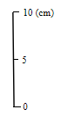

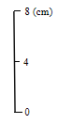
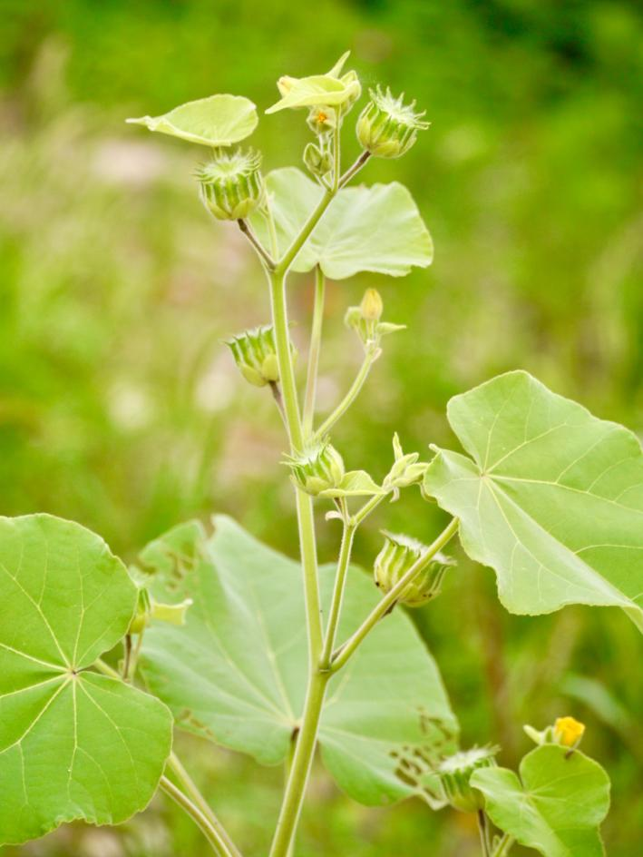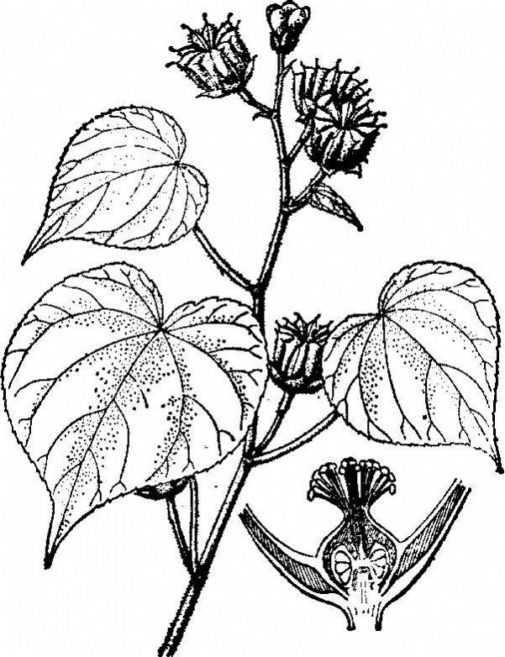
b
d
c
a
8 (cm)
8 (cm)
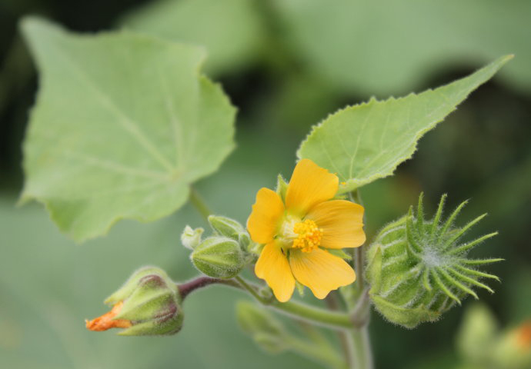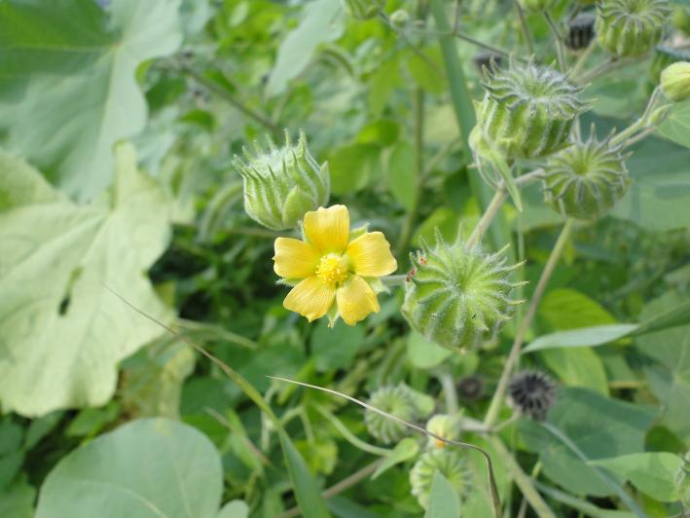
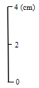

Fig. S1 The photographs (a, c, d) and sketch (b) for whole plant (a, b) and modules (c, d) of Abutilon theophrasti.

