Supplementary tables
Table S1 KEGG Enrichment of characteristic metabolites from comparing group Van+TSS with Van.
Tissue | MapID | MapTitle | Pvalue | MetaIDs
Liver | map00590 | Arachidonic acid metabolism | 0.015 | Prostaglandin E2; Prostaglandin H2; Lipoxin B4; Thromboxane B2; Prostaglandin D2; 16(R)-HETE; Arachidonic acid; Prostaglandin J2; 5-OxoETE
Liver | map04924 | Renin secretion | 0.044 | Prostaglandin E2; Adenosine; Adenosine 5'-monophosphate
Colon | map00564 | Glycerophospholipid metabolism | 0.009 | O-Phosphorylethanolamine; Phosphoethanolamine; Phosphocholine; Cytidine 5'-diphosphocholine
MapID：map ID of enriched KEGG Pathway. MapTitle：title of enriched KEGG Pathway. P-value: Over Representation Analysis was implemented using the hypergeometric test to evaluate whether a particular metabolite set is represented more than expected by chance within the given compound list. One-tailed p values are provided after adjusting for multiple testing. MetaIDs：list of those input metabolites that participated in this KEGG Pathway.
Table S2. Analysis of characteristic metabolites derived from the liver between the TSS and Con treatment groups.
Displayed as excel files for appropriate exhibition
Table S3. Analysis of characteristic metabolites derived from the colon between the TSS and Con treatment groups.
Displayed as excel files for appropriate exhibition

Supplementary figures
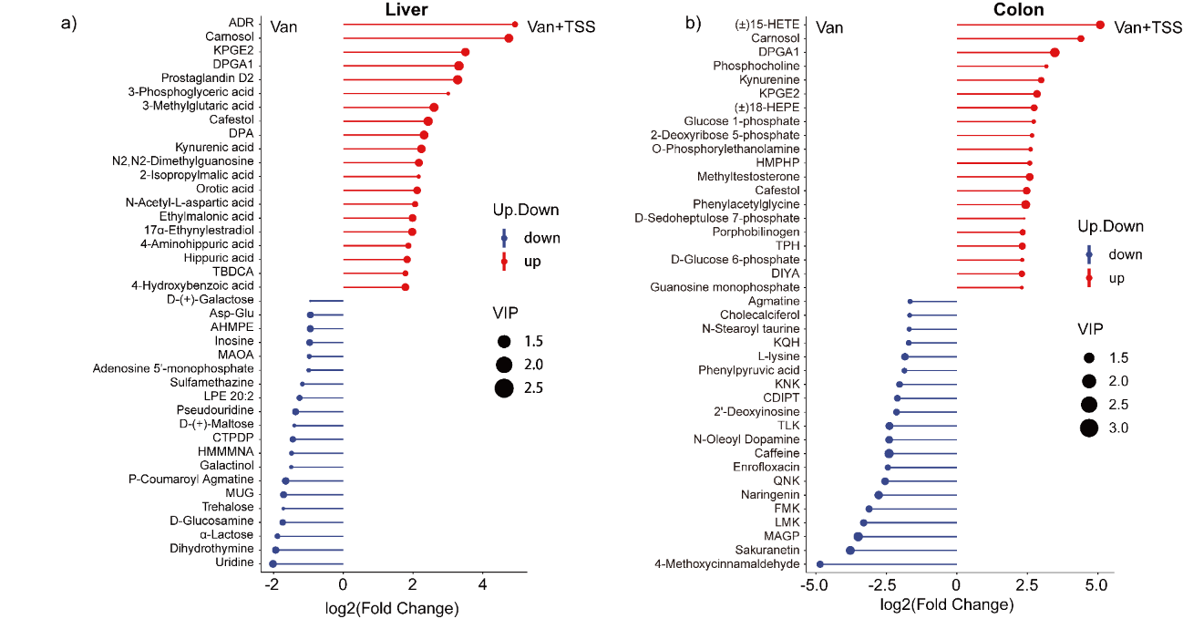
Figure S1. Metabolic profiling of comparable treatments of Van+TSS vs Van. a) and b) The top 20 up- and downregulated liver and colon metabolites for each change from the compared treatments of the Van+TSS group versus the Van group. Abbreviations: ADR, adenosine diphosphate ribose; KPGE2,8-iso-15-keto prostaglandin E2; DPGA1, 15-deoxy-126, 14-prostaglandin A1; DPA, (2R)-2,3-dihydroxypropanoic acid; TBDCA, trans-2-Butene-1,4-dicarboxylic acid; AHMPE, (2E)-N-(4-acetamidobutyl)-3-(4-hydroxy-3-methoxyphenyl)prop-2-enamide; MAOA, 2-{2-[2,5-di(methoxycarbonyl)anilino]-2-oxoethoxy}acetic acid; CTPDP, N-[2-chloro-6-(trifluoromethoxy)phenyl]-2,2-dimethylpropanamide; HMMMNA, N-[(4-hydroxy-3-methoxyphenyl)methyl]-8-methylnonanamide; MUG, 4-Methylumbelliferyl glucuronide; HMPHP, 2-hydroxy-1-(4-methoxyphenyl)propyl hexopyranoside; DIYA, (2-oxo-2,3-dihydro-1H-indol-3-yl)acetic acid; CDIP,
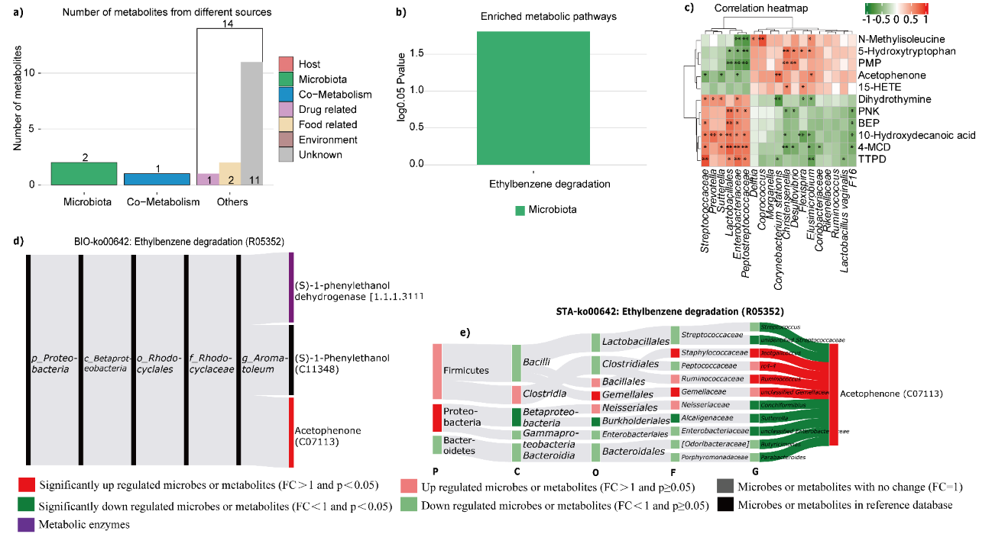
Figure S2. Cometabolism of colon-derived metabolites by the gut microbiota and its host during TSS treatment. a) Overview of the numbers of significantly changed colon metabolites that came from the host, microbiota, cometabolism, and other sources. b) Enriched metabolic pathways from metabolite pathway enrichment analysis (MPEA) according to the differentially abundant metabolites from bacteria, the host, or both. c) Heatmap of Spearman correlation coefficients between screened metabolites and microbes. d) BIO-Sankey network for the top metabolic pathway of cometabolism, in which the network included all the microbiota that participated in the network. e) STA-Sankey network for the top metabolic pathway of cometabolism, in which the network shows the identified microbiota from TSS treatment. The red or green color of the bars and bands indicates up- or downregulation of bacteria and metabolites or positive or negative correlations between them. The shades of color (dark or light) indicate the statistical significance of bacteria/metabolites and their correlations, respectively. 0.01<*p <0.05; **p <0.01. Abbreviations: PMP, 1-phenyl-3-methyl-5-pyrazolone; BEP, 2-(1,3-benzodioxol-5-yl)-7-ethylimidazo[1,2-a]pyridine; 4-MCD, 4-methoxycinnamaldehyde; TTPD, 1,3,7-trimethyl-2,3,6,7-tetrahydro-1H-purine-2,6-dione.

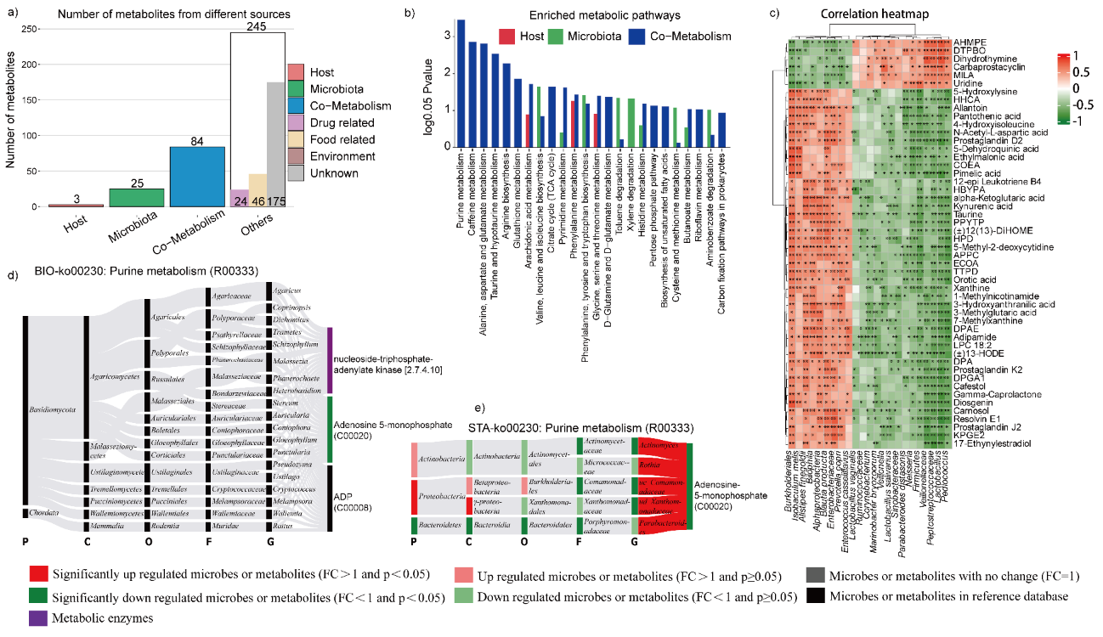
Figure S3. Cometabolism of liver-derived metabolites by the gut microbiota and its host under TSS and vancomycin treatment. a) Overview of the numbers of significantly changed liver metabolites that came from the host, microbiota, cometabolism, and other sources. b) Enriched metabolic pathways from metabolite pathway enrichment analysis (MPEA) according to the differentially abundant metabolites from bacteria, the host, or both. c) Heatmap of Spearman correlation coefficients between screened metabolites and microbes. d) BIO-Sankey network for the top metabolic pathway of cometabolism, in which the network included all the microbiota that participated in the network. e) STA-Sankey network for the top metabolic pathway of cometabolism, in which the network shows the identified microbiota from TSS treatment. The red or green color of the bars and bands indicates up- or downregulation of bacteria and metabolites or positive or negative correlations between them. The shades of color (dark or light) indicate the statistical significance of bacteria/metabolites and their correlations, respectively. 0.01<*p <0.05; **p <0.01. Abbreviations: AHMPE, (2E)-N-(4-acetamidobutyl)-3-(4-hydroxy-3-methoxyphenyl)prop-2-enamide; DTPBO, 1,3-dimethyl-6-(trifluoromethyl)-1H-pyrazolo[3,4-b]pyridin-4-ol; MILA, Methylimidazoleacetic acid; HHCA, 16-Hydroxyhexadecanoic acid; COEA, 4-(4-cyclohexylphenyl)-4-oxobut-2-enoic acid; HBYPA, (2R)-2-[(2R,5S)-5-[(2S)-2-hydroxybutyloxolan-2-yl]propanoic acid; PPYTP, 2-{[3-(2,3,4,5,6-pentamethylphenyl)prop-2-ynyl]oxy}tetrahydro-2H-pyran; HPD, 1-(4-hydroxyphenyl)propane-1,2-diol; APPC, 5-amino-1-phenyl-1H-pyrazole-4-carbonitrile; ECOA, ethyl 2-cyano-3-[(2-oxoazepan-3-yl)aminoacrylate; TTPD, 1,3,7-trimethyl-2,3,6,7-tetrahydro-1H-purine-2,6-dione; DPAE, 3,4-Dihydroxyphenylacetone; DPA, (2R)-2,3-Dihydroxypropanoic acid; DPGA1, 15-Deoxy-Δ 12,14-prostaglandin A1; KPGE2,8-iso-15-keto Prostaglandin E2.
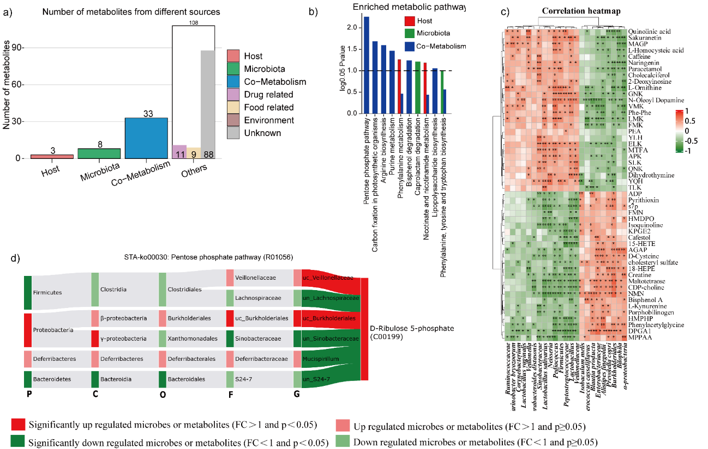
Figure S4. Cometabolism of colon-derived metabolites by the gut microbiota and its host under TSS and vancomycin treatment. a) Overview of the numbers of significantly changed liver metabolites that came from the host, microbiota, cometabolism, and other sources. b) Enriched metabolic pathways from metabolite pathway enrichment analysis (MPEA) according to the differentially abundant metabolites from bacteria, the host, or both. c) Heatmap of Spearman correlation coefficients between screened metabolites and microbes. d) STA-Sankey network for the top metabolic pathway of cometabolism, in which the network shows the identified microbiota from TSS treatment. The red or green color of the bars and bands indicates up- or downregulation of bacteria and metabolites or positive or negative correlations between them. The shades of color (dark or light) indicate the statistical significance of bacteria/metabolites and their correlations, respectively. 0.01<*p <0.05; **p <0.01. Abbreviations: MAGP, Methyl alpha-D-glucopyranoside; PEA, Palmitoyl ethanolamide; MTFA, (6R,S)-5, 10-Methylene-5,6,7,8-Tetracycline; ADP, Adenosine diphosphate; FMN, Flavin mononucleotide; HMDPO, 5-hydroxy-4-methoxy-5,6-dihydro-2H-pyran-2-one; KPGE2,8-iso-15-keto Prostaglandin E2; AGAP, N-acetylglucosamine 1-phosphate; CDP-choline, Cytidine 5-diphosphocholine; NMN, Nicotinamide mononucleotide; HMPHP, 2-Hydroxy-1-(4-methoxyphenyl)propyl hexopyranoside; DPGA1, 15-deoxy-12,14-prostaglandin A1; MPPAA, N-[4-(4-methylpiperazino)phenyl-2-phenylacetamide.

