目录
Fig3C Western blot image of BAX (9.11)① 3
Fig3C Western blot image of BAX (10.11)② 4
Fig3C Western blot image of BAX (12.1)③ 5
Fig3C Western blot image of BAX (11.2)④ 6
Fig3C Western blot image of Bcl-2(9.11)① 7
Fig3C Western blot image of Bcl-2(9.12)② 8
Fig3C Western blot image of Bcl-2(9.13)③ 9
Fig3C Western blot image of Caspase-3(9.9)① 10
Fig3C Western blot image of Caspase-3(10.30)② 11
Fig3C Western blot image of Caspase-3(11.2)③ 12
Fig3C Western blot image of β-actin(9.9)① 13
Fig3C Western blot image of β-actin(10.31)② 14
Fig4A Western blot image of PI3K(9.8)① 15
Fig4A Western blot image of PI3K(9.9)② 16
Fig4A Western blot image of AKT(9.9)① 17
Fig4A Western blot image of AKT(9.15)② 18
Fig4A Western blot image of Beclin1(9.10)① 19
Fig4A Western blot image of Beclin1(9.11)② 20
Fig4A Western blot image of Beclin1(9.13)③ 21
Fig4A Western blot image of P62(9.10)① 22
Fig4A Western blot image of P62(9.11)② 23
Fig4A Western blot image of P62(9.13)③ 24
Fig4A Western blot image of LC3(9.13)① 25
Fig4A Western blot image of β-actin (9.10)① 26
Fig4A Western blot image of β-actin(10.9)② 27
Fig5A Western blot image of CHOP(9.13)① 28
Fig5A Western blot image of CHOP(9.15)② 29
Fig5A Western blot image of eIF2-α(9.17)① 30
Fig5A Western blot image of PERK(9.17)① 31
Fig5A Western blot image of Tubulin(9.9)① 32
Maker 33
Fully automated chemiluminescence gel imaging system 34

Fig3C Western blot image of BAX (9.11)①

21KD
Maker
Cisplatin
100μmol/ L
50μmol/ L
Control
Lower glue (15%)

Fig3C Western blot image of BAX (10.11)②
Maker
21KD
100μmol/ L
Cisplatin
50μmol/ L
Control
Lower glue (15%)

Fig3C Western blot image of BAX (12.1)③

Maker

21KD

Cisplatin
100μmol/ L
50μmol/ L
Control

Lower glue (15%)

Fig3C Western blot image of BAX (11.2)④

21KD
Cisplatin
100μmol/ L
50μmol/ L
Control
Lower glue (15%)

Fig3C Western blot image of Bcl-2(9.11)①

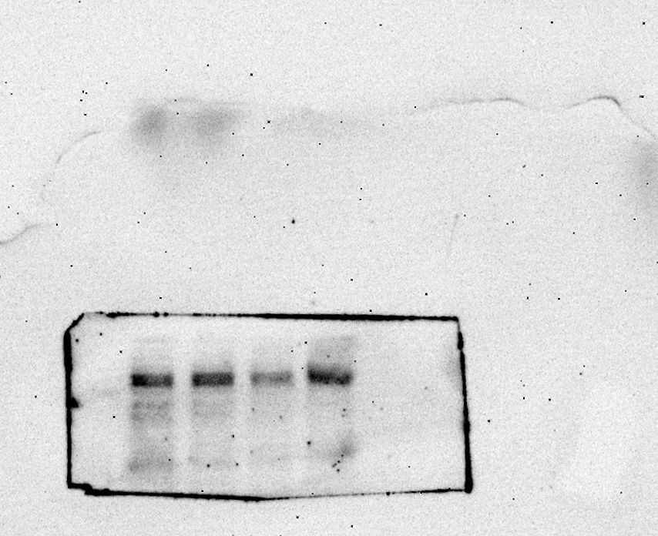
26KD
Maker
Cisplatin
100μmol/ L
50μmol/ L
Control

Lower glue (15%)

Fig3C Western blot image of Bcl-2(9.12)②
Maker
26KD
Cisplatin
100μmol/ L
50μmol/ L
Control

Lower glue (15%)

Fig3C Western blot image of Bcl-2(9.13)③
Maker

26KD
Control
50μmol/ L
100μmol/ L
Cisplatin
Lower glue (15%)

Fig3C Western blot image of Caspase-3(9.9)①

32KD
Cisplatin
100μmol/ L
50μmol/ L
Control
Lower glue (12.5%)

Fig3C Western blot image of Caspase-3(10.30)②
32KD
Cisplatin
100μmol/ L
50μmol/ L
Control
Lower glue (12.5%)

Fig3C Western blot image of Caspase-3(11.2)③

32KD
Cisplatin
100μmol/ L
50μmol/ L
Control
Maker
Lower glue (12.5%)

Fig3C Western blot image of β-actin(9.9)①

42KD
Cisplatin
100μmol/ L
50μmol/ L
Control
Lower glue (10%)

Fig3C Western blot image of β-actin(10.31)②
Lower glue (10%)
42KD
Cisplatin
100μmol/ L
50μmol/ L
Control

Fig4A Western blot image of PI3K(9.8)①
Maker

123KD
Cisplatin
100μmol/ L
50μmol/ L
Control

Lower glue (6%)

Fig4A Western blot image of PI3K(9.9)②
Maker

123KD
Cisplatin
100μmol/ L
50μmol/ L
Control

Lower glue (6%)

Fig4A Western blot image of AKT(9.9)①

Cisplatin
100μmol/ L
50μmol/ L
Control
60KD
Maker
Lower glue (10%)

Fig4A Western blot image of AKT(9.15)②
Maker
60KD
Cisplatin
50μmol/ L
100μmol/ L
Control
Lower glue (10%)

Fig4A Western blot image of Beclin1(9.10)①

52KD
Control
50μmol/ L
100μmol/ L
Cisplatin
Maker
Lower glue (10%)

Fig4A Western blot image of Beclin1(9.11)②

52KD
Cisplatin
100μmol/ L
50μmol/ L
Control
Lower glue (10%)

Fig4A Western blot image of Beclin1(9.13)③
52KD
Maker
Cisplatin
100μmol/ L
50μmol/ L
Control

Lower glue (10%)

Fig4A Western blot image of P62(9.10)①

62KD
Cisplatin
50μmol/ L
100μmol/ L
Control
Maker
Lower glue (10%)

Fig4A Western blot image of P62(9.11)②
62KD
Cisplatin
100μmol/ L
50μmol/ L
Control
Lower glue (10%)

Fig4A Western blot image of P62(9.13)③
62KD
100μmol/ L
Cisplatin
50μmol/ L
Control
Lower glue (10%)

Fig4A Western blot image of LC3(9.13)①
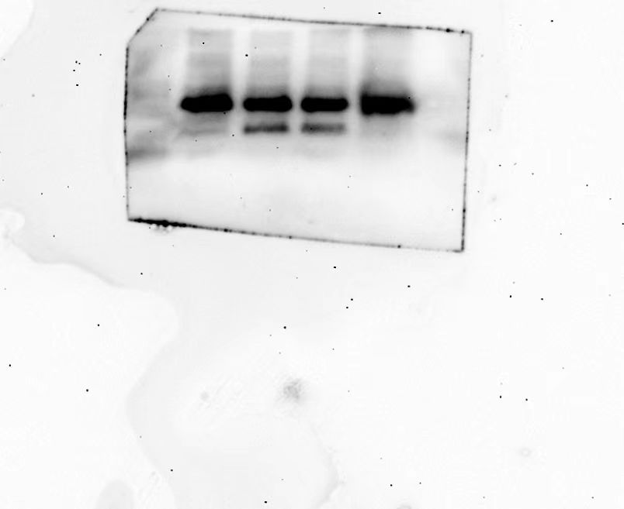
15KD
Cisplatin
100μmol/ L
50μmol/ L
Control
Maker
Lower glue (15%)

Fig4A Western blot image of β-actin (9.10)①
42KD
Cisplatin
100μmol/ L
50μmol/ L
Control
Lower glue (10%)

Fig4A Western blot image of β-actin(10.9)②

42KD
Cisplatin
100μmol/ L
50μmol/ L
Control
Lower glue (10%)

Fig5A Western blot image of CHOP(9.13)①
30KD
Cisplatin
100μmol/ L
50μmol/ L
Control
Maker
Lower glue (15%)

Fig5A Western blot image of CHOP(9.15)②
30KD
Cisplatin
100μmol/ L
50μmol/ L
Control
Lower glue (15%)

Fig5A Western blot image of eIF2-α(9.17)①
36KD
Cisplatin
100μmol/ L
50μmol/ L
Control
Lower glue (12.5%)

Fig5A Western blot image of PERK(9.17)①
125KD
Cisplatin
100μmol/ L
50μmol/ L
Control
Maker
Lower glue (6%)

Fig5A Western blot image of Tubulin(9.9)①
55KD
Cisplatin
100μmol/ L
50μmol/ L
Control
Maker

Lower glue (10%)

Maker

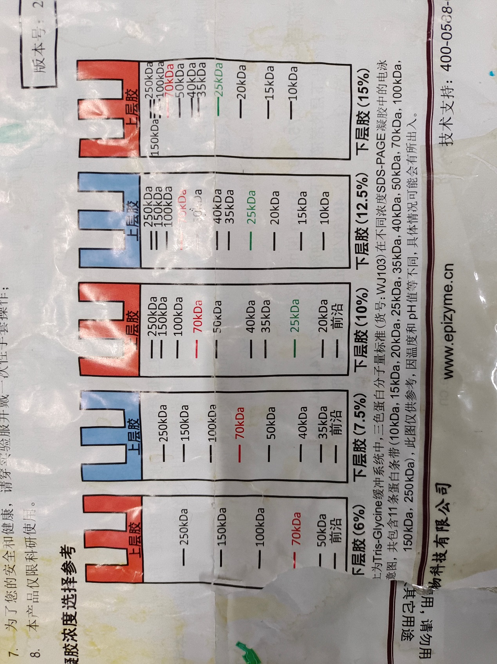

Fully automated chemiluminescence gel imaging system

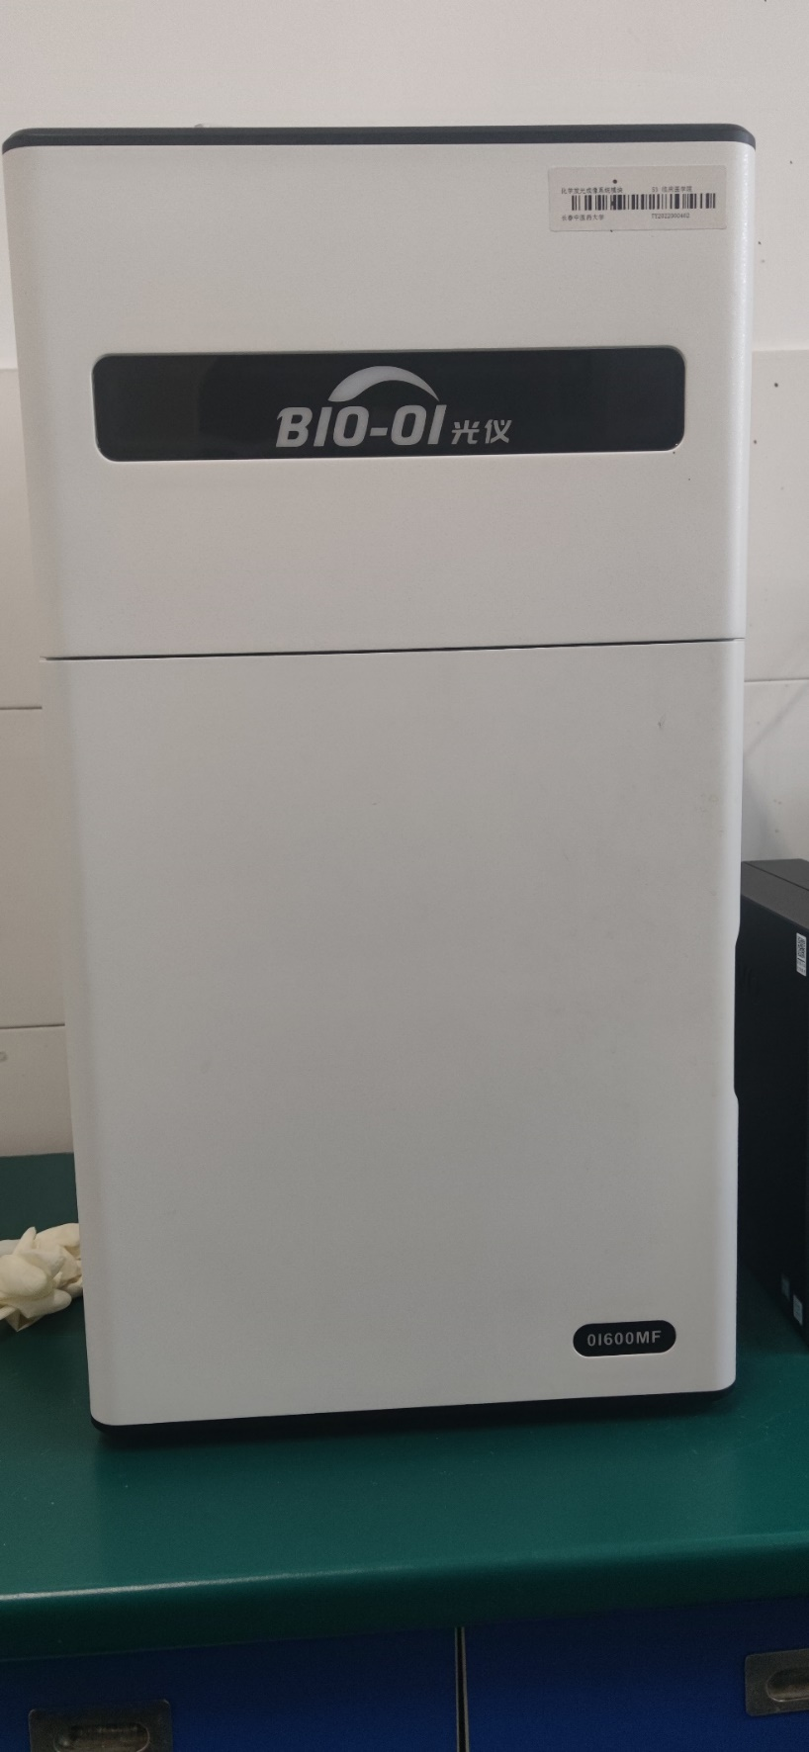
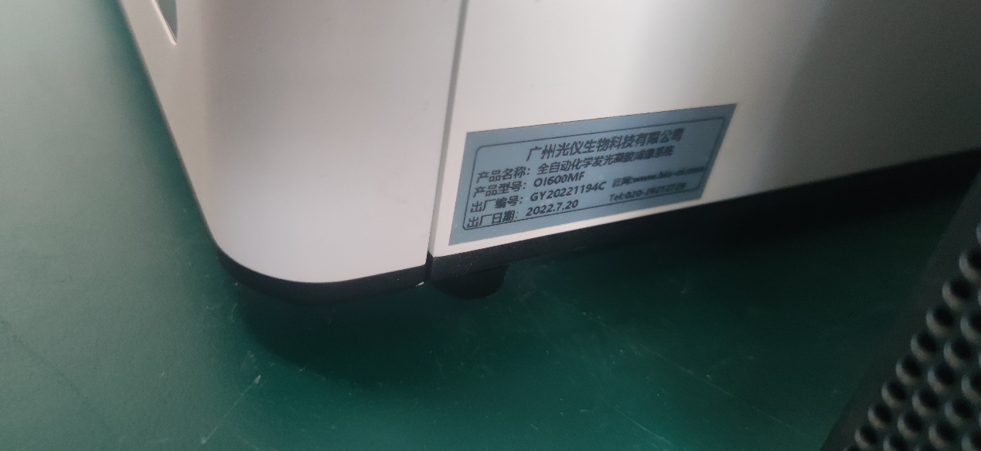

Fully automated chemiluminescence gel imaging system